Volume 2. No 3/2015. ISSN 2313-0008 (Print); ISSN 2313-0016 (Online)

**Research Article**

Malays. j. med. biol. res.

**Statistical Analysis of Tuberculosis in Jigawa State, North-**

**Western Nigeria**

**Isa Abdullahi Baba1*, Evren Hincal2**

1Department of Mathematical Sciences, Bayero University Kano, **NIGERIA**

2Associate Professor, Department of Mathematics, Near East University, **NORTH CYPRUS**

*Email: isababa7@yahoo.com

**Abstract**

Studies on Tuberculosis (TB) in Jigawa, a Northwestern state in Nigeria, is very scarce as Tuberculosis and Leprosy Control Center in the state started functioning properly only recently in 2009. Since then, there has been a hike in the number of TB patients visiting the center. This study is conducted to analyze the incidence of Tuberculosis in the state. Data used is obtained from Tuberculosis and Leprosy Control Center, Ministry of Health, Jigawa State, Nigeria. Questioners are used for the collection of the available data for the period of six years (2009–2014). Linear regression is used to analyze the trend of the disease from the same period. Trends within various age groups were recorded. HIV co–infection is analyzed and its trend is also recorded over the years. Gender parity is also analyzed using a t-test. There is an increase in the number of patients from 2009 to 2014. Out of the 9590 patients seen in the period, 6538 (68.18 %) are males and3052 (31.82%) are females. At-test is used to show the significance in the difference between the number of males and females. It is also found that, there is an increase in the number of HIV co-infection over the said years. The study shows the prevalence of TB is highest among the age group of 25 – 34 (30.15%). The commonest type of TB in the population was smear positive pulmonary TB, with 5853 patients (61.03%). TB in Jigawa state was found to be significantly increasing. Out of all the 9590 patients seen at the center, 6538 (68.18 %) are males and3052 (31.82%) are females. HIV co - infection with Tuberculosis occurred in 9.94% of the patients considered. This study shows a high percentage of infection: 30.14% between the age group of 25-34.In general, Pulmonary TB has a higher prevalence of 95.69% compared to Extra Pulmonary TB that has 4.31%.

**Key Words:** Tuberculosis, HIV, Jigawa, Prevalence, t-test, Trend



**9/18/2015** **Source of Support:** None, **No Conflict of Interest:** Declared

This article is is licensed under a Creative Commons Attribution-NonCommercial 4.0 International License.

**Attribution-NonCommercial (CC BY-NC)** license lets others remix, tweak, and build upon work non-commercially, and although the new works must alsoacknowledge & be non-commercial.

**Introduction**

Throughout the world, tuberculosis (TB) is among the serious diseases that kill human beings (Lancelot, et al, 2012)**.** In 2011 alone, there were about 8.7 million new cases of TB and about 1.4 million deaths caused by TB.The threat of TB is felt more in the low and middle-income countries (Johnbull et al, 2013)**.**

The Nigerian population is over 130 million people. Nigeria is the 4th among 22 countries with higher TB burden in the world (WHO, 2006). Nigerian annual number of TB new cases is about 368,000, making it the largest among African countries (WHO, 2005). Various statistical researches were carried out on TB in Nigeria but mostly from South-southern, Southeastern, and Southwesternstates of the country **(**Johnbull et al, 2013; **WHO, 2006; WHO, 2005)**. Jigawa State is one of the Northwestern states in Nigeria. It lies between longitude 110 to 130 North and Latitude 80to 100 East, with a land mass of 22, 140 km2 and with 27 local government areas (Diagnosis of Jigawa Agriculture, 2000). According to National Population Commission (NPC, 2006) the number of people living in the area is estimated to reach 4.3 million. Studies on Tuberculosis in Jigawa state is very limited as Tuberculosis and Leprosy Center in the

CC-BY-NC 2014. i-Proclaim | MJMBR Page 237

|  |  |
| --- | --- |
| Baba and Hincal: Statistical Analysis of Tuberculosis in Jigawa State, North-Western Nigeria | (237-241) |

state started functioning properly only recently in 2009. However, there is an increase in the number of TB patients visiting the center.

This study was conducted to analyze Tuberculosis in Jigawa StateNorth-western Nigeria, by statistical means. In order to achieve that, a review of all the patients with TB in the six-year-period (2009 – 2014) was taken to determine the prevalence of the disease in the period.The analysis is conducted between age groups, type of TB, gender parity, HIV co-infection, and to also determine new cases and retreatment.

**Methods**

**Study site and study design**

All the six (6) years TB data available in the Tuberculosis and Leprosy Control Center, Ministry of Health, Jigawa State, Nigeria was collected.

**Data collection**

**Sample size**

The sample size includes all the TB patients treated in the center within the period of 2009 to 2014.

**Data collection**

A standard questioner was prepared to obtain details from the TB laboratory and TB treatment registers. Variables considered include Period (2009 – 2014), Number of patients in each year, Gender, Age, Type, and HIV co-infection.

**Statistical analysis**

Data generated from the study were entered and recorded in Microsoft Excel computer software. The analysis of the data was performed using Statistical Package for Social Sciences (SPSS) version 20.0.Simple linear regression analysis is used to analyze the trend of the disease from 2009 – 2014. The trend within various age groups is recorded. Gender parity is analyzed and found to be significant using t-test and assuming unequal variance. HIV co-infection is also studied and analyzed.

**Results**

Between 2009 and 2014, 9590 cases of TB are recorded in the center as summarized in (Table 1). There is an increase in the number of TB cases over the years(Graph 1).

**Table1:** Prevalence of TB over the years

|  |  |  |  |  |  |  |  |
| --- | --- | --- | --- | --- | --- | --- | --- |
| **Years** | **2009** | **2010** | **2011** | **2012** | **2013** | **2014** | **Total** |
|  |  |  |  |  |  |  |  |
| Number of Cases | 1283 | 1371 | 1495 | 1643 | 1779 | 2019 | 9590 |
|  |  |  |  |  |  |  |  |

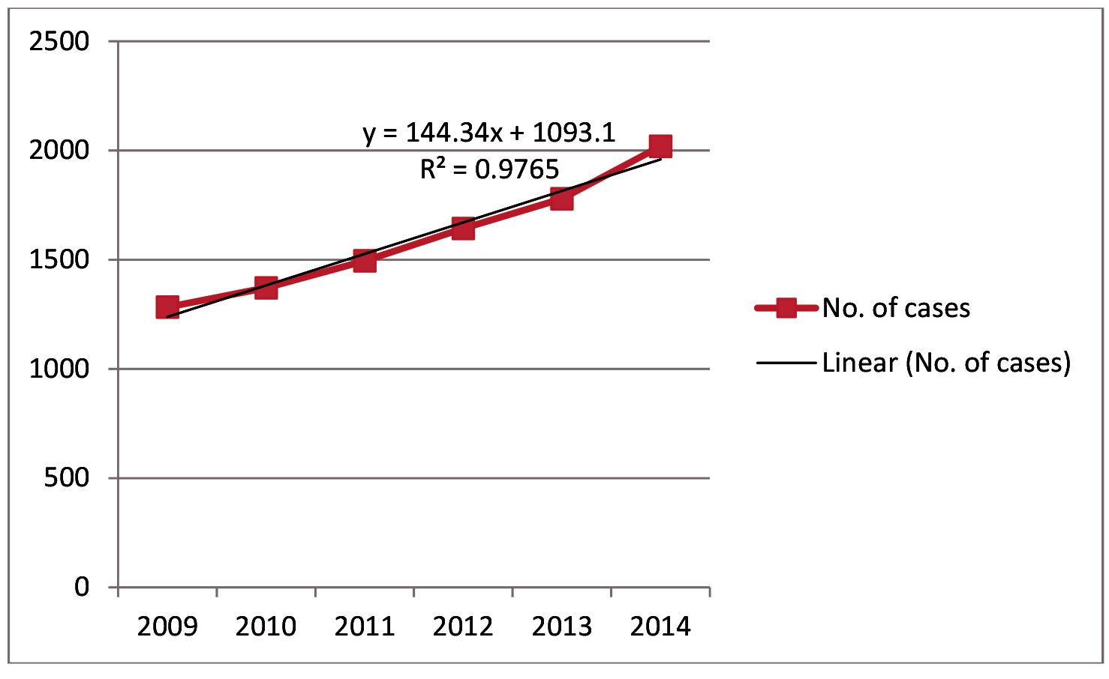

**Figure 1:** TB trend over the years

Page 238 Malaysian Journal of Medical and Biological Research **** Volume 2 **** Number 3/2015

Volume 2. No 3/2015. ISSN 2313-0008 (Print); ISSN 2313-0016 (Online)

Our study shows a differencein TB infection rate between thegenders,out of the 9590 patients seen in the center. The difference being 6538 (68.18 %) males and3052 (31.82) females is found to be statistically significant (Table 2).

**Table 2:** Prevalence of TB with respect to gender

|  |  |  |  |  |  |  |  |  |  |  |
| --- | --- | --- | --- | --- | --- | --- | --- | --- | --- | --- |
|  | **Levene’s Test** | |  |  |  | **t-test for Equality of Means** | | |  |  |
|  | **for Equality of** | |  |  |  |  |  |  |  |  |
|  | **Variances** | |  |  |  |  |  |  |  |  |
|  |  |  |  |  |  |  |  |  |  |  |
|  | **F** | **Sig.** | **t** | **Df** | **Sig. (2-tailed)** | | **Mean** | **Std. Error** | **95% Confidence** | |
|  |  |  |  |  |  |  | **Difference** | **Difference** | **Interval of the** | |
|  |  |  |  |  |  |  |  |  | **Difference** | |
|  |  |  |  |  |  |  |  |  |  |  |
|  |  |  |  |  |  |  |  |  | **Lower** | **Upper** |
|  |  |  |  |  |  |  |  |  |  |  |
| Patients | Equal | 7.320 | .022 | 6.646 | 10 | .000 | 581.000 | 87.417 | 386.223 | 775.777 |
|  | variances |  |  |  |  |  |  |  |  |  |
|  | assumed |  |  |  |  |  |  |  |  |  |
|  |  |  |  |  |  |  |  |  |  |  |
|  | Equal |  |  | 6.646 | 6.523 | .000 | 581.000 | 87.417 | 371.186 | 790.814 |
|  | variances |  |  |  |  |  |  |  |  |  |
|  | not assumed |  |  |  |  |  |  |  |  |  |
|  |  |  |  |  |  |  |  |  |  |  |

There number of HIV co-infection increases over the years (Table 3). The regression equation and the value of areshown below,(Graph 2).

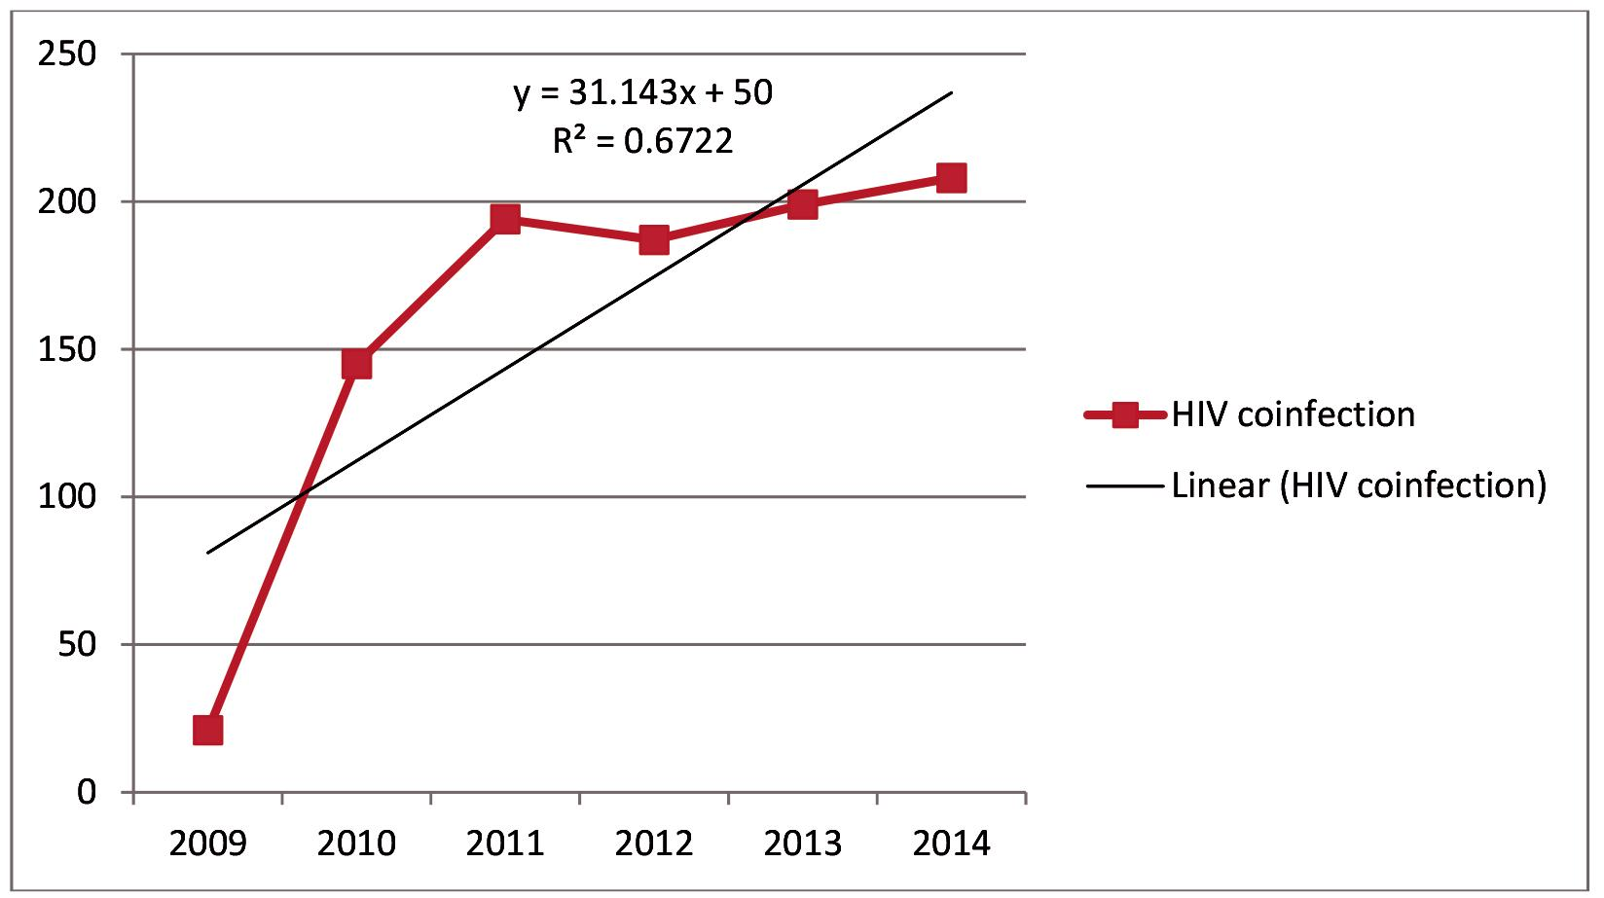

**Figure 2:** HIV co - infection

**Table3:** The prevalence of HIV in the study population

|  |  |  |  |  |  |  |  |  |
| --- | --- | --- | --- | --- | --- | --- | --- | --- |
| **HIV co – infection** | **2009** | **2010** | **2011** | **2012** | **2013** | **2014** | **Total** | **Percentage** |
|  |  |  |  |  |  |  |  |  |
| Present | 21 | 145 | 194 | 187 | 199 | 208 | 954 | 9.9478624 |
|  |  |  |  |  |  |  |  |  |
| Absent | 1262 | 1226 | 1301 | 1456 | 1580 | 1811 | 8636 | 90.052138 |
|  |  |  |  |  |  |  |  |  |
| Total | 1283 | 1371 | 1495 | 1643 | 1779 | 2019 | 9590 | 100 |
|  |  |  |  |  |  |  |  |  |

The prevalence of TB is highest among the age group of 25 – 34 (30.15%). The age group with lowest prevalence is 0 – 4 (1.78 %).Details of the prevalence isshown in Table 4.

CC-BY-NC 2014. i-Proclaim | MJMBR Page 239

|  |  |  |  |  |  |  |  |  |
| --- | --- | --- | --- | --- | --- | --- | --- | --- |
| Baba and Hincal: Statistical Analysis of Tuberculosis in Jigawa State, North-Western Nigeria | | | | |  |  |  | (237-241) |
| **Table 4:** Proportion of TB with respect to age group | | | |  |  |  |  |  |
|  |  |  |  |  |  |  |  |  |
| **Age group** | **2009** | **2010** | **2011** | **2012** | **2013** | **2014** | **Total** | **Percentage** |
| 0-4 | 15 | 19 | 26 | 43 | 44 | 24 | 171 | 1.78 |
| 4-14 | 49 | 53 | 63 | 75 | 82 | 70 | 392 | 4.09 |
| 15-24 | 182 | 206 | 245 | 250 | 214 | 300 | 1397 | 14.56 |
| 25-34 | 421 | 443 | 453 | 488 | 525 | 561 | 2891 | 30.15 |
| 35-44 | 298 | 328 | 343 | 342 | 362 | 422 | 2095 | 21.85 |
| 45-54 | 200 | 192 | 207 | 218 | 256 | 278 | 1351 | 14.09 |
| 55-64 | 80 | 82 | 101 | 143 | 175 | 202 | 783 | 8.16 |
| > 64 | 38 | 48 | 57 | 84 | 121 | 162 | 510 | 5.32 |
| Total | 1283 | 1371 | 1495 | 1643 | 1779 | 2019 | 9590 | 100 |

The commonest presentation wassmear positive pulmonary TB, with 5853 patients (61.03%), followed by Smear Negative Pulmonary TB, with 3324 patients (34.66%). The least is Extra Pulmonary TB, with 413 patients (4.31%) table 5.

**Table 5:** Distribution of the type of TB found

|  |  |  |  |  |  |  |  |  |  |  |  |
| --- | --- | --- | --- | --- | --- | --- | --- | --- | --- | --- | --- |
|  | **Type** | | **2009** | **2010** | **2011** | **2012** | **2013** | **2014** | **Total** | **Percentage** |  |
|  | |  |  |  |  |  |  |  |  |  |  |
| Pulmonary | | Smear Positive | 792 | 868 | 914 | 1070 | 1026 | 1183 | 5853 | 61.03 |  |
| TB |  |  |  |  |  |  |  |  |  |  |  |
|  | Smear Negative | 446 | 474 | 528 | 499 | 649 | 728 | 3324 | 34.66 |  |
|  |  |  |
|  | |  |  |  |  |  |  |  |  |  |  |
| Extra Pulmonary | | | 45 | 29 | 53 | 74 | 104 | 108 | 413 | 4.31 |  |
|  |  |  |  |  |  |  |  |  |  |  |  |
| Total |  |  | 1283 | 1371 | 1495 | 1643 | 1779 | 2019 | 9590 | 100 |  |
|  |  |  |  |  |  |  |  |  |  |  |  |

**Discussions**

In this research, the prevalence of TB in Jigawa state was found to be significantly increasing. This doesn’t agree with the finding in Abia State (Nigeria) between 2005 and 2006 that shows a decrease in the prevalence of the disease (Christopher et al, 2012).

This result may be as a result that Tuberculosis and Leprosy center in Jigawa State,started functioningmuch later in 2009. Therefore, TB patients began to visitthe center for awareness, medication and other purposes en mass.

Out of all the 9590 patients seen at the center, 6538 (68.18 %) were males and3052 (31.82 %) were females.This is in agreement with the study in TB referral center in South-Southern Nigeria, which shows that prevalence is more among men than women (Johnbull et al, 2013).It is also in line with the study by Obiora et al. which indicates higher rate infection among males in Benin, Nigeria (Obiora et al, 2004).Nnorom et al. also reported that higher infection is among males than females in urban and rural communities in Nigeria (Nnorom, et al, 1996).

The reason for the gender parityisperhaps due to the biological and immunological evidence that suggest men may have more smear-positive TB than women (Diwan and Thorson, 1999).

HIV co-infection with Tuberculosis occurred in 9.94% of the patients surveyed. This is an improvement compared to a value 33.9% in a study carried out in Benin City, Nigeria in 2007 (Nnorom, et al, 1996).

This improvement can be associated to the awareness about the disease aswell as the danger of its association with HIV/AIDS been carried out by different NGOs.

This study shows a high percentage of infection: 30.14% between the age group of 25-34. The result is similar to the finding in TB Referral Center in South-Southern Nigeria between January2003 to December2012 that shows 38.1%(Johnbull et al, 2013).

The above findingcan be linked with to the fact that, people in that age group tend to have moreawareness often via social networks and similar platforms.They perhaps have knowledge about Mycobacteriumwhich causes TB and try to avoid it.

In general Pulmonary TB has a higher prevalence of 95.69% compared to Extra Pulmonary TB that has only 4.31%. This result is a little bit higher than that of the TB patients seen in Ado–Ekiti, Ekiti State, Nigeria (Oluwale etal, 2012). It is also higher than that of HIV-Seropositive patients seen at Benin City Nigeria in 2007 (Nnorom, et al, 1996).

**Study limitations**

Although this study offers significant findings, there are still a few limitations notable of which might be the absence of mortality rate due to TB.

Page 240 Malaysian Journal of Medical and Biological Research **** Volume 2 **** Number 3/2015

Volume 2. No 3/2015. ISSN 2313-0008 (Print); ISSN 2313-0016 (Online)

**Conclusion**

The prevalence of TB in Jigawa state was found to be increasing. Out of all the 9590 patients seen in the center 6538 (68.18 %) are males and3052 (31.82) are females. HIV co-infection with Tuberculosis occurred in 9.94% of the patients considered.

This study shows a high percentage of infection 30.14% between the age group of 25-34.In general Pulmonary TB a has higher prevalence of 95.69% compared to Extra Pulmonary TB 4.31%.

**Acknowledgements**

We wish to sincerely thank Dr. Nura Musa Shuaib, the program manager Tuberculosis and Leprosy Control Program, Ministry of Health, Jigawa State, Nigeria.

**References**

Christopher CA, Emeka K, Vivien O.A: The Pattern of Presentation and Prevalence of Tuberculosis in HIV-Seropositive Patients Seen at Benin City, Nigeria. International Scholarly Research Network, 2012

Diagnosis of Jigawa Agriculture: Jigawa Agricultural and Rural Development Agency, 2000

Diwan K. and A. Thorson: Sex and Gender and Tuberculosis. Lancet, 1999; 353: 1000-1001

Johnbull J, Daniel OO, Peter OI: Tuberculosis and Gender Parity in a TB Referral Center, South-South Nigeria. G J of Med Sci. 2013; 3(7): 270-275

Lancelot M.P, Jasmine G, Samuel G.S, et al: Immunodiagnosis of Tuberculosis: State of the Art. Medical Principles and Practice. Med PrincPract 2012; 21: 4-13

Nnorom JA, Esu-Williams E, Tilley-Gyado A.: HIV, Tuberculosis and Syphilis in Nigeria: A Descriptive Study. International Conference on AIDS. 1996 Jul 7-12;11:138

Obiora G, et al. Comparative Study of HIV-Associated Pulmonary Tuberculosis In Chest Clinics from Two Regions of Edo State, Nigeria. Online Journal of health and Allied Sciences (unpaginated). 2004

Oluwale A.B, et al.: Two Year Trend Analysis of Default Rate in Tuberculosis Patients in Federal Medical Center, Ido – Ekiti, Ekiti State, Nigeria. Journal of Asian Scientific Research. 2012

World Health Organization: Global and Regional Incidence. TB Facts Sheets, 2006

World Health Organization: Global TB Control Surveillance, Planning,and Financing. WHO, Geneva, Switzerland, 2005

CC-BY-NC 2014. i-Proclaim | MJMBR Page 241