Volume 2. No 3/2015. ISSN 2313-0008 (Print); ISSN 2313-0016 (Online)

**Research Article**

Malays. j. med. biol. res.

**Study of Availability, Pattern of consumption and Proximate Principles of Ready to Eat Packaged Diet and Regular Snacks, in the city of Mumbai**

**Vishaka Shah, Geeta Ibrahim\***

Department of Foods Nutrition and Dietetics, College of Home Science, University of Mumbai, Nirmala Niketan, Mumbai, INDIA

*Email: teekay7@rediffmail.com

**ABSTRACT**

The present study on the availability, pattern of consumption and proximate principles of Ready to eat packaged (RTEP), Regular and Diet snacks was conducted in the city of Mumbai. 36 Shopkeepers and 100 consumers from different areas of Mumbai were interviewed as per semi-structured questionnaire specifically designed for this study. Shopkeepers were asked about the availability, shelf life and sale of RTEP regular and Diet snacks. Consumers were also individually interviewed about their dietary patterns and their preference of regular and diet RTEP snacks. Fives type of frequently consumed RTEP snacks (*Khakhara, Chivada, Chakri,* Wafers (Banana) and Biscuits (*Khari*)) (regular and their diet variety) were selected and 250 grams of each of them were coded and given for analysis of proximate principles to an ISO-9000 certified laboratory. It was observed that a wide variety of RTEP Diet snacks are available in the city of Mumbai. RTEP diet snacks are perceived as more expensive by shopkeepers and consumers. *Chivada, Khakara and Biscuits (Khari)* are most widely consumed regular and diet snacks. Consumption of Diet RTEP snacks depends on age, gender, religion and the family income of the consumer. Only RTEP Diet *Khakhra* comply with the standards and are a good option for those who wish to consume less calorie and fat in their meals. Other RTEP Diet snacks do not have less than 3 grams of fat per serving. Caution should be taken as salt content in Diet *Khakhra, Chivada and* *Chakri* is more by 52%, 10% & 136% respectively than their regular variety.

**Key Words:** Diet snack, proximate principles



**9/18/2015** **Source of Support:** None, **No Conflict of Interest:** Declared

This article is is licensed under a Creative Commons Attribution-NonCommercial 4.0 International License.

**Attribution-NonCommercial (CC BY-NC)** license lets others remix, tweak, and build upon work non-commercially, and although the new works must alsoacknowledge & be non-commercial.

**Introduction**

Today, with the changing trends in eating habits and increasing awareness about the health, consumers are looking for better options in the food market. Hence, along with Ready to eat packaged (RTEP) Regular snacks, a variety of RTEP Diet Snacks are also available in the Indian market. However the availability, consumption patterns and proximate principals for these snacks have not been studied. Therefore, the present study attempts to look at these three parameters. Vegetarian ready to eat snack foods are made up of different cereal and pulses flours and hence they are high in carbohydrates. The caloric and fat content is also high as many of these snacks contain oil, butter, ghee or are fried. Hence, these contain saturated fat and trans-fat. Some individuals are aware of the high calorie, fat and salt contents and harmful effects of these snacks. So they demand and prefer the ready to eat packaged diet snacks. To cater to the needs of these health conscious individuals a number of different types of ready to eat packaged diet snacks, branded as well as unbranded, are available in the Indian market. “Diet snacks are low salt, low sugar and, of course, low fat. Therefore, they are not very high on the taste quotient. Consumers typically prefer snacking on tastier foods; therefore, diet snacks are still not preferred by many.” (Ghosh, 2008)

CC-BY-NC 2014. i-Proclaim | MJMBR Page 293

|  |  |
| --- | --- |
| Shah and Ibrahim: Study of Availability, Pattern of consumption and Proximate Principles of Ready to Eat Packaged Diet and Regular Snacks, in the city of Mumbai | (293-307) |

As per the trend observed by the food retailers in India, though the demand for diet snacks is growing day by day many consumers lack the awareness about its availability.

Many different types of packaged branded and unbranded ready to eat snacks are available in Mumbai. Some of these snacks are labelled as Diet snacks. Some of the well-known brands mention the nutritional values (calories, protein, carbohydrate, fat etc.) on the packet itself while most of the lesser known brands do not mention the actual nutritional values on the packet. They only mention that it’s a diet food. Hence the question remains,

1. What is the availability of the diet snacks?
2. Do the consumers really buy these so called diet snacks?
3. Are these so called diet snacks really low in calorie content and fat content?
4. Do they contain trans-fat?

Hence, the present study was conducted to find the answers to these questions.

**Materials and Methods**

36 shopkeepers/salesmen of the provisional general grocery shops selling RTEP (Regular as well as Diet snacks) commonly consumed by people of Mumbai.100 men and women consumers between the age group of 18-50 years, living in city of Mumbai were selected for the study using purposive sampling technique.

**Tools**

Two questionnaires used were as follows:

* Questionnaire for shopkeepers: The questionnaire for RTEP snacks was prepared for shopkeepers. It consisted of 7 questions. The questions probed into the availability of different types of RTEP regular snacks, RTEP Diet snacks, preference and sales of the RTEP Diet snacks over RTEP regular snacks. (Appendix1)
* The second questionnaire was consumer survey questionnaire for RTEP snacks. It consisted of 18 questions and it probed into areas like: demographic profile of the consumers, their anthropometric measurements, their preference for diet snacks and frequency of consumption of ready to eat regular and diet snacks.

Based on the feedback from the shopkeepers and men and women consumers interviewed, most frequently consumed regular and diet version of 5 RTEP snack items were analyzed.

The five regular and diet variety of RTEP snacks were as follows:

*1. Khakhra*

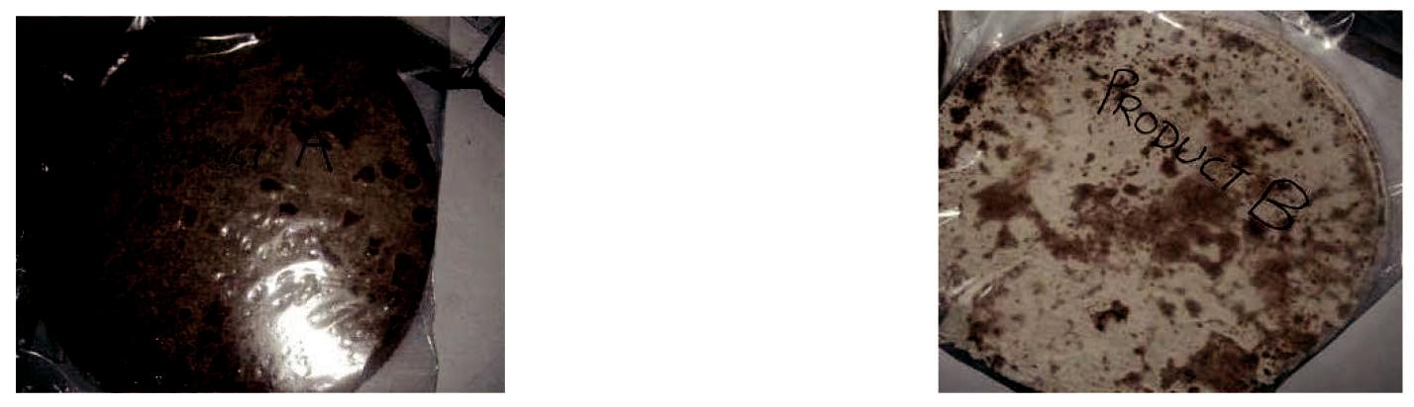

Regular Diet

**Figure 1:** Regular and Diet*Khakhra*

2. *Chivada*

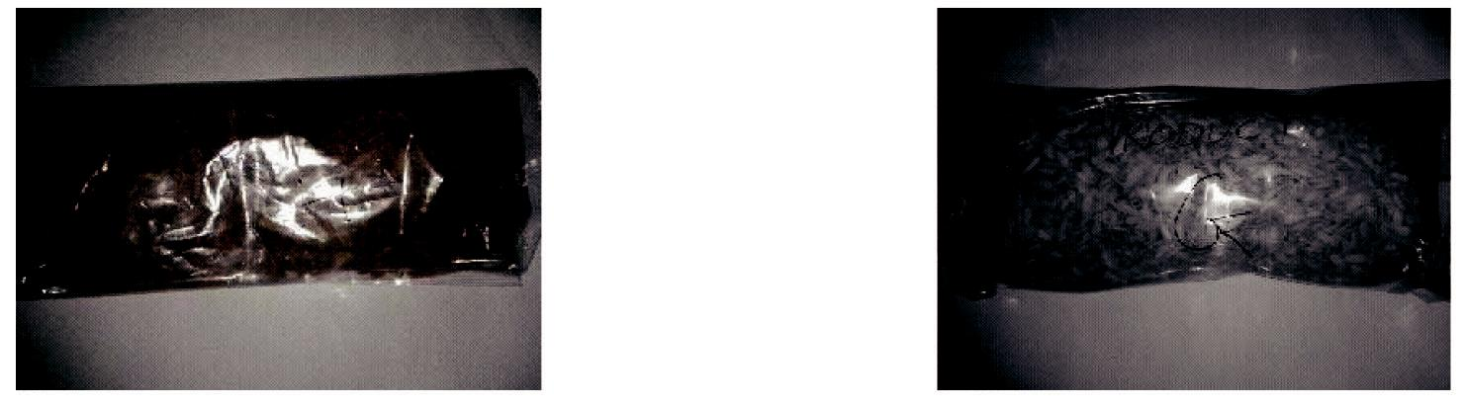

Regular Diet

**Figure II:** Regular and Diet*Chivada*

Page 294 Malaysian Journal of Medical and Biological Research **** Volume 2 **** Number 3/2015

Volume 2. No 3/2015. ISSN 2313-0008 (Print); ISSN 2313-0016 (Online)

*3.* Chakri

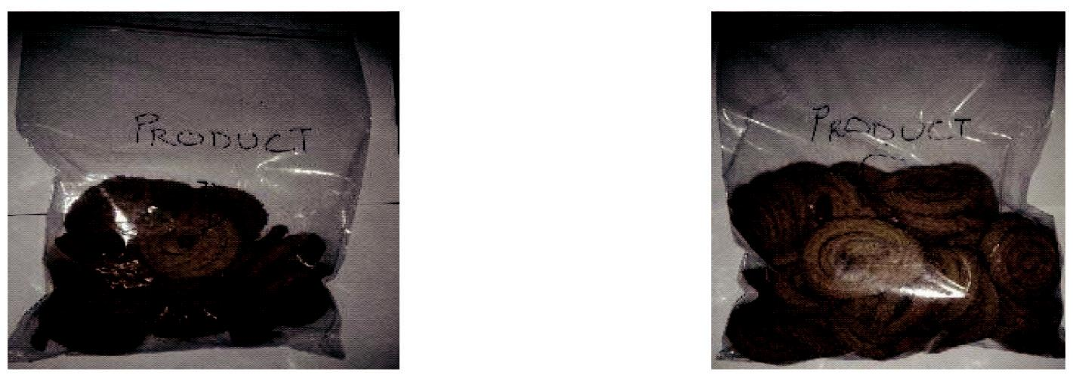

Regular Diet

**Figure III:** Regular and Diet*Chakri*

4. Wafers (Banana)

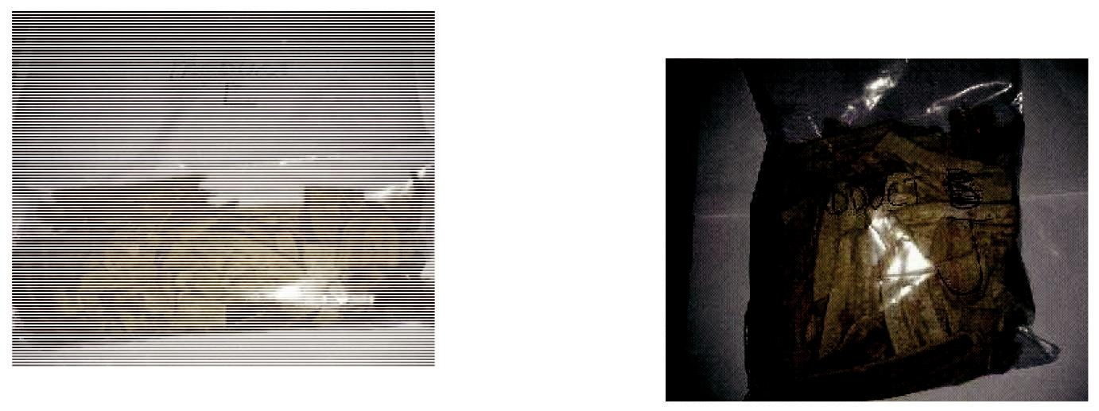

Regular Diet

**Figure IV:** Regular and Diet Wafers

5. Biscuit *(Khari)*

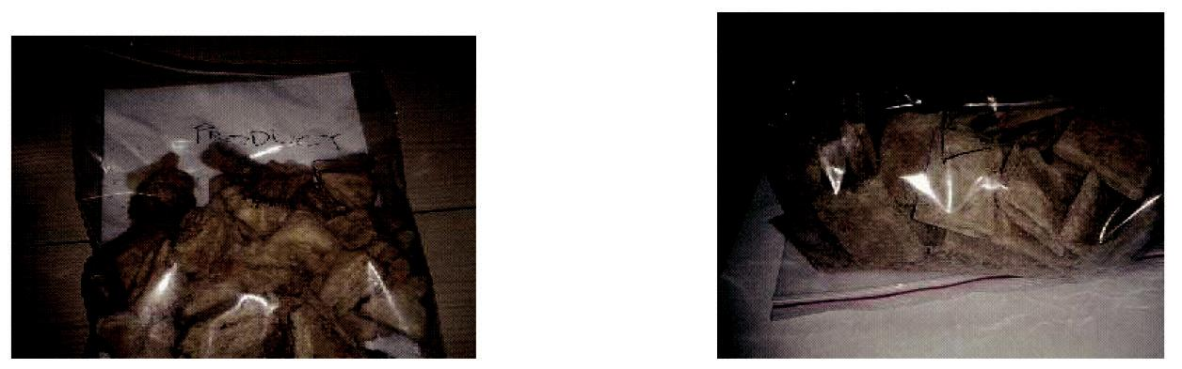

Regular Diet

**Figure V:** Regular and Diet Biscuit*(Khari)*

The 5 different Regular and Diet RTEP snack items were coded and submitted for analysis to an ISO certified food analysis laboratory. The moisture, fat, protein, crude fibre, ash, salt was analyzed by (IS: 7874 Part - I) method. Carbohydrate and energy content was calculated. The dietary fibre was analyzed by (IS: 11062) method. Sugar content by (Lane Eynon method) and trans-fat by (AOAC) method.

Data analysis

1. Data obtained from 30 shopkeepers, 100 men and women consumers was tabulated and analyzed to study the availability, preference and pattern of consumption of RTEP snack items.
2. The proximate principles of 5 different types of the regular and diet snacks were compared.
3. The statistical analysis was done using SPSS version 19.

CC-BY-NC 2014. i-Proclaim | MJMBR Page 295

|  |  |
| --- | --- |
| Shah and Ibrahim: Study of Availability, Pattern of consumption and Proximate Principles of Ready to Eat Packaged Diet and Regular Snacks, in the city of Mumbai | (293-307) |

**Results and Discussion**

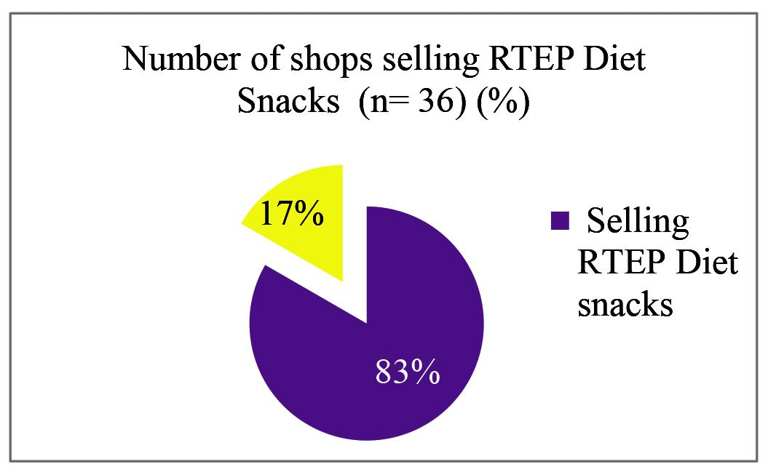

**Figure VI:** Pie Diagram for RTEP snacks

The pie diagram figure V above shows the percentage of shops selling RTEP Diet snacks in the city of Mumbai. Out of 36 which had RTEP snacks, 30 (83%) of them also had RTEP Diet snacks. The above chart indicates that RTEP Diet snacks are easily and widely available in Mumbai

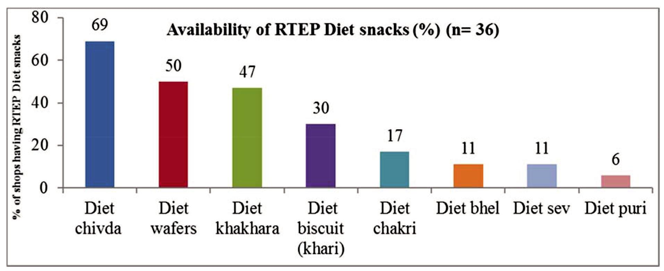

**Figure VII:** Availability of RTEP Diet snacks

The figure VII above shows the availability of different RTEP Diet snacks. Diet *Chivada,* Wafers and *Khakhra* were most frequently available RTEP Diet snacks while Diet *Bhel, Sev* and *Puri* were available only in very few shops.

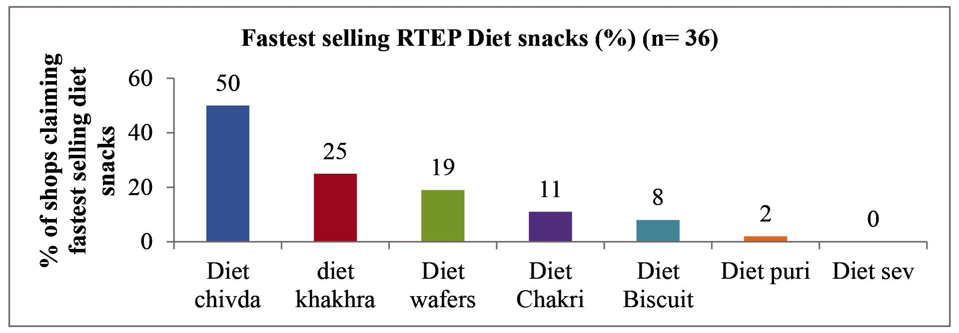

**Figure VIII:** Fasting selling RTEP Diet snacks

Page 296 Malaysian Journal of Medical and Biological Research **** Volume 2 **** Number 3/2015

Volume 2. No 3/2015. ISSN 2313-0008 (Print); ISSN 2313-0016 (Online)

Figure VIII tallys with the finding of the RTEP Regular and Diet snacks most preferred by consumers were also *Khakhras and Chivadas*. Another snack preferred by consumers is, Biscuit *(Khari),* which does not reflect in this graph asone of the fastest selling items. Probably because it is usually available at bakery shop and not in a general provisional stores that were included in present survey.

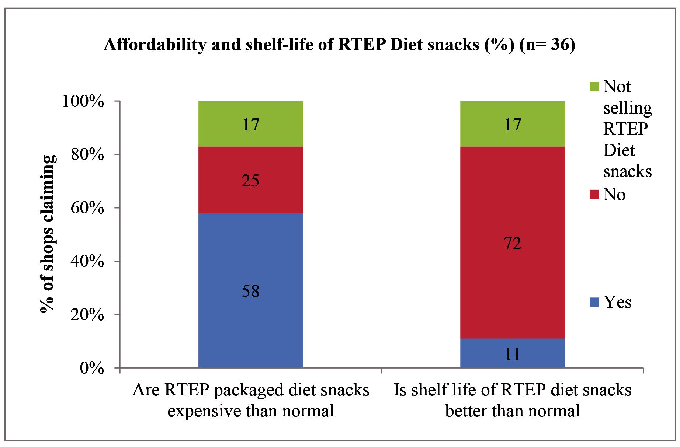

**Figure IX:** Affortability and Shelf life of RTEP Diet snacks

This figure IX shows the shopkeepers’ opinion regarding the affordability and shelf life of RTEP Diet snacks. 58% of the felt that Diet snacks were more expensive than the regular snacks and 72% claimed that shelf – life of RTEP Diet snacks was not longer than the regular snacks. Thus on these two aspects RTEP Diet snacks did not have any additional advantage on over RTEP Regular snacks. On the contrary the disadvantage was that RTEP Diet snacks were more expensive. Cost is one of the factors which determine the preference for Diet snacks by the consumers. Higher cost may reduce the preference of consumers for RTEP Diet snacks.

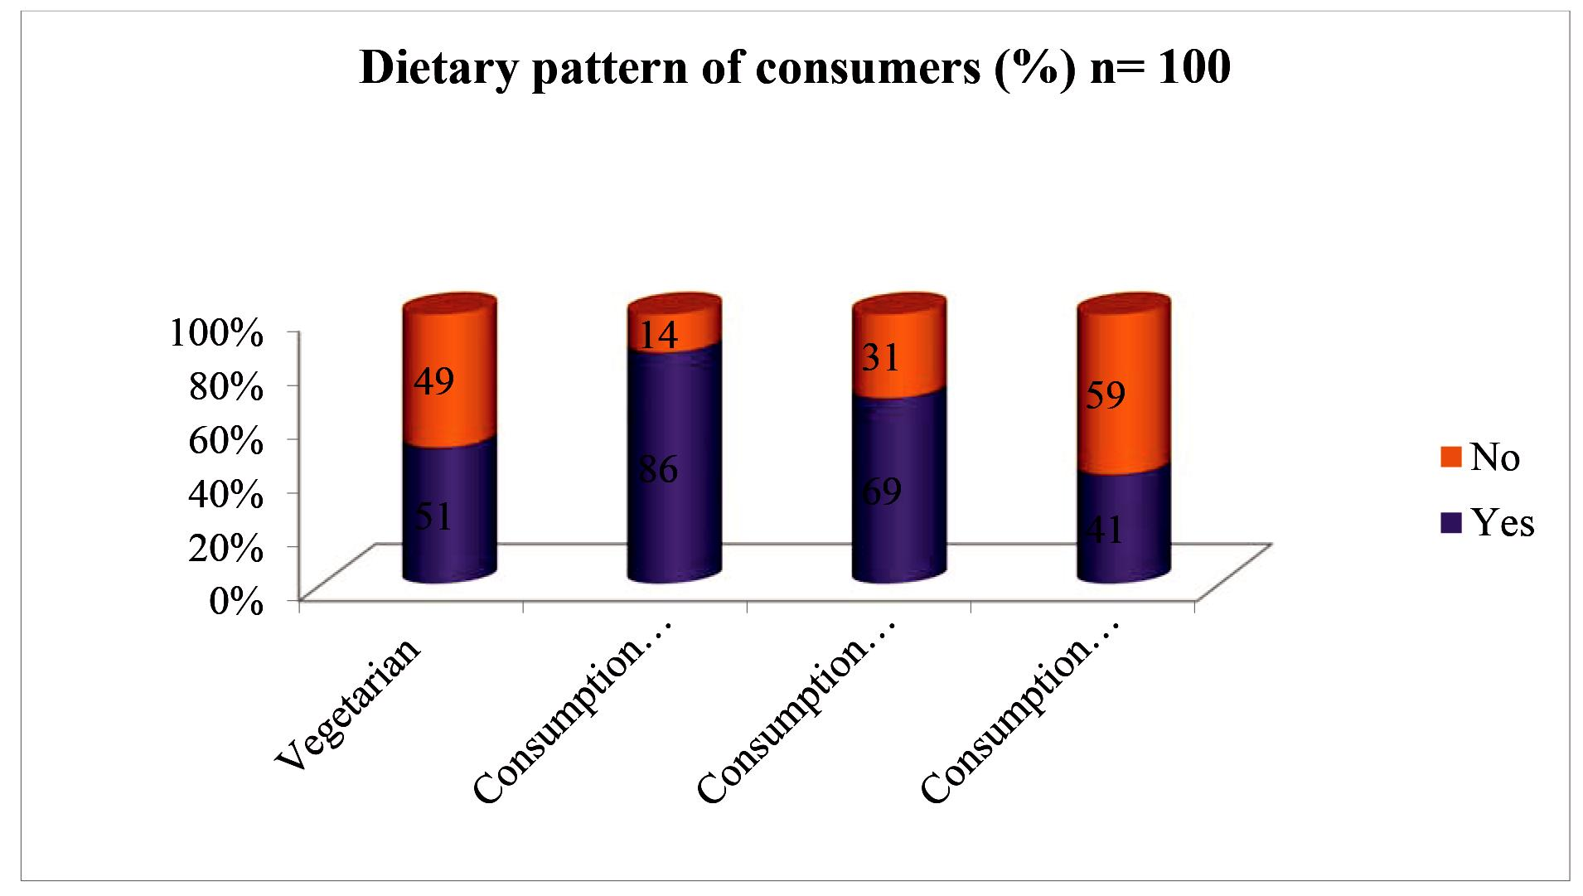

**Figure X:** Dietary Pattern of Consumers

**The above figure X shows the dietary pattern of consumers**

CC-BY-NC 2014. i-Proclaim | MJMBR Page 297

|  |  |
| --- | --- |
| Shah and Ibrahim: Study of Availability, Pattern of consumption and Proximate Principles of Ready to Eat Packaged Diet and Regular Snacks, in the city of Mumbai | (293-307) |

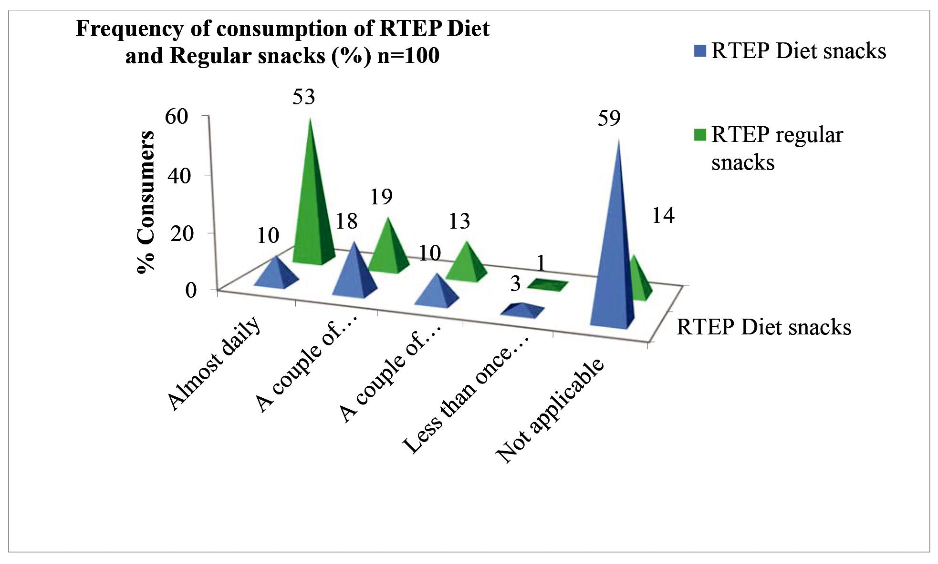

**Figure XI:** Frequency of consumption of RTEP Diet and regular Snacks

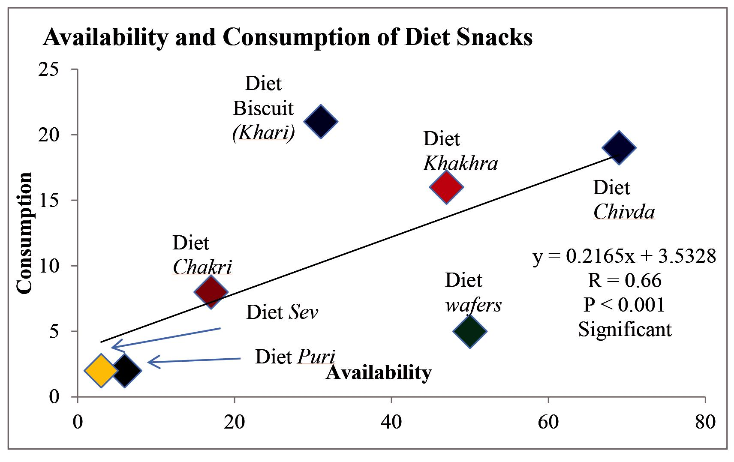

**Figure XII:** Correlation between Availability and Consumption of RTEP Diet Snacks

As evident from the figure XII an expected significant positive correlation was noticed between the availability of the specific types of RTEP Diet snacks (*Chakri*, *Chivada*, *Khakhra,*etc) in different shops and frequency of consumption of these snacks by the consumers.

Page 298 Malaysian Journal of Medical and Biological Research **** Volume 2 **** Number 3/2015

Volume 2. No 3/2015. ISSN 2313-0008 (Print); ISSN 2313-0016 (Online)

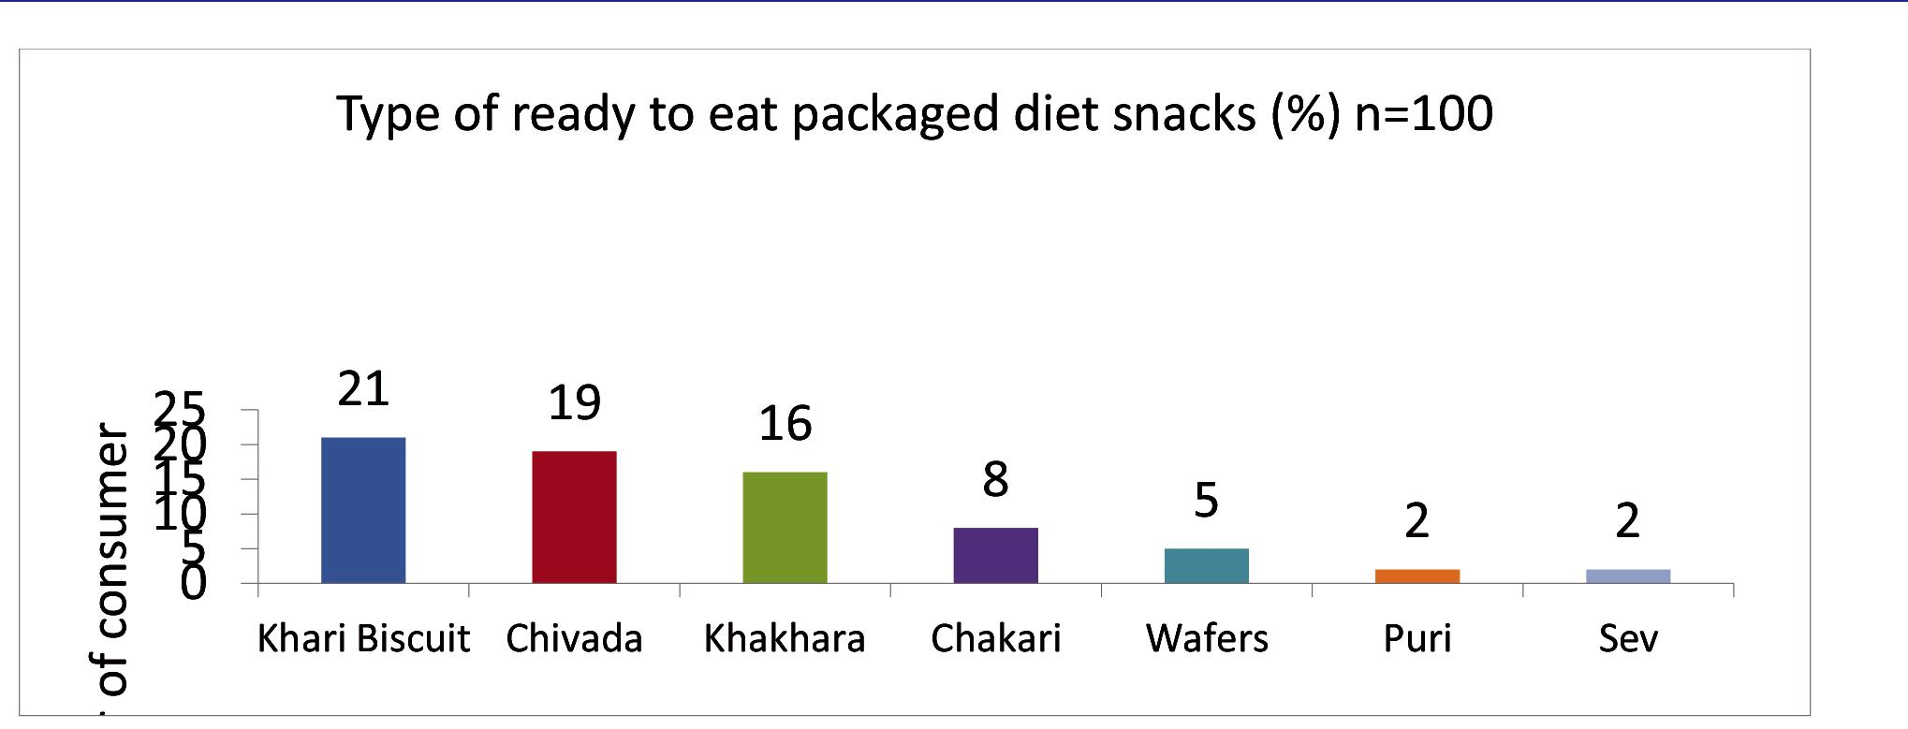

**Figure XIII:** type of ready to eat diet packaged snacks consumed by the consumer

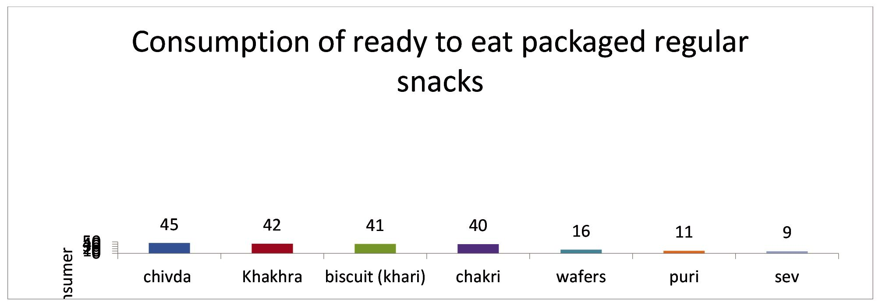

**Figure XIV:** Type of ready to eat packaged regular snacks consumed by the consumer

As evident from the graph XIII,XIV, the majority of them consumed regular *Chivada and Khakhra*. Whereas few consumed Regular *Sev.*

1. Demographic profile of consumers vs. Dietary pattern of consumers

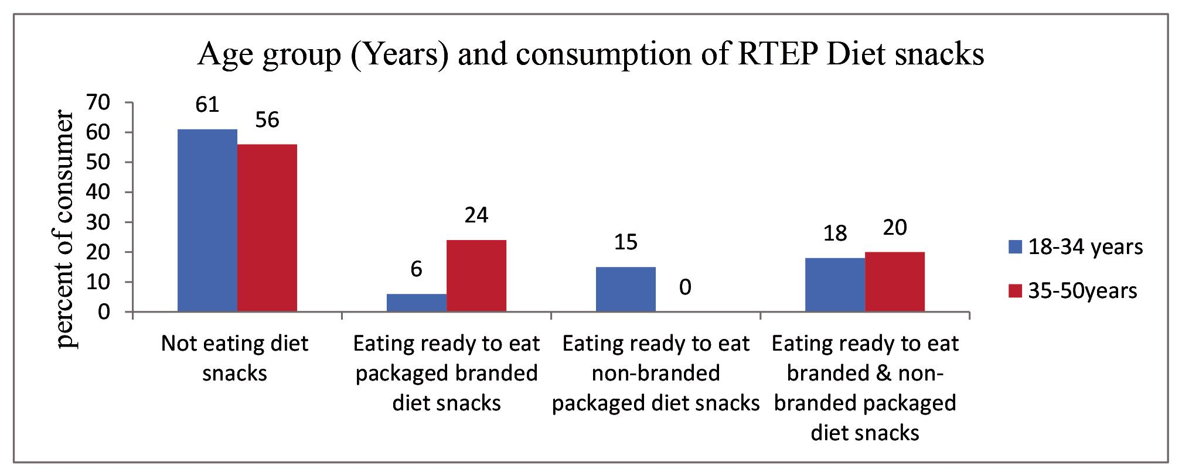

**Figure XV:** Age group and consumption of RTEP Diet Snacks

CC-BY-NC 2014. i-Proclaim | MJMBR Page 299

|  |  |
| --- | --- |
| Shah and Ibrahim: Study of Availability, Pattern of consumption and Proximate Principles of Ready to Eat Packaged Diet and Regular Snacks, in the city of Mumbai | (293-307) |

It was interesting to note that more number of (24%) of older people ( age group 35- 50 years) preferred exclusively branded ready to eat packaged diet snacks as opposed to younger population (18-34 years) (6%). Younger people did not bother about the brand and ate non-branded RTEP diet snacks as well. The difference observed in this figure XV between the two groups was found to be statistically significant (Chi-square value = 11.01, df = 3, p = 0.012, Significant).

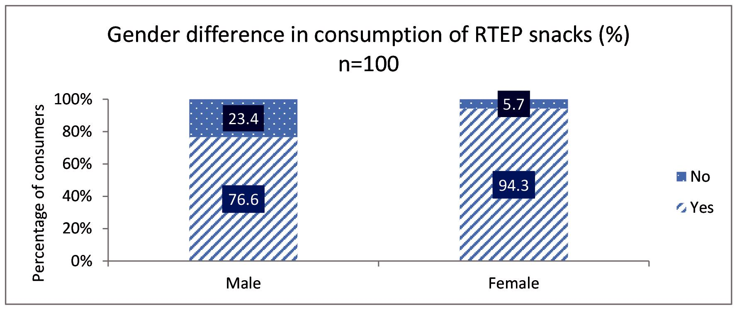

**Figure XVI:** Consumption of RTEP Regular Snacks; Male vs. Female

As illustrated in the above figure XVI there is a significant difference between males and females as far as the consumption of ready to eat packaged snacks is concerned. As depicted in the graph, majority of female consumers preferred ready to eat packaged snacks.

The study quoted in the review of literature (Berteus et al, 2005) also supports the results obtained in current study that women consumed snacks more frequently than men. A similar study by (Aruguete et al., 2006; Kiefer et al., 2005) stated that women’s greater concern with health does not prevent them from snacking more than men do.

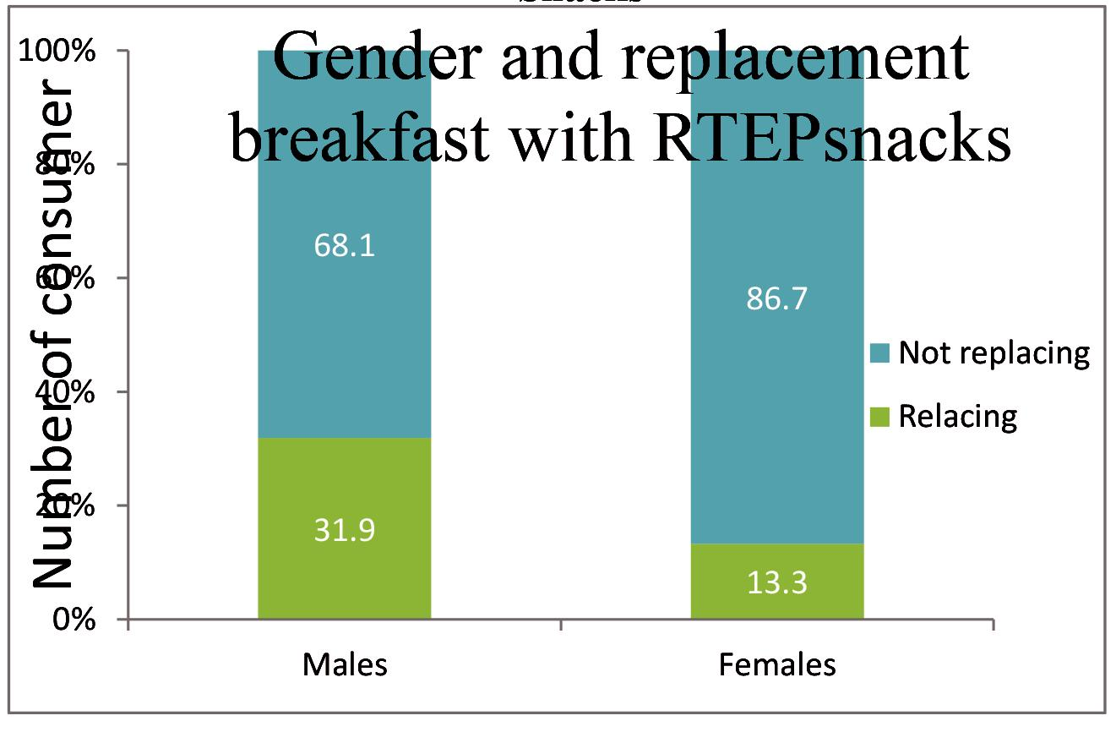

**Figure XVII:** Gender difference in replacing breakfast with of RTEP Regular and Diet Snacks

As seen in the above figure XVII significantly more number of males (31.9%) replaced breakfast with RTEP snacks than females (13.3%) (Chi-square= 5.08, df =1, p= 0.02, Significant). It is likely that single women may prepare their own breakfast while single men may not prepare their own breakfast and may prefer to have ready to eat packaged snacks for their breakfast.

Page 300 Malaysian Journal of Medical and Biological Research **** Volume 2 **** Number 3/2015

Volume 2. No 3/2015. ISSN 2313-0008 (Print); ISSN 2313-0016 (Online)

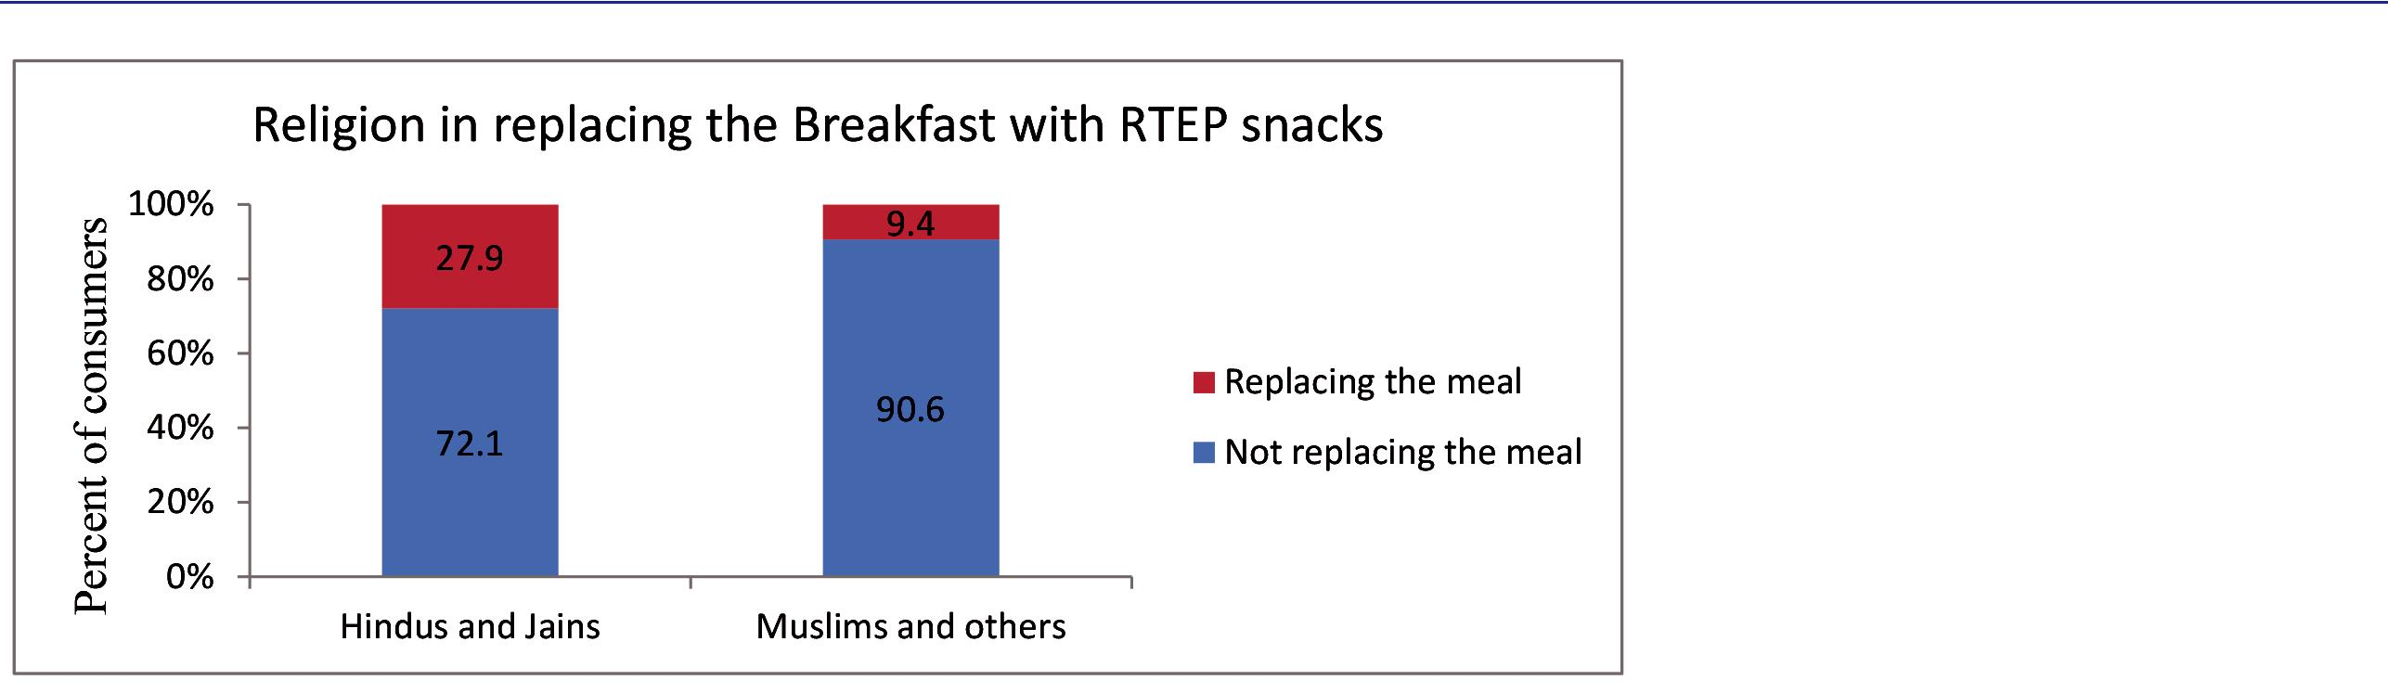

**Figure XVIII:** Religious communities and replacing breakfast with RTEP Regular and Diet snacks

As evident from the stack bar diagram, figure XVIII,significantly more number of Hindus and Jains (27.9%) replaced their breakfast with RTEP snacks as compared to Muslims and Others (9.4%). This difference may be attributed to following reasons.

1. RTEP like *Khakhras* are regularly consumed in breakfast by many Hindus and Jains while Muslims and others prefer freshly prepared *chapati*/*roti*/ *parantha* or bread in their breakfast.
2. Muslims and others (Christians and Parsis) also consume non veg preparations like egg omelete in their breakfast. These items are not available as RTEP snacks.

An attempt was made to compare the consumption of RTEP (Diet and Regular) between consumers from joint families and nuclear families. It was interesting to note that consumers from joint families more frequently preferred Diet as well as Regular RTEP snacks than the individuals from nuclear families. The difference was statistically significant only in case of Diet *Chakri*. (Chi-square= 4.43, df =1, p= 0.03, Significant).

Dietary patterns of consumers who had completed their graduation (> 15 years of education) and those who had not completed their education (< 15 years of education) were compared. It was observed that those who had completed their education preferred RTEP snacks and different types of RTEP Regular and Diet snacks barring few exceptions. On comparing the marital status and dietary patterns of consumers, it was observed that married people had little more preference for eating RTEP snacks, in between the meals and for RTEP Diet snacks than their single counterparts, though the difference was not statistically significant.

Significantly more of married individuals (23.7%) preferred RTEP branded diet snacks as compared to consumers who were single (4.8%), (Chi-square= 11.85, df =3, p= 0.008, Significant)

No significant difference between the two groups were noted as far as reasons for not consuming/ consuming RTEP Diet snacks, frequency of consumption of, preference for buying and taste of RTEP Diet and Regular snacks. Similarly, on comparison, no significant difference was noted between the two groups regarding specific type of RTEP Regular and Diet snacks, affordability and checking caloric content of RTEP Diet snacks.

As far as replacing the meals with RTEP Regular and Diet snacks was concerned it was observed that single individual were more likely to replace their meals with RTEP Regular or Diet snacks than the married individuals. This difference was statistically significant for replacing tea time meal with RTEP Regular and Diet snacks, where 38.7% of single individuals and 18.4% married individuals replaced their tea time meal with RTEP Diet or Regular snacks. (Chi-square= 4.53, df =3, p= 0.03, Significant).

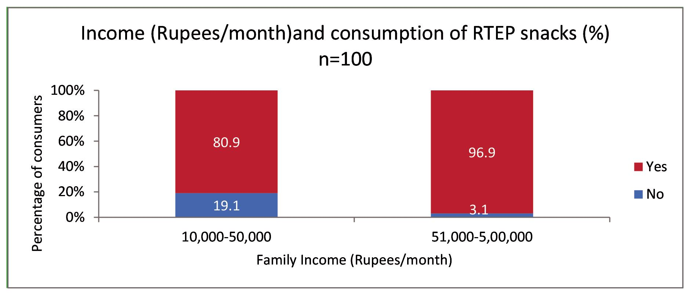

**Figure XIX:** Family Income (Rs.)/month and consumption of RTEP Snacks

CC-BY-NC 2014. i-Proclaim | MJMBR Page 301

|  |  |
| --- | --- |
| Shah and Ibrahim: Study of Availability, Pattern of consumption and Proximate Principles of Ready to Eat Packaged Diet and Regular Snacks, in the city of Mumbai | (293-307) |

Income may be one of the important factors that affect dietary patterns of individuals. To examine this, two different income groups (family income up to Rs.50,000/- per month and more than Rs.50,000/- per month) were compared for their dietary patterns.

It was observed that in figure XVIII and XIX that lower income group had somewhat less preference for eating RTEP snacks compared to higher income group. All but one (97%) from higher income group preferred RTEP snacks as opposed to 81% of the consumers from the lower income group. The difference was statistically significant (Chi-square = 4.62, df = 1, p = 0.03, Significant). On the same line 50 % of the family members of higher income groups preferred RTEP Diet snacks as compared to only 26.5% of the family members of the lower income group (Chi-square = 5.36, df = 1, p = 0.021, Significant)

No significant difference between the two groups was noted as far as eating of RTEP snack between the meals, consumption of RTEP Diet snacks, reasons for not consuming/ consuming RTEP Diet snacks, frequency of consumption of RTEP Diet and Regular snacks, preference for buying and taste of RTEP Diet and Regular snacks were concerned. Similarly, no significant difference was noted between the two groups on a comparison of preference for any type of RTEP Regular and Diet snacks, affordability and checking the caloric content of RTEP Diet snacks.

As far as replacing the meals with RTEP Regular and Diet snacks is concerned it was observed that higher income group were more likely to replace their meals with RTEP Regular or Diet snacks than the lower income group individuals, This difference was statistically significant for replacing late evening time meal with RTEP Regular and Diet snacks, where 25% of higher income group individuals and 8.8% lower income group individuals replaced their tea time meal with RTEP Diet or Regular snacks. (Chi-square = 4.72, df = 3, p = 0.03, Significant).

**Area-C: Proximate principles**

1. Proximate principles of RTEP Regular and Diet snacks

The area of proximate principle includes the various proximate contents like (Moisture, Fat, Carbohydrates, Protein, Crude Fibre, Ash, Energy, Dietary Fibre, Sugar, Trans-Fat and Salt) of 5 RTEP Regular and Diet snacks which were analyzed by the laboratory. The values given are for 100 grams and per serving of different RTEP Diet and Regular snack.

**Table 1:** Proximate principle of RTEP Regular and Diet*Khakhra*

|  |  |  |  |  |
| --- | --- | --- | --- | --- |
| **Test** | **Regular *Khakhra*** | **Regular *Khakhra*** | **Diet *Khakhra*** | **Diet *Khakhra*** |
|  | **(Values per 100** | **(Values of one** | **(Values per 100** | **(Values for one** |
|  | **grams)** | ***Khakhra* of approx** | **grams)** | ***Khakhra* of approx.** |
|  |  | **20gms)** |  | **20 gram)** |
|  |  |  |  |  |
| Moisture (gms) | 03.49 | 0.698 | 05.74 | 01.15 |
|  |  |  |  |  |
| Fat (gms) | 17.10 | 03.42 | 06.10 | 01.22 |
|  |  |  |  |  |
| Protein (Nx6.25) (gms) | 10.65 | 02.13 | 11.70 | 02.34 |
|  |  |  |  |  |
| Crude fibre (gms) | 00.55 | 00.11 | 00.70 | 00.14 |
|  |  |  |  |  |
| Ash (gms) | 01.80 | 00.36 | 02.53 | 00.51 |
|  |  |  |  |  |
| Carbohydrate (gms) | 66.41 | 13.28 | 73.23 | 14.65 |
|  |  |  |  |  |
| Energy (Kilo Calories) | 462/100gms | 92.40/20gms | 395/100gms | 79/20gms |
|  |  |  |  |  |
| Dietary fibre (gms) | 06.50 | 01.3 | 07.75 | 01.55 |
|  |  |  |  |  |
| Added Sugar (gms) | Nil | Nil | Nil | Nil |
|  |  |  |  |  |
| Trans Fat (gms) | Nil | Nil | Nil | Nil |
|  |  |  |  |  |
| Salt as Nacl (gms) | 01.23 | 0.246 | 01.87 | 00.37 |
|  |  |  |  |  |

Table 1 shows the proximate principle contents of regular and diet *Khakhras*. It is evident from the table that Diet *Khakhras* has 14.5 % less calories and 64.3% less fat. This less fat percentage in Diet *Khakhra* is proportionately compensated by high carbohydrate, protein and fibre which is desirable from health point of view. It is further reassuring to know that there is no added sugar and trans-fat in Regular as well as Diet *Khakhra*s. The only point of concern about the Diet *Khakhra* is it’s substantially (52%) higher salt content.

According to U.S. food and drug administration a product labelled as ‘low fat’ (other word for diet) should not have more than 3 grams of fat per serving; and to be labelled ‘fat free’ it must contain less than 0.5 grams of fat per serving. From table it appears that fat content of RTEP Diet *Khakhra* is only 1.22 grams per piece of *Khakhra*.

Page 302 Malaysian Journal of Medical and Biological Research **** Volume 2 **** Number 3/2015

|  |  |  |  |  |  |
| --- | --- | --- | --- | --- | --- |
| Volume 2. No 3/2015. |  | ISSN 2313-0008 (Print); ISSN 2313-0016 (Online) | | |  |
| **Table 2:** Proximate contents of RTEP Regular and Diet*Chivada* | | |  |  |  |
|  |  |  |  |  |  |
| **Test** | **Regular *Chivada*** | **Regular *Chivada*** | **Diet *Chivada*** |  | **Diet *Chivada*** |
|  | **(Values per 100** | **(Values per 50gms)** | **(Values per 100** |  | **(Values for approx.** |
|  | **grams)** | **(1 serving)** | **grams)** |  | **50 gram)** |
|  |  |  |  |  |  |
| Moisture (gms) | 3.9 | 1.95 | 3.25 |  | 1.63 |
|  |  |  |  |  |  |
| Fat (gms) | 41.73 | 20.86 | 25.72 |  | 12.86 |
|  |  |  |  |  |  |
| Protein (Nx6.25) (gms) | 11.83 | 5.915 | 9.26 |  | 4.63 |
|  |  |  |  |  |  |
| Crude fibre (gms) | 0.56 | 0.28 | 0.47 |  | 0.235 |
|  |  |  |  |  |  |
| Ash (gms) | 1.60 | 0.8 | 1.55 |  | 0.775 |
|  |  |  |  |  |  |
| Carbohydrate (gms) | 40.31 | 20.155 | 59.75 |  | 29.875 |
|  |  |  |  |  |  |
| Energy (Kilo Calories) | 584/100gms | 292/50gms | 508/100gms |  | 254/50gms |
|  |  |  |  |  |  |
| Dietary fibre (gms) | 2.11 | 1.055 | 3.42 |  | 1.71 |
|  |  |  |  |  |  |
| Added Sugar (gms) | Nil | Nil | Nil |  | Nil |
|  |  |  |  |  |  |
| Trans Fat (gms) | Nil | Nil | Nil |  | Nil |
|  |  |  |  |  |  |
| Salt as Nacl (gms) | 0.72 | 0.14 | 0.79 |  | 0.158 |
|  |  |  |  |  |  |

It is evident from the table 2 that Diet *Chivada* has 13 % less calories and 38.4% less fat. This less fat percentage in Diet *Chivada* is proportionately compensated by high carbohydrate, protein and fibre. It is further reassuring to know thatthere is no added sugar and trans-fat in Regular as well as Diet *Chivada*. The only point of concern about the Diet *Chivada* is its 9.7% higher salt content.

The fat content of Diet Chivada, per 50 grams of serving is 12.86 grams which is much higher than 3 grams per serving requirement for diet food in US.

**Table 3:** Proximate contents of RTEP Regular and Diet*Chakri*

|  |  |  |  |  |
| --- | --- | --- | --- | --- |
| **Test** | **Regular *Chakri*** | **Regular *Chakri*** | **Diet *Chakri* (Values** | **Diet *Chakri* (Values** |
|  | **(Values per 100** | **(Values for one** | **per 100 grams)** | **for one *Chakri* of 9** |
|  | **grams)** | ***Chakri* 9 grams)** |  | **grams)** |
|  |  |  |  |  |
| Moisture (gms) | 2.19 | 0.19 | 2.63 | 0.23 |
|  |  |  |  |  |
| Fat (gms) | 37.44 | 3.36 | 27.88 | 2.50 |
|  |  |  |  |  |
| Protein (Nx6.25) (gms) | 8.14 | 0.73 | 10.51 | 0.94 |
|  |  |  |  |  |
| Crude fibre (gms) | 0.48 | 0.043 | 0.52 | 0.04 |
|  |  |  |  |  |
| Ash (gms) | 2.84 | 0.25 | 3.75 | 0.33 |
|  |  |  |  |  |
| Carbohydrate (gms) | 48.91 | 4.40 | 54.71 | 4.92 |
|  |  |  |  |  |
| Energy (Kilo Calories) | 565/100gms | 50.85/9gms | 512/100gms | 46.08/9gms |
|  |  |  |  |  |
| Dietary fibre (gms) | 3.18 | 0.28 | 3.25 | 0.29 |
|  |  |  |  |  |
| Added Sugar (gms) | Nil | Nil | Nil | Nil |
|  |  |  |  |  |
| Trans Fat (gms) | Nil | Nil | Nil | Nil |
|  |  |  |  |  |
| Salt as Nacl (gms) | 0.98 | 0.08 | 2.32 | 0.20 |
|  |  |  |  |  |

Table 3 depicts the proximate principle contents of regular and diet *Chakri*. It is evident from the table that Diet *Chakri* has 9.4 % fewer calories and 25.75% less fat. The point of concern about the Diet *Chakri* is its 136% higher salt content that is not desirable for individuals on a low salt diet.

Fat content of Diet Chakri per piece (9 grams of serving) is 2.5 grams which meets the definition for diet food in US. Fat content will be higher if one considers more than one Chakri per serving which violets the criteria for diet food.

CC-BY-NC 2014. i-Proclaim | MJMBR Page 303

|  |  |  |  |  |  |
| --- | --- | --- | --- | --- | --- |
| Shah and Ibrahim: Study of Availability, Pattern of consumption and Proximate Principles of Ready to Eat Packaged Diet and Regular Snacks, in the city of Mumbai | | | | | (293-307) |
| **Table 4:** Proximate contents of RTEP Regular and Diet Biscuit*(Khari)* | | |  |  |  |
|  |  |  |  |  | |
| **Test** | **Regular** | **Regular** | **Diet *Biscuit(Khari)*** | **Diet *Biscuit(Khari)*** | |
|  | ***Biscuits(Khari)*** | ***Biscuits(Khari)*** | **(Values per 100** | **(Values for one** | |
|  | **(Values per 100** | **(Values for one** | **grams)** | ***Khari* of approx. 6** | |
|  | **grams)** | ***Khari* of approx 6** |  | **gram)** |  |
|  |  | **grams)** |  |  |  |
|  |  |  |  |  |  |
| Moisture (gms) | 4.02 | 0.2412 | 3.95 | 0.23 |  |
|  |  |  |  |  |  |
| Fat (gms) | 36.26 | 2.1756 | 24.75 | 1.48 |  |
|  |  |  |  |  |  |
| Protein (Nx6.25) (gms) | 8.59 | 0.5154 | 9.23 | 0.55 |  |
|  |  |  |  |  |  |
| Crude fibre (gms) | 0.25 | 0.015 | 0.31 | 0.01 |  |
|  |  |  |  |  |  |
| Ash (gms) | 1.96 | 0.1176 | 2.32 | 0.13 |  |
|  |  |  |  |  |  |
| Carbohydrate (gms) | 48.92 | 2.9352 | 59.44 | 3.5664 |  |
|  |  |  |  |  | |
| Energy (Kilo Calories) | 556/100gms | 33.36/6gms | 497/100gms | 29.82/6gms | |
|  |  |  |  |  |  |
| Dietary fibre (gms) | 10.02 | 60.12 | 9.50 | 0.57 |  |
|  |  |  |  |  |  |
| Added Sugar (gms) | Nil | Nil | Nil | Nil |  |
|  |  |  |  |  |  |
| Trans Fat (gms) | Nil | Nil | Nil | Nil |  |
|  |  |  |  |  |  |
| Salt as Nacl gm | 1.83 | 0.1098 | 1.82 | 0.10 |  |
|  |  |  |  |  |  |

Table 4 slates the proximate principle contents of regular and Diet Biscuit *(Khari)*. It is evident from the table that Diet Biscuit *(Khari)* has 10.6 % fewer calories and 31.7% less fat. Whereas as salt content of RTEP Diet and Regular Biscuit *(Khari)* is almost the same

Fat content of Diet Biscuit *(Khari)* per piece (6 grams of serving) is 1.48 grams which meets the definition for diet food in US. Fat content will be higher if one considers more than two Diet Biscuit *(Khari)* per serving which does not meet the criteria for diet food.

**Table 5:** Proximate contents of RTEP Regular and Diet Wafers

|  |  |  |  |  |
| --- | --- | --- | --- | --- |
| **Test** | **Regular Wafers** | **Regular Wafers** | **Diet Wafers (Values** | **Diet Wafers (Values** |
|  | **(Values per 100** | **(Values per 1 katori** | **per 100 grams)** | **for one** *katori* **30** |
|  | **grams)** | **30 grams)** |  | **gram)** |
|  |  |  |  |  |
| Moisture (gms) | 3.20 | 0.96 | 5.74 | 1.72 |
|  |  |  |  |  |
| Fat (gms) | 25.87 | 7.76 | 23.66 | 7.09 |
|  |  |  |  |  |
| Protein (Nx6.25) (gms) | 2.42 | 0.72 | 2.79 | 0.83 |
|  |  |  |  |  |
| Crude fibre (gms) | 4.21 | 1.26 | 4.49 | 1.34 |
|  |  |  |  |  |
| Ash (gms) | 1.57 | 0.47 | 1.41 | 0.42 |
|  |  |  |  |  |
| Carbohydrate (gms) | 63.73 | 19.11 | 61.91 | 18.57 |
|  |  |  |  |  |
| Energy (Kilo Calories) | 493/100gms | 147.90/30gms | 472/100gms | 141.60/30gms |
|  |  |  |  |  |
| Dietary fibre (gms) | 2.08 | 0.62 | 1.93 | 0.57 |
|  |  |  |  |  |
| Added Sugar (gms) | Nil | Nil | Nil | Nil |
|  |  |  |  |  |
| Trans Fat (gms) | Nil | Nil | Nil | Nil |
|  |  |  |  |  |
| Salt as Nacl (gms) | 0.32 | 0.09 | 0.20 | 0.06 |
|  |  |  |  |  |

Table 5 shows the proximate principle contents of Regular and Diet Wafers (banana). It is evident from the table that Diet Wafers (banana) has 4.3 % less calories and 8.8% less fat, whereas as the salt content of RTEP Diet and Regular Wafers (banana) is almost the same.

Fat content of Diet Wafers (banana) (30 grams of serving) is 7.09 grams which do not meet the definition for diet food in US.

Page 304 Malaysian Journal of Medical and Biological Research **** Volume 2 **** Number 3/2015

Volume 2. No 3/2015. ISSN 2313-0008 (Print); ISSN 2313-0016 (Online)

**Summary and Conclusion**

Snack foods and snacking are an integral part of Indian culture. Snacks are eaten in between the meals or mostly during tea time. Nowadays along with RTEP Regular snacks, there are varieties of RTEP Diet Snacks available in the Indian market. Hence, it was thought that it would be interesting to study the availability, pattern of consumption and proximate principles of RTEP regular and diet snacks, in the city of Mumbai.

With this aim in mind, 36 Shopkeepers and 100 consumers from different areas of Mumbai were interviewed as per semi-structured questionnaire designed for this study. Shopkeepers were asked about the availability, shelf life and sale of RTEP regular and Diet snacks. Consumers were also individually interviewed as per another semi-structured questionnaire designed for this purpose. The questionnaire tapped the data related to their dietary patterns and their preference of regular and diet RTEP snacks. Fives types of frequently consumed RTEP snacks (*Khakhra, Chivada,* *Chakri,* Wafers (Banana) and Biscuits (*Khari*)) (regular and their diet variety) were selected. 250 grams of each of themwere coded and given for analysis of proximate principles to an ISO-9000 certified laboratory.

It was observed that 83% (30/36) of the shops had RTEP Diet Snacks. Most commonly available RTEP Diet snacks were Diet *Chivada* (69%), Diet Wafers (Banana) (50%), Diet *Khakhra* (47%) and Diet Biscuit (*Khari*) (30%) and the fastest selling RTEP regular and Diet were *Chivada* and *Khakhra*. According to the shopkeepers, only around 20-30% of the consumers asked for diet snacks. Fifty-eight per cent of shopkeepers mentioned that diet snacks were more expensive than the regular ones, and 72% did not feel that the diet snacks had longer shelf life.

Majority of consumers were middle aged, Hindu and Jain, men and women with on an average 14 years of schooling. Almost half of them were single and were from nuclear families with mean monthly income of around Rs.52,000. Almost half of them were vegetarian. Eighty six per cent and 41% consumed RTEP Regular and Diet snacks respectively. 69% reported of having consumed RTEP between the meals. Out of the 41% who consumed Diet snacks, half of them munched branded as well as non-branded RTEP Diet snacks. Out of the 59% who did not consume diet snacks, did so as either because they did not like the taste or since they were not dieting. 53% of the consumers preferred to eat RTEP Regular snacks almost daily as compared to only 10 % who preferred RTEP Diet snacks daily. *Khakhra, Chivada* and Biscuits (*Khari)*, Regular as well as Diet variety were most preferred snacks by the consumers and they replaced either the tea-time meal or the breakfast by the RTEP snacks. A statistically significant positive co-relation was noted between the availability and consumption of RTEP Diet Snacks. Diet *Puri* and Diet *Sev* were least available and least consumed Diet Snacks while Diet *Khakhra* and diet *Chivada* were most widely available and most widely consumed Diet Snacks. The common reasons for the preference of RTEP Diet snacks included “because it is healthy” and “to lose weight”. On inquiring about various aspects of diet snacks it was learnt that majority did not check the calorie content of Diet snacks, half of them found it expensive, 44% found its taste to be different and in majority neither their family preferred it nor they persuaded their family members to eat Diet snacks.

On studying the relationship between the age of the consumer and the consumption of different RTEP snacks it was noted that older people (age range 36-50 years) preferred more Regular variety of *Khakhra, Chivada and Chakri* while younger people (age range 18-35) preferred Regular and Diet biscuits. While analysing the relationship between gender and consumption of Diet snacks it was learnt that 94.3% of women consumed RTEP snacks as opposed to 76.6% of males, this difference was found to be statistically significant. It was also noted that regular variety of *Khakhra* *and Chakri* and diet variety of *Chivada and Chakri* were significantly more consumed by female consumers than theirmale counterparts.31.9 % of males replaced their breakfast with RTEP Snacks as compared to only 13.3 % female consumers; this difference was also found to be statistically significant. It was interesting to note that religion and family income also affected the pattern of consumption RTEP snacks. Where 27.9% of Hindus and Jains replaced their breakfast with RTEP snacks, only 9.4 % from Muslims and other communities did so. Almost all (96.9%) consumers from higher family income group Rs.51,000 and above per month consumed RTEP Snacks, and 80.9% did so from lower family income group Rs.50,000 and less. On comparing other demographic profile such as type of family, number of family members and marital status with dietary patterns, no significant results were found.

On comparing the proximate principles between the regular snacks (*Khakhra*, *Chivada*, *Chakri*, Wafers (Banana) and Biscuit (*Khari*)) and their diet varieties and the results showed that

The energy contents of RTEP Diet snacks was around 5-15 % less than their Regular counterparts

The fat content of Diet Snacks was less as expected than their Regular varieties but only diet *Khakhra* had less than three grams of fat per serving (2 *Khakhras*, 40gm). All other snacks (*Chivada*, *Chakri*, Wafers (Banana) and Biscuit (*Khari*)) had more than three grams of fat per serving and thus they did not meet the recommended criteria for Diet snacks.

Though the RTEP Diet snacks had less energy and fat as mentioned above they were high in their carbohydrate and protein contents. The carbohydrate was higher in the RTEP Diet snacks because of higher fiber content that is beneficial for health.

CC-BY-NC 2014. i-Proclaim | MJMBR Page 305

|  |  |
| --- | --- |
| Shah and Ibrahim: Study of Availability, Pattern of consumption and Proximate Principles of Ready to Eat Packaged Diet and Regular Snacks, in the city of Mumbai | (293-307) |

An unexpected finding was that the Diet Snacks like *Khakhra, Chivada and Chakri* had much more salt content than the regular varieties. This finding raises the concern as the recommended daily salt allowance by ICMR is only 6gms per day. Hence, a caution should be taken while consuming RTEP Diet snacks high in salt contents

**References**

Agrawal A, Gupta R, Varma K and Mathur B, (2008) “High trans fatty acid content in common Indian fast foods”, Nutrition & Food Science, Emeral Group, 38 (6): 564 – 569

AMisra, L Khurana (2007). Salt Intake and Hypertension: Walking the Tight Rope, JAPI, Vol 55. Retrieved from http://www.japi. org/june2007/E-401.pdf

Annemien H, LISETTE, Wijaa S (1998). Snack Patterns of Older Europeans, Journal of the American Dietetic Association 98, (11): 1297-1302, DOI: 10.1016/S0002-8223(98)00290-9)

Barbara J Rolls et al (2004). Increasing the portion size of a packaged snack increases energy intake in men and women. Appetite,Department of Nutritional Sciences, The Pennsylvania State University, 226 Henderson Building, University Park, PA 16802-6502, USA, 42 (1): 163 -169

Basdevant A, Craplet S, Guy-Grand B (1993). Snacking pattern in obese French women. Appetite, 21: 17-23

Bellisie F, Dalix AM, Menen L, Galan P, Hercberg S, de Castro J and Gausseres N. (2003). Contribution of snacks and meals in the diet of French adults: a diet diary study, PhisiolBehav, 79 (2): 183-9

Brian W and Chandon P (2006), Can low fat nutrition label lead to obesity? Journal of marketing and research, 43 (4): 605-617

Committee on Diet and Health (1993), Dietary intake and nutritional status trend and assessment In: Diet and health: implications for reducing chronic disease risk, By National Research Council (U.S.). National Academy Press Washington D C, p-76

Corinne M, Didier C, Marc F and Jeanine L (2002). Snacks consumed in non-hungry state have poor satiating efficiency: Influence of snack composition on substrate utilization and hunger, Am J ClinNutr, 76 (3): 518-528

Dhruv S, Patel S and Iyer U (2011). Snacking pattern of residants of baroda: pilot study, International Journal of Applied Biology and Pharmaceutical Technology, ISSN 0976-4550, 2 (2): 81-87,

Dominic M, Adrian J, (2000). In: Shelf –Life evaluation of Foods, 2nded, Adrian J, Dominic M (eds), ASPEN publication, 200 Orchard Ridge Drive, Gaitherburg, Mary land, p-

Dr. J. S. Pai (2008). Enchanting Snack Foods and Newer Trends in Chocolate: *Food* of the Gods, PFNDAI bulletin, Dr Bajekar. D et al (eds).

Food and nutrition board, institute of medicine of the national academies (2005). Dietary Reference Intakes for Energy, Carbohydrate, Fiber, Fat, Fatty Acids, Cholesterol, Protein, and Amino Acids (Macronutrients). National Academies Press, p. 504.

France B (2005). The determinants of Food Choice. European Food Information Council. Ghosh S (2008), Diet Snack: the new age food. In: Snack Down. Progressive Grocer p-59-60.

Herbert T, Young, Lodge, Richard W, McKenzie, Donald L, Wilkins, Richard L (1992). Process for making low fat snack, The Procter and Gamble Company, United States. 5171600.

Institute of Medicine, (2010). Savoury Snacks In: Strategies to Reduce Sodium Intake in the United States, Jane H, Christine L, Taylor, Cathin B (eds), The National Academics Press, 500 fifth street, N.W. Washington DC p – 113.

Jin- Sook y and nan-Jo L (2010). Dietary patterns of obese high school girls: snack consumption and energy intake, Nutr Res Pract, 4 (5): 433-437

K.T.H Farrer (1990). Nutritional Implications in: Snack Food, (R. Gordon Booth), CBS publisher and distributer 1990, p- 327-347

Kahe Barbara, Krause, Chritstina (2010). Presenting Thin Media Model Affects Women’s Choice of Diet or Normal Snacks. Wiley-Blackwell, 350 Main Street, Malden, MA 02148; 34 (3): 349- 355

Leann L. Birch (1999),DevelopementOf Food Preferences, Annual Review of Nutrition 19 (1): 41-62

Lusas (1950). title of chapter In: Snack Food Technology Recent Development, (J.I. Duffy), Noyes Data corporation publication 1981.

Marie P, Kathleen K and Steven H (2003) changes in child hood food consumption patterns; a cause for concern in light of increasing body weights, Am J ClinNutr, 78 (6): 1068-1073

Megan M, Paul F, Joy M, Manjiang Y, Angela V, Nicholas H and Susan R (1999). Dietary variety within food groups: association with energy intake and body fatness in men and women. Am J ClinNutr 69 (3): 440-447

Mozaffarian D, Katan MB, Ascherio A, Stampfer MJ, Willett WC (2003). “Influence of trans fatty acids on infant and fetus development”. ActaMicrobiologicaPolonica 52: 67–74.

Mozaffarian D, Katan MB, Ascherio A, Stampfer MJ, Willett WC (2006).”Trans Fatty Acids and Cardiovascular Disease”. New England Journal of Medicine 354 (15): 1601- 1613. doi:10.1056/NEJMra054035. PMID 16611951

O.O. Pikuda and N.O.A. Ilelaboye, 2009. Proximate Composition of Street Snacks Purchased from Selected Motor Parks in Lagos. Pakistan Journal of Nutrition, 8 (10): 1657-1660.

Ovaskaines M, Reinivuo h, Tupananinen H, Hannila M, Korhonen T and Pakkala H (2006). Snacks as element of energy intake and food consumption, European Journal of Clincal Nutrition 60: 494-501

Pai J (2010). A Grain of Salt, PFNDAI bulletin: 1-4

Page 306 Malaysian Journal of Medical and Biological Research **** Volume 2 **** Number 3/2015

|  |  |  |
| --- | --- | --- |
| Volume 2. No 3/2015. | ISSN 2313-0008 (Print); ISSN 2313-0016 (Online) |  |
| Profiting from | Changing Snacking Preferences of Indian Consumers (2010) (http://www.scribd.com/ashish_chourasiya/ | |
| d/39996718-lte-chc). | |  |

Radhika G, Sathya RM, Sudha V, Ganesan A, Mohan V.SourceMadras (2007). Dietary salt intake and hypertension in an urban south Indian population. J Assoc Physicians India, Chennai, India.55:405-11

Ruxton C.H.S, Kirke T.R, Belton N.R (1996). The contribution of specific dietary patterns to energy and nutrient intake in 7-8 year old Scottish School Children, Snacking habits. Journal of Human Nutrition and dietetics, 9: 23-3.

Seok-Young Kim1 and Se Min Kim2,Nutr Res Pract. 2010 February; 4(1): 43–50.Energy intake and snack choice by the meal patterns of employed people.

Thomas F, Erin B, Lauren F, Janet R (2010). The Ubiquity of Energy-Dense Snack Foods: A National Multicity Study. American Journal of Public Health, American public Health association; 100 (2): 306-311

Trans Fat Task Force (2006). TRANSforming the Food Supply. Retrieved 2007-01-07.

Turcotte M (2009) Snack foods high in fibre (http://www.livestrong.com/article/30492-snack-foods-high-fiber/)

**Web References**

http://en.wikipedia.org/wiki/Food_preservation#Artificial_food_additives http://en.wikipedia.org/wiki/Food_preservation#Vacuum_packing http://en.wikipedia.org/wiki/Snack http://en.wikipedia.org/wiki/Snack_food http://kidshealth.org/teen/food_fitness/nutrition/healthy_snacks.html# http://pediatrics.about.com/od/nutrition/a/low_fat_foods.htm http://whfoods.org/genpage.php?tname=diet&dbid=11#principles http://whfoods.org/genpage.php?tname=diet&dbid=11#principles http://www.docstoc.com/docs/14514494/SNACKS-_-NAMKEENS http://www.fao.org/WAIRdocs/x5434e/x5434e08.htm http://www.fao.org/WAIRdocs/x5434e/x5434e08.htm#packaging and storage http://www.fnbnews.com/article/detnews.asp?articleid=28401&sectionid=1 http://www.fnbnews.com/article/detnews.asp?articleid=31215&SectionId=1 http://www.formatex.org/microbio/pdf/Pages475-486.pdf

http://www.fpi-international.com/articles/flavours_colours/FTI009_011_SnackFood.pdf http://www.google.com/patents/US5171600 http://www.pulverizerindia.com/namkeen-snacks-making-machine.html http://www.slimseekers.co.uk/features/snacks_feature.html

http://www.yarlcuisine.com/index.php?option=com_content&view=article&id=231:snackssweetsintroduction&catid=74:snacks-a-sweets&Itemid=76

www.diabeteshormone.com

www.dietpedia.com

www.scribd.com/doc/22615061/Namkeen-Industry-in-India), management project by sabir.

CC-BY-NC 2014. i-Proclaim | MJMBR Page 307