Volume 2. No 3/2015. ISSN 2313-0008 (Print); ISSN 2313-0016 (Online)

**Research Article**

Malays. j. med. biol. res.

**Preparation of CdTe Nuclear Detector Material in Thin Film Form using Thermal Evaporation Method**

**K M A Hussain1*, T. Faruqe2, J. Parvin3, S Ahmed4, Z. H. Mahmood5, Ishtiaque M Syed6**

1Head, Experimental Physics Division, Atomic Energy Centre, Dhaka, **BANGLADESH**

2Scientific Officer, Experimental Physics Division, Atomic Energy Centre, Dhaka, BANGLADESH

3Senior Engineer, Experimental Physics Division, Atomic Energy Centre, Dhaka, BANGLADESH

4Experimental Officer, Experimental Physics Division Institution/Affiliation: Atomic Energy Centre, Dhaka, ANGLADESH

5Professor, Electrical and Electronics Engineering, University of Dhaka, BANGLADESH

6Professor, Department of Physics, University of Dhaka, BANGLADESH

*Email: kazi326@yahoo.com

**ABSTRACT**

A study is initiated about cadmium telluride (CdTe) materials deposition and characterization for radiation detector application. The CdTe thin film was grown on glass substrate using thermal evaporation technique in vacuum to avoid the inclusion of impurities in the films. Three different samples were prepared where film thickness were 500, 600 and 700 nm measured by *insitu* quartz crystal thickness monitoring device during deposition process. The structural studies of the films were carried out using (X-ray diffraction) XRD analytical study and optical measurements were performed in the UV-VIS-NIR region using a spectrophotometer. The films grown at room temperature are polycrystalline as found by X-ray diffraction peaks. The optical transmission spectra of CdTe films showed a high transmission of about 85% to 90% in the visible region with a sharp fall near the fundamental absorption at 880 nm wavelength for the 500 and 600 nm films, and fundamental absorption at 1270 nm wavelength for 700 nm film.

**Key words:** Cadmium Telluride, Nuclear detector, Thin film



**9/18/2015** **Source of Support:** None, **No Conflict of Interest:** Declared

This article is is licensed under a Creative Commons Attribution-NonCommercial 4.0 International License.

**Attribution-NonCommercial (CC BY-NC)** license lets others remix, tweak, and build upon work non-commercially, and although the new works must alsoacknowledge & be non-commercial.

**Introduction**

Patient dose optimization is a big challenge in the present medical field. Digital sensors have potential to combat this challenge. CdTe is a potentially active material for room temperature radiation detector due to wide energy band gap and high atomic absorption coefficient. The crystalline films of high atomic number and high radiation absorption coefficient can absorb the X-rays and convert them directly into electrical charges that can be read by imaging devices. CdTe has favourable physical characteristics for medical applications that have been investigated in the 1980s. The material is considered to be one of the most useful materials for the fabrication of X-ray and γ-ray detectors operating at room temperature due to specific properties of high average atomic number, fine charge-transport properties, high resistivity, and relatively large band gap energy **(Lovergine** ***et al.*, 2005, Katlander** ***et al.*, 2006)**. During last decade, they have been used in miniaturised probes such as for inter-operative surgery guidance which is today in a fast growing phase. This material has charge transport problems that slowed down the imaging applications. CdTe detector exhibits a little charge collection efficiency also non-ideal ohmic contacts limit their uses for medical imaging applications. Poor collection efficiency is caused by deep level traps which reduce the mobility-lifetime product of the carriers. On the other hand, reduced ohmic contacts induce high leakage currents and polarization effects. However, new detector designs are promising greater potential for the application of CdTe detectors to the X-ray and γ-ray applications (**Carchon** ***et al.*, 2007)**. The present investigation is preparation and characterization of CdTe thin film semiconductor with new deposition parameters.

CC-BY-NC 2014. i-Proclaim | MJMBR Page 195

|  |  |
| --- | --- |
| Hussain et al: Preparation of CdTe Nuclear Detector Material in Thin Film Form using Thermal Evaporation Method | (195-199) |

**Material and Methodology**

The CdTe thin film was deposited using thermal evaporation method. A vacuum unit (Edwards, E306A, UK) was used to prepare the films. The vacuum coating unit contains a rotary pump and a diffusion pump. There are two pressure gauges. The Pirani Gauge measures low vacuum pressure up to 10-3 Torr and the Penning Ionization Gauge is very sensitive which measure relatively high vacuum from 10- 2 Torr to about 10-8 Torr. A rotator is used to rotate boats for different elemental deposition. The vacuum remains unchanged as the boats could be rotated from outside. A radiant heater is used in the vacuum system. The substrate holder radiates the heat and thus the heat flow through the substrate is continuous, and consequently the surface temperature of the substrate remains uniform. The glass substrates were thoroughly cleaned in a detergent solution and then ultrasonically cleaned in an aceton solution. Distilled water was used throughout in different stages of cleaning. The thickness of the CdTe thin film was measured by a quartz crystal monitor Edward model FTM 5. The face of the crystal monitor was facing the source and was placed at the same height as the substrate. The rate of deposition was controlled through the thickness monitor which requires the density of the material. A high deposition rate was used to prepare the studied films to get a correct average composition of the films. The crystalline phases of the CdTe film were analyzed using a Phillips PW 3040 X’ Pert PRO X–ray diffraction system that recorded the diffraction intensity as a function of Bragg angles. The transmittance (T %) and reflectance (R %) of the CdTe films were recorded using a dual-beam UV-VIS-NIR recording spectrophotometer (Shimadzu, UV-3100, Japan) in the photon wavelength range from 300-2500 nm. The absorption co-efficient and optical band gaps were found from the transmittance data.

**Results and Discussion**

After baseline correction, the transmittance (T %) was measured using following definition,

T %= [Transmitted Intensity (IT) / Total Intensity (I0)] x 100

Right after the completion of the measurement of T%, the system was set to measure the reflectance (R %) of the sample which is given by

R %= [Reflected Intensity (IR) / Total Intensity (I0)] x 100

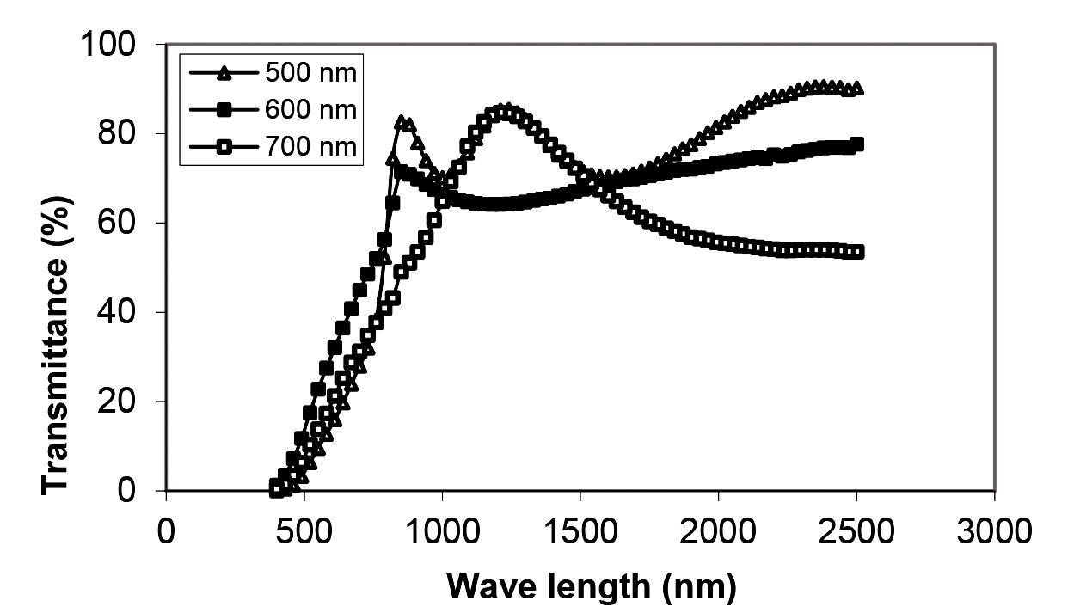

**Figure 1:** Optical transmittance spectra of CdTe thin films for different thickness.

The figure-1 shows the transmittance as a function of photon wavelength of 400 nm to 2500nm. It is observed that high transmittance (90.54%) in the visible region is obtained for the three samples. The films of thickness 500 nm show interference pattern that indicates better homogeneity and good quality of CdTe thin film. A sharp absorption edge was observed in all films. Such behavior of the transmission spectra is an evidence of the uniformity of the films. The transmittance falls steeply with decreasing wavelength (400–850 nm). The reduction in transmission could arise due to the increase in absorbance associated with a change in surface microstructure as reported by **Gouda** ***et al.*, 2012**. This result showed that the material can be useful in manufacturing optical components for high power sensor. The figure shows that a shift of transmittance peak toward the shorter wavelength region (higher energies) is observed for 700 nm thickness. The shifting is due to the structural improvement represented by the crystalline grain size as reported by **Balkanaski and Wallis, 2000**.

Page 196 Malaysian Journal of Medical and Biological Research **** Volume 2 **** Number 3/2015

Volume 2. No 3/2015. ISSN 2313-0008 (Print); ISSN 2313-0016 (Online)

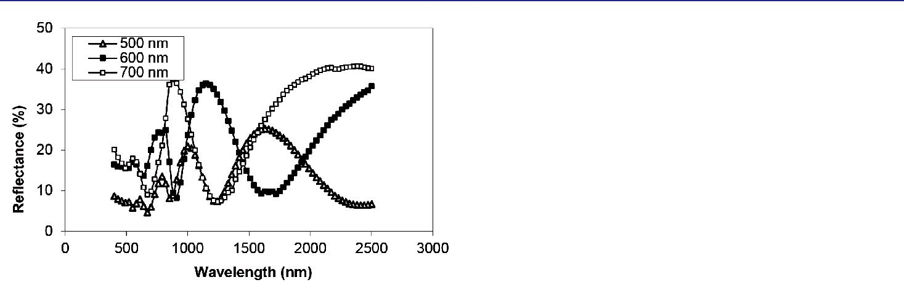

**Figure 2:** Variation of reflectance vs. wave length (nm) for CdTe films for different thickness.

The reflectance with photon wavelength (300-2500 nm) of the CdTe thin films of different thicknesses is shown in figure-2. The reflectance spectra show interference pattern with distinct peaks and valleys. The reflectance decreases for all the films in the NIR region. It is observed that the maximum reflectance (38%) at 800nm is obtained for the film thickness of 500nm.

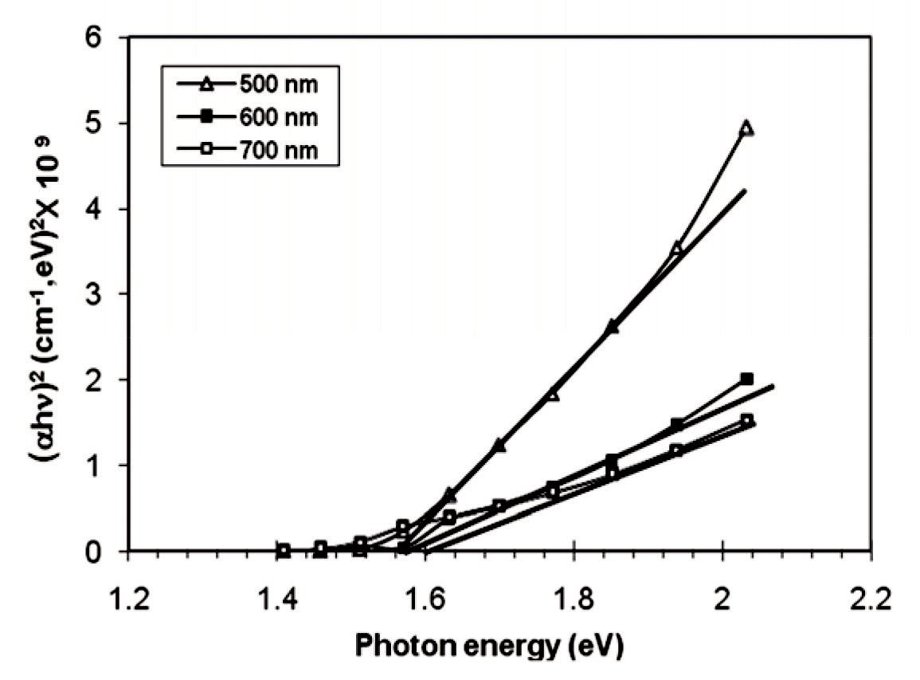

**Figure 3:** (αhn)2vs. photon energy with different thickness of CdTe thin films.

To determine the optical band gap energy (Eg) of CdTe thin films, following equation was used (ahn)2 = A (hν – Eg) where, A is constant, a is the absorption coefficient and hn is the incident photon energy. Figure 3 shows a plot of (ahn)2 vs. hn for the three samples. The corresponding bandgap is found from the intersection of the x axis. The bandgap energy increases from 1.54 eV to 1.58 eV with increasing thickness of 500 nm to 700 nm respectively. The values are in good agreement with the other reported values **(Hussain** ***et al.*, 2014)**. However, these values are greater than the value of 1.5 eV for single crystal [ref? ], which is probably due to the imperfect crystallinity that gives rise to defect states.

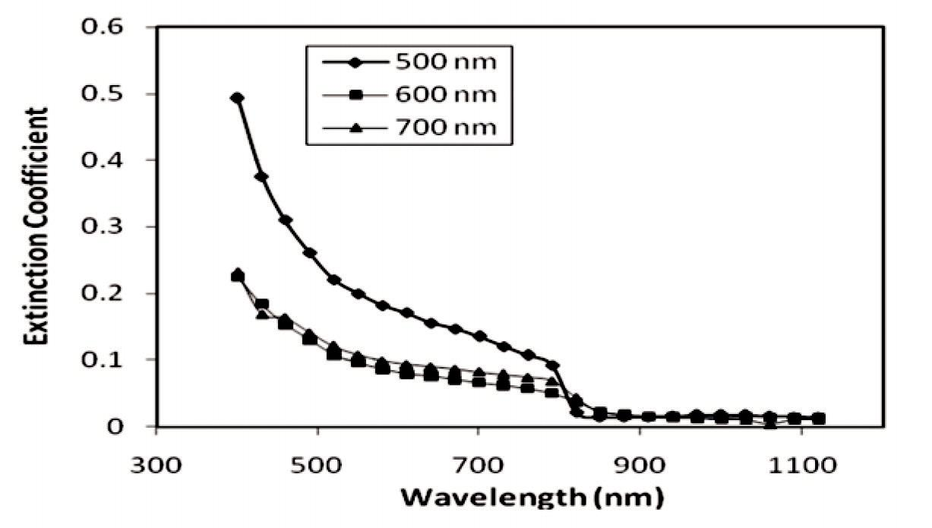

**Figure 4:** Variation of Extinction coefficient at different thickness

CC-BY-NC 2014. i-Proclaim | MJMBR Page 197

|  |  |
| --- | --- |
| Hussain et al: Preparation of CdTe Nuclear Detector Material in Thin Film Form using Thermal Evaporation Method | (195-199) |

The figure 4 shows that the extinction coefficient of all films decreases with increase in wavelength upto 800 nm and then it remains constant. The behavior of the films is in agreement with that of **Alnajjar** ***et al.*, 2012**. It is also noted that, extinction coefficient is very high for the sample of 500 nm thickness compared to the samples of 600 nm & 700 nm thickness. The continuity and stability of the extinction co-efficient show that the films are quality thin films.

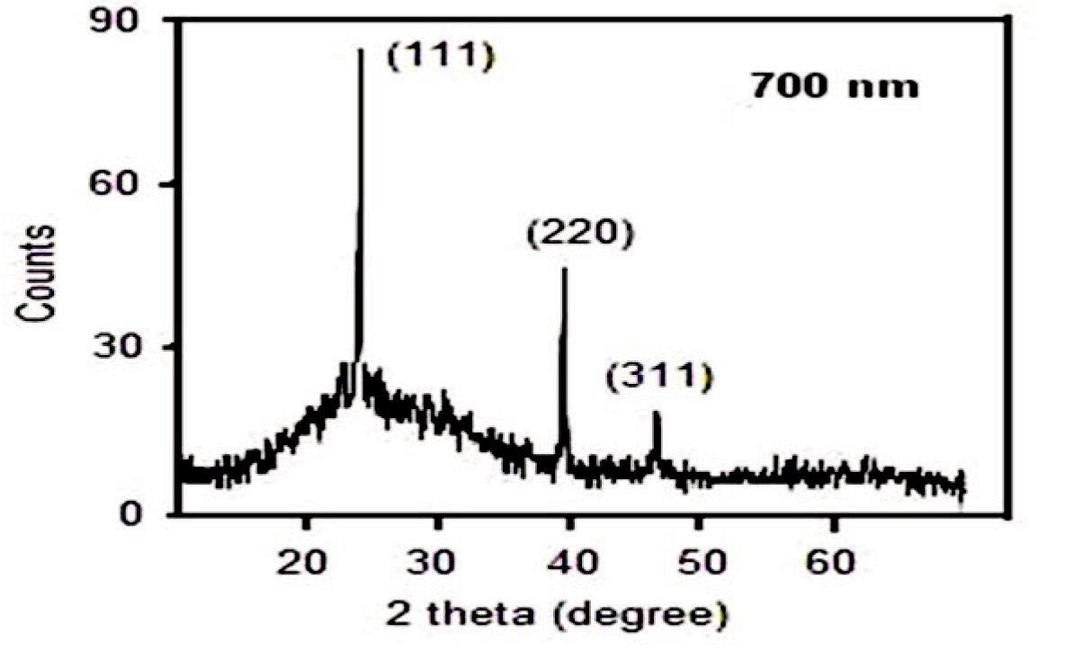

**Figure 5:** CdTe thin film of thickness 700 nm deposited at 250ºC

The X-ray diffraction analysis shows that the (111) diffraction plane is localized at approximately 23.7º and the two weak peaks are at approximately 39.3º and 46.6º matchs with the (220) and (311) diffraction plane of the cubic phase CdTe films which is in good agreement with the reported work **of Sathyamoorthya** ***et al.*, 2003)**. The CdTe thin film has face centered cubic (f.c.c) structure. It was therefore suggested **(S. S. Patil and P. H. Pawer, 2012)** that for the (face-centered) the indices must be all odd or all even. All films show the most preferred plane (111) to the other (220) and (311) prominent reflections. No other peak beside these is observed which establishes the single phase cubic structure of the films. All peaks reflected in the XRD patterns are in good agreement with the standard (cubic) JCPDS (75-2086) values (**Hussein** ***et al.*, 2013)**. The (111) direction is the close packing direction of the zinc blende structure and this type of formation is often observed in polycrystalline films **( Singh et.al., 2010, Abdul** ***et al.*, 2009, Shaaban** ***et al.*** **2009)** grown on heated amorphous substrates. From these results, it can be concluded that the substrate temperature 250ºC is the suitable optimum growth conditions to prepare good quality polycrystalline thin film.

**Conclusions**

The CdTe thin film was successfully deposited using thermal evaporation method. In-situ film thicknesses were measured using Quartz crystal monitor. The structural and optical properties of those thin films with varying film thickness (500-700 nm) were investigated. The high transmittance showed all the films have high absorption coefficient above the fundamental absorption edge. The band gap was found from 1.54 eV to 1.58 eV. All films showed a preferred orientation along (111) plane of the cubic phase compared to other two prominent planes (220) & (311). The crystalline quality is observed at the optimum substrate temperature.

**Acknowledgement**

Authors would like to thank Director, Atomic Energy Centre, Dhaka Bangladesh for supporting the research.

**References**

Abdul-Kadom, A. H., Allaa, A. A.and Mahdi, M. A. (2009), “ Preparation cadmium elluride compound and study structural properties of thermal evaporation thin films.” Iraqi Journal of Physics, Vol.7, No. 9 pp 20-26.

Alnajjar, A. A, Al-Shaikley, F. Y. and Alias, M. F. A. (2012), “Optical properties and photoconductivity of undoped and In-doped CdTe thin films.” Journal of Electron Devices, Vol. 16 pp 1306-1314.

Balkanaski, M. and Wallis, R. F.(2000), “Semiconductor Physics and Applications”, Oxford University Press.

Carchon, R., Moeslinger, M., Bourva, L., Bass, C. and Zendel, M. (2007), “ Gamma radiation detectors for safeguards applications.” Nuclear Instruments and Methods in Physics Research Section A: Accelerators, Spectrometers, Detectors and Associated Equipment, Vol. 579, No. 1 pp 380–383.

Gouda, L., Aniruddha,Y. R. and Ramasesha, S.K. (2012), “Correlation between the Solution Chemistry to Observed Properties of CdTe Thin Films Prepared by CBD Method.” Journal of Modern Physics, Vol. 3 pp 1870-1877.

Hussain, K. M. A., Mahmood, Z. H., Syed, I. M., Begum, T., Faruqe, T. and Parvin, J. (2014), “Thermal vacuum deposition of cadmium telluride thin films solar cell material.” American Journal of Materials Science and Application, Vol. 2 No.6 pp 91-95.

Page 198 Malaysian Journal of Medical and Biological Research **** Volume 2 **** Number 3/2015

Volume 2. No 3/2015. ISSN 2313-0008 (Print); ISSN 2313-0016 (Online)

Hussein, M. M.A., Abdullah, M. M. and Mohammed, G. H. (2013), “ Effect of Annealing and Deposition Temperature on Structural Properties of CdTe Thin Films Prepared by Thermal Evaporation Method.” Indian Journal of Applied Research, Vol.3 No. 2 pp 319-323.

Katlander, J., Bargholtz, Chr,, Batres-Estrada, G. and Behrooz, K. (2006)., ”Development of Methods to Use CdTe Detectors in Field Measurements”, Journal of Physics Conference Series, Vol. 41 pp 523-526.

Lovergine, N., Prete, P., Tapfer, L., Marzo, F. and Mancin, A. I. (2005), ”Hydrogen Transport Vapor Growth and Properties of Thick CdTe Epilayers for RT X-ray Detector Applications”, Cryst Res Tech. Vol. 40 pp 1018-1023.

Patil, S. S. and Pawer. P. H. (2012), “Effects of thickness on the structural and optical properties of thermally evaporated CdTe thin films”, J. Chemical, Biological and Physical Sciences, Vol.2. No. 2 pp 968-978.

Sathyamoorthya, R. Narayan dass, Sa. K. and Mangalarajb, D. (2003), “Effect of substrate temperature on the structure and optical properties of CdTe thin film”, Solar Energy Materials & Solar Cells, Vol. 76 pp 339–346.

Shaaban, E.R., Afify, N., and El-Taher, A. (2009), “ Effect of film thickness on microstructure parameters and optical constants of CdTe thin films.” Journal of Alloys and Compounds, Vol. 482 pp 400–404.

Singh, S., Kumar, R. and Sood, K. N. (2010) “Structural and electrical studies of thermally evaporated nanostructured CdTe thin films. Thin Solid Films.” Vol. 519 No. pp 1078–1081.

CC-BY-NC 2014. i-Proclaim | MJMBR Page 199