Volume 2. No 3/2015. ISSN 2313-0008 (Print); ISSN 2313-0016 (Online)

**Research Article**

Malays. j. med. biol. res.

**An Impact of Socio-Cultural Practices on Maternal Mortality in Masasi District, Tanzania**

**Robert Ngelela Shole**

Lecturer, Sociology Department, Stella Maris Mtwara University College, P.O.Box 674, **TANZANIA**

Email: sholeh79@yahoo.com

**ABSTRACT**

This study was about to find out the impact of socio-cultural practices on maternal mortality rate in Tanzania by using Masasi District as the case study. The study involved 3 sample hospital namely Mkomaindo, Maendeleo, and Mkapa Road. The data obtained from 30 total respondents namely clinical officers, maternal mothers, and midwives. The study used mixed research approach under Explanatory Design in which data collection were done by questionnaire and interview. Data was processed by a computer to obtain tabulation, simple figures, Percentages and content analysis. Findings showed that the impact of socio-cultural practices on maternal mortality rate was loss of blood, miscarriage, difficulties during the time of giving birth, lack of good health to the maternal mother and child. Researcher recommended some ways on how to reduce the problem of socio-culture practices on maternal mortality rate include the provision of education to maternal mother. Also, the government should enact strict law against those who still practice bad traditional to maternal mother also the government should ensure services to maternal mother are cheap so that they can be able to go to the hospital

**Key words:** Socio-cultural practices, maternal mortality, Health care, mother, health service delivery



**9/18/2015** **Source of Support:** None, **No Conflict of Interest:** Declared

This article is is licensed under a Creative Commons Attribution-NonCommercial 4.0 International License.

**Attribution-NonCommercial (CC BY-NC)** license lets others remix, tweak, and build upon work non-commercially, and although the new works must alsoacknowledge & be non-commercial.

**Introduction**

**Background of the Study**

According to Chinwe (2012), the maternal mortality is one of the greatly neglected problems of health care in developing countries. It is a major health problem in Sub-Saharan Africa. Estimates by the World Health Organization (WHO) and United Nations Children Fund (UNICEF) show that each year, all over the world an estimated 585 000 women die from causes related to pregnancy and childbirth. Every day, 1 500 women die from pregnancy or child birth related complications and most of these deaths occurred in developing countries.

The same study showed that maternal mortality rates in developing countries are estimated to be 100 times higher than those seen in industrialized countries. No wonder, improving maternal health is one of the eight Millennium Development Goals adopted by the International Community at the United Nations Millennium Summit in 2000. To achieve the objectives of the Millennium Development Goals, Countries have indicated the commitment of reducing the maternal mortality ratio by three-quarters between 2000 and 2015. About 99% of all the maternal deaths occur in developing countries where 85% of the populations live. Women in developing countries have many pregnancies on the average and their life time risk reflects the overall burden of these women. Women die from a wide range of complications in pregnancy, child birth, or the post-partum period.

There are four major causes of maternal mortality including severe bleeding (mostly postpartum), infection (mostly soon after delivery), hypertensive disorders in pregnancy (eclampsia), obstructed labor and unsafe abortion. There are, however, socio-cultural factors that contribute to women dyeing in pregnancy, labor and puerperium that most of the times are neglected. Some of these problems include harmful traditional practices like female genital mutilation that could

CC-BY-NC 2014. i-Proclaim | MJMBR Page 211

|  |  |
| --- | --- |
| Shole: The Impacts of Cost Sharing in Health Services in Geita Distrct, Tanzania | (211-220) |

lead to prolonged and obstructed labor as a result of adhesions. Four percent of maternal deaths have been attributed to such practices. Other problems include food restrictions and taboos associated with the pre and post-partum periods of a woman’s life, like preventing a pregnant woman from eating eggs so that the child will not born without hair Nyirenda (2012) indicates that the higher maternal mortality rate has been observed in the regions namely Mtwara 50%, Shinyanga 47%, Simiyu 43%, and Rukwa 41%.

Mpembeni (2012), report that the problem of the maternal mortality rate continues to affect the wellbeing of marginalized people especially woman in Mtwara rural areas because 36% of delivery occurred in health institution, mostly delivery occur at home. Therefore one of major issue to look on include traditional-cultures issues particularly rural areas where seemed to be the victims, Mtwara as shown above is one of the area found as victim while 37% people’ life is under poverty line, in this case, influence the socio-cultural practices on maternal mortality rate.

**Statement of the problem**

Mascarenhas (2007), stipulates that the socio-cultural practices on maternal mortality rate was one of the great ambiguity on health activities, especially in developing countries include Tanzania. It seems that there some of Tanzania region like Mtwara still have some socio-cultural practice that contribute to maternal mortality rate. The mortality rate in this region is influenced by conservativeness among the clan and family elders who tend to force their daughters to practice traditional maternal health practices like conceiving children using traditional medicines without going to hospital. Also, some social members and friends tend to convince expected women not to go to the hospital and instead can bear the children at home so as to reduce costs, also because of having good health of pushing a child during the time of conceiving hence these expected women enter into these temptations and face the risks of deaths or even loss of reproductive capacity.

According to the most recent maternal mortality data collected by Tanzania government,578 women died in 2004 that marked an increase of 10% of deaths occurred in 2005 that was equal to 58 women who dead in 2005. In 2006, a number of maternal deaths were seen to be 632 that still marked an increase of the maternal mortality rate. Hence, this recalls me to conduct research and come up with new strategies for solving the problem.

**Objectives of the study**

The general objective of the study was to assess the socio-cultural impacts on practices that led maternal mortality rate in Masasi District.

**Specific objectives**

* To identify the socio-cultural practices influence on maternal mortality rate in Masasi District.
* To identify the trends of maternal mortality rate in Masasi District.
* To explore the impact of socio-cultural practices on maternal mortality rate in Masasi District.
* To determine measures that can be used to overcome this problem in Masasi District.

**Research Questions**

* What are the socio-cultural practices on the maternal mortality rate?
* What are the trends of maternal mortality rate in Masasi?
* What are the impacts of socio-cultural practice on maternal mortality rate?
* What measures should be taken to reduce the problem of maternal mortality rate?

**Significance of the study**

The study was very significant, since the findings could be used as the references or documentary sources that would help the government, non-government organization take measure towards reduction and even elimination or improve the findings that would be reported from the field.

**Conceptual Framework**

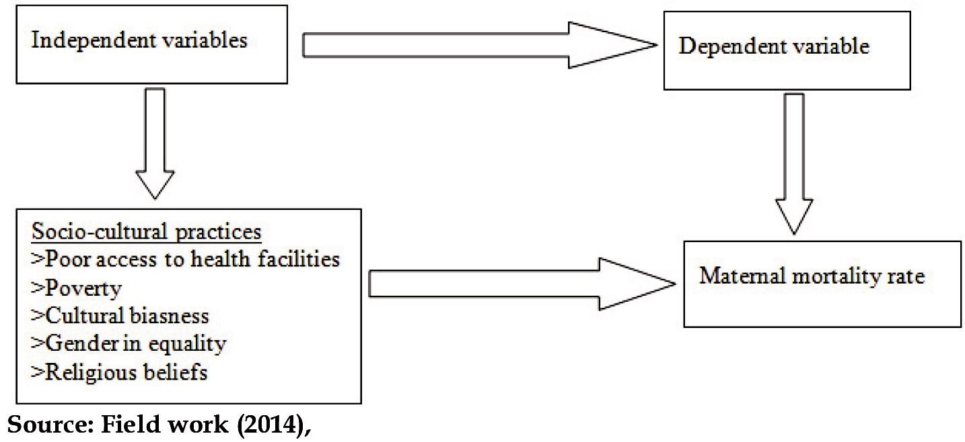

Page 212 Malaysian Journal of Medical and Biological Research **** Volume 2 **** Number 3/2015

Volume 2. No 3/2015. ISSN 2313-0008 (Print); ISSN 2313-0016 (Online)

**Literature review**

**Maternal mortality**

Moore (2012) explains that the maternal mortality is a key indicator for expressing socio-cultural and economic inequalities that adversely affect women and girls and impede progress on the development goals set for 2015. Women with less education are more likely to live in poverty than those who have attained higher levels of education. They have lower salaries and precarious working conditions, with fewer benefits such as family and medical leave, health insurance and holidays. Women are living in poverty also have less access to health care. These conditions are most often passed onto their sons and daughters, perpetuating the viscous cycle of poverty.

Gender inequality, poverty, and disparities in women’s and girls’ access to health, education and income as well as lower socio-cultural status are all key factors that negatively impact maternal health, because women who suffer these inequalities also have fewer possibilities of accessing HIV prevention information and contraceptives, putting them at greater risk of unplanned pregnancies. This leads to increased rates of induced abortion, especially unsafe abortion, because abortion is illegal or highly restricted in most developing countries. Making these interconnections, visible shows how the improvement of maternal health goes hand in hand with the improvement of other social determinants that go beyond women’s needs in health care services. Putting this in the context of the development goals framework, we must recognize that all MDGs are interrelated, and none of them can be fully achieved without the others. Regarding the debate about improving maternal health and universal reproductive health, the main cross-cutting issues that cannot be excluded are: poverty alleviation, universal education, empowerment of women and gender equality and combating HIV/AIDS. To achieve all these goals, women and girls must be guaranteed the full exercise of their human rights, including their sexual and reproductive rights, and the right to live free of all forms of stigma, discrimination and violence. Also, Moore still explains that in Latin America and the Caribbean the average MMR is much lower than in Africa and Asia Pacific, but, despite progress, the goal set for 2015 will not be met. Between 1990 and 2010 the MMR in Latin America descended from 130 to 72, and in the Caribbean from 280 to 190.

**Socio-cultural practices**

Harris *et al.*, (1996), the social factors which make women in risks, such as poor nutrition, heavy work, powerlessness to make decisions, incorrect information on health services and inadequate service delivery, are mostly avoidable by considering the welfares of the culture in relation to maternal health. This means that there should be a link between cultural affairs and maternal health so as to save the lives of maternal women. In developing countries, the problem of cultural interference on maternal health has become a catastrophic problem, especially in rural areas.

According to Noah (2001), drinking alcohol during pregnancy can cause physical and mental birth defects. The report shows that no level of alcohol use during pregnant has been proven safe. Each year, more than 50,000 babies are born with some degree of alcohol-related damages. Many women are aware that heavy drinking during pregnancy can cause birth defects, but many do not realize that moderate or even light drinking also could harm the fetus.

According to (Osken, 1993), he said in some traditional communities, girls are engaged in marriage at their very early ages of life (12-13) and they are usually exposed to the pressure of having male children not only to belong to the husband’s lineage but also to secure access to inheritance. For instance in the traditional community of Mbaises in Imo state, a woman who has 10 or more children is compensated with a cow on the10th live birth. Such cultural practices can expose women/girls to the health risks of early and frequent pregnancies that can lead to high maternal morbidity and mortality. Food taboos are prevalent in several Nigerian communities, during pregnancy and child birth; women’s eating habits are guided by these local taboos, which deny the consumption of certain food that can fall within the range of protein, carbohydrate or fruits. For instance, some communities among the Yoruba’s prohibit the ingestion of meat, egg, beans or other protein-containing foods during pregnancy,similarly in some communities of both the eastern and southern parts of Nigeria, pregnant women are discouraged from eating egg as they believe that it reduces contraction strength during labor, hence leading to difficult labor. Other forbidden foods are Okra soup and snail, for fear of excessive salivation of the infant garden egg for fear of impaired speech in infant; fish for fear of extra digits and plantain for fear of delayed ossification of the anterior fontanels; palm oil for fear of jaundice and certain fruits for fear of baldness (Adebayo, 1992). Sinha (2008), explains that in the world today most of the countries are following the suggestions and recommendations of world organizations such as WHO,UNICEF, WB and UNAIDS to implement the projects, policy and programs in the field of health in general and reproductive health in particular. Even though the international conference on population and health development are in different countries including both developed and developing countries but still the problem of the maternal mortality associated with socio-cultural practices is the problem in the developing countries including Tanzania and Mtwara in particular. Despite of all that have been explained by the previous scholars, we still difficultly find the effects of socio-cultural practices on the maternal mortality rate. Therefore, this research is directly aiming at investing on the effects of socio-cultural practices on the maternal mortality rate as it was not conducted in Masasi district by any researcher.

CC-BY-NC 2014. i-Proclaim | MJMBR Page 213

|  |  |
| --- | --- |
| Shole: The Impacts of Cost Sharing in Health Services in Geita Distrct, Tanzania | (211-220) |

**Beliefs:** According to Chinwe (2012), explains that there are some traditional beliefs that lead to the maternal mortalityrate, these include food restriction and taboos associated with the pre and post-partum periods of a woman’s life like preventing a pregnant women from eating eggs so that the child will not be born without hair and female genital mutilation that could lead to prolonged and obstructed labor as a result of adhesion.

**Illiteracy/lack of education:** The poor health welfare in terms of maternal care is affected by poverty that is associatedwith illiteracy among the society, the high maternal mortality rate estimated to 74% of death per 1000 women and live birth in which the main reasons for these death comes from ignorance on maternal health care services (James,1998). **Early marriage:** According to Wydra (2013), explains that under the battle so-called marriage under Sharia law isfought by pious Muslims who advocate for the legalization of child marriage in places where it is banned by the state. The later outcomes of early marriage are what brining about deaths of young women during the time of bearing the children.

**Relationship between maternal mortality and socio-cultural practice.**

Uwe (20012), explain that the majority in both urban areas and rural areas do not consider about the human health during the time of maternity life, most of the women are not attending clinical checkup due to accumulation of work at home and lack of advice from their family members. Also, some do not need women to make decision on maternal health care, this causing labor difficulties during the time of conceiving.

According to Nasah et al (1991), explain that most of the Africans societies have different practices and beliefs related to reproduction, These may adversely affect the behavior of women with complicated pregnancy, Traditional healers using traditional practices may delay hospitals treatment of serious conditions. Some cultural and behavioral factors such as female circumcision and infibulations have also been found to associate with high maternal mortality rate.

Also, there are some cultural norms that exert a strong influence on the nutritional intake of women in the pregnant and post- delivery period, these cultural beliefs may limit intake of iron and protein food especially from animal sources such as chicken and eggs this leads the problem of anemia that is caused to closely space births of the maternal women due to poor nutritional.

**Research Gap**

The impact on socio-cultural practice towards maternal mortality rate in Masasi is still practices. Even if the research conducted about the socio-cultural practice towards the maternal mortality rate but it did not fulfil the problem and did not involve Masasi as the case study. This study wills more details on Masasi as the case study with regards to the topic.

**Research Methodology**

**General research approach**

Research approach refers to the whole design of the research which includes the process of investigating types of data collection and analysis (Kothari, 2004).

The researcher used mixed research approach for the purpose of having the room for collecting, analyzing and mixing both quantitative and qualitative data in a single study. Under this assumption, the weaknesses in each single method were compensated by the counter- balancing the strength of another.

**Research Design**

According to Kothari, C.R (2004) a research design is the arrangement of conclusion for collection and analysis of data in a manner that aims to combine relevance to the research purpose with economy in procedure. The research design employed to this study are qualitative and quantitative design since the qualitative approach engages in naturalist inquiry studying the real world setting inductively to generate rich narrative deception and construct themes about the study (Thungu *et al.,* 2008). The study studied so as to answer the questions that the researcher wants to employ in the field.

**Targeted Population**

In this study, the targeted population was medical officers, midwives, and maternal women. The targeted population of this study was 50 respondents from which a researcher aimed at collecting information from them.

**Sampling Procedures**

**Sample Size:** According to Bailay (1994) minimum of 30 respondents is the bare minimum for studies in whichstatistical data analysis can be done. The key study of this study were clinical officers, midwives and maternal mothers, on the side of clinical officers 5 from Mkomaindo and other 5 were from Maendeleo, maternal mother 4 were from mkomaindo,3 were from Maendeleo and other 3 were from Mkapa Road, also on the side of midwives 3 were from Mkomaindo, 3 were from Maendeleo, and other 4 were from Mkapa Road

Page 214 Malaysian Journal of Medical and Biological Research **** Volume 2 **** Number 3/2015

Volume 2. No 3/2015. ISSN 2313-0008 (Print); ISSN 2313-0016 (Online)

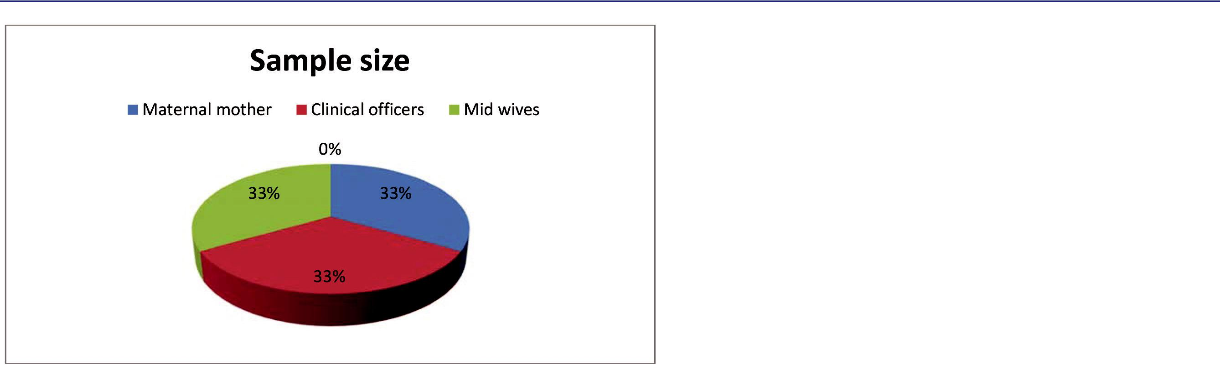

**Data collection techniques**

**Primary data:** This are the data that collected direct from the field by researcher, example of the methods used tocollect primary data is interview, questionnaire, observation and focus group discussion. In this study the technique which used was questionnaire both open and closed questions, and the interview.

**Secondary data:** Secondary data are the data that collected from different writings such as books and journals(document analysis) all this was used in this study. And this technique enabled the researcher to obtain the intended information on the factors contributing to moral decay within primary school pupils.

**Data processing and analysis**

**Data processing:** This is the process whereby a researcher enters data into the computer, edit and recording them.Therefore, all collected data was entered into the computer, edited and recorded.

**Data analysis:** According to Mwanje (2001) the nature of problem to a large extent dictates the type of data analysistechniques to be used. This data analysis is the process of bringing order, structure and meaning to the mass of information collected. In analyzing the data, the researcher used both Quantitative and Qualitative method to analyze data. Quantitative method used descriptive statistic to describe different aspects of the study across tables, percentage and graphs, Qualitative method used explanations description to analyze or arrange data.

**Data Presentation, Results and Discussion of Findings**

**Characteristics of respondents**

The study involved 30 respondents 12 clinical officers, 10 mid wives and 8 maternal mothers from selected wards in Masasi District.

**Table 1:** Showing the characteristics of respondents (N=30).

|  |  |  |  |
| --- | --- | --- | --- |
| **Items** | **Interval** | **Frequency** | **Percentage %** |
| Sex | Female | 28 | 93 |
|  | Male | 2 | 6 |
| Age | 21-30 | 15 | 50 |
|  | 31-40 | 5 | 16 |
|  | 41 above | 14 | 13 |
| Marital status | Single | 15 | 50 |
|  | Married | 5 | 16 |
|  | Divorced | 5 | 16 |
| Residence | Mkomaindo | 5 | 16 |
|  | Mkapa Road | 10 | 33 |
|  | Maendeleo | 3 | 10 |
| Occupation | Chnical officers | 12 | 40 |
|  | Midwives | 10 | 33 |
|  | Maternal mothers | 8 | 26 |
| Educational level | Primary | 10 | 33 |
|  | Secondary | 10 | 33 |
|  | Tertiary | 5 | 16 |

**Source: Field data (2014)**

CC-BY-NC 2014. i-Proclaim | MJMBR Page 215

|  |  |
| --- | --- |
| Shole: The Impacts of Cost Sharing in Health Services in Geita Distrct, Tanzania | (211-220) |

**Sex of the respondents:** The analysis of this research considers types of respondents in sex to show the importance ofeach sex in contributing different views concerning social-cultural practices on maternal mortality rate. About 93% of respondents were female especially at the age of 21-30 because most of them have experienced many different social-cultural practices on the maternal mortality rate. Also, about 6% of respondents were male.

**Age group of respondents:** The total respondents of 30, who participated in the field their age group based onthree categories, 50% of the respondents aged between 21-30 where by most of respondents in this group were the maternal mother. About 5% of respondents aged between 31-40 where by most of them were mid wives. About 13% of respondents aged between 41 and above where by most of them were clinical officers.

**Marital status of respondents:** The field data showed that most of respondents of about 16% are married, about 50%of the respondents are single, and most of them are in new intake of employment. About 16% are divorced due to different problems.

**Residence of respondents:** The study was conducted from three wards which were Mkomaindo, Maendeleo, andMkapa Road, where by 16% of respondents come from Mkomaindo. Also about 33% of the respondents come from Mkapa Road.

**Occupation of respondents:** During the study it was observed that, most of respondents in the study area were engagingin different income generation activities so that they can enhance family life and build their society. Respondents have engaged in different activities such as, about 40% of the respondents were clinical officers of District hospital, 33% of respondents are Midwives, and also 26% of the respondents are maternal mother.

**Level of education:** The inhabitant of Masasi District has the poor education. During the study it was observed thatabout 41% attained primary education, 17% attained secondary school and 41% attained the tertiary education.

**The socio-cultural practices on maternal mortality rate in Masasi District**

**Table 2:** Showing the socio-cultural practices on the maternal mortality rate in Masasi District (N=30).

|  |  |  |  |  |  |  |  |  |  |
| --- | --- | --- | --- | --- | --- | --- | --- | --- | --- |
| **Factors** |  |  | **Respondents** | |  |  |  | **Total** | |
|  |  |  |  |  |  |  |  |  |  |
|  | **Clinical officers** | | **Midwives** | | **Maternal mother** | |  |  |  |
|  |  |  |  |  |  |  |  |  |  |
|  | **Freq** | **%** | **Freq** | **%** | **Freq** | **%** | **Freq** |  | **%** |
|  |  |  |  |  |  |  |  |  |  |
| Believes | 4 | 40 | 4 | 40 | 2 | 20 | 10 |  | 100 |
|  |  |  |  |  |  |  |  |  |  |
| Early marriage | 3 | 60 | 2 | 20 | — | 0 | 5 |  | 80 |
|  |  |  |  |  |  |  |  |  |  |
| Lack of education | 5 | 50 | 4 | 40 | 1 | 10 | 10 |  | 100 |
|  |  |  |  |  |  |  |  |  |  |
| Religious believes | 2 | 20 | 1 | 10 | 2 | 20 | 5 |  | 50 |
|  |  |  |  |  |  |  |  |  |  |

**Source: Field data (2015)**

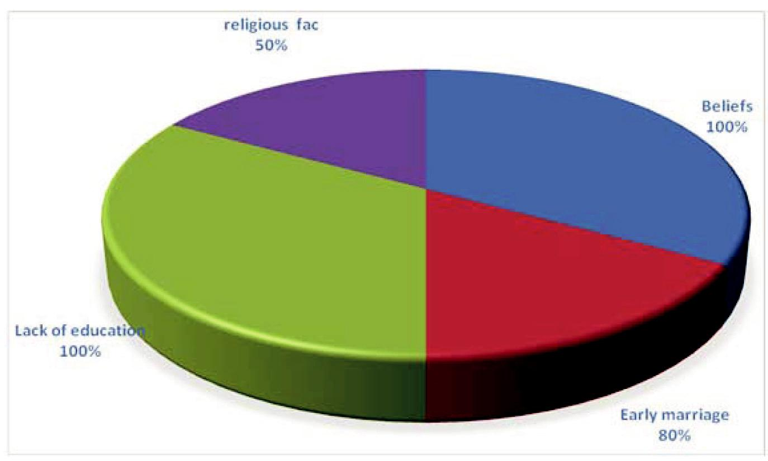

**Figure 2:** Showing the socio-cultural practices on maternal mortality rate in Masasi District

**Beliefs:** From Table 2, it revealed that 33.3% of the total of 30 respondents argued that the problem of poor beliefs oncultural practices such as norms and traditions is what causes deaths among the maternal women during the time of taking births or conceiving. This is because tradition and norms especially in rural areas make women not to attend health and child development check-ups during the time of pregnancy thus causing them to get problems during the time of delivery. Also women deliver their children at home regularly thus causing deaths after the failure to nurse mother during the time of delivery

Page 216 Malaysian Journal of Medical and Biological Research **** Volume 2 **** Number 3/2015

Volume 2. No 3/2015. ISSN 2313-0008 (Print); ISSN 2313-0016 (Online)

**Early pregnancy:** According to table 2, 17% of all respondents replied that a tendency of having pregnancy at youngages lead to mismanagement of pregnancies and causing in ability to take care of the pregnancy due to immaturity of the reproductive organs and economic incapability towards affording basic requirements of pregnant mothers such as food and health services hence causing deaths and injuries during the time of child delivery.

**Lack of education:** Referring table 2, 35% of 30 respondents commented that there is no enough education to thesociety that can help to rescue the problem of the maternal mortality rate in Masasi district. Most of the campaigns are done in town areas and through mass media whereby they do not reach directly to rural areas. This causes women to get pregnancy without having the education of handling their health until the time of delivery hence causing deaths among the maternal women.

**Religious factors:** As shown on table 2, 15% said that some regions do not emphasize women to go to hospital for regularhealth check up and instead they should pray to God so that he can heal them. This leads to problems to those who have no critical faith thus causing also problems during the time of taking birth because of having poor clinical records.

**The trends of maternal mortality rate in Masasi district**

**Table 3:** Showing the trend of maternal mortality rate

|  |  |
| --- | --- |
| **Year** | **Death** |
|  |  |
| **2010** | **17** |
|  |  |
| **2011** | **29** |
|  |  |
| **2012** | **27** |
|  |  |
| **2013** | **14** |
|  |  |
| **Source: Field data (2015)** |  |

As observed from the study findings in table 3, it discovered that from 2010 ( 17) women died, 2011 (29), women died, in 2012 ( 27) women died and 2013 (14) women died from the maternal problems associated with socio-cultural practices such as taking birth at home and using improper methods of maternal care.

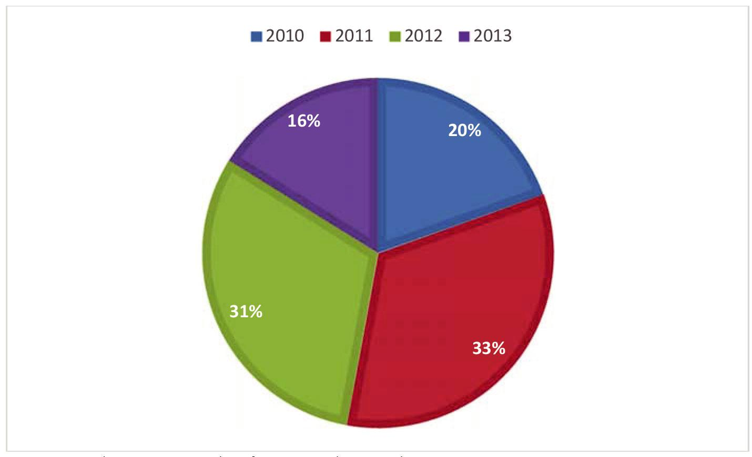

**Figure 3:** Showing trends of maternal mortality rate

**The impacts of socio-cultural practices on maternal mortality rate in Masasi**

**Table 4:** Showing the impacts of socio-cultural practices on maternal mortality rate (N=30)

|  |  |  |  |  |  |  |  |  |  |
| --- | --- | --- | --- | --- | --- | --- | --- | --- | --- |
| **Impacts** | **Clinical officers** | | **Midwives** | | **Maternal mother** | |  | **Total** | |
|  |  |  |  |  |  |  |  |  |  |
|  | **Freq** | **%** | **Freq** | **%** | **Freq** | **%** | **Freq** |  | **%** |
|  |  |  |  |  |  |  |  |  |  |
| Lack of good health to | 6 | 60 | 2 | 20 | 2 | 20 | 10 |  | 100 |
| maternal mother and child |  |  |  |  |  |  |  |  |  |
|  |  |  |  |  |  |  |  |  |  |
| Miscarriage | 3 | 60 | 1 | 20 | 1 | 20 | 4 |  | 100 |
|  |  |  |  |  |  |  |  |  |  |
| Difficulties during the time | 4 | 40 | 4 | 40 | 2 | 20 | 10 |  | 100 |
| of giving birth |  |  |  |  |  |  |  |  |  |
|  |  |  |  |  |  |  |  |  |  |
| Loss of blood | 2 | 40 | 2 | 40 | 1 | 20 | 5 |  | 100 |
|  |  |  |  |  |  |  |  |  |  |

**Source: Field data (2015)**

CC-BY-NC 2014. i-Proclaim | MJMBR Page 217

|  |  |
| --- | --- |
| Shole: The Impacts of Cost Sharing in Health Services in Geita Distrct, Tanzania | (211-220) |

**Lack of good health to maternal mother and child:** From table 4 above, 100% of the respondents contributed to thisby saying that socio-cultural practices result to poor health to the maternal mother and her child due to the fact that norms and customs deny women from eating certain food stuff during the time of pregnancy including eggs and meat due to the fear of increasing weight of a child in the womb. This situation later results to malnutrition to the expectancy mothers and their children leading to even problems during the time of pushing the child out during the time of delivering a child due to lack of energy in the body, also due to this, sometimes mother can deliver safely but her child can die after a short time that can be from one to eight months due to poor health. Mrisho *et al.,* (2009), stipulated that both infant and under-five mortality rate assesses the child health status in a particular country. Children in sub-Saharan Africa are about over 16 times more likely to die before the age of five than children in developed regions.

**Miscarriage:** According to table 4, it showed that 20% of the respondents said that cultural practices do not provideeducation of good health to the pregnant women, but rather they destroy the health of pregnant women. This is evidenced when pregnant women are prohibited from going to the hospital for clinical check up and being prohibited from using certain kinds of food stuffs such as meat and eggs. These cultural practices result to poor health development of an expected mother with her child thus resulting to miscarriage due to lack of scientific checkups and innutritious food substances that they eat at home without being advised by health experts.

**Difficulties during the time of giving birth:** Referring table 4, it revealed that 37% of 30 respondents replied that thepregnant women get difficulties during the time of giving birth because of having abrupt anguish at home before being informed by doctors thus causing delivering children at home with grat pains while using traditional means of assisting them to take birth.The outcomes of this situation of having a birth with difficulties are death of either mother or a child or both of them.

**Loss of blood:** According to table 4, 13% of the respondents commented that pregnant women lose more bloodduring the time of taking birth as a result of having no scientific medical services for the whole period of 9 months. Loss of blood or bleeding occur due to weak physical fitness caused by lack of physical exercise as recommended by doctors and also by taking birth using traditional ways or traditional mid wives. All of these result to blood loss since a woman will deliver a child by forcing the cervical

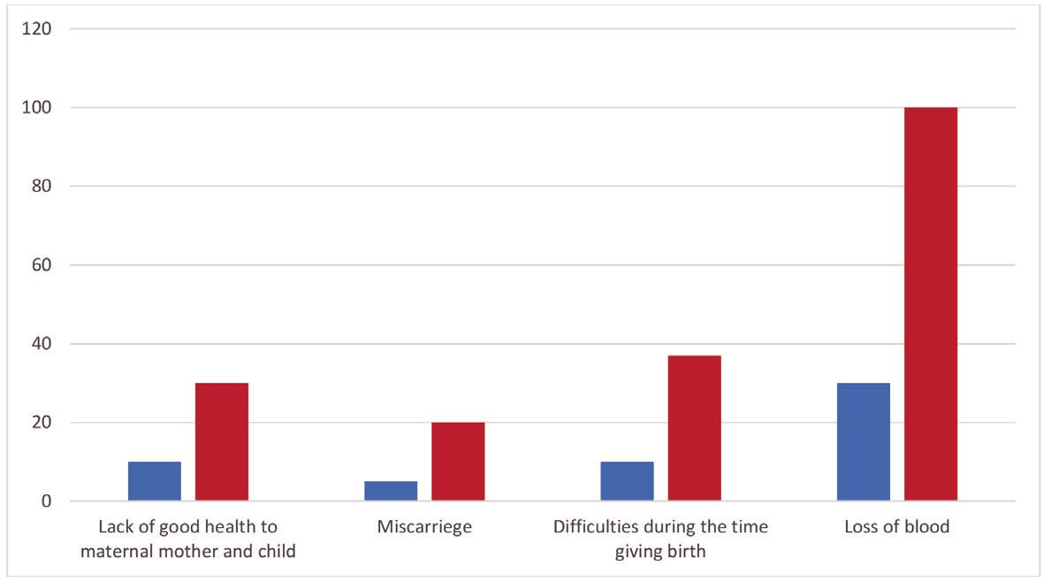

**Figure 4:** Showing the impacts of socio-cultural practices on maternal mortality rate

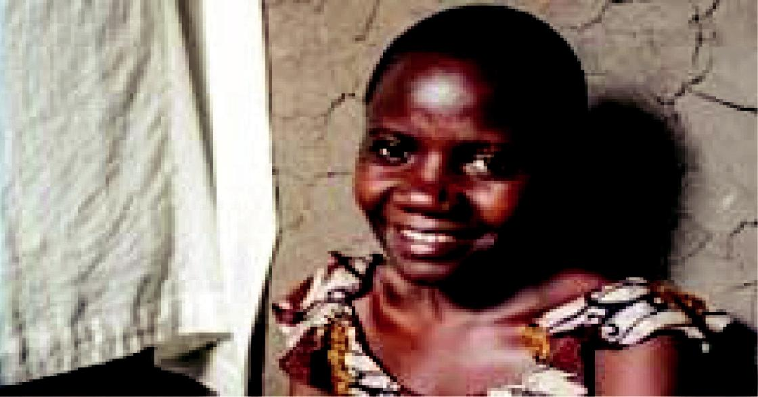

**Plate 1:** Showing one of the maternal women faced by the problem of miscarriage as a result of using traditionalmedicine during the time of pregnancy

**Source: Field data (2015)**

Page 218 Malaysian Journal of Medical and Biological Research **** Volume 2 **** Number 3/2015

Volume 2. No 3/2015. ISSN 2313-0008 (Print); ISSN 2313-0016 (Online)

**The measures are taken to reduce the problem of maternal mortality rate in Masasi**

**Table 5:** Showing measures taken to reduce the problem of maternal mortality rate in Masasi District (N=30)

|  |  |  |  |  |  |  |  |  |  |
| --- | --- | --- | --- | --- | --- | --- | --- | --- | --- |
| **The Suggested solution** | **Clinical officers** | | **Midwives** | | **Maternal mothers** | |  | **Total** | |
| **to maternal mortality** |  |  |  |  |  |  |  |  |  |
|  |  |  |  |  |  |  |  |  |  |
|  | **Freq** | **%** | **Freq** | **%** | **Freq** | **%** | **Freq** |  | **%** |
|  |  |  |  |  |  |  |  |  |  |
| Provision of education | 7 | 50 | 5 | 35 | 2 | 14 | 14 |  | 46 |
|  |  |  |  |  |  |  |  |  |  |
| Reduction of health costs | 1 | 50 | 00 | 0 | 1 | 50 | 2 |  | 7 |
| to maternal mother |  |  |  |  |  |  |  |  |  |
|  |  |  |  |  |  |  |  |  |  |
| Government should | 5 | 41 | 4 | 33 | 3 | 25 | 12 |  | 89 |
| establish strict law |  |  |  |  |  |  |  |  |  |
| agains local beliefs |  |  |  |  |  |  |  |  |  |
|  |  |  |  |  |  |  |  |  |  |
| Good family planning | 4 | 33 | 6 | 50 | 2 | 16 | 12 |  | 40 |
|  |  |  |  |  |  |  |  |  |  |

**Source: Field data (2015)**

**Provision of education:** Referring table 5, it revealed that 46% of the respondents from the field commented that thereshould be education to be provided to the mass so that socio-cultural practices in the society could be swept away. This education should be provided at a maximum level to both rural and urban areas so as to reduce and remove totally the deaths of maternal women in Masasi district. Mass media, individuals, government and non-government organizations should cooperate effectively in warning bad socio-cultural practices affecting maternal health.

**Reducation of health costs to maternal mother:** From table 5, it shown that 7% of the respondents suggested thatcosts of health services should be reduced to fit the needs of maternal women. This can be done by formulating good government policies on health sector so as to enable maternal women getting free services at the hospital and not delivering at home. Respondents added that the problems of applying socio-cultural practices is sometimes caused by high costs in health services in the hospital, hence efforts are needed to overcome the health obstacles leading to the use of cultural ways of motherhood caring.

**Government should establish strictly law against local beliefs:** Refer table 5, 7% of all 30 respondents said that localbeliefs on witchcraft industry should be strictly prohibited by the government through formulation of laws that will accuse all participants practising cultural practices that affect the health of maternal women. Also, respondents said that cultural practices should be well observed to check if they meet the current generation or not so as to get updated with the current world of science and techology. Fear of laws that will be made by the government will get off all local beliefs that destroy the health of maternal mothers and the generation of today. Christopher and Raul (2008), in their book entitled Introduction to Global Health argued that One of the major problems with maternal health in Tanzania is the existence of widespread poverty throughout the country.

**Good family planning**

As it shown on table 5, 40% of the respondents said that there is a need for the people to have good family planning so that the health of women could be maintained. Socio-cultural practices that cause families to have many children should be omitted so as to avoid the problems that face women health during the time of child delivery. For example, in Masasi district one family can have more than seven children in which every child has a name of either uncle of famous people of his or her clan. David Montez (2011), in his research entitled ‘Family Planning and Maternal Health in Tanzania ‘said that Family planning and Maternal and Child Health (FP-MCH) are key components of the UN’s Millennium Development Goals, given their central role in healthy and productive populations. Tanzania has made some progress in these areas in recent years - for example, mortality rates among infants and children under five have declined. However, Tanzania has lagged in maternal health, with the UN MDG Monitor declaring that the country’s goal of reducing the maternal mortality ratio and increasing access to reproductive health is “off track”.

**Conclusion and Recommendations**

**Conclusion**

The obtained research findings indicate that still there is an existence of maternal death in Masasi District which were mainly contributed by beliefs, lack of education, early marriage, and poverty. All these factors resulted to the increase of maternal death, Also,measures to be taken to combat this problem is reduction of health coast to maternal mother, provision of education. Also, the government should enact strict law against those who conduct local believes to maternal mother.

CC-BY-NC 2014. i-Proclaim | MJMBR Page 219

|  |  |
| --- | --- |
| Shole: The Impacts of Cost Sharing in Health Services in Geita Distrct, Tanzania | (211-220) |

**New knowledge**

This study through replicating the knowledge concerning with the impacts of socio-cultural practices on the maternal mortality rate with the new site and new participant; it was possible to come up with new impacts on the maternal mortality rate in table 4; from which the major belonging are maternal mother. Thus this study has added awareness to government, clinical officers, maternal mothers, and community at large. On the impact of socio-cultural practices on the maternal mortality rate. Its impact and measures to be taken hence the new knowledge on how to prevent various use of tradition medicine to eventually result good health to the maternal mother.

**Recommendations**

For maternal mortality rate to be combated and then to have reduced the problem, the researcher suggested the following to be put into consideration by the society, the government and further study.

**Recommendations to the government:** The government should ensure that good and favourable policies are createdon health sector so as to help women in all rural and town areas. This can be done by preparing special fund for pregnant women throughout the country. Also, services in hospitals should be cheap especially to pregnant women and children.

**Recommendations to the society:** The society is requested to promote good and acceptable cultural practices thatcan not harm the physical and mental status of maternal women so as to reduce unplanned deaths among the women or children during the time of child delivery. Also, elders in the societies should understand that the world is changing, and life styles change everyday, so they need to cope with the new life of changing world rather than being conservative. By doing that, health of the maternal women and children to be born, can be at the good state, and the labor power of the nation shall not be lost in vain.

**Suggestion for further studies:** The coming researchers with their works should try to investigate more about theimpacts of socio-cultural practices on the maternal mortality rate by not basing on a small area and instead should investigate on a large geographical area such as a district, country or regional level so as to determine different problems facing different areas. If they might face the problem of finance the researchers can consult the specific ministry of health and social welfare for assistance or requesting financial support to the stake holders such as private companies and financial organizations such as banks and companies. Although doing research is good but it requires self commitment and affection of conducting it, so they should not give up when facing challenges from the respondents or working context until they fulfil their objectives planned by them.

**References**

Ahmed Driouchi (2013). ICT’s for heath education onomic policies: Regional cases. Morocco: Al akhawayn University.

Boniface Nasah,Tatchwenghe J.G and Mat Joseph (1991). Contemporary issues in Maternal Health Care.CRC press. ). The Research Methodology

C.R.Kothari (2006). The Research Methodology: Methods and women in Kilimanjaro region, Northern Tanzania: Dar es salaam. Tanzania Publishing House.

James D. Wolfensohn (1998). Poverty reduction and World Bank Progress in Fiscal. World Bank Kothari C.R (2004: Methods and Techniques. New Delhi:New Age International Publishers. Machandooluechi and Hill Kaufor (2004). Culture and maternal health.Nigeria; Hillfield Publications.

Mgongo et al. (2013). “Prevalence and predictors of exclusive breastfeeding among children”. New Delhi Mpembeni, (2012). Mortality rate. Retrieved from en.wikipedia.org/wiki/ maternal_health in Angola/22:30

Mrisho *et al.* (2009).”The use of antenatal and postnatal care: perspectives and experiences of women and health care providers in rural southern Tanzania”. Dares salaam; Tanzania Publishing House.

Nyirenda O. (2012).Maternal Mortality. Retrieved from http//www. business.co.tz/19:20pm Osken, P. (1993). The Hosken Report: Genital and Sexual Mutilation of Publishers.,2008. Uwe G. (2012). Maternal Child Health. Germany: Gottingen International Health Network.

Wydra K. And JohsonGrob(2013).Maternal Child Health;Inter disciplinary aspects within the perspective of global health. Germany:University of Gottinge.

Page 220 Malaysian Journal of Medical and Biological Research **** Volume 2 **** Number 3/2015