Volume 2. No 3/2015. ISSN 2313-0008 (Print); ISSN 2313-0016 (Online)

**Research Article**

Malays. j. med. biol. res.

**Traumatic Enucleation and Bilateral Colles’ Fracture in a 70 Year Old Farmer**

**Kehinde Fasasi Monsudi1, Abdulkabir Ayansiji Ayanniyi2*, Muhammed Danfulani3,**

**Hamza Aliyu Balarabe4**

1,4Ophthalmologist, Department of Ophthalmology, Federal Medical Centre, BirninKebbi, NIGERIA

2Ophthalmologist, Department of Ophthalmology, College of Health Sciences, University of Abuja, Abuja, NIGERIA 3Radiologist, Department of Radiology, UsmanuDanFodiyo University Teaching Hospital, Sokoto, NIGERIA

*Email: ayanniyikabir@yahoo.com +2348058548765

**Abstract**

Purpose: To report a case of traumatic enucleation and Colles’ fracture in a 70-year-old male farmer following a fall from a height.

Design: A case report.

Findings: Enucleated right eye and bilateral Colles’ fracture.

Practical implications: The attending health care personnel should do a complete assessment of a patient with a history of fall from a height to avoid missing important bodily injuries. Fall from height is a cause of avoidable blindness.

Originality: Rare original case of traumatic enucleation after a fall.

**Keywords:** Colles’ fracture, fall from a height, traumatic enucleation

**Consent**

Permission to publish this work granted by Ethical Committee of Federal Medical Centre, Birnin Kebbi, Nigeria and the patient by written informed consent



**9/18/2015** **Source of Support:** None, **No Conflict of Interest:** Declared

This article is is licensed under a Creative Commons Attribution-NonCommercial 4.0 International License.

**Attribution-NonCommercial (CC BY-NC)** license lets others remix, tweak, and build upon work non-commercially, and although the new works must alsoacknowledge & be non-commercial.

**Introduction**

Traumatic enucleation of the globe is rare event, however; there are few cases in literature including ones caused by road traffic injuries, sporting accidents and falls (Sawhney, 2003; Atmaca and Yilmaz, 1993; Anand et al. 2003). Others were assault for a ritual (Mpyet, 1999) and door handle trauma (Chaudhry et al., 2005).

The mechanisms leading to traumatic optic nerve avulsion have been explained including severe, forced rotation of the globe causing the optic nerve to avulse from the weaker posterior sclera (Pillai et al., 1987), disruption at the weaker lamina crib rosa by the sudden elevation of intraocular pressure caused by compression of the globe or by sudden forward propulsion of the globe as a result of increased intraorbital pressure (Anand et al. 2003; Pillai et al., 1987) and abrupt deceleration (Lelli et al., 2007).

**Case report**

A 70-year-old farmer who presented to our emergency unit on account of a sudden loss of vision and protrusion of the right eye (RE) of six hours’ duration (Figure 1, Upper). The patient allegedly fell from a tree and hit the right part

CC-BY-NC 2014. i-Proclaim | MJMBR Page 221

|  |  |
| --- | --- |
| Monsudi et al: Traumatic Enucleation and Bilateral Colles’ Fracture in a 70 Year Old Farmer | (221-223) |

of his face on a tree stump at his farm. Also, his palms were injured. There were associated bleeding from right orbit, and swelling of the right side of the face and both wrists. There was neither loss of consciousness nor bleeding from the nostrils. He enjoyed normal vision both eyes before the incident, and there was no significant past medical history. Except for painful distress the patient was conscious (Glasgow Coma Score of 15) and in a stable clinical state. The visual acuities were nil perception of light, RE and 6/9 left eye (LE). The LE was normal. However; RE was remarkable and had dangling globe with exposed optic nerve (7.5 cm) the globe only attached to the orbit superiorly (Figure 1, Upper). Also, there were lacerations of middle and margin of the right upper lid. There were multiple lacerations in the right lower lid with the main one being sickle shaped extending from medial canthal area (but spared the punctum) to the zygoma (12 cm in length) (Figure 1, Upper and Middle). The radiological studies revealed a linear fracture of right maxillary bone (Figure 2, Upper) and distal bilateral radial bone fracture (towards the wrists joint – Colles’ fractures) (Figure 2, Lower). The packed cell volume (PCV) was 23%.

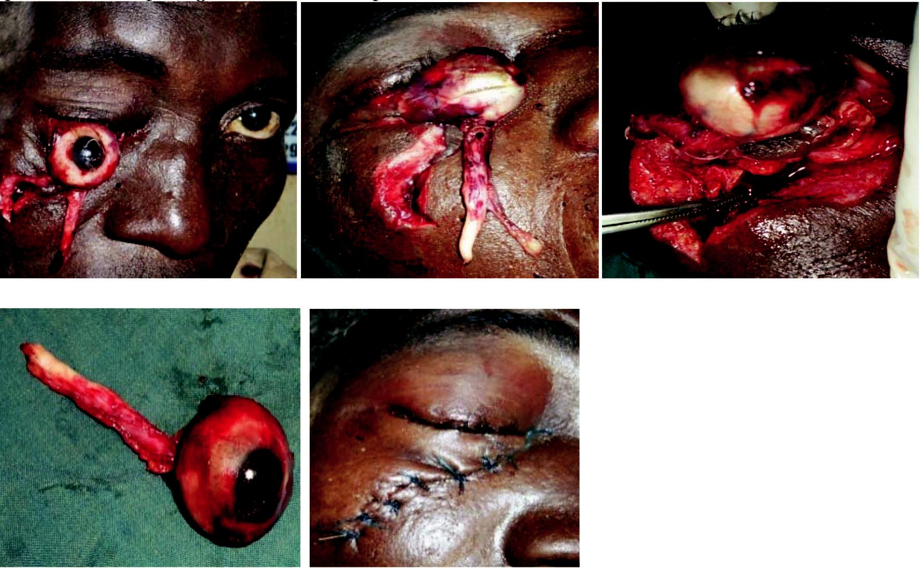

**Figure 1:** Traumatised right eye/orbit. Upper: Left (at presentation), Right (on the theatre table before wound repair);Middle, right eye/orbital wound at surgery; Lower: Left (traumatic enucleated globe with optic nerve stump), Right (after wound repair)

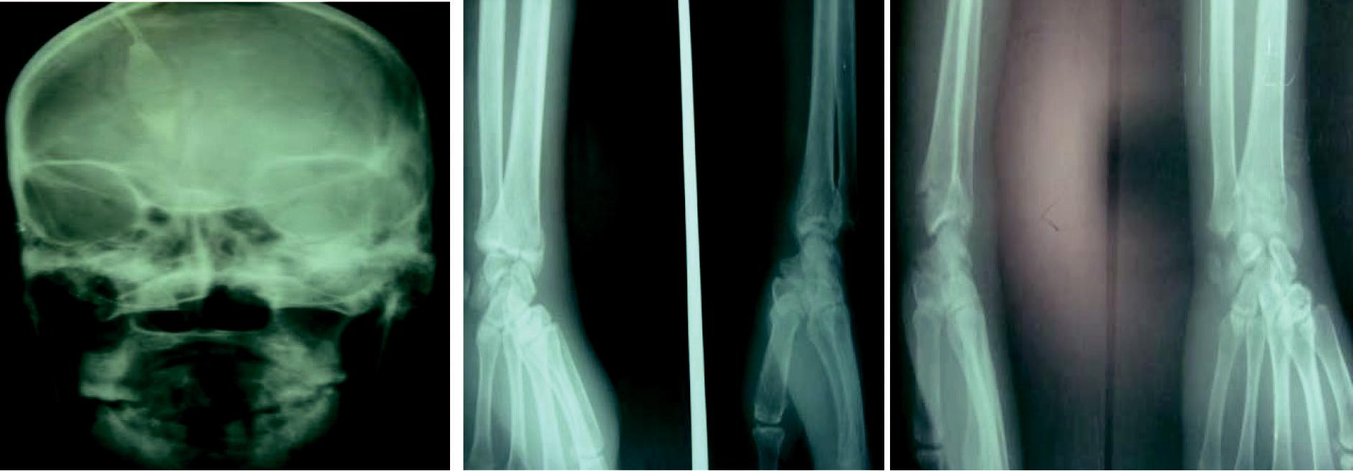

**Figure 2:** X ray findings. Upper:right inferior orbital marginal fracture; Lower: Left, left distal radial bone (Colles’)fracture; Right: right distal radial bone (Colle’s) fracture

The patient subsequently underwent examination under anaesthesia (EUA). The right eye enucleation completed, and the orbit/the eyelids repaired (Figure 1, Lower Right). Except for the linear partial maxillary bone fracture about 6cm in size visualisable at surgery all other surgical findings were essential as above documented. The patient was placed on medications including chloramphenicol eye ointment, tablets cipro Xin 500 mg 12 hourly for ten days,

Page 222 Malaysian Journal of Medical and Biological Research **** Volume 2 **** Number 3/2015

Volume 2. No 3/2015. ISSN 2313-0008 (Print); ISSN 2313-0016 (Online)

metronidazole 400 mg 8 hourly for seven days, Cataflam 50 mg 12 hourly for seven days, folic acid 5 mg daily for two weeks, Vitamin C 200 mg 8 hourly for two weeks and folate 200 mg 12 hourly for two weeks. The patient refused plaster of Paris application for the treatment of Colles’ fracture and went for a local treatment of the fracture.

**Discussion**

Fall from height is a common surgical emergency, and the impact is related to the height and acceleration due to gravity. To the best of authors’ knowledge, this is the first reported case of traumatic optic nerve severance with bilateral Colles’ fracture and Lefort 1 fracture in our environment. Probably, the orbito-adnexal injuries was caused by a pointed end of a tree stump entering the orbit, medial to the globe, creating a wedge effect in the orbit pushing the eye against the lateral wall of the orbit, forcing the eye anteriorly. The increasing force exceeded the tensile strength of the optic nerve and orbital contents causing their severance (Sawhney et al., 2003; Morris et al., 2002; Arkin et al., 1996). The impact of the tree stump on the orbital margin was most likely resulted in a Lefort1 fracture. The bilateral Colles’ fracture should be due to a traumatic impact on the patients’ outstretched hands on falling. Furthermore, the advanced age of the patient might also contribute to the fracture of distal end of the radial bone as osteoporosis is a risk factor for Colles’ fracture. The refusal of the patient to consent to plaster of Paris (POP) application at the hospital is not rare among the rural farmers in the environment of this study. There is a need for public enlightenment about the usefulness of POP application over the local bone treatment. Intracranial complication following optic nerve transection beyond 4cm is well documented in a previous study (Suzuki et al., 1999). The right optic nerve in our patient avulsed at 7.5 cm, and there were no associated visual field defects in the patient’s left eye (LE). Unlike in our case report Parmar et al (2002) report LE temporal hemianopia in a 24-year-old man who also suffered similar traumatic right optic nerve avulsion.

**Conclusion**

Falling from height causes multiple bodily injuries especially eye and bones. The eye injury can be severe causing blindness. The need for complete assessment of a patient with a history of fall from a height by attending health care personnel underscored. The public enlightenment on the dangers and preventive measures to fall from height is advocated.

**References**

Anand, S., Harvey, R., Sandramouli, S. (2003) Accidental self‐inflicted optic nerve head avulsion. Eye,Vol.17, pp.646–648. Arkin, M.S, Rubin, P.A., Bilyk, J.R. *et al. (1996)* Anterior chiasmal optic nerve avulsion. Am J Nucl Res, Vol.17, pp.1777–1818. Atmaca, L.S., Yilmaz, M. (1993) Changes in the fundus caused by blunt ocular trauma. AnnOphthalmol, Vol.25, pp.447–452.

Chaudhry, I.A, Al-Sharif, A.M., Shamsi, F.A. *et al. (2005)* Severe ocular injuries from pointed door-handles in children. Ophthalmology, Vol.112, pp.1834–1837.

Lelli, G.J., Demirci, H., Fruch, B.K. (2007) Avulsion of the optic nerve with luxation of the eye after motor vehicle accident,Ophthal plastic Reconstr Surg.,Vol.23 No.2, pp.158-60.

Morris, W.R., Osborn, D., Fleming, J.C. (2002) Traumatic avulsion of the globe. Ophthalm Plast Reconstr Surg, Vol.18, pp.261–267. Mpyet, C.D. (1999) Enucleation for ritual practices, Trop Doct., Vol.29, No.2 pp.100-1.

Parmar, B., Edmunds, B., Plant, G. (2002) Traumatic enucleation with chiasmal damage: magnetic resonance image findings and response to steroids, Br J Ophthalmol, Vol.86, pp.1317-18.

Pillai, S., Mahmood, M.A., Limaye, S.R. (1987) Complete avulsion of the globe and optic nerve, Br J Ophthalmol, Vol.71, pp.69-72.

Sawhney, R., Kochhar, S., Gupta, R.. et al. (2003) Traumatic optic nerve avulsion: the role of ultrasonography, Eye, Vol. 17, pp. 667–670.

Suzuki, N., Fujitsu, K., Tanaka, N., *et al*. (1999) Traumatic enucleation of the eyeball. Report of a case and considerations concerning the pathogenic mechanism of intracranial complications, Acta OphthalmolScand, Vol.77, pp.340–342.

CC-BY-NC 2014. i-Proclaim | MJMBR Page 223