|  |  |
| --- | --- |
| Rajangam et al: Behavioural Influence of Atorvastatin alone and in Combination with Antiepileptics against Electroconvulsions in Mice | (224-230) |

**Research Article**

Malays. j. med. biol. res.

**Behavioural Influence of Atorvastatin alone and in**

**Combination with Antiepileptics against Electroconvulsions in Mice**

**Jayaraman Rajangam1*, K. Manogna2, K. Mounica3, C. Padma4, A. Swathi5**

1Associate Professor, Pharmacology, Sree Vidya Nikethan College of Pharmacy, Jntua, Sree Sainath Nagar, Tirupati-517 102, A.P, **INDIA** 2,3,4,5Student, Pharmacology, Sree Vidya Nikethan College of Pharmacy, Jntua, Sree Sainath Nagar, Tirupati-517 102, A.P, **INDIA**

*Email: jayaraam81@gmail.com

**Abstract**

The aim of the present study was to investigate the behavioral influence of atorvastatin alone and in combination with antiepileptics like lacosamide and levetiracetam in the mouse after the experimental convulsions induced by maximal electroshock method. The maximal seizure pattern was induced in mice in alternative days for upto 9 days by giving an alternating current of 45 mA for 0.2 Sec. Atorvastatin (10mg/ kg i.p) were administered intraperitoneally 30 min before the electrical induction of seizures in alone and in combination with lacosamide (10mg/kg i.p) and levetiracetam (10mg/kg i.p). Rota rod, hole board, tail suspension and were used to record behavioral effects periodically. Additionally, the effects of administration of atorvastatin on the adverse effect potential of an lacosamide and levetiracetam were assessed in the chimney test for its motor performance. The results shows that, there is a gradual significant increase of muscle grip strength (p<0.05) and reduction in immobility time (p<0.05) on the 7th day which indicates modulatory effect of atorvastatin on behavior while combining with levetiracetam and lacosamide. In hole board test there was a significant increase in head poking were observed which indicates that the given drug atorvastatin has alleviated the anxiety and depression which confirms its modulatory effects on behavior while combining with levetiracetam and lacosamide. In addition to this atorvastatin in combinations with both antiepileptic drugs had no impact on their adverse effects in the chimney test. Based on the study, the results suggest that the HMG-CoA inhibitor atorvastatin fails to protect the seizures alone and in combination with levetiracetam and shows modulatory effects on behavior while combining with antiepileptics in MES convulsion model.

**Keywords:** Atorvastatin, Phenytoin, MES Convulsion, lacosamide, levetiracetam, Behavior



**9/18/2015** **Source of Support:** None, **No Conflict of Interest:** Declared

This article is is licensed under a Creative Commons Attribution-NonCommercial 4.0 International License.

**Attribution-NonCommercial (CC BY-NC)** license lets others remix, tweak, and build upon work non-commercially, and although the new works must alsoacknowledge & be non-commercial.

**Introduction**

Atorvastatin is belongs to statins family, which are used primarily for lowering blood cholesterol and for prevention of events associated with cardiovascular disease. Like all other statins, atorvastatin works by inhibiting HMG-CoA reductase enzyme thus used in the treatment of dyslipidemia (Bersot,2011).Besides, their proven cholesterol-lowering effect, statins exert a number of cholesterol-independent, pleiotropic effects including increasing the nitric oxide levels, reducing oxidative stress, reducing neuro inflammation, and neurotoxicity (Davignon,2004; Laufs,2003). Increasing evidence suggested that statins are neuroprotective in several conditions, including stroke, epilepsy, cerebral ischemia and traumatic brain injury 11, 12. However, only few reports are available on anticonvulsant action of statins (Shafaroodi et al., 2012; Ramirez et al., 2011). Moreover, reports clearly documented the beneficial effect of statins for lowering the

Page 224 Malaysian Journal of Medical and Biological Research **** Volume 2 **** Number 3/2015

Volume 2. No 3/2015. ISSN 2313-0008 (Print); ISSN 2313-0016 (Online)

incidence of neurodegenerative disorders like Alzheimer’s disease, Parkinson’s disease and multiple sclerosis, also acute stroke (Harvey et al.,2004;Wahner et al.,2008; Floris et al., 2004).Statins also reduce circulating levels of various inflammatory molecules and restore nitric oxide (NO) bioavailability via several cellular mechanisms, which might contribute to their reduction of clinical events (Vaughan and Delanty 1999; Floris et al., 2004). However, the exact role of statins in behaviour is still elusive and poorly understood.

In addition,drugs developed for the treatment of epilepsy and dyslipidemia have been evaluated for their modulatory actions in other conditions, such as pain and behavioral effects. Therefore, a functional link between the proposed connection with epilepsy and depression and other behavioral changes may exist at the level of the brain monoamine system. To support this concept very few experiments have been conducted in animal models to study the relationship between epilepsy and depression and other related behavioral changes. In view of the above and controversial reports of atorvastatin on experimental seizure models, the present study was aimed to investigate behavioural influence of atorvastatin alone and in combination with antiepileptics against MES induced convulsions in mice.

**Materials and Methods**

**Animals and experimental conditions**

Adult albino mice (weighing 20-25 g) were kept in polypropylene cages with free access to food and water, under standardized housing conditions were used. After 7 days of adaptation period, the animals were randomly assigned to different groups of 6 animals each. The experimental protocols were duly approved by the institutional animal ethics committee (SVCP/IAEC/I-003/2014-15) and the experiments were conducted as per the guidelines by CPCSEA (New Delhi) at Sree Vidyanikethan College of Pharmacy, Tirupati.

**Drugs, chemicals and instruments**

The drugs and chemicals were used in this study includes atorvastatin, lacosamide and levetiracetam from Lupin Research Park Pune whereas Phenytoin from Sun pharmaceuticals, India. All drugs were administered intraperitoneally (i.p.) 30 min before along with antiepileptics in a volume of 5 ml/kg body wt and appropriate amount of the corresponding vehicles (NS- 0.9%) were given to the control animals. Drug preparation and administmion was done by mixing the drug in saline, which served as the vehicle. Dose of ATOR,LACO and LEVI was based on recommended human treatment regimes so as to closely mimic human situations of use. Rota rod, hole board, tail suspension were used for behavioral estimation.

**Induction of seizure by MES model**

The maximal seizure pattern was induced by using electro convulsiometer (Techno, India) with an alternating current (0.2s stimulus durations and 45 mA) delivered via ear-clip electrodes and the duration of tonic flexion and extensor phase was noted(Mandhane et al.,2007; Swinyard et al.1952). A drop of 0.9% saline solution was poured into each ear prior to placing the electrodes. Atorvastatin alone and in combination with lacosamide and levetiracetam were administered intraperitoneally 30 min before being subjected to an electroshock**15**. The animals were observed closely and subjected to various behavioral studies. The selection of doses were based on the earlier studies and the experimental designs are as follows.

|  |  |  |
| --- | --- | --- |
| **Experimental Design** |  |  |
| Group I | - | Control (NS-0.9%) |
| Group II | - | Atorvastatin (10mg/kg.i.p) |
| Group III | - | Phenytoin (25mg/kg.i.p) |
| Group IV | - | Atorvastatin + Levetiracitam (10+10 mg/kg.i.p) |
| Group V | - | Atorvastatin + Lacosamide (10+10 mg/kg.i.p) |

**Neurotoxicity Test**

Neurotoxicity of the drug atorvastatin was assessed by chimney test (Swiader *et al*. 2003; Mandhane et al.,2007). This test was carried out over the period of 45 min and the animals were subjected to prior training. a Pyrex glass tube (25 cm long and 3cm diameter) marked at a point 20cm from its base; a mouse was introduced at the end, nearest the mark. When the animal reached the other end of the tube, the tube was moved to the vertical position and immediately the mouse tried to climb backwards.The ability of mice to leave the tube within 1min was considered to indicate the lack of neurotoxic properties of the test drug.Screened mice were injected intraperitoneally as per the experimental design and were tested after 45min as described above.

CC-BY-NC 2014. i-Proclaim | MJMBR Page 225

|  |  |
| --- | --- |
| Rajangam et al: Behavioural Influence of Atorvastatin alone and in Combination with Antiepileptics against Electroconvulsions in Mice | (224-230) |

**Assessment of Behaviour Activity**

**Rota rod test**

The rotarod apparatus consisted of a rotating bar suitably machined to provide grip. Latency to fall from the bar is automatically recorded in seconds. Mice were initially selected for the ability to remain on the rotarod for at least two consecutive 180 seconds trials before the test day. On the test day (24 h after mice were randomly divided into 12 groups(n=5) and treated as described for the beam traversal task before using being placed on the rotarod was rotating at a constant speed of 25rev/min . On the test day animals were placed individually as per the experimental design in each compartment and their fall of time were noted (Taiwe et al.,2010).

**Tail suspension method**

Mice were treated with the test compounds or the vehicles by intraperitoneal injection 30 minutes prior to testing. The duration of immobility is recorded for a period of 5mins. Mice are considered immobile when they hang passively and completely motionless for at least 1mins (S.K.Kulkarni,3rdedition; Steru et al., 1985).

**Hole board test**

The hole board test was conducted by using a white printed wooden board designed (400cm x 40cm) with 16 equidistant holes (1cm diameter x 2cm depth). The mice were placed at the center of the board and allowed to move freely in the box. A head dip into holes was used to indicate exploratory behaviour.The animals were randomly grouped into five groups each containing six mice. Drug administration was made as per the experimental design and 30 minutes after treatment, the mice were placed individually on the board and the number of times the mice dipped their head into the holes at the level of their eyes during a five minute trial period was counted (Perez et al.,1998).).

**Statistical Analysis**

Results was expressed as mean ± S.E.M the significance of difference in the response between treatment group and control was determined by one way analysis of variance (ANOVA) followed by Tukey-Kramer Multiple Comparisons test. p<0.05 was considered as statistically significant.

**Results**

**Maximal electroshock induced seizure**

In MES induced seizure model, the duration of tonic extensor phase was recorded in all experimental groups including control after the electroshock (Fig.1 ).The standard drug PHT (25mg/kg.i.p) administration before electroshock significantly lowered the convulsive threshold (P<0.001) whereas in ATOR alone and ATOR +LEVI group there was no significant reduction of tonic extension were observed. But the concurrent treatment LACO with ATOR at a dose of 10mg/kg.i.p reduces the potency of tonic extension (** P<0.001) throughout the acute study when compared with control groups.

**Chimney Test**

No neurotoxic effects were observed with atorvastatin (10mg/kg i.p.)and it has no impact on motor coordination in the chimney test in mice at the investigated dose and the animals were able to leave the tube with in 1 min.

**Rota rod test**

In rota rod test, between control and experimental group On day 1, there was no significant increase in muscle grip strength were noticed but results on day 7 shows that there was gradual significant increase in muscle grip strength were noticed (P<0.05) in ATOR + LEVI (10+10 mg/ kg) and ATOR +LACO (10+10 mg/kg) treated groups when compared to control groups (Fig.2).

**Tail suspension and hole board test**

The results from tail suspension test between control and the experimental groups shows that, there was no significant changes were observed On day 1,3 & 5 whereas on day 7 there was reduction in immobility time (*P<0.05) in both ATOR + LEVI (10+10 mg/ kg) and ATOR +LACO (10+10 mg/kg) treated groups when compared to control groups (Table.1).

In hole board test there was a significant increase in head poking were observed at the doses of atorvastatin (10 mg/kg i.p) which indicates that the given drug atorvastatin has alleviated the anxiety and depression to some extent possibly by interfering with the inhibitory neurotransmitter like GABA (Table.2).

Page 226 Malaysian Journal of Medical and Biological Research **** Volume 2 **** Number 3/2015

Volume 2. No 3/2015. ISSN 2313-0008 (Print); ISSN 2313-0016 (Online)

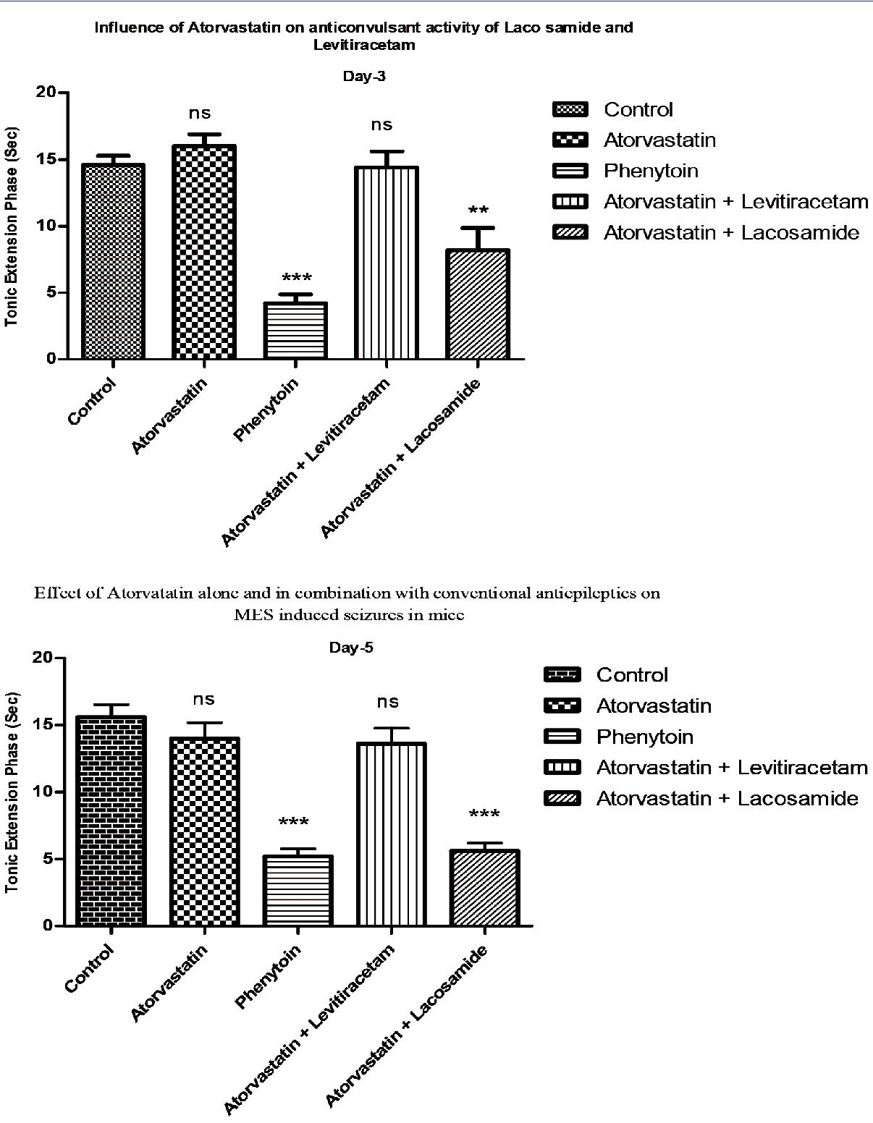

**Figure 1:** Effect of acute administmiceion of atorvastatin alone and in combination with levetiracetam and lacosamideon MES induced seizures in mice on Day 3& 5

Number of animals (n=5): Values are mean ± SEM: *P<0.05,** P<0.01 & *** P<0.001 when compared to Control and phenytoin treated groups; ns: Non significant.

CC-BY-NC 2014. i-Proclaim | MJMBR Page 227

|  |  |
| --- | --- |
| Rajangam et al: Behavioural Influence of Atorvastatin alone and in Combination with Antiepileptics against Electroconvulsions in Mice | (224-230) |

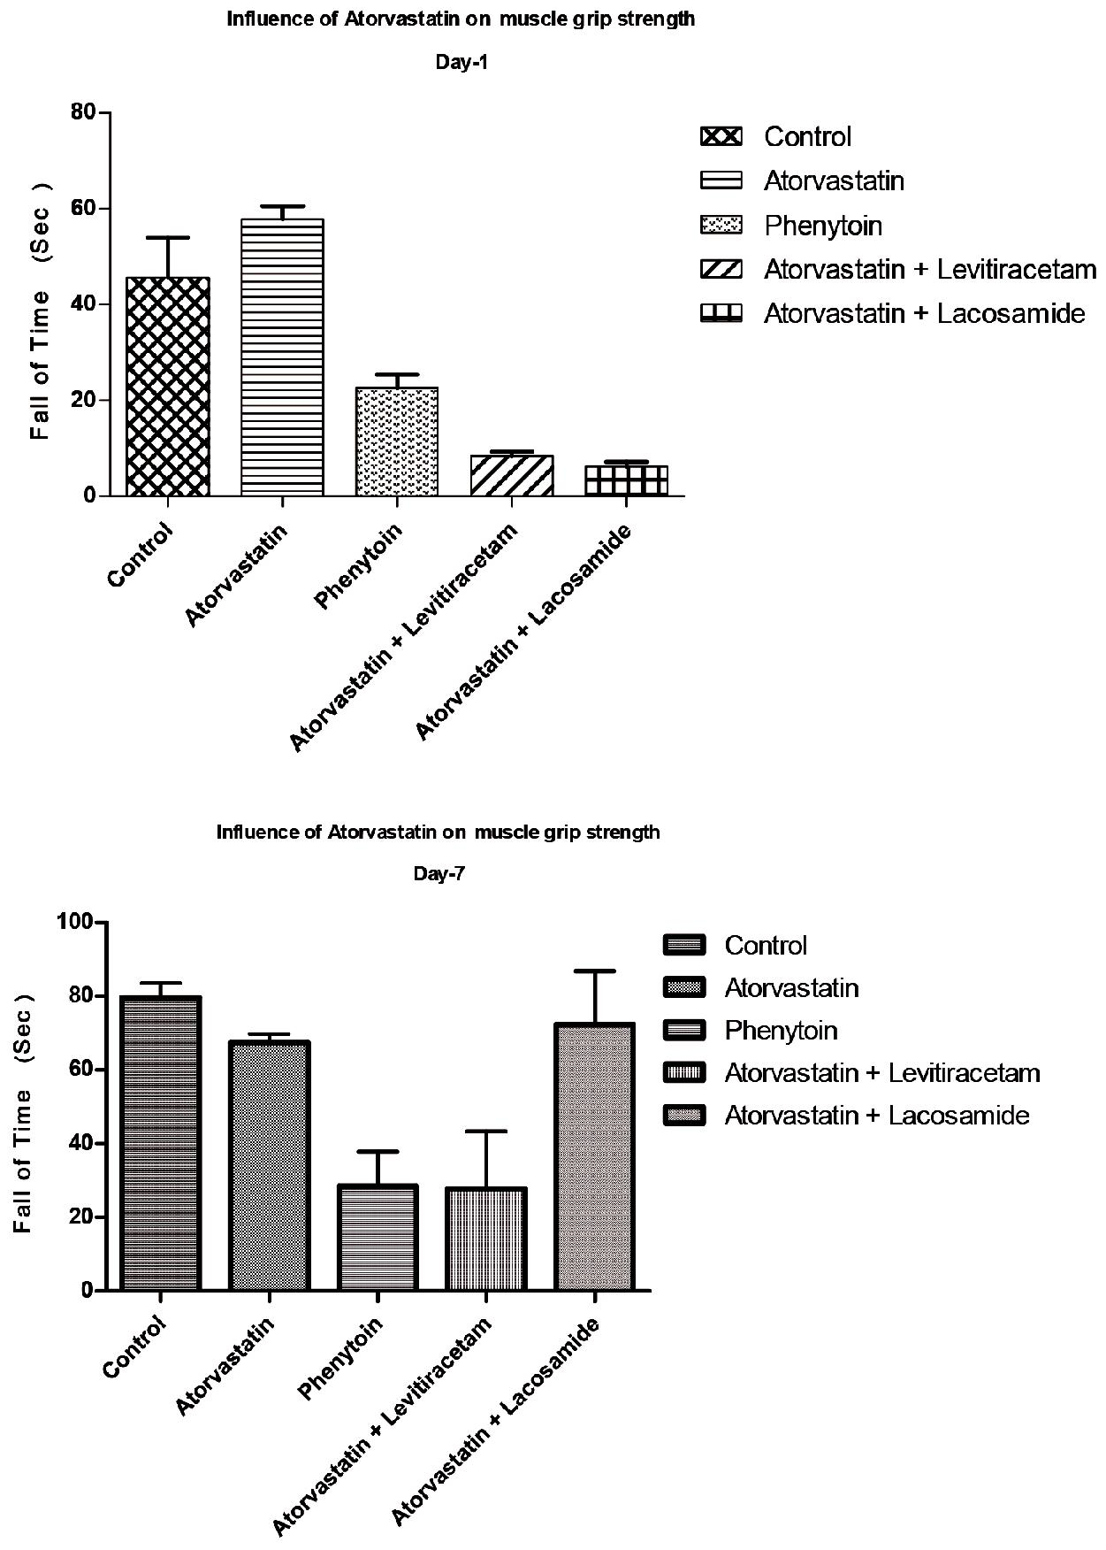

**Figure 2:** Effect of acute administmiceion of atorvastatin alone and in combination with levetiracetam and lacosamideon muscle grip strength

In rota rod test, between control and experimental group On day 1, there was no significant increase in muscle grip strength were noticed but results from day 5 and day 7 shows that there was gradual significant increase in muscle grip strength were noticed (P<0.05 ) in ATOR + LEVI (10+10 mg/ kg) and ATOR +LACO (10+10 mg/kg) treated groups when compared to control groups.

Page 228 Malaysian Journal of Medical and Biological Research **** Volume 2 **** Number 3/2015

Volume 2. No 3/2015. ISSN 2313-0008 (Print); ISSN 2313-0016 (Online)

**Table 1:** Shows the behavioral effect of acute administmiceion of atorvaststin alone and in combination withlevetiracetam and lacosamide on tail suspension test in mice

|  |  |  |  |  |
| --- | --- | --- | --- | --- |
| **Groups** | **Dose Mg/kg.i.p** | **Tail suspension test -Immobility (Sec)** | | |
|  |  | **Day 3** | **Day 5** | **Day 7** |
| Control | NS- 0.9% | 120.41±3.51 | 125.64±7.16 | 135.29±7.31 |
| Phenytoin | 25 | 124.42±6.82 | 130.36±8.53 | 135.46±8.11 |
| Atorvastatin | 10 | 121.75±9.18 ns | 135.37±7.16 ns | 142.99±13.22 ns |
| Atorvastatin + | 10+10 | 121.94±5.69 ns | 124.78±5.33 ns | 130.24±3.20* |
| levetiracetam |  |  |  |  |
| Atorvastatin + | 10+10 | 121.47±6.49 ns | 136.46±6.83 ns | 127.85±4.73* |
| lacosamide |  |  |  |  |

Number of animals (n=6): Values are mean ± SEM: *P<0.05,** P<0.01 & *** P<0.001 When compared to control and phenytoin treated groups; ns: Non significant**.**

**Table 2:** Behavioral effect of acute administmiceion of atorvaststin alone and in combination with levetiracetam andlacosamide on hole board test in mice

|  |  |  |  |  |
| --- | --- | --- | --- | --- |
| **Groups** | **Dose Mg/kg.i.p** | **Hole board test (No. of Head poking for 3 min)** | | |
|  |  |  |  |  |
|  |  | **Day 3** | **Day 5** | **Day 7** |
|  |  |  |  |  |
| Control | NS- 0.9% | 24.69±5.23 | 27.41±4.23 | 29.42±5.25 |
|  |  |  |  |  |
| Phenytoin | 25 | 25.78±5.09 ns | 25.44±5.61* | 33.68±3.50* |
| Atorvastatin | 10 | 26.92±6.50ns | 29.38±3.36ns | 34.50±4.00* |
| Atorvastatin + | 10+10 | 27.22±3.51ns | 27.24±3.11ns | 34.11±3.72* |
| levetiracetam |  |  |  |  |
|  |  |  |  |  |
| Atorvastatin + | 10+10 | 24.74±6.50 ns | 26.14±6.56ns | 33.90±6.60* |
| lacosamide |  |  |  |  |
|  |  |  |  |  |

Number of animals (n=6 ): Values are mean ± SEM: *P<0.05,** P<0.01, *** P<0.001When compared to control group, *P<0.05, ns: Non significant.

**Discussion**

Atorvastatin is a competitive inhibitor of HMG-CoA reductase, an rate limiting enzyme in cholesterol biosynthesis, thus used in the treatment of dyslipidemia (Bersot,2011). In addition to reducing the serum level of cholesterol, statins have various additional beneficial effects such as increasing nitric oxide, reducing oxidative stress, neuroinflammation, and neurotoxicity. Increasing evidence indicates that statins are neuroprotective in several conditions, including stroke, epilepsy,cerebral ischemia and traumatic brain injury (Shafaroodi et al.,2012).However, only scanty reports are available on anticonvulsant action of statins and its behavioural influence in which some are comprising controversial reports on anticonvulsant activity of statins.

In the present study, in ATOR +LEVI group there was no significant reduction of tonic extension were observed which shows that levetiracetam fails to protect the seizures in MES or there may be no or least kinetic interaction between atorvastatin and levetiracetam. In accordance with the previous studies the present study also confirmed and supports that, levetiracetam is devoid of protective actions in acute convulsion models (e.g., MES, PTZ seizures). But the concurrent treatment LACO with ATOR at a dose of 10mg/kg shows beneficial effect towards reduction of the potency of tonic extension (P<0.05).

In the present study, a number of behavioral differences between control, seizure animals treated with atorvastatin were observed. Firstly, the results of the all the models studied reveals that, the behavioral changes of the atorvastatin treated mice probably not only due to their physical condition but also changes in neurochemistry of the brain transmitters. In rota rod test, the results indicate altered type of behavior of the animals. The results from tail suspension test shows that, there was no significant changes were observed on day 1 whereas on day 5 and day 7 (*P<0.05) there was reduction in immobility time were noticed .Whereas in hole board test there was a significant increase in head poking were observed at the the doses of atorvastatin (10 mg/kg i.p) which indicates that atorvastatin has alleviated the anxiety and depression to some extent possibly by interfering with the inhibitory neurotransmitter like GABA.

Report from earlier studies supports that, epilepsy is associated with alterations in central monoaminergic system changes are linked to behavioral changes like anxiety and depression. (Ranje and Ungerstedt,1977; Giros, et al., 1996).

CC-BY-NC 2014. i-Proclaim | MJMBR Page 229

|  |  |
| --- | --- |
| Rajangam et al: Behavioural Influence of Atorvastatin alone and in Combination with Antiepileptics against Electroconvulsions in Mice | (224-230) |

In addition to this, dopamine systems play an important role in controlling movement and locomotion. Therefore, a functional link between the proposed connection with epilepsy and depression and other behavioral changes may be due to the alterations in brain monoamine system (Uhl et al.,2002; Uhl et al.,2002). In conclusion, collectively, these results strongly suggest that neurochemical mechanisms in addition to changes in brain monoamine systems may contributed to some of the behavioral effects of atorvastatin (10 mg/kg) in mice.

**References**

Bersot T.P*.,* Drug therapy for hypercholesterolemia and dyslipidemia. Brunton L, Chabner B, Knollman B editors. Goodman & Gillman’s the pharmacological basis of therapeutics, 12thed. New York: McGraw Hill; 2011. p.893.

Davignon, J., Beneficial cardiovascular pleiotropic effects of statins. Circulation, 2004, 109, Suppl III, 39–43.

Floris, S., Blezer, E.L., Schreibelt, G., Dopp, E., van der Pol, S.M., Schadee-Eestermans, I.L., Nicolay K. Bloodbrain barrier permeability and monocyte infiltration in experimental allergic encephalomyelitis: a quantitative MRI study. Brain, 2004, 127, 616–627.

Giros, B., Jaber, M., Jones, S.R., Wightman,R.M., Caron, M.G. Hyperlocomotion and indifference to cocaine and amphetamine in mice lacking the dopamine transporter.Nature 1996,379, 606–612.

Harvey, B.H, Oosthuizen. F., Brand, L., Wegener, G., Stein, D.J. Stress–restress evokes sustained iNOS activity and altered GABA levels and NMDA receptors in rat hippocampus. Psychopharmacology.2004, 175, 494–502.

Kulkarni,S.K. Handbook of experimental pharmacology 3rd edition Page No:117,119,135

Laufs, U. Beyond lipid-lowering: effects of statin on endothelial nitric oxide. Eur J Pharmacol. 2003, 58, 719–731.

Losher, W., Schmidt, D.Which animal models should be used in the search for new antiepileptic drugs? A proposal based on experimental and clinical considerations. J epilepsy Res.1988; 2:145-181*.*

Mandhane, S.N., Aavula, K., Rajamannar, T. Timed pentylenetetrazole infusion test: A compamiceive analysis with s.c. PTZ and MES models of anticonvulsant screening in mice. Seizure. 2007,16:636-44.

Mandhane, S.N., Aavula, K., Rajamannar, T. Timed pentylenetetrazole infusion test: A compamiceive analysis with s.c. PTZ and MES models of anticonvulsant screening in mice. Seizure. 2007,16:636-44.

Perez, G.R.M., Perez, I.J.A., Garcia, D., Sossa, M.H. Neuropharmacological activity of *Solanum nigrum* fruit. J. Ethnopharmacol.1998, 62:43-48.

Ramirez, C., Tercero, I., Pineda, A., Burgos, J.S. Simvastatin is the statin that most efficiently protects against kinate-induced excitotoxicity and memory impairment. J.Alzheimers Dis 2011, 24(1):161-74.

Ranje, C., Ungerstedt, U. High correlations between number of dopamine cells, dopamine levels and motor performance. Brain Res. 1977,134, 83–93.

Shafaroodi, H., Mezi, L., Fakhrzad, A., Hassanipou, M., Rezayat, M., Dehpour, A.R. The involvement of nitric oxide in the anti-seizure effect of acute Atorvastatin treatment in mice. Neurol Res. 2012; 34(9): 847-53.

Steru, L., Chermat, R., Thierry, B., Simon, P. The tail suspension test: a new method for a new method for screening antidepressants in mice. Psychopharmacology.1985,85:367.

Swiader, M. Influence of vigabatrin, a novel antiepileptic drug on the anticonvulsant activity of conventional antiepileptic in pentetetrazole induced seizures in mice. Pol J Pharmacol 2003, 55: 363-370.

Swinyard, E.A. Comparative assay of antiepileptic drugs in mice and rats. J Pharmacol. Exp. Ther. 1952, 106: 319-330.

Taiwe,G.S., Ngo Bum,T..Dimo. antidepressant, myorelaxant and Anti-anxiety like effects nauclea latifolia smith(Rubiaceae)roots extract in murine models. International journal of pharmacology.2010;6(4):364-371

Uhl, G.R., Hall, F.S., Sora, I.Cocaine, reward,movement and monoamine transporters. Mol. Psychiatry.2002, 7, 21–26.

Uhl, G.R.. Dopamine transporter: basic science and human variation of a key molecule for dopaminergic function, locomotion, and Parkinsonism. Mov. Disord.2003,18, S71–S80.

Vaughan, C.J., Delanty, N. Neuroprotective properties of statins in cerebral ischemia and stroke. Stroke. 1999, 30, 1969–1973. Wahner, A.D., Bronstein, J.M., Bordelon, Y.M, Ritz, B. Statin use and the risk of Parkinson disease. Neurology. 2008, 70, 1418–1422.

Page 230 Malaysian Journal of Medical and Biological Research **** Volume 2 **** Number 3/2015