Mar. 23, 2015
iRIC 3.0 Build environment setup manual

1. Abstract 2
2. Install Visual Studio Express 2013 for Windows Desktop 2
3. Install Qt 5.3.2 2
4. Build VTK with Qt binding 2
4.1. Download VTK source code 2
4.2. Install CMake 3
4.3. Build VTK with Qt binding 3
5. Build HDF5 7
5.1. Build SZip 7
5.2. Build ZLib 8
5.3. Build HDF5 9
6. Build CGNS library 3.2.1 10
7. Build Shapefile C library 11
8. Build Qwt 12
9. Build GDAL library 13
10. Build Proj.4 library 13
11. Build NetCDF 14

Abstract
In this document, the procedure to set up build environment for 64-bit iRIC is explained. You are going to prepare the followings:
- Visual Studio Express 2013 for Windows Desktop
- Qt 5.3 compiled with Visual C++ 2013 OpenGL (64-bit)
- VTK compiled with Qt bindings
- HDF5 library
- CGNS library
- Shapefile C library
- Qwt compiled with Qt
- Proj.4
- GDAL
- NetCDF
Please note that you need 64-bit Windows (For example Windows 7 64-bit edition) to build iRIC 64-bit Edition.

Install Visual Studio Express 2013 for Windows Desktop
Install Visual Studio Express 2013 with Update 4 for Windows.
Visual Studio Express 2013 with Update 4 can be downloaded from the following URL.
http://www.visualstudio.com/downloads/download-visual-studio-vs#d-express-windows-8

Install Qt 5.3.2
Download Qt 5.3.2 for Visual C++ 2013 OpenGL (64-bit). It can be downloaded from the following URL:
http://qt-project.org/downloads
Download Qt Online Installer for Windows first, and launch it.
In the Install component selection menu, select the following items to be downloaded:
- Qt\Qt 5.3\msvc2013 64-bit OpenGL
- Tools\Qt Creator 3.2.2

When the install process finishes, Qt will be installed into C:\Qt\5.3.

Build VTK with Qt binding

Download VTK source code
Download VTK source code from the following URL:
http://www.vtk.org/VTK/resources/software.html

Please note that you download the source package (vtk-6.1.x.zip). That's because you'll compile VTK with Qt binding.
When you finished downloading, expand the zip file to somewhere, like “E:\usr/src/vtk-6.1.0”.

Install CMake
Please install CMake. It is a cross-platform build tool required to build VTK. CMake also is a product of KitWare, that developed VTK.
CMake is freely available from the following URL:
http://www.cmake.org/cmake/resources/software.html
Please download the newest CMake. Download binary distribution for Windows, and install it. Currently, the newest binary is available from the following URL:
http://www.cmake.org/files/v2.8/cmake-2.8.12.2-win32-x86.exe

Build VTK with Qt binding
First, launch "Qt 5.3 64-bit for Desktop (MSVC 2013) ". This menu exists under "Qt\5.3\MSVC 2013 OpenGL (64-bit)” menu. This is a command prompt with settings to use Qt related tools (like qmake).
First, execute the batch file to add path to Visual Studio 2013 compilers, by the following:
"E:\Program Files (x86)\Microsoft Visual Studio 12.0\VC\vcvarsall.bat" x86_amd64
Launch cmake-gui, by typing the following in the command prompt:
"C:\Program Files (x86)\CMake 2.8\bin\cmake-gui.exe"
Then CMake GUI program will launch, like the following image. Then, specify the source directory ("Where is the source code"), and the build directory ("Where to build the binaries"). Build directory name may be arbitrary, but take care not to specify a sub folder of source directory. in the following example, source directory is "E:/iricdev_2013/lib/src/vtk-6.1.0", and build directory is " E:/iricdev_2013/lib/build/vtk-6.1.0 ".

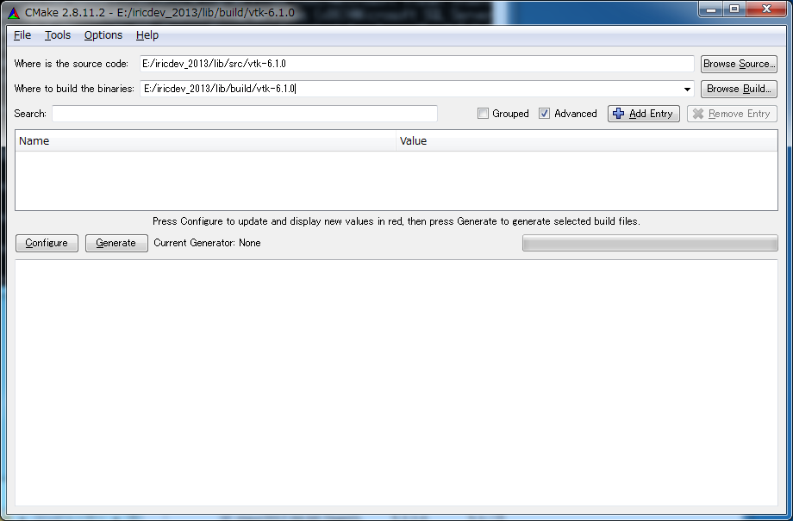
After specifying those directories, press "Configure" button, then a dialog is shown and you'll have to specify the generator for the project. Visual Studio 12 Win64 is already selected by default, so push "Finish" button.
Configuring process starts. Maybe you'll need to wait for 10 minutes, to finish this process.
When the configure process is finished, check on “Advanced” first. Modify "CMAKE_INSTALL_PREFIX" value, into "E:\iricdev_2013\lib\install\vtk-6.1.0\debug". Check on “VTK_USE_GL2PS” to build vtkGL2PSExporter.

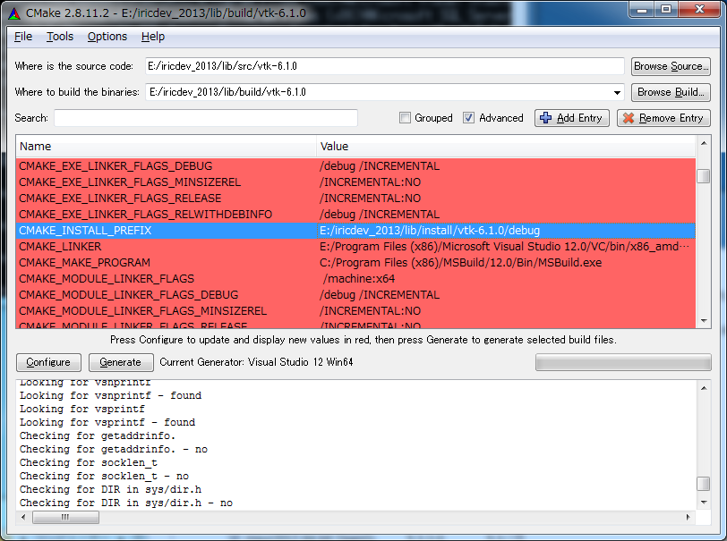
CMake GUI after specifying CMAKE_INSTALL_PREFIX

Find the followings and toggle the checkboxes:
- Module_vtkGUISupportQt
- Module_vtkGUISupportQtOpenGL
- Module_vtkRenderingQt
- Module_vtkViewsQt
Then press "Configure" button again. This time, configure process ends quickly, because the most of the results are cached.
Now select “5” for value of “VTK_QT_VERSION”, and press "Configure" button again.
Now you’ll see that Qt5Core_DIR, Qt5Designer_DIR etc. are specified correctly.
Press “Configure” button again, and press on the “Generate” button, and you'll see so many files are generated under "E:/iricdev_2013\lib\build\vtk-6.1.0".

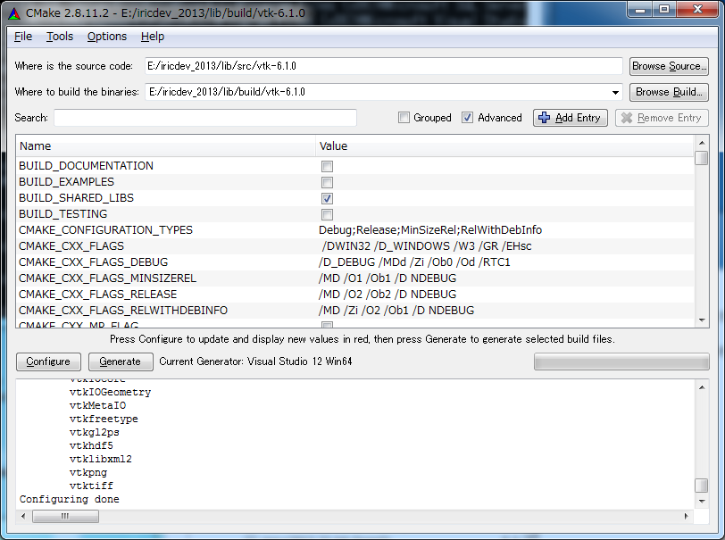

Launch Visual Studio 2013 Express Edition from Start menu, and open "VTK.sln" under the build directory. Then, build the solution, by pressing "F7" button. This process takes SO LONG time. Maybe it will take one hour to compile.
When the build process is finished, right-click the "INSTALL" project, and press "Build" menu. Then, the header files, library files, and DLLs are copied into the directories under E:\iricdev_2013\lib\install\vtk-6.1.0\debug. Please check that the files exist. VTK built in this way will include Qt-binding classes, and related libraries. Make sure that "vtkGUISupportQt-6.1.dll" exists under "bin" directory.
Now, activate the CMake GUI again. If you've closed CMake GUI, don't worry, when you launch again, it loads the cache it created last time. No long configure process again! This time, modify "CMAKE_INSTALL_PREFIX" into "C:/iricdev_2013/lib/install/vtk-6-1.0/release". Press "Configure" button. When configure process is finished, press "Generate" button.
Now activate Visual Studio. It will inform that the project files are updated, so press "Yes" to reload the project files.
Now, you'll build VTK for release versions. Select "Release" instead of "Debug" at the Combo box that appears in the Toolbar. Press "F7" button, to build VTK in release mode. It will take as long time as building debug, so have a break time again.
When the build process is finished, right-click the "INSTALL" project, and press "Build" menu. Then, the header files, library files, and DLLs are copyied into the directories under C:\iricdev_2013\lib\install\vtk-6.1.0\release . Please check that the files exist.

Build HDF5
Build HDF5 1.8.13 with SZIP and ZLIB support. HDF5 source code can be downloaded from the following URL:
http://www.hdfgroup.org/HDF5/release/cmakebuild.html
Download hdf5-1.8.14.zip, SZip.tar.gz, ZLib.tar.gz, and unzip each file under E:\iricdev_2013\lib\src\hdf5-1.8.14. After unzipping the three files, the folder structure will be like the following:

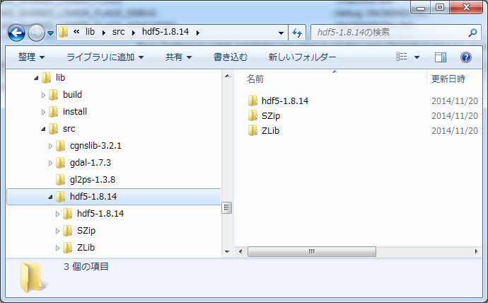

Build SZip
Launch CMake GUI program just like in 4.3. Then, specify the source directory ("Where is the source code"), and the build directory ("Where to build the binaries"). In the following example, source directory is "E:/iricdev_2013/lib/src/hdf5-1.8.14/SZip", and build directory is "E:/iricdev_2013/lib/build/hdf5-1.8.14/SZip".
After specifying those directories, press "Configure" button, then a dialog is shown and you'll have to specify the generator for the project. Visual Studio 12 Win64 is already selected by default, so push "Finish" button.
When the configure process is finished, do the followings:
- CMAKE_INSTALL_PREFIX → "E:/iricdev_2013/lib/install/hdf5-1.8.14/SZip/debug"
- CMAKE_LIBRARY_OUTPUT_DIRECTORY
→ "E:/iricdev_2013/lib/install/hdf5-1.8.14/SZip/debug/bin"
- CMAKE_RUNTIME_OUTPUT_DIRECTORY
→ "E:/iricdev_2013/lib/install/hdf5-1.8.14/SZip/debug/bin"
- MSVC12_REDIST_DIR
→ “C:\Program Files (x86)\Microsoft Visual Studio 12.0\VC\redist”
- BUILD_SHARED_LIBS → Check

Press “Configure” again, and press "Generate" button, and you'll see files are generated under "E:/iricdev_2013/lib/build/hdf5-1.8.14/SZip".
Launch VS Express 2013 for Desktop from Start menu, and open "SZip.sln" under the build directory. Then, build the solution, by pressing "F7" button.
Create “INSTALL”, and “HISTORY.txt” in E:/iricdev_2013/lib/src/hdf5-1.8.14/SZip. It can be any file. It can be an empty file.
Right-click the "INSTALL" project, and press "Build" menu. Files will be copied into E:/iricdev_2013/lib/install/hdf5-1.8.14/SZip/debug.
Build Release version too. Please don’t forget to modify the settings: “debug” → “release”.

Build ZLib
Launch CMake GUI program just like in 4.3. Then, specify the source directory ("Where is the source code"), and the build directory ("Where to build the binaries"). In the following example, source directory is "E:/iricdev_2013/lib/src/hdf5-1.8.14/Zlib", and build directory is "E:/iricdev_2013/lib/build/hdf5-1.8.14/Zlib".
After specifying those directories, press "Configure" button, then a dialog is shown and you'll have to specify the generator for the project. Visual Studio 12 Win64 is already selected by default, so push "Finish" button.
When the configure process is finished, do the followings:
- CMAKE_INSTALL_PREFIX → "E:/iricdev_2013/lib/install/hdf5-1.8.14/ZLib/debug"
- CMAKE_LIBRARY_OUTPUT_DIRECTORY
→ "E:/iricdev_2013/lib/install/hdf5-1.8.14/ZLib/debug/bin"
- CMAKE_RUNTIME_OUTPUT_DIRECTORY
→ "E:/iricdev_2013/lib/install/hdf5-1.8.14/ZLib/debug/bin"
- MSVC12_REDIST_DIR
→ “C:\Program Files (x86)\Microsoft Visual Studio 12.0\VC\redist”
- BUILD_SHARED_LIBS → Check

Press “Configure” again, and press "Generate" button, and you'll see files are generated under "E:/iricdev_2013/lib/build/hdf5-1.8.14/ZLib".
Launch VS Express 2013 for Desktop from Start menu, and open "ZLIB.sln" under the build directory. Then, build the solution, by pressing "F7" button.
Right-click the "INSTALL" project, and press "Build" menu. Files will be copied into E:/iricdev_2013/lib/install/hdf5-1.8.14/ZLib/debug.
Build Release version too. Please don’t forget to modify the settings: “debug” → “release”.

Build HDF5
Launch CMake GUI program just like in 4.3. Then, specify the source directory ("Where is the source code"), and the build directory ("Where to build the binaries"). In the following example, source directory is "E:/iricdev_2013/lib/src/hdf5-1.8.14/hdf5-1.8.14", and build directory is "E:/iricdev_2013/lib/build/hdf5-1.8.14/hdf5-1.8.14".
After specifying those directories, press "Configure" button, then a dialog is shown and you'll have to specify the generator for the project. Visual Studio 12 Win64 is already selected by default, so push "Finish" button.
When the configure process is finished, do the followings:
- CMAKE_INSTALL_PREFIX → "E:/iricdev_2013/lib/install/hdf5-1.8.14/hdf5-1.8.14/debug"
- CMAKE_LIBRARY_OUTPUT_DIRECTORY
→ "E:/iricdev_2013/lib/install/hdf5-1.8.14/hdf5-1.8.14/debug/bin"
- CMAKE_RUNTIME_OUTPUT_DIRECTORY
→ "E:/iricdev_2013/lib/install/hdf5-1.8.14/hdf5-1.8.14/debug/bin"
- MSVC12_REDIST_DIR
→ “C:\Program Files (x86)\Microsoft Visual Studio 12.0\VC\redist”
- BUILD_SHARED_LIBS → Check
- HDF5_ENABLE_Z_LIB_SUPPORT → Check
- HDF5_ENABLE_SZIP_SUPPORT → Check
- HDF5_BUILD_HL_LIB → Check

Press “Configure” again, and press "Generate" button, and you'll see files are generated under "E:/iricdev_2013/lib/build/hdf5-1.8.14/hdf5-1.8.14".
Launch VS Express 2013 for Desktop from Start menu, and open "HDF5.sln" under the build directory.
Select “hdf5” in “libraries”, and add ZLib and SZip include folders by right-click on “hdf5”, select “Property”. You can add additional include folders from “C/C++” → “General” → “Additional Include Directory”. Add the followings:
- “E:\iricdev_2013\lib\install\hdf5-1.8.14\SZip\debug\include”
- “E:\iricdev_2013\lib\install\hdf5-1.8.14\ZLib\debug\include”
Press F7 to build the library.
Right-click the "INSTALL" project, and press "Build" menu. Files will be copied into E:/iricdev_2013/lib/install/hdf5-1.8.14/hdf5-1.8.14/debug.
Build Release version too. Please don’t forget to modify the settings: “debug” → “release”.

Build CGNS library 3.2.1
Build CGNS library 3.2.1. CGNS source code can be downloaded from the following URL:
http://cgns.sourceforge.net/download.html
Download cgnslib_3.2.1.tar.gz, and unpack it to E:/iricdev_2013/lib/src/cgnslib-3.2.1.
Launch CMake GUI program just like in 4.3. Then, specify the source directory ("Where is the source code"), and the build directory ("Where to build the binaries"). In the following example, source directory is "E:/iricdev_2013/lib/src/cgnslib-3.2.1", and build directory is "E:/iricdev_2013/lib/build/cgnslib-3.2.1".
After specifying those directories, press "Configure" button, then a dialog is shown and you'll have to specify the generator for the project. Visual Studio 12 Win64 is already selected by default, so push "Finish" button.
When the configure process is finished, do the followings:
- CMAKE_INSTALL_PREFIX → "E:/iricdev_2013/lib/install/cgnslib-3.2.1/debug"
- CMAKE_BUILD_TYPE → Debug
- CGNS_ENABLE_64BIT → Check
- CGNS_ENABLE_FORTRAN → Check
- CGNS_ENABLE_HDF5 → Check
- CGNS_ENABLE_LFS → Check

Press “Configure” again, and do the followings:
- HDF_INCLUDE_PATH
→ “E:/iricdev_2013/lib/install/hdf5-1.8.14/hdf5-1.8.14/debug/include”
- HDF_LIBRARY
→ “E:/iricdev_2013/lib/install/hdf5-1.8.14/hdf5-1.8.14/debug/lib/hdf5_D.lib”
- HDF5_NEED_SZIP → Check
- HDF5_NEED_ZLIB → Check
Press “Configure” again, and press "Generate" button, and you'll see files are generated under "E:/iricdev_2013/lib/build/cgns-3.2.1".
Launch VS Express 2013 for Desktop from Start menu, and open "cgns.sln" under the build directory. Press F7 to build the library.
Copy “cgnsdll.dll” from “E:/iricdev_2013/lib/build/cgnslib-3.2.1/src/Debug” to “E:/iricdev_2013/lib/build/cgnslib-3.2.1/src”.
Right-click the "INSTALL" project, and press "Build" menu. Files will be copied into E:/iricdev_2013/lib/install/cgnslib_3.2.1/debug.
Build Release version too. Please don’t forget to modify the settings: “debug” → “release”. Please notice about HDF_LIBRARY value:
- HDF_LIBRARY
→ “E:/iricdev_2013/lib/install/hdf5-1.8.14/hdf5-1.8.14/release/lib/hdf5.lib”

Build Shapefile C library
Build shapefile C library. Shapefile C library can be downloaded from the following URL:
http://download.osgeo.org/shapelib/
Download shapelib-1.3.0.zip, and unpack it to E:\iricdev_2013/lib/src/shapelib-1.3.0.
Launch "Qt 5.3 64-bit for Desktop (MSVC 2013)", change directory to E:\iricdev_2013/lib/src/ shapelib-1.3.0, and type the following:

nmake –f makefile.vc

Then, shapelib.lib will be generated. Create E:\iricdev_2013/lib/install/shapelib-1.3.0/release folder, and copy shapelib.lib, shapefil.h to that folder.

Now modify makefile.vc as follows, and input the following:
Before: CFLAGS = /nologo /Ox /MD /DSHAPELIB_DLLEXPORT
After: CFLAGS = /nologo /Ox /MDd /DSHAPELIB_DLLEXPORT

nmake –f makefile.vc clean
nmake –f makefile.vc

This time, debug version shapelib.lib will be generated. Create E:\iricdev_2013/install/shapelib-1.3.0/debug folder, and copy shapelib.lib, shapefil.h to that folder.

Build Qwt
Build Qwt 6.1.0. Qwt source code can be downloaded from the following URL:
http://sourceforge.net/projects/qwt/files/qwt/6.1.0/
Download qwt-6.1.0.zip, and unzip it to E:/iricdev_2013/lib/src/qwt-6.1.0.
Open “Qt 5.3 64-bit for Desktop (MSVC 2013)”, and change directory to E:\usr\src\qwt-6.1.0\src. Input the following commands to build Qwt for debug mode.

qmake
nmake debug
nmake install

“include”, “lib” folders will be created under “C:\Qwt-6.1.0”, so create “E:/iricdev_2013/lib/install/qwt-6.1.0”, and move the two folders under that folder.

Build GDAL library
Build GDAL 1.11.2. GDAL source code can be downloaded from the following URL:
http://download.osgeo.org/gdal/
Download gdal-1.11.2.tar.gz, and unzip it to E:\iricdev_2013\lib\src\gdal-1.11.2.
Create “C:\warmerda\bld” folder. This is used for install target as default.
Open nmake.opt, and uncomment the following line, by removing “#”.

WIN64=YES

Also, modify MSVC_VER value to “1500”, like the following:
MSVC_VER=1800

Open “Qt 5.3 64-bit for Desktop (MSVC 2013)”, and change directory to C:\gdal-1.7.3. Input the following commands to build GDAL for debug mode.

nmake –f makefile.vc DEBUG=1
nmake –f makefile.vc DEBUG=1 devinstall
“bin”, “data”, “html”, “include” and “lib” folders will be created under “C:\warmerda\bld”. Create “E:/iricdev_2013/lib/install/gdal-1.11.2/debug” folder and move the five folders under “debug” folder. Then, input the following commands to build GDAL for release mode.

nmake -f makefile.vc clean
nmake -f makefile.vc
nmake -f makefile.vc devinstall
“bin”, “data”, “html”, “include” and “lib” folders will be created under “C:\warmerda\bld”. Create “release” folder under “E:/iricdev_2013/lib/install/gdal-1.11.2”, and move the five folders under “release” folder.

Build Proj.4 library
Build Proj 4.8.0. Proj.4 source code can be downloaded from the following URL:
http://trac.osgeo.org/proj/
Download proj-4.8.0.zip, and unzip it to E:/iricdev_2013/lib/src/proj-4.8.0.

Open nmake.opt, and modify MSVC_VER value to “1500”, like the following:
MSVC_VER=1500

Open “Qt 4.6.3 Command Prompt” under “Qt by Nokia v4.6.3 (VS2008 OpenSource)”, and change directory to E:/iricdev_2013/lib/src/proj-4.8.0. Input the following commands to build Proj.4.

nmake /f makefile.vc
nmake /f makefile.vc install-all
“bin”, “include”, “lib” and “share” folders will be created under “C:\PROJ”. Create “E:\iricdev_2013/lib/install/proj.4.8.0\release” folder and move the folders under “release” folder.

Build NetCDF
Build NetCDF 4.3. NetCDF source code can be downloaded from the following URL:
http://www.unidata.ucar.edu/downloads/netcdf/index.jsp
Download netcdf-4.3.x.zip from link “”, and unzip it to E:/iricdev_2013/lib/src/netcdf-4.3.x.

Launch CMake GUI program. Then, specify the source directory ("Where is the source code"), and the build directory ("Where to build the binaries"). In the following example, source directory is "E:/iricdev_2013/lib/src/netcdf-4.3.3", and build directory is "E:/iricdev_2013/lib/build/netcdf-4.3.3".
After specifying those directories, press "Configure" button, then a dialog is shown and you'll have to specify the generator for the project. Visual Studio 12 Win64 is already selected by default, so push "Finish" button.
When the configure process is finished, do the followings:
- CMAKE_INSTALL_PREFIX → "E:/iricdev_2013/lib/install/netcdf-4.3.3/debug"
- ENABLE_DAP → Uncheck
- ENABLE_TESTS → Uncheck
- HDF5_DIR → “E:/iricdev_2013/lib/build/hdf5-1.8.14/hdf5-1.8.14”
- ZLIB_INCLUDE_DIR → “E:/iricdev_2013/lib/install/hef5-1.8.14/ZLib/debug/include”
- ZLIB_LIBRARY → “E:/iricdev_2013/lib/install/hdf5-1.8.14/ZLib/debug/lib/zlib_D.lib”
- BUILD_UTILITIES → Uncheck
- BUILD_TESTING → Uncheck
- BUILD_TESTSETS → Uncheck
- MSVC12_REDIST_DIR
→ “C:\Program Files (x86)\Microsoft Visual Studio 12.0\VC\redist”

Press “Configure” again, and press "Generate" button, and you'll see files are generated under "E:/iricdev_2013/lib/build/netcdf-4.3.3".
Launch VS Express 2013 for Desktop from Start menu, and open "netCDF.sln" under the build directory.
Select “netcdf4” and add hdf5 include folders by right-click on “netcdf4”, select “Property”. You can add additional include folders from “C/C++” → “General” → “Additional Include Directory”. Add the followings:
- “E:/iricdev_2013/lib/install/hdf5-1.8.14/hdf5-1.8.14/debug/include”
Select “netcdf” and remove zlib.lib, szip.lib from additional dependent library, by right-click on “netcdf”, select “Property”. You can see additional dependent libraries from “Linker” → “Input” → “Additional Dependent Files”. Remove the followings:
- “zlib.lib”
- “szip.lib”
Right-click the "INSTALL" project, and press "Build" menu. Files will be copied into E:/iricdev_2013/lib/install/netcdf-4.3.x/debug.
Build Release version too. Please don’t forget to modify the settings: “debug” → “release”. Please notice about ZLIB_LIBRARY value:
- ZLIB_LIBRARY
→ “E:/iricdev_2013/lib/install/hdf5-1.8.14/ZLib/release/lib/zlib.lib”

