iRIC GUI Developer Manual
2015/3/20

Table of contents
1. About iRIC GUI 2
1.1 Abstract 2
1.2 Related Web sites 2
1.3 Basic functions 3
2. iRIC development environment setup 4
2.1 Install needed tools and libraries 4
2.2 Build iRIC GUI 4
3. iRIC GUI File interfaces 5
3.1 Project file 5
3.2 Input / Output (Data that iRIC can import or export) 8
4. iRIC development processes 10
4.1 Introduction 10
4.2 Working with subversion 10
4.3 Adding a new file 11
4.4 Developing a GUI dialog 13
4.5 Debugging GUI 13
4.6 Internationalization 14
4.7 Adding new resources (image file, text file etc.) 15
4.8 Version number update 15
4.9 Topics 17
5. iRIC GUI source code review 19
5.1 Programs and libraries used in iRIC GUI development 19
5.2 Folder structure 20
5.3 Important classes and methods 21
5.4 Other Information 22
6. Developing iRIC GUI Plugins 23
6.1 Developing a grid import plugin 23
6.2 Developing a grid export plugin 30

About iRIC GUI

Abstract
The International River Interface Cooperative (iRIC) GUI provides an integrated river simulation environment.
iRIC provides a comprehensive, unified environment in which data that are necessary for river analysis solvers (hereafter: solvers) can be compiled, rivers can be simulated and analytical results can be visualized.

Related Web sites
# | URL | Remarks
1 | http://i-ric.org/en/ | iRIC official web site
2 | http://my.redmine.jp/iric/ | iRIC development portal site

Basic functions
Figure 1 shows the basic workflow to use iRIC GUI.
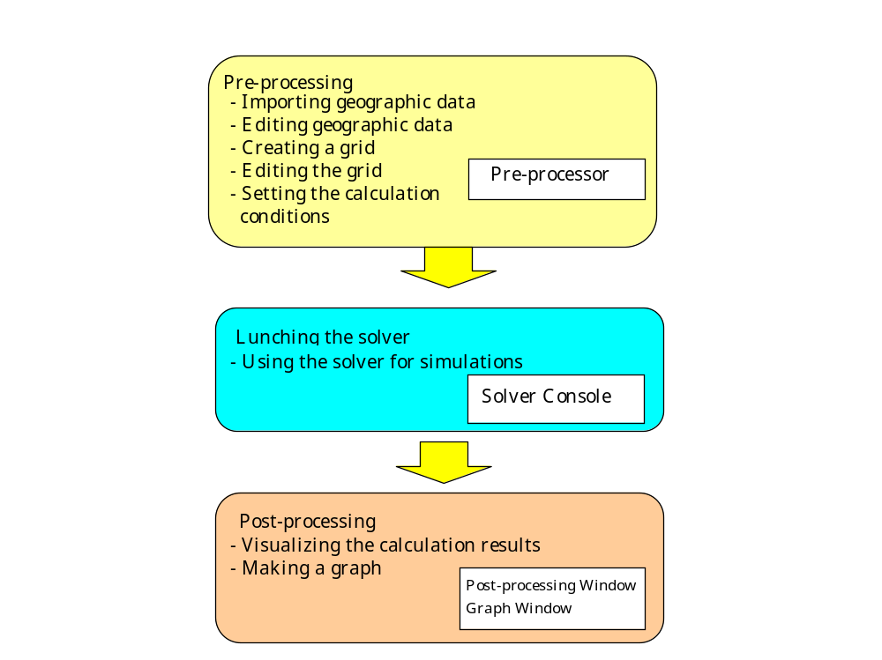
Figure 1 iRIC Basic functions

iRIC development environment setup

Install needed tools and libraries
Let’s setup development environment for iRIC GUI.
Please refer to the setup manual.

Build iRIC GUI

Get iRIC source code
Get the iRIC full source code. Check out the whole iRIC GUI repository into your my document folder with “iRIC_trunk”. It is very HUGE.
https://my.redmine.jp/svn/iric/v2.X/gui/trunk

Build iRIC (64 bit)
- Launch “Qt 5.3 64-bit for Desktop (MSVC 2013 OpenGL)” from start menu.
- Go to iriclib folder, and input the following:
qmake
nmake debug
nmake release

- Go to tools folder, and input the following:
Python qmakevc.py
- Input the following:
set PATH=(iRIC Build folder)\src\libdlls\debug;%PATH%
"C:\Program Files (x86)\Microsoft Visual Studio 12.0\Common7\IDE\WDExpress.exe" /useenv
- Open “src.sln” in src folder from Visual Studio 2013, and press F7 key to build.
- DLLs and iRIC.exe will be built, but the DLL files needed by iRIC.exe are not in the path, so debugging will fail. Execute the folloing:
python copydlls.py
- DLL files are now copyed to libdlls\debug and libdlls\release folder, so you can start debugging now.

iRIC GUI File interfaces

Project file
Project file is a zip file, with extention “*.ipro”. All data related to the project is saved into the project file.
When a project is open, the content of the project file is unzipped into a subfolder in the following folder. The unzip target folder can be changed from iRIC GUI preference dialog.
(User root folder)/.iRIC_workspace

Project folder structure
The project folder structure is shown in Figure 2:
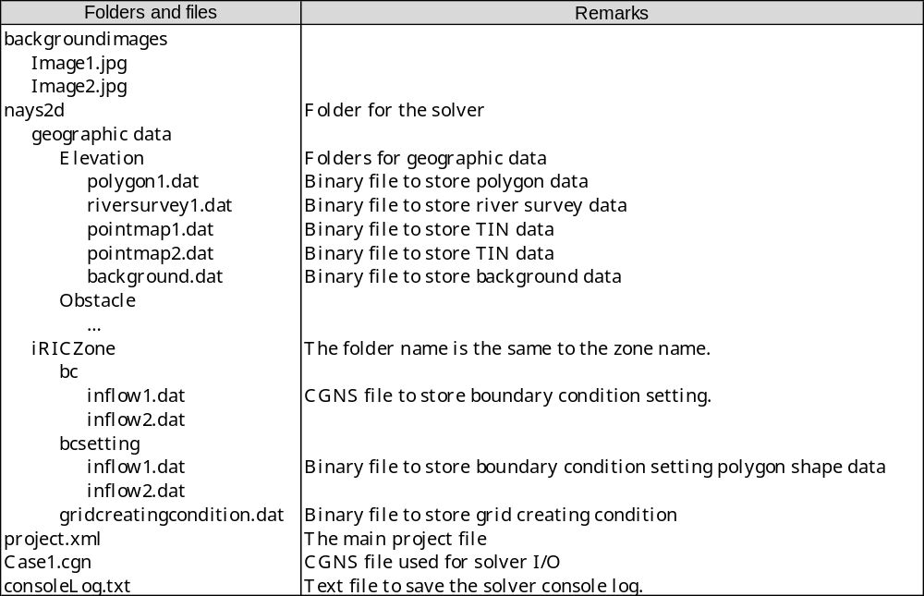
Figure 2 iRIC workspace folder structure

The main project file structure
The main project file “projext.xml” is a XML file.
An example of a main project file is shown below:

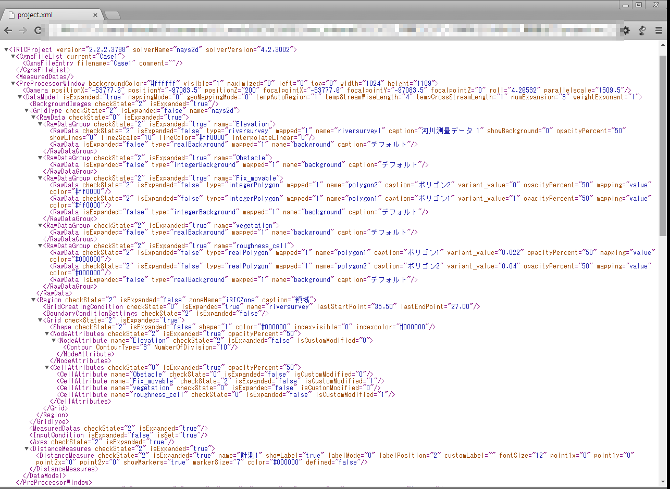
Figure 3 iRIC main project file (projext.xml) example

The CGNS file structure
The CGNS file (usually with the name “Case1.cgn”) stores all information handled to the solver. The solver overwrite the CGNS file, to add calculation result information. Figure 4 shows the structure inside the CGNS file.

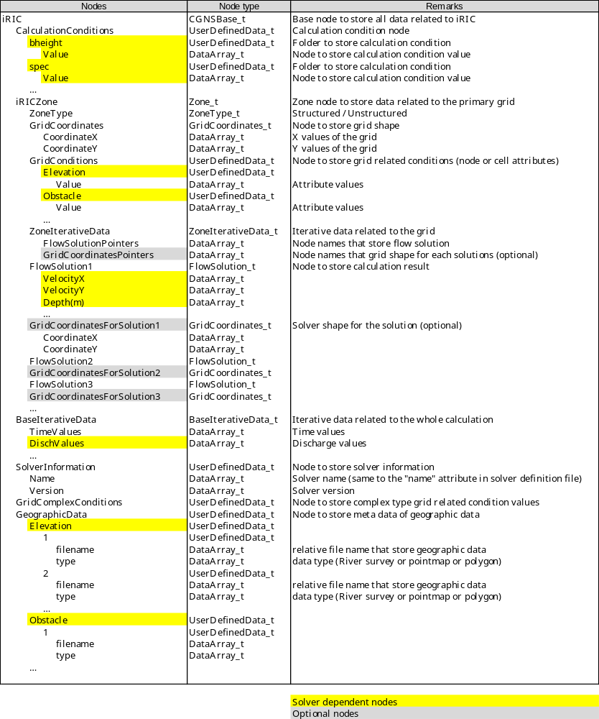
Figure 4 CGNS file structure

Input / Output (Data that iRIC can import or export)

Data | File Format | Import | Export | Remarks
Geographic Data  (River Survey) | RIC-Nays river survey  (*.riv) | X | X
Geographic Data  (TIN) | Topography file  (*.tpo, *.anc) | X
Geographic Data  (TIN) | RIC-Nays DEM  (*.dat, *.txt) | X
Geographic Data  (TIN) | USGS NED  (*.adf) | X
Geographic Data  (TIN) | Stereolithography file  (*.stl) | X | X
Geographic Data  (Polygon) | ESRI shape file  (*.shp) | X | X
Hydraulic Data  (Water Elevation) | CSV file  (*.csv) | X
Grid | CGNS file  (*.cgn) | X | X
Grid | iRIC Grid CSV file  (*.csv) | X | X | Structured grid only
Grid | RIC-Nays grid file  (*.grid) | X | X | Structured grid only
Grid | iRIC Project file  (*.ipro) | X | X
Grid | VTK file  (*.vtk) |  | X
Calculation Condition | iRIC project file  (*.ipro) | X | X
Calculation Condition | CGNS file  (*.cgn) | X | X
Calculation Result | CGNS file  (*.cgn) | X
Calculation Result | VTK file  (*.vtk) |  | X
Calculation Result | CSV file  (*.csv) |  | X
Measured Values | Text file  (*.csv, *.txt) | X | X
Background Image | Image file  (*.png, *.jpg, *.tif) | X |  | World file (pgw, jgw, tfw) can be loaded at the same time.
Background Image  (from Google Map) |  | X |  | Download Google Map Image through Web API
Visualization/Graph Setting | Setting file  (*.vgsetting) | X | X | XML file
Screenshot | Raster image file  (*.png, *.jpg, *.bmp) |  | X
Screenshot | Vector image file  (*.pdf, *.eps, *.svg) |  | X | Exported using gl2ps
Google Earth mapping file | KML file  (*.kml) |  | X | Used to map the calculation result onto Google Earth
Animation movie | Movie file  (*.wmv) |  | X | Created from continuous screenshots

iRIC development processes

Introduction
iRIC is built on Qt and other many libraries. For building a program on Qt, I strongly recommend to use Qt Creator. Qt Creater has good features to edit almost every type of files used in Qt developing processes.

Working with subversion
iRIC source code is stored in subversion repository.
Files related to iRIC GUI are stored in the following URL:
https://my.redmine.jp/svn/iric/v2.X/gui

To handle files in subversion repository, I recommend you to use tortoiseSVN.

Adding a new feature
When you want to add a new feature, create a “topic branch” from trunk/src.
This can be done in the following procedure:
- In the Explorer, right-click on any folder, and select “TortoiseSVN” → “Repo-browser”.
- Input “https://my.redmine.jp/svn/iric/v2.X/gui/trunk” in the “URL” textbox, and press “OK”.
- The Repository browser will open. Select “src” folder under “trunk” folder, right-click to open menu, and select “Copy to”. A dialog will be shown, so input the branch name, like “……/branches/newtopic”.

Now, the branch is created. Next, prepare a source code set to develop on that branch:
- Create a new folder like “newtopic” somewhere in your hard disk
- Create “src” folder, and checkout from https://..../branches/newtopic.
- Create “cgnslib” folder, and checkout from https://..../trunk/cgnslib.
- Create “iriclib” folder, and checkout from https://..../trunk/iriclib.

Then, add or modify codes under src folder, and commit to the branch.
And, when you finished the feature, and you think you’ve removed all the bugs, merge that branch to trunk.
You should merge the branch at the trunk/src. Execute merge, resolve conflicts, and commit the trunk.
When bugs is found, that is related to new feature eveloped in a topic branch, that is already merged into trunk, that bug should be fix at trunk.

Create a “maintenance” branch
When you release a new minor version, like “2.3.0”, “2.4.0”, create a maintenance branch, like “branches/2.3”. The maintenance branches should be used only for bug fixes.
Also, create an environment on your PC to build that maintenance branch, using the procedure shown in 4.2.1.
When bugs are reported on that branch, fix the bug, and commit on the maintenance branch. Please do not forget to merge that commit also to trunk/src.

Adding a new file
When you want to add a new file to iRIC source code, follow the procedure below:
- Select the folder you want to add a file, in Qt creator project view.

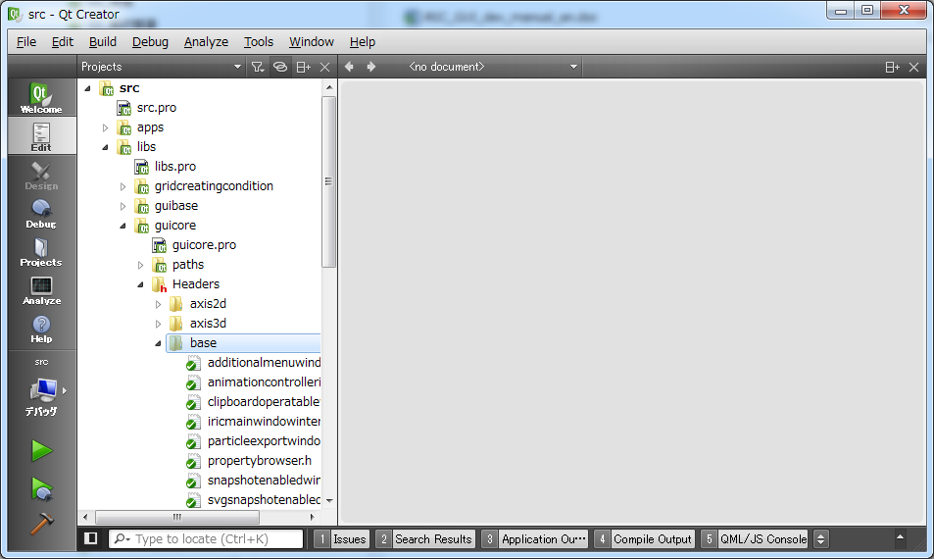

- Right click to open context menu, and select “Add new file”.

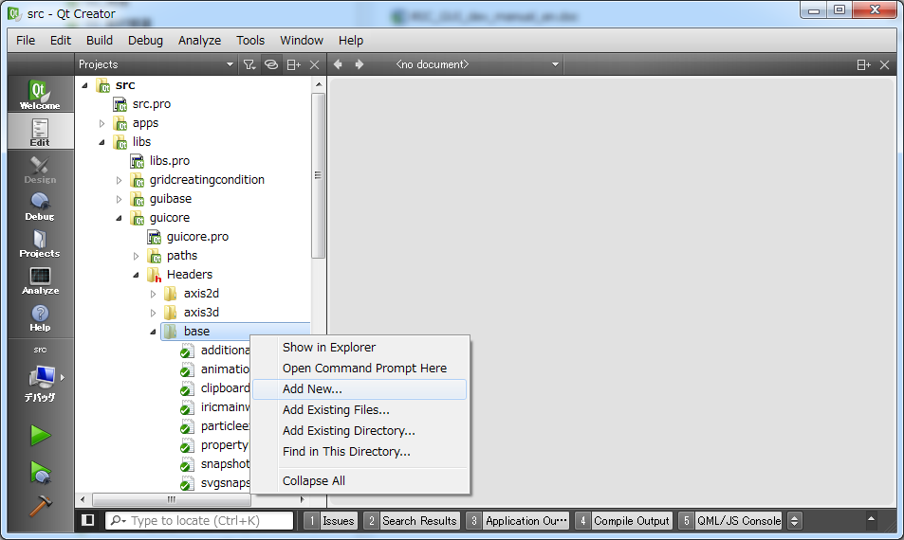

- Select the template, and press “Choose” button. You’ll input the class name or file name etc in the following dialogs. In iRIC developing processes, you’ll mainly add the files In the following types:
  - C++ Source File
  - C++ Header File
  - Qt Designer Form Class

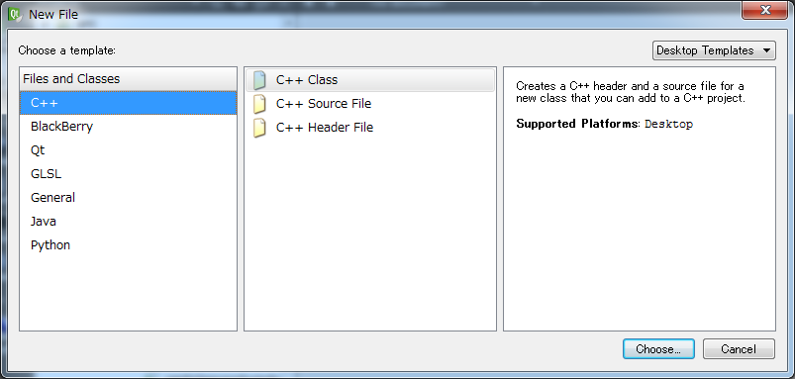

Developing a GUI dialog
When you develop a GUI dialog, you have to design the dialog as *.ui file. Follow the procedure below, to develop a GUI dialog.
- Add GUI components (Buttons, Check boxes, List views etc) by dragging from the toolbar, edit the name, caption, size, default values etc.
- Layout the dialog using spacers and layouts.
- Use “Edit signal and slots” to minimize the volume of source code in *.h, *.cpp.
- Use “Preview” to check whether the dialog layout is OK even when you resize the dialog.
- Edit *.h, *.cpp to implement the logic on the dialog.

Debugging GUI
Qt creator itself has debug feature, but in my opinion, Visual Studio is the better IDE for debugging. It’s faster and more stable (Qt Creater often stuck when debugging).
Build iRIC GUI in debug mode, add breakpoints, and start debugging using F5 key.

Internationalization

Overview
Qt source codes are all written in English, but intended to be used worldwide, so internationalization is important.
- When developing GUI dialogs, you’ll have to care nothing. Qt automatically do the needed things for internationalization.
- When adding some sentences inside *.cpp files, that should be translated in other languages, use tr() to inform that the sentence should be translated, like the following:
QMessageBox::warning(this, tr(“Warning”), tr(“File open error”));

Preparing internationalization dictionary
When some new sentences to be translated are added, you have to prepare updated internationalization dictionary, by the following procesure:
- Open Command prompt for Qt, go to the “src” folder, and input the following command.
lupdate src.pro

This command will update languages/*.ts files.

- Launch Linguist (bundled with Qt), open the dictionary file, and edit the translated sentences.

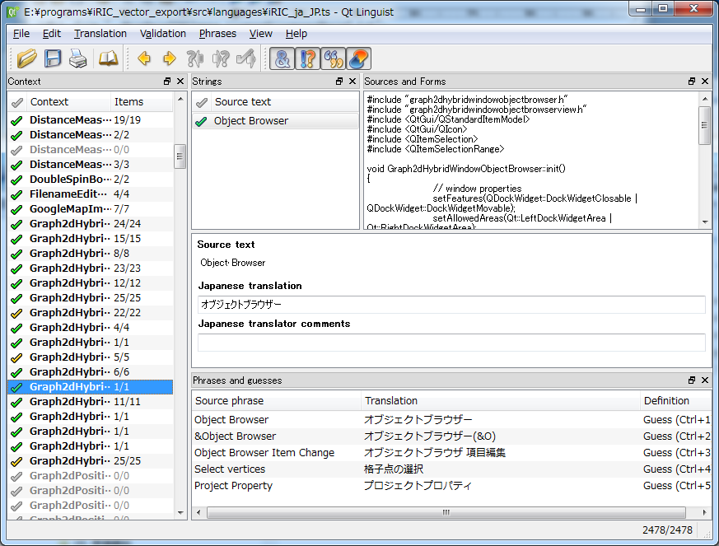
Input translation here.

- Open Command prompt for Qt, go to the “src” folder, and input the following command.
lrelease src.pro

This command will generate languages/*.qm from languages/*.ts

How to add new language to support?
When you want to add a new language to support, you can do it by adding a single line in each project files (*.pro). iricgui.pro now has the following settings:
TRANSLATIONS += \
languages/iRIC_ja_JP.ts \
languages/iRIC_ko_KR.ts \
languages/iRIC_id_ID.ts \
languages/iRIC_th_TH.ts \
languages/iRIC_zh_CN.ts \
languages/iRIC_vi_VN.ts \
languages/iRIC_fr_FR.ts \
languages/iRIC_es_ES.ts \
languages/iRIC_ru_RU.ts

Adding new resources (image file, text file etc.)
Using Qt, resources like images, texts etc can be included in the executable binary (iRIC.exe). It can be done like follows:
- Add the resource file into the source tree. Image files should be placed under “images” folder, and text files should be placed under “data” folder.
- Register the resource file to iRIC.qrc. You can do it using GUI, from Qt Creator. This will make the resource file included in the executable binary.
- Refer to the file using QFile, like follows:
QFile f(":/data/iricinfo.xml");

Version number update
When you update iRIC, you have to update the version number. The version number and release date is written in data\iricinfo.xml. Please edit this file.
<?xml version="1.0" encoding="utf-8"?>
<iricinfo
version="2.3.1.4150"
displayVersion="2.3.1.4150"
release="2014/5/30"
url="http://i-ric.org/"
tou="http://i-ric.org/privacy"
copyright="2009-2014 RIC and USGS All rights reserved."
/>

“version” attribute is used to check project file compatibility.
When the major version is different, there is no compatibility.
When the minor version is different, there is backward compatiblity. For example, iRIC 2.3 can read project file created using iRIC 2.2, but iRIC 2.2 can not read project file created using iRIC 2.3
The fix version is not used for compatibility check. For example iRIC 2.3.0 can read project file created using iRIC 2.3.1.
“displayVersion” attribute is shown in “About iRIC” dialog. Usually, “displayVersion” should be the same to “version”, but it is an arbitrary string. For example you can use “iRIC 2.3 X’mas special version” for “displayVersion”.

Topics

Implementing Project File I/O
When you want to save some new data into a project, and it can be expressed as text, you should think of saving that into project file.
Implement I/O for Project File (project.xml), by overriding the following functions:
- ProjectDataItem::doLoadFromProjectMainFile(const QDomNode& node)
- ProjectDataItem::doSaveToProjectMainFile(QXmlStreamWriter& writer)

Please refer to misc\xmlsupport.h. It has convenient functions to load/save bool, integer, and double attributes from/to project file.

Implementing CGNS File I/O
When you want to handle some new data to solver, you should think of saving that data into CGNS file.
When you decide that the data should be saved into CGNS file, implement I/O for CGNS file, by overriding the following functions:
- ProjectDataItem::loadFromCgnsFile(const int fn)
- ProjectDataItem::saveToCgnsFile(const int fn)

When you conclude that the data is not suitable to be saved into CGNS File, implement I/O for External File. Please refer to Geographic data I/O implementation for example. Geographic data I/O functions are implemented in iRIClib, and used from both GUI and solvers.

Implementing External File I/O
When you want to save some new data into a project, and it is not suitable to save that data as text data, you should think of saving that into a separate file inside the project folder (just like background images or grid creating condition).
- Set value to ProjectDataItem::m_filename, and that will be used for the separate file.
- Set value to ProjectDataItem::m_subFolder for the ancient node classes if needed.
- Implement I/O for external File, by overriding the following functions:
  - ProjectDataItem::loadExternalData(const QString& filename)
  - ProjectDataItem::saveExternalData(const QString& filename)

Implementing some data modification feature
Some of iRIC GUI functions are made undo-able. This is implemented in the following way:
- Data modification action is implemented as a subclass of QUndoCommand.
- When user do the modification, the following code will be executed:

iRICUndoStack::instance()->push(new SomeUndoCommand());

But in some cases, it is hard to make some action undo-able. In that case, execute the following code after that action is executed:

iRICUndoStack::instance()->clear();

iRIC GUI source code review

Programs and libraries used in iRIC GUI development
iRIC depends on many programs and libraries. Table 1 shows the list of programs and libraries used in iRIC development.
Table 1 Programs and libraries used in iRIC development
# | Program / Library | Remarks
1 | Visual Studio 2013 | C/C++ Compiler, Development IDE
2 | Qt 5.3 | Cross-platform GUI Toolkit
3 | VTK 6.1 | Visualization library (Countour, streamline etc)
4 | Qwt 6.1 | Chart drawing library, built on Qt
5 | CGNS library 3.2 | CGNS file I/O library
6 | Proj 4.8 | Cartographic projections library (Longitude-latitude ⬄ X-Y)
7 | GDAL 1.11 | Raster GIS Data I/O library
8 | Shapelib 1.3 | ESRI Shape file I/O library
9 | iRIClib | Wrapper library for CGNS library
10 | HDFView | GUI Tool to browse CGNS files (HDF5 files)
11 | FFMPEG | Movie encoder
12 | Zip / Unzip | Program for zipping and unzipping ZIP files.
13 | Nullsoft Scriptable Install System | Tool to build installer

Folder structure
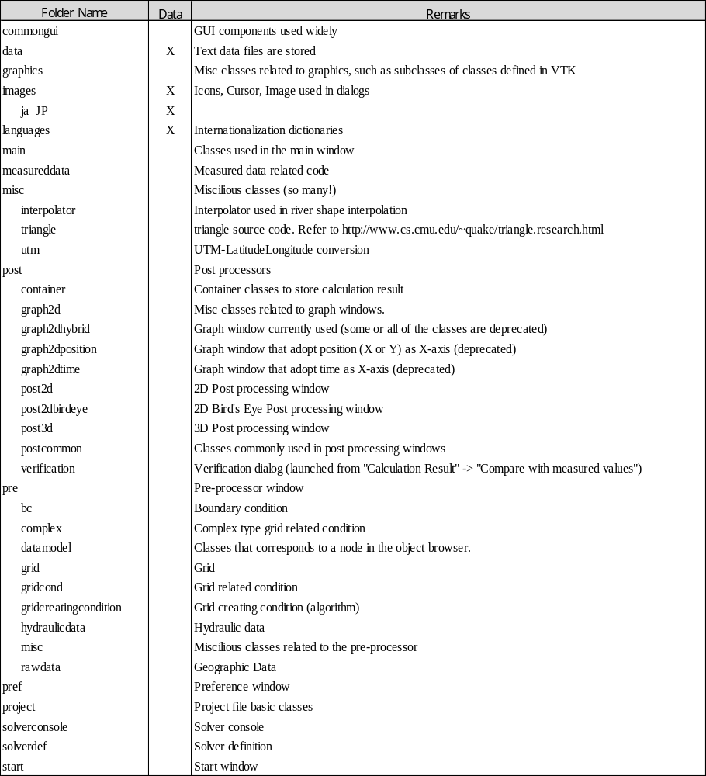

Important classes and methods
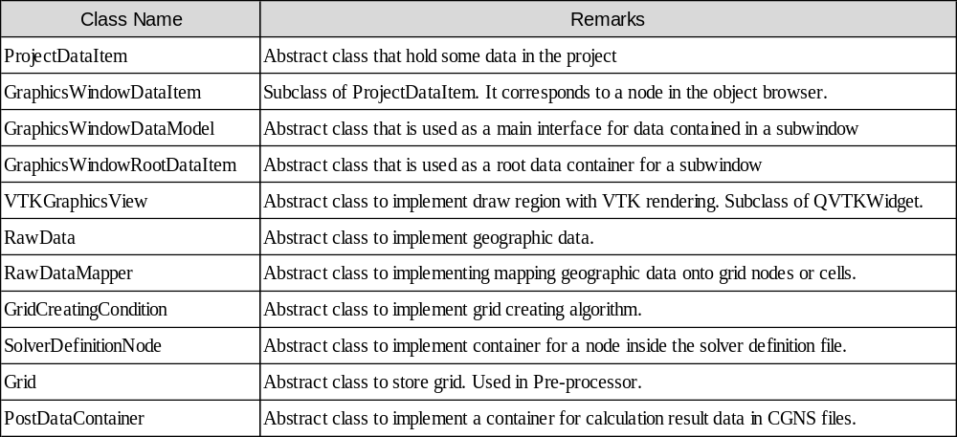

Other Information

iRIC GUI source code documentation
iRIC GUI source code is documented with comments for Doxygen, partially. Please use Doxygen to generate HTML documentation.

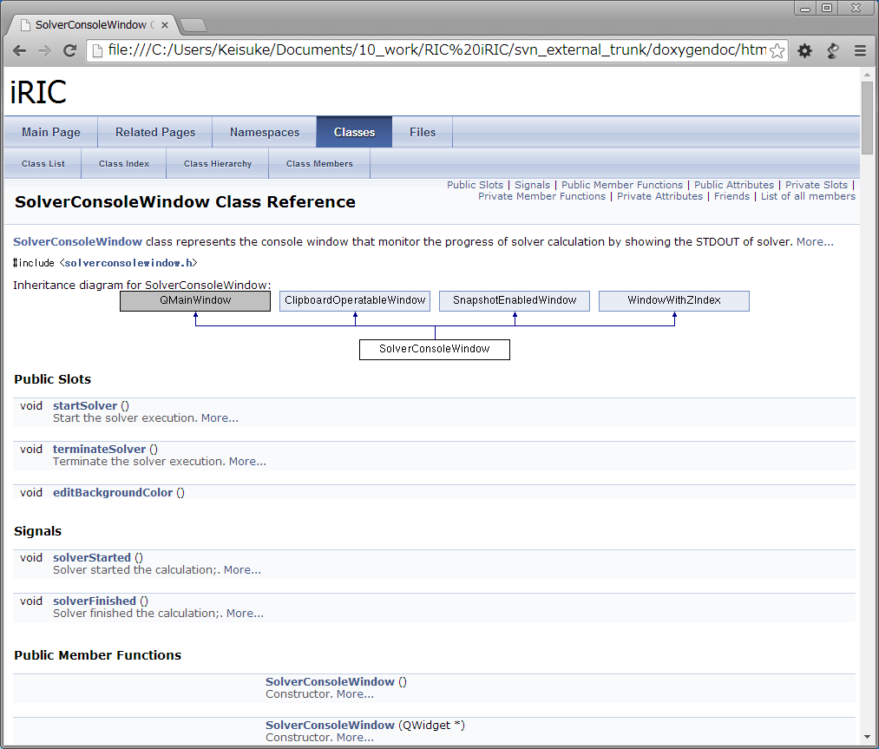
Figure 5 iRIC source code document generated by Doxygen

Qt Documentation
Qt is well documented, and the documentation can be accessed through “Qt Assistant”. It can be launched from the start menu.

VTK Documentation
VTK documentation is on the web.
http://www.vtk.org/doc/release/5.4/html/

Developing iRIC GUI Plugins
In iRIC GUI, you can develop the following components as plugin DLLs:
- Grid importing function
- Grid exporting function

In the following chapter the procedure to develop these components are described.

Developing a grid import plugin
Grid import plugins exists in the following folder:
plugins/gridimporter

To develop a new plugin, create a new folder under that folder. In the new folder, you have to create the files shown in Table 2.

Table 2 The files to add a grid import plugin
No. | File name | Description
1 | (Plugin name).pro | Project file
2 | (Plugin name).h | Header file
3 | (Plugin name).cpp | Source file
4 | extrafilters.json | JSON file
5 | languages\( Plugin name)_(locale).ts | Dictionary files

Project file
An example of project file is shown in Table 3
Table 3 An example of project file
#-------------------------------------------------
The setting to link against guicore library, in that GridImporterInterface class is defined.
If you need to link against other libraries, add settings here.
Specify header file, source file,and dictionary files.
#
# Project created by QtCreator 2014-10-17T11:05:29
#
#-------------------------------------------------
Specify the name of DLL
TARGET = $$qtLibraryTarget(structured2dgridnayscsvimporter)
QT += widgets xml
TEMPLATE = lib
CONFIG += plugin

include( ../../../paths.pri )

# iricGuicore library

CONFIG(debug, debug|release) {
LIBS += -L"../../../libs/guicore/debug"
} else {
LIBS += -L"../../../libs/guicore/release"
}
LIBS += -liricGuicore

# VTK

LIBS += \
-lvtkCommonCore-6.1

HEADERS = structured2dgridnayscsvimporter.h
SOURCES = structured2dgridnayscsvimporter.cpp
TRANSLATIONS += languages/structured2dgridnayscsvimporter_es_ES.ts \
languages/structured2dgridnayscsvimporter_fr_FR.ts \
languages/structured2dgridnayscsvimporter_id_ID.ts \
languages/structured2dgridnayscsvimporter_ja_JP.ts \
languages/structured2dgridnayscsvimporter_ko_KR.ts \
languages/structured2dgridnayscsvimporter_ru_RU.ts \
languages/structured2dgridnayscsvimporter_th_TH.ts \
languages/structured2dgridnayscsvimporter_vi_VN.ts \
languages/structured2dgridnayscsvimporter_zh_CN.ts

Header file
An example of header file is shown in Table 4. In the header file, define a class that inherits QObject and GridImporterInterface.

Table 4 An example of header file
#ifndef STRUCTURED2DGRIDNAYSCSVIMPORTER_H
#define STRUCTURED2DGRIDNAYSCSVIMPORTER_H

#include <guicore/pre/grid/gridimporterinterface.h>
#include <QObject>

class Structured2DGridNaysCSVImporter : public QObject, public GridImporterInterface
{
Q_OBJECT
Q_PLUGIN_METADATA(IID GridImporterInterface_iid FILE "extrafilters.json")
Q_INTERFACES(GridImporterInterface)
public:
/// Constructor
Structured2DGridNaysCSVImporter();
~Structured2DGridNaysCSVImporter(){}
QString caption() const;
bool isGridTypeSupported(SolverDefinitionGridType::GridType gt)
{
return gt == SolverDefinitionGridType::gtStructured2DGrid;
}
const QStringList fileDialogFilters();
/// Import grid data from external file.
bool import(Grid* grid, const QString& filename, const QString& selectedFilter, QWidget* parent);
};

#endif // STRUCTURED2DGRIDNAYSCSVIMPORTER_H

In the class that you define in the header file, you have to overload the methods in Table 5, that is defined in GridImporterInterface as pure virtual functions.

Table 5 The methods to overload in plugin class
No. | Method name | Description
1 | QString caption() const | Returns the name of the plugin
2 | bool isGridTypeSupported  (SolverDefinitionGridType::GridType gt) | Returns true when the grid type that can be imported with this plugin is handled as gt.
3 | Const QStringList fileDialogFilters() | Returns the file types that can be imported with this plugin.
4 | bool import(Grid* grid, const QString& filename, const QString& selectedFilter, QWidget* parent) | Implement the grid importing

Source file
An example of a source file is shown in Table 6. Please notice that in source file, tr() macto is used for internationalization.
Table 6 An example of a source file
#include "structured2dgridnayscsvimporter.h"
#include <guicore/pre/grid/structured2dgrid.h>
#include <guicore/pre/gridcond/container/gridrelatedconditionrealnodecontainer.h>
#include <guicore/pre/gridcreatingcondition/gridcreatingcondition.h>

#include <QObject>
#include <QFile>
#include <QTextStream>
#include <QVector2D>
#include <QString>
#include <QMessageBox>
#include <sstream>

Structured2DGridNaysCSVImporter::Structured2DGridNaysCSVImporter()
: GridImporterInterface(), QObject()
{

}

QString Structured2DGridNaysCSVImporter::caption() const
{
return tr("iRIC Grid CSV file");
}

const QStringList Structured2DGridNaysCSVImporter::fileDialogFilters()
{
QStringList ret;
ret << tr("iRIC Grid CSV files (*.csv)");
return ret;
}

bool Structured2DGridNaysCSVImporter::import(Grid* grid, const QString& filename, const QString& /*selectedFilter*/, QWidget* parent)
{
// Show warning dialog first.
QMessageBox::warning(parent, tr("Warning"), tr("Cell flag values will not be loaded."), QMessageBox::Ok);
Structured2DGrid* grid2d = dynamic_cast<Structured2DGrid*>(grid);

QFile f(filename);
if (f.open(QFile::ReadOnly | QFile::Truncate | QIODevice::Text)){
GridRelatedConditionContainer* c = grid2d->gridRelatedCondition("Elevation");
if (c == 0){
// this grid does not have elevation. Impossible to import.
f.close();
return false;
}
GridRelatedConditionRealNodeContainer* container
= dynamic_cast<GridRelatedConditionRealNodeContainer*>(c);

QTextStream in(&f);
QString qstr;
std::string str;

// Skip the first line.
qstr = in.readLine();
qstr = in.readLine();
qstr.replace(",", " ");
str = qstr.toStdString();
std::istringstream iss(str);

int imax;
int jmax;
int kmax;
iss >> imax >> jmax >> kmax;

// In case the grid is too big, import fails.
if (imax * jmax > GridCreatingCondition::MAXGRIDSIZE){
return false;
}
grid2d->setDimensions(imax, jmax);

// Skip the third line.
qstr = in.readLine();

vtkPoints* points = vtkPoints::New();
points->SetDataTypeToDouble();
points->Allocate(imax * jmax);
points->InsertPoint(imax * jmax - 1, 0, 0, 0);
grid2d->vtkGrid()->SetPoints(points);

// allocate memory for all grid related conditions.
QList<GridRelatedConditionContainer*>::iterator it;
QList<GridRelatedConditionContainer*>& clist = grid2d->gridRelatedConditions();
for (it = clist.begin(); it != clist.end(); ++it){
(*it)->allocate();
}
for (int k = 0; k < kmax; ++k){
for (int j = 0; j < jmax; ++j){
for (int i = 0; i < imax; ++i){
qstr = in.readLine();
qstr.replace(",", " ");
str = qstr.toStdString();
std::istringstream iss(str);

int dummyi, dummyj, dummyk;
double x, y, z;

iss >> dummyi >> dummyj >> dummyk >> x >> y >> z;

if (k == 1){continue;}
unsigned int id = grid2d->vertexIndex(i, j);
points->InsertPoint(id, x, y, 0);
container->setValue(id, z);
}
}
}
}
f.close();
return true;
}

JSONfile
An example of JSONfile is shown in Table 7.
Table 7 An example of JSON file
{}

Dictionary files
Add dictionary settings in the project file, execute lupdate command to generate *.ts files, add translated strings to that, and execute lrelease command to generate *.qm files.
For internationalization, refer to 4.6 for detail.

Building plugin
Build the plugin with the same procedure described in 2.2. When building finished, (plugin name).dll is generated under debug or release folder.

Installing plugin
To install the plugin you developed, copy the following files into plugins\gridimporter subfolderunder iRIC GUI install folder.
- (plugin name).dll
- (plugin name)_(locale).qm

Now, when you select Import → Grid, the string you specified in fileDialogFilters() will be shown in the combobox. If you select that in the combobox and click on “open”, a grid will be imported with the import() method you implemented.
An example of combobox to select import source is shown in Figure 6.

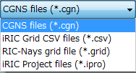
Figure 6 Grid import source selecting combobox

Developing a grid export plugin
Grid export plugins exists in the following folder:
plugins/gridexporter

To develop a new plugin, create a new folder under that folder. In the new folder, you have to create the files shown in Table 8.

Table 8 The files to add a grid export plugin
No. | File name | Description
1 | (Plugin name).pro | Project file
2 | (Plugin name).h | Header file
3 | (Plugin name).cpp | Source file
4 | extrafilters.json | JSON file
5 | languages\( Plugin name)_(locale).ts | Dictionary files

Project file
An example of project file is shown inTable 9.
Table 9 An example of project file
#-------------------------------------------------
#
# Project created by QtCreator 2014-10-17T11:05:29
#
#-------------------------------------------------
Specify the name of DLL
TARGET = $$qtLibraryTarget(structured2dgridnayscsvexporter)
QT += widgets xml
TEMPLATE = lib
CONFIG += plugin

include( ../../../paths.pri )

# iricGuicore library

CONFIG(debug, debug|release) {
The setting to link against guicore library, in that GridImporterInterface class is defined.
If you need to link against other libraries, add settings here.
LIBS += -L"../../../libs/guicore/debug"
} else {
LIBS += -L"../../../libs/guicore/release"
}
LIBS += -liricGuicore

# VTK

LIBS += \
-lvtkCommonCore-6.1
Specify header file, source file, and dictionary files.
HEADERS = structured2dgridnayscsvexporter.h
SOURCES = structured2dgridnayscsvexporter.cpp
TRANSLATIONS += languages/structured2dgridnayscsvexporter_es_ES.ts \
languages/structured2dgridnayscsvexporter_fr_FR.ts \
languages/structured2dgridnayscsvexporter_id_ID.ts \
languages/structured2dgridnayscsvexporter_ja_JP.ts \
languages/structured2dgridnayscsvexporter_ko_KR.ts \
languages/structured2dgridnayscsvexporter_ru_RU.ts \
languages/structured2dgridnayscsvexporter_th_TH.ts \
languages/structured2dgridnayscsvexporter_vi_VN.ts \
languages/structured2dgridnayscsvexporter_zh_CN.ts

Header file
An example of header file is shown in Table 10. In the header file, define a class that inherits QObject and GridExporterInterface.

Table 10 An example of header file
#ifndef STRUCTURED2DGRIDNAYSCSVEXPORTER_H
#define STRUCTURED2DGRIDNAYSCSVEXPORTER_H

#include <guicore/pre/grid/gridexporterinterface.h>
#include <QObject>

class Structured2DGridNaysCSVExporter : public QObject, public GridExporterInterface
{
Q_OBJECT
Q_PLUGIN_METADATA(IID GridExporterInterface_iid FILE "extrafilters.json")
Q_INTERFACES(GridExporterInterface)
public:
/// Constructor
Structured2DGridNaysCSVExporter();
~Structured2DGridNaysCSVExporter(){}
QString caption() const;
bool isGridTypeSupported(SolverDefinitionGridType::GridType gt)
{
return gt = SolverDefinitionGridType::gtStructured2DGrid;
}
const QStringList fileDialogFilters();
bool doExport(Grid* grid, const QString& filename, const QString& selectedFilter, QWidget* parent);
};

#endif // STRUCTURED2DGRIDNAYSCSVEXPORTER_H

In the class that you define in the header file, you have to overload the methods in Table 11, that is defined in GridImporterInterface as pure virtual functions.

Table 11 The methods to overload in plugin class
No. | Method name | Description
1 | QString caption() const | Returns the name of the plugin
2 | bool isGridTypeSupported  (SolverDefinitionGridType::GridType gt) | Returns true when the grid type that can be imported with this plugin is handled as gt.
3 | Const QStringList fileDialogFilters() | Returns the file types that can be exported with this plugin.
4 | doExport(Grid* grid, const QString& filename, const QString& selectedFilter, QWidget* parent) | Implement the grid exporting

Source file
An example of a source file is shown in Table 12. Please notice that in source file, tr() macto is used for internationalization.
Table 12 An example of a source file
#include "structured2dgridnayscsvexporter.h"
#include <guicore/pre/grid/structured2dgrid.h>
#include <guicore/pre/gridcond/container/gridrelatedconditionrealnodecontainer.h>
#include <guicore/pre/gridcond/container/gridrelatedconditionintegercellcontainer.h>

#include <QObject>
#include <QFile>
#include <QTextStream>

Structured2DGridNaysCSVExporter::Structured2DGridNaysCSVExporter()
: GridExporterInterface(), QObject()
{

}

QString Structured2DGridNaysCSVExporter::caption() const
{
return tr("RIC-Nays CSV");
}

const QStringList Structured2DGridNaysCSVExporter::fileDialogFilters()
{
QStringList ret;
ret << QObject::tr("iRIC Grid CSV files (*.csv)");
return ret;
}

bool Structured2DGridNaysCSVExporter::doExport(Grid* grid, const QString& filename, const QString& /*selectedFilter*/, QWidget* /*parent*/)
{
Structured2DGrid* grid2d = dynamic_cast<Structured2DGrid*>(grid);
int imax = grid2d->dimensionI();
int jmax = grid2d->dimensionJ();
int kmax = 2;

QFile f(filename);
if (f.open(QFile::WriteOnly | QFile::Truncate | QIODevice::Text)){
GridRelatedConditionContainer* c = grid2d->gridRelatedCondition("Elevation");
if (c == 0){
// this grid does not have Elevation node. Impossible to export data.
return false;
}
GridRelatedConditionRealNodeContainer* container
= dynamic_cast<GridRelatedConditionRealNodeContainer*>(c);

c = grid2d->gridRelatedCondition("CellCondition");
GridRelatedConditionIntegerCellContainer* cellcond
= dynamic_cast<GridRelatedConditionIntegerCellContainer*>(c);
QTextStream o(&f);
o.setRealNumberPrecision(8);
o << "IMAX,JMAX,KMAX " << endl;
o << imax << "," << jmax << "," << kmax << endl;

o << "I,J,K,X,Y,Z" << endl;
o << scientific;
for (int k = 0; k < kmax; k++){
for (int j = 0; j < jmax; j++){
for (int i = 0; i < imax; i++){
o << i << "," << j << "," << k << ","
<< grid2d->vertex(i, j).x() << ","
<< grid2d->vertex(i, j).y() << ","
<< container->value(grid2d->vertexIndex(i, j)) << endl;
}
}
}
if (cellcond != 0){
o << "I , J , K , FLAGS" << endl;
for (int k = 0; k < kmax - 1; k++){
for (int j = 0; j < jmax - 1; j++){
for (int i = 0; i < imax - 1; i++){
o << i << "," << j << "," << k << ","
<< cellcond->value(grid2d->cellIndex(i, j)) << endl;
}
}
}
}
}else{
// file not opened successfully.
return false;
}
f.close();
return true;
}

JSONfile
An example of JSONfile is shown inTable 13.
Table 13 An example of JSON file
{}

Dictionary files
Add dictionary settings in the project file, execute lupdate command to generate *.ts files, add translated strings to that, and execute lrelease command to generate *.qm files.
For internationalization, refer to 4.6 for detail.

Building plugin
Build the plugin with the same procedure described in 2.2. When building finished, (plugin name).dll is generated under debug or release folder.

Installing plugin
To install the plugin you developed, copy the following files into plugins\gridimporter subfolderunder iRIC GUI install folder.
- (Plugin name).dll
- (Plugin name)_(locale).qm

Now, when you select Import ? Grid, the string you specified in fileDialogFilters() will be shown in the combobox. If you select that in the combobox and click on “open”, a grid will be imported with the import() method you implemented.
An example of combobox to select import source is shown in Figure 7.

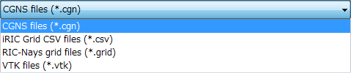
Figure 7 Grid export target selecting combobox

