2012/07/18
Multilingualization of iRIC

Overview

iRIC support multiple languages. Language setting can be changed with menu [Option]-[Preferences...]. When you change language setting, you have to restart iRIC to apply the setting.

This document describes the procedure to prepare translation dictionaries of iRIC.
Language dictionary files needed to prepare translation for iRIC software are follows. (Fig1.)

Fig1. Dictionary file
Extension | Description | Solver | GUI
*.ts | Xml text file  This file contains the translated texts for English texts used in iRIC. | ☓ | ☓
*.qm | Binary file  This file is created from “*.ts” file by “lrelease.exe”.  *”lrelease.exe” is a executable program which is included in Qt SDK. Detail can be seen at Appendix. |  | ☓

You can find out the translation file(*.ts and *.qm) for GUI system at the following folder.

\\Your Computer \installed folder \iRIC2.0\languages

The languages currently supported in iRIC, and the file names of translation files for each language are shown in Fig2 (July 2012). If you want to add translation for additional languages, please contact us.

Fig2. Translation languages file
language | File name
Japanese | iRIC_ja_JP.ts
Korean | iRIC_ko_KR.ts
Thai | iRIC_th_TH.ts
Indonesian | iRIC_id_ID.ts
Chinese | iRIC_zh_CN.ts

GUI translation

Step1: Find the translation file (*.ts) you want to edit, which is located in “ <installed folder >\iRIC 2.0\languages”.

Step2: Open the translation file with text editor and add translations for each English word.

Fig3. Before edit *.ts file
<message>
<location filename="../main/animationcontroller.cpp" line="48"/>
<source>Animation ToolBar</source>
<translation type="unfinished"></translation>
</message>

Fig4. After edit *.ts file
<message>
<location filename="../main/animationcontroller.cpp" line="48"/>
<source>Animation ToolBar</source>
<translation>アニメーションツールバー</translation>
</message>

- Delete “type=unfinished”
- Add translated text between <translation> and </translation>
- Save

Step3: Compile “*.ts” file using “lrelease.exe”
You should install Qt SDK before following this step. See Appendix for detail.

- Start up the “Qt 4.6.3 Command Prompt” from [Windows Start Menu] -> [Qt by Nokia v4.6.3 (VS2008 OpenSource)]->[ Qt 4.6.3 Command Prompt]
- Move to the folder which contains “*.ts” file.
- Execute the following command.
lrelease.exe (dictionary file name)
Ex. “lrelease.exe iRIC_ja_JP.ts” (for Japanese)
When you execute the command, you’ll see that iRIC_ja_JP.qm is created in the same folder.

Step4: Finish
You can see the translated text in the iRIC software when you restart the iRIC software.

Solver translation
Step1: Create or update the translation file (*.ts) for the solver you want to prepare translation.
- Select [Option]>[Create/Update Translation Files]
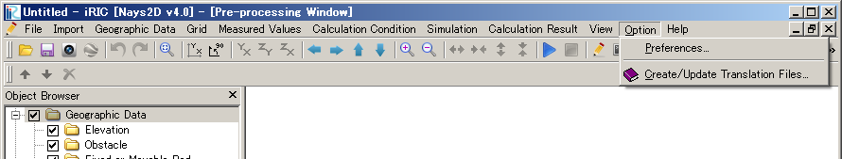

- Click the next button.
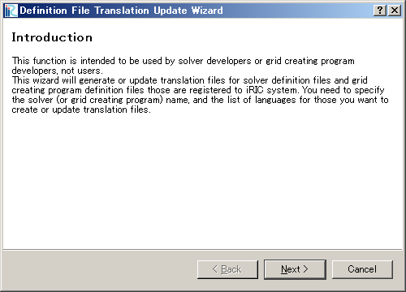

- Select Solver and Languages. And Click the Next button.
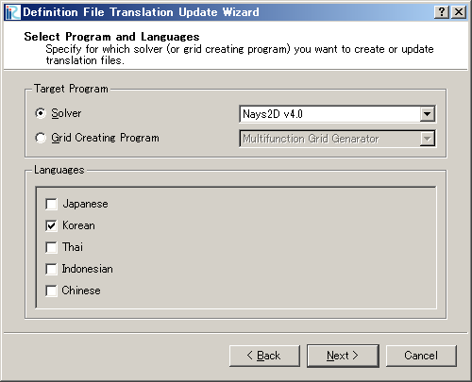
- Click the Finish button. You can get the translation file (*.ts) at the indicated folder.
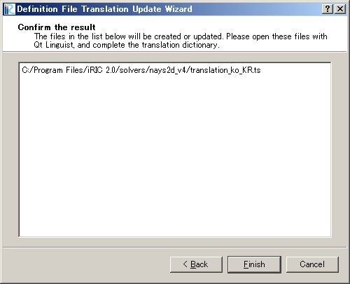
You can see the translation file here.

Step2: Open the translation file with text editor and add translations for each English word.

Fig5. Before edit *.ts file
：
<message>
<source>Boundary Condition</source>
<translation></translation>
</message>
<message>
<source>Periodic boundary condition</source>
<translation></translation>
</message>
：

Fig6. After edit *.ts file
：
<message>
<source>Boundary Condition</source>
<translation>境界条件</translation>
</message>
<message>
<source>Periodic boundary condition</source>
<translation>周期境界条件</translation>
</message>
：

- Add translated text between <translation> and </translation>
- Save

Step3: Finish
You can see the translated text in the iRIC software when you restart the iRIC and starts a project for the solver you prepared translation file.

<Appendix>

*Install Qt SDK
- You can download the Qt SDK installer from following url.
http://qt.nokia.com/downloads/windows-cpp-vs2008

- Double click the downloaded installer to install the Qt SDK.
- Finish.

You can use “lrelease.exe” on the “Qt 4.6.3 Command Prompt”.
“Qt 4.6.3 Command Prompt” can be started from the following:
[Windows Start Menu] -> [Qt by Nokia v4.6.3 (VS2008 Open Source)]->[ Qt 4.6.3 Command Prompt]

