# **TASK NO 1:**

Take any integer as input, if the number is greater than 5 print it

If a >5, print a

Else if a = 0, then Halt

Else if a < 5, then halt

# **CODE:**

IN

STO 90

LDA 90

SUB 91

BRZ 05

BRP 07

HLT

LDA 90

OUT

HLT

*91

DAT 005

## **OUTPUT:**

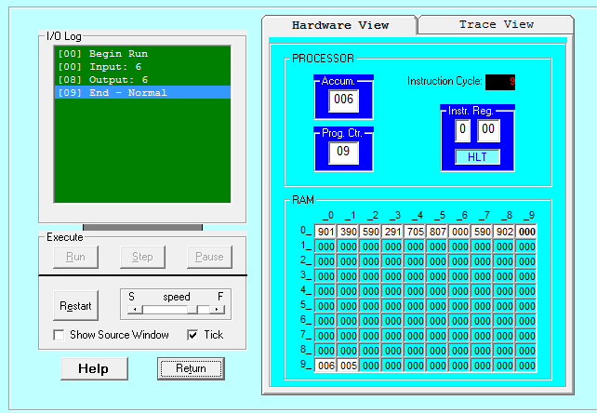

# **TASK NO 2:**

Take two numbers as input and print the larger number

# **CODE:**

IN

STO 90

IN

STO 91

LDA 90

SUB 91

BRP 10

LDA 91

OUT

HLT

LDA 90

OUT

HLT

## **OUTPUT:**

