

**Evaluation of Luxury Hotel Brands:  
An Image-Based Analysis**

By

Adnan Nazmuddin  
Venkatesh Shirbhate

Vidushi Sharma  
Sahil Vakkani

Under the guidance of

**Dr. Nitin Pise**

Assistant Professor

(School of Computer Science and Engineering)

School of Computer Engineering and Technology  
MIT World Peace University, Kothrud  
Pune 411 038, Maharashtra – India 2022-2023

# Certificate

**Acknowledgement**

# List of Abbreviations

CNN Convolutional Neural Networks

HICM Hotel Image Classification Model

SD Standard Deviation

# Abstract

The objective of the research is to analyze luxury hotel pictures posted online in social media by the tourists to understand the different hotel attributes (bedroom, living room, dinner room, restaurant etc.,) influencing the consumer evaluation of luxury hotel brands.

Users seek out hotel photos before making a decision to book. The research evaluates consumers’ visual data on TripAdvisor through a deep learning approach. Four different deep CNN architectures were trained and compared, of which EfficientNet B4 performed the best, hence was used to classify the images in actual dataset.

Results shed light on the significant part of non-textual elements of the hotel experience such as pictures, which cannot be explored through traditional methods. In particular, the analysis of 9,251 consumers’ pictures leads to the identification of the attributes that had the higher impact on their experience. These attributes emerged as specific features of interior elements of the hotels (restaurant, bedroom and bathroom).

Finally, the study shows how deep learning algorithms can -

* help monitoring social media and understand consumers perception of luxury hotels through the new analysis of visual data, and
* turn into better brand management strategies for luxury hotel managers

**Contents**

**List of Tables**

**List of Figures**

# Introduction

The increasing demand of luxury brands is adding complexity to the luxury marketplace, by positing new challenges for brand managers [1]. Success in brand management results from the right understanding of consumers’ expectations and the ability of managers to reply accordingly to generate profitability [2]. Specifically, luxury hotel management is acquiring the interest of scholars and practitioners in both brand management and tourism management literature. Social media monitor would allow understanding consumers’ behavior and engagement with the brand.

With the widespread adoption of the smartphone and other hand-held devices in everyday life as well as the availability of multitudes of social media platforms, online photo sharing has become a common social activity that facilitates people’s exchange of experiences and opinions. Particularly in hospitality, photography plays an integral role in the travel experience, and photo sharing is an important activity in documenting, reliving, and sharing that experience.

While photo sharing may serve many purposes, user-provided photos on the Internet are becoming increasingly important in the context of product evaluation [3]. For example, many online review sites such as TripAdvisor allow users to post photos along with product reviews, which in tandem may generate higher impact on consumers’ perception of the travel products during the decision making process. As such, understanding the effects of user-provided photos can be of great interest.

The past decade has seen a resurgence in deep learning, from a niche field of research to a major part of many industrial applications. One of the significant impacts has been in the field of Computer Vision using Convolutional Neural Networks (CNNs). CNNs have become defacto for most image recognition/classification/detection tasks and have not only outperformed conventional machine learning techniques but also humans for a lot of these tasks.

Therefore, the primary goal of this study is to introduce deep learning techniques to assess the information value of user-provided photos embedded in online hotel reviews. As the old saying goes, “is a picture worth a thousand words?” Specifically, we designed an analytics exercise by applying deep learning techniques to examine the attributes that influence how customer evaluates luxury hotel brands using hotel images.

# Literature Review

Past studies made some attempts to understand the source of consumers’ satisfaction with hotel brands through questionnaires [4], online rating and sentiment analysis [5], and social media interactions [6].

Recent studies also demonstrated the extent to which the image of a certain destination influences tourists’ behavior prior to, during, and after visiting a certain place [7]. Indeed, pictures are among the preferred contents included in online posts, able to enhance the attractiveness, by providing a virtual access to the hotel features [8]. To this end, social media like Instagram and Facebook are also used for branding places. This usage does not imply the generation of new images, but the set of a certain choreography according to the functionalities of the medium (i.e., the choice of particular filters to improve the quality of the image or to add appealing digital effects)

[9].

Thus, the presence on social media as part of marketing campaign has become a consolidated practice for brand managers [10]. For instance, this presence allows firm to both find new customers (also exploiting the electronic word of mouth communication- eWOM), and to maintain and retain the existing ones, who can consider this digital tool as a direct channel to interact with the brand [11]. From a brand management perspective, the exploitation of fan pages on social media like Facebook further allows brand to increase reputation [12] and awareness [13], as well as to develop and disseminate corporate identity [14].

More specifically, specialized tourism platforms like TripAdvisor or Booking provide travelers with the access to a massive amount of online reviews to support their choice when planning holidays. Indeed, TripAdvisor is considered the largest travel platform with more than 455 million average monthly unique visitors and over 630 million reviews of hotels, restaurants, and attractions related businesses [15]. In particular, the platform collects consumers’ rating, ranking, and pictures that are freely accessible without registration or login. Since taking pictures allows tourists to share with other the meaningful tourism experience lived in a certain place, sharing pictures online allows tourists to get the appreciation of others including strangers [16]. For this reason, an increasing number of studies in tourism considers pictures taken by tourists as rich data sources for tourism research.

Although there is growing interest in social media analytics research using user-provided photos as data to describe travel patterns [17], how these photos contribute to the communicative effect of online reviews has not been empirically examined. For example, compared to review texts and other user-provided cues, how do user-provided photos influence users’ perception of the quality of online reviews? In order to gain a deeper understanding of the information value of online reviews in hospitality and tourism, it is important to identify and develop new approaches to process and interpret these user-provided product photos. As such, deep learning techniques recently developed in natural language processing and, especially, computer image processing appears to be an ideal tool for many of the problems related to usergenerated contents on the Internet.

# Methodology of Research

Our research is based on the hotel-image classification dataset. A deep learning model was used to identify which class a hotel image belongs to based on its appearance. Classified images can be used to identify a frequent class and suggest hotels to make the place more appealing.

## Dataset

We used a public dataset that contained 73,993 images of different areas of hotels belonging to 15 classes. The classes are as follows:

|  |  |
| --- | --- |
| *1. Balcony* | *9. Living room* |
| *2. Bar* | *10. Lobby* |
| *3. Bathroom* | *11. Patio* |
| *4. Bedroom* | *12. Pool* |
| *5. Business Centre* | *13. Restaurant* |
| *6. Dining room* | *14. Sauna* |
| 1. *Exterior* 2. *Gym* | *15. Spa* |

The number of images for each class was around 5100, except for the sauna and business center, which had around 4000 images each. For validation, 20 percent images were taken for each class. This validation set ensured that the model was not overfitting to the training data while, at the same time, generalizing well on the test data.

Web scraping was used to prepare the test dataset. Ten hotels were selected in London (UK) and then the pictures uploaded by travelers were scraped for these hotels.

The ten hotels -

1. had similar prices and
2. had more than 300 photos posted by travelers.

The test dataset consisted of 9,251 images of 10 hotels in the UK, posted by travelers on TripAdvisor. Figure I summarizes the number of images in the test dataset for each hotel.

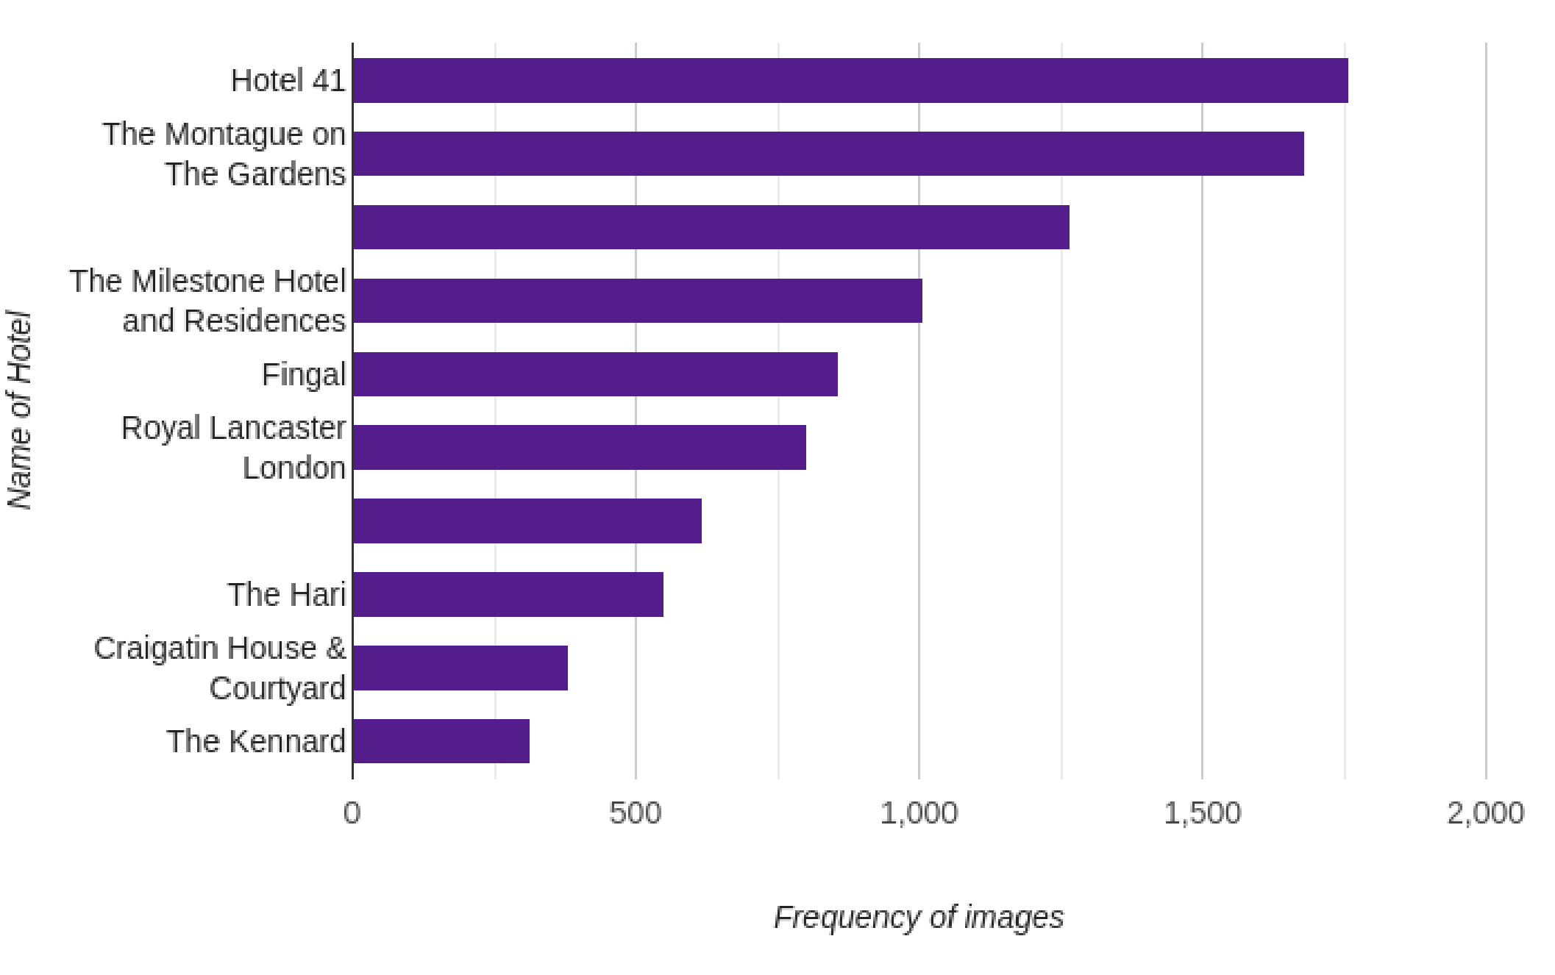

***Figure I:***  Test dataset distribution

## Data Pre-Processing

Since the training data have a variable aspect ratio and size, a stage-dependent rescaling policy was adopted. During the training stage, an image was re-scaled so that the minimum side is 256 pixels wide while keeping the aspect ratio of the original. In this way, spatial information was not lost, and at the same time, input to models was within trainable limits. Many other augments from Albumentations [20] were adopted to prevent overfitting. Since all the images are similar to real-world images, all arguments were considered to mirror real-world images.

## Proposed Approach

The approach consists of extracting visual features from images that are then passed through a custom classifier to determine class. To extract features, EfficientNet B4 [22] was used. The HICM mainly focuses on classifying hotel images into different hotel locations.

It was desired to have a model with high accuracy on ImageNet [21] that can be trainable with limited hardware resources, so the EfficientNetB4 architecture, pre-trained on ImageNet was used. The last dense layer was replaced with a dense layer of size 256 followed by a batch normalization layer. The EfficientNetB4 has 19 million parameters and achieves a top-1 accuracy of 83% on ImageNet. It balances the trade-off between classification accuracy and computational efficiency for the task.

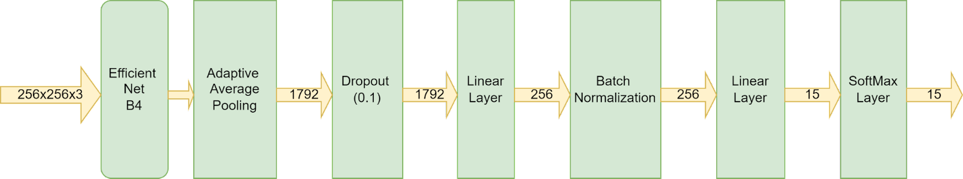

***Figure II:***  Architecture of HICM

## Training and Hyperparameter Settings

The preprocessed images were resized to 256 x 256 before passing them through the image feature extractor model. An initial learning rate of 3 x 10-5   was used with an LR scheduler. ReduceLRonPlateau was used with monitoring validation loss and patience of 5 epochs. Cross-Entropy Loss was used as a metric and Adam as an optimizer. As it was multiclass classification so Cross-Entropy Loss works perfectly. Our best model i.e The HICM was trained for 50 epochs after which the decrease in validation loss was insignificant. The model was trained using the NVIDIA Tesla P100 GPU with 16 GB of memory and also used RTX5000, having 32 GB of memory.

# Findings

Figure III shows examples of some images present in test dataset classified by HICM.

Table I shows the frequency of images of each class for every hotel.

Table II summarizes the results related to the ten most photographed class per hotel.

Figure IV reports the most recurring classes, considering the images of all the 10 hotels.

It was found that the most photogenic area was the restaurant followed by the bedroom and bathroom. Findings also show that customers are very attracted to the bar and exterior of the hotels.

### *Bedroom Restaurant*

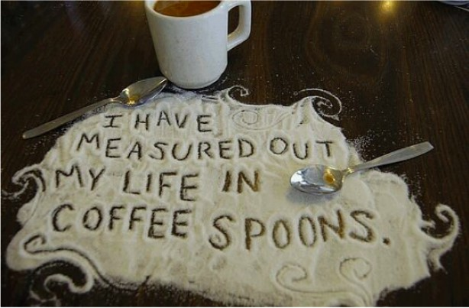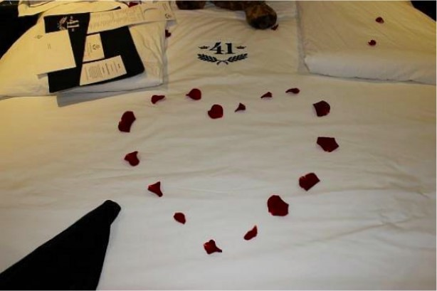

### *Sauna Balcony*

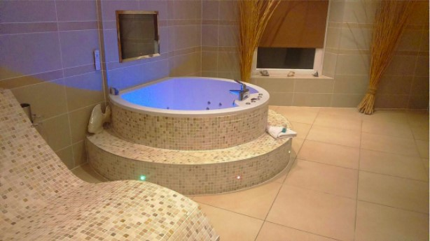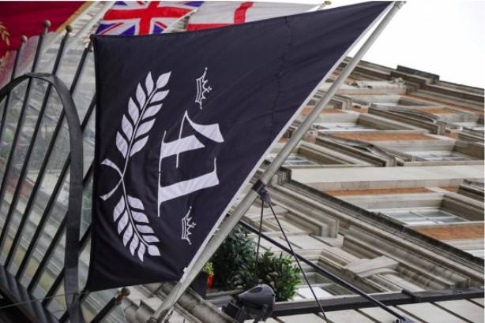

### *Living room Exterior*

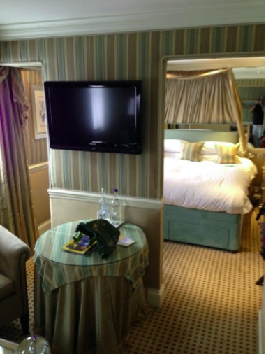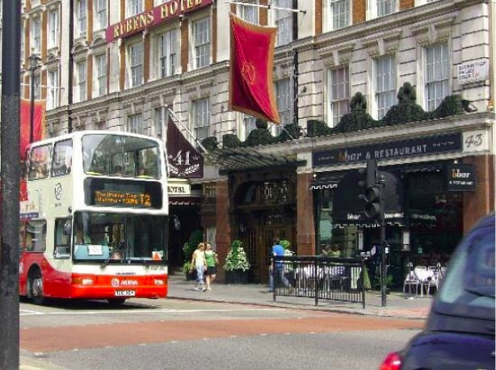

***Figure III:***  Some example images of test dataset classified by HICM

|  |  |  |  |  |  |  |  |  |  |  |  |  |  |  |  |
| --- | --- | --- | --- | --- | --- | --- | --- | --- | --- | --- | --- | --- | --- | --- | --- |
| **Class →** | Balcony | Bar | Bathr oom | Bedr oom | Bussi ness Centr  e | Dining room | Exte  rior | Gy m | Livin g  room | Lob by | Pati o | Pool | Resta urant | Saun  a | Spa |
| **Name of Hotel**  **↓** |
| Craigatin  House  & Courtyard | 29 | 12 | 25 | 76 | 1 | 10 | 28 | 3 | 33 | 3 | 106 | 3 | 38 | 6 | 8 |
| Fingal | 72 | 89 | 119 | 79 | 12 | 18 | 110 | 13 | 21 | 30 | 26 | 7 | 188 | 41 | 35 |
| Hotel 41 | 69 | 288 | 278 | 252 | 26 | 43 | 58 | 6 | 200 | 92 | 57 | 1 | 351 | 23 | 17 |
| Royal  Lancaster  London | 70 | 42 | 83 | 98 | 7 | 11 | 160 | 1 | 62 | 53 | 35 | 2 | 151 | 15 | 14 |
| The Hari | 29 | 58 | 98 | 76 | 9 | 5 | 41 | 6 | 83 | 26 | 23 | 0 | 82 | 7 | 7 |
| The Kennard | 25 | 12 | 40 | 76 | 0 | 8 | 23 | 0 | 19 | 3 | 50 | 1 | 57 | 2 | 0 |
| The Milestone  Hotel and  Residences | 51 | 153 | 104 | 133 | 10 | 35 | 63 | 6 | 118 | 47 | 30 | 3 | 230 | 19 | 7 |
| The Montague  on  The Gardens | 72 | 189 | 245 | 300 | 13 | 44 | 73 | 11 | 205 | 44 | 103 | 2 | 336 | 21 | 23 |
| The Roseate Villa Bath | 55 | 31 | 49 | 128 | 6 | 21 | 88 | 9 | 39 | 3 | 28 | 6 | 139 | 5 | 13 |
| Windermere  Boutique Hotel | 26 | 50 | 421 | 288 | 8 | 27 | 19 | 5 | 176 | 9 | 88 | 14 | 88 | 43 | 7 |
| Mean | 49.8 | 92.4 | 146.2 | 150.  6 | 9.2 | 22.2 | 66.3 | 6 | 95.6 | 31 | 54.6 | 3.9 | 166 | 18.2 | 13.1 |
| SD | 20.649 | 90.36  6 | 127.7 59 | 92.4 30 | 7.254 | 14.474 | 44.1 01 | 4.1 37 | 74.2 94 | 28.  852 | 32.7 29 | 4.17  5 | 110.5 86 | 14.4 82 | 10.0 16 |

***Table I:***  Frequency of images of each class for every hotel

|  |  |  |  |  |  |  |  |  |  |  |
| --- | --- | --- | --- | --- | --- | --- | --- | --- | --- | --- |
| **Name of**  **Hotel →** | Craigatin  House &  Courtyard | Fingal | Hotel 41 | Royal  Lancaste r London | The Hari | The  Kennard | The  Milestone  Hotel and Residence  s | The  Montague on The Gardens | The  Roseate  Villa Bath | Windermer e Boutique  Hotel |
| **Rank of class ↓** |
| ` 1 | Patio | Restaur ant | Restaur ant | Exterior | Bathro om | Bedroom | Restauran t | Restauran t | Restauran t | Bathroom |
| 2 | Bedroom | Bathroo m | Bar | Restaura nt | Living room | Restaura nt | Bar | Bedroom | Bedroom | Bedroom |
| 3 | Restaurant | Exterior | Bathroo m | Bedroom | Restau rant | Patio | Bedroom | Bathroom | Exterior | Living room |
| 4 | Living room | Bar | Bedroo m | Bathroo m | Bedroo m | Bathroo m | Living room | Living room | Balcony | Patio |
| 5 | Balcony | Bedroo m | Living room | Balcony | Bar | Balcony | Bathroom | Bar | Bathroom | Restaurant |
| 6 | Exterior | Balcony | Lobby | Living room | Exterio r | Exterior | Exterior | Patio | Living room | Bar |
| 7 | Bathroom | Sauna | Balcony | Lobby | Balcon y | Living room | Balcony | Exterior | Bar | Sauna |
| 8 | Bar | Spa | Exterior | Bar | Lobby | Bar | Lobby | Balcony | Patio | Dining room |
| 9 | Dining room | Lobby | Patio | Patio | Patio | Dining room | Dining room | Dining room | Dining room | Balcony |
| 10 | Spa | Patio | Dining room | Sauna | Bussin ess Centre | Lobby | Patio | Lobby | Spa | Exterior |

***Table II:***  Ten most photographed class for each hotel

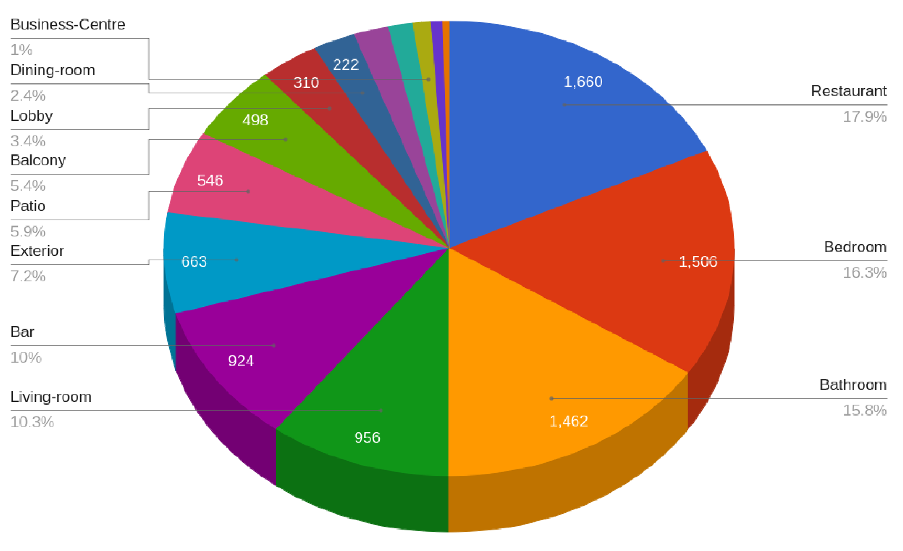

***Figure IV:***  Most recurring classes, considering the images of all the 10 hotels

# Discussion and experiments

Travelers usually share photos of their experiences through social media that hotels can monitor to get reliable insights. In this paper, deep learning models have been explored to classify those images and derive crucial insights regarding the preferences of the travelers.

For classification, 4 [18][19] different deep CNN architectures were trained replacing the last dense layer with a dense layer of size 256 followed by a batch normalization layer, for 30 epochs. The comparison of metrics of these architectures is described in Table III.

From Table III, it is clear that EfficientNet B4 [22] gave the highest accuracy as well as F1-score. So, the modified EfficientNet B4, say HICM, was trained for 50 epochs. Table IV summarizes the metrics of this model.

|  |  |  |  |  |  |
| --- | --- | --- | --- | --- | --- |
| Model | Accuracy | Cross-Entropy Loss | Precision | Recall | F1-score |
| Resnet-50 | 93.0068% | 1.888447 | 0.9315 | 0.9311 | 0.9310 |
| EfficientNet B3 | 93.1014% | 1.888970 | 0.9327 | 0.9316 | 0.9320 |
| Xception | 93.6486% | 1.881312 | 0.9375 | 0.9377 | 0.9374 |
| EfficientNet B4 | 93.8514% | 1.881036 | 0.9402 | 0.9386 | 0.9392 |

***Table III:***  Comparison of metrics of the four different CNN architectures trained

|  |  |
| --- | --- |
| Accuracy | 94.6081% |
| Loss | 1.871460 |
| Precision | 0.9473 |
| Recall | 0.9566 |
| F1-score | 0.9468 |

***Table IV:***  Metrics of HICM used

# Conclusion

The restaurant, bedroom and bathroom were the most photographed areas of hotels, in order. Apart from this, the customers are also attracted to the bar and exterior of the hotels. It can be concluded that people are more focused on capturing things which depict luxury, comfort and cleanliness. Hotels need to pay more attention to these attributes, in particular, in order to gain more customers.

The HICM can be used to identify the most commonly occurring classes in the images of any hotel and hence find the areas in which the hotels need to focus more in order to gain more customers.

# References

1. Hennigs, N., Wiedmann, K. P., Behrens, S., & Klarmann, C. (2013). Unleashing the power of luxury: Antecedents of luxury brand perception and effects on luxury brand strength. Journal of Brand Management, 20(8), 705–715.
2. Atwal, G., & Williams, A. (2009). Luxury brand marketing–the experience is everything!. Journal of Brand Management, 16(5–6), 338–346.
3. E. Konijn, N. Sluimer and O. Mitas Int. J. Tour. Res., 18 (6) (2016), pp. 525-535.
4. 2019. Chan, N. L., & Guillet, B. D. (2011). Investigation of social media marketing: How does the hotel industry in Hong Kong perform in marketing on social media websites? Journal of Travel & Tourism Marketing, 28(4), 345–368
5. Boo, S., & Busser, J. A. (2018). Meeting planners' online reviews of destination hotels: A twofold content analysis approach. Tourism Management, 66, 287–301.
6. Kim, J., & Lee, K. H. (2019). Influence of integration on interactivity in social media luxury brand communities. Journal of Business Research, 99, 422–429.
7. Tasci, A. D. A. (2018). Testing the cross-brand and cross-market validity of a consumerbased brand equity (CBBE) model for destination brands. Tourism Management, 65, 143–159.
8. 2019. Chan, N. L., & Guillet, B. D. (2011). Investigation of social media marketing: How does the hotel industry in Hong Kong perform in marketing on social media websites? Journal of Travel & Tourism Marketing, 28(4), 345–368.
9. Thelander, A., & Cassinger, C. (2017). Brand new images? Implications of Instagram photography for place branding. Media and Communication, 5(4), 6–14. [10] Hsu, L. C., Wang, K. Y., Chih, W. H., & Lin, K. Y. (2015). Investigating the ripple effect in virtual communities: An example of Facebook Fan Pages. Computers in Human Behavior, 51, 483–494.
10. Lim, J., Hwang, Y., Kim, S., & Biocca, F. (2015). How social media engagement leads to S. Giglio, et al. Journal of Business Research xxx (xxxx) xxx–xxx 6 sports channel loyalty: Mediating roles of social presence and channel commitment. Computers in Human Behavior, 46, 158–167.
11. Lee, D., Kim, H. S., & Kim, J. K. (2012). The role of self-construal in consumers’ electronic word of mouth (eWOM) in social networking sites: A social cognitive approach. Computers in Human Behavior, 28(3), 1054–1062.
12. Chen, A., Lu, Y., Wang, B., Zhao, L., & Li, M. (2013). What drives content creation behavior on SNSs? A commitment perspective. Journal of Business Research, 66(12), 2529–2535.
13. Devereux, L., Melewar, T. C., & Foroudi, P. (2017). Corporate identity and social media: Existence and extension of the organization. International Studies of Management and Organization, 47(2), 110–134.
14. Swani, K., Milne, G. R., & Miller, E. G. (2019). Social media services branding: The use of corporate brand names. Journal of Business Research.
15. Balomenou, N., & Garrod, B. (2019). Photographs in tourism research: Prejudice, power, performance and participant-generated images. Tourism Management, 70, 201–217.
16. F. Girardin, F. Calabrese, F. Dal Fiore, C. Ratti and J. Blat IEEE Pervasive Comput., 7 (4) (2008).
17. François Chollet, Xception: Deep Learning with Depthwise Separable Convolutions
18. Kaiming He, Xiangyu Zhang, Shaoqing Ren, Jian Sun, Deep Residual Learning for Image Recognition
19. A. Buslaev, V. I. Iglovikov, E. Khvedchenya, A. Parinov, M. Druzhinin, A. A. Kalinin, Albumentations: fast and flexible image augmentations, Information 11 (2020) 125.
20. J. Deng, W. Dong, R. Socher, L.-J. Li, K. Li, L. Fei-Fei, Imagenet: A large-scale hierarchical image database, in: 2009 IEEE conference on computer vision and pattern recognition, Ieee, 2009, pp. 248–255.
21. Mingxing Tan, Quoc V. Le, EfficientNet: Rethinking Model Scaling for Convolutional Neural Networks