**Locker** – help!

Welcome to the Locker help document. This document is intended to give guidance on how to operate the Locker and the applications in the locker. Content covered in this document is focused on how to best operate the applications user interface to optimize your user experience. No source code is covered in this document. For further assistance, please visit my profile on <https://github.i-am-monza@io/profile> and leave me a message on the contact page. On my behalf, enjoy the experience.

About application:

* The Locker is an enterprise inspired system that takes a variety of JavaScript applications and runs them under one component, allowing them to server resources.
* Locker is scalable, you can add or remove application as you please. Configurations will need to be adjusted by administrator as the system is not fully self-configuring.
* Locker also has a Hub, a resource routing junction for the running applications to be available upon request. Terms and conditions apply.
* Including the Hub, five other pages are accessible on the application; these are the Home page, Calculator, Weather, Search iTunes and Help (of which is how you got here, right!)

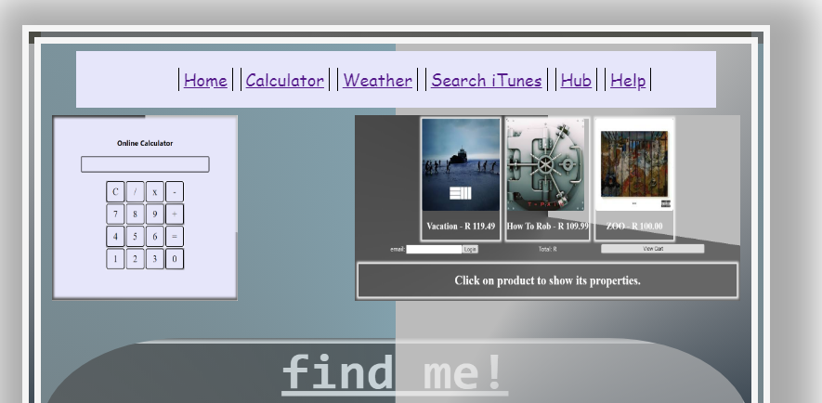*Home:* Upon loading Locker, the application navigates to the landing page. The landing page is accessible through the Home link on the light-blue background navigation bar. The page is a static page that only renders information. Images of the applications on Locker are viewable for the user’s convenience. Below is an image of how the typical Home page of Locker would look like.

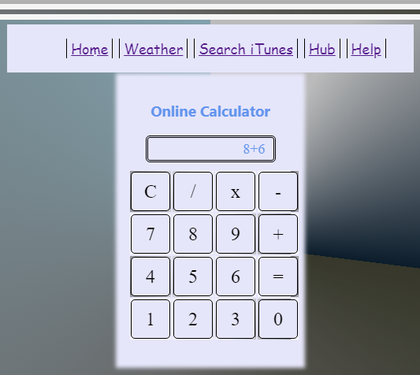*Calculator:* When the user clicks on the navigation item Calculator, they are redirected to the basic calculator application developed in node with a few additional libraries. The calculator evaluates basic operations only. These are addition, subtraction, multiplication and division. The calculator has the clear action button available and the user is advised to use it after every operation. Below is a typical image of how the basic calculator looks like.