BLOCKCHAIN OLYMPIAD BANGLADESH 2026, ARTIFICIAL INTELLIGENCE CATEGORY
FINAL ROUND: TECHNICAL DOCUMENTATION
Shebar Janala
What a citizen sees, what an official sees, and what is still just a plan
This is the second version of this document. The first drew a hard, mostly correct critique for reading like an audit instead of a pitch, for having no pictures, for burying every limitation in one long apologetic stretch, and for repeating one slogan until it stopped meaning anything. This version keeps every corrected fact from that draft, but shows the product instead of describing it: sixteen screenshots from the running prototype, five diagrams of how a request actually moves through the system, and the real code behind the two claims most worth checking.
One naming note before anything else: the interface in every screenshot below is branded নাগরিক সাথী, Nagorik Sathi, "the citizen's companion." Shebar Janala is the name this whitepaper and competition entry were written under. Both point at the same running codebase; nobody renamed the product in Word and forgot to rename it in the code.

1. What this is, in one screenshot
A citizen who has just lost her husband writes, in Bangla, exactly what happened: her husband has died, she has three children, what help can she get. Nobody taught her a programme name first. The screenshot below is that exact exchange, running against the seeded demo data in this repository, not a mockup drawn for this document.
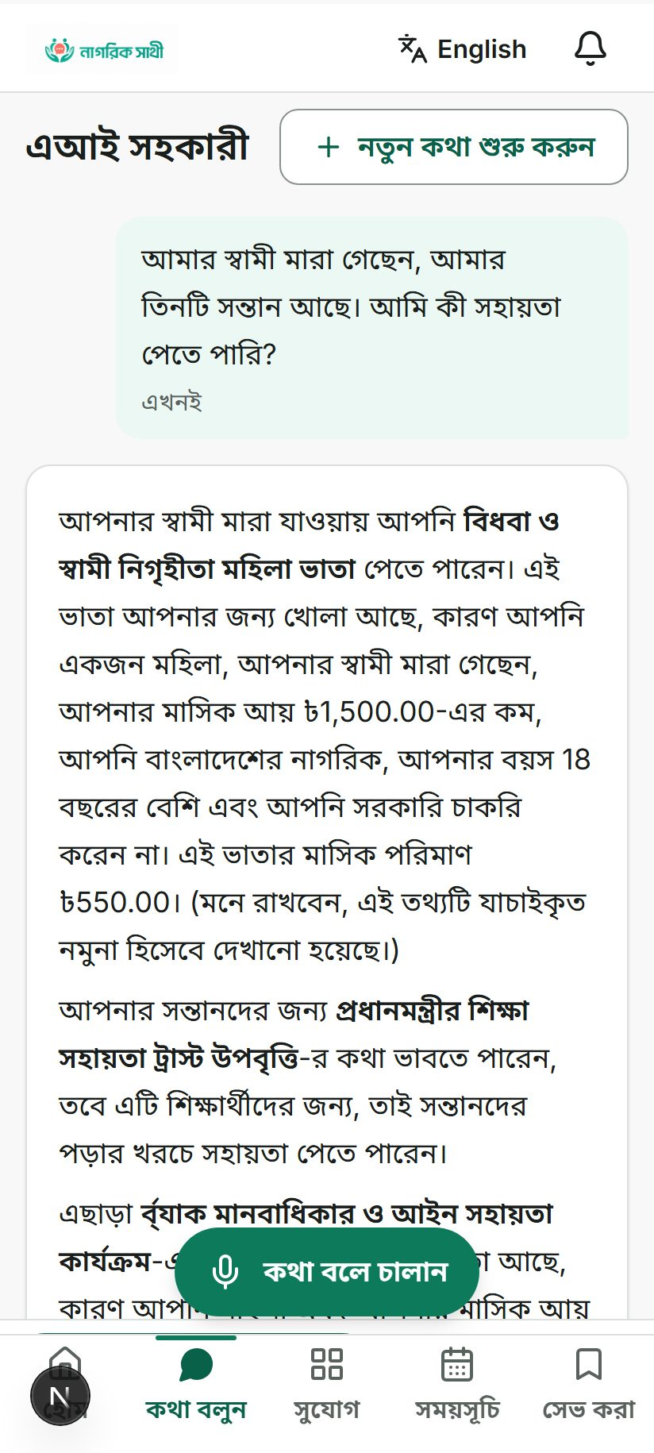
Figure 1. A citizen describes a life event in Bangla ("my husband has died, I have three children, what help can I get"). The assistant names the Widow and Deserted Woman Allowance, states the monthly amount, and marks the record as a verified sample.
Everything after this section is the argument for why that answer can be trusted: which parts of it a machine-learning model actually produced, which parts came from a rule a human wrote down and a computer only checked, and which parts of the picture above are still a plan rather than shipped code. Nothing here is described without something to point at, a file, a passing test, or another screenshot.
Since the whitepaper that won a place in this final, the same team built a second layer underneath the one described there: citizens can now see where their union's budget money went, flag an allocation that looks wrong, and reach a caseworker by dialling a short code on a phone with no internet connection at all. That layer is real, and it is covered here in full rather than left for a judge to find first.

2. What a citizen actually sees
The screenshots in this section were taken from the running prototype in the order a first-time user would hit them: open the app, describe a problem, get a traced answer, find a nearby office, save a programme.
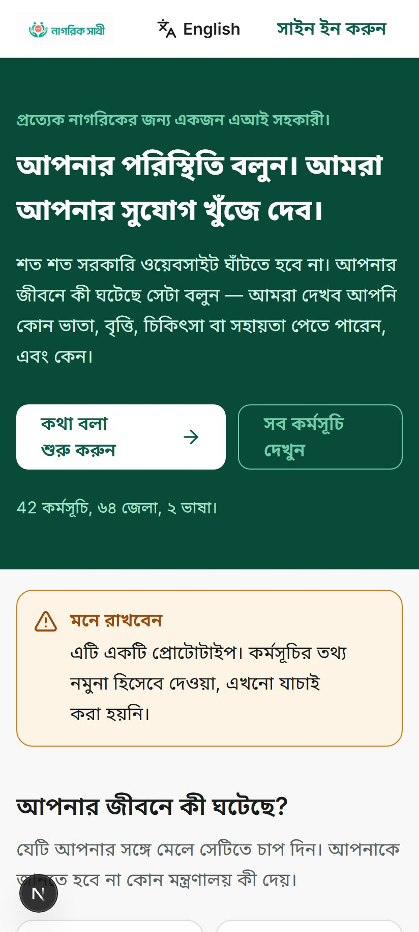
Figure 2. The landing screen in Bangla: "Tell us what happened. We'll find your opportunity." The line beneath it reads 42 programmes, 64 districts, 2 languages, and an amber notice states plainly that this is a prototype and the programme data is a sample that has not yet been verified.
That notice is not something this document is adding after the fact. It is baked into the product itself, the same instinct that produced the errata section later in this document.
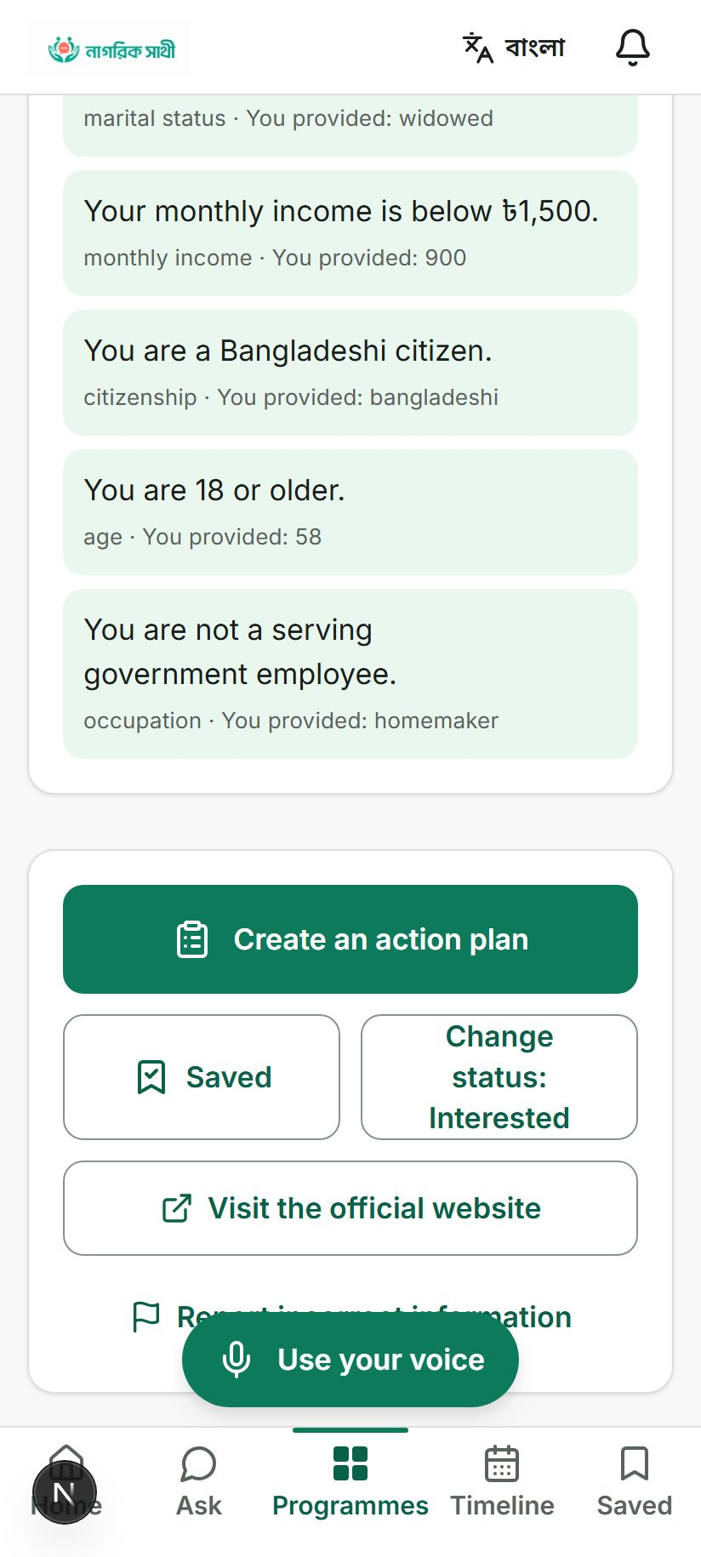
Figure 3. The eligibility trace for the same widow scenario: marital status widowed, monthly income below 1,500 taka (she provided 900), Bangladeshi citizenship, age 18 or older (she provided 58), and not a serving government employee. Each line names the rule and what she provided, so the verdict is checkable line by line rather than asserted.
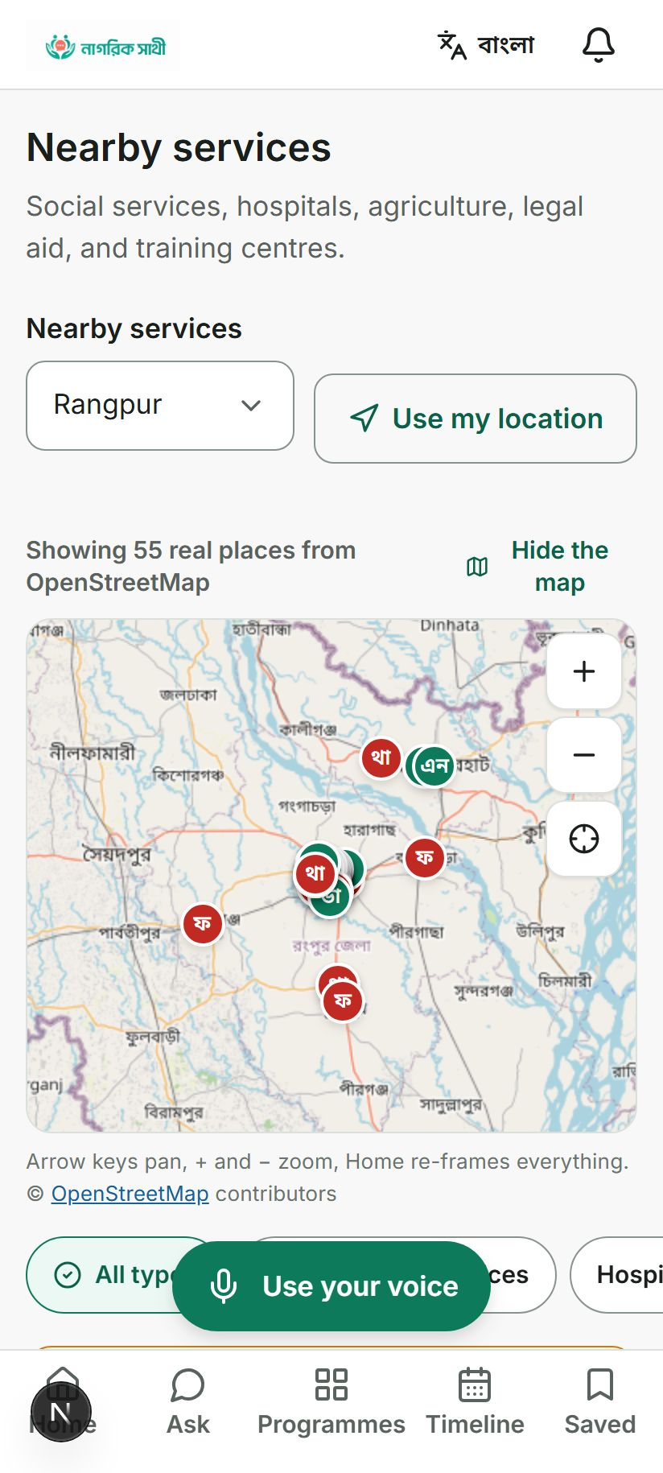
Figure 4. Nearby services for Rangpur, showing 55 real places pulled live from OpenStreetMap, not a fixed list bundled with the app.
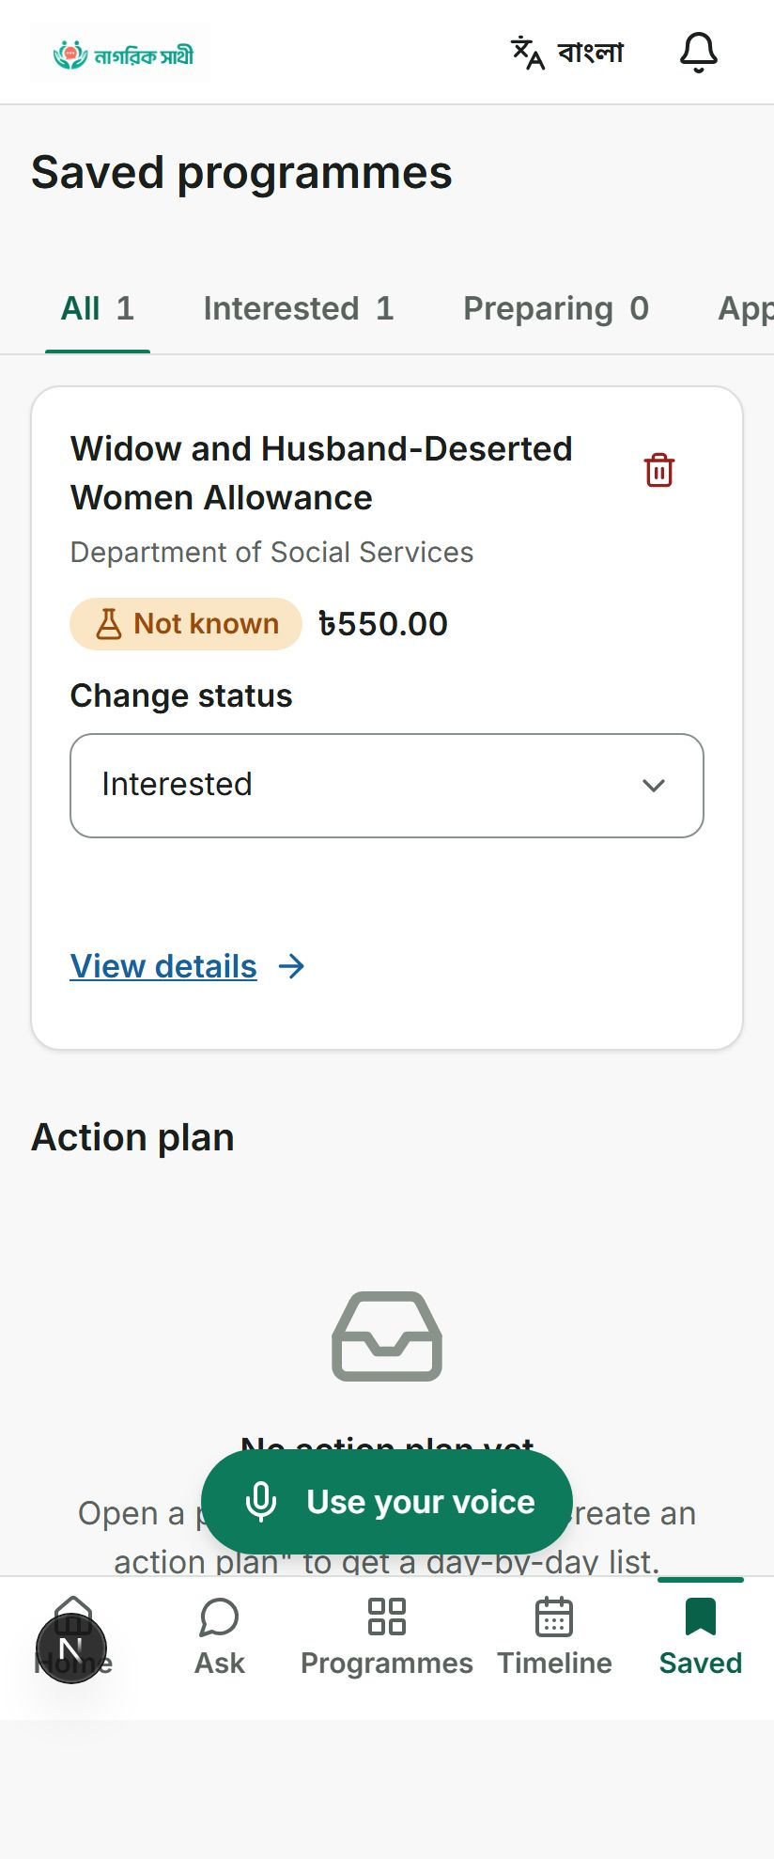
Figure 5. A saved programme, with its eligibility verdict shown in plain words: "Not known" is how the engine's unknown outcome from Section 8 reads on screen, next to a status the citizen controls and an action plan they can build from it.

3. Reporting a problem, and the honesty about identity
Voting on a local issue or filing a budget flag requires knowing who is voting, so the platform asks for a national ID and a union. What it does with that ID is stated on the same screen a citizen sees it, not buried in a technical appendix.
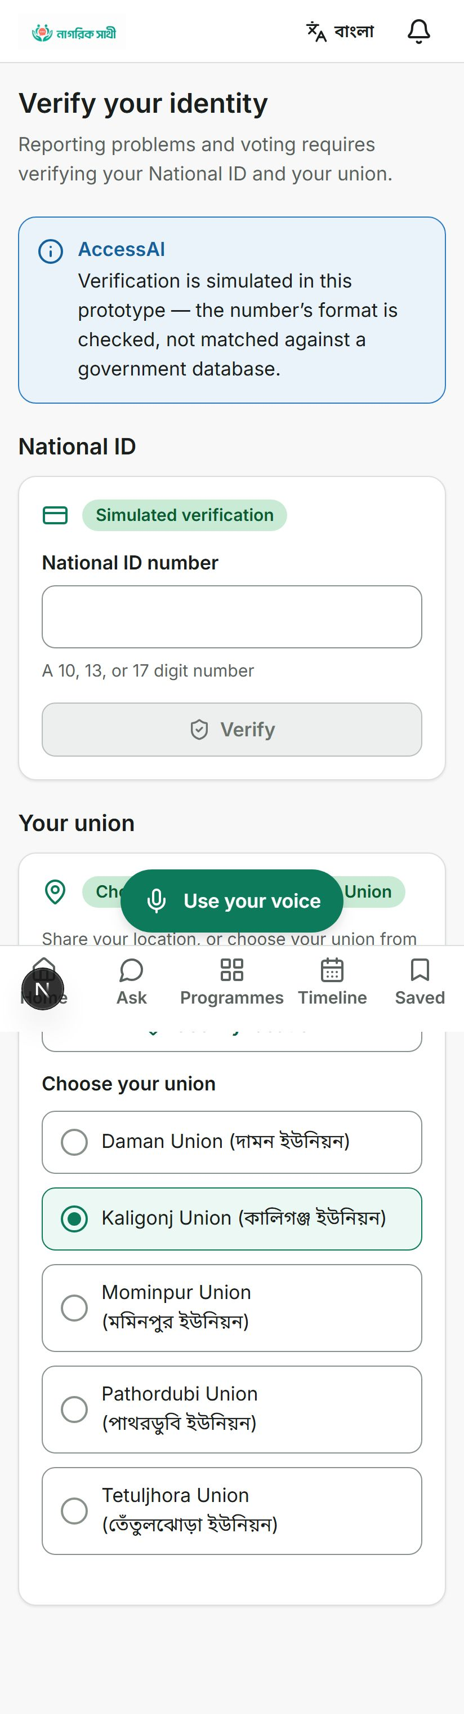
Figure 6. The identity verification screen states outright: "Verification is simulated in this prototype, the number's format is checked, not matched against a government database." The badge on the input field reads Simulated verification. This is the actual, shipped copy, not a paraphrase.
That single screen is worth more than a paragraph of disclosure elsewhere in this document, because it means the honesty travels with the product even if this whitepaper did not exist.
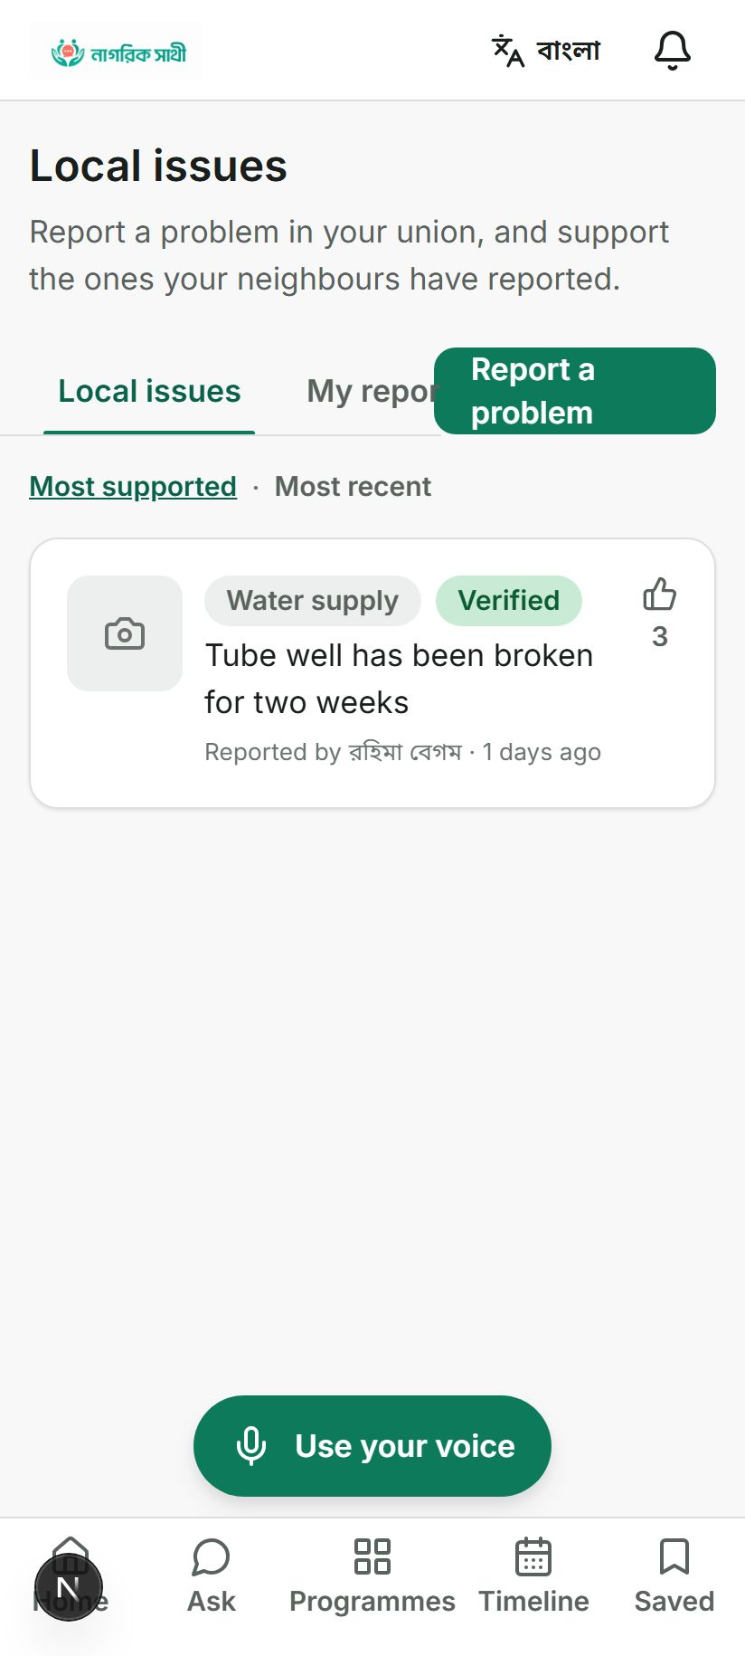
Figure 7. A real reported issue: a broken tube well, reported by রহিমা বেগম, tagged Water supply, marked Verified, and supported by three neighbours. Moderation, tagging, and voting are all live, not placeholders.
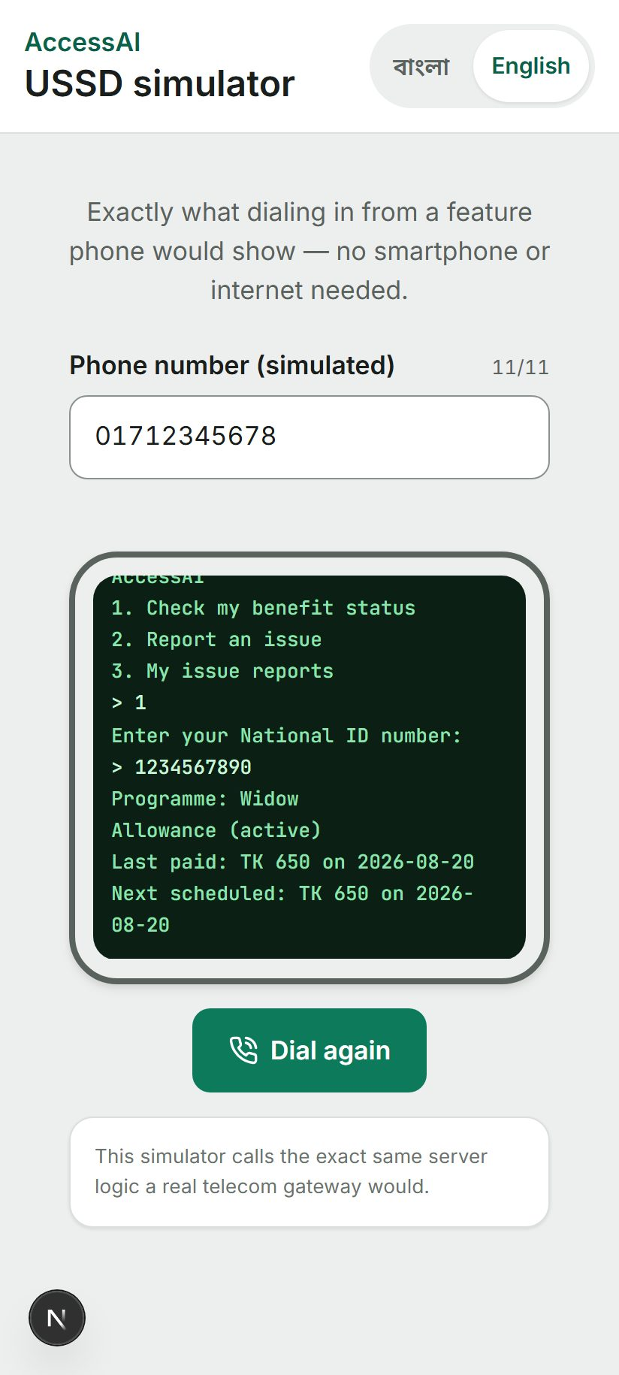
Figure 8. The USSD simulator dials a menu identical to what a feature phone with no internet connection would show, then walks through checking a benefit status by national ID. The caption under the terminal states this simulator calls the exact same server logic a real telecom gateway would, meaning the menu is not a separate, unconnected demo.
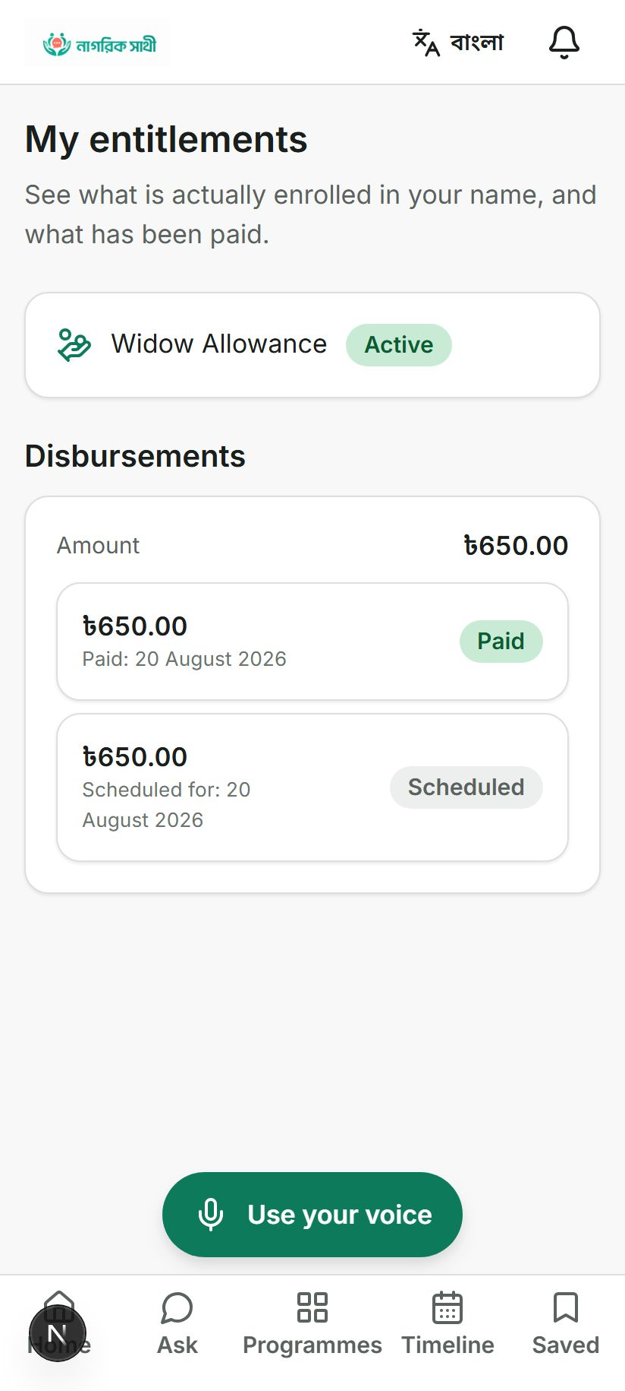
Figure 9. My entitlements: what is actually enrolled and paid against a citizen's name, distinct from what the eligibility engine merely calculated. 650 taka paid on 20 August 2026, and the same amount scheduled for the next cycle.

4. Where the budget layer sits underneath all of this
A union posts an allocation. A citizen can flag it. Enough flags, and it escalates on its own to the upazila officer, without anyone having to notice and forward it by hand.
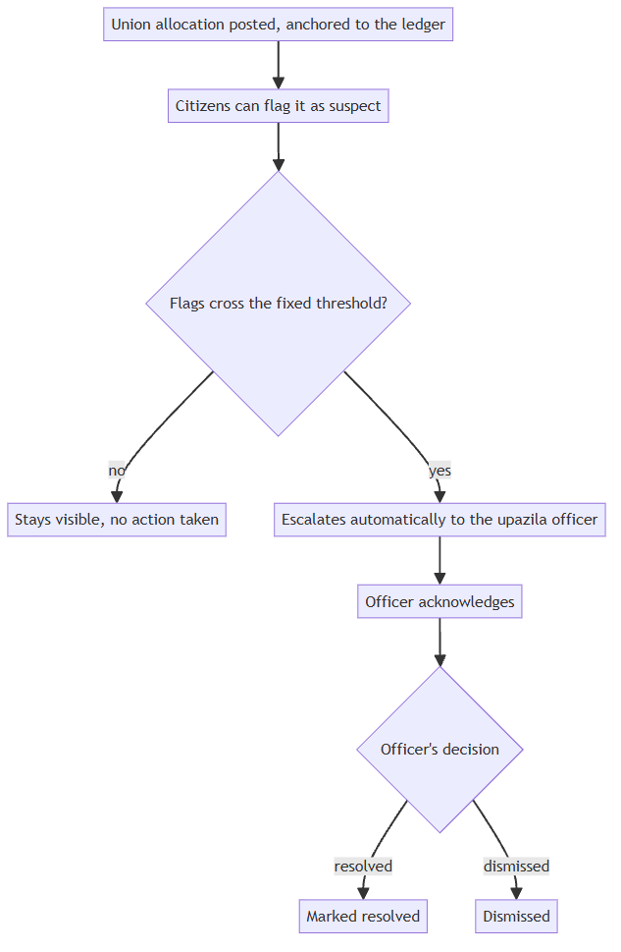
Figure 10. How a flagged allocation moves from a citizen's tap to an officer's queue. The threshold and the escalation are both automatic; nobody has to notice the pattern themselves.
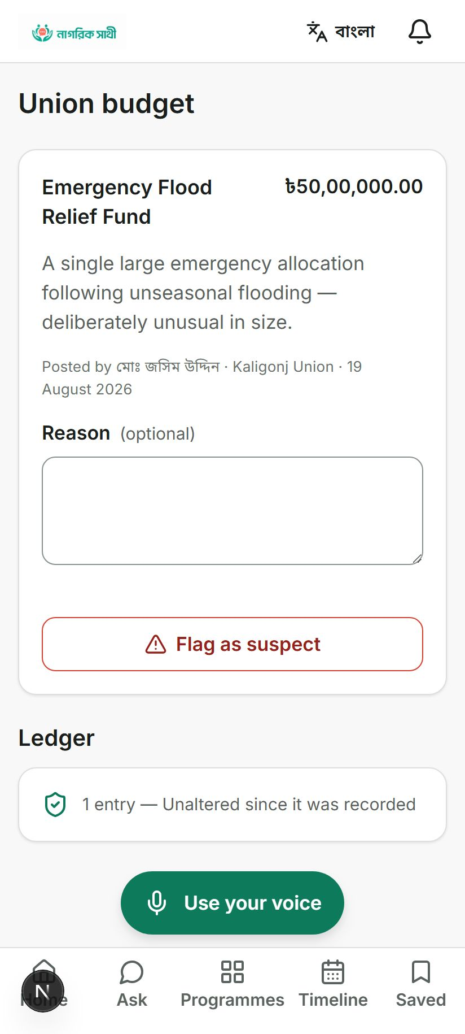
Figure 11. A real allocation in the seed data: an Emergency Flood Relief Fund of 50 lakh taka, posted by মোঃ জসিম উদ্দিন in Kaligonj Union, deliberately sized to be unusual so the anomaly detector has something to catch. The ledger line beneath it already reads 1 entry, unaltered since it was recorded.
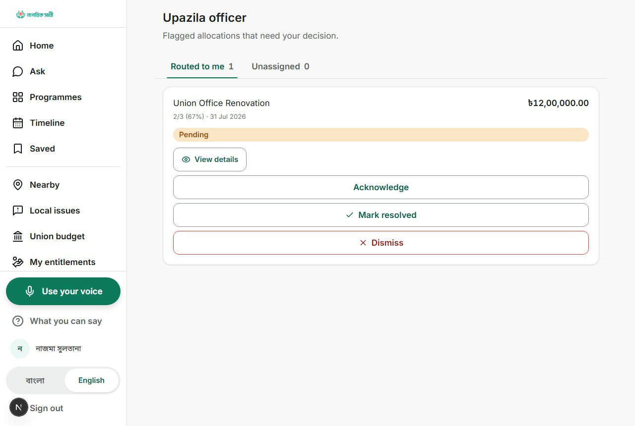
Figure 12. The upazila officer's queue: a Union Office Renovation allocation, 12 lakh taka, routed to this officer specifically, with acknowledge, resolve, and dismiss as the only three things they can do to it. There is no fourth option to quietly edit the number.

5. What a union leader, an upazila officer, and an outside auditor each see
Three different people look at the same underlying data through three different screens, and none of them can see more than their role allows.
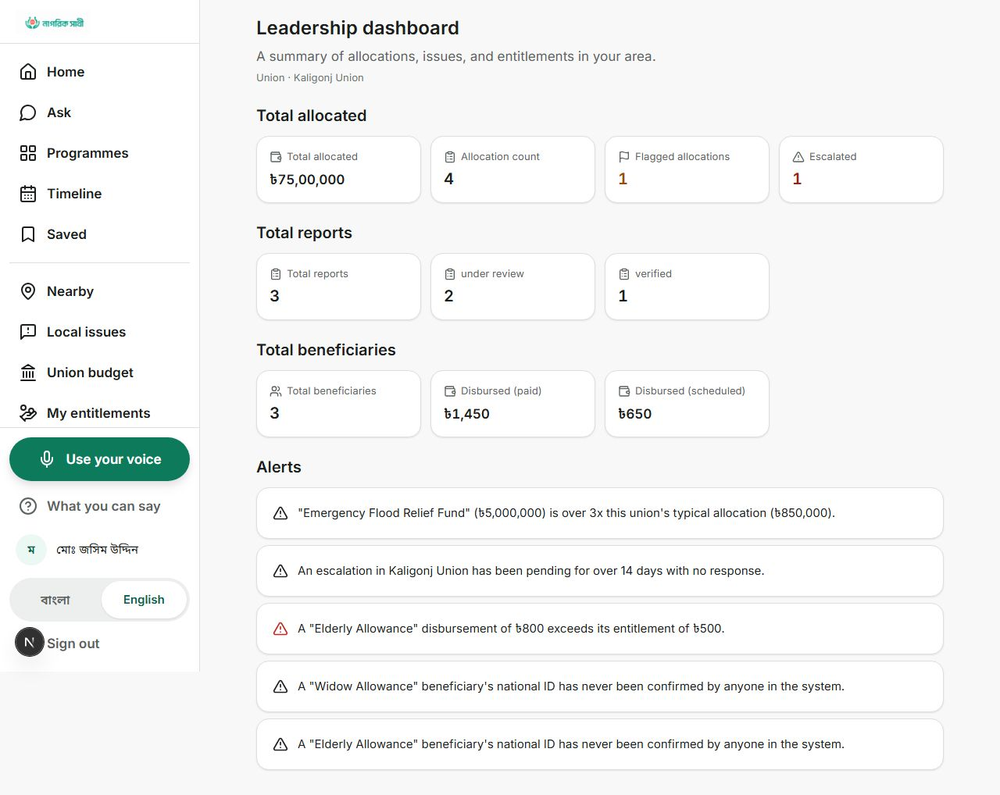
Figure 13. A union leadership dashboard for Kaligonj Union. The alerts are not generic warnings; they name the exact allocation, the exact multiple of the union's typical spend, and the exact beneficiary whose national ID has never been confirmed by anyone.
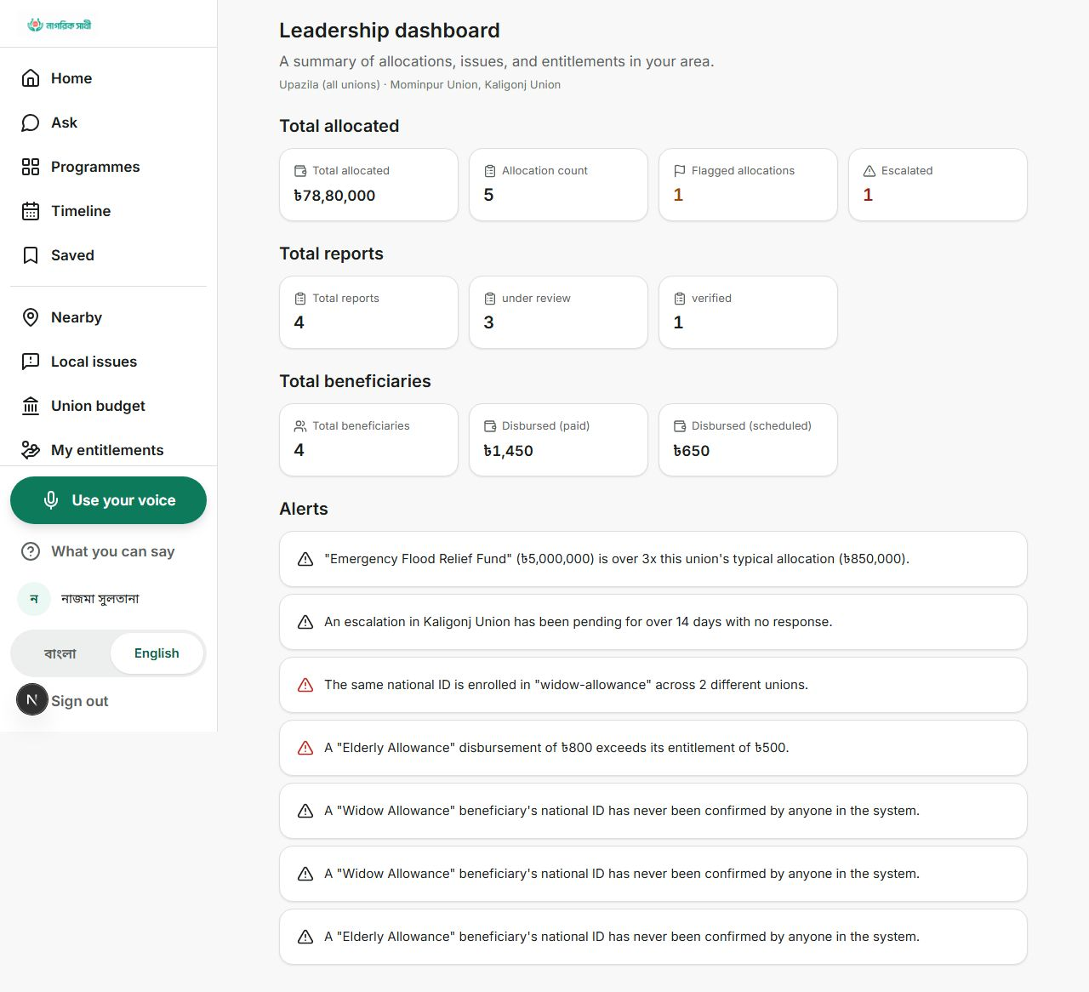
Figure 14. The same dashboard rolled up to upazila level catches something a single union's view cannot: "the same national ID is enrolled in widow-allowance across 2 different unions", a duplicate-enrollment case that only becomes visible once two unions' records sit side by side.
That duplicate-enrollment alert is the deterministic oversight detector described later in this document doing exactly the job it was built for, not a hypothetical example invented for this whitepaper.
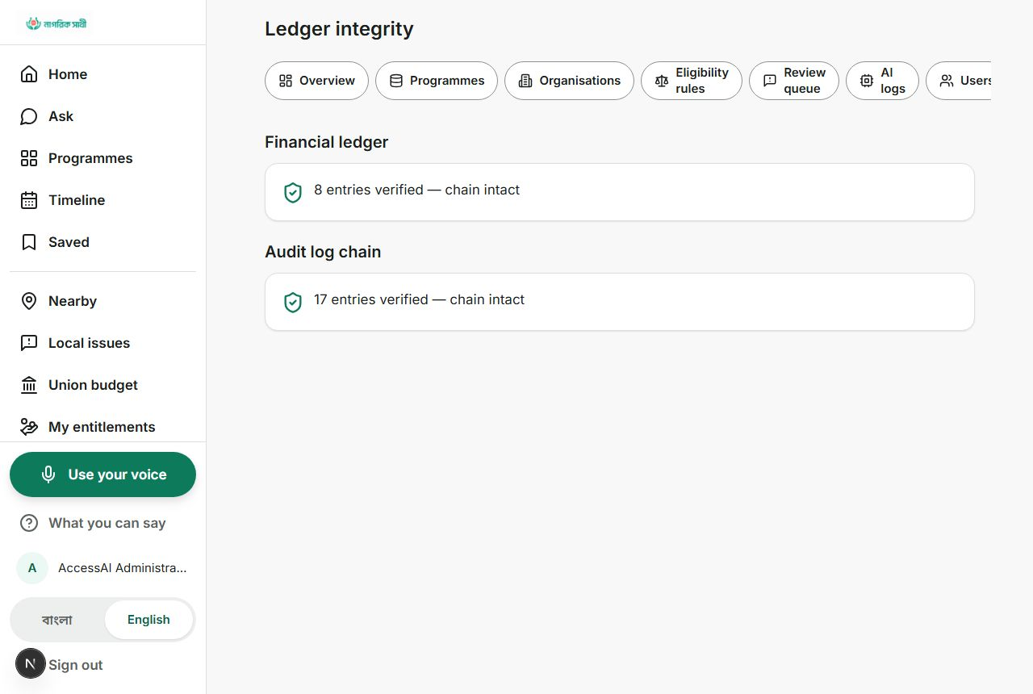
Figure 15. The administrator's ledger integrity page, read directly off the running prototype: the financial ledger shows 8 entries verified, chain intact; the separate staff audit log shows 17 entries verified, chain intact. Both numbers are computed by re-hashing every entry, not read from a flag someone could set by hand.
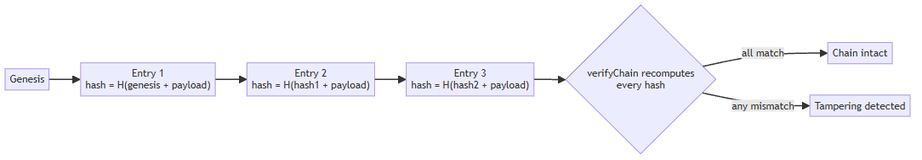
Figure 16. What "chain intact" actually checks: each entry's hash is built from the entry before it, so an edited or deleted row breaks every hash after it, and verifyChain() recomputes all of them to find out.
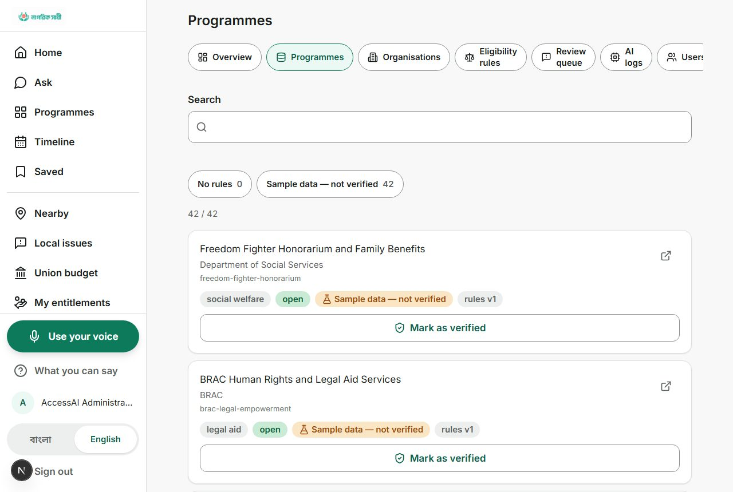
Figure 17. The programme verification queue: 42 of 42 seeded programmes are still tagged Sample data, not verified. This is the same 42 the landing page advertises and the same 42 referenced throughout this document; nobody rounded the number differently in different places.
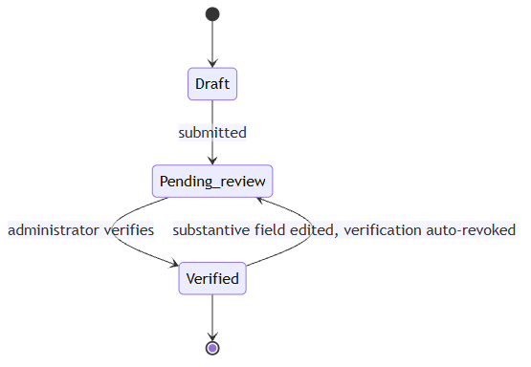
Figure 18. Why that queue cannot quietly go stale: verifying and editing a record can never happen in the same action, and editing a substantive field on an already-verified record throws it straight back to pending review.
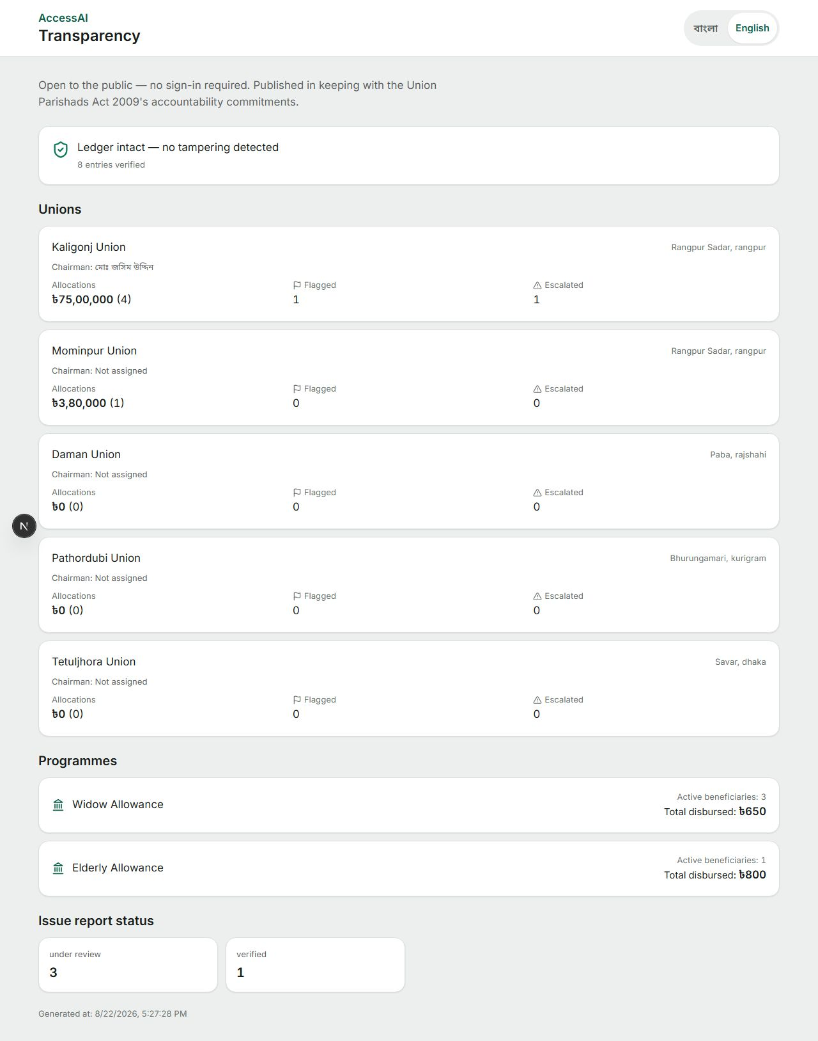
Figure 19. The public transparency page needs no sign-in at all. It lists every union's allocations, flags, and escalations, cites the Union Parishads Act 2009 as the reason it exists, and stamps the exact moment it was generated, 22 August 2026, so nobody can claim the numbers were quietly touched up after the fact.

6. How the pieces actually fit together
The application is one Next.js 15 codebase (React 19, TypeScript in strict mode) over Drizzle ORM and libSQL. It starts with two commands, needs no external database server, cache, or API key to boot, and a jury can clone it and have it running in minutes.
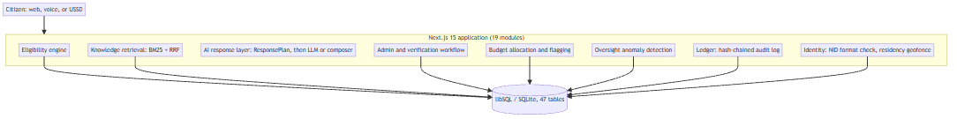
Figure 20. Nineteen modules behind one application boundary. The citizen-facing modules described in Section 2 and the governance modules described in Sections 3 to 5 write to the same 47-table database; nothing here is a second, bolted-on system.

The numbers, corrected against the whitepaper that won the prelim
The earlier whitepaper's own stat block was wrong on three counts, and running the test suite for this document found a fourth correction nobody had caught yet: the true test count is higher than what either the whitepaper or an earlier draft of this document claimed, because a plain text search misses parameterised tests that only multiply out when the suite actually runs.
Metric | Whitepaper claimed | Verified now | How it was verified
Database tables | 32 | 47 | Counted every sqliteTable(...) definition in the schema file
API route files | 31 | 58 | Counted route.ts files under src/app/api/v1
Exported API handlers | 51 | 84 | Counted exported GET/POST/PUT/PATCH/DELETE handlers
Automated tests | 685 | 789 | Ran `npm test` (vitest run): 26 test files, 789 tests passed, 7.17 seconds
Module domains | 19 | 19 | Matches exactly
$ npm test
Test Files 26 passed (26)
Tests 789 passed (789)
Duration 7.17s
That log is not reproduced from memory. It is the actual output of running the suite while preparing this document, and a judge with the repository open can run the same command and get the same shape of result.

7. The part that is actually machine learning, shown, not just claimed
A model never decides whether a citizen qualifies for anything. That is not a slogan repeated for effect; it is the literal name of a design principle written into this codebase's own prompt file, Principle 4: rules decide, AI explains. The diagram below is what that principle looks like as a request actually moves through the system.
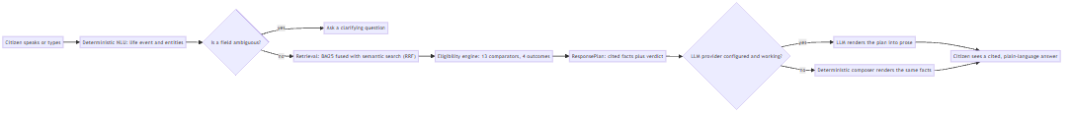
Figure 21. One citizen turn, start to finish. Retrieval and the eligibility engine always run first and always produce the same answer regardless of which model, if any, is available; the model's only job is the last mile, turning a fixed set of facts into readable prose.

Retrieval: BM25 fused with semantic search
Programme search runs on Okapi BM25 with real IDF smoothing, computed over pre-stored term frequencies, not a call to an external search service. Here is the actual scoring loop:
const numerator = tf * (BM25_K1 + 1);
const denominator =
tf + BM25_K1 * (1 - BM25_B + BM25_B * (length / averageLength));
score += idf * (numerator / denominator);
// BM25_K1 = 1.5, BM25_B = 0.75
A second, semantic channel embeds text through a configured provider and is fused with the BM25 ranking by Reciprocal Rank Fusion, a rank-based combination rather than a weighted average, because BM25 scores and cosine similarity live on scales that cannot honestly be averaged together. That channel needs a live embedding API key to do anything; without one it returns nothing and the system runs on BM25 alone, rather than inventing a vector score to fill the gap.

What has no trained model behind it yet
Three pieces of the whitepaper's own AI roadmap are not code yet, and this document is not going to describe them as further along than they are. A Bangla-adapted speech model, a learned field-extraction model to replace today's regex extractor, and a document-intelligence pipeline that turns government circulars into draft rules are all still proposed. Each has a specific bar it has to clear before it is trusted with a citizen's profile: 0.98 precision on income, age, and land fields for extraction, with mandatory abstention below that; word and character error rates reported per district rather than as one flattering average for speech; and an exact field match against a human-authored answer key before a document-intelligence draft ever reaches a review queue, let alone a live rule.

How to check any of this without taking our word for it
$ npm test # 789 tests, the eligibility engine alone has 28
$ npm run ledger:audit # independent re-verification of both hash chains,
# calling the exact function the admin page calls
That second command is worth dwelling on. It is a plain script, not a page inside the app, and its own top comment explains why that matters: it calls the same verifyLedgerChain and verifyAuditChain functions the admin dashboard calls, deliberately not a second, separately written check that could quietly drift from what the app actually enforces. An operator cannot make the in-app badge say intact while this script would say otherwise, because they are, literally, the same function.

8. The rule that decides, and the ranking that never overrides it
The eligibility engine evaluates a validated rule structure over 13 comparators against a citizen's profile: eq, neq, gt, gte, lt, lte, in, not_in, between, exists, not_exists, contains_any, and contains_all. Here is the actual comparison for a numeric rule, unedited:
case 'gt':
case 'gte':
case 'lt':
case 'lte': {
const a = typeof actual === 'number' ? actual : Number(actual);
...
if (condition.operator === 'gt') return a > e ? 'met' : 'failed';
if (condition.operator === 'gte') return a >= e ? 'met' : 'failed';
if (condition.operator === 'lt') return a < e ? 'met' : 'failed';
return a <= e ? 'met' : 'failed';
}
The result is always one of four values: eligible, partially_eligible, not_eligible, or unknown. A missing field always resolves to unknown, never to a silent no, because treating absent data as failure is how entitlements quietly go unclaimed. Every evaluation is stored with the citizen's full profile snapshot and the exact rule version that produced it, so the trace in Section 2's screenshot is still reproducible in six months even after both the citizen's data and the rule itself have changed.
Ranking works differently, and the codebase is unusually candid about where it stops. The formula is a weighted sum: eligibility fit 40%, stated preference 15%, location 15%, deadline urgency 10%, popularity 10%, and a similar-user-success factor worth 10% that the code hardcodes to a neutral value on purpose, because the prototype has no outcome data to train it on. The comment inside the file says this better than any paraphrase would:
// "Similar User Success" requires historical outcome data the prototype
// has not accumulated. Rather than inventing a number, this component
// returns a NEUTRAL 50 and reports similarUserDataAvailable: false...
// Fabricating a success rate would be exactly the kind of unsupported
// claim PRD section 33 forbids.
A ranking factor that admits it has nothing to contribute is a stranger thing to put in a competition document than a ranking factor that claims more than it can prove, and it is exactly the kind of detail a technical judge is meant to reward.

9. What data actually moves through the system

Citizen profile
35 structured fields cover demographics, income, disability, marital and family status, education, land and livelihood assets, pregnancy, and self-reported medical conditions. Health-related fields are opt-in and encrypted at rest with AES-256-GCM. Nothing is written to a profile until the citizen confirms it, which is the same confirm-before-write habit visible in the eligibility trace screenshot in Section 2.

Programme knowledge
42 seed programme records, the same 42 visible on the landing page and in the verification queue in Section 5, chunked bilingually for retrieval. Every record carries a verification state, a source URL, and a last-verified date, and the confidence shown for any AI-rendered answer is capped by that state (100, 75, 65, 45, or 25) so an unverified or stale record can never be dressed up as more certain than it is.

Identity and residency
National ID numbers are never stored in the clear, only a one-way hash, visible in the duplicate-enrollment alert in Section 5 that flags a shared hash across two unions without ever revealing the number itself. Residency is checked against a real geofence of union boundary polygons, though the boundary data on hand today covers only a handful of authored unions, not national coverage, exactly as the identity screen in Section 3 states about verification generally.

Voice, still mostly a plan
The production plan calls for Bangla speech adaptation using OpenSLR SLR53 and Mozilla Common Voice bn, plus opt-in corrections from a confirm-what-we-heard step already built into the voice interface. None of that training data has been collected or used yet. Today's voice path calls a generic, non-Bangla-adapted speech endpoint when a key is configured, which is why Section 7 lists Bangla ASR adaptation as a target to hit, not a result to report.

10. What we got wrong the first time, and fixed
Preparing this document meant re-checking every number and every attribution in the whitepaper that won the prelim round against the code as it stands today. Four things needed correcting.
- Password hashing was described elsewhere as Argon2id. The shipped code uses scrypt instead, because Argon2id needs native bindings that do not run on the Cloudflare Workers runtime this deployment targets. Deliberate, and documented in the code, but not what earlier material said.
- The rule engine was described as 12 comparators. It implements 13; contains_all had gone uncounted.
- The citizen profile was described as 34 fields. The schema has 35 core fields, plus 9 more added for the identity and residency work in Section 3, which came after the original count was made.
- An earlier internal document said flatly that nothing in the repository touches a ledger. That was true when it was written and has not been true for a while: Sections 4 and 5 describe two independent hash chains now in place. What remains true is that neither is a distributed, multi-party blockchain. Both run inside this one application's own database, which is a real limit, stated in the ledger module's own code comments, not hidden behind the word ledger.
The table and route counts in Section 6 are corrected there rather than repeated here.

11. What to actually put in front of the judges
A technical document and a ten-minute demo video are two different arguments, and they should reinforce each other instead of standing apart. Here is the walk that follows the same order as this document, and every step names the screen it uses.
- Open on the landing page (Section 2, Figure 2), then speak the same unscripted life event live rather than typing it, so the judges hear the assistant handle real audio, not a script.
- Open the eligibility trace (Section 2, Figure 3) and read one condition aloud: monthly income below 1,500, you provided 900. That is the moment a judge sees the model did not invent the verdict.
- Search for a paraphrase with no lexical overlap with any programme name, and show whether the semantic channel catches it when a live embedding key is configured; if it is not configured for the demo, say so on camera rather than letting BM25's result pass silently as the full system.
- Flag a budget allocation live (Section 4, Figure 11), and show it land in the upazila officer's queue (Section 4, Figure 12) within the same session, not in a separate, unconnected recording.
- Open the admin ledger integrity page (Section 5, Figure 15) and actually run `npm run ledger:audit` from a terminal on screen, so the chain-intact claim is something the judges watch happen, not a screenshot they have to trust.
- Close on the public transparency page (Section 5, Figure 19), and point out that it needed no login to reach, which is the whole accountability argument in one URL.

12. Risks that do not go away just because they are named
Risk | What actually limits it
Confident but wrong entitlement advice | unknown instead of a guess on missing data; every claim cited; confidence capped by verification state, visible directly in the saved-programme screenshot in Section 2
Regional or dialect speech failure once real adaptation ships | word and character error rates to be reported per district, not as one average; typed and assisted modes stay fully equivalent fallbacks
A simulated identity check being mistaken for a real one | the result field is labelled simulated_verified in the API response and the phrase "verification is simulated" is on the screen itself, not only in this document
A hash chain that only proves tampering after the fact | stated in the ledger module's own code comments: it cannot stop an operator with direct database access from rewriting the whole chain and recomputing every hash; it can only make that rewrite detectable
Institutional non-adoption of the budget and oversight layer | the layer is opt-in per union and per upazila; the citizen-discovery product in Section 2 still functions on its own if no local government partner signs on
The cost of verifying 42 programmes against current law | unchanged from the original whitepaper's position: the real cost is skilled human review time, not inference, and no number here pretends otherwise

13. Roadmap
Phase | Scope | Status
1. Foundation | Eligibility engine, retrieval, admin verification workflow, voice navigation, action plans, maps, the 47-table schema, 789 tests | Done
2. Governance layer | Budget flagging, ledger anchoring, oversight anomaly detection, USSD, identity and residency | Done, shown in full for the first time in this document
3. AI hardening | Bangla speech adaptation, learned field extraction with confirm-before-write gating, document intelligence over real circulars, semantic retrieval enabled in production | Next; the validation floors are in Section 7
4. Institutional pilot | Deploy with one NGO, Union Digital Centre, or government partner on real programme data; measure whether the unknown rate actually falls | Proposed

14. Conclusion
The whitepaper that reached this final told the truth about a citizen who should be able to describe a life event and get a traced, cited answer without first learning a programme name. It still does. What it did not yet know is that the same team spent the months since building a second layer underneath it, one where the same citizen can see what happened to her union's money and a caseworker can reach her by dialling a number on a phone that has never touched the internet.
Nothing in this document asks a jury to take a claim on faith that a screenshot, a diagram, or a line of real code could not stand behind instead. Where a model is actually involved, Section 7 shows the code and tells you how to run the check yourself. Where nothing has been trained yet, Section 7 says that too, plainly, with the bar it will have to clear before it changes. That is the whole of what changed between the first version of this document and this one: not a bigger claim, the same one, shown rather than told.

