
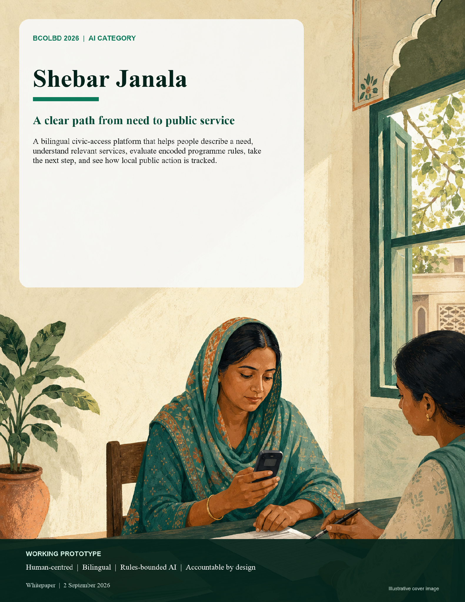

01 | THE HUMAN PROBLEM
The distance between a need and a service
Live Prototype Link : https://shebar-janala.tasknext.workers.dev/bn


The barrier is rarely a complete absence of services. It is the distance between a person’s lived situation and the administrative language, channels and proof required to reach the right service.

scenario Rokeya has recently lost her husband. She has heard that an allowance may exist, but she does not know the programme name, whether her age, income and location meet its rules, which documents are required, or where to ask. A portal can show pages. A helpline can explain a question. A general assistant can sound confident. What Rokeya needs is a clear answer in Bangla, the basis for that answer, an honest statement of uncertainty, and one practical next step. Rokeya is illustrative, not a verified beneficiary or pilot participant.

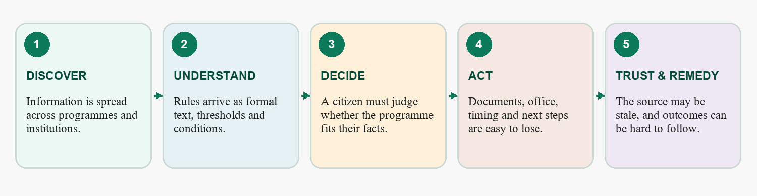
Figure 1. The access gap is a chain; failure at any link can turn an available service into an unreachable one.

Bangladesh’s official social-protection strategy describes continuing fragmentation, targeting errors, exclusion of poor and vulnerable households, uneven accountability and weak coverage for some groups even after major progress in digitisation.[1] These are not arguments against existing systems. They are evidence that a citizen-facing navigation and explanation layer still matters.
The burden is heaviest for people who must cross several barriers at once: limited literacy or digital confidence, Bangla-first communication, shared devices, uncertain connectivity, disability, distance from an office, or a life event that does not map neatly to a ministry name.

02 | EXISTING SOLUTIONS AND THE VISION
Complement the channels that already work
Bangladesh already has important public-service channels. Shebar Janala is not a replacement portal, call centre or authority. Its role is to translate a lived need into grounded guidance, then hand the citizen to the relevant official or assisted channel with a clearer case.

Existing channel | What it does well | Where Shebar Janala adds a distinct layer
myGov | One-stop search, application and status functions across government services.[2] | Begins from a free-form life event; evaluates encoded programme rules; explains conditions and uncertainty.
National Helpline 333 | Voice-based information, service assistance and grievance access without requiring internet literacy.[3] | Creates a persistent, replayable rule trace, saved plan and follow-up record that can support a call or referral.
Union Digital Centres / caseworkers | Trusted assisted access for people who need human help. | Gives the operator a consistent bilingual explanation, document checklist and next-step workflow.
General-purpose AI | Flexible conversation and plain-language explanation. | Restricts citizen-visible facts to retrieved records; encoded rules—not a language model—evaluate eligibility guidance.



The vision
A person should be able to say what happened in their own words and leave with a defensible next step: relevant services, a condition-by-condition explanation, required documents, a nearby place to go, and a record they can return to. The same system should let authorised local actors review issues, entitlements and public-resource signals without hiding uncertainty or sample data.
Scope today A working bilingual prototype joins service discovery, encoded-rule eligibility guidance, action planning, nearby-service discovery, issue reporting, entitlements, local budget visibility, oversight and public transparency. The data shown in demonstration dashboards is sample data. No government or NGO adoption, nationwide coverage or real-world outcome is claimed.

03 | THE SOLUTION
One journey, not another directory
Shebar Janala organises public-service access around the citizen’s journey rather than the institution’s org chart. A person can ask in Bangla or English, explore programmes, receive rule-based guidance, see documents and service locations, save an opportunity, create an action plan, and track progress. Related civic workflows extend the same idea to local issues, entitlements and public-resource transparency.
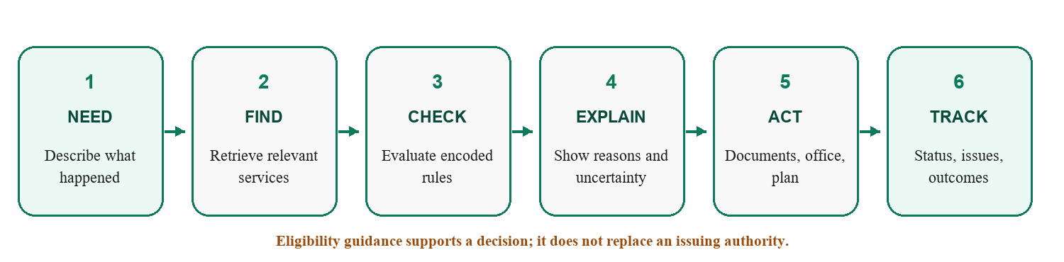
Figure 2. The complete user journey. The system gives eligibility guidance, not an official benefit determination.

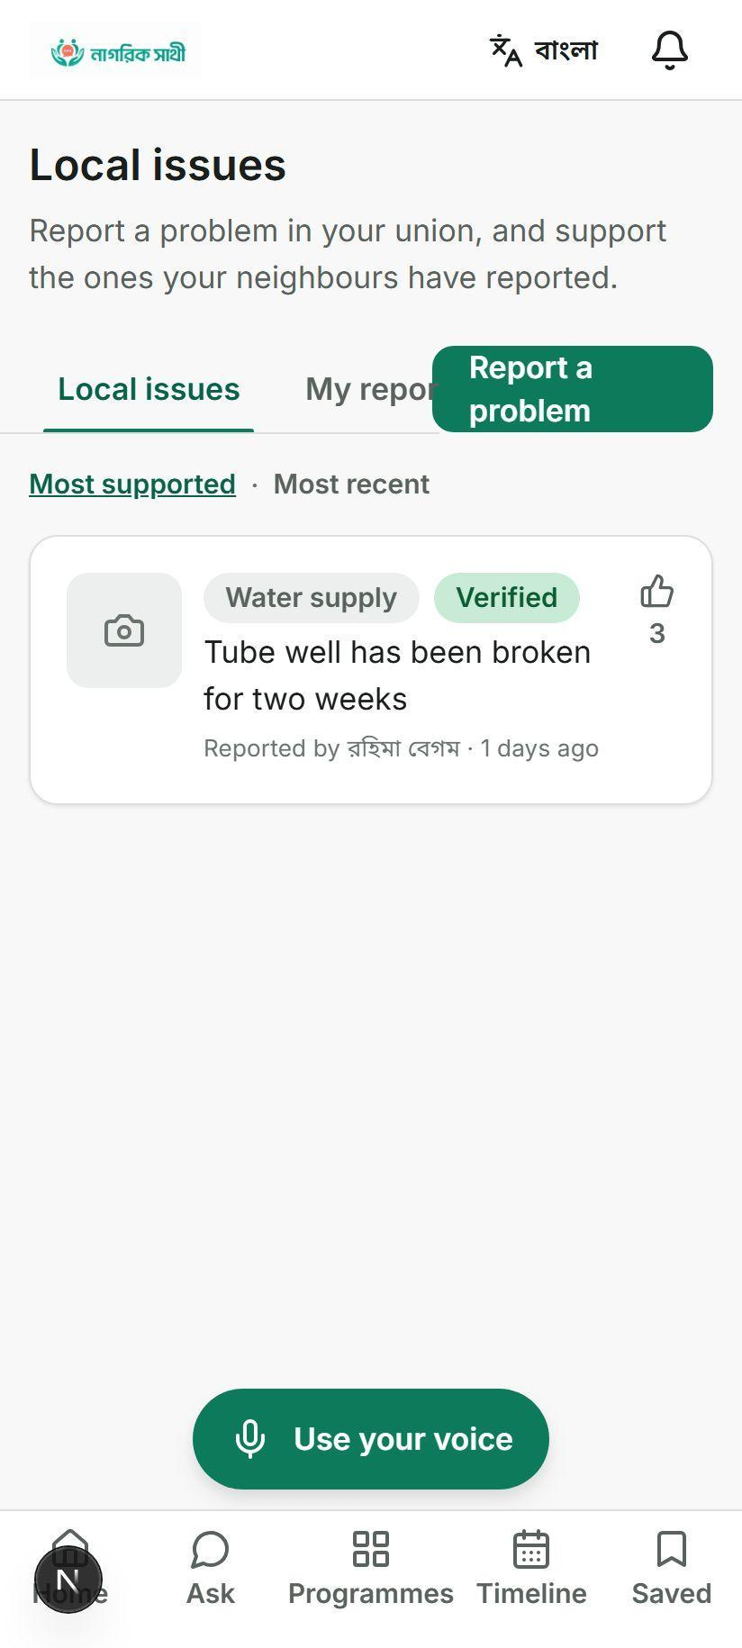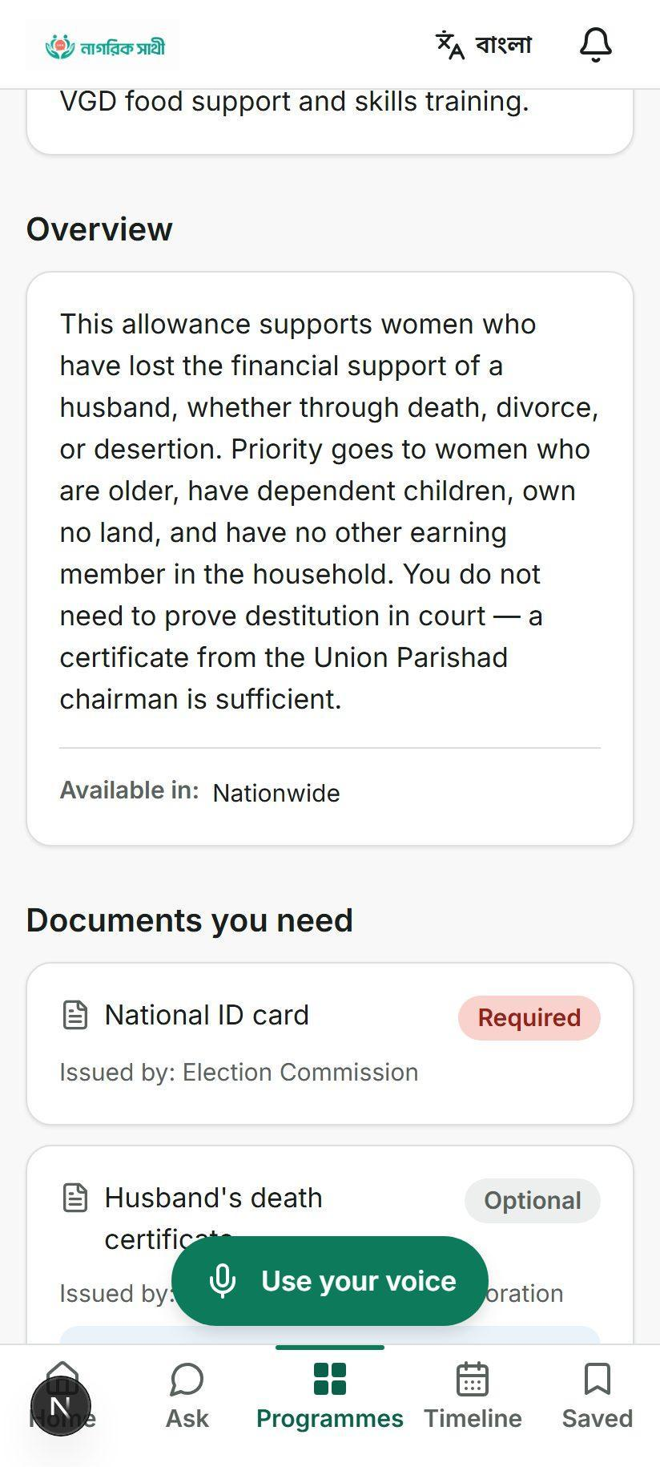
Prototype interface · sample programme and civic data shown
- Citizen value. The interface turns a question into reasons, documents, places and a plan instead of stopping at a search result.
- Operator value. Authorised staff can review programmes, issues, beneficiaries, escalations and anomaly signals in the same operational model.
- Trust value. Source status, rule versions, profile snapshots, history records and hash-chain checks create a basis for review—while current coverage limits remain visible.
04 | WHY AI MATTERS
AI handles language. Rules handle rights.
AI is useful where the input is uncertain: understanding how a citizen describes their circumstances. It is the wrong authority for income thresholds, age cut-offs or legal entitlement.
A citizen may say:
“আমার স্বামী মারা গেছে, আমার বয়স ৫৮, মাসে প্রায় পাঁচ হাজার টাকা আয় হয়, আমি কুমিল্লায় থাকি।”
Another citizen may describe the same situation as:
“I lost my husband last year. I don't earn much and I heard there is some allowance.”
Shebar Janala uses AI and language processing to bridge those descriptions into structured civic information. It does not use a language model to decide eligibility.

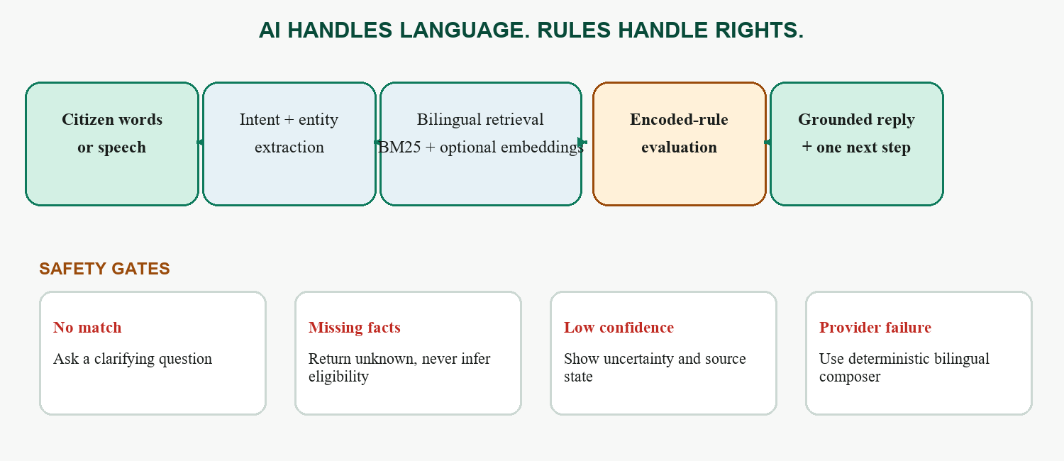
Figure 3. No model output directly becomes an eligibility fact; missing evidence produces clarification or ‘unknown’.
Capability | Current implementation | Why it is appropriate
Understand | Conservative Bangla/English keyword, regex and intent logic; voice via browser or configured provider. | Extract only what can be supported; confirm consequential voice commands.
Retrieve | Hand-built BM25 with bilingual tokenisation/stemming; optional embeddings fused by Reciprocal Rank Fusion.[5][6] | Lexical precision works without a provider; semantic matching can improve paraphrase recall when enabled.
Evaluate | Deterministic rule engine with 13 comparators, group logic, traces and ‘unknown’ for missing required facts. | The same inputs and rule version produce the same guidance.
Explain | Fixed-fact response plan; optional LLM rendering; deterministic bilingual composer on failure. | Language quality may vary, but the model cannot invent a programme or threshold.

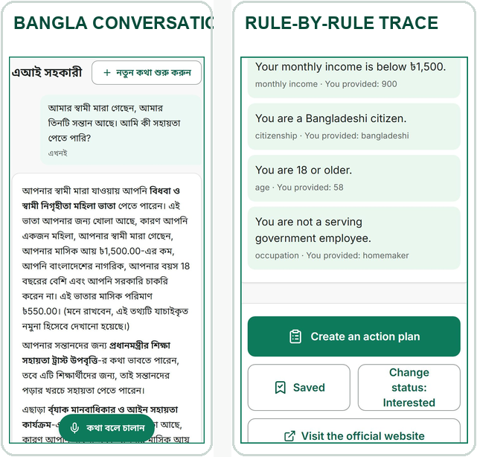
Prototype interface · sample programme information shown.

05 | THE CIVIC INTELLIGENCE PIPELINE
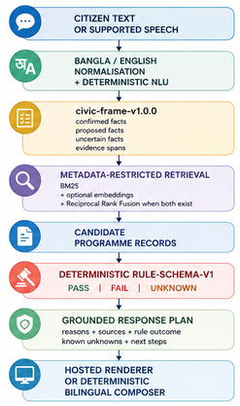
THE CIVIC INTELLIGENCE PIPELINE
AI is useful where the input is uncertain: understanding how a citizen describes their circumstances. It is the wrong authority for income thresholds, age cut-offs or legal entitlement.
A citizen may say:
“আমার স্বামী মারা গেছে, আমার বয়স ৫৮, মাসে প্রায় পাঁচ হাজার টাকা আয় হয়, আমি কুমিল্লায় থাকি।”
Another citizen may describe the same situation as:
“I lost my husband last year. I don't earn much and I heard there is some allowance.”
Shebar Janala uses AI and language processing to bridge those descriptions into structured civic information. It does not use a language model to decide eligibility.

A controlled boundary between AI and rules
A local deterministic Bangla/English parser extracts facts that can be supported directly by the citizen's text. An optional hosted language model may propose additional facts or retrieval hints, but it must return strict structured output against closed vocabularies.
The distinction between confirmed, proposed and uncertain facts is deliberate.
Only deterministic facts or values previously confirmed by the citizen can cross the eligibility boundary. Proposed model facts are never persisted as confirmed and are never passed to the rule engine.
For example, a citizen may say that her husband died, she is 58, earns about BDT 5,000 per month and lives in Cumilla. The civic frame can preserve those supported facts while separately recording information that is still unknown, such as citizenship, occupation or NID availability. The system does not fill those gaps simply because a likely answer can be guessed.

Retrieval narrows the search; rules make the decision reproducible
Candidate programmes are first restricted using available metadata such as programme status, deadline, district, category, selected IDs and detected life events. Bilingual chunks are then ranked using BM25. When configured, OpenAI text-embedding-3-small provides a semantic channel and the lexical and semantic rankings are combined using equal-weight Reciprocal Rank Fusion. If the embedding service is absent or fails, retrieval continues with BM25 rather than inventing a semantic score.
The selected programme is then evaluated by rule-schema-v1, a pure local rule engine. The same confirmed facts and the same rule version produce the same result. Every consequential condition resolves to PASS, FAIL or UNKNOWN; missing information stays unknown rather than being inferred.

The response is generated after the decision
The language model, when enabled, does not receive an open-ended instruction to decide what the citizen qualifies for. It receives a grounded response plan containing the candidate programme, deterministic rule outcomes, reasons, citations, known unknowns and permitted next steps.
If the hosted provider fails, the same response plan can be rendered through the deterministic bilingual composer. This keeps the civic decision path available even when generative AI is unavailable.
06 | ACCESSIBILITY AND LOW-CONNECTIVITY REALITY
Inclusion is a channel strategy
A service is not inclusive because its interface can be translated. It must support the device, confidence, language and assistance a person actually has. The prototype therefore uses several access modes, with different maturity levels.
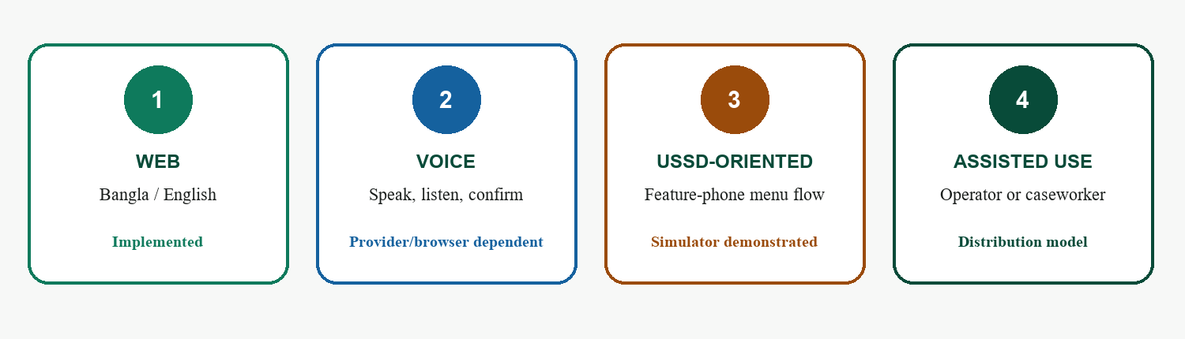
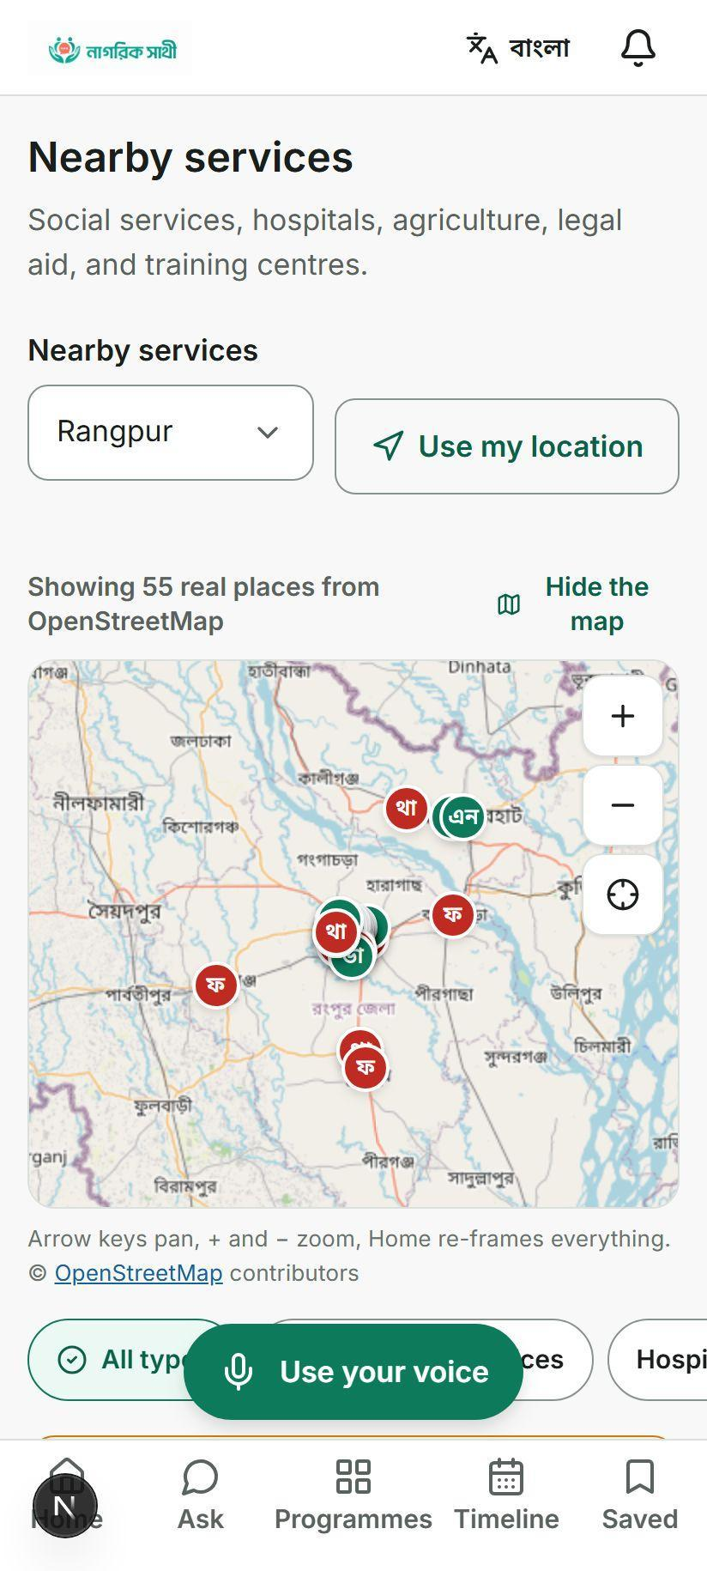
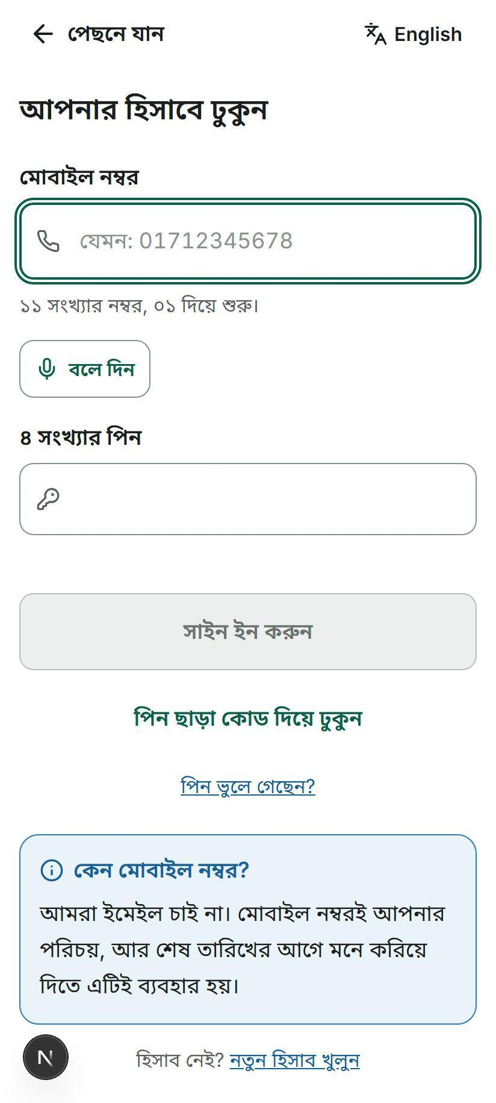

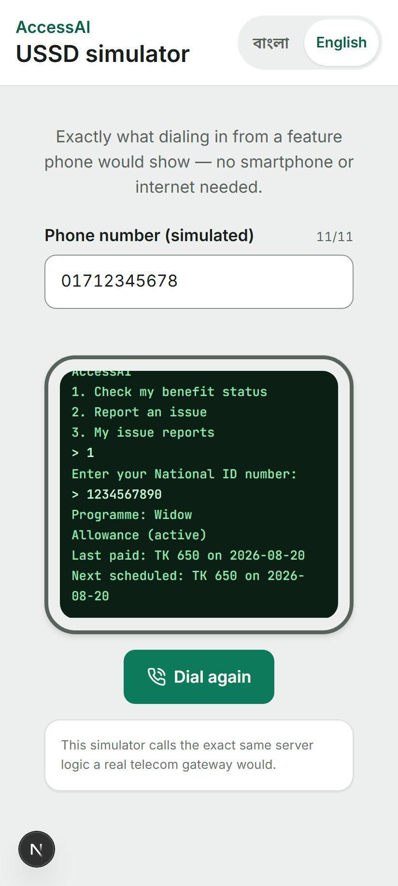
Figure 4. The inclusion model combines direct and assisted access; it does not claim full offline operation.

Prototype interface · sample data shown · USSD gateway integration is not demonstrated.
- Implemented. Bangla/English localisation, phone OTP/PIN flows, large touch targets, read-aloud/voice components, nearby-service mapping, accessible primitives and deterministic Bangla number handling.
- Provider dependent. Server speech-to-text/text-to-speech, production SMS and optional semantic embeddings require configured services; browser capabilities also vary.
- Demonstrated, not deployed. A stateful USSD simulator reuses entitlement and issue logic, but no live telecom gateway or national short code is evidenced.
- Connectivity truth. The assistant can fall back to a deterministic composer when an AI provider is unavailable, but the application is not fully offline. Maps, authentication and most workflows still require network access.

07 | SYSTEM ARCHITECTURE AND INFRASTRUCTURE
Serious enough to inspect; simple enough to operate
Shebar Janala is implemented as a Next.js 15 / React 19 / TypeScript modular monolith. It is one deployable application, but the responsibilities inside it remain separated: route handlers adapt incoming requests, domain services own business behaviour, repositories own persistence, and the civic intelligence pipeline remains independent from the interface that invokes it.
The architecture favours inspectability over unnecessary distribution. For the current scale, splitting the system into many independently deployed services would add operational complexity without improving the safety of the civic decision path.
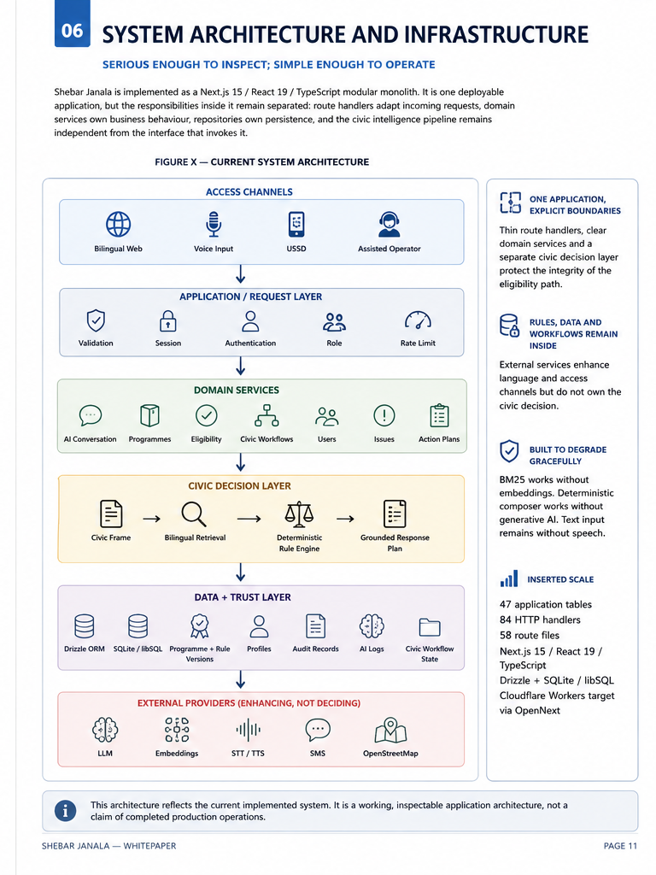
Figure 5. Current holistic architecture. External providers enhance channels; core rule evaluation and stored workflows remain inside the application.

Implementation scale
The current repository defines:
- 47 application tables
- 84 exported HTTP handlers
- 58 route files
- Next.js 15 / React 19 / TypeScript
- Drizzle + SQLite/libSQL
- Cloudflare Workers deployment target through OpenNext

Infrastructure reality
The current system deliberately does not claim infrastructure that has not been implemented.
Concern | Current state
Compute | Cloudflare Workers target; local Node.js development
Packaging | OpenNext / Cloudflare build; no container image
Queue | None; maintenance operations are currently synchronous HTTP-triggered jobs
Cache | Database-backed OSM place cache and framework/runtime caches; no Redis
Load balancing | Delegated to Cloudflare when deployed
Monitoring | Application logs, AI logs, job records and administrative views; no external APM or alerting
Secrets | Environment variables / Cloudflare deployment secrets expected
Backup | No tested automated backup-and-restore process in the repository
The architecture is therefore best understood as a working, inspectable application architecture, not a claim of completed production operations.

Optional small performance box

Operation | p50 | p95
Complete retrieval pipeline | 0.227 ms | 0.484 ms
Eligibility rule evaluation | 0.004 ms | 0.015 ms

These are development-machine microbenchmarks of local algorithms, not service-level objectives. Hosted AI latency, network latency, database contention and concurrent-user behaviour were not included.
08 | DATA AND EXPERIMENTAL EVIDENCE
Measure what the system actually does
Shebar Janala does not train a new language model. Its evidence therefore focuses on the parts the project actually implements: civic-language framing, programme retrieval, deterministic eligibility, grounding controls and executable system behaviour.
The current programme corpus contains 42 bilingual authored sample programmes from 24 named organisations across 11 categories, together with a 64-district geography registry.
These records are designed to exercise the system. They are marked unverified_sample and are not represented as a verified production corpus or as current authoritative government policy.

Evaluation evidence
Evaluation set | Size | Purpose
Programme corpus | 42 programmes / 24 organisations | Retrieval and rule execution
Retrieval benchmark | 500 queries — 250 Bangla / 250 English | Ranking regression
Rule-contract benchmark | 200 profiles across 10 programmes | Deterministic eligibility regression
Safety suite | 9 invariants | Grounding and decision-boundary controls
Bangla command probe | 33 Bangla/Banglish utterances | Command-routing regression

Retrieval performance
Retrieval system | Recall@1 | Recall@3 | Recall@5 | MRR
Keyword overlap | 56.0% | 74.0% | 79.8% | 0.670
BM25 | 62.6% | 78.4% | 84.2% | 0.721
NLU metadata + BM25 | 68.8% | 86.6% | 88.2% | 0.780
Bangla Recall@3: 80.4% English Recall@3: 92.8%
The 12.4 percentage-point language gap remains visible rather than being hidden inside the aggregate result.
Semantic retrieval exists as an implementation seam but was not scored in the submitted offline benchmark. No semantic result is simulated.

09 | SECURITY, PRIVACY AND PRODUCTION REALITY
Trust requires controls outside the AI pipeline
A civic system may process identity, location, programme history and potentially sensitive personal information. The safety of the eligibility logic therefore matters alongside the security of the application that stores and exposes those facts.
Shebar Janala implements several concrete controls in the current system, while explicitly identifying the areas that would have to be strengthened before authoritative deployment.

Authentication and access
Phone/PIN and OTP flows are implemented.
PINs use scrypt with:
N = 32768 · r = 8 · p = 1
and a random 16-byte salt.
Access JWTs expire after 15 minutes. Opaque refresh sessions last 30 days, rotate, support reuse detection and can be revoked by session or account.
The application uses hierarchical user roles together with separately scoped civic roles for union, upazila and district-level access.
Authentication and AI endpoints use database-backed token-bucket rate limits.

Data protection
Area | Current implementation
PIN storage | scrypt + random salt
Sessions | Short-lived access token + rotating refresh sessions
NID lookup | Deterministic SHA-256 hash
Sensitive field encryption | AES-256-GCM for medicalConditions
Secrets | Environment variables / intended Cloudflare secret storage
Access control | Application roles + geographic civic scopes
Rate limiting | Database-backed token buckets

Production gaps
The NID lookup hash is not a keyed blind index. A database attacker could attempt enumeration. A production deployment should migrate this mechanism to HMAC with a separately managed key and a defined migration and rotation process.
Only medicalConditions currently receives field-level AES-256-GCM encryption.
There is no independent administrative MFA, KMS/HSM/Vault integration, automated encryption-key rotation or tested backup-encryption control.
AI logs may retain up to 500 characters of input and output. Comprehensive PII redaction is not yet implemented.
No penetration test, DAST engagement, independent code audit or formal threat-model review has been completed.

10 | RISKS, SAFEGUARDS AND RESIDUAL UNCERTAINTY
Risk is part of the product design
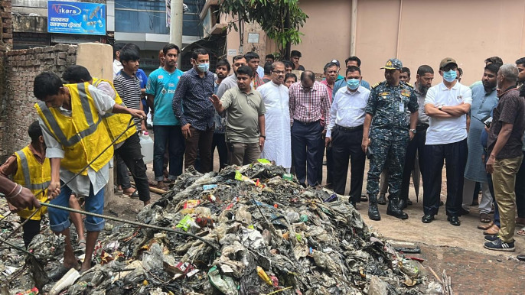A credible civic system should state where it can fail, what prevents harm, and what risk remains. The mitigations below exist partly in code and partly as deployment gates; none should be treated as a substitute for accountable human ownership.
Risk | Safeguard / deployment gate | Residual risk
Wrong or hallucinated eligibility guidance | Encoded rules decide; missing facts return ‘unknown’; replies use retrieved facts and citations; deterministic composer on provider failure; guidance is non-authoritative. | High until programme rules are verified by an accountable owner and evaluated against golden profiles.
Stale, incomplete or incorrect service data | Source URL, verification state, last-verified date, rule version, review workflow and confidence ceilings; edits to verified records revoke verification. | Human verification labour is the central operational dependency.
Privacy, identity and sensitive-data misuse | NID stored as a hash; medical conditions encrypted; purpose-based profile fields; no claim of official NID verification; minimise provider prompts and define retention before pilot. | Legal review, consent design, breach response and provider agreements are not yet demonstrated.
Language, disability or connectivity exclusion | Bilingual UI, voice/read-aloud, confirmation, accessible primitives, assisted use and USSD-oriented flow; measure task success by language and user group. | Dialect accuracy and feature-phone delivery remain unvalidated; the app is not fully offline.
Operational or institutional failure | Role/civic scopes, status histories, review queues, audit/ledger verifiers and explicit sample labels; require E2E tests, transaction safety, runbooks and named owners. | CI/CD is implemented through a GitHub Actions Cloudflare workflow that runs typechecking, tests and an OpenNext build before deployment. Remaining gaps include tested backup/restore, external monitoring and production.
Overclaiming ledger integrity | Describe SHA-256 hash chains as tamper evidence, not blockchain; route all new events through one serialised writer; verify before and after deployments. | Financial sample chain verifies eight rows; only 23 of 150 inspected audit rows form the verified chain.

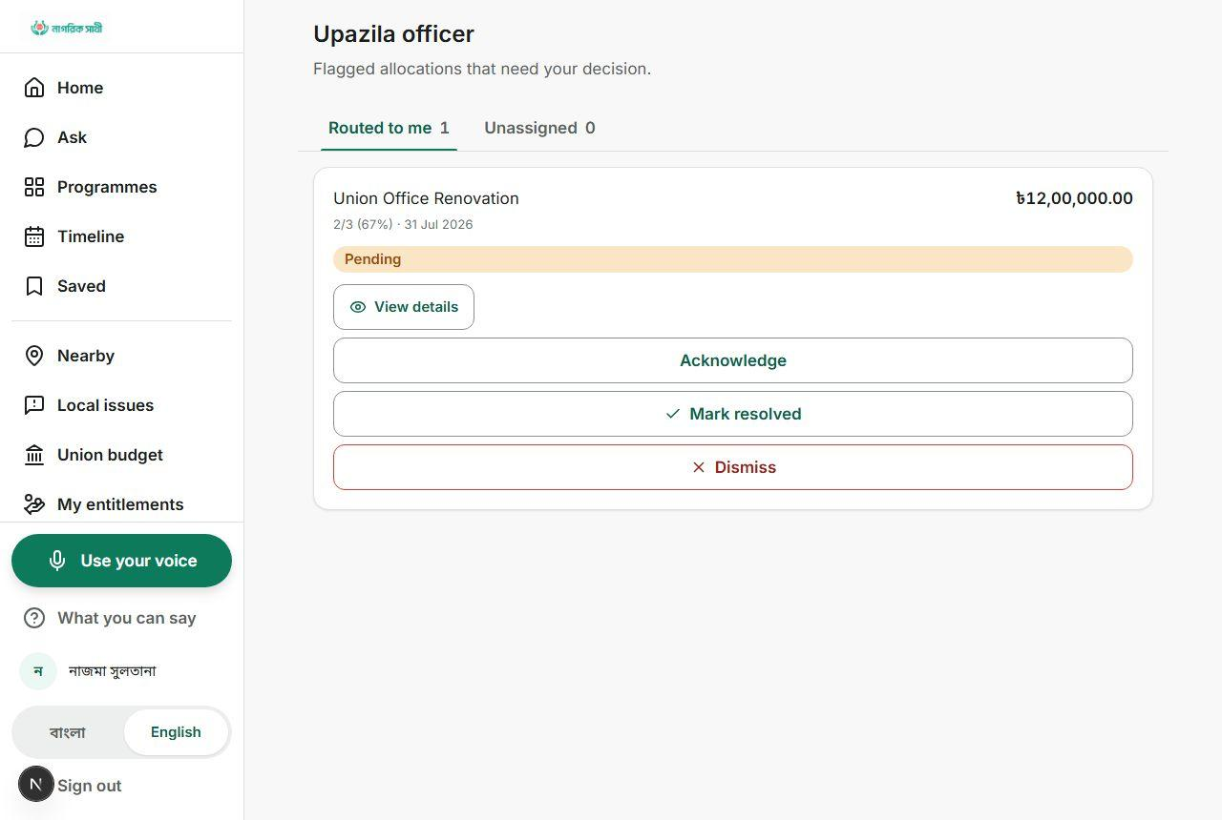
Prototype interface · sample data shown · current verification coverage is incomplete.
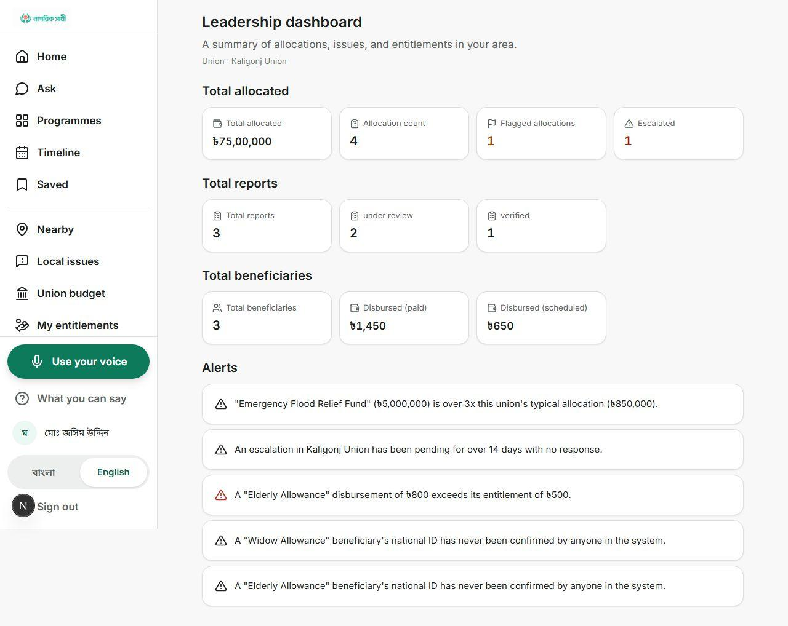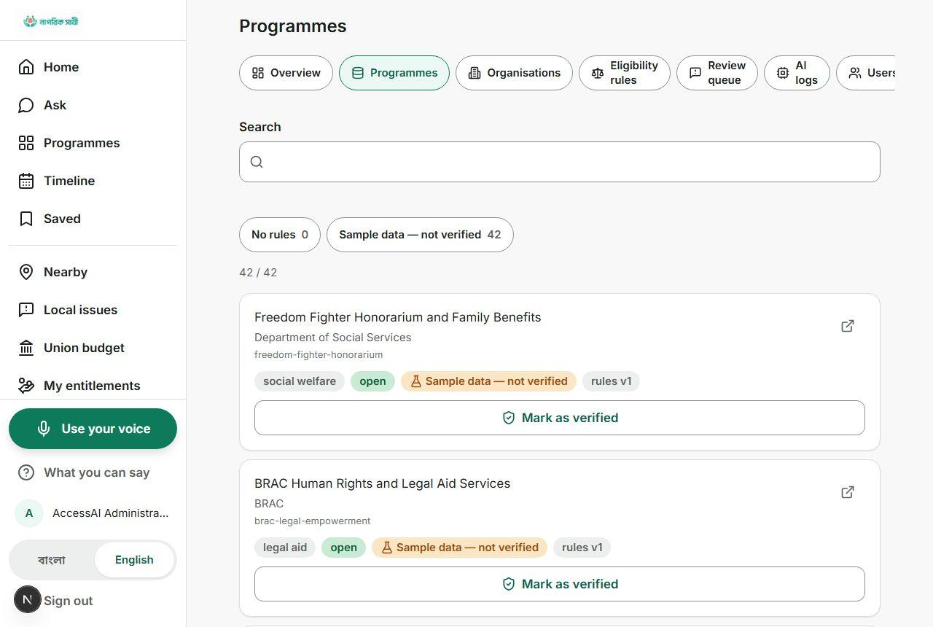

11 | IMPACT, DISTRIBUTION AND SUSTAINABILITY
Impact must be measured where the journey changes
Shebar Janala does not claim citizens reached, trips saved or benefits received. Its impact thesis is testable: if people can move from a life event to grounded guidance and a next step, while institutions maintain fresher rules and visible follow-up, fewer journeys should end in confusion or preventable rework.
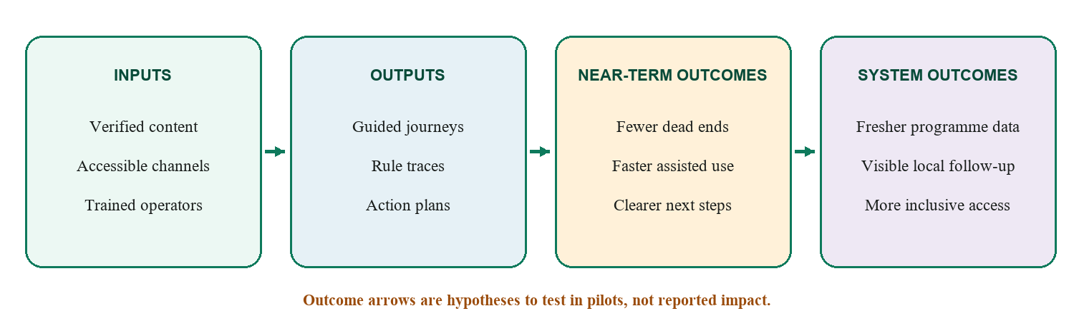
Figure 6. A measurement framework, not an impact claim.
Question | Pilot measure | Safety / equity cut
Did the person reach a usable next step? | Task completion; time to correct programme, document list or office; return-to-plan rate. | Compare Bangla/English, voice/text, assisted/self-service, disability needs and connectivity conditions.
Was the guidance correct and honest? | Golden-profile agreement; false-positive eligibility guidance; unknown/clarification rate; citation and grounding failures. | Report by programme and rule version; never hide a weak group average inside a total.
Did institutions improve delivery? | Verification freshness; operator minutes per case; issue acknowledgement/resolution time; unresolved escalation age. | Audit edits and overrides; separate prototype records from real operational data.

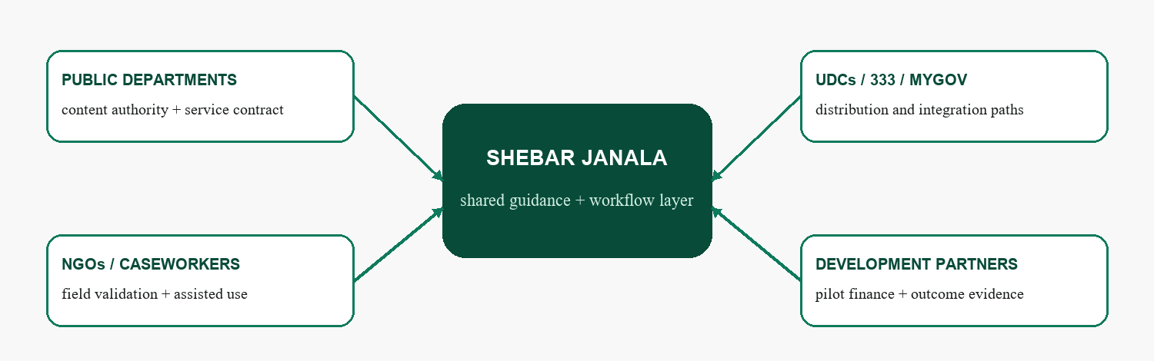
Figure 7. Potential adopters and payers; no partnership or contract is claimed.

Sustainability model. Citizens should not pay for guidance. Plausible institutional revenue includes implementation and integration agreements, annual hosted operations and support, and funded content-verification services. Development partners may fund pilots and evaluation; departments or NGOs may fund ongoing operation when caseworker efficiency and service outcomes are evidenced. Pricing and willingness to pay remain unvalidated. Citizen data, advertising and paid referrals are excluded because they would compromise trust.

12 | ROADMAP AND CLOSING
Scale only what the evidence can carry
The immediate objective is not national rollout. It is a bounded field pilot that proves three things: people can complete a real service-navigation task, encoded guidance is correct and appropriately uncertain, and an accountable organisation can keep the relevant programme data current.
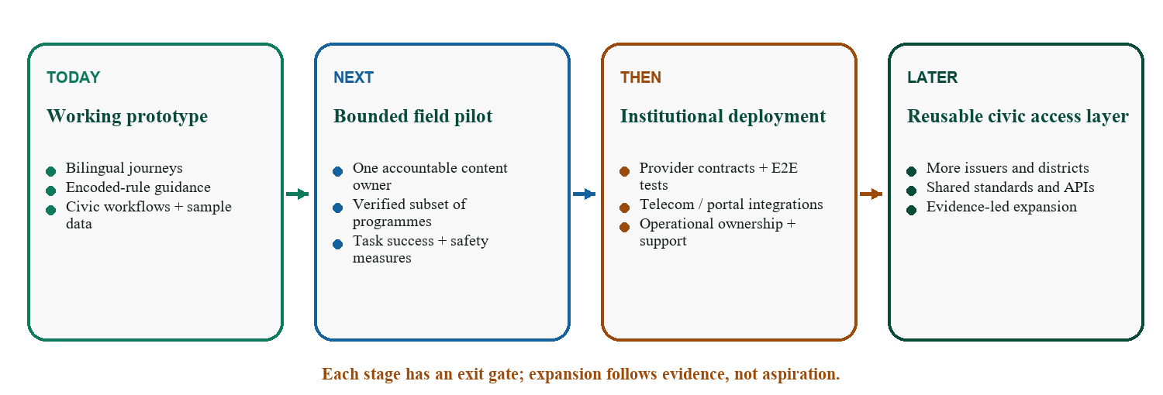
Figure 8. Expansion is gated by evidence and accountable ownership.
What exists today | What must happen next | What becomes possible later
Bilingual web journeys; phone/PIN auth; service discovery; encoded-rule guidance; action plans; maps; civic and oversight workflows; sample transparency data. | Select one accountable content owner; verify a small programme subset; repair release gates; establish consent, privacy and incident processes; run stratified field evaluation. | Live telecom and portal integrations; more issuers and districts; provider-independent speech; document-to-draft-rule assistance with human approval; third-party reuse through governed APIs.

What success would mean
Success is not that every citizen talks to an AI. It is that a person who begins with a confusing life event can understand what may apply, see why, know what remains uncertain, and take a next step without surrendering judgement to a model. It is also that the organisation behind the service can show which rule was used, who reviewed it, and what happened next.
The closing promise: a public service can exist on paper and still be absent from a person’s life. Shebar Janala is an attempt to close that distance—carefully, visibly, and one defensible next step at a time.

APPENDIX
Appendix A — Current capability and evidence ledger
Status | Capabilities evidenced
Implemented | Bangla/English shell; phone OTP/PIN and sessions; citizen profile; programme search; deterministic eligibility engine; saved status/action plans/timeline; nearby-service map; issue workflow; entitlements/beneficiaries; budget/escalation; role-scoped oversight; public transparency surface; hash-chain modules and verifiers.
Implemented with fallback | Conversation pipeline, bilingual retrieval, response plans and deterministic composer; optional LLM rendering does not own eligibility facts.
Demonstrated / sample | Seed programme corpus and civic/financial data; administrator review screens; leader/officer views; transparency aggregates; USSD simulator; format-only NID check; sample residency boundaries.
Provider dependent | Production SMS, server STT/TTS, semantic embeddings, LLM rendering, S3-compatible photo storage and live map/place sources.
Not evidenced as production | Official NID integration; live telecom USSD; institutional case routing; nationwide geofences or verified programme corpus; full offline use; production scheduler; E2E/provider-contract/concurrency testing; signed partner agreements.
Planned / appropriate next | Accountable content governance; bounded field pilot; domain speech evaluation; document-to-draft-rule assistance with deterministic validation and human approval; operational integrations after contracts and safety gates.

Appendix B — References and evidence basis
- [1] Social Security Policy Support Programme, Government of Bangladesh. Strategic Framework of the National Social Security Strategy 2026–2035 (2026). https://socialprotection.gov.bd/2026/05/strategic-framework-of-the-national-social-security-strategy-2026-2035/
- [2] myGov, Government of Bangladesh. One-stop government service portal and help materials. https://www.mygov.bd/
- [3] National Information and Service Helpline 333 / Aspire to Innovate. Official service descriptions. https://333.gov.bd/ and https://a2i.gov.bd/pages/static-pages/6922df18933eb65569e1fced
- [4] World Bank. A tech revolution helps boost Bangladesh’s development (Digital Centres overview, 2017). https://blogs.worldbank.org/en/endpovertyinsouthasia/tech-revolution-helps-boost-bangladesh-s-development
- [5] Robertson, S., and Zaragoza, H. The Probabilistic Relevance Framework: BM25 and Beyond. Foundations and Trends in Information Retrieval 3(4), 2009.
- [6] Cormack, G., Clarke, C., and Buettcher, S. Reciprocal Rank Fusion Outperforms Condorcet and Individual Rank Learning Methods. SIGIR, 2009.
- [7] W3C. Web Content Accessibility Guidelines (WCAG) 2.2. https://www.w3.org/TR/WCAG22/
- [8] OpenStreetMap contributors. Map data and attribution under the Open Database License. https://www.openstreetmap.org/copyright
- [9] Blockchain Olympiad Bangladesh. Guideline & Evaluation Scheme for Artificial Intelligence Category, 2026; and Final Round Submission Guidelines, 2026.
- [10] Project evidence. Current repository, test suite, exhaustive technical handoff, product screenshots, and whitepaper/codebase audit, evidence snapshot 2 September 2026.

