BLOCKCHAIN OLYMPIAD BANGLADESH 2026, ARTIFICIAL INTELLIGENCE CATEGORY
FINAL ROUND TECHNICAL DOCUMENTATION
Shebar Janala
A benefits-navigation and local-accountability system, and an honest account of what it does not yet do
Field | Value
Document version | 3.3
Date | 3 September 2026
Repository | github.com/i-am-mushfiq/AccessAI
Running interface name | নাগরিক সাথী (Nagorik Sathi). Shebar Janala is the submission name; both refer to this codebase.
Verification basis | Every figure re-counted from the working tree. Test and retrieval numbers produced by running the commands in Section 11.
Author | Tanjim Mahmud Rakin
How to read this document: claims are labelled IMPLEMENTED (running code you can execute), SPECIFIED (a decision fixed by this document, not yet code), or GAP (neither, with a severity and a proposed fix). Section 13 is a consolidated register of every GAP. A reviewer who only reads two things should read Section 1 and Section 13.

Contents
1. The problem, and the position this system takes
2. Architecture and trust boundaries
3. Data model, and the reconciliation gap
4. The decision layer: deterministic eligibility
5. The AI layer, with measured retrieval results
6. The governance layer: budget, escalation, ledger
7. Security and privacy
8. Reliability and failure modes
9. Operations
10. Requirement traceability
11. Validation: what is measured, and how to reproduce it
12. Access channels and accessibility
13. Consolidated known-issues register
14. Roadmap, driven by the register
15. Team and responsibilities
16. Conclusion
Appendix A. Specification decisions that remove ambiguity
Appendix B. Glossary

1. The problem, and the position this system takes
A woman in Rangpur whose husband has just died is entitled to a monthly allowance. Whether she receives it depends on facts that have nothing to do with her entitlement: whether she knows the programme exists, whether anyone can tell her if she qualifies, and whether the person she asks happens to be right. If the answer she gets is wrong, the cost is not an error message. It is a day's wage and a bus fare to a district office, or years of an allowance never claimed.
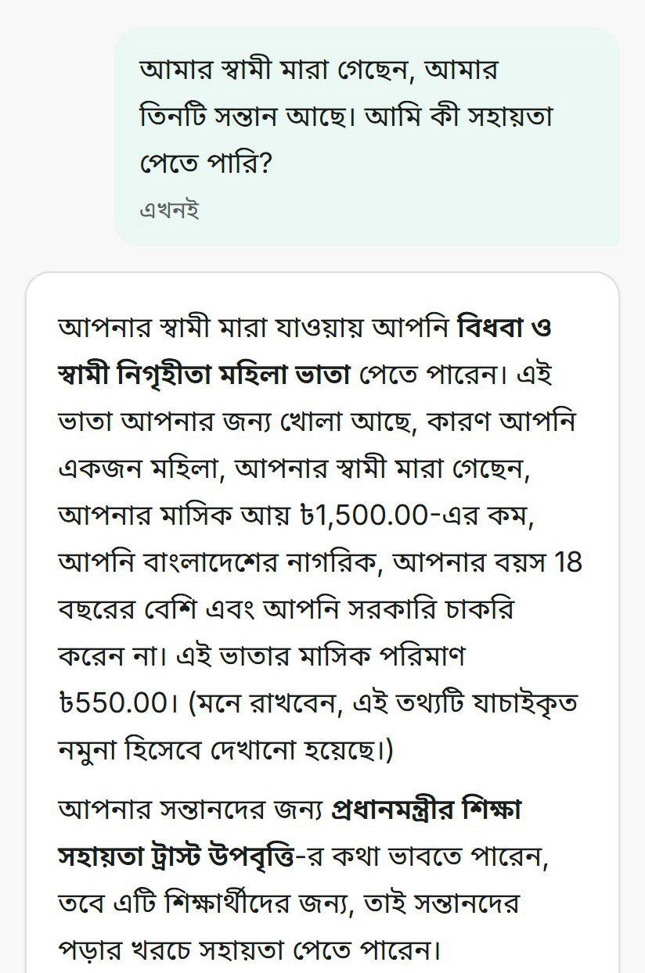
Figure 1. The running prototype answering that exact question in Bangla. The citizen describes a life event; the system names the Widow and Husband-Deserted Women Allowance and states a monthly amount.
Read the figure above with its most important caveat attached: the ৳550 shown there comes from seeded sample data. All 42 programme records in this build carry the status unverified_sample, which caps the confidence the system may display at 65 and is stated on the citizen's own screen. Nothing in this system has yet been checked against a current government circular. That is the single largest limitation in this document, it is issue R-01 in Section 13, and no engineering here fixes it. Verification is human institutional work.

The design position
Given that the expensive failure is confident wrongness, the system is organised around making wrongness detectable rather than merely unlikely. Three commitments follow, and they are enforced in types and data rather than in policy documents.
First, the eligibility verdict is a pure function of a stored profile snapshot and a versioned rule, so any decision can be recomputed months later and compared against what the citizen was told. Second, not-knowing is a first-class value: unknown is one of four possible eligibility outcomes, a missing field never silently becomes a no, a ranking factor with no data behind it reports itself unavailable rather than guessing, and a simulated identity check is stored under the literal status simulated_verified. Third, the money layer is hash-chained, so an edit to a historical financial record is detectable by re-running a script that anyone with database access can run outside the application.
This document is written to be checked. Where a claim can be executed, the command is given. Where something is missing, it is listed with a severity in Section 13 rather than omitted.

2. Architecture and trust boundaries
One Next.js 15 application (React 19, TypeScript strict) over Drizzle ORM and libSQL, organised as 19 modules behind a single deployment boundary. It runs with no external database server, no cache, and no API key. Every external dependency is optional and key-gated; with none configured the product still answers citizens, using lexical search and a deterministic text composer.
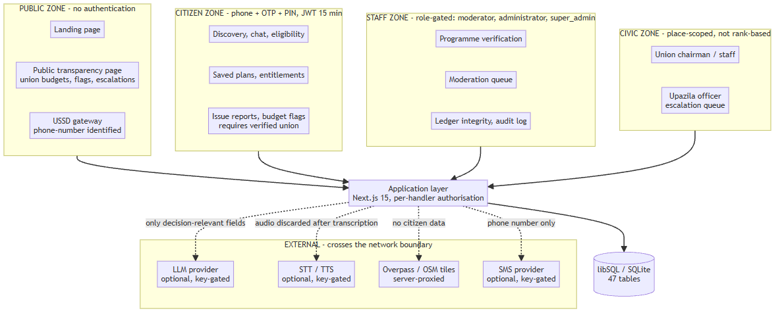
Figure 2. Trust zones and the network boundary. Note what leaves the system: the LLM receives only decision-relevant profile fields, the speech provider receives audio that is discarded after transcription, the map proxy sends no citizen data, and the SMS provider receives only a phone number.

Verified implementation figures
The whitepaper that reached this final understated three of its own numbers, and an interim draft of this document understated a fourth in the opposite direction. All four are re-counted here.
Metric | Whitepaper | Verified | Method
Database tables | 32 | 47 | sqliteTable definitions in src/lib/db/schema.ts
API route files | 31 | 58 | route.ts files under src/app/api/v1
Exported HTTP handlers | 51 | 84 | Exported GET/POST/PUT/PATCH/DELETE
Automated tests | 685 | 789 passing | npm test: 26 files, 789 tests, 7.17 s
Module domains | 19 | 19 | Directories under src/modules
Programme records | 42 | 42 | Seed corpus, all unverified_sample
Retrieval chunks | 158 | 158 | Deterministic: 34 records to 4 chunks, 6 to 3, 2 to 2

Deployment, current and target
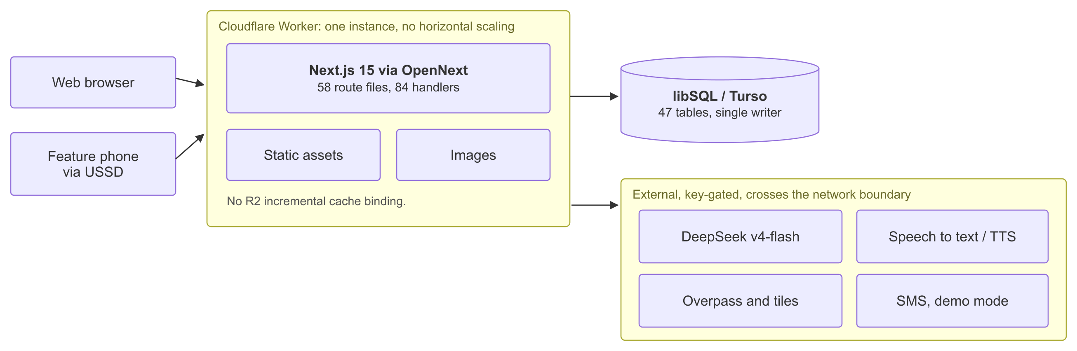
Figure 3. Runtime and deployment topology: one Worker instance, one durable store, and four optional externals, all key-gated. There is no OpenNext R2 cache binding now, so Turso holds everything that outlives a request. Four gaps in this deployment: no scheduled trigger (O-01), no backup or restore (O-02), a schema that is pushed rather than migrated (O-03), and a ledger append that assumes the single writer (G-04).
Concern | Today (IMPLEMENTED) | Target (SPECIFIED)
Runtime | Single Next.js instance on Cloudflare Workers via OpenNext | Two or more stateless instances behind managed load balancing
Database | libSQL / SQLite, single writer | PostgreSQL with pgvector for the embedding channel
Ledger appends | Read-then-write, protected by a uniqueness constraint (Section 6) | Serialised appends: advisory lock or single-writer queue, required before horizontal scaling
Inference | DeepSeek deepseek-v4-flash, named in wrangler.jsonc and gated on DEEPSEEK_API_KEY. Other providers remain optional third-party HTTP APIs | In-country host for speech and extraction where data residency is required
Background jobs | Six jobs, manual HTTP trigger only, run inline in the request | Scheduled runner with retry and a dead-letter path (GAP O-01)
Backups | None (GAP O-02) | Automated snapshot with a stated RPO and a tested restore
Caching | None. libSQL and Turso hold everything durable; the OpenNext R2 cache binding was dropped from wrangler.jsonc and open-next.config.ts to keep the deployment card-free | Re-introduce R2 or an equivalent edge cache when traffic justifies it

3. Data model, and the reconciliation gap
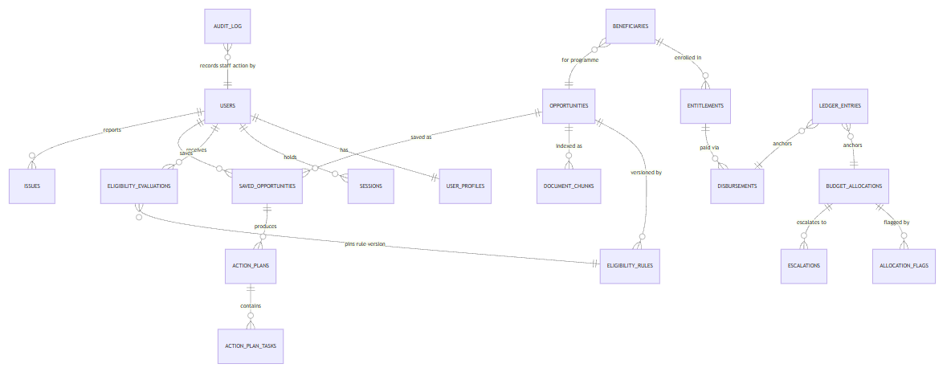
Figure 4. Core entities. The left cluster is what the system calculates for a citizen; the right cluster is what a union actually enrolled and paid. They are joined by nothing.

Two truths that never meet
The system maintains two independent records of a citizen's relationship to a programme. Eligibility evaluations record what the rules say a person should qualify for. Beneficiary, entitlement, and disbursement records record what a union actually enrolled and paid. These are correctly modelled as separate concerns, because a calculation is not an enrolment. But nothing reconciles them.
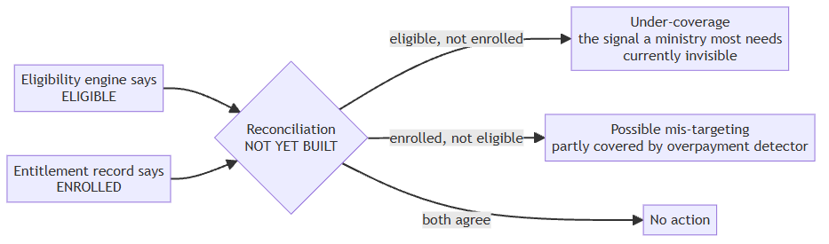
Figure 5. The reconciliation that does not exist. Five oversight detectors examine records that already exist, so the system can see money going to the wrong place and cannot see money never reaching the right one.
This matters more than any other data-model observation in this document. The five oversight detectors described in Section 6 all read tables of things that happened: allocations, beneficiaries, disbursements, escalations. Not one of them asks whether a citizen the engine found eligible was ever enrolled. The system therefore detects leakage and is blind to under-coverage, which is the failure mode the National Social Security Strategy names as the harder problem, and the one a ministry would most want a tool to surface. It is issue D-01 in Section 13.

Replayability and its limit
Every evaluation stores the citizen's full profile snapshot and the rule version applied, so a verdict can be recomputed exactly. That guarantee holds only while the meaning of those stored structures is stable: rename a profile field or change a comparator's semantics and an old snapshot replays differently or not at all. No schema version is stored alongside the snapshot. Issue D-02, low severity today because the schema has not yet changed under a live corpus, and cheap to fix now by stamping a schema version on write.

Concurrency
The codebase contains no database transactions. A repository-wide search for transaction and batch calls returns nothing. Two consequences are described where they bite: the verify-and-edit race in Section 4 and the ledger append race in Section 6. Both are issue D-03.

4. The decision layer: deterministic eligibility
The engine evaluates a validated JSON rule structure over 13 comparators against a profile: eq, neq, gt, gte, lt, lte, in, not_in, between, exists, not_exists, contains_any, contains_all. Conditions are hard (a statutory bar decides immediately) or soft (weighted, contributing to a score). No language model can reach this code path.
case 'gt':
case 'gte':
case 'lt':
case 'lte': {
const a = typeof actual === 'number' ? actual : Number(actual);
...
if (condition.operator === 'gt') return a > e ? 'met' : 'failed';
if (condition.operator === 'gte') return a >= e ? 'met' : 'failed';
if (condition.operator === 'lt') return a < e ? 'met' : 'failed';
return a <= e ? 'met' : 'failed';
}
// src/modules/eligibility/engine.ts
The outcome is always one of eligible, partially_eligible, not_eligible, or unknown. A field the citizen has not supplied yields unknown and never a negative verdict. This is the difference between a system that says no and a system that says it does not yet know, and for a benefits product that distinction is the whole ethical content of the design.
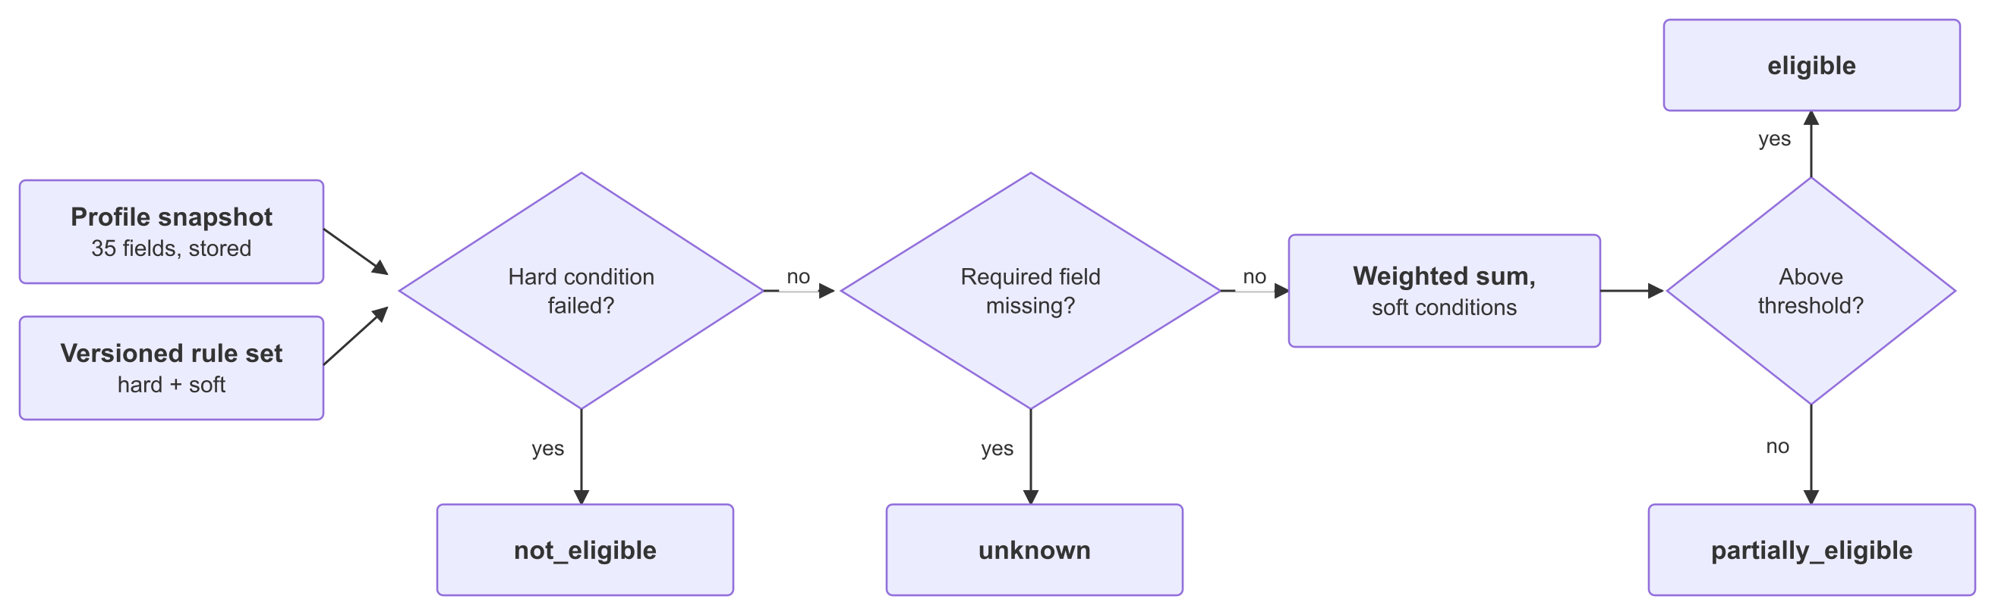
Figure 6. The decision path. A hard condition decides immediately, a field the citizen never supplied yields unknown rather than a negative verdict, and only soft conditions reach the weighted score. No language model can reach this path; the verdict is a pure function of the stored profile snapshot and the rule version, so it can be recomputed months later and checked against what the citizen was told.
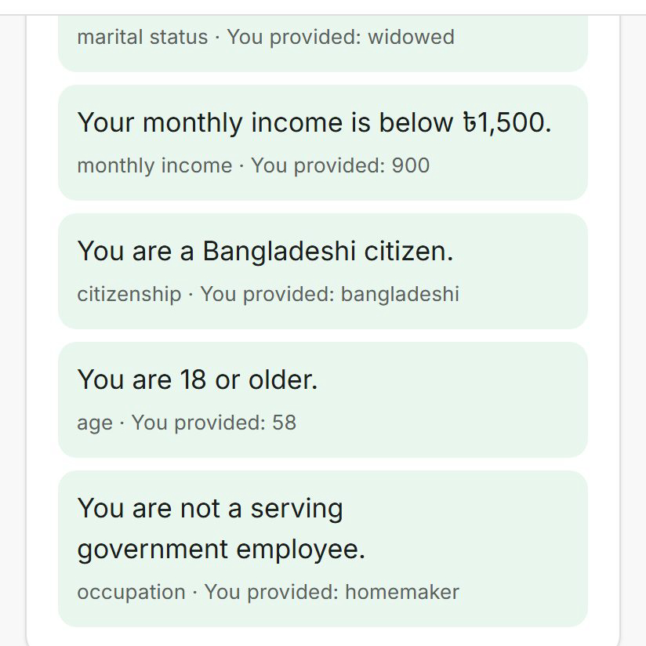
Figure 7. The per-condition trace a citizen sees. Each line names the rule, the profile field, and the value the citizen supplied, so a caseworker can audit the verdict without database access.

Verification cannot be edited into existence
Verifying a programme record and editing its content cannot happen in one request; the handler rejects a PATCH that attempts both. Editing a substantive field on a verified record forces the record back to pending review and clears its last-verified date. The race remains: two administrators acting simultaneously, one verifying while the other edits, are not serialised, because the codebase has no transactions. Specified fix in Appendix A, item 3.

Ranking never overrides the verdict
Ordering within a result set is a weighted sum: eligibility fit 40 percent, stated preference 15, location 15, deadline urgency 10, popularity 10, and a similar-user-success factor of 10 that is hardcoded to a neutral value and reports similarUserDataAvailable false to the client, because there is no outcome data to learn from. Ranking never lifts an ineligible programme above an eligible one; the weights order results inside an outcome band only.

5. The AI layer, with measured retrieval results
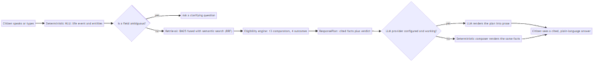
Figure 8. One citizen turn. Retrieval and the eligibility engine complete before any model is invoked, and produce the same facts whether or not a provider is configured.

5.1 Retrieval, and what measuring it revealed
Search runs Okapi BM25 (k1 = 1.5, b = 0.75, IDF smoothing) over 158 bilingual chunks, with hand-built tokenisation: Unicode-aware Bangla segmentation, a curated Bangla suffix stemmer, a Porter-style English stemmer, and separate stopword lists. A semantic channel embeds the query through a configured provider and is combined with the lexical ranking by Reciprocal Rank Fusion at k = 60, chosen over a weighted score average because BM25 scores and cosine similarity are not on comparable scales. Without an embedding key that channel returns nothing and contributes nothing.
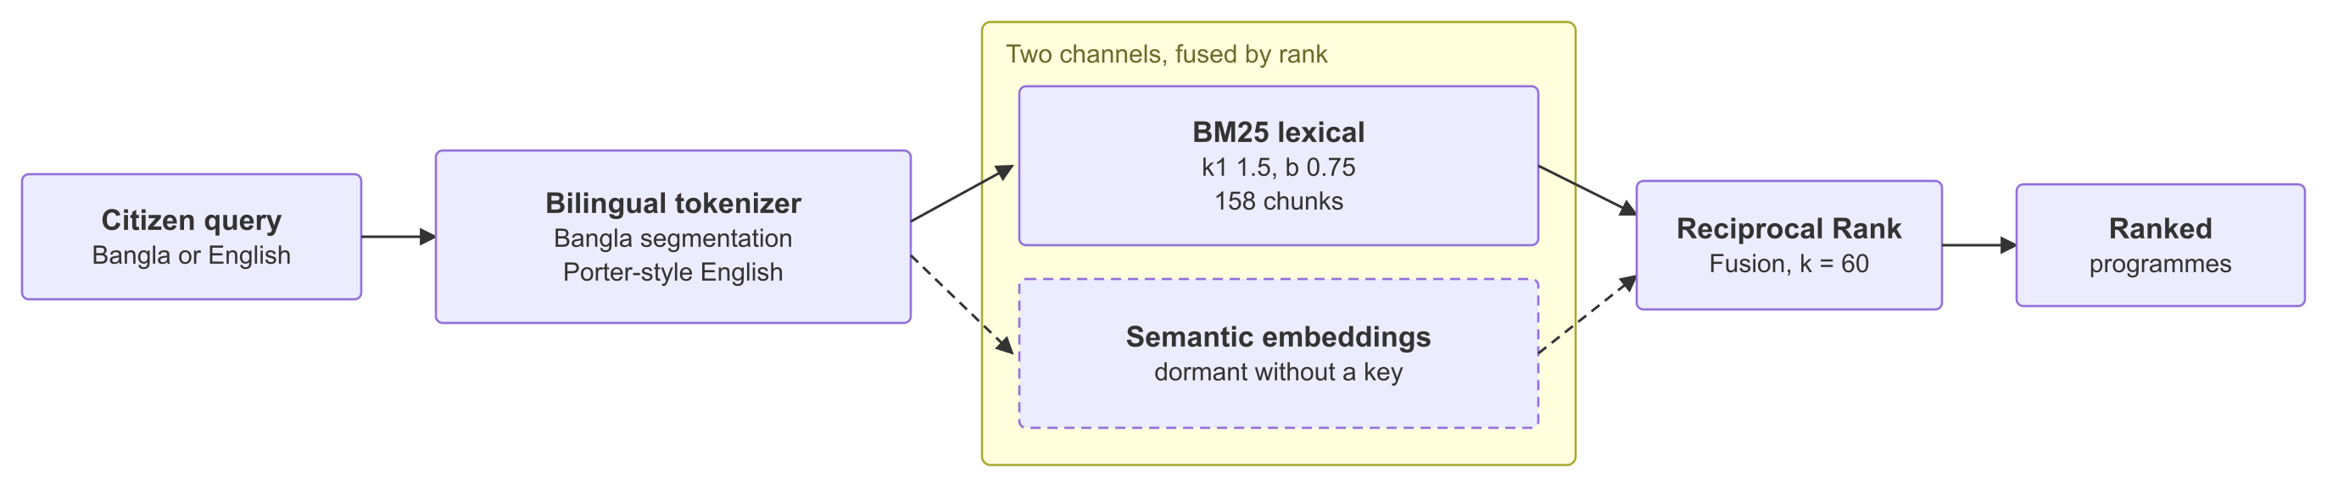
Figure 9. The retrieval pipeline. The semantic channel is dashed because it is dormant without a provider key, so every number here comes from the lexical channel alone: Recall@1 85%, Recall@3 90%, MRR 0.867 over 20 labelled known-item queries. English scored 10 out of 10 and Bangla 8 out of 10. Recall is flat from k=3 to k=10, so both Bangla failures are total misses rather than ranking problems, and the cause is morphological.
Until now the quality of that pipeline was asserted and never measured. A relevance harness was written for this document: 20 known-item queries, half Bangla and half English, each labelled with the programme records a caseworker would accept as a correct answer. It runs against the shipped retrieval function, not a reimplementation.
$ npx tsx scripts/retrieval-eval.ts
Retrieval evaluation — 20 labelled queries (10 Bangla, 10 English)
Channel: BM25 lexical only unless an embedding key is configured.
Recall@1 17/20 85.0%
Recall@3 18/20 90.0%
Recall@5 18/20 90.0%
Recall@10 18/20 90.0%
MRR 0.867
Recall@3 by language: Bangla 8/10 English 10/10
The headline number is not the 90 percent. It is that English scores 10 out of 10 and Bangla scores 8 out of 10, on a product whose entire purpose is serving citizens who speak Bangla. Recall is also flat from k=3 to k=10, which means the two failures are total misses rather than ranking problems: the correct record is never retrieved at all.
Both failures were diagnosed rather than merely counted. A query meaning "I am 70 years old and poor" fails to reach the Old Age Allowance because the corpus writes বয়স্ক (elderly) where the query says বয়স (age), and writes "no income or very little" where the query says গরিব (poor). A query meaning "a stipend for my children's studies" fails because the corpus writes উপবৃত্তি (stipend) where the query says বৃত্তি (scholarship). That second case is structural: the difference is a prefix, and a suffix stemmer cannot bridge a prefix by construction.
This is the empirical case for the semantic channel, and it is a stronger case than the assertion it replaces. Dense retrieval addresses exactly this class of failure, morphological and synonym mismatch in a low-resource language, and the harness now provides the baseline that any future claim of improvement has to beat. Enabling embeddings without re-running it would be a claim with no evidence behind it.
Honest limits of the measurement: 20 queries is small, the labels are author-created rather than independently adjudicated, and this measures retrieval mechanics only. It says nothing about whether the retrieved record's contents are factually correct, which is issue R-01 and cannot be measured until the corpus is verified. The repository's own testing notes argue that relevance work should wait for verified data; the counter-argument, adopted here, is that whether a Bangla sentence finds the right record is a matching question that is answerable today, and leaving it unmeasured is how a language gap stays invisible.

5.2 Grounded generation, and what does not check it
A deterministic layer assembles a fixed response plan (cited facts, verdict, next steps) before any model is called. A configured model then renders that plan as prose at temperature 0.3 with a 900-token ceiling. Context is deliberately narrow: only seven profile fields reach the prompt (age, gender, district, occupation, monthly income, marital status, education), conversation history is truncated to the last four messages at 400 characters each, and citations are capped at six with 320-character excerpts. Medical conditions, pregnancy, and disability status are never sent to a third-party model.
wrangler.jsonc names the provider for the deployed Worker: DeepSeek deepseek-v4-flash, with chain of thought disabled. The call still needs DEEPSEEK_API_KEY as a Worker secret, and without that key the turn degrades to the deterministic composer described below.
If no provider is configured or a call fails, a deterministic composer renders the same facts, the response is marked degraded, and the citizen is shown that badge. This fallback is the reason the model is not load-bearing.
Three grounding gaps, stated plainly. First, nothing validates the model's output against the plan it was given: no number check, no programme-name check, no citation-survival check. Grounding is enforced by prompt instruction beforehand, never by inspection afterwards (issue A-01, high). Second, the groundingFailure flag is written to the log after the response has already been persisted and shown; it is an admin metric, not a control (A-02). Third, when retrieval returns nothing the model is still invoked with the literal context string NO CONTEXT AVAILABLE, which contradicts a comment in the same file claiming the model is not called in that case (A-03). A separate citizen-visible flag, ungrounded, does render a warning banner in that situation.

5.3 Cost, latency, and timeout behaviour
Property | Value | Note
Model call ceiling | 900 output tokens, temperature 0.3 | Set per request
Provider timeout | 30 s per attempt, 1 retry, 400 ms backoff | No jitter
Route abort | 45 s, returns HTTP 504 | Two provider attempts can exceed this: a design inconsistency, issue A-04
Response caching | None | Every turn is a fresh call
Provider failover | None | One provider is selected from config and cached for the process lifetime; a dead provider degrades to the composer rather than trying another
Deterministic path cost | Zero external calls | Retrieval, eligibility, ranking, and the composer never leave the process
Unit inference cost is deliberately not stated as a figure. Token volume per turn is bounded by the settings above, but the price of those tokens depends on a vendor contract that does not exist yet, and a number invented now would be the kind of unsupported claim the rest of this document avoids. What can be said is the shape: roughly the majority of turns reach no model at all, and the deterministic path has no marginal cost.

5.4 Prompt injection
Retrieved programme text enters the model's context, and under the roadmap that text will eventually be machine-extracted from government circulars. That is a live indirect-injection surface. Today the exposure is bounded because the corpus is authored in-repository rather than fetched, and because the model cannot take actions: it renders text and nothing else, with no tool access, no write path, and no ability to change a verdict. Before any automated ingestion ships, retrieved content must be delimited and marked as data in the prompt, and extraction must be schema-constrained. Issue A-05, currently low exposure and rising the moment ingestion is built.

5.5 What has no model behind it
Life-event detection, intent classification, and entity extraction are keyword lexicons and conservative regular expressions, not trained models, and this document does not present them as AI. Three genuinely model-backed components are proposed and unbuilt: Bangla speech adaptation, learned field extraction, and circular-to-rule document intelligence. Each has a release floor it must clear before it may touch a citizen's profile: 0.98 precision on income, age, and land fields with mandatory abstention below that; word and character error rates reported per district rather than as one average; and exact field match against a human-authored answer key with a mandatory human review step. No training data has been collected for any of them.

6. The governance layer: budget, escalation, ledger

6.1 Flagging and escalation, with the real thresholds
A union allocation is posted and anchored to the ledger. Citizens can flag it. Escalation fires when at least 2 flags exist and the flag count divided by the number of registered residents of that union reaches 0.5.
export const ESCALATION_THRESHOLD_RATIO = 0.5;
export const ESCALATION_MIN_FLAGS = 2;
// src/modules/budget/escalation-rules.ts
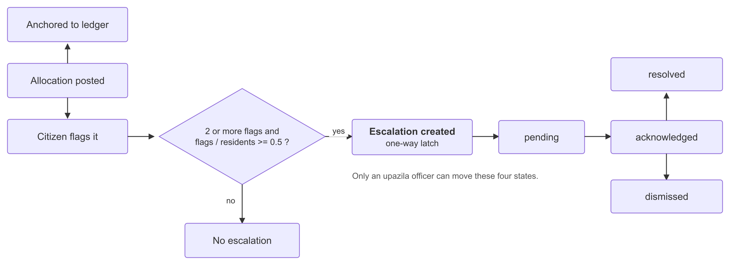
Figure 10. What happens to a flagged allocation, and the three places the chain breaks. The thresholds are the constants shown above. The denominator counts residents whose residency was never verified (G-01), the latch never re-notifies anyone as the flag count keeps rising (G-02), and nothing moves an escalation an officer ignores: no timeout, no service-level target, no automatic promotion, no reassignment (G-03).
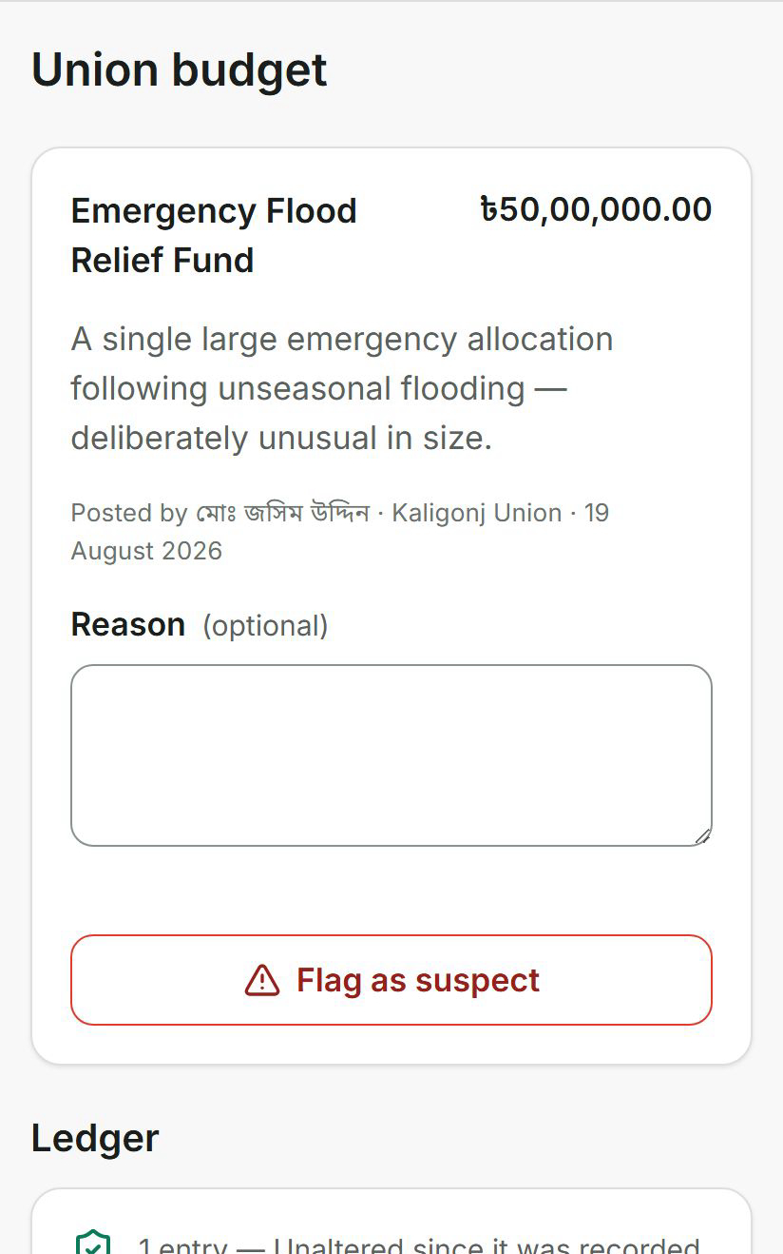
Figure 11. A seeded allocation of 50 lakh taka, deliberately sized to be anomalous, with the citizen flag control and the ledger status shown on the same screen.
Two defects in that mechanism. The denominator counts every profile whose residency union matches, without checking whether that residency was ever verified, although a verification timestamp column exists and the surrounding code and UI both call these "verified residents" (issue G-01). And because escalation is a one-way latch protected by a uniqueness constraint, a rising flag count after the first escalation never re-notifies anyone (G-02).
The larger gap is what happens next: nothing, if the officer does nothing. An escalation has four states and only an upazila officer can move it. There is no timeout, no service-level target, no automatic promotion to district level, and no reassignment. An unacted escalation stays pending indefinitely. A detector reports escalations older than 14 days as a dashboard anomaly, but that detector only runs when a staff member manually triggers the job, and reporting is not routing. This is the accountability layer failing at the exact point where accountability is the product. Issue G-03, high, with a specified remedy in Appendix A item 1.
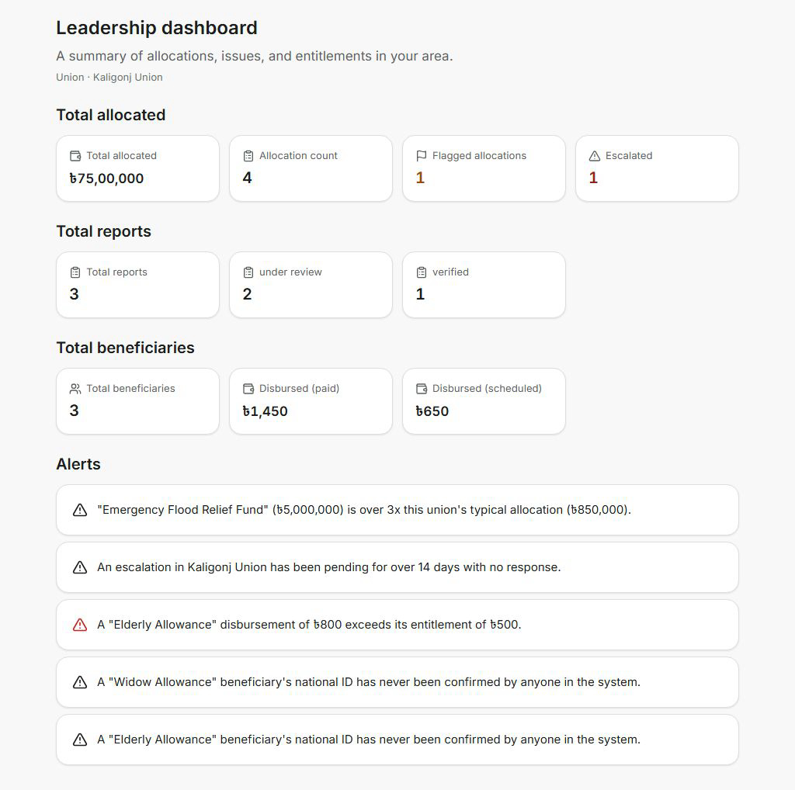
Figure 12. The oversight dashboard naming specific anomalies: an allocation over three times the union's typical size, an escalation pending beyond 14 days, a disbursement exceeding its entitlement, and beneficiaries whose national ID has never been confirmed.

6.2 The five detectors, and the sixth that does not exist
Detector | Rule | Severity
Allocation outlier | Amount over 3x the median of other allocations in the same union, requiring at least 2 comparisons | Medium
Duplicate enrolment | Same national-ID hash and programme active in more than one union | High
Unverified beneficiary identity | Active beneficiary whose ID hash appears in no verified set | Medium
Overpaid disbursement | Disbursement amount greater than the entitlement amount | High
Stale escalation | Status still pending more than 14 days after creation | Medium
Under-coverage: eligible but never enrolled | DOES NOT EXIST. See Section 3 and issue D-01. | Not implemented

6.3 The ledger, and precisely what it proves
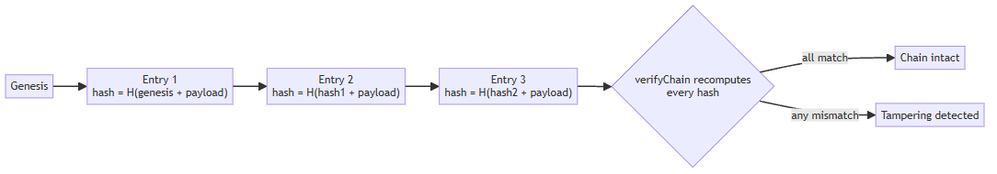
Figure 13. Each entry's hash derives from the entry before it, so an altered or removed row breaks every hash after it.
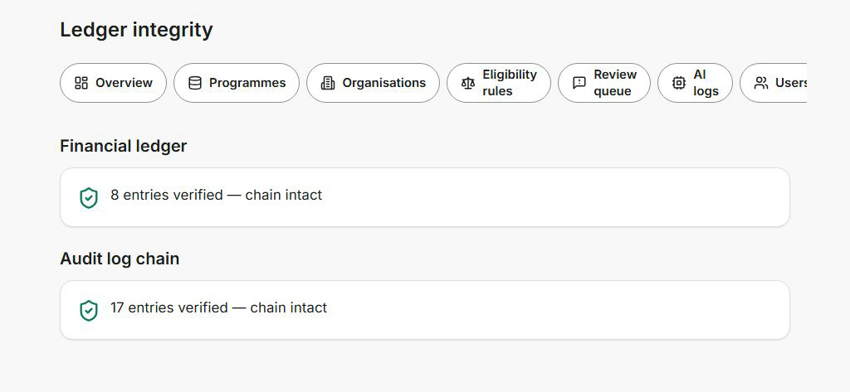
Figure 14. Both chains re-verified in the running prototype: eight financial entries and seventeen audit entries, each checked by recomputing hashes rather than reading a stored flag.
What this proves is bounded, and the code says so in its own comments before this document does. It detects alteration after the fact. It does not prevent an operator with direct database access from rewriting every row and recomputing the whole chain, because there is one writer and no independent second copy to disagree with. It is tamper-evident, not tamper-proof, and calling it a blockchain would be false: there is no distributed consensus and no external witness.
The append itself reads the current head and writes a new row in two separate statements with no transaction. A uniqueness constraint on the previous-hash column means a concurrent second writer fails loudly on insert rather than silently forking the chain, which is the right failure direction, but the losing write leaves its allocation recorded and unanchored. Ordering also depends on millisecond-precision timestamps, so two entries written in the same millisecond have ambiguous order. Issue G-04, and a blocker for the multi-instance deployment in Section 2.
The verification is independently runnable. It is a plain script requiring no server and no staff login, and it calls the same functions the administrator dashboard calls rather than a second implementation that could drift from what the application actually enforces.
$ npm run ledger:audit

7. Security and privacy
This section states what is enforced, then lists what is not. The second list is longer than a team would like, and publishing it is the point: every item was found by auditing our own code against this document rather than by a reviewer finding it later.

7.1 Controls that are implemented
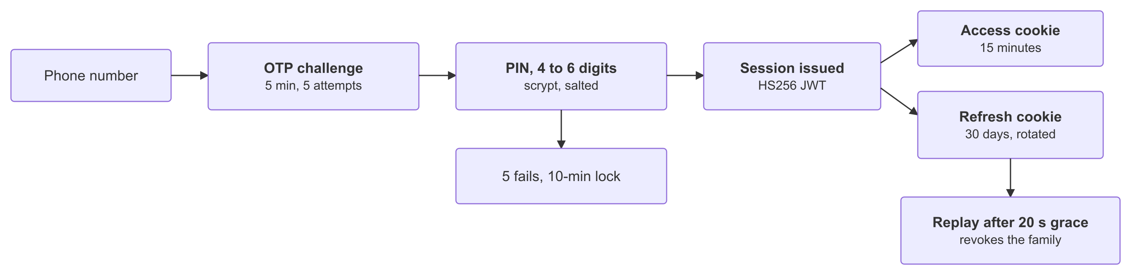
Figure 15. Authentication and session lifetimes, as the code enforces them. Three weaknesses in this flow: token-only guards read the role from the access token and never reload the user, so a demotion can lag by up to the 15-minute access lifetime (S-06); the one-time-code comparison is plain string equality rather than the constant-time comparison already used for PINs (S-08); and the demo shortcut signs in as a seeded, verified beneficiary account without touching the OTP path (S-11).
Control | Implementation
Credential hashing | scrypt, N=32768 r=8 p=1, 64-byte key, fresh 16-byte random salt per credential, constant-time comparison. Argon2id was specified originally and rejected because it needs native bindings the Workers runtime cannot load; the deviation is documented in code.
Session tokens | HS256 JWT, 15-minute access and 30-day refresh, both httpOnly and secure in production
Refresh rotation | Opaque 48-byte second factor, rotated on use; replay outside a 20-second race window revokes every session for that user and writes an audit event
Brute-force limits | OTP 5-minute validity, 5 attempts, 30-second resend cooldown. PIN 5 attempts then a 10-minute lock; trivial and repeated-digit PINs rejected
Rate limiting | DB-backed token bucket: 120 requests per minute default, 20 for AI, 10 for auth, 30 for voice
Authorisation | Role hierarchy of five roles, plus place-scoped civic authority that is deliberately not rank-based, so a national administrator is not automatically a union officer
Sensitive fields | Medical conditions encrypted at rest with AES-256-GCM and a fresh 12-byte IV per value; never sent to any model
Audit trail | Every staff mutation appended to a hash-chained log with actor, role, before and after
Browser hardening | CSP with default-src self and frame-ancestors none, nosniff, X-Frame-Options DENY, strict referrer policy, scoped permissions policy

7.2 Security issues found, with severity and fix
ID | Issue | Severity | Specified fix
S-01 | National ID numbers are stored as an unsalted, unkeyed single-round SHA-256 digest. The ID space is 10 to 17 digits, so the digest is reversible by exhaustive enumeration in seconds. The hash utility's own documentation says it is only safe for inputs with 32+ bytes of entropy, which a national ID is not. | Critical | Replace with HMAC-SHA-256 under a secret key held in the environment, or a slow KDF. Roughly a ten-line change plus a re-hash migration.
S-02 | A production safety check exists that would refuse to boot with development JWT secrets, OTP echo enabled, or no field-encryption key. It has no caller anywhere in the codebase. Earlier project documents stated that production boot is blocked; that claim was false. | Critical | Invoke it at startup and fail closed. The check is already written.
S-03 | OTP echo defaults to on in the schema, returning the one-time code in the API response. wrangler.jsonc now sets OTP_DEV_ECHO to false, so the deployed Worker is covered, but the schema default is unchanged and S-02 still has no caller to enforce it. | Critical | Flip the schema default to false and call the S-02 check at boot, so no later deployment can regress silently. The wrangler.jsonc override is a mitigation, not a fix.
S-04 | Field encryption silently falls back to a hardcoded development key when the environment variable is absent, with no environment guard, so health data can be encrypted under a key that is in the source tree. | High | Refuse to start without a real key in production. No key rotation path exists either.
S-05 | Rate limiting covers 11 of 58 API routes. The token refresh and session endpoints are unprotected, and the bucket update is read-then-write, so concurrent requests can exceed the quota. | High | Apply the default bucket globally in middleware; make the bucket update atomic.
S-06 | A suspended or demoted staff member's existing access token remains valid on routes that read the role from the token rather than the database, for up to its 15-minute lifetime. | Medium | Re-check user status on privileged handlers, as the refresh path already does.
S-07 | The public transparency page publishes per-union allocation, flag, escalation, and per-programme beneficiary counts with no authentication. With three active beneficiaries in a small union, aggregate plus local knowledge can identify individuals. | High | Suppress cells below a minimum count and round beneficiary totals into bands.
S-08 | OTP comparison is a plain string equality, not constant-time. | Low | Use the constant-time comparison already used for PINs.
S-09 | No HSTS header, and script-src permits unsafe-inline in production. | Medium | Add HSTS; move to nonce-based script policy.
S-10 | Flagging is Sybil-vulnerable: the escalation threshold rests on identity verification that is simulated, so a small coordinated group can force or bury escalations. | Medium | Treat as blocked on real identity verification; until then, cap flags per account and log flag provenance.
S-11 | The login screen carries a one-click demo shortcut, with a phone number and PIN hardcoded in the client. It signs in as a seeded account that the seed script marks a verified beneficiary in Rangpur, so any visitor can hold a verified civic identity, the credential the escalation denominator (G-01) and the Sybil argument (S-10) both rest on. The button says Rahima Khatun; the seeded account is Rahima Begum. | Medium | Put the shortcut behind a build-time flag so it cannot reach a real deployment, and strip the demo account of verified residency and the right to flag. Reconcile the two names. Until then, treat any flag or issue raised from it as unattributed.
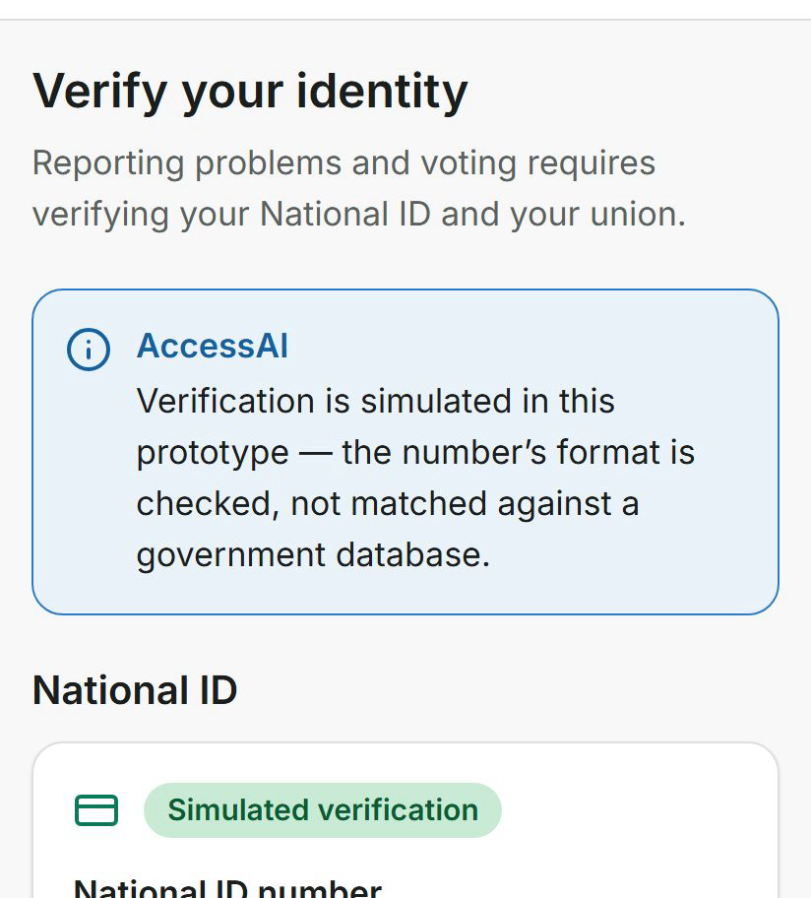
Figure 16. Identity verification tells the citizen, on the screen itself, that the check is simulated and the number is only format-checked. The honesty is in the product, not only in this document.
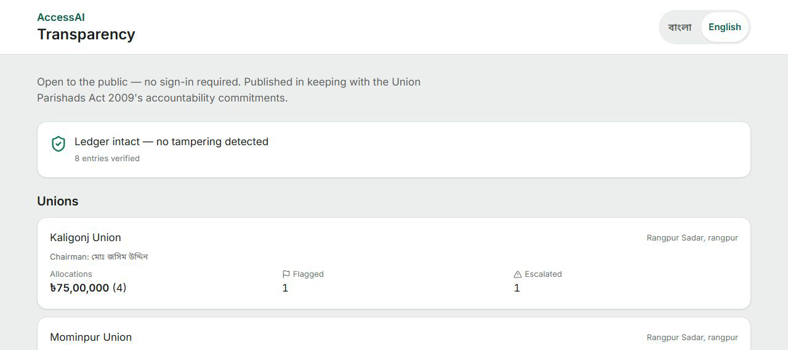
Figure 17. The public transparency page, reachable with no login. Issue S-07 concerns exactly this surface: it is the right instinct for accountability and needs small-cell suppression before real beneficiary data appears on it.

8. Reliability and failure modes

8.1 External dependency behaviour
Dependency | Timeout | Retry | Failure behaviour
LLM provider | 30 s per attempt, 45 s route ceiling | 1, 400 ms backoff | Degrades to the deterministic composer; citizen sees a degraded badge
Speech to text | 45 s | None | Fails closed; microphone disabled with a stated reason
Text to speech | NONE (issue X-01) | None | A hung provider is bounded only by the platform
Overpass / OpenStreetMap | 30 s | None, though failures are classified retryable | Seeded locations still served; map marked unavailable
Map tiles | 8 s | None | 504 and a grey grid
SMS providers | NONE (issue X-01) | None | Throws; OTP delivery fails
Vision moderation | NONE (issue X-01) | None | Marked unavailable and routed to human review, which is the safe direction

8.2 Reliability gaps
ID | Gap | Severity | Specified fix
X-01 | Three outbound calls have no timeout at all: text to speech, all three SMS providers, and vision moderation. | High | Apply the same AbortSignal pattern already used for speech to text.
X-02 | No idempotency anywhere. No endpoint accepts a client-supplied key, and disbursement and ledger writes are therefore replay-sensitive. | High | Accept an Idempotency-Key on every financial write and store it uniquely.
X-03 | No circuit breaker. Each request pays the full timeout against a dead upstream. | Medium | Trip after N consecutive failures per provider with a cooldown.
X-04 | No health or readiness endpoint, so a load balancer has nothing to probe. | Medium | Add a readiness route checking database reachability.
X-05 | Backoff has no jitter, so retries from many clients align. | Low | Add randomised jitter.
X-06 | Escalations have no terminal path when an officer never acts (see G-03). | High | Appendix A item 1.

9. Operations
ID | Operational gap | Severity | Detail and fix
O-01 | Background jobs never run on their own | High | Six jobs exist, including staleness detection and data-retention enforcement, but they are triggered only by a staff member clicking in the admin panel and execute inline in that HTTP request. A retention job that is never clicked never runs. Add a scheduled trigger, move execution off the request path, add retry and a dead-letter record.
O-02 | No backup or restore of any kind | Critical | There is no snapshot, export, or restore path in the repository. A tamper-evident financial ledger with no durability guarantee protects integrity while risking total loss. Add automated snapshots with a stated recovery objective and a rehearsed restore.
O-03 | Schema changes are pushed, not migrated | High | Deployment uses a schema-diff push with no ordered migration history and no rollback. One generated migration file exists and is applied by nothing. Adopt versioned migrations before any deployment holding real data.
O-04 | A destructive script is one word away from a routine one | Medium | The seed script deletes roughly twenty tables including the financial ledger, and the documented reset script is missing entirely, so the command in package.json fails. Remove the broken entry and require an explicit confirmation flag for destructive scripts.
O-05 | One job iterates all citizens inside a single request | Medium | Scheduled notifications loop over every citizen in one handler, bounded only by platform limits. Batch it.
O-06 | Observability is a dashboard, not telemetry | Medium | Request IDs, AI logs with model and prompt version, grounding-failure counts, and job history all exist and are visible in the admin panel, but nothing is exported to a metrics or alerting system, so no one is paged when something breaks.

10. Requirement traceability
The codebase carries requirement identifiers in comments at the point of implementation, which is the right habit and is unusual in a prototype. Four families are in use: PRD sections referencing the product requirements document, SJ items referencing the older Shebar Janala civic specification, BDS sections for the design system, and BRD identifiers for business rules.
Requirement | Where implemented | Where verified
PRD 24: eligibility must not use an LLM | src/modules/eligibility/engine.ts | tests/eligibility/engine.test.ts, 28 tests
PRD Principle 4: rules decide, AI explains | src/prompts/index.ts, engine.ts | Architecture, Section 5
PRD 17: unknown as a first-class outcome | src/lib/domain/rules.ts | tests/eligibility/engine.test.ts
PRD 31: ranking weights | src/modules/recommendation/ranker.ts | Section 4
PRD 32, 33: confidence must never overstate | src/modules/ai/confidence.ts | tests/ai/confidence.test.ts, 16 tests
PRD 90: prompts versioned outside services | src/prompts/index.ts | Prompt version written to every AI log row
SJ-13, SJ-14: audit log and financial ledger | src/modules/ledger/hash-chain.ts | tests/ledger/hash-chain.test.ts, 12 tests
SJ-16 to SJ-18: budget flagging and escalation | src/modules/budget/ | tests/budget/escalation-rules.test.ts, 7 tests
SJ-19, SJ-28: anomaly detection | src/modules/oversight/anomaly.ts | tests/oversight/anomaly.test.ts, 14 tests
SJ-31 to SJ-34: civic roles | src/lib/domain/enums.ts, civic/roles.ts | tests/civic/roles.test.ts, 7 tests
SJ-37: public transparency | src/modules/oversight/oversight.service.ts | Section 7, issue S-07
SJ-41: independent ledger audit | scripts/ledger-audit.ts | npm run ledger:audit
SJ-44: field encryption | src/lib/security/field-encryption.ts | tests/security/field-encryption.test.ts
Traceability gap T-01, medium: both requirement families point at documents that are not in the repository. The product requirements document exists only as a binary PDF, the Shebar Janala specification is not present at all, and there is no master index for either. A reviewer can see that a line of code claims to satisfy requirement SJ-28 but cannot read SJ-28. Publishing both as versioned Markdown in the repository would make this table verifiable rather than merely orderly.

11. Validation: what is measured, and how to reproduce it
Component | Method | Result | Command
Whole system | Automated test suite | 789 tests across 26 files, all passing, 7.17 s | npm test
Eligibility engine | Unit tests: three-valued logic, all 13 comparators, group combinators, weighted scoring, replayable trace | 28 tests passing | npm test
Retrieval relevance | 20 labelled known-item queries, 10 Bangla and 10 English | Recall@1 85%, Recall@3 90%, MRR 0.867. Bangla 8/10 against English 10/10 | npx tsx scripts/retrieval-eval.ts
Ledger and audit chains | Independent hash recomputation outside the application | Both chains verify; breaks report the offending row | npm run ledger:audit
Confidence scoring | Tests asserting the score can never exceed its verification ceiling | 16 tests passing | npm test
Accessibility contrast | WCAG ratios computed from the actual design tokens | 27 tests passing | npm run test:a11y
Anomaly detectors | Unit tests for all five detectors | 14 tests passing | npm test
Grounded generation | Zero-citation flag counted in logs | Metric only, no pass or fail gate (issue A-02) | Admin AI logs
Speech accuracy | Not measured | No model adapted yet; floors defined in Section 5.5 | Not applicable
Coverage gap V-01, medium: the retrieval module itself has no unit tests. The scoring arithmetic, the fusion, the metadata pre-filter, and the per-programme diversity cap are exercised only through the new relevance harness, which measures outcomes rather than pinning behaviour. The repository's own testing notes also understate the suite as five files and 119 tests; the real figures are in the table above.

12. Access channels and accessibility
A product for citizens with limited literacy and shared low-specification phones cannot assume a smartphone. Three channels exist.
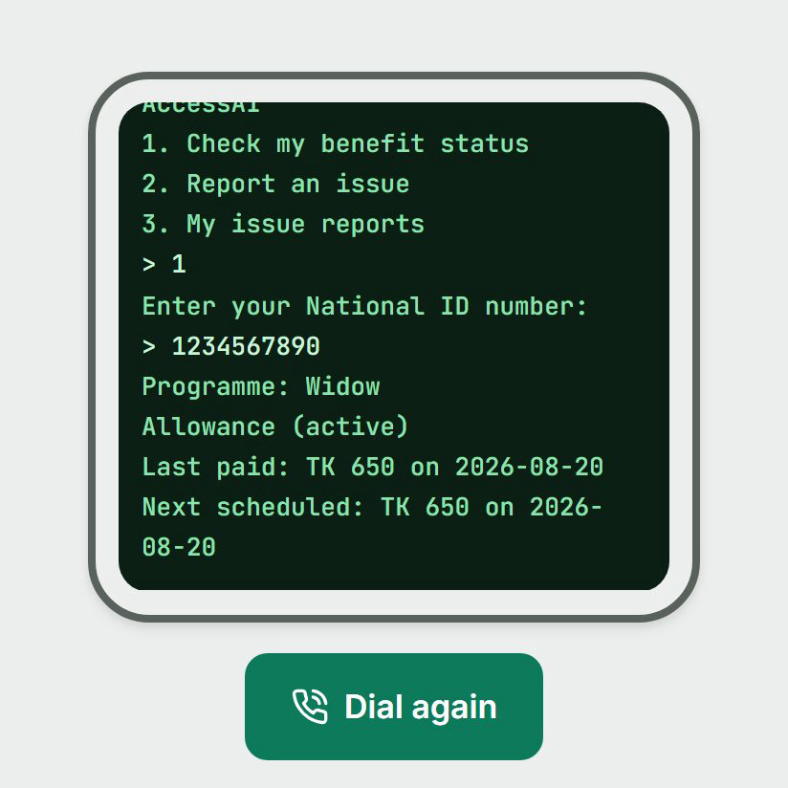
Figure 18. The USSD channel: benefit status and issue reporting from any handset, over a menu identical to what a telecom gateway would render, calling the same server logic as the web app.
Voice covers navigation, dictation, and read-aloud. Command routing is deterministic and works offline; server transcription requires a key and is disabled with a stated reason when absent. The Bangla vocabulary hint sent to the speech provider is a curated list of 26 domain phrases covering programme names, navigation words, and money terms, with a shorter command-mode variant capped at 560 characters to stay inside the model's prompt window. The team measured prompt bleed during development, where a silent recording returned a word from the hint list, and documented it rather than ignoring it.
Accessibility is verified rather than asserted: 27 tests compute real WCAG contrast ratios from the design tokens, including a documented erratum where a design specification value fell below its own stated floor.
Two later additions belong here. The login screen carries a one-click demo shortcut, so a reviewer can skip phone and OTP registration; it signs in as a seeded account marked a verified beneficiary in Rangpur, with the phone number and PIN hardcoded. Because that account carries verified civic standing, it is recorded as issue S-11 at medium severity rather than offered as a convenience. The deployment itself is reachable without cloning the repository, by scanning the QR code at public/shebar-janala-live-qr.png.

13. Consolidated known-issues register
Every gap named in this document, ranked. Nothing here was found by a reviewer; all of it came from auditing the codebase against its own claims while writing this.
ID | Issue | Severity
R-01 | All 42 programme records are unverified sample data. Every answer the system gives today rests on content no authority has confirmed. | Critical
S-01 | National ID hashing is unsalted and unkeyed, therefore reversible by enumeration. | Critical
S-02 | The production safety check has no caller; development secrets are not blocked at boot. | Critical
S-03 | One-time codes are echoed in API responses by default. wrangler.jsonc turns the echo off for the deployed Worker, but the schema default and S-02 remain open. | Critical
O-02 | No backup or restore exists. | Critical
D-01 | No reconciliation between eligibility and enrolment; under-coverage is undetectable. | High
G-03 | Escalations have no timeout, no service-level target, and no automatic promotion. | High
A-01 | No post-generation validation of model output against the response plan. | High
S-04 | Field encryption falls back to a hardcoded development key with no environment guard. | High
S-05 | Rate limiting covers 11 of 58 routes and is not atomic. | High
S-07 | The public transparency page can re-identify beneficiaries in small unions. | High
X-01 | Three outbound integrations have no timeout. | High
X-02 | No idempotency on financial writes. | High
O-01 | Scheduled work runs only when a human clicks. | High
O-03 | Schema is pushed rather than migrated; no rollback path. | High
G-04 | Ledger append is not transactional; concurrent writes fail loudly and leave records unanchored. | High
A-03 | The model is invoked even when retrieval returns nothing, contrary to a comment claiming otherwise. | Medium
A-04 | Provider retry budget can exceed the route abort. | Medium
G-01 | The escalation denominator counts unverified residents as verified. | Medium
G-02 | Escalation is a one-way latch and never re-notifies. | Medium
S-06 | A demoted staff token stays valid for up to 15 minutes. | Medium
S-09 | No HSTS; inline scripts permitted in production. | Medium
S-10 | Flagging is Sybil-vulnerable while identity verification is simulated. | Medium
S-11 | A one-click demo shortcut on the login screen hands any visitor a seeded, verified beneficiary identity, with no build-time gate. | Medium
X-03 | No circuit breaker. | Medium
X-04 | No health or readiness endpoint. | Medium
O-04 | A destructive seed script and a broken reset script. | Medium
O-05 | One job iterates all citizens in a single request. | Medium
O-06 | No exported metrics or alerting. | Medium
T-01 | Requirement identifiers reference documents absent from the repository. | Medium
V-01 | The retrieval module has no unit tests. | Medium
D-02 | No schema version stored with a profile snapshot, weakening long-term replay. | Low
D-03 | No database transactions anywhere. | Low
A-02 | The grounding flag is a post-hoc log entry, not a control. | Low
A-05 | Prompt-injection surface will open when document ingestion ships. | Low
S-08 | One-time code comparison is not constant-time. | Low
X-05 | Retry backoff has no jitter. | Low

14. Roadmap, driven by the register
Phase | Contents | Exit condition
0. Correctness before anything else | S-01, S-02, S-03, S-04, X-01, O-04. All small, all defects rather than features. | No critical security item open; no unbounded outbound call
1. Make it operable | O-01, O-02, O-03, X-02, X-04, G-04. Scheduling, backups, migrations, idempotency, serialised ledger appends. | A tested restore, and appends safe under two instances
2. Close the accountability loop | G-03, D-01, G-01, S-07, S-11. Escalation service levels, eligibility-to-enrolment reconciliation, small-cell suppression, and a build-time gate on the demo login shortcut. | An unacted escalation escalates itself; under-coverage is visible
3. Verify the corpus | R-01. Ten programmes verified against current circulars with a named reviewer. | Ten records above the unverified ceiling
4. Earn the AI claims | Enable embeddings and re-run the harness; then Bangla speech adaptation and learned extraction against the floors in Section 5.5. | Bangla recall matches English; every model meets its floor
The ordering is deliberate and may be the most important judgement in this document. The tempting order is to build the models first, because that is the category this competition is judged in. The defensible order puts a reversible national-ID hash and a missing backup ahead of a fine-tuned speech model, because a system that leaks identities or loses its ledger has no business holding either.

15. Team and responsibilities
Role | Responsibility | Holder
Product and research | Vision, civic-tech strategy, governance, partnerships, documentation | Tanjim Mahmud Rakin
Engineering | Application, eligibility engine, retrieval, governance modules, test suite | To be completed by the team
AI and data | Retrieval evaluation, planned speech and extraction work, corpus pipeline | To be completed by the team
Field and verification | Programme verification against circulars, pilot coordination | To be completed by the team
Mentor or advisor | Institutional guidance | To be completed by the team

16. Conclusion
The eligibility engine, the retrieval pipeline, the governance layer, and both hash chains are real, tested, and runnable by anyone who clones the repository. The measurement in Section 5 is the first honest quality number this project has produced about its own AI, and it found a language gap in the direction that matters most. The register in Section 13 lists 37 things that are wrong or missing, ordered by how much they could hurt a citizen.
A reviewer is entitled to ask which of those two facts is the real state of the project. The answer is both, and the second is why the first can be trusted: a system whose weaknesses are enumerated with severities is one whose strengths were probably measured the same way. What remains before this touches a real beneficiary is not a longer feature list. It is a corpus somebody with authority has verified, a national identifier that cannot be reversed, a backup that has been restored at least once, and an escalation that escalates itself when nobody is listening.
For a widow in Rangpur, none of that is abstract. She is not helped by an eligibility engine that is elegant, nor harmed by a hash chain that is only tamper-evident. She is helped when the amount on the screen is one a government office will honour, and when the flag she raises about her union's money reaches somebody who has to answer for it.

Appendix A. Specification decisions that remove ambiguity
A reviewer asked whether two competent engineers reading this document would build the same system. In eight places the honest answer was no. Each is now fixed by decision, with implementation status marked.
# | Question | Decision | Status
1 | What happens to an escalation nobody acts on? | Acknowledgement is due within 7 days and resolution within 30. At 7 days it is reassigned to any officer in the upazila; at 14 it is promoted to the district tier and marked overdue on the public page. No escalation may rest in pending indefinitely. | SPECIFIED
2 | What exactly is the escalation denominator? | Residents of the union whose residency verification timestamp is present. The current query omits that filter and must be corrected. | SPECIFIED, code differs
3 | How is the verify-and-edit race resolved? | Optimistic concurrency: every programme record carries a version, a mutation supplies the version it read, and a mismatch is rejected. | SPECIFIED
4 | Which missing field does the system ask about next? | The field appearing in the most unresolved conditions across the candidate set, one question per turn, stopping after three consecutive unanswered questions. | SPECIFIED
5 | How do confidence and eligibility outcome compose? | They do not, and this must be stated in the interface. Confidence expresses certainty about the data; the outcome expresses the verdict. A confident not_eligible and a confident eligible are both possible and mean different things. | IMPLEMENTED, undocumented in UI
6 | What reconciles eligibility against enrolment? | A nightly comparison producing an under-coverage report per union, listing citizens the rules find eligible with no matching entitlement. | SPECIFIED, not built (D-01)
7 | What happens if the model fails mid-render? | The deterministic composer answers, the turn is marked degraded, and the evaluation persists regardless. A route-level abort returns 504 without a composed answer, which is inconsistent and should also fall back. | PARTLY IMPLEMENTED (A-04)
8 | Who can see beneficiary-level data across unions? | Union officers see their own union only. Upazila officers see aggregates across their unions and beneficiary identifiers only within a flagged anomaly. Donors see aggregates only. The public page sees suppressed aggregates. | SPECIFIED, partly enforced

Appendix B. Glossary
Term | Meaning
Union | The smallest rural administrative unit in Bangladesh, governed by an elected Union Parishad council
Union Parishad | The elected council of a union; the Union Parishads Act 2009 obliges it to publish budget information
Upazila | Sub-district, the administrative tier above a union
Zila | District, the tier above an upazila; Bangladesh has 64
UDC | Union Digital Centre, a staffed local point where citizens get help with online government services
NID | National Identity Document number, 10, 13, or 17 digits
USSD | A text menu protocol working on any mobile handset without internet
Taka | Bangladeshi currency, written ৳. One lakh is 100,000
BM25 | A standard lexical ranking function scoring term overlap between a query and a document
RRF | Reciprocal Rank Fusion, a way of combining two ranked lists by position rather than by score
Recall@k | The share of queries where a correct answer appears in the first k results
MRR | Mean Reciprocal Rank, the average of one divided by the position of the first correct answer

