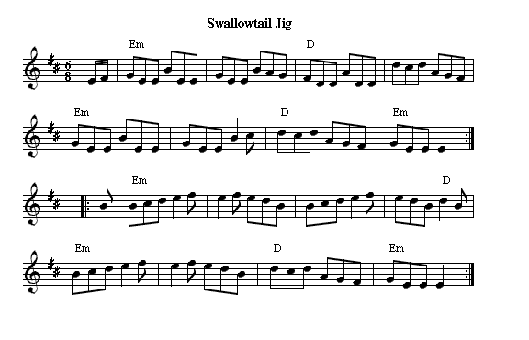

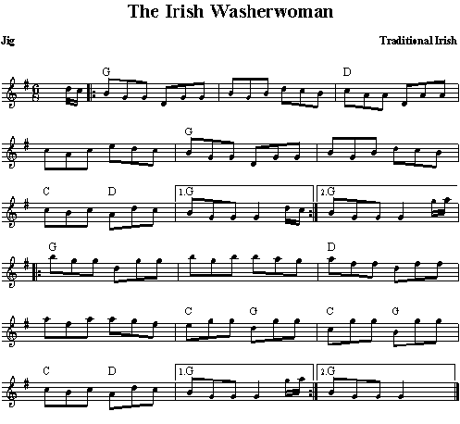

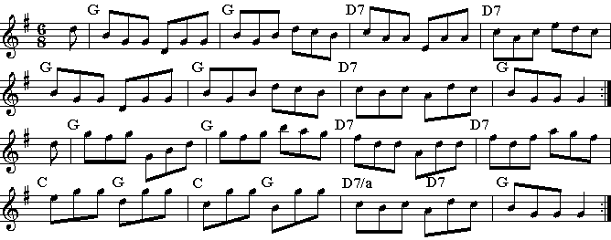
Garry Owen

//: D / D / G-D / A7 / D / D /F#m-Bm / Em-A :/
//: D / D / G / G / D / D / F#m-Bm / Em-A ://
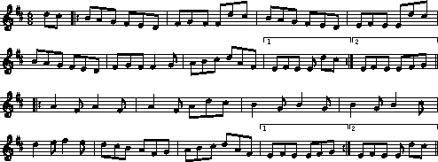

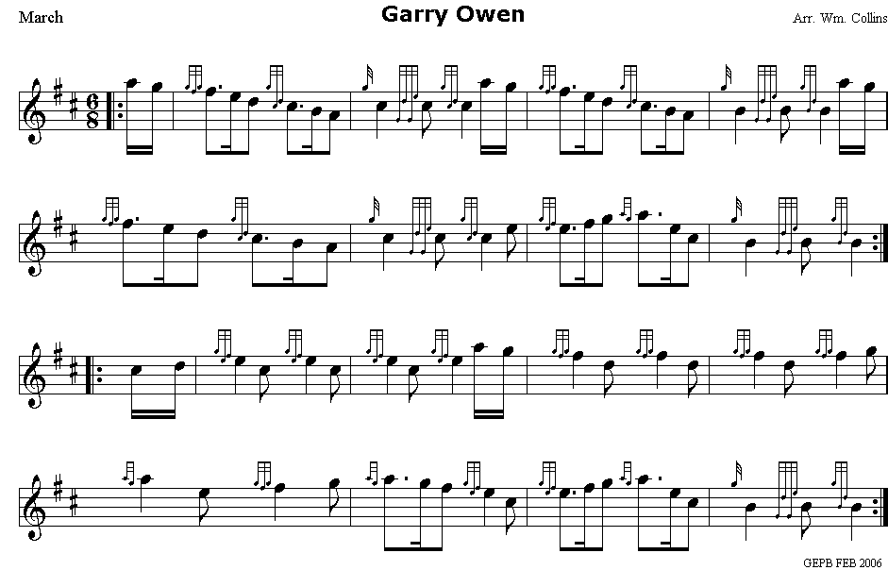

Saint Anne’s Reel

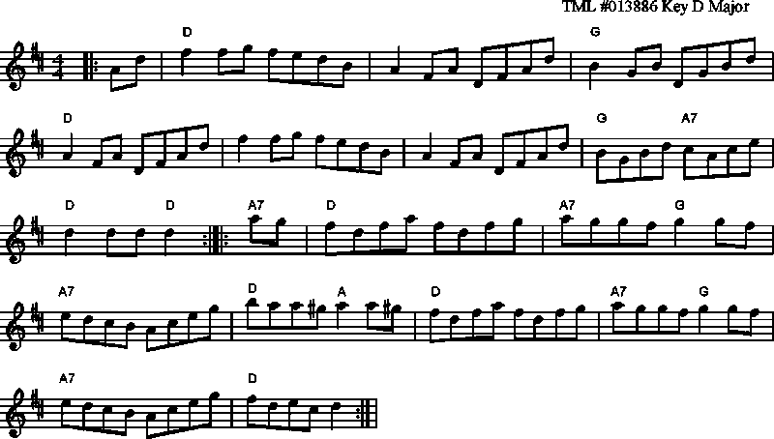

Dill Pickle Rag
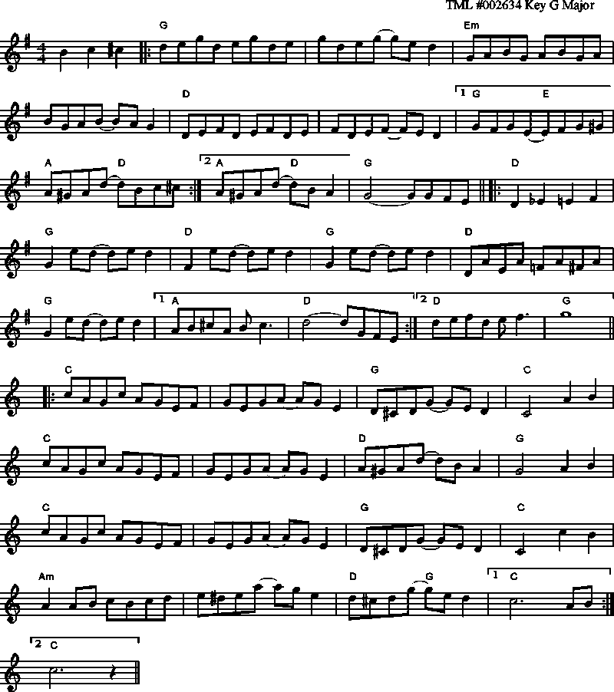

http://www.celticguitarmusic.com

