**PROJECT TOPIC**

**DESIGN AND IMPLEMENTATION OF ELECTRONIC TICKETING SYSTEM**

(A CASE STUDY OF NATIONAL THEATRE IGANMU, LAGOS)

**ABSTRACT**

This project was centered on electronic ticketing system. The current process of management is being operated manually and due to this procedure numerous problem are been encountered. A design was taken to electronic ticketing the manual process in order to check this problem.

The problem were identified after series of interviews and examination of documents after which analysis was made and a computerized procedure recommended. This project will also suggest how to successfully implement the computerized procure and to overcome the obstacle that would hinder the successful implementation of the system.

The new system was designed using Microsoft visual basic 6.0 programming language. This language was chosen because of its easy syntax and features of developing windows based applications.

**CHAPTER ONE**

**INTRODUCTION**

* 1. **BACKGROUND OF THE STUDY**

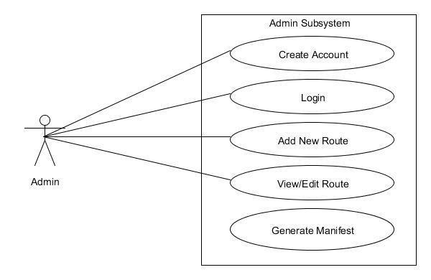In the advanced world like China, Britain, Australia and the United State of America, ticketing system are usually automated with the use of internet and e-commerce. Smart cards are usually used to make payment and ticket generated after. The use of electronic ticketing system has increasingly helped to address the problem of long queue and time wastage problem. An electronicticketing system is a computerized system that is designed to collect, store and retrieve information as well as conduct transactions related to customers. The idea behind a web-based electronic ticketing and payment system was originally designed and incorporated by airlines operators.  
E-tickets or card indicates that its holder has right to a specified service, rightor consideration. Electronic tickets (e-tickets) give evidence that their holders have permission to enter a place of entertainment, use a means of transportation, or have access to some internet services (Wee Kim Li, 2007). E-ticket system is an easy and quick way to pay for train services. Electronic ticketing is a way of documenting sale, checking ticket usage and accounting for customers without the traditional usage of paper “value documents”. Customers can make payment and print their e-tickets ubiquitously. Electronic ticketing system is an essential system designed to address the problem of long queue and unnecessary time wastage associated with electronic ticketing. Ticket counter is generally associated with long queue; the problem is so clear and visible that it demands an urgent step in addressing the situation. The customers also experience stress and frustration. Reasons for the long queue that is associated with the traditional electronic ticketing includes the limited counters available to deal with customers at peak time and transaction time (the time it takes the person at the service point to issue ticket and handle the "change" problem).  
Making payment online saves time as payment can be made anytime around the world. It also gives the electronic corporation insight into what logistics will be needed for. The aim of the system is to make electronic ticketing quick, easy and less frustrating. The system attempts to reducethe service time of checking route and obtaining train ticket.  
The System will make it possible for electronic customers to manage their payment electronically, and the administrators to work on the databases in a user friendly manner. The customers are to register online before getting access to the database. Once a user is registered, the user has an account which the user can use for query. The user can check availability of electronic service for a particular day, make payment and print the electronic ticket. The user account will contain adequate information about the user entered during the registration and will also allow the user to get access to his previous transactions, make enquiry payment and update his account. The electronic administrator is required to login using an administrative password, once the password is authenticated, the administrator will have access to register another administrator, modify all the information stored in the database of the system. The information stored in the database will include; description of the train stoppages attributes and statistics of stations, and physical description of coaches, all the reservations that have been made, etc.

* 1. **STATEMENT OF THE PROBLEM**

The current system that the electronic corporation make use of is an internal system (counter system). The counter system can only service all customer need from one point. Customers will have to go to the counter in order to make enquiry. The customers will have to stay on the queue for long hour before been attended to. This counter system of attending to customers gave rise to a number of problems, some of which are;

i. Inefficient customer service which leads to long queue during peak period (productive time is wasted on the queue).

ii. Business manager lacks the capacity to provide specialized service because they don’t have real time information.

iii. Poor financial management.

iv. No customer database.

* 1. **AIM AND OBJECTIVES OF THE STUDY**

The aim of the project work is to develop a system that will handle electronic ticketing process electronically. This is achieved by the following objectives;

i. To analyze the existing system and determine its weaknesses.

ii. To design a system that allows electronic customers.

iii. To design a system that will reduce the cost of management associated with electronic ticketing.

* 1. **SCOPE OF THE STUDY**

The scope of this project is to design a system that provides electronic customerwith adequate information, register the personal data of the intending customer, allow customer to check service availability and also make payment electronically.

* 1. **LIMITATION OF THE STUDY**

The system is limited to checking electronic service availability, electronic payment and e-ticket generation. The system will not handle reservation without payment.

* 1. **SIGNIFICANCE OF THE STUDY**

It is expected that the design and implementation of a system to automate electronic ticketing will unveil. The benefit of the system will be looked at from two perspectives;

**1.6.1**Significance of the system for the Electronic Service Operator

i. Better control of revenues

ii. Gain new customers with modern approach

iii. Reduce operation and maintenance costs

iv. Increased speed at boarding once the delay in transaction (ticketing process) has been removed.

v. Valuable opportunities to add “new services”.

**1.6.2**Significance of the system for the customers

i. Easy way to purchase their travel pass

ii. Convenient as it can be done by anyone and anywhere with an internet connection.

* 1. **OPERATIONAL DEFINITION OF TERMS**

The following are the definitions of some of the basic terms used in the study:

1. Ticketing: The process of producing and selling tickets/slot for an event, service or sport game.
2. Ticket: A paper slip or card indicating that its holder has paid for or is entitled to a specified service, right or consideration.
3. Nigeria Electronic Corporation (NEC): Nigeria Electronic Corporation is the state-owned enterprise with exclusive rights to operate electronic in Nigeria.

**CHAPTER TWO**

**LITERATURE REVIEW**

1. **Introduction**

Existence of virtual markets, customers and stores that have not occupy any physical space, allowing access and circulation in these markets for a moment and anywhere in the world without leaving home is possible with information technology. Technology has open up new ways of doing business.

1. **Electronic Commerce**

Using the internet and other digital technology to organize, coordinate and manage a firm is gradually becoming a must in today’s business has triggered the growth of electronic commerce. Electronic commerce refers to the process of trading goods and services electronically. E-commerce transaction simply refers to the sale or purchase of goods or services over the Internet (TorbjörnFredriksson, 2013). It encompasses all the activities supporting those market transactions, such as marketing, payment, advertising, customer support and delivery. Replacing the paper-based and manual procedure of doing business with electronic alternative accelerate ordering, delivery and payment for goods and service while also reducing the operational cost of the firm. Laudon, K. and Laudon, J. (2006) viewed internet as the major technological platform for electronic commerce. Likewise significant is the fact that technology facilitates the management of the rest of the business. Companies can now take the full advantage of the internet technology to create what is called intranet (internal corporate network).

**2.3 Types of Electronic Commerce**

Electronic commerce comes in different form. Classified e-commerce

Into:

* 1. **Business-to-business:** This class of electronic commerce currently perceived as the mostimportant segment of e-commerce, it represents the supply of goods and services between companies (manufacturers, suppliers, distributors, retailers, etc.) in order to obtain the final economic assets.
  2. **Business-to-consumer:** Business-to-consumer is the second element of e-commerce and itis centered on satisfying consumers’ need
  3. **Business-to-government and government-to-business:** Business-to-government andgovernment-to-business represents the ways in which business transactions take place between the companies and public sector. In business-to-government, companies carry out activities that will benefit the public sector (procurement contracts, auctions, etc.) while in government-to-business, the public institutions work out the legal framework and opportunities available for the private sector.
  4. **Consumer-to-consumer:** This is the type of trade between buyers and individuals. One ofthe best examples is eBay with his e-auctioning system.

1. **Benefits of Electronic Commerce**

Previous sections discuss what e-commerce is, but why e-commerce and what do the major actors stand to gain? The benefits of electronic commerce can be seen in three fold; benefits to the society, organizations and the consumers.

1. **Benefits of Electronic Commerce to Organizations**
2. **International marketplace:** The one time physical market place that is characterized bygeographical boundary has now become a borderless marketplace. Integrating commerce into the internet makes business accessible to people all over the world.
3. **Reduced Operational Cost:** Cost of creating, processing, distributing, storing andretrieving paper-based information has been greatly reduced.
4. **Digitizing products and processes:** Services such as shopping and ticketing can bedigitized via the internet.
5. **24/7 business:** Businesses can be conducted at any time of the day.
   1. **Benefits of Electronic Commerce to Consumers**
6. **24/7 access:** Customers can conduct business transactions 24 hours a day, all year round.For example, checking balances, making payments, obtaining travel and other information.
7. **More choices:** Customers can have a whole range of products and services that they canchoose from.
8. **Price comparisons:** Customers can visit a number of sites to check their price and thenmake an informed decision.
9. **Improved delivery processes:** Product and services can be delivered digitally or viacourier service in a timely manner.
   1. **Benefits of Electronic commerce to Society**
10. **Enables more flexible working practices:** The working practices of people can becomemore flexible with the emergence of electronic commerce. People can now work from anywhere in the world which invariably improves the quality of life.
    1. **Connects people:** People from all nations of the earth can now enjoy the same serviceswhich would have been unavailable to those in the developing and under-developed nation.
11. **Challenges of Electronic Commerce**

TorbjörnFredriksson (2013) opined that as good as automating world commerce is, it is still faced with a number of challenges. These challenges are:

* 1. Cost of technological infrastructure (Internet, broadband)
  2. The level of ICT literacy among the major actors
  3. Means of payment (e-payment system)
  4. Means of delivering goods (physical means of transportation)
  5. Tracking, monitoring and taxing transactions
  6. Legal framework to build trust
  7. Risk of bias/unfair competition

1. **Electronic Ticketing System (E-ticketing)**

In the view of Pedone (2001), widespread use of internet has led to the emergence of a variety of electronic services (e-services). Electronic ticket (e-ticket) which is an example of such services (e-service), gives evidence that the ticket holders have permission to enjoy a service or enter a place.

Ticketing is a tool for the implementing pricing policy with the consideration of operational, commercial and social objectives. The ticketing system is the translation of fares into concrete means of payment and fare collection on the part of the operator (Mohamed Mezghani, 2008). Wikipedia defined electronic ticket (commonly abbreviated as e-ticket) as a digital ticket.

The electronic tickets (e-tickets) is an integrated pass, it is a ticket with seat reservations details, product detail (class of reservation), schedule information, and payment detail on a single piece of paper/card. The electronic ticketing system is easy to use through a quality web browser. With the emergence of electronic ticketing systems, customers can make reservation and payments online - payments can be made with smart card –and then customerscan print e-ticket. E-ticket solution is all about producing ticket coupon in electronic format.

One of the main objectives of electronic ticketing system is to optimize the cost of distribution of tickets.

1. **Benefits Electronic Ticketing System**

Although electronic ticketing is still and evolving ticketing system, it is an interesting field to study. Thus, it is still very early to access or judge the cost-benefit implication of e-ticketing. The electronic ticketing system in transport is a potential system in Nigeria with a number of benefits. Frankly speaking, electronic ticketing offers a wide range of possibilities and benefit in the subsector of the economy.

According to NTU (2004) a series of such possibilities can be identified:

* 1. More easy integration
  2. Better control and forecast of fare collecting
  3. Safety improvements
  4. Better control of the transport voucher
  5. More easy procedure of operational data collection
  6. More comfort and better access to users
  7. Better working conditions for operators
  8. Reduction on the boarding time

1. **Review of Related System**

Numerous electronic ticketing systems exist in the world and is growing rapidly all over the world. Examples of this kind of system are Complete Ticketing Solution, Ticket Goose Ticketing System and Jefferson Lines Ticketing System.

1. **Tix- The Complete Ticketing Solution**

Tix is one of the major ticketing solution providers in the area of entertainment and sport. Figure 2.1 shows the snapshot of electronic ticketing system:

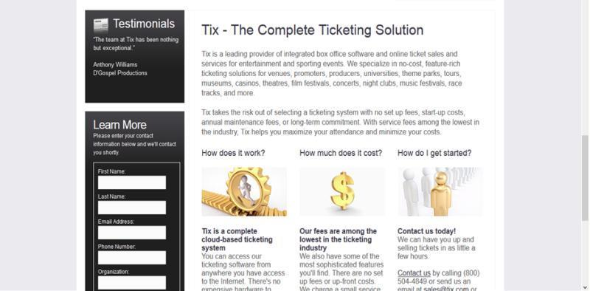

**Figure 2.1: Snapshot of Tix Ticketing Solution**

1. **Ticket Goose Ticketing System**

Ticket Goose is an Indian web based bus-ticketing system created in 2007. Figure 2.2 below shows the snapshot of Ticket Goose ticketing system:

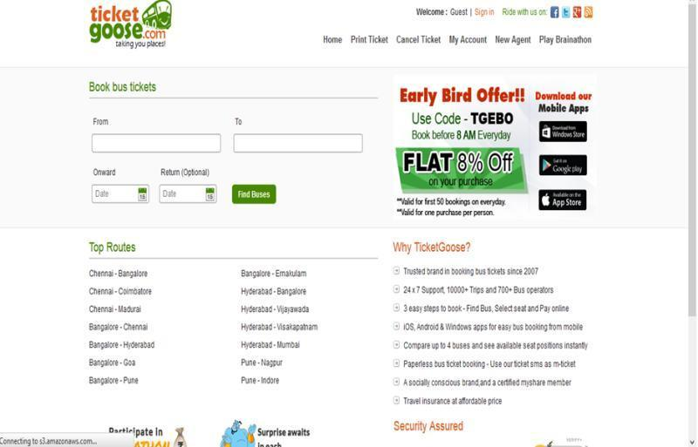

**Figure 2.2: Snapshot of Ticket Goose Ticketing System**

**2.8.3 Jefferson Lines Electronic Ticketing System**

Jefferson Lines Electronic Ticketing System provides a web based ticketing system. The snapshot of Jefferson Lines Electronic Ticketing System is shown below:

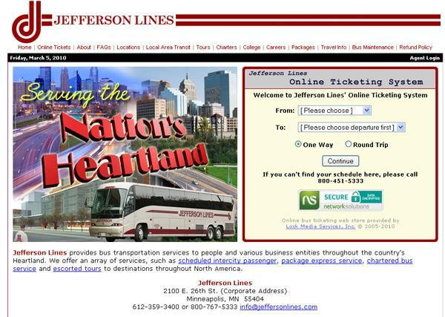

**Figure 2.3: Snapshot of Jefferson Line Electronic Ticketing System**

Figure 2.3 show the diagram of Jefferson electronic ticketing system, the system has the following features:

1. **Real-time schedules and fares** –Jefferson Lines Electronic Ticketing system maintainstandard pricing policy and schedule information all through the year. One can purchase a ticket for next month without increase.
2. **Travel pass with passenger information** –The ticketing system of Jefferson Lines generatespassengers’ ticket with detailed information
3. **Tour Management Software** - Helps bus companies to manage tours, serve there travelersand analyze business from multiple angles.
4. **Electronic Ticketing System**

Electronic ticketing occupies a significant role in the ticketing system of a country because the development of industry and commerce of a country largely depends on the development of electronic. Electronic ticketing plays a giant role in the ticketing sector.

1. **Advantages Electronic Ticketing System**
2. Electronic ticketing aids the movement of bulky goods which are not easily ticketed.
3. Electronic ticketingis a quick and regular means of ticketingbecause it helps in the ticketingof goods with speed and certainty.
4. It helps in the industrialization process of a country by easy ticketingof coal and raw-materials at a cheaper rate.
5. It helps in the quick movement of goods from one place to another at the time of emergencies like famines and scarcity.
6. It provides employment opportunity.
7. Electronic ticketing is a safe form of ticket. The chances of accidents are reduced as compared to other modes of ticket.
8. Electronic ticketing can carry extremely large number of people and amount of goods. Also, its capacity can be increased by adding additional wagons.
9. It is the largest public ticket system undertaking in the country. Electronic perform many public utility services. Their charges are based on the need to help the poor.
   1. **Disadvantages of Electronic Ticketing System**
10. The electronic ticketing system requires a large amount of capital investment. The cost of construction, maintenance and overhead expenses are very high as compared to other modes of ticket.
11. Electronic ticketing is not flexible as the timing and routes cannot be adjusted to meet individual requirement.
12. Electronic cannot provide door to door service as it is tied to a particular track. Intermediate loading or unloading involves greater cost, more wear and tear and wastage of time. The time cost of terminal operations are a great disadvantage of electronic ticketing.
13. As ticketing require huge capital outlay, they may give rise to monopolies and work against public interest at large. Even if controlled and managed by the government, lack of competition may breed in inefficiency and high costs.
14. Electronic ticketing is unsuitable and uneconomical for short distances and small of goods.
15. It involves much time and labour in booking and taking delivery of goods through ticketing as compared to motor transport.

Because of huge capital requirements, ticketing cannot be operated economically inrural areas. Thus, large rural areas have no ticketing even today. This causes much inconvenience to the people living in rural areas.

**CHAPTER THREE**

**SYSTEM ANALYSIS AND DESIGN**

1. **Introduction**

This chapter focuses on system analysis and design. The chapter begins with the analysis of the existing system, discussing its weaknesses and features. Next, the proposed system is analyzed alongside its features, advantages and disadvantages. The analysis of the proposed system is followed by the system design, system algorithm and the design methodology.

1. **Analysis of the Existing System**

It is imperative to understand the existing system before making attempt to design a new system. The existing system is purely manual and it is thus faced with a number of problems. For each customer to obtain, the customers will have to go the electronic ticketing office, stay on the queue for long hours.

The existing ticketing system in Nigeria is still done manually (the traditional old way of ticketing). With the present ticketing system, the customers will have to physically go to the stadium and queue up for long hours before obtaining their ticket.

It is also very tedious for the electronic corporation to balance their account manually. This manual balancing will require a lot of time and invariably lead to time wastage. Maintaining the current system requires a handy number of man-power which will tell on the cost. Another issue with the existing system is the inability of the system to personalize services and operations.

1. **Weaknesses of the Existing System**

The traditional method of obtaining ticket is faced with a number of weaknesses, among which are;

1. **Data redundancy:** The traditional means of obtaining ticket encourage data redundancy. Data redundancy refers to the unnecessary repetition of data which can lead to inconsistency.
2. **Time Wastage:** The existing system is time consuming as the customers will have to queue up for long hours trying to obtain ticket. Productive time is wasted on the queue.
3. **Unreliable:** The current system of obtaining ticket is manual and thus reliability cannot be guaranteed. The current system is highly prone to human errors which can be very costly.
4. **Poor financial management:** The existing system does not encourage proper financial management, tickets can be cornered and records manipulated.
5. **Difficulty in performing query:** The existing system does not encourage the performance of query on database as it is very tedious to find information with the manual system.
6. **No data security:** The current system of obtaining ticket cannot guarantee the data and information of customers.
   1. **Features of the Existing System**

The current system of obtaining ticket is manual and thus has its own feature which includes;

1. The current system is not economical in terms of operational cost
2. Complicated process of accomplishing specific task
   1. Time wastage in processing task
   2. The existing system requires a lot of man-power.
3. **Analysis of the Proposed System**

The human race is constantly faced with the need to improve on its existence, the means or methods by which the human race can improve on the means of its existence can differ from time to time. The advent of internet has brought about the opportunity to make life easy, thus the need to design a system that can relate with the present development. Over the years, the internet has grown into a device bringing billions of people from all works of life together. With the proposed system, the customers will be able to obtain their ticket from the comfort of their home or office. The proposed system does not require customers to go to the stadium and queue up for long hours before obtaining their ticket. The proposed system is time saving and it will reduce the stress associated with the traditional means of obtaining ticket. The system is easily understandable and user friendly, quick entries can be made in this online system.

The proposed system will store customers information no longer be an issue.

The proposed system will be accurate and efficient.

People from far and near can conveniently obtain ticket electronically. The electronic ticketing system guides the customers to view and select the class category of service that they required. The system is designed in a well referential manner which will guide new and existing users in the usage of the system. The new system also guarantees maximum security.

Having done a thorough analysis of the existing system with its weaknesses, it is imperative that a new, effective and efficient system be introduced. The proposed system will be simple, very fast, accurate, user-friendly and reliable. The system will be portable, reliable and can be accessed from anywhere in the world with internet access.

1. **Advantages of the Proposed System**

The electronic ticketing system comes with a number of benefits, among which are;

1. **Effective means of disseminating information:** Working with the proposed system will make information dissemination more effective as customers can get information online rather than physically going to the stadium to make enquiry. Customers can get information that relates to the class of ticket available, the prices of the tickets available, time and date of event.
2. **Enhance service operation:** The automation of the electronic ticket process will offer enhanced service delivery to customers.
3. **It is a fast and efficient system:** Automating the process of obtaining ticket will make the process of obtaining ticket fast and efficient. The long hours spent on the queue will be eliminated and thus customers can engage in more productive ventures.
4. **It is Reliable:** The proposed system provides a reliable means of obtaining ticket and generating attendee’s manifest which the event managers can use for proper planning.
   1. **Disadvantages of the Proposed System**

Notwithstanding the advantages presented by automating the process of obtaining ticket, the system comes with a number of potential disadvantages;

1. **Unemployment:** As much as the automation of the process of obtaining ticket will bring about improved customer service, it will greatly add to the number of unemployed people.
   1. **Security:** Automating the process of obtaining ticket implies that customers can make payment from anywhere in the world, this pose a possible threat to other ticket customers as it will not be easy to detect risk.
   2. **Possibility of losing information:** System can crash and customer disappear. Although, most of this online system have server backup but it still remains a possibility.
   3. **No automatic ticket cancellations:** Once a customer obtain his/her ticket, it becomes impossible to cancel because the system does not support reversal of payment.
2. **Data Collection**

Observation method of data collection was employed. The researcher personally observed the process of checking ticket service availability for a particular event and obtaining ticket. The observed counter method of attending to customers gave the researcher insight on how to design the proposed system.

1. **Methodology**

The researcher observed the current ticketing system of the National Theatre to determine and understand its weaknesses and ways to come out with a better system. UML use case diagram was used to show the actions to be performed by users and implemented on Graphical User Interface: HTML, CSS & JavaScript, JQuery.

1. **Proposed System Design**

Designing a system is always a result of tedious research work which requires innovation and creativity. System design involves the translation of the work carried out during the analysis stage into a specification of the system to be produced. The aim of this project work is to develop an efficient electronic ticketing system for the electronic subsector of the ticketing sector. The proposed system needs to be simple and user friendly.

The system design for this project work is structured into the following sub-sections;

1. **UML Use Case Diagram for the Proposed System**

A use case is a written description of how users will perform tasks on a particular website. A use case diagram, specify the behavior of a well-defined sequence of very simple step. The proposed system UML use-case diagrams are shown in figure 3.1

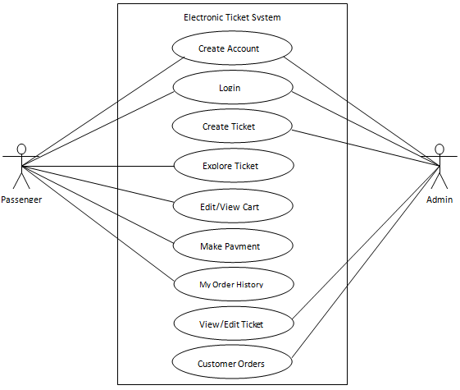

Customer

**Figure 3.1: UML Use Case Diagram for the Proposed System**

1. **Database Design**

The data in the database need to be organized logically in order to store data and other relevant information. In this project work, MySQL database management system is used for the database development. The database design refers to tables designed to store necessary information. Each table is made up of fields which correspond to rows and column.

1. **Proposed System Architectural Design**

Figure 3.2 shows the subsystems that make up the proposed system and the communication that exist between them.

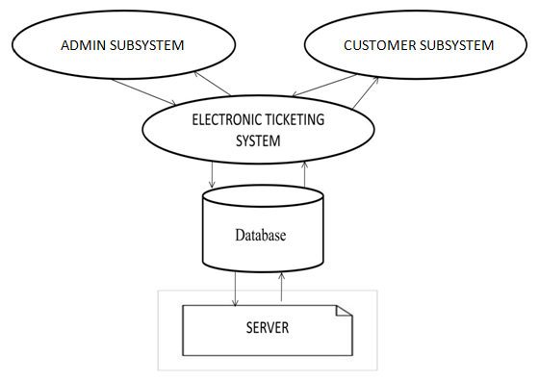

**Figure 3.2: Architectural Design for the Proposed System**

**CHAPTER FOUR**

**DESIGN AND IMPLEMENTATION**

* 1. **DESIGN OF THE PROPOSED SYSTEM**

**4.1.1 OUTPUT DESIGN**

It is necessary to consider what is required from the system before deciding how to sit about producing it. The choice of output media will also have to be made, including when to use hard copy and when to use screen displays.

The system employed a markup language (HTML) and cascading style sheet (CSS) in the display of data and information. A user friendly computer interface was designed and used in the proposed system to enhance communication between the user and the computer system. The various outputs are usually displayed on the monitor screen.

In addition to displaying output on the screen, the various report generated from the system, can equally be printed out through a print media. This is usually useful to produce a hard copy of the outputs and it encourages documentation.

Output design is the specification of the expected computer output and description of the output medium. The output is report based tabular report generated from the information stored in the database. The primary medium of the output is the computer screen; facility to print the reports in hardcopy through the line printer is also provided. The display of the output interface as follows;

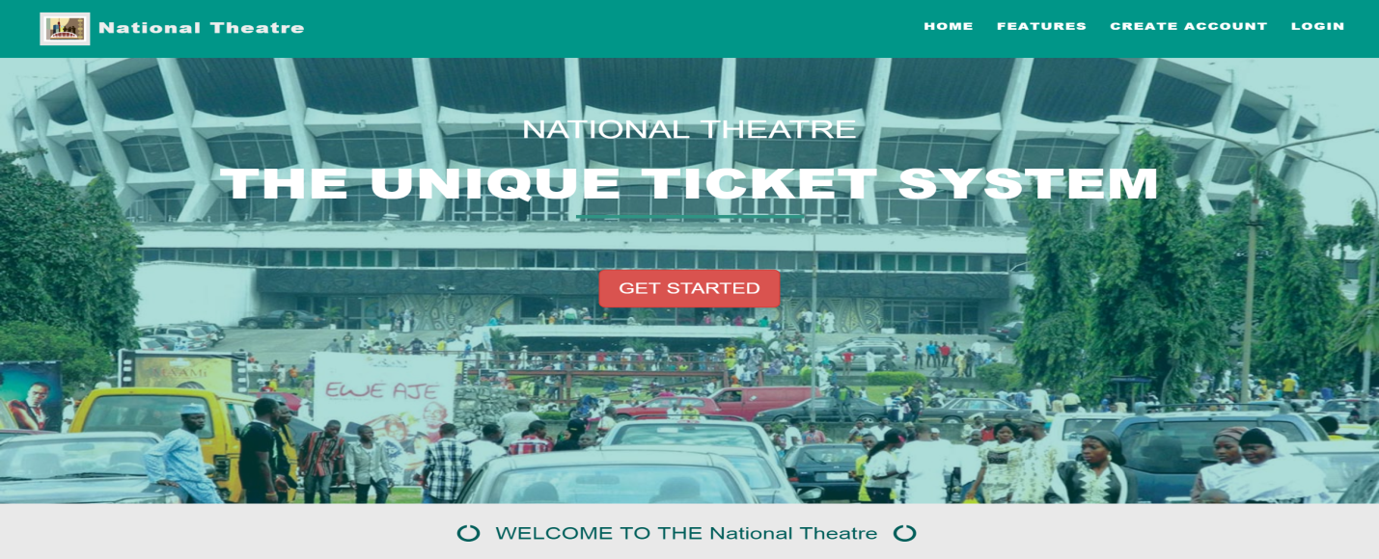

**Figure 4.1: Online HomePage**

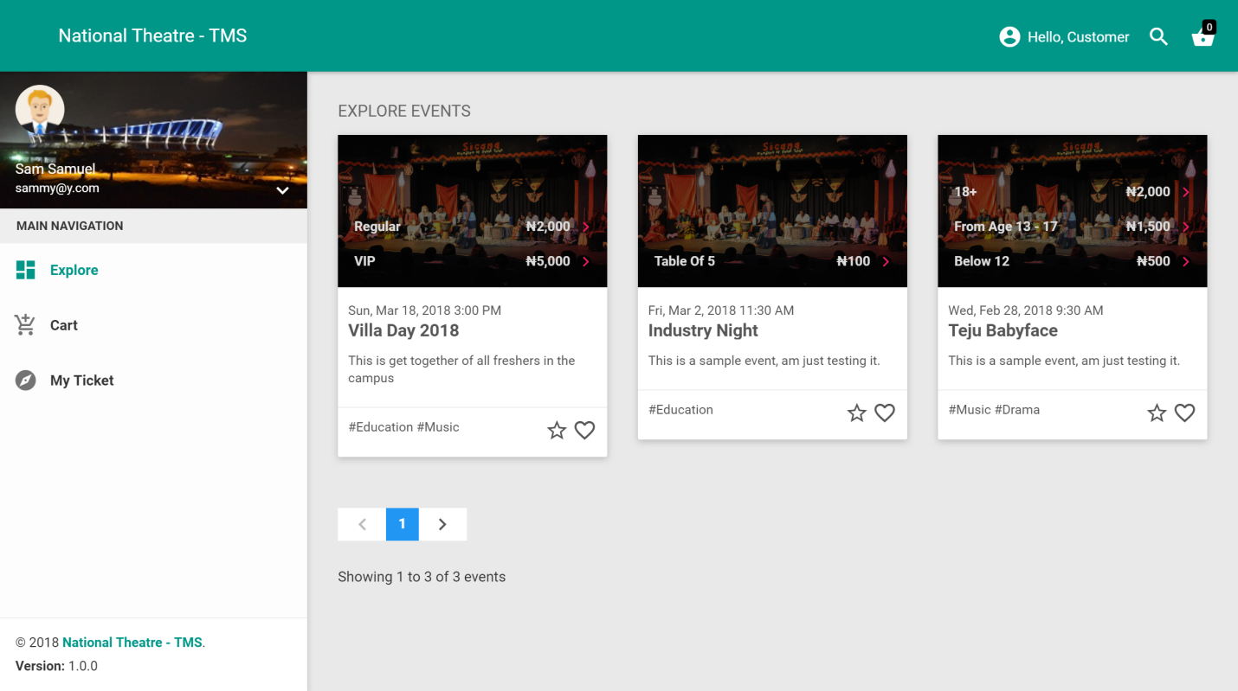

**Figure 4.2: Explore Tickets**

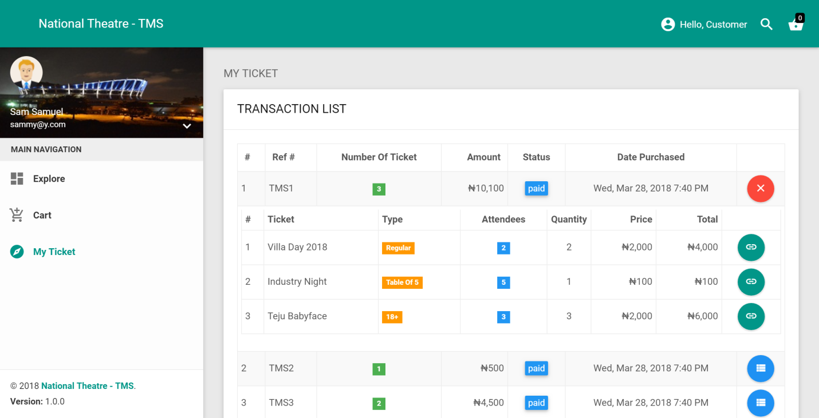

**Figure 4.3: My Ticket**

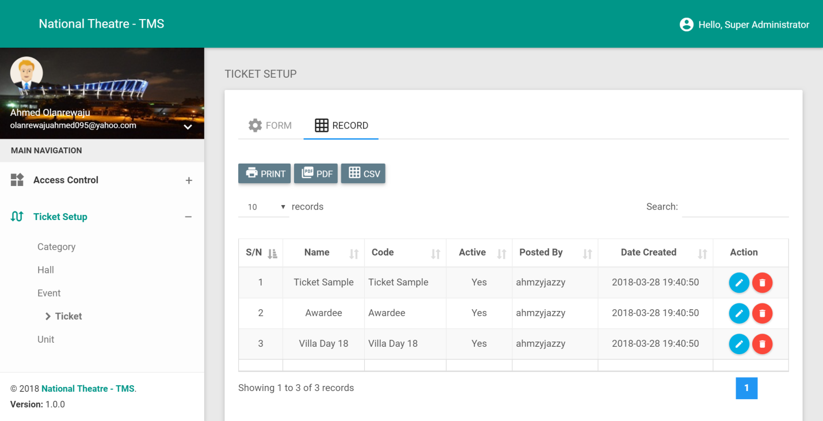

**Figure 4.4: Output of Ticket Record**

**4.1.2 INPUT DESIGN**

The input file of the proposed system analyzed the input data needed to produce the desired output design. The file contains all necessary fields which user will supply data.

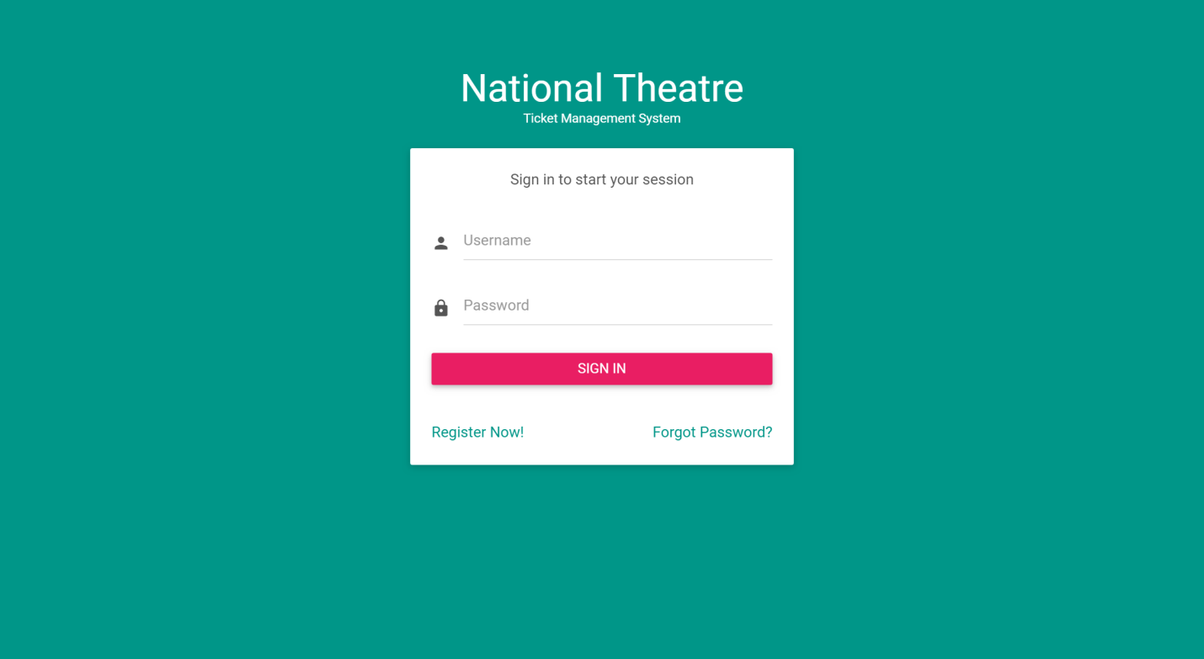

**Figure 4.5: Login input**

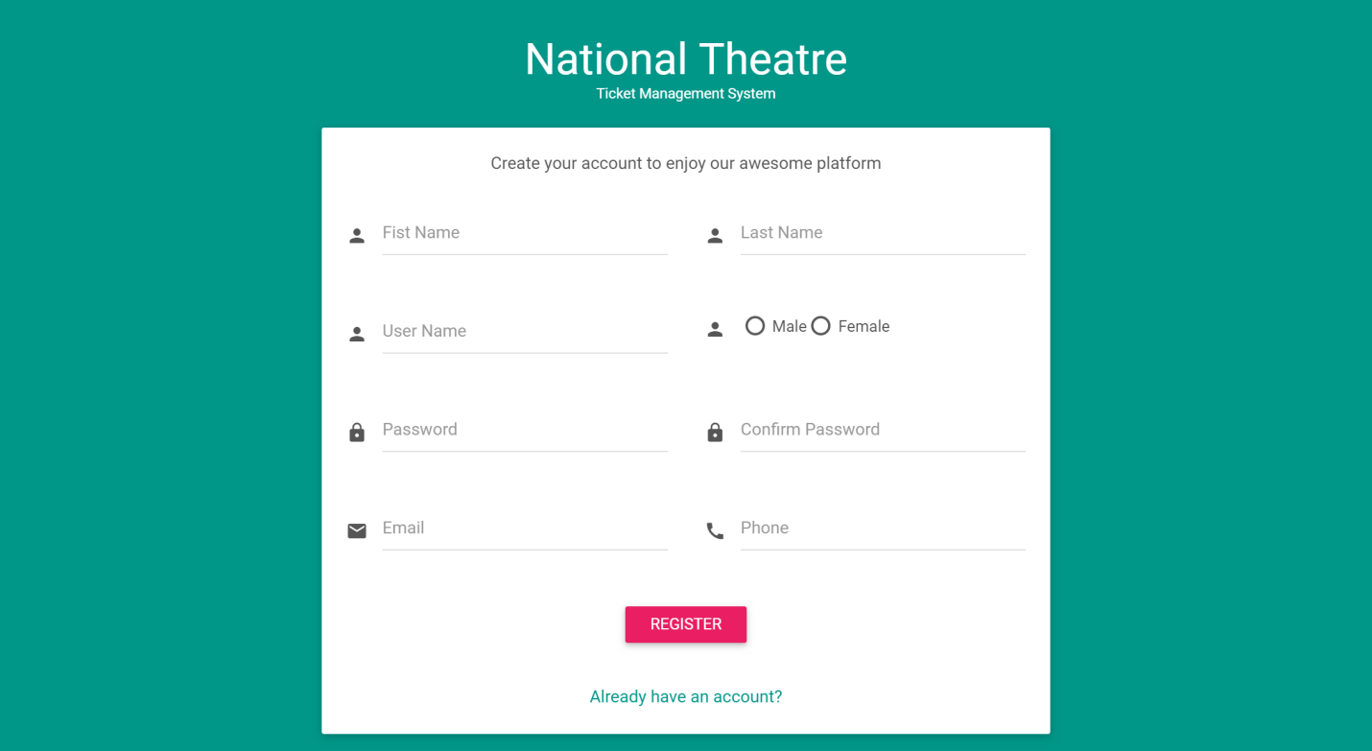

**Figure 4.6: Customer registration input**

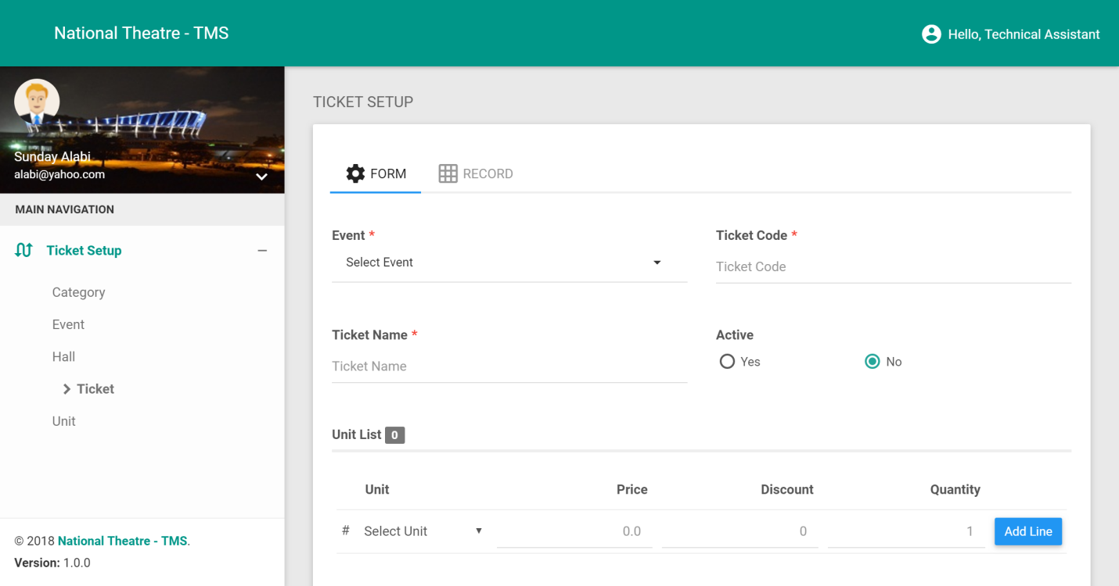

**Figure 4.7: Ticket setup input**

**4.1.3 DATABASE STRUCTURE**

* 1. **DATABASE TABLE STRUCTURE**

A **database table structure** described in a formal language supported by the **database** management system (DBMS) and refers to the organization of data as a blueprint of how a **database** is constructed (divided into **database** tables in the case of Relational **Databases**).

The database design refers to tables designed to store necessary information. Each table is made up of fields which correspond to rows and column.

Below are the tables used for the system:

**Table 4.1: Role**

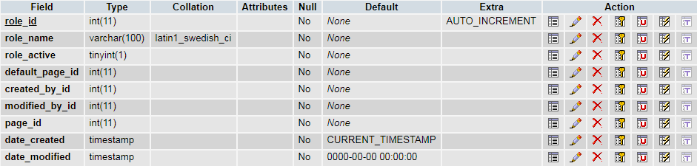

**Table 4.2: User**

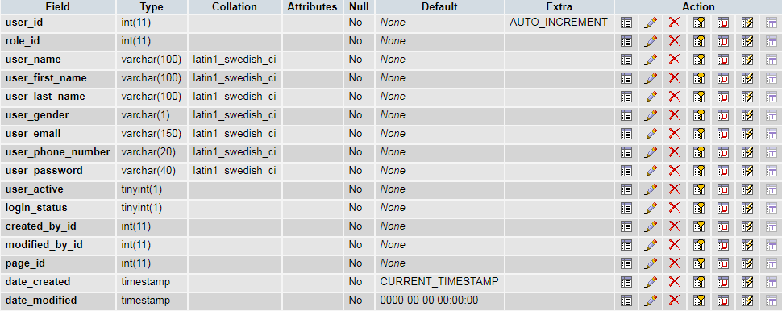

**Table 4.3: Category type**



**Table 4.4: Category**

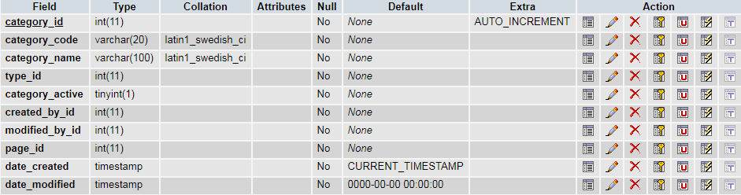

**Table 4.5: Hall**

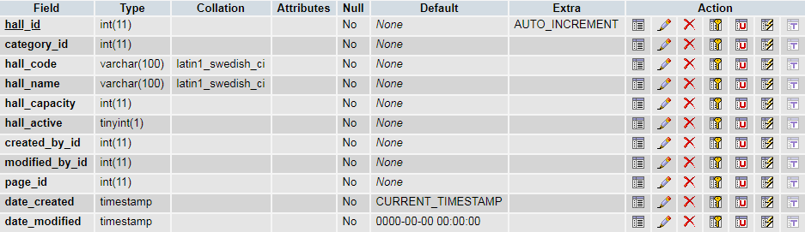

**Table 4.6: Event**

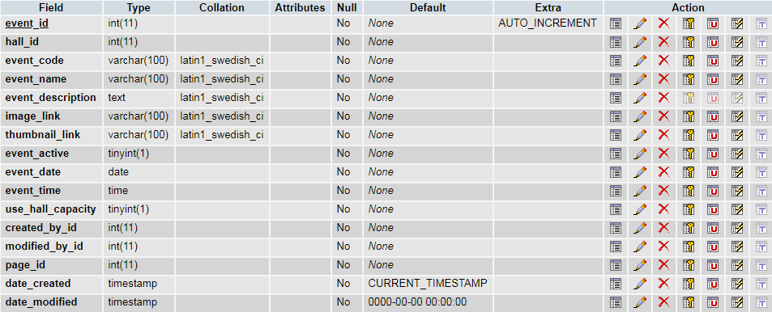

**Table 4.7: Tag**

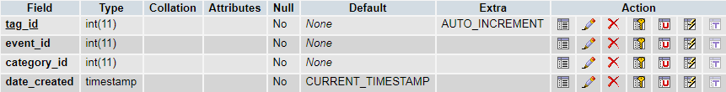

**Table 4.8: Unit**

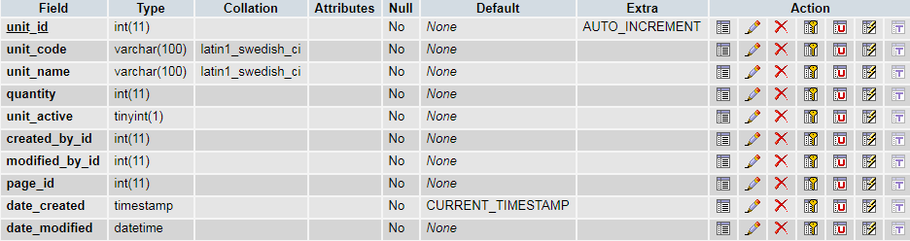

**Table 4.9: Ticket**

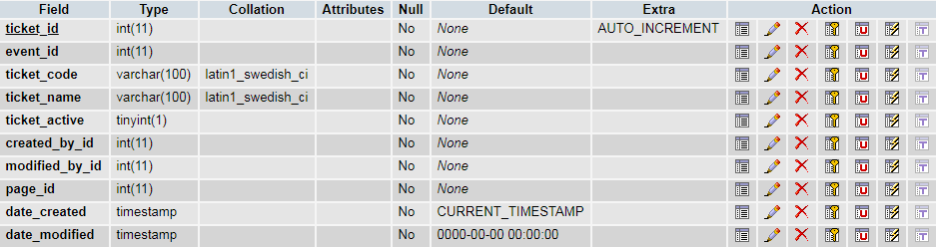

**Table 4.10: Ticket detail**

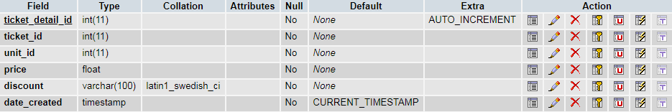

**Table 4.11: Transaction**

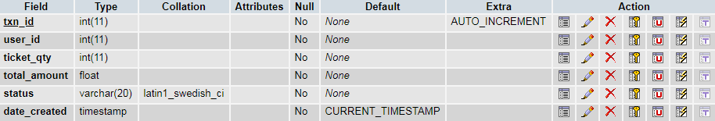

**Table 4.12: Transaction detail**

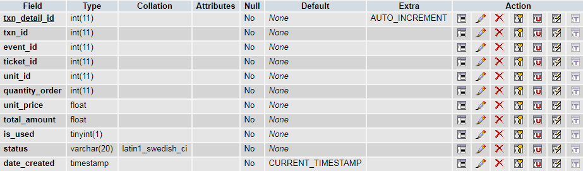

**4.1.4 PROCEDURE DESIGN**

The procedure in this project work is the customer getting to the registration process, after which initialize the webpage of the system to allow the customer have access to booking of ticket for events and then a receipt will be printed for customer documentation.

The procedural and generalized description of the various main modules is discussed below;

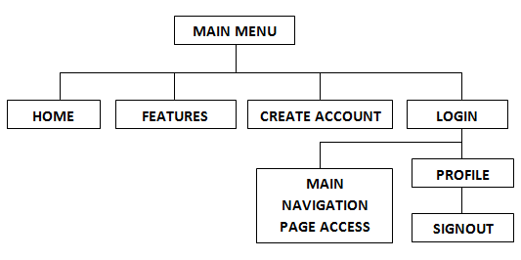

**Figure 4.8: Procedure Design**

**HOME:** This is the landing page of the electronic ticket system.

**FEATURES:** This contain major features of the system.

**CREATE ACCOUNT:** This is where users/customers register to access the system.

**LOGIN:** This is where users enter their credentials to access the system.

**MAIN NAVIGATION:** This contains list of pages a logged on user has access to. The following are the pages that are controlled by access: **Explore, Cart, My Ticket, Role, User, Category, Unit, Hall, Event and Ticket**.

**PROFILE:** This is where users can view and edit their registered information.

**SIGN OUT:** This is where users enter their credentials to access the system.

**4.2 IMPLEMENTATION OF THE SYSTEM**

The parallel approach operates the old and the new system simultaneously for a period to make sure that the new system meets the requirement that the old system has been meeting all along. This approach is particular appropriate for systems that produce to routine output that users or recipient expect regularly. The outputs of the new and the old system versions may be compared to make sure that the new is providing the required output.

**4.2.1 HARDWARE REQUIREMENT**

* Pentium VI and Above

* 256 MD RAM and above

* 500GB HD

* Printer

**4.2.2 SOFTWARE REQUIREMENT**

Software is a program which contains sets of instructions given to the computer to perform a specific task in a specified way using a particular programming language.

1. Operating System: Windows (2000, 7, 8 and 10, Vista, 7 and 8)
2. WampServer
3. Graphical User Interface: HTML, CSS & JavaScript, JQuery
4. Mysql Database

**4.2.3 CHOICE OF PROGRAMMING**

The requirement of the research work demands that a capable programming language be used for its implementation. Hence, HTML/CSS, Mysql Database, was chosen. The tools was selected because it offers Rapid Application Development (RAD) features that enables Application developers to put up visually appealing user interface design in less time. Application includes several features to help you develop applications that access data, the data source configuration wizard simplifies connecting your application to data in database.

**4.3 SYSTEM DOCUMENTATION**

Program documentation is a written description of what each program modules does and the interrelationship within them. It guides the user how to go about using the system. Below are the three (3) main discussions under documentation of this research work

1. Accessing the program
2. Starting the program
3. Maintaining the system

**4.3.1 PROGRAM DOCUMENTATION**

The program is packaged with a well documented README.txt file, which contains all the necessary guides and information on how to setup the system to achieve its full functionality. The README.txt file is located in the root folder of this project.

**4.3.2 OPERATING THE SYSTEM**

The program can be run or executed by clicking the start button on the window taskbar, move the mouse pointer to ‘All programs’ and click to pop out the sub-menu. Locate ‘Mozilla Firefox’ or ‘Chrome browser’ and then click to activate (or run) the program. Then locate ‘Search or Enter Address’ on top of the web browser page. Type the web address to initiate the system software and then follow the required instructions given on the screen.

Once the webpage has been fully initialized, you can add it to the bookmark of the web browser for easy access.

**4.3.3 MAINTENANCE OF THE SYSTEM**

The last stage for the Electronic Ticketing System explained above in the system life cycle is the maintenance, which can be described as the periodically evaluation and modification of the system. This is done from time-to-time to see whether a system is meeting the goals and providing the services which it’s designed for.

This System can easily be maintained by adding more Web pages to it or removing existing Webpage that is found to be irrelevant to the user’s need. Also the database allows for data resilience and portability. Maintenance at program refers to the correction, addition, or deletion of part of the program with ease program that has structure and features of maintainability which is referred to as a good ‘structured program’.

**CHAPTER FIVE**

**SUMMARY, RECOMMENDATION AND CONCLUSION**

1. **Introduction**

This chapter focuses on the summary of the design, suggestions for further work, recommendation and conclusion.

1. **Summary**

Electronic Ticketing System has thus been discussed in this study. The rapid development of the ticket sector has made it impossible to isolate the sector from technology driven commerce. Incorporating technological changes into the transportation sector will greatly open the door to greater possibilities.

Electronic Ticketing generally has been improved upon in the advanced countries so as to offer better, safe and convenient service to all categories of users. For a ticketing system to meet international standard, it must be reliable with minimum failure rate.

1. **Suggestions for Further Work**

The following suggestions have been made for further studies:

1. Literacy and electronic commerce
2. The need for skilled manpower in the ticket ordering sector of the economy
3. Problems facing electronic commerce in Nigeria
4. **Recommendation**

Based on the findings and conclusions made in this study, the following recommendations have been proffered:-

1. Both the staff and management should undergo proper training before the use of the new system.
2. The cost of implementing this system should not serve as setback as it will be better off in the long run.
3. Ticket management should embrace the moving trend of technology in customer sector so as to enjoy the great possibilities provided by the IT.
4. Ticket staff should make themselves available to learn and be acquainted with contemporary IT awareness and literacy.
   1. **CONCLUSION**

Customers service has moved from paper based service to technological driven service. The technological driven service provides better service to customers to check event service availability and make payment ahead of time in contrast to the paper based system that required customers to wait on the queue for long hour before they can obtain their ticket pass (ticket).

The current trend of development in ICT alongside the improved literacy level in the sector will to a large extent promote the growth and development of the sector.

After thorough examination of the new system, it has been discovered that the new system is capable of eliminating the abnormalities associated with the old system to a large extent.

The new system designed to handle ticketing interest. The system will also increase the revenue of the ticket company.

Electronic-ticketing system promises a better and improved way of checking event service availability and making payment. The system will do away with the inconveniences of waiting on the queue for long hours to obtain ticket. The system was designed to attend to customers based on the category of service they want. Hence, customers can make payment along the line of the service they want to get.

**Main menu**

Yes

Yes

No

No

Is option = create account

start

Display Option

Select Option

Is option = Login

Is option = Features

Register

Login

Display Features

Return

No

Yes

**Login**

Enter username and password

Yes

No

Is detail in the database?

Main menu

Display Error Message

Return

start

Open Database

Close Database

**Register**

Enter Registration Information

Yes

No

No

Yes

Any field empty?

start

Open Database

Return

Close Database

Save to Database

Any more record?

**Explore Ticket**

Yes

No

start

Open Database

Query database for event and ticket list

Is it END of file?

Return

Close Database

Display Event and Tickets

**Order Ticket**

Yes

No

Yes

No

No

Yes

start

Select an event and choose ticket

Explore Tickets

Explore more tickets?

Input or modify ticket quantity

Display Success Message

View cart for added tickets

Proceed to checkout?

Load Cart

Input Payment Details

Yes

Payment is successful?

No

Return

Try again?

**My Ticket - Purchase History**

Yes

No

start

Open Database

Query database for Purchase History

Is it END of file?

Return

Close Database

Display History List