# VISVESVARAYA TECHNOLOGICAL UNIVERSITY

## 2022-23

## BELAGAVI – 590018, Karnataka INTERNSHIP REPORT

#### ON

“TEMPLATE TO CHECK VRL TICKET AVAILABILITY”

***Submitted in partial fulfilment for the award of degree (18CSI85)***

## BACHELOR OF ENGINEERING IN YOUR

## COMPUTER SCIENCE AND ENGINEERING

## 

## NAME USN

**S S AKASH 4VM19CS037**



Conducted at

**VARCONS TECHNOLOGY PVT LTD**

# 

# VIDYA VIKAS INSTITUTE OF ENGINEERING & TECHNOLOGY, MYSURU

# #127-128, Mysore - Bannur Road, Alanahally,

# Mysore, Karnataka -570028

# Vidya Vikas Educational Trust ®

# VIDYA VIKAS INSTITUTE OF ENGINEERING

# & TECHNOLOGY, MYSURU

**Department of Computer science & engineering**

#127-128, Mysore - Bannur road, Alanahally, Mysore,

Karnataka - 570028Vidya Vikas Educational Trust ®



**CERTIFICATE**

This is to certify that the Internship titled **“Template to check VRL ticket availability”** carried out by **Mr. S S AKASH (4VM19CS037),** a bonafide student of **VIDYA VIKAS INSTITUTE OF ENGINEERING & TECHNOLOGY** fulfillment for the award of **Bachelor of Engineering**, in **Computer Science & Engineering** under **Visvesvaraya Technological University**, Belagavi, during the year 2022-2023. It is certified that all corrections/suggestions indicated have been incorporated in the report. The project report has been approved as it satisfies the academic requirements in respect of Internship prescribed for the course Internship / Professional Practice (18CSI85).

#### Signature of Guide Signature of HOD Signature of Principal

**External Viva:**

Name of the Examiner Signature with Date

1)

2)

# DECLARATION

I, **S S AKASH**, final year student of Computer Science & Engineering, Vidya Vikas Institute of Engineering & technology Mysuru - 570028, declare that the Internship has been successfully completed, This report is submitted in partial fulfillment of the requirements for award of Bachelor of Engineering in Computer Science & Engineering, during the academic year 2022-2023.

Date: 24-09-2022

Place: Mysore

USN: 4VM19CS037

NAME: S S AKASH

**CERTIFICATE OF INTERNSHIP COMPLETION**

# ACKNOWLEDGEMENT

This Internship is a result of accumulated guidance, direction and support of several important persons. We take this opportunity to express our gratitude to all who have helped us to complete the Internship.

We express our sincere thanks to our Principal, for providing us adequate facilities to undertake this Internship.

We would like to thank our Head of Dept. – CSE, for providing us an opportunity to carry out Internship and for his valuable guidance and support.

We would like to thank our (Prof Syed Salem) Software Services for guiding us during the period of internship.

We express our deep and profound gratitude to our guide, Guide name, Assistant/Associate Prof Syed Salem, for his keen interest and encouragement at every step in completing the Internship.

We would like to thank all the faculty members of our department for the support extended during the course of Internship.

We would like to thank the non-teaching members of our dept., for helping us during the Internship.

Last but not the least, we would like to thank our parents and friends without whose constant help, the completion of Internship would have not been possible.

**NAME: S S AKASH**

**USN: 4VM19CS037**

**ABSTRACT**

Online bus reservation system is a project which provides a portal for bus ticket reservation. This application allows users to book bus tickets from anywhere and anytime. The user can easily book their tickets and cancel tickets. The user can view all the details of the website, bus, and drive. The user can also view the details of the journey and the details of the journey timings. Online Bus Ticket Reservation System is a Web based application that works within a centralized network. This project presents a review on the software program "Online Bus Ticket Reservation System" as should be used in a bus transportation system, a facility which is used to reserve seats, cancellation of reservation and different types of route enquiries used on securing quick reservations. OBTRS is built for managing and computerizing the traditional database, ticket booking and tracking bus and travel made. It maintains all customer details, bus detail reservation

Details. In order to achieve the design.

**TABLE OF CONTENTS**

|  |  |  |
| --- | --- | --- |
| **Sl no** | **Description** | **Page no** |
| 1 | Company Profile | 8 |
| 2 | About the Company | 9 |
| [3](https://1.bp.blogspot.com/-dODuK8N5h1Q/Wlnyb3V9HFI/AAAAAAAACL4/WxQtCJ1pM5wccDABg4wIrTBUB0vlikXQQCLcBGAs/s1600/poly1.jpg) | Introduction | 12 |
| [4](https://1.bp.blogspot.com/-dODuK8N5h1Q/Wlnyb3V9HFI/AAAAAAAACL4/WxQtCJ1pM5wccDABg4wIrTBUB0vlikXQQCLcBGAs/s1600/poly1.jpg) | System Analysis | 14 |
| [5](https://1.bp.blogspot.com/-dODuK8N5h1Q/Wlnyb3V9HFI/AAAAAAAACL4/WxQtCJ1pM5wccDABg4wIrTBUB0vlikXQQCLcBGAs/s1600/poly1.jpg) | Design [Analysis](https://4.bp.blogspot.com/-IOOxgPaXMVc/Wlj3LWvcnjI/AAAAAAAACKE/UeTFYvAxDmUDel5UBjdifeWaApB3-dXVgCLcBGAs/s1600/img1.jpg) & [Implementation](https://4.bp.blogspot.com/-IOOxgPaXMVc/Wlj3LWvcnjI/AAAAAAAACKE/UeTFYvAxDmUDel5UBjdifeWaApB3-dXVgCLcBGAs/s1600/img1.jpg) | 17 |
| 6 | Requirement Analysis | 21 |
| 7 | Snapshots | 22 |
| 8 | Conclusion | 26 |
| 9 | References | 27 |

**[CHAPTER](https://1.bp.blogspot.com/-dODuK8N5h1Q/Wlnyb3V9HFI/AAAAAAAACL4/WxQtCJ1pM5wccDABg4wIrTBUB0vlikXQQCLcBGAs/s1600/poly1.jpg) 1**

**COMPANY PROFILE**

## A Brief History of Varcon’s Technologies

Varcons Technologies, was incorporated with a goal “To provide high quality and optimal Technological Solutions to business requirements of our clients”. Every business is a different and has a unique business model and so are the technological requirements. They understand this and hence the solutions provided to these requirements are different as well. They focus on clients requirements and provide them with tailor made technological solutions. They also understand that Reach of their Product to its targeted market or the automation of the existing process into e-client and simple process are the key features that our clients desire from Technological Solution they are looking for and these are the features that we focus on while designing the solutions for their clients.

Sarvamoola Software Services. Is a Technology Organization providing solutions for all web design and development, MYSQL, PYTHON Programming, HTML, CSS, ASP.NET and LINQ. Meeting the ever increasing automation requirements, Sarvamoola Software Services. Specialize in ERP, Connectivity, SEO Services, and Conference Management, effective web promotion and tailor-made software products, designing solutions best suiting client’s requirements.

Varcons Technologies, strive to be the front runner in creativity and innovation in software development through their well-researched expertise and establish it as an out of the box software development company in Bangalore, India. As a software development company, they translate this software development expertise into value for their customers through their professional solutions.

They understand that the best desired output can be achieved only by understanding the clients demand better. Varcons Technologies work with their clients and help them to defiine their exact solution requirement. Sometimes even they wonder that they have completely redefined their solution or new application requirement during the brainstorming session, and here they position themselves as an IT solutions consulting group comprising of high caliber consultants.

They believe that Technology when used properly can help any business to scale and achieve new heights of success. It helps Improve its efficiency, profitability, reliability; to put it in one sentence ” Technology helps you to Delight your Customers” and that is what we want to achieve.

# [CHAPTER](https://1.bp.blogspot.com/-dODuK8N5h1Q/Wlnyb3V9HFI/AAAAAAAACL4/WxQtCJ1pM5wccDABg4wIrTBUB0vlikXQQCLcBGAs/s1600/poly1.jpg) 2

# ABOUT THE COMPANY

# 

Varcons Technologies is a Technology Organization providing solutions for all web design and development, MYSQL, PYTHON Programming, HTML, CSS, ASP.NET and LINQ. Meeting the ever increasing automation requirements, Varcons Technologies specialize in ERP, Connectivity, SEO Services, Conference Management, effective web promotion and tailor-made software products, designing solutions best suiting clients requirements. The organization where they have a right mix of professionals as a stakeholders to help us serve our clients with best of our capability and with at par industry standards. They have young, enthusiastic, passionate and creative Professionals to develop technological innovations in the field of Mobile technologies, Web applications as well as Business and Enterprise solution. Motto of our organization is to “Collaborate with our clients to provide them with best Technological solution hence creating Good Present and Better Future for our client which will bring a cascading a positive effect in their business shape as well”. Providing a Complete suite of technical solutions is not just our tag line, it is Our Vision for Our Clients and for Us, We strive hard to achieve it.

## Products of Varcons Technologies.

**Android Apps**

It is the process by which new applications are created for devices running the Android operating system. Applications are usually developed in Java (and/or Kotlin; or other such option) programming language using the Android software development kit (SDK), but other development environments are also available, some such as Kotlin support the exact same Android APIs (and bytecode), while others such as Go have restricted API access.

The Android software development kit includes a comprehensive set of development tools. These include a debugger, libraries, a handset emulator based on QEMU, documentation, sample code, and zutorials. Currently supported development platforms include computers running Linux (any modern desktop Linux distribution), Mac OS X 10.5.8 or later, and Windows 7 or later. As of March 2015, the SDK is not available on Android itself, but softwaredevelopment is possible by using specialized Android applications.

**Web Application**

It is a client–server computer program in which the client (including the user interface and client- side logic) runs in a web browser. Common web applications include web mail, online

retail sales, online auctions, wikis, instant messaging services and many other functions. Web applications use web documents written in a standard format such as HTML and JavaScript, which are supported by a variety of web browsers. Web applications can be considered as a specific variant of client–server software where the client software is downloaded to the client machine when visiting the relevant web page, using standard procedures such as HTTP. The Client web software updates may happen each time the web page is visited. During the session, the web browser interprets and displays the pages, and acts as the universal client for any web application. The use of web application frameworks can often reduce the number of errors in a program, both by making the code simpler, and by allowing one team to concentrate on the framework while another focuses on a specified use case. In applications which are exposed to constant hacking attempts on the Internet, security- related problems can be caused by errors in the program.

Frameworks can also promote the use of best practices such as GET after POST. There are some who view a web application as a two-tier architecture. This can be a “smart” client that performs all the work and queries a “dumb” server, or a “dumb” client that relies on a “smart” server. The client would handle the presentation tier, the server would have the database (storage tier), and the business logic (application tier) would be on one of them or on both. While this increases the scalability of the applications and separates the display and the database, it still doesn’t allow for true specialization of layers, so most applications will outgrow this model. An emerging strategy for application software companies is to provide web access to software previously distributed as local applications. Depending on the type of application, it may require the development of an entirely different browser-based interface, or merely adapting an existing application to use different presentation technology. These programs allow the user to pay a monthly or yearly fee for use of a software application without having to install it on a local hard drive. A company which follows this strategy is known as an application service provider (ASP), and ASPs are currently receiving much attention in the software industry.

Security breaches on these kinds of applications are a major concern because it can involve both enterprise information and private customer data. Protecting these assets is an important part of any web application and there are some key operational areas that must be included in the development process. This includes processes for authentication, authorization, asset handling, input, and logging and auditing. Building security into the applications from the beginning can be more effective and less disruptive in the long run.

**Web design**

It is encompasses many different skills and disciplines in the production and maintenance of websites. The different areas of web design include web graphic design; interface design; authoring, including standardized code and proprietary software; user experience design; and

search engine optimization. The term web design is normally used to describe the design process relating to the front-end (client side) design of a website including writing mark up. Web design partially overlaps web engineering in the broader scope of web development. Web designers are expected to have an awareness of usability and if their role involves creating mark up then they are also expected to be up to date with web accessibility guidelines. Web design partially overlaps web engineering in the broader scope of web development.

## Departments and services offered

Varcons Technologies plays an essential role as an institute, the level of education, development of student’s skills are based on their trainers. If you do not have a good mentor then you may lag in many things from others and that is why we at Varcons Technologies gives you the facility of skilled employees so that you do not feel unsecured about the academics. Personality development and academic status are some of those things which lie on mentor’s hands. If you are trained well then you can do well in your future and knowing its importance of Varcons Technologies always tries to give you the best.

They have a great team of skilled mentors who are always ready to direct their trainees in the best possible way they can and to ensure the skills of mentors we held many skill development programs as well so that each and every mentor can develop their own skills with the demands of the companies so that they can prepare a complete packaged trainee.

## Services provided by Varcons Technologies.

* Core Java and Advanced Java
* Web services and development
* Dot Net Framework
* Python
* Selenium Testing
* Conference / Event Management Service
* Academic Project Guidance
* On The Job Training
* Software Training

[**CHAPTER**](https://1.bp.blogspot.com/-dODuK8N5h1Q/Wlnyb3V9HFI/AAAAAAAACL4/WxQtCJ1pM5wccDABg4wIrTBUB0vlikXQQCLcBGAs/s1600/poly1.jpg) **3**

**INTRODUCTION**

## Introduction to Web Apps

Web applications are similar to the traditional applications you’d install on your Information, such as Microsoft Office. They are able to perform the same kinds of tasks, they look the same and they feel the same but there is one key difference - the application itself is not installed on your phone or Information, but lives in the cloud. Web apps are not new, but it used to be that they were often unable to compete with more traditional applications for business critical functions or where rich user interaction was required. This is no longer the case. With the power of modern web technologies, we are able to design and build performing, secure, and feature rich applications that live in the cloud and bring with them a huge number of benefits.

#### They can be accessed from anywhere.

* Because web applications are built with web technologies and they run in a web browser Internet Explorer, Google Chrome, Mozilla Firefox – this allows them to be accessed from every web enabled tool. As long as you have an internet connection you can use them.
* It allows for remote working, it allows for rapid publishing of content, it allows for real time collaboration between teams. If you have web access, you have the ability to access your business tools.

#### They are cost effective.

* Web applications are cheaper to produce and maintain than traditional applications. No matter how many platforms your business uses (Mac, Linux, Windows) web application build can be used across them all.

#### They benefit from more rapid update cycles.

* A huge benefit of web applications is that when an update is released, all of your users are immediately using that version. This doesn’t happen with installed applications, especially in large organizations with IT policies that restrict administrator access.

#### They are secure.

* Web developers have had to become experts in security – the web is a platform designed to share everything with everyone! As such, the types and levels of security included in web applications are often far greater than those seen in traditional applications.
* They also benefit from the ability to launch updates in real-time – the application on the servers is the application people are using. The applications on people’s laptops however is the version last installed. And when those laptops get left on a train it’s not a concern, as nothing is stored locally.

#### They enable more computing with fewer Information.

* Web applications push all of the hard work to the servers, and act as intermediaries between the user interface and the calculations happening behind the scenes. This means you can accomplish terrifyingly complex work on a tablet, or your phone.
* We’ve built web applications that allow people to understand the complex relationships between 250,000 pieces of art on their phones, and applications that run the business systems of one of the largest solar energy providers in the world. Often these products are not financially viable to build using traditional application processes.

## Problem Statement

Develop an application which facilitates creation of web pages having a need to install any HTML editor based software and also which can be used by any novice user (no HTML knowledge needed) that is developing web pages on the online. This module is designed to reduce the process involved in managing the activity of customers and business where the business can sell their services and the customers can buy those.

## Introduction to B2C Ecommerce Website Development with Admin Panel

B2C E-commerce website content providers to focus on creating effective assessment questions and focusing on providing a platform for easy access between Buyer and Consumer.

Here we present techniques that are pertinent to the elements of assessment process: answers submission, Informational grading, and feedback after submission. As the modern organizations are automated and Information’s are working as per the instructions, it becomes essential for the coordination of human beings, commodity and Information’s in a modern organization.

[**CHAPTER**](https://1.bp.blogspot.com/-dODuK8N5h1Q/Wlnyb3V9HFI/AAAAAAAACL4/WxQtCJ1pM5wccDABg4wIrTBUB0vlikXQQCLcBGAs/s1600/poly1.jpg) **4**

# SYSTEM ANALYSIS

# Existing System

The existing Bus Booking System is not completely computerized. The customer has to visit any booking branch if he wants to book a ticket. Bus scheduling, ticket booking, bill generation and many other operations are done manually. This may lead to incorrect entries and there is a lot of room for errors as the data is not completely synced. The availability of seats is not centrally maintained and the travel operator is not fully aware of the availability and occupancy of the seats in his buses. This is the major bottle neck.

1. Existing system is totally on book and thus a great amount of manual work has to be done. The amount of manual work increases exponentially with increase in services.
2. Needs a lot of working staff and extra attention on all the records.
3. In existing system, there are various problems like keeping records of items, seats available, prices of per/seat and fixing bill generation on each bill.
4. Finding out details regarding any information is very difficult, as the user has to go through all the books manually.
5. Major problem was lack of security.
6. The work is done manually.
7. Those who are interested in inquiring about the Bus Type, its
8. Tickets Price, available seats, facility of the bus etc. has to walk to the Booking office.

**Proposed system**

**MODULES OF ONLINE BUS BOOKING SYSTEM:**

There are several modules required to complete this system. Here we are discussing the main modules or core modules of the system.

**Admin Profile:**

Admin is super user of our system. Admin can view all data in the system. Admin must log in to the system then there is authentication process. Admin view bus details verified the bus details, check the employee data.

**Customer Profile:**

The customer is the end user of our system. The customer can see bus details, check availability, book the ticket, make an enquiry, and make payment to confirm a seat. At any point of time before boarding of bus. Customer has all rights to cancel ticket.

**Add Buses:**

This module would help to add new bus details. Bus details include Bus Number, Model Number, Numbers of seats, Type of bus, the condition of the bus.

**Availability:**

This module would help to search the bus and find availability of seats. The customer can check bus availability anytime. Desired available seats can be booked by the client using this system.

**Enquiry:**

Any question can be made using email id or filling website form. Customer care representatives will reach you with solutions. Any question about bus timing, the system can do seat availability with human interaction.

**Cancel:**

At any point of time before boarding of bus customer has all right to cancel tickets. The money will be credited to a customer account as per bank policy and timing.

**Booking:**

If customer finds the desired bus and available seats. The customer can book the seats using this module. The booking process is entirely computerized. Real time seat availability. Once a place has been locked it can’t be available for booking.

**Payment:**

Currently the aim is to check the availability of the bus in the browser which helps for the users to know whether there is any bus available and also the number of seats available. Hence the payment method only offline and online payment methods and be implemented for future enhancements.

## CHAPTER 5

## DESIGN ANALYSIS & IMPLEMENTATION

A data flow diagram (DFD) is a graphical representation of the "flow" of data through an information system, modeling its process aspects. A DFD shows what kind of information will be input to and output from the system, where the data will come from and go to, and where the data will be stored.

The development of DFD’S is done in several levels. Each process in lower level diagrams can be broken down into a more detailed DFD in the next level. The Top-level diagram is often called context diagram. It consist a single process bit, which plays vital role in studying the current system. The process in the context level diagram is exploded into other process at the first level DFD.

**5.1 FLOW DIAGRAM**

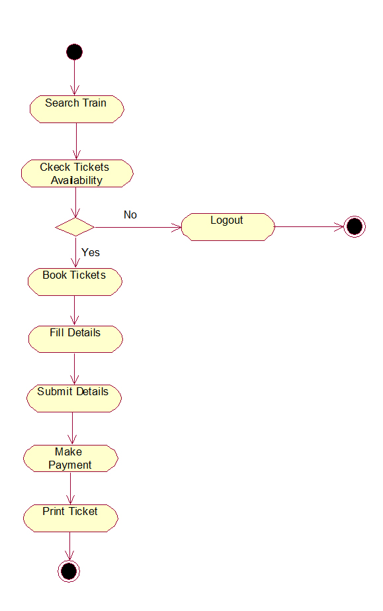

Figure : Flow Chart

**5.2 DATAFLOW DIAGRAM**

**5.2.1 USER DATAFLOW DIAGRAM**

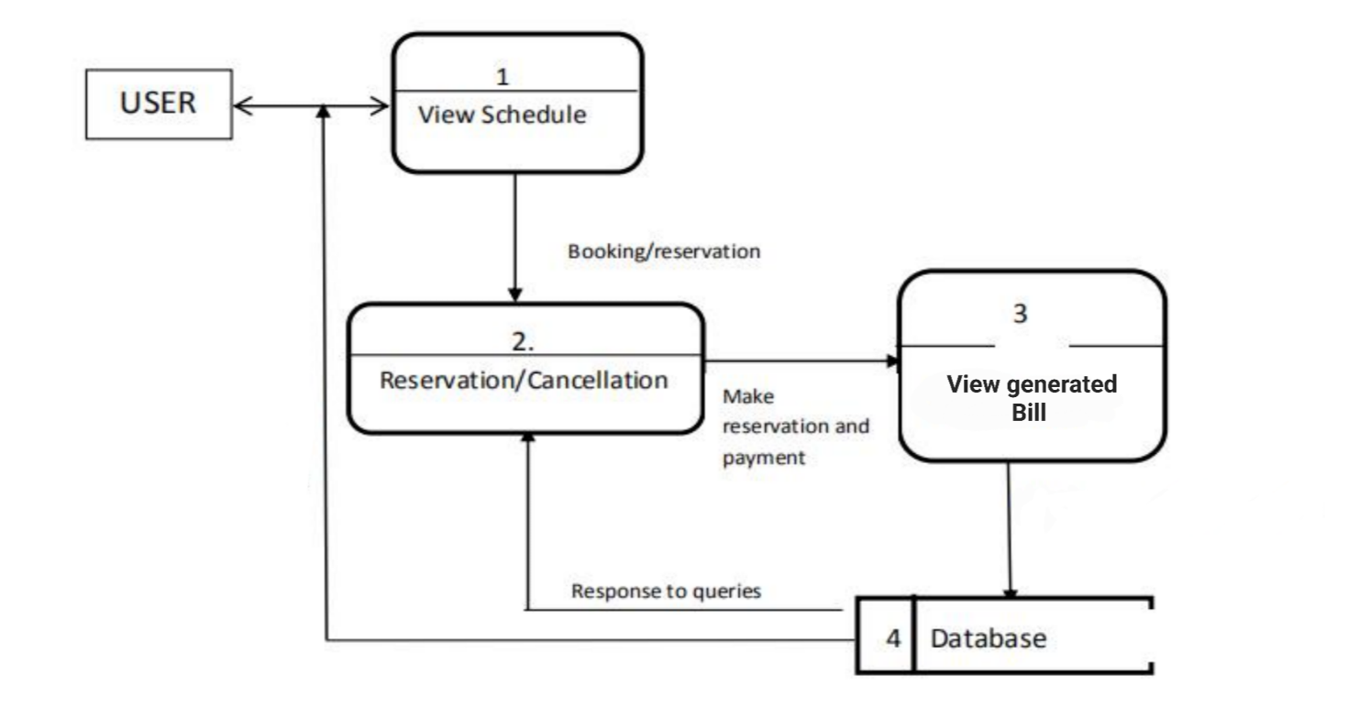

Figure : User DFD

**5.2.2 ADMIN DATAFLOW DIAGRAM**

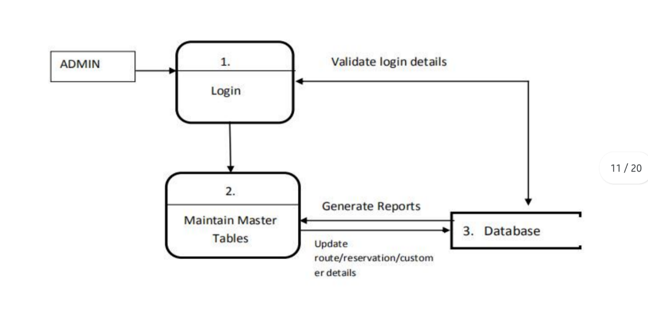

Figure : Admin DFD

# 5.2.3 USE CASE DIAGRAM FOR USERS AND ADMIN

A use case is a description of a system’s behavior as it responds to a request that originates from outside of that system (the user). , a use case of the activities in a bus transport system is shown.

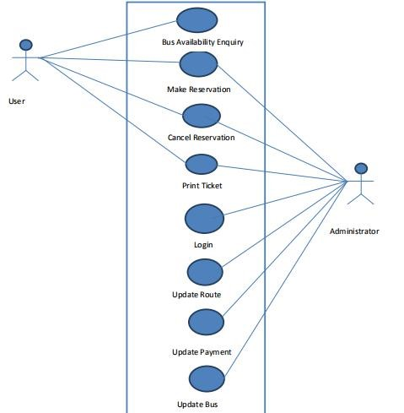

Figure : Use case diagram

**CHAPTER 6**

**REQUIREMENT ANALYSIS**

**Software requirement**

* Python 3.10
* Django (latest version)
* Bootstrap 4 / Bootstrap 5
* Web Browser (recommend: Google Chrome)

**Hardware requirement**

**Django minimum requirements**

* Memory : 4 GB
* Graphic Card : AMD Radeon R5 M230
* CPU : Intel Core i3-2340UE
* Storage : 5 GB min

**CHAPTER 7**

**SNAPSHOTS**

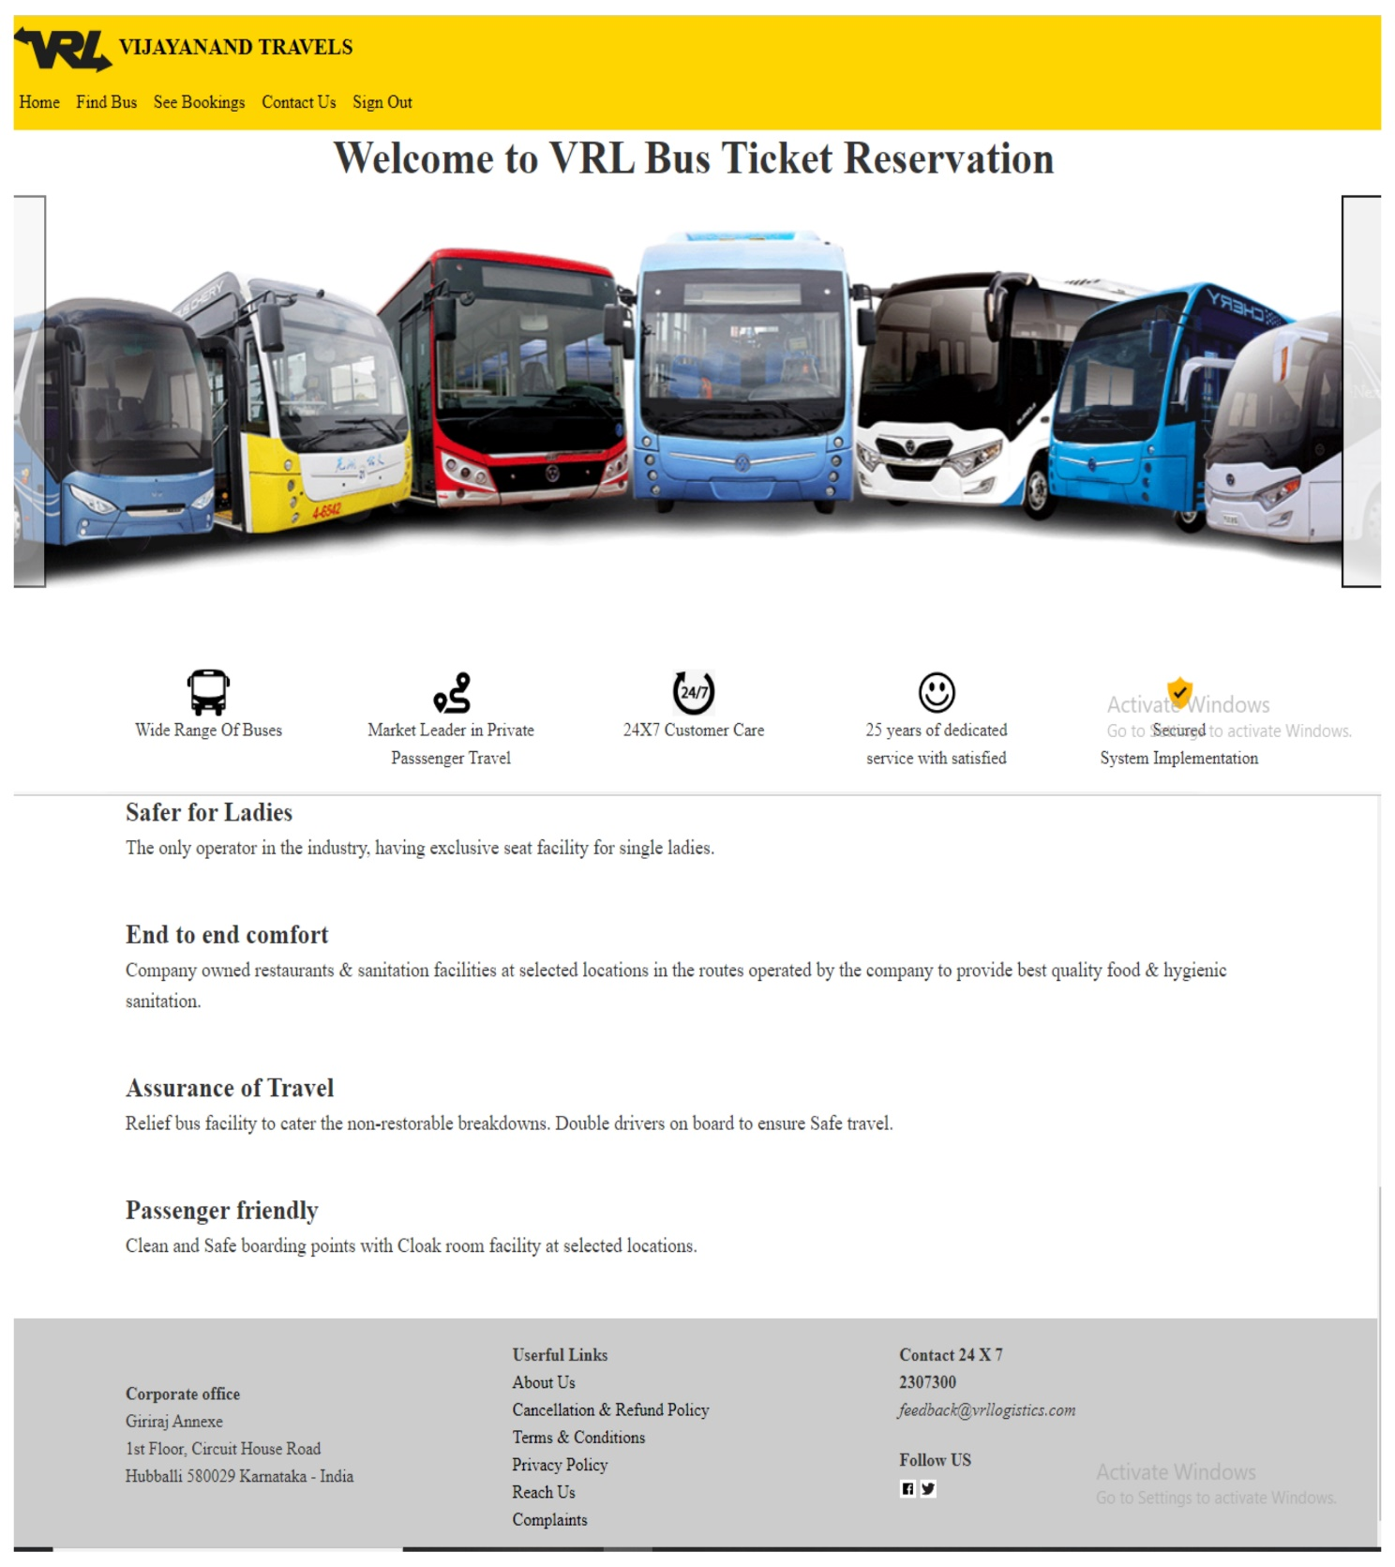

Figure 5: Home Page

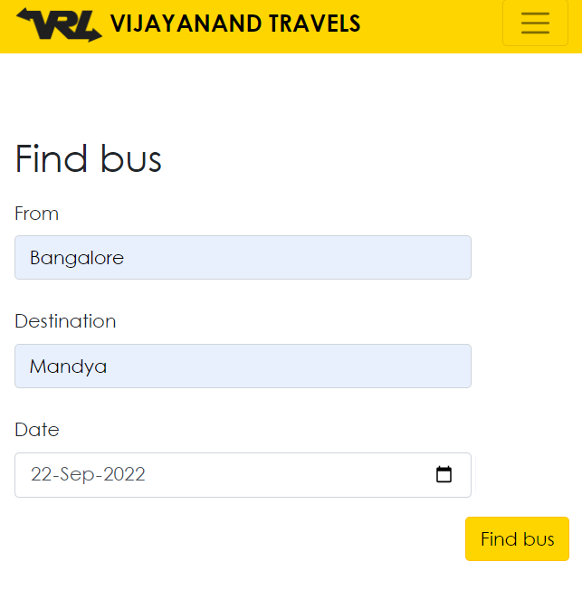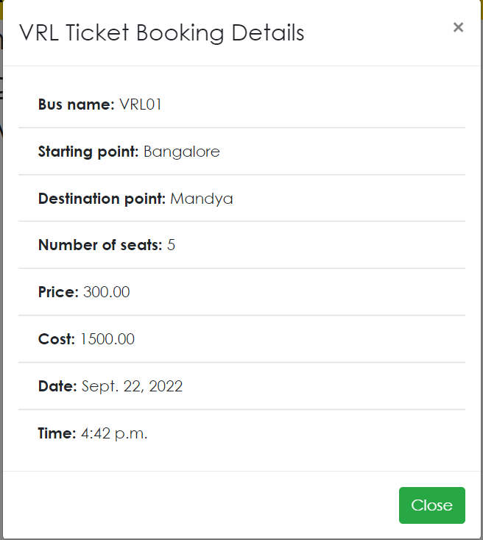

Figure 6: Find Bus

Figure 7: Generated Bill

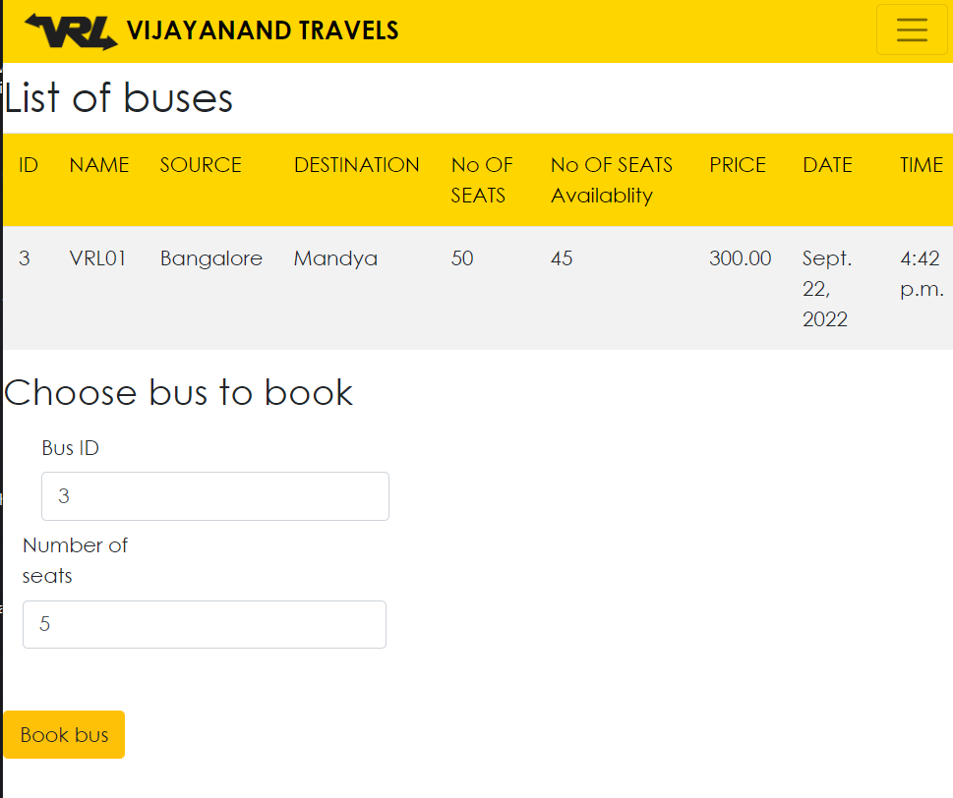

Figure 8: List of Bus found

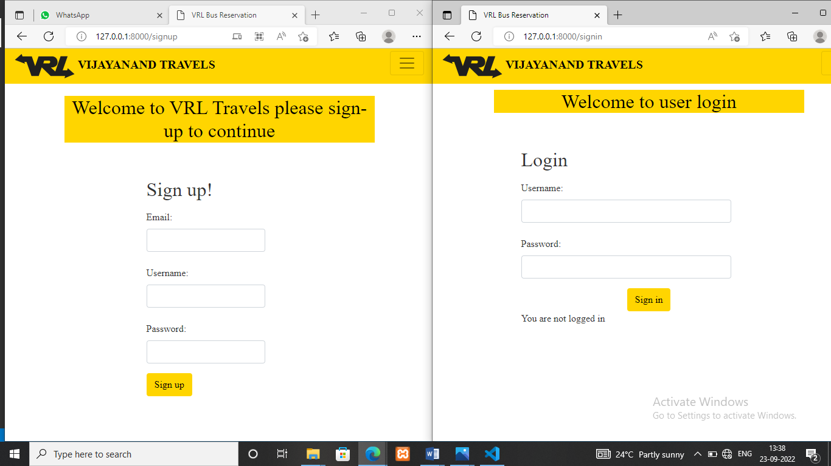

Figure 9: Sign-Up & Sign-In

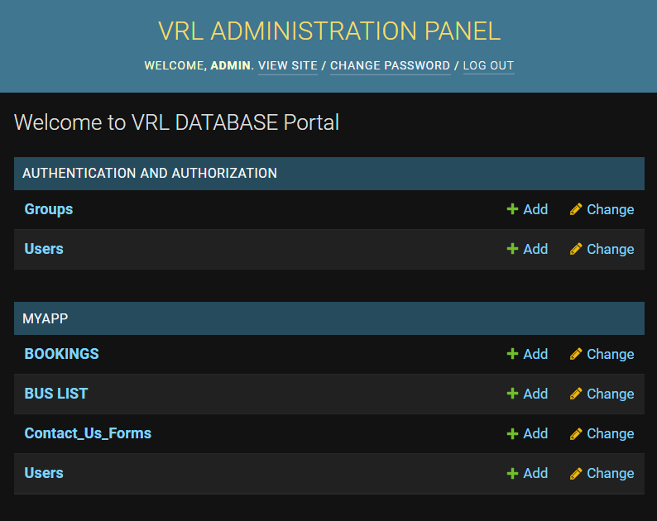

Figure 10: Admin Control Panel

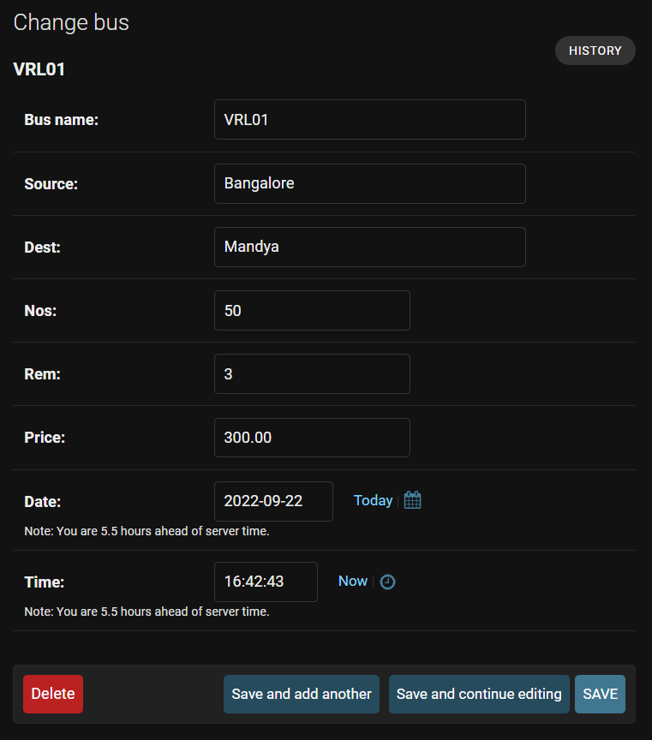

Figure 11: Update Bus details

**CHAPTER 8**

**CONCLUSION**

It can be observed that computer applications are very important in every field of human endeavor. Here all the information about customer that made reservation can be gotten just by clicking a button with this new system, some of the difficulties encountered with the manual system are overcome. It will also reduce

The workload of the staff, reduce the time used for making reservation at the bus terminal and also increase efficiency. The application also has the ability to update records in various files automatically thereby relieving the company’s staff the stress of working from file security of data.

Our project online bus reservation system provides an easy way for booking the bus tickets. Our project has succeeded in managing the data and providing the best service to the users.

This project, as a whole, will give a new way in bus reservations and ticketing processes. The automation and management of seats and reservations will be done online. However, this project does not limit the walk-in passengers that is passengers who visit the company’s counter because it also caters for them.

This also lessens the use of papers like in the traditional way of ticketing.

Finally, in Online Bus Booking System, we have developed a secure, user-friendly Bus Reservation System. This Project basically provides a Bus information and regarding bus information. First of all, in our website any user or visitors view our system and search the bus and how many seats are available in our buses.

The user can also register its own seats in the bus this website. The user can post a comment on different Bus Services. But user can compulsory registered first in the system. Search Bus category wise.

This is the cloud based online system. Therefore, to access this system you only need a web browser, internet connection. This is the 24X7 available system. We observed the working of the Bus reservation system and after going through it, we get to know that there are many operations, which they have to do manually. It takes a lot of time and causing many errors while data entry. Due to this, sometimes a lot of problems occur and they were facing many disputes with customers.

To solve the above problem, and further maintaining records of passenger details, seat availability, price per seat, bill generation and other things, we are developed computerized reservation system.

By using this software, we can reserve tickets, through telephone lines, via the internet. The customer can check the availability of bus and reserve selective seats. The project provides and reviews all sorts of constraints so that user does give only user data and thus validation is done in an efficient manner.

**CHAPTER 9**

**REFERENCES**

<https://docs.djangoproject.com/en/4.1/>

<https://www.w3schools.com/django/django_intro.php>

<https://developer.mozilla.org/en-US/docs/Learn/Server-side/Django/Introduction>

<https://docs.djangoproject.com/en/4.1/ref/contrib/admin/>

<https://docs.djangoproject.com/en/4.1/intro/>

<https://www.geeksforgeeks.org/how-to-create-an-app-in-django/amp/>