# Name - Aman Maurya

# Roll No. - 223CS3153

# Course - M. Tech (Year-I)

# Branch - CSE (Software Engineering)

# Assignment - (6) Jumble

# Factorial

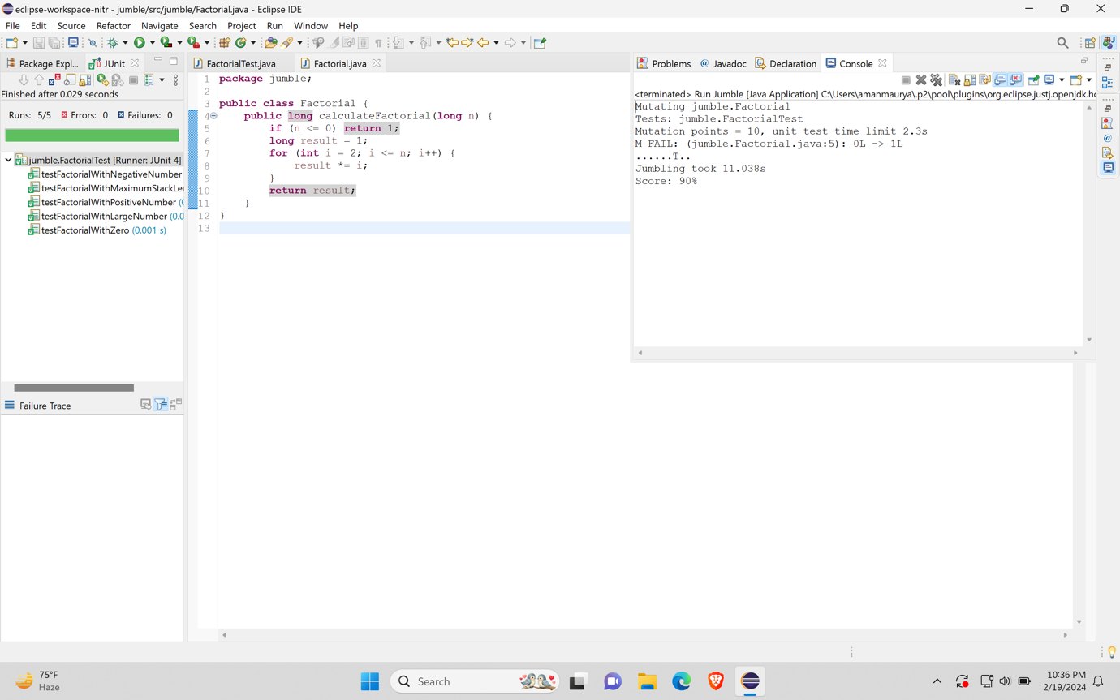

# Fibonacci

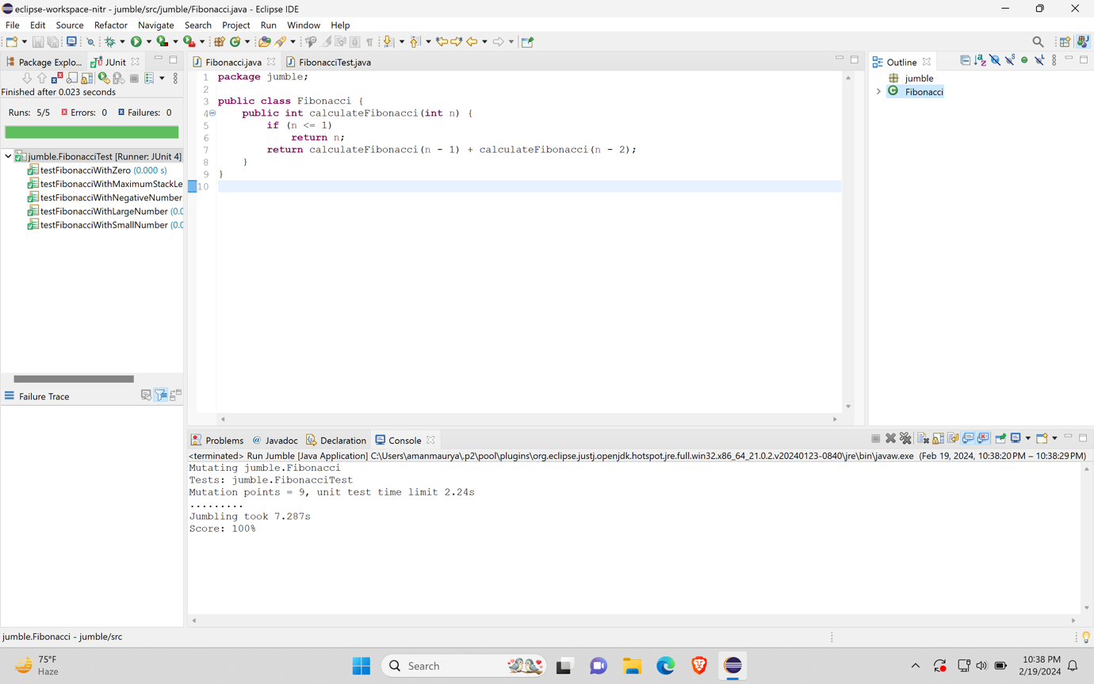

# QuickSort

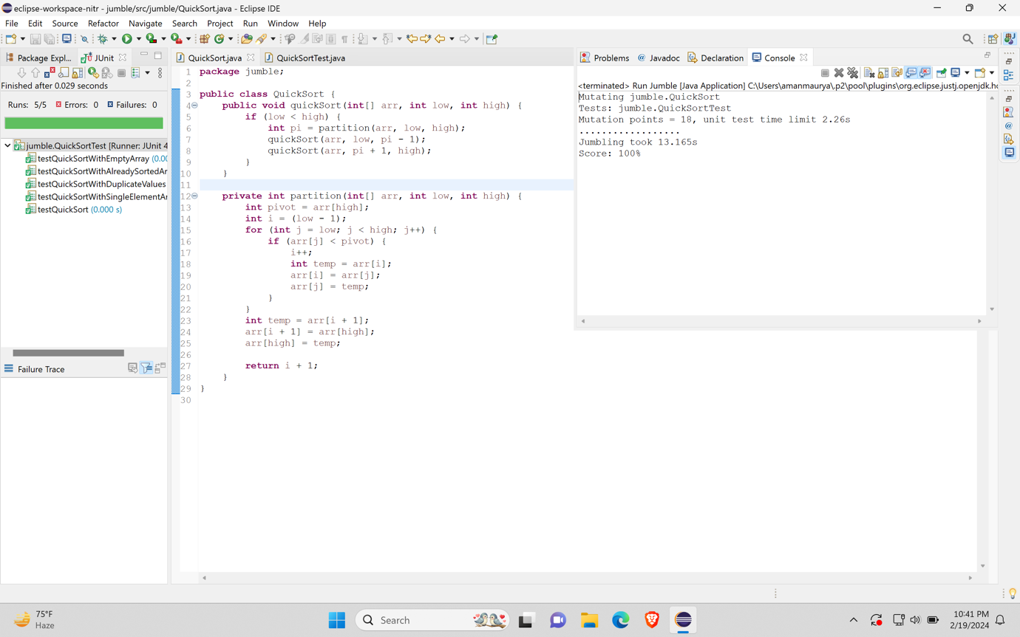

# Matrix Transpose

# Matrix Addition

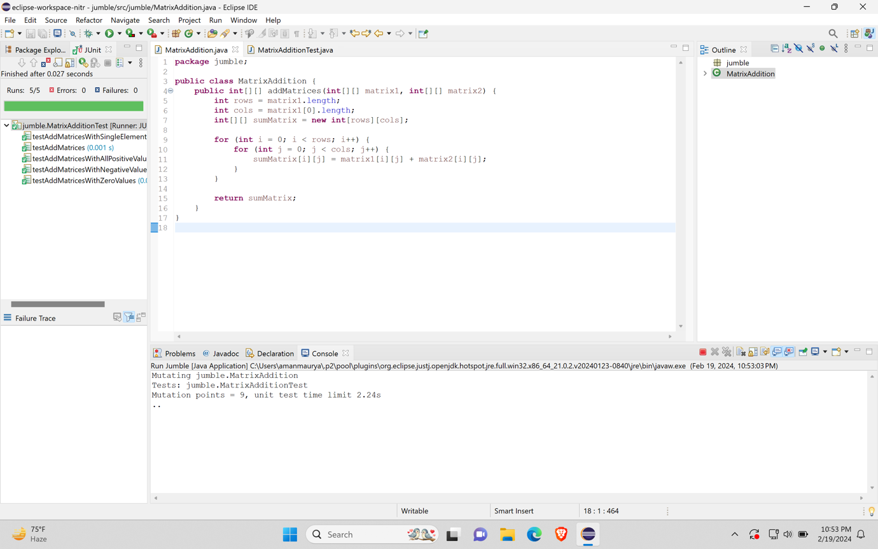

# Prime Numbers

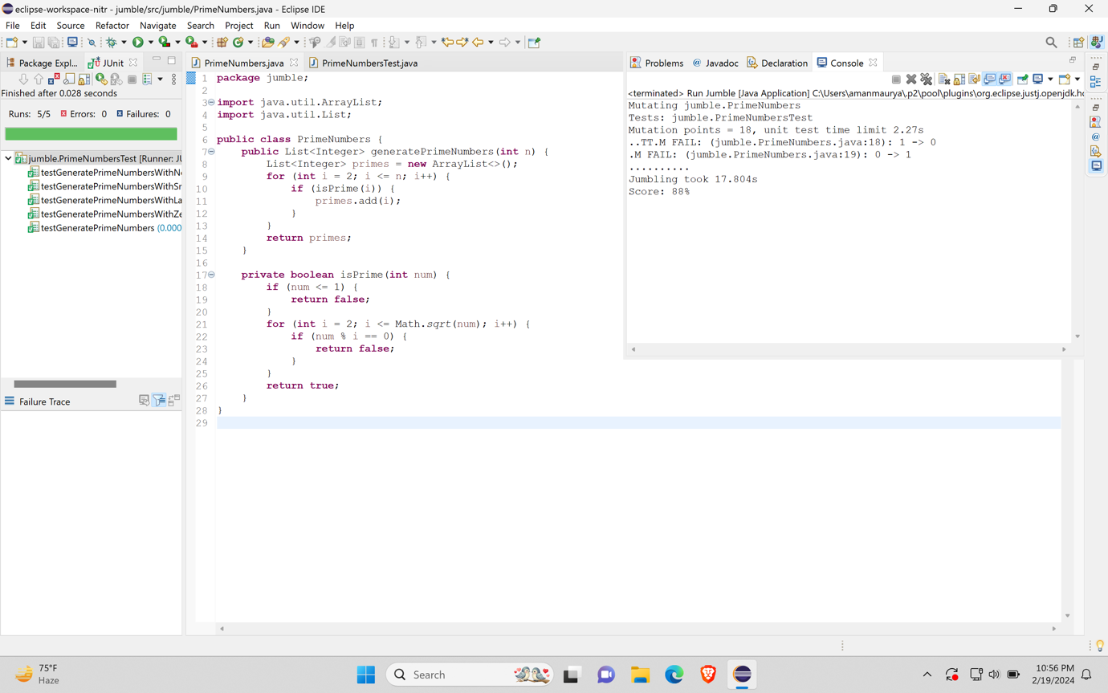

# Palindrome

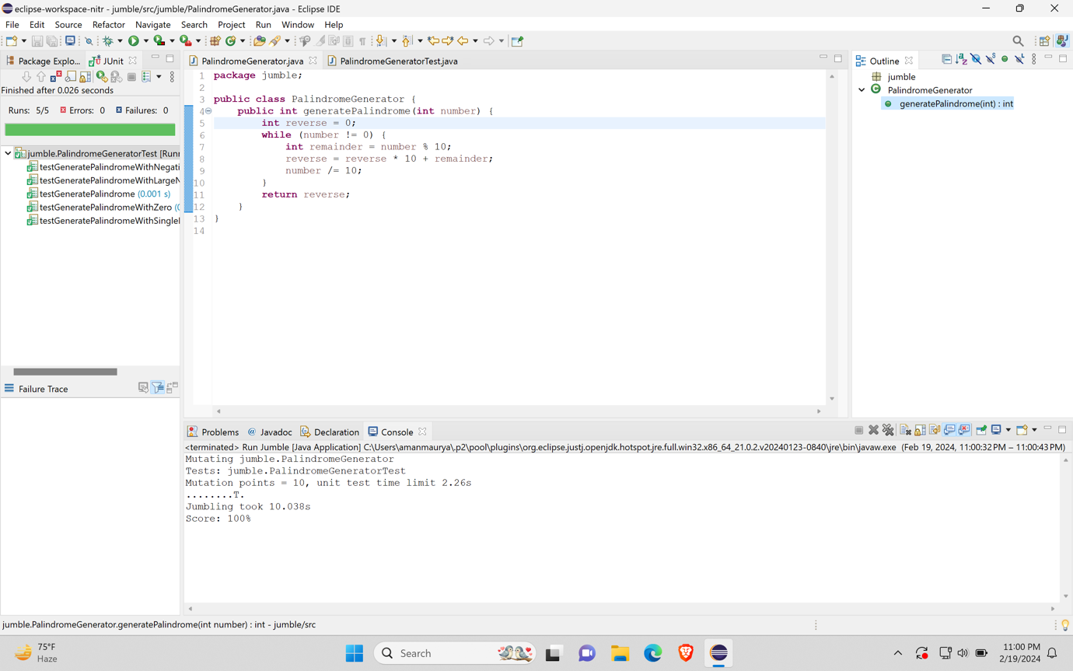

# Sum Of Arrays

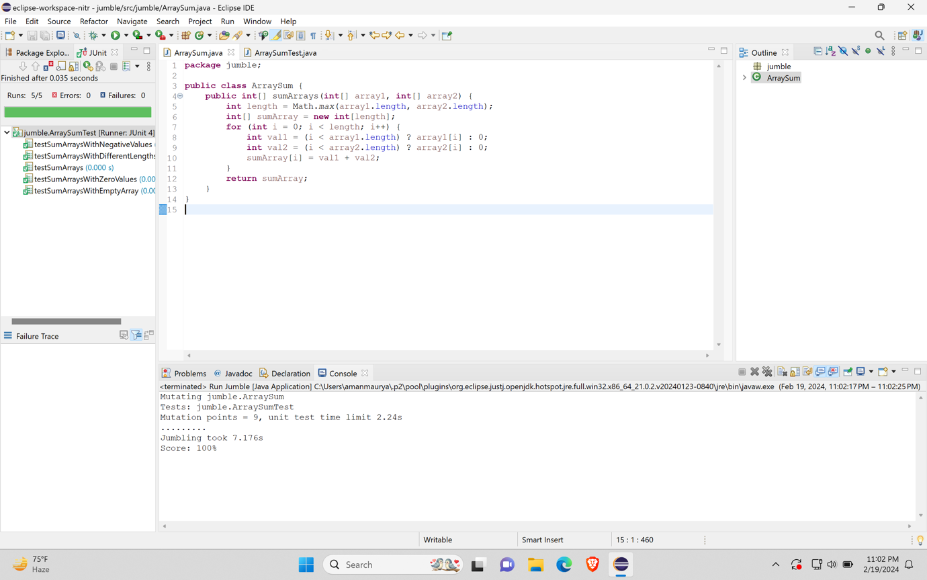

# Even Or Odd

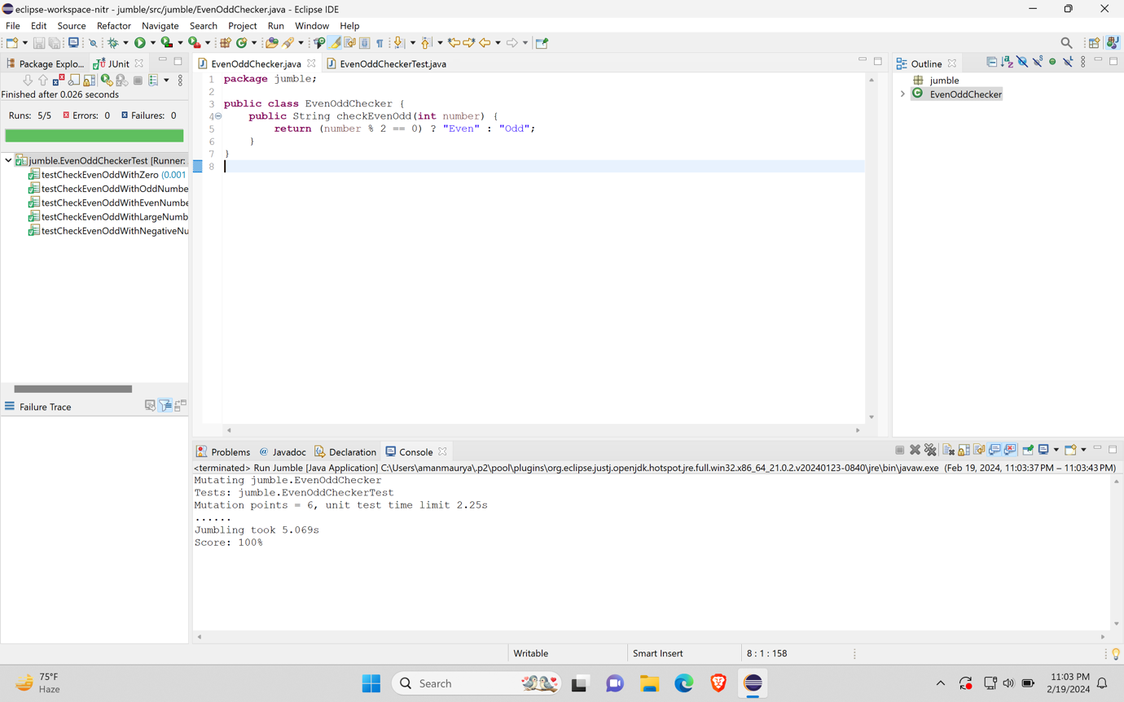

# Binary To Hexadecimal

