# Name - Aman Maurya

# Roll No. - 223CS3153

# Course - M. Tech (Year-I)

# Branch - CSE (Software Engineering)

# Assignment - (1) Selenium

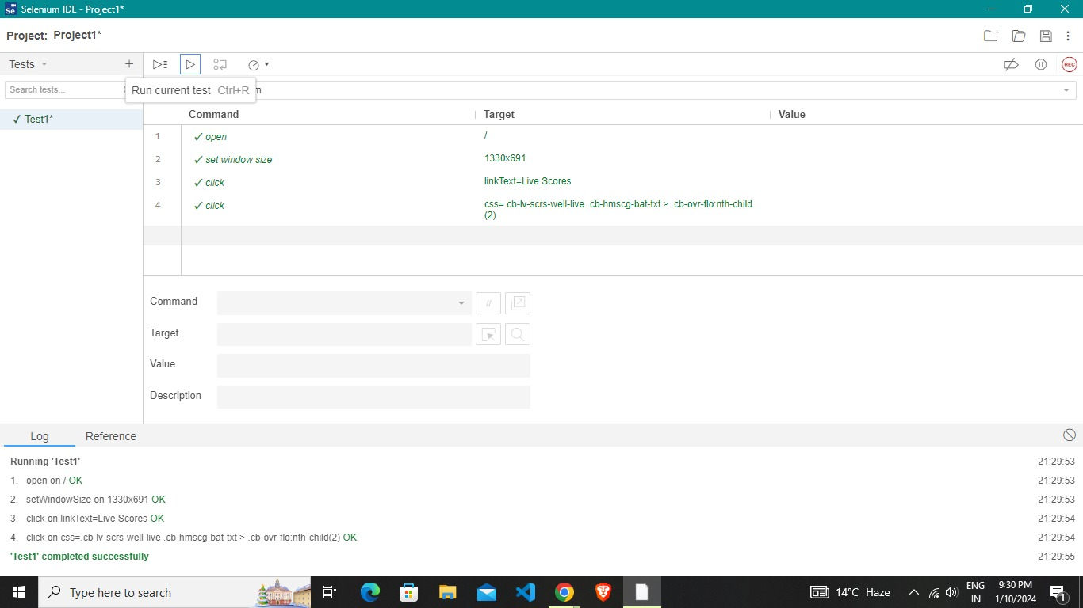**WEBSITE 1: CRICBUZZ**

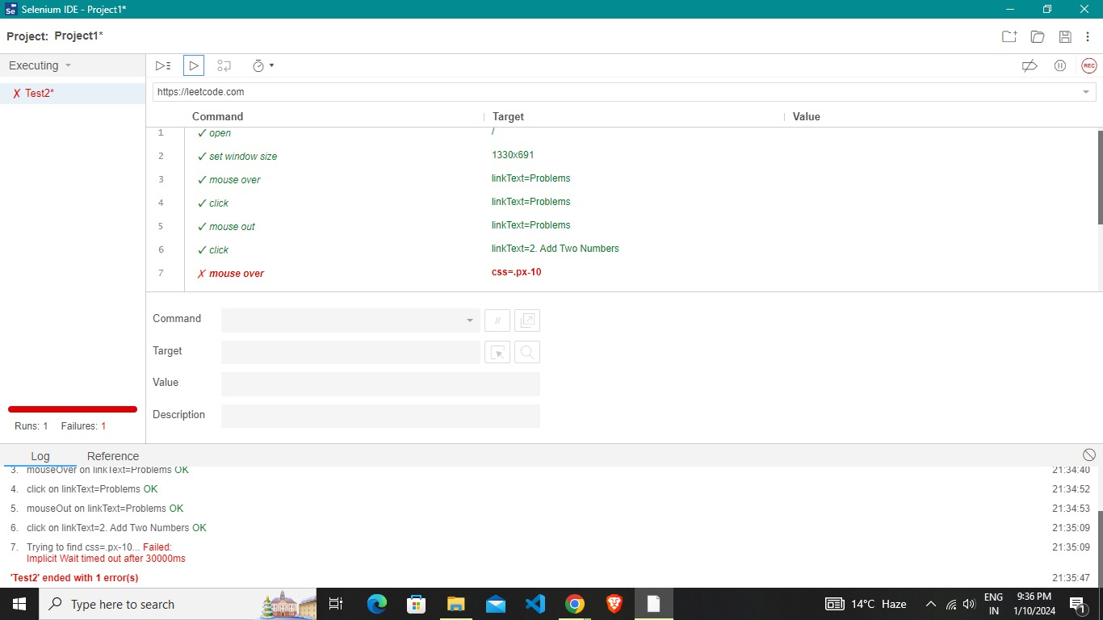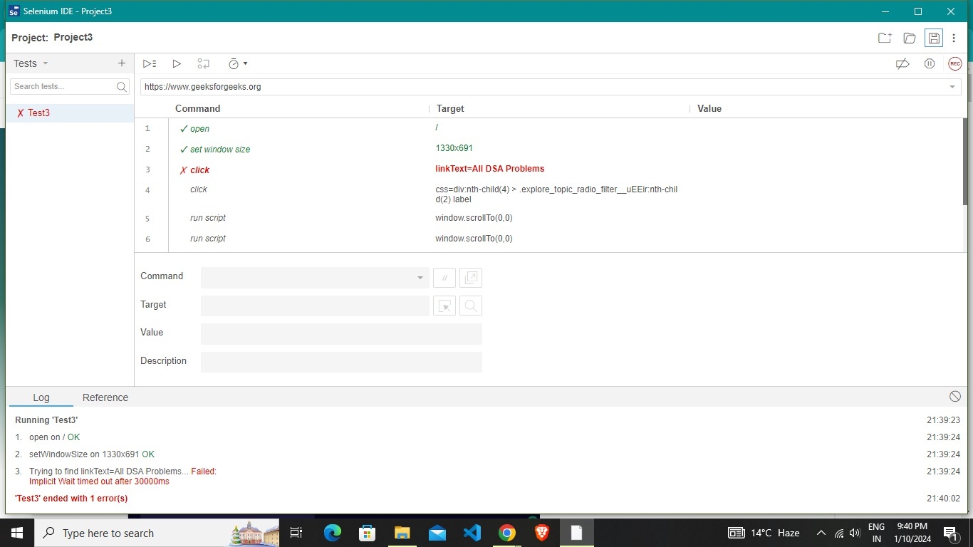

**WEBSITE 2: GEEKSFORGEEKS**

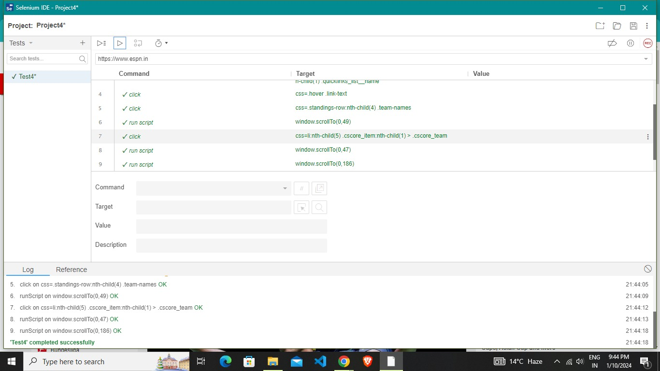

**WEBSITE 3: ESPN**

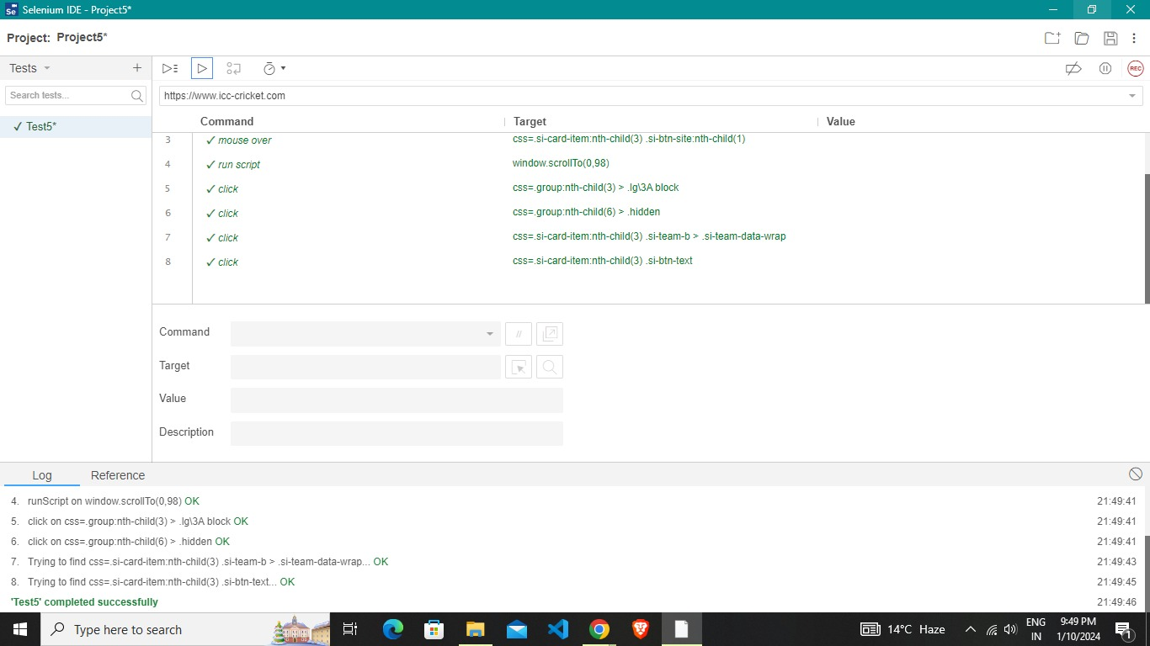

**WEBSITE 4: ICC-CRICKET**

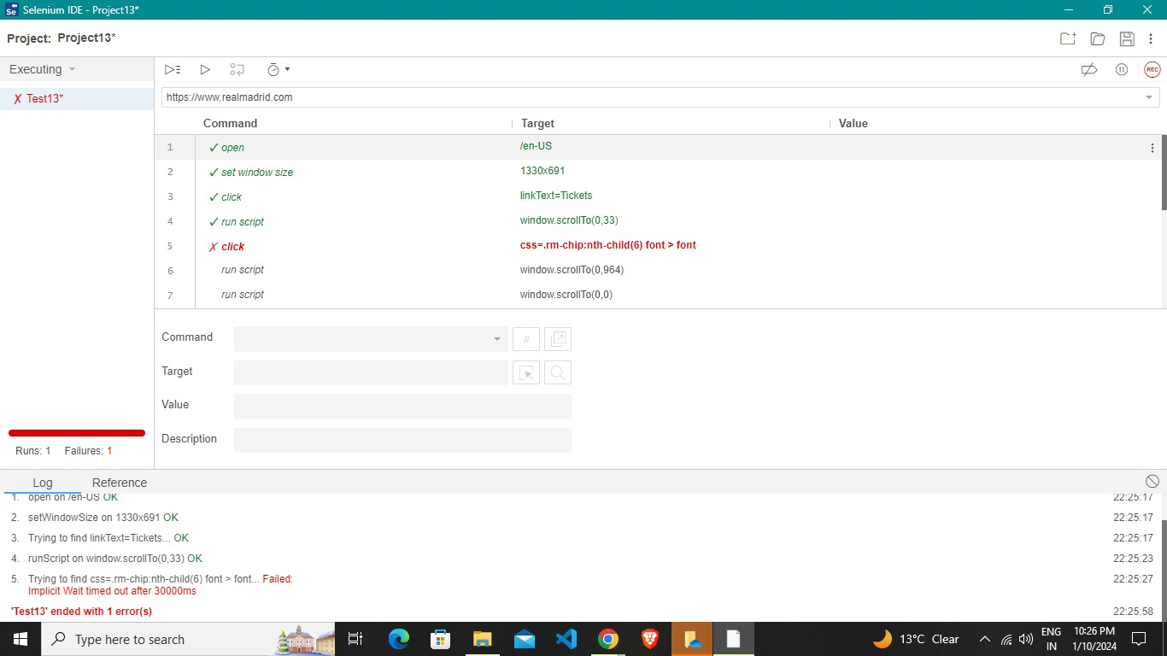

**WEBSITE 5: REALMADRID**

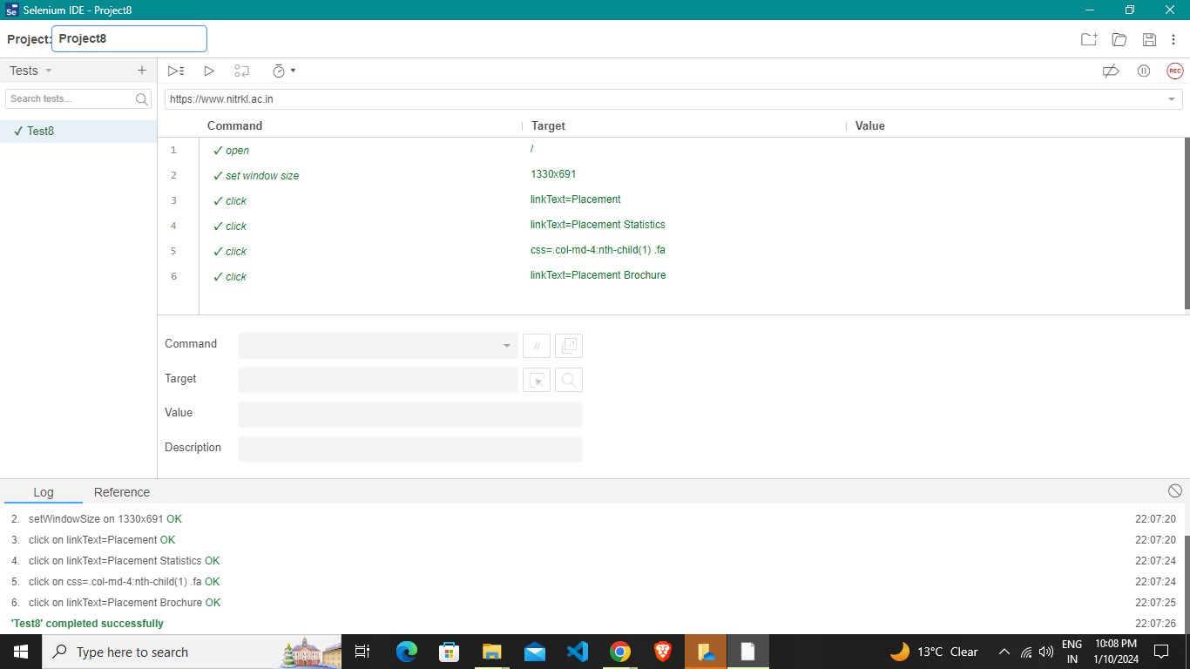

**WEBSITE 6: NITRKL**

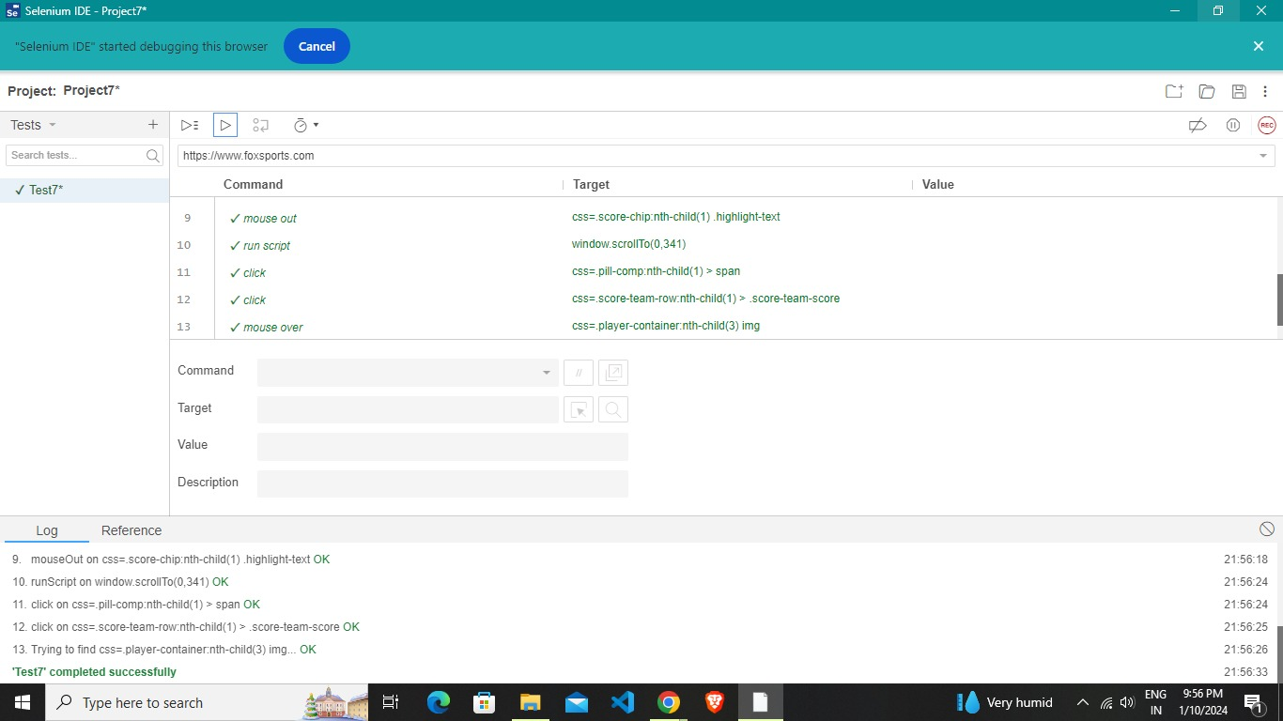**WEBSITE 7: FO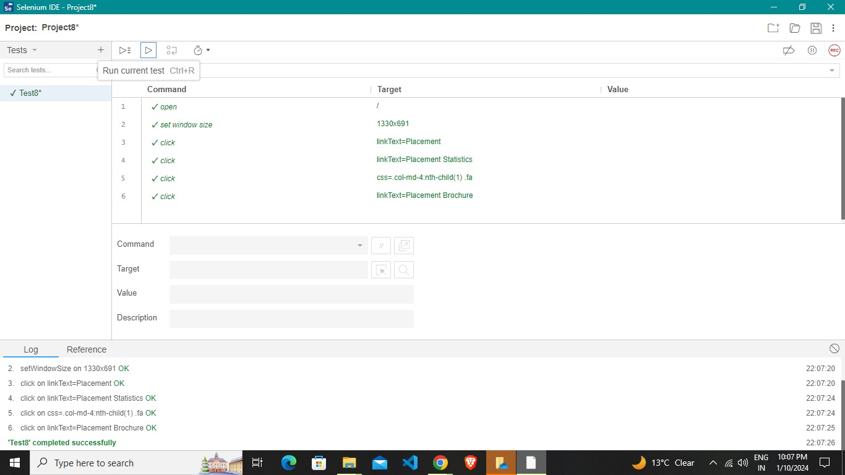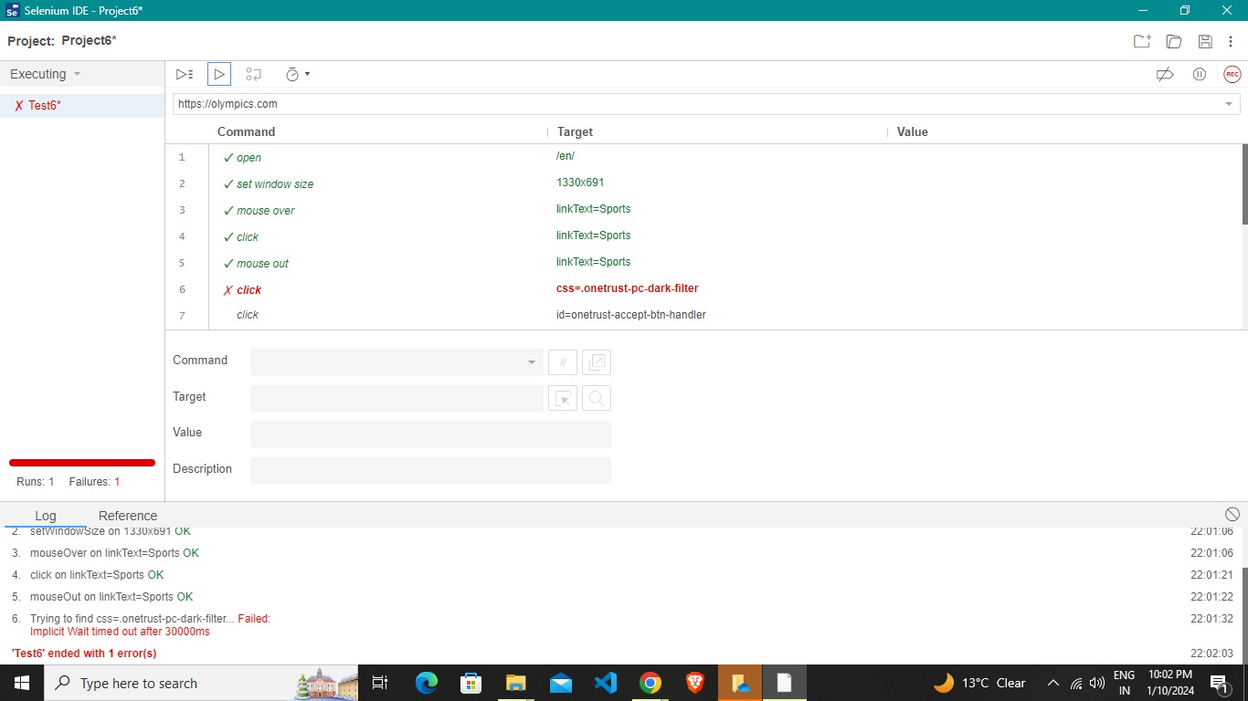XSPORTS**

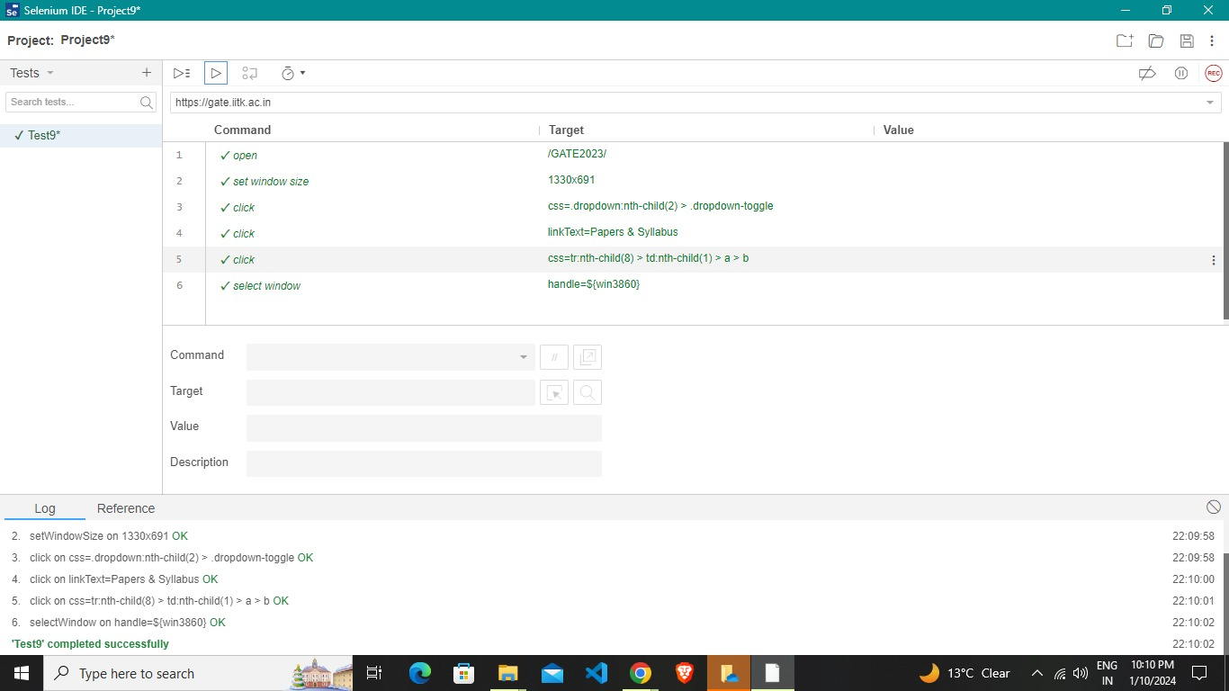**WEBSITE 8: GATE.IITK**

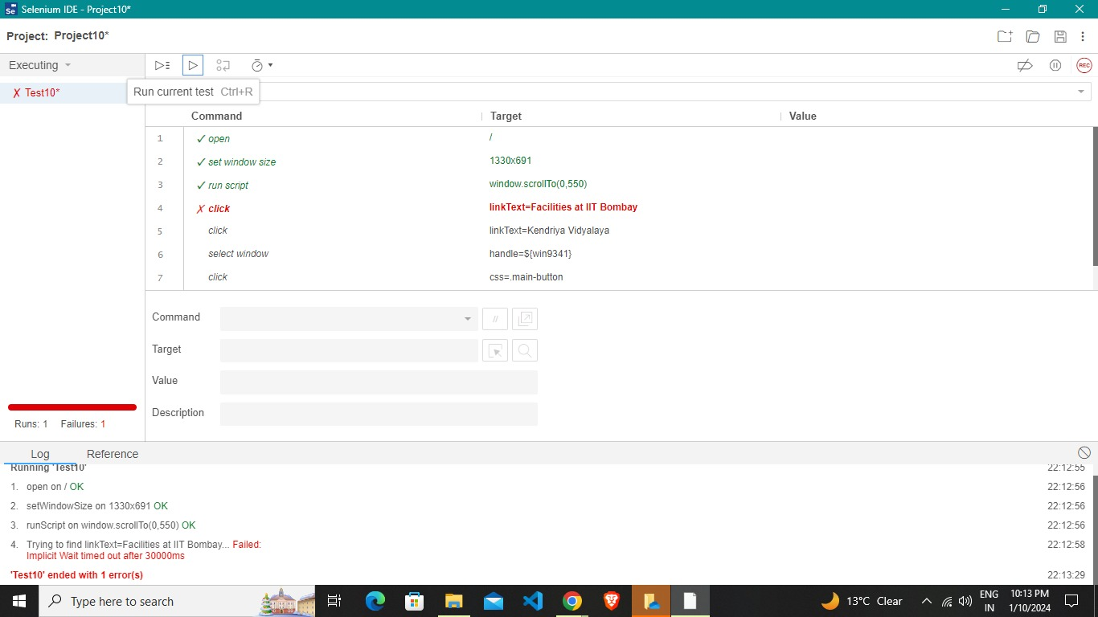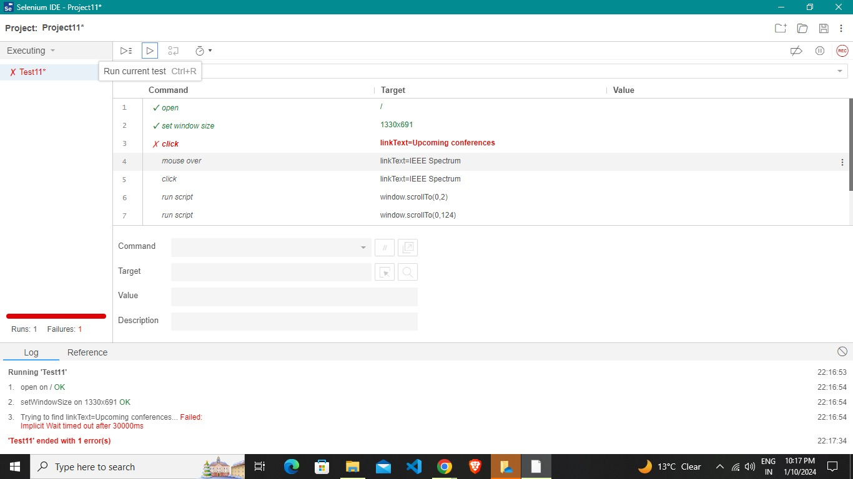

**WEBSITE 9: OLYMPICS**

**WEBSITE 10: KV**

**WEBSITE 11: REALMADRID**

**WEBSITE 12: VEDABASE**

**WEBSITE 13: MYGOV**

**WEBSITE 14: AMAZON**



**WEBSITE 15: GEEKSFORGEEKS**