University of Central Punjab
Faculty of Information Technology and Computer Science
Course Title: Software Construction & Development
Course Code: SESD3242
Assignment 3

Name | ID | Contribution in the assignment
Tayyab Sarwar | L1F22BSSE0081 | Worked on GUI design, validations, debugging, and contributed code updates and commits on GitHub through personal account.
Subhan Iqbal | L1F23BSSE0169 | Worked on exception handling, functionality improvements, debugging, and contributed code updates and commits on GitHub through personal account.

CLO | At the end of the course the students will be able to: | BT Level* | PLO
CLO2 | Apply construction techniques to write a clean and maintainable code that meets industry standards and best practices. | C2 | 2

Deadline: 20-May-26 Total Marks= 50

Instructions:
- Late submission will cause 20% deduction. No submission after 2 Days.
- This assignment is a group assignment. 2 members in each group. Individual submissions will not be accepted.
- ASSIGNMENT SHOULD BE PROPERLY TYPED.
- Attach this title page to your submission. (5 marks)
- Upload it on the portal on 20-May-26_at 11:55pm
- Plagiarism is seriously your own choice.
Library Book Issue System – Report
GitHub Repository: https://github.com/i-am-subhan-iqbal/Library-System

Problem Statement:
The objective of this project is to develop a simple Library Book Issue System using Java Swing. The system allows a student to issue a book by entering their personal details such as name, roll number, issue date, and return date.
The application also provides options to select a book from a dropdown list and choose the book type using radio buttons. The main focus of this project is to implement proper exception handling to validate user input and ensure correct data entry.

GUI Description:
The graphical user interface of the system is developed using Java Swing components. The interface includes:
- Labels for Student Name, Roll Number, Book Title, Book Category, Issue Date, and Return Date
- TextFields for entering student name, roll number, issue date, and return date
- A JComboBox (dropdown list) for selecting book titles such as Java, C++, React, etc.
- Radio buttons for selecting book edition (New Edition / Old Edition)
- A JTextArea for optional remarks
- Buttons including Submit (Issue Book), Reset, and Exit
The layout is designed to be simple and user-friendly so that students can easily interact with the system.

Exception Handling Used:
In this project, exception handling is implemented to validate user input and prevent incorrect data entry.

Custom Exceptions Created:
- EmptyFieldException : triggered when any required field is left empty
- InvalidRollNumberException : triggered when roll number contains invalid characters
- InvalidDateException : triggered when return date is earlier than issue date
- NullSelectionException : triggered when no book is selected or no option is chosen

Built-in Exception Used:
- NumberFormatException : handled when converting roll number to numeric format

Additional Custom Exception:
- (If implemented) InvalidBookTypeException : for invalid book selection logic

Working of the System:
When the user clicks the “Submit” button, the system checks all input fields inside a try block. If any invalid input is found, the program throws a custom exception.
Each exception is handled using catch blocks and appropriate error messages are shown using JOptionPane.
A finally block is also used which displays a message like “Operation Completed” regardless of whether the input is valid or not.

Screenshots:
The following screenshots are included in the project:
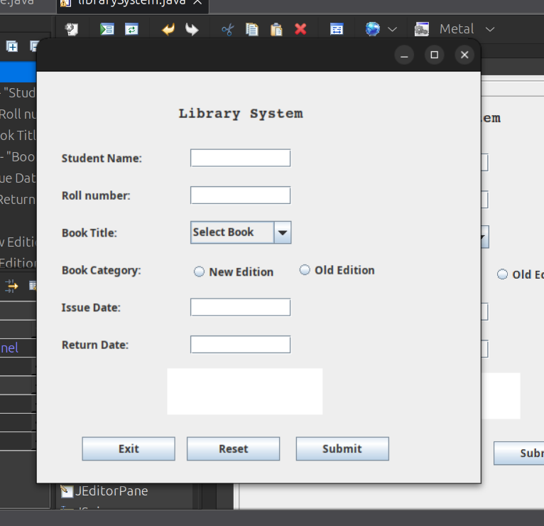

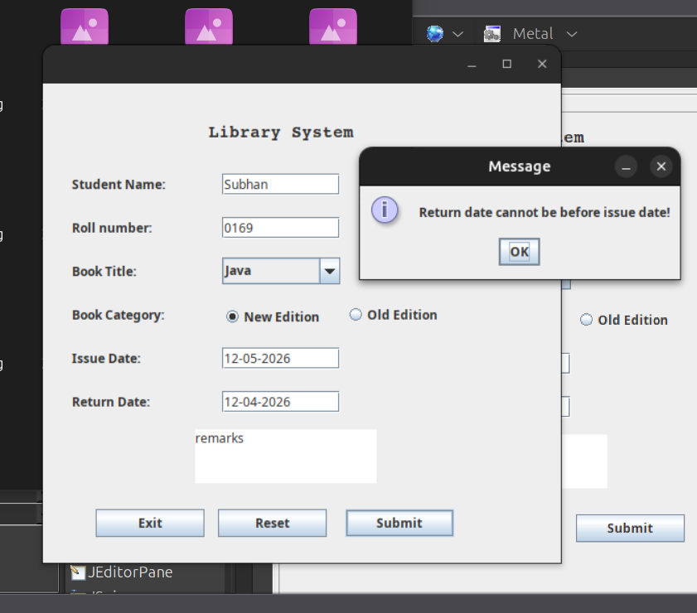

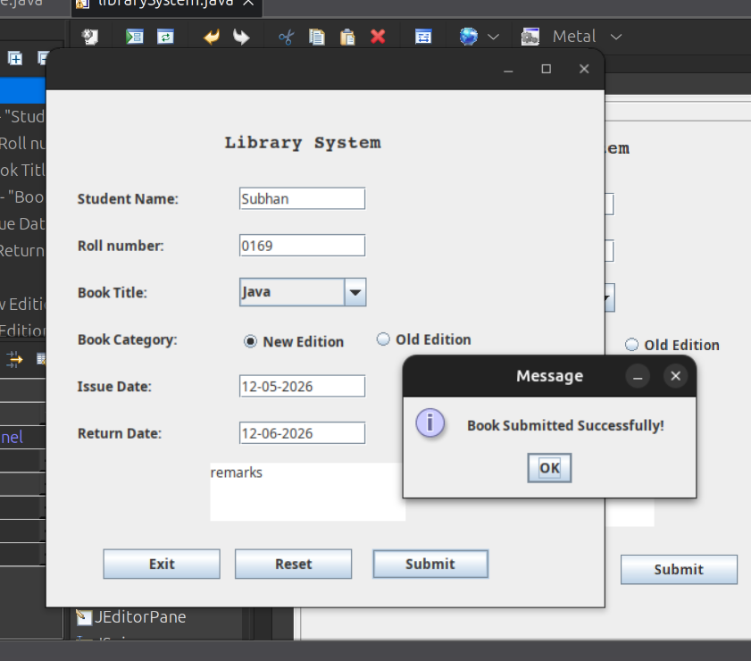

(All screenshots are attached in the GitHub repository under the screenshots folder)

GitHub Repository:
The complete source code and project files are uploaded on GitHub:
https://github.com/i-am-subhan-iqbal/Library-System

Conclusion:
This project helped in understanding how Java Swing is used for creating graphical user interfaces. It also improved understanding of exception handling concepts such as try-catch blocks, throw keyword, and finally block.
Overall, the system successfully demonstrates input validation and error handling in a simple library management application.

