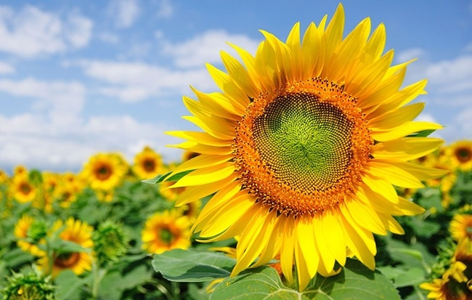
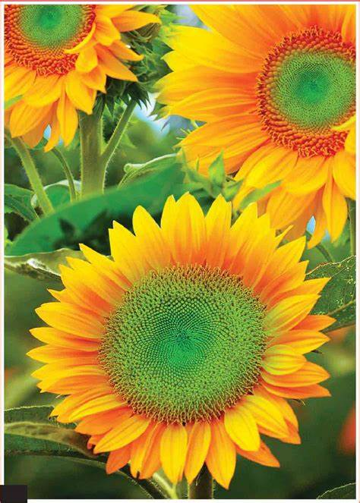
[Type the caption for the picture]
[COMPANY NAME]
Replace with  LOGO | [Address]  [City, ST ZIP Code]  [Phone]
A rose is a woody perennial flowering plant of the genus Rosa, in the family Rosaceae, or the flower it bears. There are over three hundred species and thousands of cultivars. They form a group of plants that can be erect shrubs, climbing, or trailing, with stems that are often armed with sharp prickles. Flowers vary in size and shape and are usually large and showy, in colours ranging from white through yellows and reds. Most species are native to Asia, with smaller numbers native to Europe, North America, and northwestern Africa. Species, cultivars and hybrids are all widely grown for their beauty and often are fragrant. Roses have acquired cultural significance in many societies. Rose plants range in size from compact, miniature roses, to climbers that can reach seven meters in height. Different species hybridize easily, and this has been used in the
development of the wide range of garden roses.
Who We Are

About Us
With the vision of sharing our knowledge of Information Technology in general and Informatic in specific, we create website HOCICT-Information Communications and Technologies to collect and rearrange educational materials and our own resources.

Contact Us
Address:
Phone:
Email:
Website:

in a matrix of fine, but stiff, hairs. Rose hips of some species, especially the dog rose (Rosa canina) and rugosa rose (Rosa rugosa), are very rich in vitamin C, among the richest sources of any plant. The hips are eaten by fruit-eating birds such as thrushes and waxwings, which then disperse the seeds in their droppings. Some birds, particularly finches, also eat the seeds.

Rosa
Rosa (the type subgenus, sometimes incorrectly called Eurosa) containing all the other roses. This subgenus is subdivided into 11 sections.
- Banksianae – white and yellow flowered roses from China.
- Bracteatae – three species, two from China and one from India.
- Caninae – pink and white flowered species from Asia, Europe and North Africa.
- Carolinae – white, pink, and bright pink flowered species all from North America.
- Chinensis – white, pink, yellow, red and mixed-color roses from China and Burma.
Synstylae – white, pink, and crimson flowered roses from all areas. Etymology
The name rose comes from French, itself from Latin rosa, which was perhaps borrowed from Oscan, from Greek ρόδον rhódon (Aeolic βρόδον wródon), itself borrowed from Old Persian wrd- (wurdi), related to Avestan varəδa, Sogdian ward, Parthian wâr.

[TYPE A CAPTION FOR YOUR PHOTO]

includes Address

