Introduce about hocict.edu.vn

Welcome to website http://www.hocict.edu.vn. This website is used for sharing document, lecture, reference material without using storage device. The creators’ purpose is for studying, exchanging and sharing knowledge with positive construction not for profit.
Moreover, students can check studying schedule, exam report, grade, etc. The website’ main contain covers lecture slides, curriculum, exercise is constructed by website owner and his colleagues.
With the vision of sharing our knowledge of Information Technology in general and Informatic in special, we create website HOCICT-Information Communications and Technologies to collect and rearrange educational materials and our own resources.
The website contains many literatures in different categories which have smaller groups so it is more convenience for readers. Besides, there are sections for top read articles, new articles, etc.

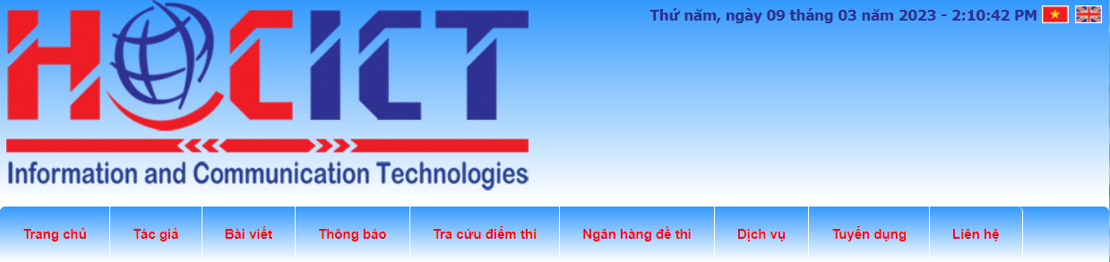

categories:

The list topics in each category:
- Informatics Technology  - Fundamental  - Graphic | - Multimedia  - Web Technologies  - Application Programming

founder information
Ly Tran Thai Hoc, M.Sc. (I.T)
Microsoft Certified Trainer – IC3 GS4 Authorized Educator
YouTube: HOCICT Official Channel
Skype: hocict – Yahoo: hocict
Signature by:

Bibliography
[Insert Built-in Bibliography Here]

