Our mission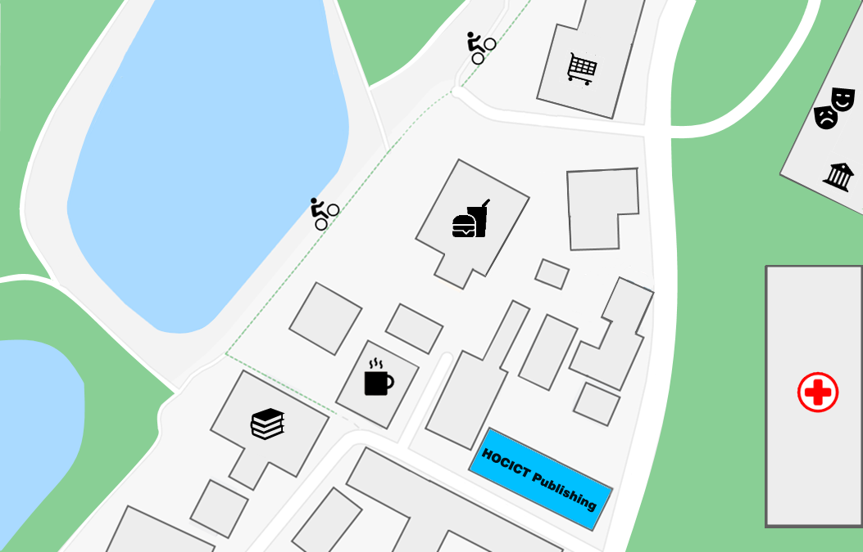
Some say that everyone is capable of writing a book. Anyway, at HOCICT Publishing, we love books and authors.
Writing a book can be a daunting and scary experience, and the fear of a refusal can distract many people from a life's goal. At HOCICT Publishing we can support you throughout the process. Our team consists of excellent writers, designers and other DTP specialists to help you every step of the way.

Editing process
As soon as you are ready to start, you can send us a first version of your book. If we like what you've written, you'll be invited to meet with the team and discuss in person how to publish.
We can handle all editing processes for you so you can focus on creating your content. Our writers will help you shape the message you intend to communicate to your readers. Our DTP specialists will take care of the layout of the book to achieve a professional print. Our illustrators and designers can turn your cover ideas into visuals.
We can offer you great rates from printers to help you contain your overall costs while creating a professional-quality publication. We can also put you in touch with book sales and marketing specialists who will help you get your book published in bookstores and put it in the hands of your readers!

Publishing
If you don't need all our services, you can self-publish your book for a small fee. For more information, visit our website or call us for free advice on how best to move forward. We can offer you design advice or other services to help make your publication a success.

Our specializations
If HOCICT Publishing specializes in Comptuing and Internet's books, our experience extends to many other genres. In the table below, you will find the list of all the genres we do. Fortunately, we collaborate with external publishing partners who can help you if we can't ourselves.
Gender | HOCICT Publishings | External partner
Biographies
Commerce
Children's books
Computing and Internet
Theatre
Fantastic
Health, family and lifestyle
History
Home and gardening
Humor
Detective novel
Poetry
Romance novel
Science fiction
Personal development

Where to find us

