6/28/2020
By: Michael Carter
My Life as History Text

Table of Contents

Table of Contents 1
Introduction 2
5 Fun Facts 2
My Proximal and Distal Goals 2
Major Work Events 3
The Biggest Event 4
My Recent Favourite 4
Conclusion: 4
Bibliography 5


Introduction

My name is Mike Carter and my passion in life is being an educator. I grew up with a sister with a severe physical disability. That might not seem related to teaching but seeing how the teachers could be creative and alter their plans to make Julie feel included made me want to be an inclusive teacher just like them some day. My first formal teaching experience happened when I was 16; I became a swim instructor. What I took away from this experience was the value of feedback. Unlike other teachers who did not engage with swimmers, I would jump in the water, stop my students, and let them know if they could improve something about their stroke. This led a lot of students to learn faster than some in other classes where feedback was minimal. Teaching swimming lessons led to my current job at Centennial College. One day I was teaching a boy who seemed uninterested in swimming. He found it boring and his mom said it’s because he only thinks about hockey. I thought what if I could combine the two? It took me two weeks, but I had a friend help me create an underwater puck with a heavy metal and I made a few sticks out of wood. Over the next few weeks his skills got better as I used the underwater hockey as an incentive to work hard. His mom was the program coordinator of the program I currently teach in at Centennial College.
5 Fun Facts
I have one foot that is 14 inches long and the other is 12 inches long
I am a huge Toronto Maple Leafs fan
I met a legendary, professional athlete, Johnny Bower
I jumped off a waterfall in Maui
I love video games

My Proximal and Distal Goals
Goal | Proximal Goal | Distal Goal
Perform push ups | 40 push ups | 100 push ups
Increase YouTube watch time | 300,000 (minutes) | 1 million (minutes)
Increase monthly views | 70, 000 views | 250,000 views

Major Work Events

The Biggest Event

I
n the spring of 2016, I remember nervously awaiting a response from the George Wicken award for teaching excellence committee at Centennial College to let me know if I had won the award based on my teaching. A few months earlier I had been nominated by my students and subsequently performed a teaching demonstration in front of a panel of 11 highly respected educators at Centennial College. I remember thinking, “it would be nice to win, but I’m happy just to be nominated”. When I finally received the email letting me know I had one, I was ecstatic and completely humbled that I had won it when I was competing against some very caring and truly talented teachers.
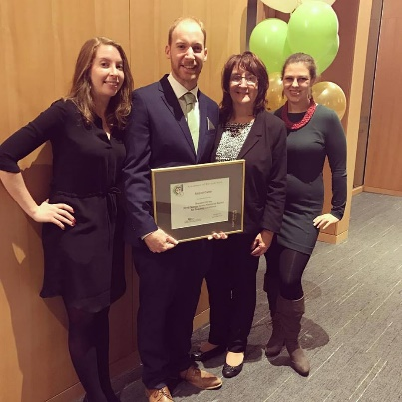
The night of the George Wicken Teaching Excellence awards, I was so nervous as I had to give a speech and accept the award. I had the honour of accepting the award in front of the president of Centennial College, the dean of our school, my chairperson, fellow colleagues, and my mom, my wife, and my sister. This was my proudest moment as an educator and one that is very hard to top. Centennial College has some amazing teachers who care so much for their students, and I was very proud to beconsidered one of them.
Figure 1-Me and My Family
My Recent Favourite
My recent favourite book is Primal Branding by Patrick Hanlon (Hanlon, 2006). This book changed the way that I think about growing an audience on YouTube. The most important message I took away from this book is to create and believe in a message that transcends your business or hobby. It allowed me to discover a belief system that I truly believe in and help me create my new slogan toward online education and that is: “Providing you with accessible education, to help you unlock new opportunities”. If anyone reading this is considering starting is a business at some point, you need to read this book!
Conclusion:
As I started to reflect on my recent experience as an online educator, I realized that I had a fear of online teaching. One that is quickly dissipating thanks to help of my courageous students. They did not sign up for this COVID-19 lockdown and have adapted admirably to learning online. They have taken to the online discussions and use forum threads to support one another. This was something I was worried about as we lose the informal discussion opportunities of a “live” class. Teaching and learning look a lot different online versus the in class experience, but my love for supporting and encouraging students is still the same for me. I believe this group will go on to do some great things.

Bibliography
Hanlon, P. (2006). Primal Branding. New York: Free Press.

