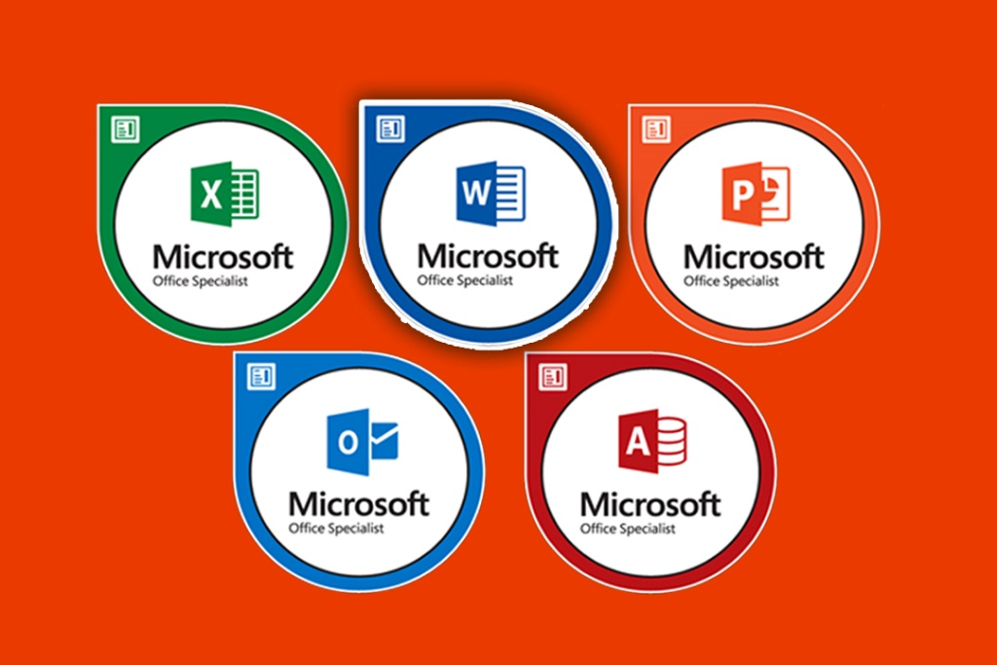
Exam MO-100: Microsoft Word (Office 2019)

About Course

Text editing is a very regular job for anyone working in the office. This book to reinforce your knowledges and skills as well as Microsoft Office Word 2016 Specialist certification exam.
The specialized materials of appropriated skills will be tested and evaluated in Exam 77-725: Microsoft Word 2016 Core published by Microsoft. Besides, the author has complied 10 simulator projects so that learners can self-assess their abilities after the review process before taking the exam to get Microsoft Office Specialist Certification.
To use this book, learners need to be proficient in using computer (Windows, keyboard, mouse) and already have a basic knowledge of Microsoft Word.

The outline of the document is shown below:

About Course i
About MOS 3
What is MOS Certification? 3
Author 4
Chapter 1 Manage Documents 5
1.1 Navigate within documents 5
1.2 Format documents 5
1.3 Save and share documents 5
1.4 Inspect documents for issues 5
Chapter 2 Insert and Format Text, Paragraphs, and Sections 6
2.1 Insert and paragraphs 6
2.2 Format text and paragraphs 6
2.3 Create and configure document sections 6
Chapter 3 Manage Tables and Lists 7
3.1 Create tables 7
3.2 Modify tables 7
3.3 Create and modify lists 7
Chapter 4 Create and Manage References 8
4.1 Create and manage reference elements 8
4.2 Create and manage reference tables 8
Chapter 5 Insert and Format Graphic elements 9
5.1 Insert illustrations and text boxes 9
5.2 Format illustrations and text boxes 9
5.3 Add text to graphic elements 9
5.4 Modify graphic elements 9
Chapter 6 Manage Document Collaboration 10
6.1 Add and manage comments 10
6.2 Manage change tracking 10

I always appreciate your valuable feedback to improve the quality of this book via email lytranthaihoc@hocict.edu.vn.
Due care and diligence have been taken while editing or printing the book, the author of the book hold any responsibility for any mistake that may have inadvertently crept in.
Ly Tran Thai Hoc, M.Sc. (I.T)
(MCT, IC³ GS4 Authorized Educator)
NTT Center for Informatics
Nguyen Tat Thanh University

About MOS
At present, individuals with an international MOS (Microsoft Office Specialist) certifications are getting attention from many domestic and foreign companies in employment recruiting, such as major financial institutes, and telecom corporations. Besides, MOS program is being used as a standard curriculum for K1-12 pupils and college students in our country. Since MOS is still new, therefore studying and obtaining the MOS certification is difficult due to some obstacles for the students.
Base on my own professional experiences and personal encounters, I will summarize several important topics to keep in mind when studying as well as taking exam for MOS certification.

What is MOS Certification?
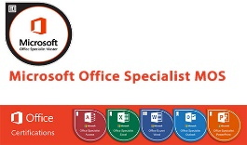
MOS is an abbreviation for Microsoft Office Specialist; it is a certification for advance proficiency skill of each application is Microsoft Office suite. This examination was created by Microsoft and implemented by Certiport (United States) worldwide.
MOS is the only justification that validates your skills in using Microsoft Office and is directly certified by the CEO of the Microsoft Corporation.

MOS Level

- Expert: Certification of expert skills in Microsoft Office product: Microsoft Word and Microsoft Excel.
- Specialist: Certification of basic skills in Microsoft Office product: Word, Excel, PowerPoint, Access, Outlook.

MOS Version

Office 2010
Exam Question Minutes Max Score Require Score
77-881: Word 2010 20 50 1000 700
77-882: Excel 2010 18 50 1000 700
77-883: PowerPoint 2010 40 50 1000 700
77-884: Outlook 2010 38 50 1000 700
77-885: Access 2010 34 50 1000 700
77-887: Word 2010 Expert 27 50 1000 700
77-888: Excel 2010 Expert 29 50 1000 700

Office 2013
Exam |  |  |  | Require Score

Office 2016
- 77-725: Word 2016  - 77-727: Excel 2016  - 77-729: PowerPoint 2016 | - 77-730: Access 2016  - 77-726: Word 2016 Expert  - 77-727: Excel 2016 Expert

Office 2019
Exam | Question | Minutes | Max Score | Require Score
MO-100: Microsof Word (Office 2019) | 35 | 50 | 1000 | 700
MO-200: Microsof Excel (Office 2019) | 35 | 50 | 1000 | 700
MO-300: Microsoft PowerPoint (Office 2019) | 35 | 50 | 1000 | 700
MO-400: Microsoft Outlook (Office 2019) | 35 | 50 | 1000 | 700
MO-101: Microsoft Word Expert (Office 2019) | 25 | 50 | 1000 | 700
MO-102: Microsoft Excel Expert (Office 2019) | 25 | 50 | 1000 | 700
MO-103: Microsoft Access Expert (Office 2019) | 31 | 50 | 1000 | 700

About Author
Ly Tran Thai Hoc, M.Sc. (I.T)

- Microsoft Certified Trainer - IC³ Global Standard 4 Authorized Educator
- MOS 2019 Masder Expert - MOS 2016 Master – MOS 2013 Master – MOS 2010 Master
Ly Tran Thai Hoc was born in Long An, Vietnam. He received Master degree of Information Technology (2018) from Ho Chi Minh City University of Technology (HUTECH), Vietnam. He has been working at the NTT Center for Informatics - Nguyen Tat Thanh University, HCMC, Vietnam as a lecturer since 2014 until now.
He is also the founder, manager, and leader of the administration team of fan page hocict.edu.vn and the HOCICT Official Channel on YouTube. All his compiled materials are freely available to the community.
- Website: http://www.hocict.edu.vn
- Fanpage: https://www.facebook.com/hocict.edu.vm
- Email: lytranthaihoc@hocict.edu.vn
- YouTube: HOCICT Official Channel
- Skype: hocict – Yahoo: hocict
Signature by:

Manage Documents

Navigate within documents

Format documents

Save and share documents

Inspect documents for issues

Insert and Format Text, Paragraphs, and Sections

Insert and paragraphs

Format text and paragraphs

Create and configure document sections

Manage Tables and Lists

Create tables

Modify tables

Create and modify lists

Create and Manage References

Create and manage reference elements

Create and manage reference tables

Insert and Format Graphic elements

Insert illustrations and text boxes

Format illustrations and text boxes

Add text to graphic elements

Modify graphic elements

Manage Document Collaboration

Add and manage comments

Manage change tracking

