Preparing Perfect Muffins

Overview
Fourth Coffee uses muffin recipes that were created for our exclusive use by the Culinary School at Bellows College. The recipe ingredients differ, but all the muffins are produced by using the same method.

Top Sellers
Each day we bake the six most popular muffin varieties based on the past quarter's sales) and one specialty muffin, the "muffin of the week." The current best sellers are:

- Blueberry streusel muffins  - Apple muffins  - Savory bacon cheddar corn muffins | - Apple bran muffins  - Zucchini chocolate chip muffins  - Whole grain banana muffins

Processes
Weighing

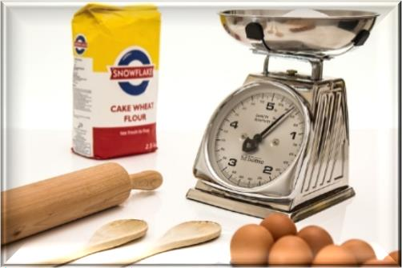
Mixing
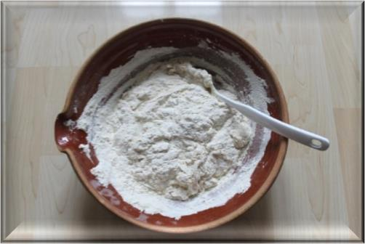
Portioning
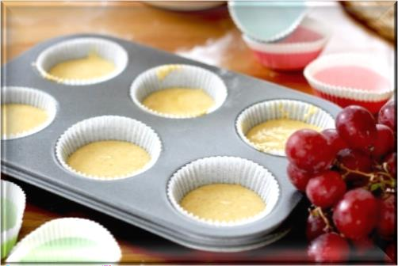
Baking

Fourth Coffee sells over 100 muffins per day to students and faculty at Bellows College. Many of our customers buy a muffin and a cup of coffee each day before attending class. Our customers expect our products to be delicious and consistent every day.
To ensure consistency, always use the scale to weigh the ingredients for our muffin recipes.

Pour the wet ingredients into the dry ingredients. Mix gently with a large spoon until the dry ingredients are mostly moistened. The mixture will be lumpy, and you will see streaks of dry flour in the mixture. This is OK. The lumps will smooth out during baking.
If you overmix the batter, the baked muffins will be dense and tough.

Insert paper liners into each muffin cup in the muffin trays. If you forget to do this, the muffins will stick to the sides of the muffin cups and will break when you try to remove them after baking.
Use the #16 ladle to portion the muffin mixture into the muffin trays. The #16 ladle contains 2.5 ounces (75 mL) of muffin mixture.

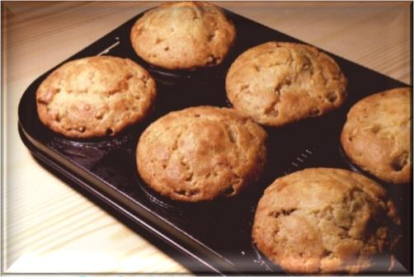
Preheat the oven to 350 ℉ (175 ℃).
Bake the muffins for 30–35 minutes. When the muffins are done baking, the tops should be golden brown. To confirm that the muffins are baked through, insert a toothpick into the center of a muffin. If the toothpick is clean when you remove it, the muffins are done.

Cooling


Depanning

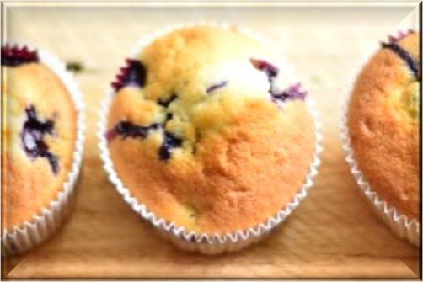
Serving

Cool the muffins in the muffin tray for 15–20 minutes.
If you remove the muffins from the tray too early, the muffins will fall apart.
If you cool the muffins in the tray for too long, the bottoms of the muffins will become soggy.

The muffin tray will still be hot! Protect your hands with hot pads or a dry towel when you remove the muffins from the muffin tray.
Run a small knife or spatula around the sides of the muffin cups to loosen them from the muffin tray. Invert the muffin tray and pop the muffins out. Tap gently on the bottom of each muffin cup if necessary.

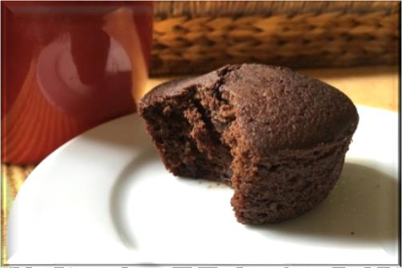
Offer to reheat muffins for customers. Heat for 7 seconds in the microwave and serve on a plate.
Otherwise, place the muffin in a white bakery bag

