Kafka Replication, minISR & Region-Failure Survival
A practical summary for a stretched KRaft cluster on OpenShift

This note summarises how replication factor (RF), in-sync replicas (ISR) and min.insync.replicas interact to decide whether a partition stays writable when a broker — or a whole region — goes down. The central lesson: surviving a region loss is governed by how many replicas of each partition survive, not by how many brokers remain running.

1. The building blocks

Replication factor (RF)
RF is a count of distinct brokers that hold a copy of each partition. RF=3 means every partition has three replicas on three different brokers: one leader and two followers. A hard rule follows from this: RF can never exceed the number of brokers available in the placement scope. RF=3 on two brokers is impossible, and Kafka will fail the partition assignment rather than silently lower it.

In-sync replicas (ISR)
The ISR is the subset of a partition's replicas that are currently caught up to the leader. It shrinks when a replica falls behind or its broker fails, and grows again as replicas catch back up.

min.insync.replicas (minISR)
minISR is the durability floor. With a producer using acks=all, a write is only acknowledged when at least minISR replicas are in sync. If the ISR drops below minISR, acks=all writes are rejected with NOT_ENOUGH_REPLICAS. Note that minISR only takes effect with acks=all — with acks=1 or acks=0 it is ignored, so the two settings work as a pair.
The standard pairing is RF=3 with minISR=2. The gap of one between them is deliberate: you can lose one replica and keep writing (3 → 2, still ≥ 2), and lose a second and still not lose data (reads continue, writes pause on a single surviving copy).

2. Losing a leader is not the problem — losing replicas is
Each partition has one leader at a time, but the leader is not a single point of failure. If the broker holding the leader dies, the controller automatically promotes an in-sync follower to leader, usually within seconds, and producers resume writing. What actually stops writes is the ISR count falling below minISR — which is about how many replicas survive, not which one happened to be the leader.
So the accurate statement is: if a region goes down and that region held a majority of a partition's replicas (2 of 3), the partition drops below minISR and cannot accept writes — regardless of where the leader was. The leader is re-elected either way; the co-located replica majority is what's fatal.

3. Why 2 regions can't survive a region loss, but 3 can
Three replicas cannot spread evenly across two regions — the only split is 2 + 1. So for every partition, one region holds the majority. Lose that region and only one replica survives: below minISR, the partition goes read-only. With three regions the split is 1 + 1 + 1, so no single region holds more than one replica, and any one region can be lost while two in-sync replicas remain.
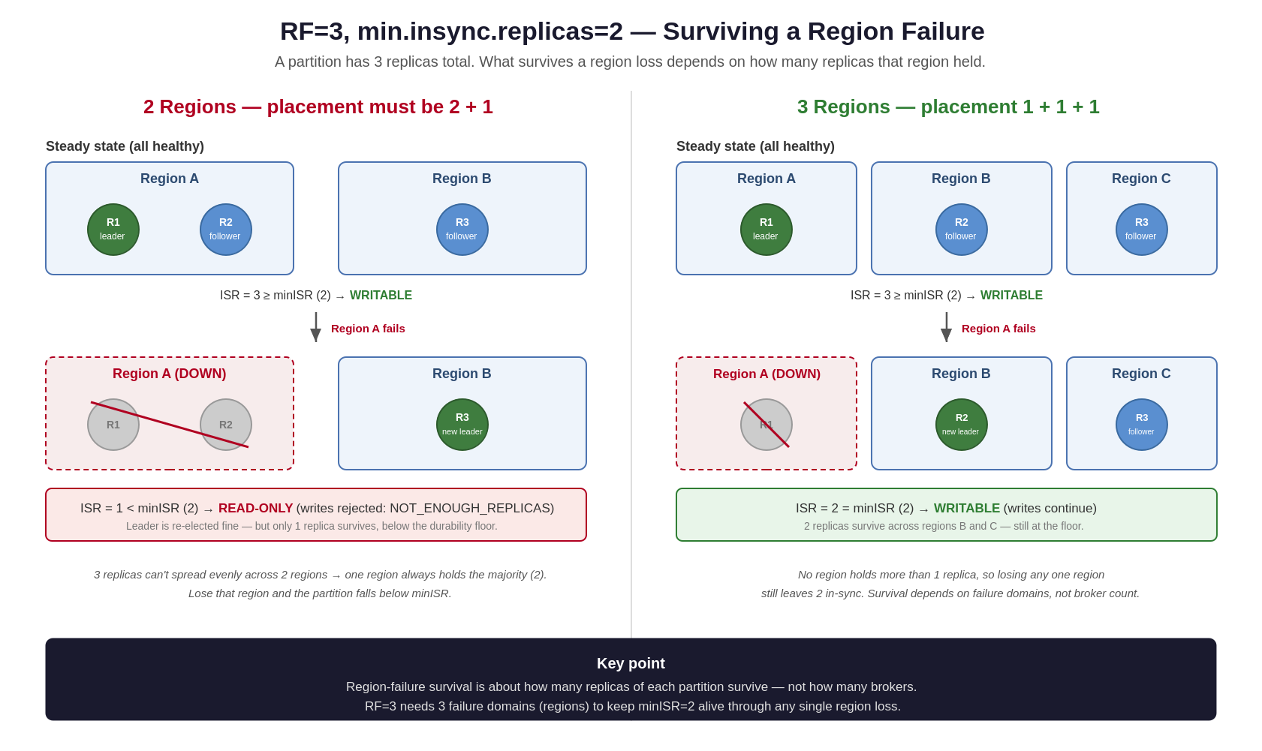
Figure 1 — RF=3 / minISR=2 behaviour under a region failure: 2 regions (left) vs 3 regions (right).

Placement comparison
Layout | Replicas per region | Left after region loss | Writes survive?
3 brokers × 2 regions (6 total) | 2 + 1 | 1 | No
1 broker × 3 regions (3 total) | 1 + 1 + 1 | 2 | Yes
3 brokers × 3 regions (9, rack-aware) | 1 + 1 + 1 | 2 | Yes
Notice the 3-broker / 3-region row survives on fewer total brokers than the 6-broker / 2-region row. Survival is a function of failure domains (regions), not broker count. And with 9 brokers you need rack awareness (broker.rack set to the region) so RF=3 places one replica per region rather than clumping three in one.

4. A region loss is uneven — some partitions writable, some read-only
The impact is per-partition, because which region holds a given partition's 2-replica majority varies across the cluster. With balanced 2+1 placement over two regions, losing one region typically leaves roughly half the partitions writable and half read-only — a patchy, partial outage rather than a clean stop.
Consequences worth planning for:
- A single topic can be simultaneously up and down — producers see some partitions accept writes and others reject them with NOT_ENOUGH_REPLICAS.
- With keyed partitioning the effect is deterministic per key: some keys' writes succeed while others fail, based purely on replica placement.
- Retries to blocked partitions can back up and, depending on producer buffer and timeout settings, create backpressure that spills over to healthy partitions.
Three regions removes the lottery: with 1+1+1, every partition keeps two in-sync replicas through any single region loss, so the failure mode is uniform and testable rather than dependent on placement.

5. Why lowering minISR to 1 is the wrong fix
Setting min.insync.replicas=1 stops the write-blocking, but it trades away the exact guarantee RF=3 was meant to provide — and it does so permanently, during stable operation, not just during an outage.
- Data-loss window open 24/7: a write can be acked when only the leader holds it; if that leader then crashes before a follower copies it, the acknowledged write is silently lost. This risk applies to every routine leader crash, not just region failures.
- Routine maintenance becomes risky: rolling restarts and upgrades briefly shrink the ISR. With minISR=2 that's safe (dip to 2, still at floor); with minISR=1 those frequent operations run with no floor at all.
- It masks degradation: a partition running on a single copy no longer alerts you — a loud, safe failure becomes a quiet, dangerous one.
- It doesn't deliver durability anyway: during the region loss it keeps you writing on possibly a single replica — availability without redundancy, which is the opposite of the goal.
minISR=1 is defensible only for data where loss is tolerable — replayable logs, metrics, rebuildable caches — and should be set per-topic, never as the cluster default (the default would also weaken Kafka's own internal topics such as _schemas and __consumer_offsets).

6. Alternative: surviving a region loss with only two data regions (RF=5)
If a third data region is not available, RF=3 cannot survive a region loss — but RF=5 across two regions can. It is the standard trick for a two-datacenter stretched cluster that still needs region-loss write availability.
The math:
Five replicas split 3 + 2 across two regions (they cannot split evenly). The worst case is losing the region that holds 3, which still leaves 2 replicas in the surviving region — exactly minISR(2), so writes continue:
- Lose the 3-replica region → 2 survive → 2 ≥ minISR(2) → writable.
- Lose the 2-replica region → 3 survive → writable.
So RF=5 guarantees a minimum of two surviving replicas through any single region loss, which is precisely what minISR=2 requires.

What makes it work — forced 3+2 placement
The guarantee rests entirely on the split being exactly 3+2 per partition. Without rack awareness Kafka may place a partition 4+1 (loses its 4-region → drops to 1 → read-only) or even 5+0 (region loss → offline, possible data loss). So rack awareness is non-negotiable here: set broker.rack to the region, and RF=5 over two racks produces the required 3+2 automatically (ceil(5/2)=3, floor(5/2)=2).

Caveats
- Broker count: RF=5 needs ≥5 brokers. Aim for 3 in each region (6 total) so the 3-side has its brokers and the 2-side keeps a spare to re-replicate after a broker failure. A bare 3+2 (5 brokers) works but has zero slack.
- You are capped at minISR=2 — raising it to 3 would fail on losing the 3-region (2 < 3 → read-only). RF=5 here buys survival, not a higher durability floor.
- Cost: five copies means 5× storage and replication traffic versus 3× for RF=3 — a real multiplier.
- Consistency wrinkle: with 3+2 and minISR=2 the ISR can shrink to just the 3 local replicas while still accepting writes (if cross-region lag pushes the remote 2 out). In that window acked writes may live in only one region, so a region failure right then could lose them. Monitor ISR shrink and cross-region replication lag.

RF=5 / 2 regions vs RF=3 / 3 regions
Aspect | RF=5 across 2 regions | RF=3 across 3 regions
Data regions needed | 2 (existing) | 3 (new broker region)
Copies / storage | 5× (higher) | 3× (lower)
Acks in degraded case | on a minority (2 of 5) | on a majority (2 of 3)
Durability floor | minISR=2 (capped) | minISR=2
Survives a region loss | Yes (with 3+2 rack placement) | Yes (1+1+1 placement)
Deciding factor: is a third data region actually available? If region C can only ever be a controller-only site, RF=5 across the two data regions is the correct way to get region survival. If region C could hold brokers, RF=3 across three regions gives the same survival for less storage and a cleaner majority-ack consistency story. Either way the three-region controller quorum already lets metadata survive a region loss; this choice is about bringing the data plane up to the same resilience.

7. Recommendations
- Keep RF=3 with minISR=2 as the durability standard for production data.
- For genuine region-failure survival, use three data regions so RF=3 places one replica per region; a broker in a third region does far more than extra brokers in an existing one.
- If nine brokers (3 × 3 regions), enable rack awareness so replicas actually spread one-per-region.
- If constrained to two data regions but region-loss write availability is required, use RF=5 with rack-aware 3+2 placement (see section 6) — the one arrangement that keeps 2 replicas alive through a region loss within two regions.
- If two data regions are acceptable and a brief read-only period is not a problem, keep RF=3 / minISR=2 and accept that a region loss makes the affected partitions read-only until recovery — a recoverable write pause beats silent, permanent loss of acknowledged writes.
- Set the internal-topic replication defaults in the Kafka CR (default.replication.factor, offsets.topic.replication.factor, transaction.state.log.replication.factor) and remember existing topics need reassignment — the defaults only apply to newly created topics.

8. Operational note: cross-region networking
A stretched cluster spans namespaces (and regions), so brokers, controllers, and components must reach each other across namespaces. If a NetworkPolicy restricts cross-namespace traffic to only the external client port, the cluster forms at the metadata level but cannot replicate or read topic data between regions — which surfaces as confusing, misattributed errors.

Symptom vs. root cause
The failure disguises itself. Brokers in the restricted region crash on startup with A valid license must be configured using confluent.license, because the license lives in the internal _confluent-command topic and the broker cannot read it. The error looks like licensing, then like replica placement, then like broker registration — but the actual cause is that the data-plane port is blocked between namespaces.

The key distinction: metadata plane vs. data plane
Cluster membership and topic data access travel on different connections and ports, and can fail independently:
- Metadata plane (controller listener): controllers gossip membership, so kafka-metadata-quorum ... describe --status in one region shows brokers from another region. This proves membership, not data reachability.
- Data plane (broker/replication listener): a broker fetching a topic's records opens a separate connection to the partition leader in the other region. If that port is blocked, the fetch fails even though the broker is a recognized cluster member.
So "the controller sees the other region's brokers" and "a broker there can read the topic" are different claims. The gap between them is exactly where a port-restricted NetworkPolicy bites.

Cross-region ports to allow
Port | Listener / purpose | Cross-namespace?
9071 | Internal broker listener — inter-broker replication & data fetch | Required
9072 | Replication listener | Required
9074 | Controller listener (KRaft quorum) | Required
9092 | External client listener | Often the only one open — insufficient alone
8090 | Admin/REST endpoint (if components reach it cross-region) | As needed
Open these in both directions (inter-broker replication is bidirectional) and between every pair of region namespaces, not just the one that failed — a region still on a client-port-only policy will fail the same way once it hosts replicas.

Verify and prevent
- Test the data port from the restricted region (works even if the broker is crash-looping — run from a throwaway pod): </dev/tcp/kafka.<other-ns>.svc.cluster.local/9071 should connect.
- Check what the target brokers advertise (advertised.listeners) — an address the other region can't resolve fails the fetch even when the port is open.
- Keep the NetworkPolicy in IaC / the Helm chart, not applied by hand — a namespace rebuild otherwise reintroduces the client-port-only rule and the failure returns.
- NetworkPolicies are a security control: widening them is the platform/security team's call, and a restrictive rule may be deliberate. Confirm before opening cross-namespace ports.
Rule of thumb: if a stretched-cluster broker reports a licensing, placement, or registration error but the controller quorum shows it as a member, suspect the data-plane network path before the Kafka config.

