**Appendix S1**

Here we provide additional information on the distribution of AGC, numbers of large trees, and stand-level variables (basal area, wood density, tree height, stem density) in Gabon based on 104 NRI sites (Fig. S1.1, S1.2) and broken down by disturbance type (Fig. S1.3, S1.4). AGC per site varies by disturbance, ecosystem, habitat, and management (Fig. S1.5). We also demonstrate the relationship between AGC and the other stand variables (Fig. S1.6).

To verify our calculations of AGC, after completing our analyses (Methods, Calculation of AGC), we used the R package, BIOMASS, to re-analyze the data (Réjou-Méchain et al. 2017). BIOMASS assigns wood density values to trees, builds a local D:H allometry from five potential models, and propagates errors associated with diameter and wood density measurements, tree height predictions, and the allometric model. Results for plot-level AGC from our approach and the BIOMASS package were very similar (RMSE = 12.96).

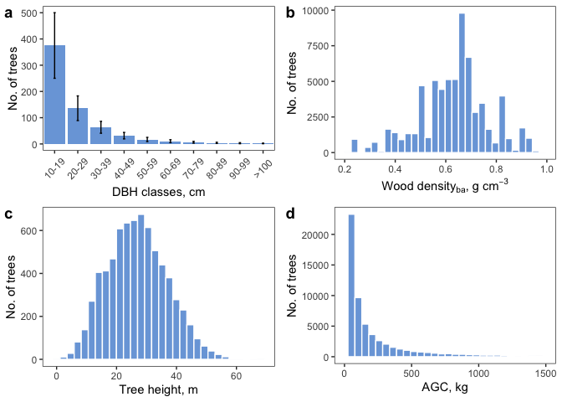

Figure S1.1. Number of trees (No. of trees) by stand characteristics, including: (a) stem density (ha-1) over DBH (cm) classes (error bars are standard errors); (b) distribution of basal area-weighted wood density (g cm-3) of all trees; (c) distribution of heights (m) of trees with field-based tree height measurements; and, (d) distribution of tree AGC (Mg).

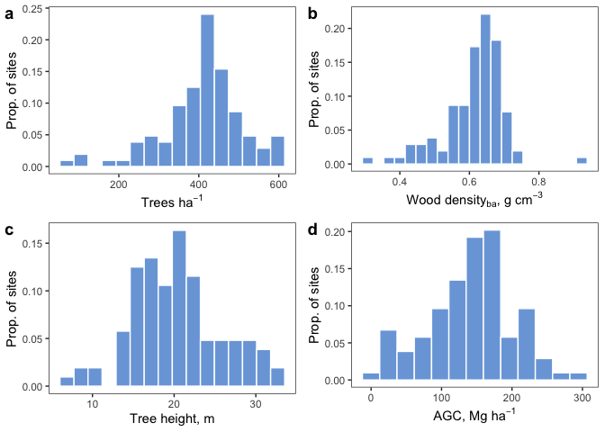

Figure S1.2. Proportion of all NRI sites (Prop. of sites) by stand characteristics, including: (a) mean stem density (stems ha-1); (b) mean tree height (m ha-1) of trees with field-based tree height measurements; (c) mean basal area-weighted wood density (g cm-3 ha-1); and, (d) AGC at the site-level (Mg ha-1).

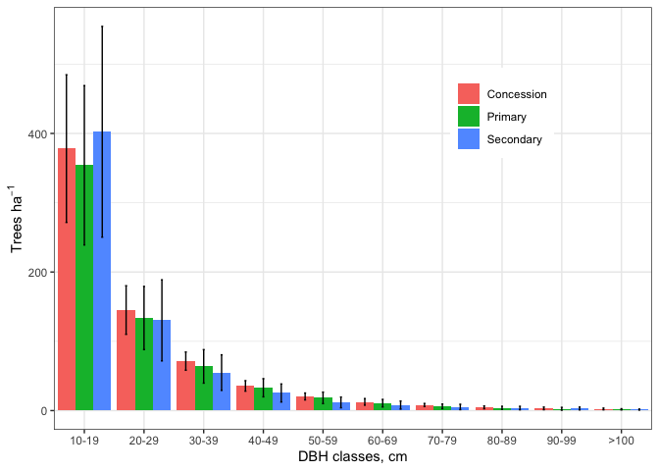

Figure S1.3. Mean stem densities (ha-1) over the range of DBH (cm) classes (error bars are standard errors) for each disturbance type.

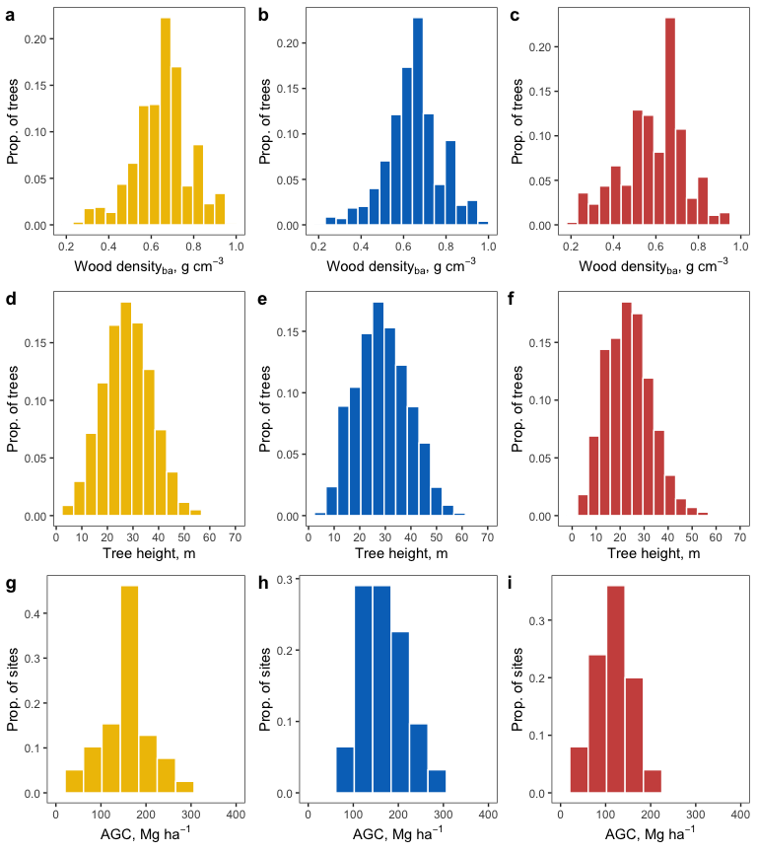

Figure S1.4. Proportion of trees (Prop. of trees) in NRI sites by stand characteristics and disturbance type, including: (a-c) distribution of heights (m) of trees with field-based tree height measurements; (d-f) distribution of wood density (g cm-3) of all trees; and, (g-i) distribution of AGC at the site-level (Mg ha-1). Colors represent disturbance types (yellow = primary, blue = concession, and red = secondary).

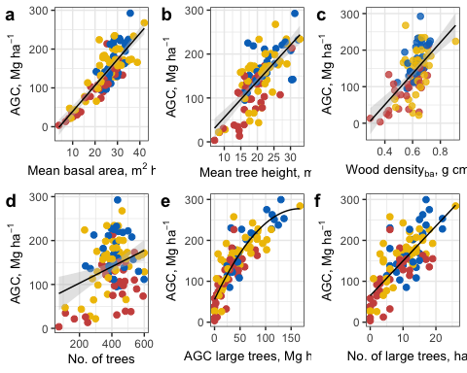

Figure S1.5. Aboveground carbon plotted against (a) basal area (); (b) tree height (); (c) basal area weighted wood mass density (), (d) stem density (), and (e) number of big trees () for the 104 NRI plots. Lines represent the best-fit regression line with their 95% confidence intervals (shading).

# References

Réjou-Méchain, Maxime, Ariane Tanguy, Camille Piponiot, Jérôme Chave, and Bruno Hérault. 2017. “Biomass: an R Package for Estimating Above-Ground Biomass and Its Uncertainty in Tropical Forests.” Methods in Ecology and Evolution 8 (9): 1163–7. <https://doi.org/10.1111/2041-210X.12753>.

**Appendix S2**

Here we provide additional information related to large trees and differences among disturbance types. Most of the AGC in Gabon’s forests is concentrated in a small number of large trees (Fig. S2.6).









**Appendix S3**

Here we provide additional information on the climatic, edaphic and anthropogenic variables that drive spatial patterns of AGC and large trees in Gabon based on 104 1-ha NRI plots. Results of the principal components analyses demonstrate our reductions of multiple climatic and edaphic variables to three linearly uncorrelated variables (Tables S3.6 and S3.7). We also show the bivariate relationships among independent variables and six response variables (AGC, basal area, wood density, tree height, stem density, and number of big trees; Figures S3.11 - S3.16). Below we describe the effects of environmental and anthropogenic variables on stand variables and provide the results of model averaging for AGC, numbers of large trees, and all stand variables (basal area, tree height, wood density, stem density), showing the effects of independent variables as coefficients and standardized coefficients (Table S3.8): these results make up Fig. 6 in the main text.

In Gabon’s forests, variation in basal area was most strongly influenced by savanna ecosystems and secondary forests, both of which are characterized by having few large trees relative to other ecosystem and less disturbed forest types. Basal area also decreased with annual precipitation. This result differs from previous reports that basal area decreases proportionally to increases in dry season length due to water stress (Malhi et al. 2006; Baraloto et al. 2011). However, like Lewis et al. (2013), ever-wet forests tend to have lower AGC, implying that excess rainfall either reduces net primary productivity or elevates mortality. Finally, basal area also increased slightly on slopes, which might reflect a lower abundance of large trees in low-lying swamps and streams or that large basal area provides better structural support on slopes.

Wood density increased with elevation, which controls soil chemistry and hydrology and can profoundly influence forest structure (Jucker et al. 2018). Trees on ridges and at higher elevations could have higher wood density as competition for nutrients and water favors species with life-history traits that maximize survival rather than rapid growth (Werner and Homeier 2015). However, similar to Lewis et al. (Lewis et al. 2013), we also found that wood density increased with soil fertility contrary to predictions that competitive, fast-growing species would dominate resource rich sites (Malhi et al. 2006; Gourlet-Fleury et al. 2011). Annual precipitation negatively affected wood density, providing evidence to findings that wood density is correlated with drought tolerance (Slik 2004). West African rainforest trees also demonstrated a positive relationship between wood density and precipitation with high wood density possibly providing greater structural stability and greater resistance against physical damage and pathogens in the shaded understory (Maharjan et al. 2011).

Tree height tended to be negatively affected by slope and especially by seasonality of precipitation. The decline of tree height with slope is consistent with empirical evidence highlighting strong shifts in carbon allocation strategies and crown architecture of trees as soil nutrients and water availability become limiting (Jucker et al. 2018). Soil mineral layers on slopes are likely to be thinner, more waterlogged and generally less favorable for root development (Quesada et al. 2012), providing little mechanical support for tall trees. Tall trees are at higher risk of falling or being blown over on slopes as wind speeds increase with altitude on mountains and proximity to ridges (Woodward 1993). Lawton (1982) found that for a given tree height, trunk diameter increases with proximity to the ridge-crest (which might also explain increasing basal area with slope above). In terms of seasonality in precipitation, Feldpausch et al. (2012) found dry-season length was a key factor influencing height-diameter relationships, with a longer dry season being associated with stouter trees. Greater stem diameter relative to tree height may serve to increase overall rates of water transport due to higher sapwood cross-sectional areas (Meinzer, Goldstein, and Andrade 2001).

Stem density was only weakly affected by environmental variables, increasing with slope, seasonality of precipitation, and soil drainage and decreasing with annual precipitation and soil depth. Stem density likely increases with slope because large trees are limited by soil, water, and mechanical support, opening space for higher numbers of smaller trees. The effects of climate and soil are difficult to explain. In contrast to our results, previous studies in the Amazon and Borneo have found stem density to be negatively correlated with seasonality and positively correlated with annual rainfall (Steege et al. 2013; Slik et al. 2010). In Borneo, stem density decreased with soil depth like this study, but decreased with better drainage (Slik et al. 2010). Environmental variables may have a weak effect on stem density; Lewis et al. (Lewis et al. 2013) suggested that stem density in African old-growth forests is largely an emergent property of a disturbance regime favoring low stem turnover, long carbon residence times and high ACG.

Table S3.6. Principal components analysis (PCA) factor loadings for the three climate axes.



Table S3.7. Principal components analysis (PCA) factor loadings for the three soil axes.



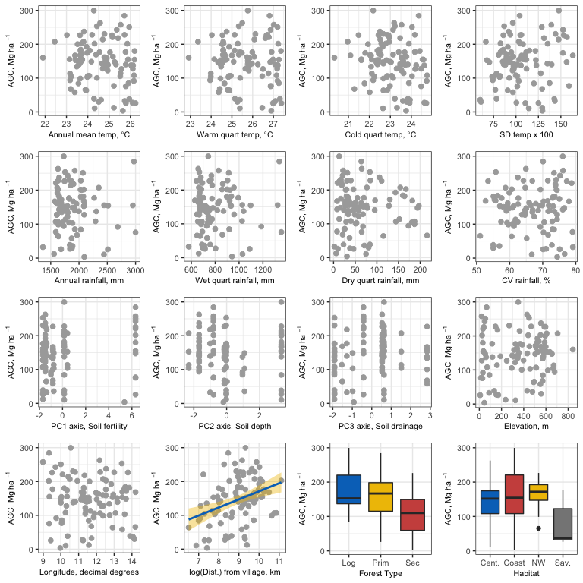

Figure S3.9. Bivariate plots of AGC versus (a) temperature, top (annual mean temperature, temperature in warmest quarter, temperature in coldest quarter, standard deviation (SD) of temperature); (b) rainfall, second row (annual rainfall, rainfall in wettest quarter, rainfall in driest quarter, coefficient of variation (CV) of rainfall); (c) soil and elevation, third row (PC axis 1, PC axis 2, PC axis 3, elevation); (d) geography and disturbance, bottom (latitude, longitude, distance from village, and forest type). Fit lines represent a significant relationship, and shading is the 95% CI around the line.

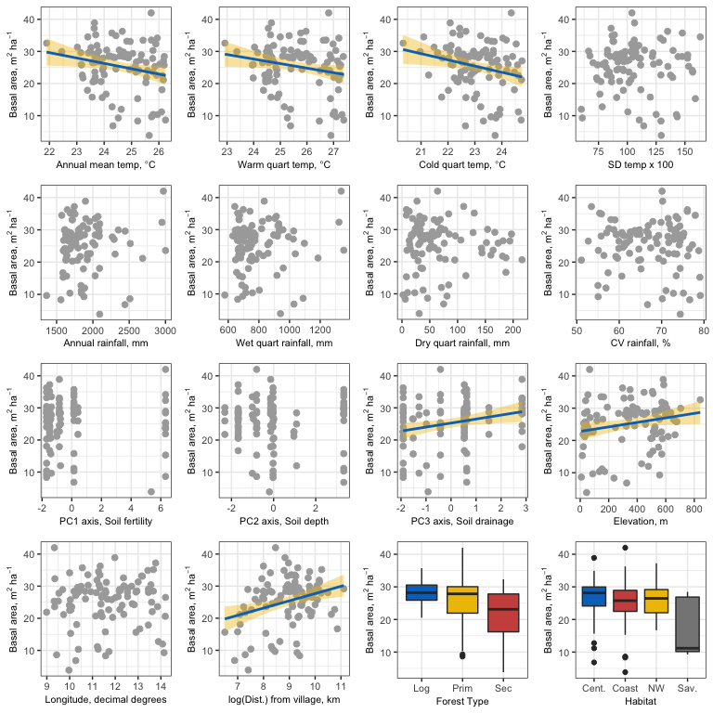

Figure S3.10. Bivariate plots of basal area versus (a) temperature, top (annual mean temperature, temperature in warmest quarter, temperature in coldest quarter, standard deviation (SD) of temperature); (b) rainfall, second row (annual rainfall, rainfall in wettest quarter, rainfall in driest quarter, coefficient of variation (CV) of rainfall); (c) soil and elevation, third row (PC axis 1, PC axis 2, PC axis 3, elevation); (d) geography and disturbance, bottom (latitude, longitude, distance from village, and forest type). Fit lines represent a significant relationship, and shading is the 95% CI around the line.

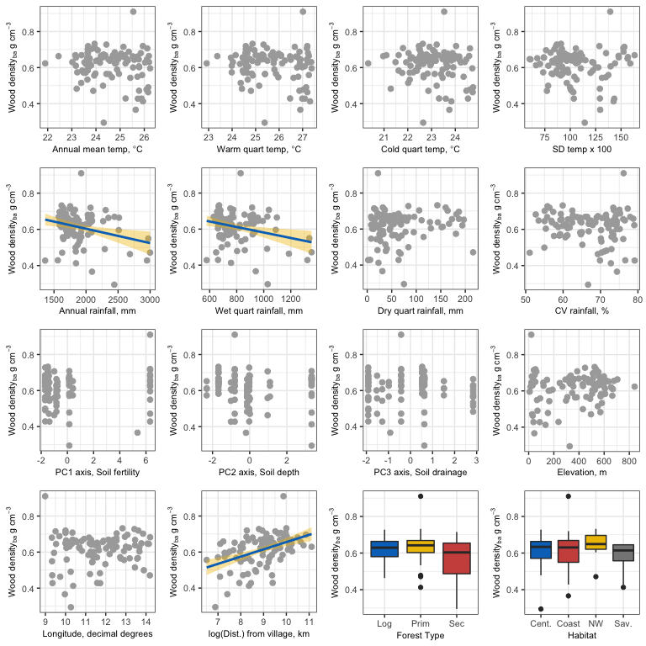

Figure S3.11. Bivariate plots of basal area-weighted wood density versus (a) temperature, top (annual mean temperature, temperature in warmest quarter, temperature in coldest quarter, standard deviation (SD) of temperature); (b) rainfall, second row (annual rainfall, rainfall in wettest quarter, rainfall in driest quarter, coefficient of variation (CV) of rainfall); (c) soil and elevation, third row (PC axis 1, PC axis 2, PC axis 3, elevation); (d) geography and disturbance, bottom (latitude, longitude, distance from village, and forest type). Fit lines represent a significant relationship, and shading is the 95% CI around the line.

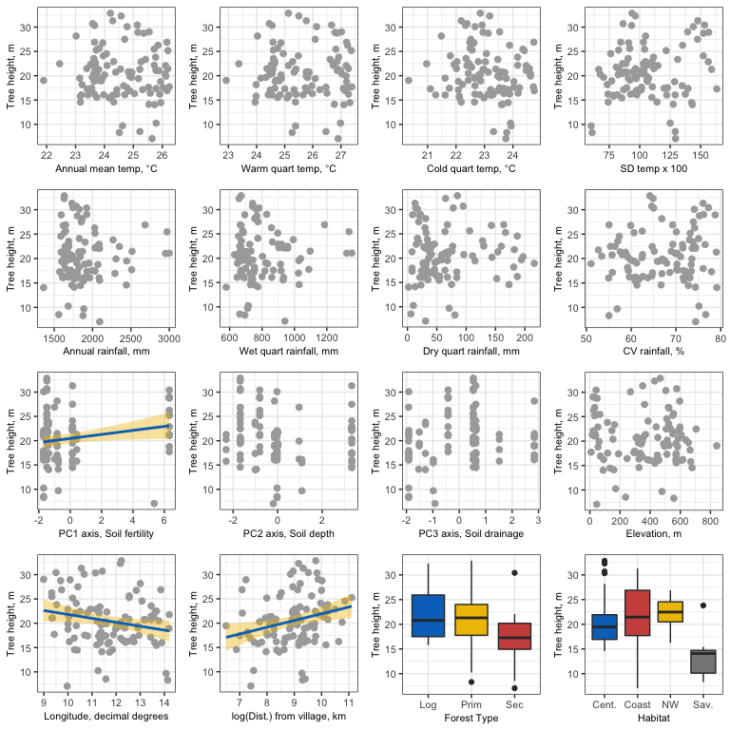

Figure S3.12. Bivariate plots of tree height versus (a) temperature, top (annual mean temperature, temperature in warmest quarter, temperature in coldest quarter, standard deviation (SD) of temperature); (b) rainfall, second row (annual rainfall, rainfall in wettest quarter, rainfall in driest quarter, coefficient of variation (CV) of rainfall); (c) soil and elevation, third row (PC axis 1, PC axis 2, PC axis 3, elevation); (d) geography and disturbance, bottom (latitude, longitude, distance from village, and forest type). Fit lines represent a significant relationship, and shading is the 95% CI around the line.

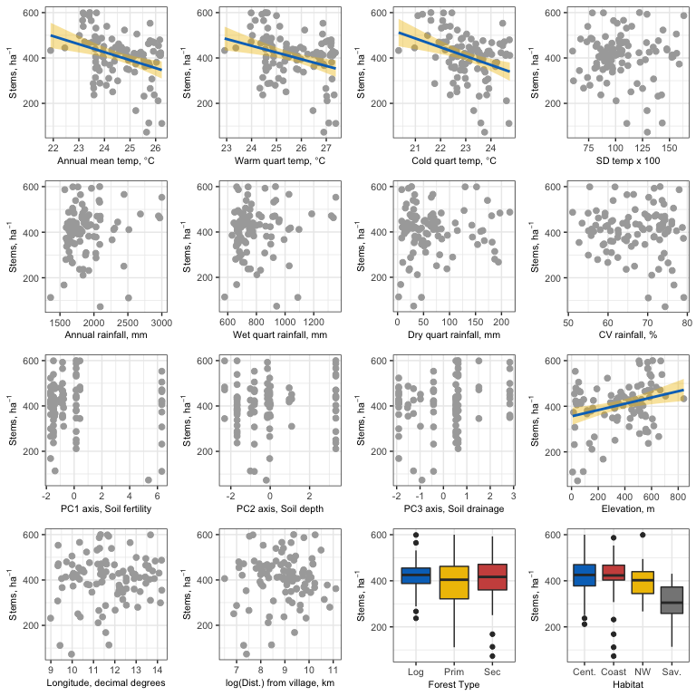

Figure S3.13. Bivariate plots of stem density versus (a) temperature, top (annual mean temperature, temperature in warmest quarter, temperature in coldest quarter, standard deviation (SD) of temperature); (b) rainfall, second row (annual rainfall, rainfall in wettest quarter, rainfall in driest quarter, coefficient of variation (CV) of rainfall); (c) soil and elevation, third row (PC axis 1, PC axis 2, PC axis 3, elevation); (d) geography and disturbance, bottom (latitude, longitude, distance from village, and forest type). Fit lines represent a significant relationship, and shading is the 95% CI around the line.

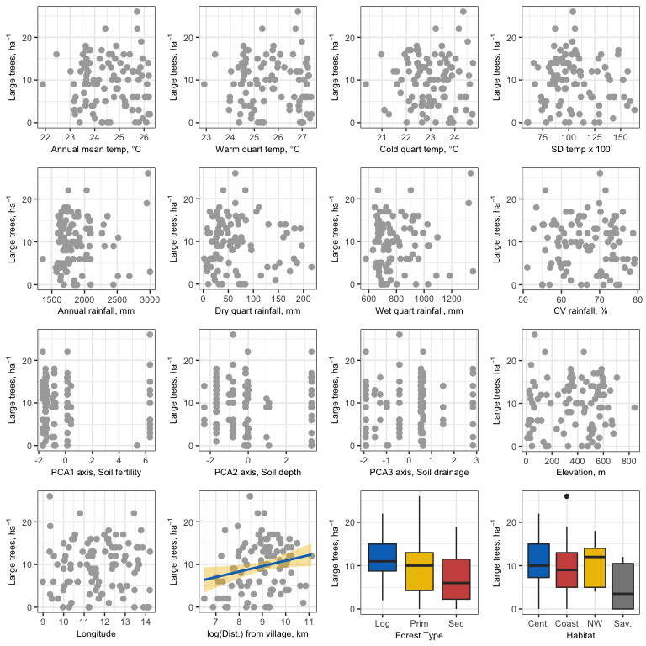

Figure S3.14. Bivariate plots of number of large trees ( 70 cm dbh) versus (a) temperature, top (annual mean temperature, temperature in warmest quarter, temperature in coldest quarter, standard deviation (SD) of temperature); (b) rainfall, second row (annual rainfall, rainfall in wettest quarter, rainfall in driest quarter, coefficient of variation (CV) of rainfall); (c) soil and elevation, third row (PC axis 1, PC axis 2, PC axis 3, elevation); (d) geography and disturbance, bottom (latitude, longitude, distance from village, and forest type). Fit lines represent a significant relationship, and shading is the 95% CI around the line.

Table S3.8. Results of model averaging for each of six response variables: aboveground carbon, mean basal area, mean tree height, mean wood density, stem density, and number of big trees. For each response variable, we provide the following: Var. is a list of abbreviations of independent variables in order of relative importance; Coef. is the regression or GLM (big trees) coefficient for the variable; S-Coef. is the standardized coefficient for the variable; and, Supp. is the relative support for each independent variable, quantified as the proportion of models in which the variable occurred.



# References

Baraloto, Christopher, Suzanne Rabaud, Quentin Molto, Lilian Blanc, Claire Fortunel, Bruno Hérault, Nallarett Dávila, et al. 2011. “Disentangling stand and environmental correlates of aboveground biomass in Amazonian forests.” Global Change Biology 17 (8): 2677–88. <https://doi.org/10.1111/j.1365-2486.2011.02432.x>.

Gourlet-Fleury, Sylvie, Vivien Rossi, Maxime Rejou-Mechain, Vincent Freycon, Adeline Fayolle, Laurent Saint-André, Guillaume Cornu, et al. 2011. “Environmental filtering of dense-wooded species controls above-ground biomass stored in African moist forests.” Journal of Ecology 99 (4): 981–90. <https://doi.org/10.1111/j.1365-2745.2011.01829.x>.

Jucker, Tommaso, Boris Bongalov, David F.R.P. Burslem, Reuben Nilus, Michele Dalponte, Simon L. Lewis, Oliver L. Phillips, Lan Qie, and David A. Coomes. 2018. “Topography shapes the structure, composition and function of tropical forest landscapes.” Ecology Letters, DOI: 10.1111/ele.12964. <https://doi.org/10.1111/ele.12964>.

Lewis, Simon L., Bonaventure Sonké, Terry Sunderland, Serge K. Begne, Gabriela Lopez-Gonzalez, Geertje M. F. van der Heijden, Oliver L. Phillips, et al. 2013. “Above-ground biomass and structure of 260 African tropical forests.” Philosophical Transactions of the Royal Society B 368 (1625): 1–14.

Maharjan, S.K.a B, L.a B Poorter, M.b Holmgren, F.a Bongers, J.J.c Wieringa, and W.D.d Hawthorne. 2011. “Plant functional traits and the distribution of West African rain forest trees along the rainfall gradient.” Biotropica 43 (5): 552–61. <https://doi.org/10.1111/j.1744-7429.2010.00747.x>.

Malhi, Yadvinder, Daniel Wood, Timothy R. Baker, James Wright, Oliver L. Phillips, Thomas Cochrane, Patrick Meir, et al. 2006. “The regional variation of aboveground live biomass in old-growth Amazonian forests.” Global Change Biology 12 (7): 1107–38. <https://doi.org/10.1111/j.1365-2486.2006.01120.x>.

Meinzer, F.C., G. Goldstein, and J.L. Andrade. 2001. “Regulation of water flux through tropical forest canopy trees Do universal rules apply?” Tree Physiology 21: 19–26.

Quesada, C. A., O. L. Phillips, M. Schwarz, C. I. Czimczik, T. R. Baker, S. Patiño, N. M. Fyllas, et al. 2012. “Basin-wide variations in Amazon forest structure and function are mediated by both soils and climate.” Biogeosciences 9 (6): 2203–46. <https://doi.org/10.5194/bg-9-2203-2012>.

Slik, J. W.F. 2004. “El Niño droughts and their effects on tree species composition and diversity in tropical rain forests.” Oecologia 141 (1): 114–20. <https://doi.org/10.1007/s00442-004-1635-y>.

Slik, J. W.F., Shin Ichiro Aiba, Francis Q. Brearley, Chuck H. Cannon, Olle Forshed, Kanehiro Kitayama, Hidetoshi Nagamasu, et al. 2010. “Environmental correlates of tree biomass, basal area, wood specific gravity and stem density gradients in Borneo’s tropical forests.” Global Ecology and Biogeography 19 (1): 50–60. <https://doi.org/10.1111/j.1466-8238.2009.00489.x>.

Steege, Hans ter, Nigel C.A. Pitman, Daniel Sabatier, Christopher Baraloto, Rafael P. Salomão, Juan Ernesto Guevara, Oliver L. Phillips, et al. 2013. “Hyperdominance in the Amazonian tree flora.” Science 342: 1243092. <https://doi.org/10.1126/science.1243092>.

Werner, Florian A., and Jürgen Homeier. 2015. “Is tropical montane forest heterogeneity promoted by a resource-driven feedback cycle? Evidence from nutrient relations, herbivory and litter decomposition along a topographical gradient.” Functional Ecology 29 (3): 430–40. <https://doi.org/10.1111/1365-2435.12351>.

Woodward, F. I. 1993. “The Lowland-to-Upland Transition - Modelling Plant Responses to Environmental Change.” Ecological Applications 3 (3): 404–8.

**Appendix S4**

Site and plot level characteristics. Note that aboveground biomass (AGB) is reported.

|  |  |  |  |  |  |  |  |  |  |  |  |  |
| --- | --- | --- | --- | --- | --- | --- | --- | --- | --- | --- | --- | --- |
| Plot | Latitude (dd) | Longitude (dd) | Site AGB, Mg/ha | Site area, ha | Plot AGB, Mg/ha | Forest Type | Ecosystem | Protected Area | Distance Village, km | Distance City, km | Distance Road, km | Elevation, m |
| 1 | 0.58 | 9.34 | 190.4 | 1.64 | 161.0 | Secondary | Coast | Yes | 3.3 | 23.8 | 0.6 | 28 |
| 2 | 0.57 | 9.32 | 568.3 | 1.64 | 603.4 | Primary | Coast | Yes | 4.8 | 23.2 | 1.2 | 66 |
| 3 | 0.56 | 9.35 | 282.5 | 1.64 | 329.2 | Secondary | Coast | Yes | 2.8 | 21.2 | 0.8 | 38 |
| 4 | -3.4 | 11.26 | 356.9 | 1.64 | 354.4 | Primary | Coast | No | 17.8 | 43.5 | 14.9 | 511 |
| 5 | -3.37 | 11.72 | 73.8 | 1.48 | 68.8 | Secondary | Savannah | No | 4.7 | 11.8 | 0.4 | 88 |
| 6 | -2.8 | 10.04 | 164.7 | 1.64 | 163.6 | Primary | Coast | Yes | 3.3 | 2.4 | 1.5 | 15 |
| 7 | -2.8 | 10.09 | 376.9 | 1.64 | 468.7 | Primary | Coast | Yes | 1.4 | 7.3 | 1.4 | 33 |
| 8 | -2.66 | 10.55 | 621.0 | 1.64 | 636.0 | Logged | Coast | Yes | 11.2 | 46.8 | 3.4 | 350 |
| 9 | -2.67 | 11.33 | 368.8 | 1.64 | 303.0 | Primary | Coast | No | 3 | 27.1 | 1.5 | 297 |
| 10 | -2.84 | 11.57 | 45.7 | 1.32 | 26.5 | Secondary | Coast | No | 12.1 | 5.1 | 5 | 237 |
| 11 | -2.47 | 9.99 | 299.7 | 1.64 | 312.9 | Primary | Coast | Yes | 12.6 | 34.3 | 5.9 | 53 |
| 12 | -2.41 | 10.34 | 427.1 | 1.64 | 370.3 | Primary | Coast | Yes | 21.3 | 44.6 | 8.5 | 386 |
| 13 | -2.24 | 10.67 | 442.0 | 1.64 | 489.3 | Logged | Coast | No | 7.1 | 5.8 | 4.3 | 269 |
| 14 | -2.5 | 11.25 | 59.4 | 1.16 | 55.7 | Primary | Savannah | No | 1.8 | 15.9 | 1.6 | 171 |
| 15 | -2.31 | 11.4 | 239.1 | 1.16 | 242.4 | Secondary | Savannah | No | 2.9 | 10.9 | 0.4 | 159 |
| 16 | -2.21 | 13.44 | 165.4 | 1.64 | 123.6 | Secondary | Aucoumea | No | 9.3 | 18.5 | 3.3 | 550 |
| 17 | -2.1 | 9.5 | 453.8 | 1.64 | 480.6 | Secondary | Coast | Yes | 13.6 | 64.9 | 5.6 | 41 |
| 18 | -2.03 | 9.69 | 497.4 | 1.64 | 515.4 | Primary | Coast | Yes | 22.4 | 70.4 | 6.1 | 48 |
| 19 | -2.05 | 10.41 | 468.8 | 1.64 | 454.7 | Logged | Coast | Yes | 7.7 | 32.6 | 0.4 | 363 |
| 20 | -1.78 | 10.81 | 294.7 | 1.64 | 297.5 | Logged | Coast | No | 7.8 | 28.2 | 2.3 | 190 |
| 21 | -1.99 | 11.32 | 412.9 | 1.64 | 462.7 | Logged | Aucoumea | No | 10 | 28.7 | 0.5 | 164 |
| 22 | -1.97 | 11.71 | 156.0 | 1.64 | 144.1 | Secondary | Aucoumea | No | 1.9 | 23.8 | 1.5 | 570 |
| 23 | -1.74 | 12.36 | 366.3 | 1.64 | 339.9 | Primary | Aucoumea | Yes | 16.8 | 31.1 | 16.6 | 842 |
| 24 | -2.05 | 13 | 471.1 | 1.64 | 482.0 | Logged | Aucoumea | No | 10.1 | 25.5 | 1.8 | 596 |
| 25 | -1.85 | 13.59 | 205.2 | 1.64 | 219.1 | Logged | Aucoumea | No | 2.5 | 26.2 | 0.4 | 458 |
| 26 | -1.93 | 13.67 | 273.4 | 1.16 | 315.4 | Primary | Savannah | No | 9.5 | 32.9 | 6.9 | 432 |
| 27 | -1.42 | 10.05 | 201.5 | 1.64 | 180.8 | Logged | Coast | No | 17 | 49.2 | 0.7 | 91 |
| 28 | -1.69 | 10.38 | 55.2 | 1.64 | 81.9 | Secondary | Savannah | No | 4.3 | 2.2 | 0.8 | 134 |
| 29 | -1.28 | 10.69 | 270.6 | 1.64 | 293.1 | Logged | Coast | No | 3 | 14.3 | 0.3 | 118 |
| 30 | -1.42 | 11.33 | 273.3 | 1.64 | 324.7 | Primary | Aucoumea | No | 11.6 | 37 | 3.8 | 608 |
| 31 | -1.45 | 11.56 | 137.6 | 1.64 | 178.7 | Primary | Aucoumea | No | 1.1 | 19.2 | 0.2 | 572 |
| 32 | -1.32 | 11.98 | 352.1 | 1.64 | 354.1 | Primary | Aucoumea | No | 6.8 | 20 | 1.1 | 582 |
| 33 | -1.55 | 12.71 | 275.5 | 1.64 | 284.4 | Logged | Aucoumea | No | 10.5 | 15.8 | 0 | 572 |
| 34 | -1.32 | 12.9 | 296.5 | 1.64 | 325.8 | Secondary | Aucoumea | No | 13.1 | 42.7 | 2.6 | 526 |
| 35 | -1.33 | 13.56 | 334.0 | 1.64 | 375.4 | Primary | Aucoumea | No | 3.5 | 31.6 | 3.5 | 369 |
| 36 | -1.46 | 14.07 | 65.0 | 1.64 | 75.7 | Secondary | Savannah | No | 10.8 | 24.8 | 3.5 | 478 |
| 37 | -1.25 | 14.14 | 46.3 | 1.48 | 63.4 | Primary | Savannah | No | 11 | 30.7 | 9.4 | 557 |
| 38 | -1.17 | 8.98 | 475.7 | 1.64 | 547.1 | Primary | Coast | No | 19.5 | 53.3 | 1.5 | 21 |
| 39 | -0.99 | 9.32 | 372.2 | 1.32 | 428.0 | Primary | Coast | No | 5 | 64.6 | 5.7 | 25 |
| 40 | -0.91 | 9.99 | 464.0 | 1.64 | 532.7 | Logged | Coast | No | 3.9 | 36.2 | 1.2 | 54 |
| 41 | -0.88 | 10.19 | 378.1 | 1.64 | 382.3 | Logged | Coast | No | 3 | 20.9 | 5.1 | 31 |
| 42 | -0.67 | 11.16 | 333.4 | 1.64 | 357.0 | Logged | Aucoumea | No | 36.2 | 70.5 | 0.4 | 598 |
| 43 | -1.04 | 11.28 | 367.3 | 1.64 | 385.1 | Secondary | Aucoumea | No | 7.6 | 63.4 | 0.7 | 588 |
| 44 | -1.03 | 11.61 | 425.2 | 1 | 425.2 | Primary | Aucoumea | Yes | 25.9 | 32.5 | 6 | 593 |
| 45 | -0.97 | 12.19 | 285.9 | 1.64 | 286.9 | Secondary | Aucoumea | No | 1.6 | 34.3 | 0.4 | 346 |
| 46 | -0.97 | 12.53 | 356.7 | 1.64 | 337.0 | Logged | Aucoumea | No | 4.1 | 19.9 | 0.4 | 313 |
| 47 | -0.98 | 12.74 | 226.3 | 1.64 | 212.9 | Secondary | Aucoumea | No | 4.2 | 19.1 | 0.9 | 382 |
| 48 | -1.15 | 13.18 | 348.7 | 1.64 | 295.6 | Logged | Aucoumea | No | 10.4 | 44.4 | 3.7 | 307 |
| 49 | -1.15 | 13.89 | 82.9 | 1.64 | 82.6 | Secondary | Aucoumea | No | 5.6 | 2.5 | 0.2 | 431 |
| 50 | -0.45 | 9.52 | 360.9 | 1.64 | 376.1 | Primary | Savannah | Yes | 27.7 | 84.1 | 2.4 | 116 |
| 51 | -0.79 | 9.96 | 7.6 | 1 | 7.6 | Secondary | Coast | No | 1.7 | 32.5 | 10.3 | 45 |
| 52 | -0.59 | 10.3 | 218.6 | 1.64 | 271.3 | Secondary | Coast | No | 1.2 | 14.3 | 1.2 | 22 |
| 53 | -0.21 | 10.8 | 448.5 | 1.64 | 483.8 | Logged | Aucoumea | No | 8.8 | 6.1 | 0.5 | 146 |
| 54 | -0.76 | 11.19 | 338.7 | 1.64 | 328.7 | Primary | Aucoumea | No | 25.9 | 80.6 | 1.9 | 573 |
| 55 | -0.67 | 11.88 | 205.7 | 1.64 | 224.5 | Secondary | Aucoumea | No | 11.4 | 60.9 | 0.4 | 292 |
| 56 | -0.51 | 12.53 | 313.8 | 1.64 | 374.7 | Secondary | Aucoumea | No | 11.2 | 39.7 | 0.7 | 326 |
| 57 | -0.72 | 12.94 | 321.7 | 1.64 | 343.3 | Logged | Aucoumea | No | 3.8 | 26 | 2.7 | 335 |
| 58 | -0.66 | 13.42 | 478.0 | 1.64 | 537.9 | Logged | Aucoumea | No | 6.6 | 27.9 | 1 | 448 |
| 59 | -0.76 | 14.31 | 80.9 | 1.64 | 98.9 | Secondary | Savannah | No | 10.2 | 1 | 0.9 | 418 |
| 60 | 0.08 | 9.42 | 100.5 | 1.64 | 55.0 | Primary | Coast | Yes | 1.5 | 35.3 | 1.5 | 8 |
| 61 | -0.23 | 10 | 277.6 | 1.64 | 292.1 | Secondary | Coast | No | 17.2 | 47.2 | 1.5 | 61 |
| 62 | -0.01 | 10.25 | 236.6 | 1.64 | 229.8 | Logged | Coast | No | 5.8 | 29.7 | 1.4 | 70 |
| 63 | 0.01 | 10.92 | 386.5 | 1.64 | 428.8 | Logged | Aucoumea | No | 8.3 | 29.1 | 1.1 | 440 |
| 64 | -0.08 | 11.21 | 92.6 | 1.48 | 58.2 | Primary | Aucoumea | No | 4.1 | 52.5 | 2.5 | 153 |
| 65 | 0.11 | 11.45 | 293.0 | 1.64 | 298.0 | Primary | Aucoumea | No | 10.6 | 59.2 | 1.6 | 331 |
| 66 | 0 | 12.12 | 308.0 | 1.64 | 346.2 | Secondary | Aucoumea | No | 16.6 | 23.1 | 1.7 | 341 |
| 67 | -0.31 | 12.3 | 259.6 | 1.64 | 269.5 | Secondary | Aucoumea | No | 13.1 | 46.8 | 0.3 | 247 |
| 68 | -0.83 | 13.16 | 345.1 | 1.48 | 320.1 | Logged | Aucoumea | No | 7.5 | 47.7 | 0 | 355 |
| 69 | -0.16 | 13.45 | 336.3 | 1.64 | 359.3 | Primary | Aucoumea | No | 27.9 | 59.6 | 22 | 451 |
| 70 | -0.1 | 13.77 | 495.8 | 1.64 | 481.1 | Primary | Congolian | No | 7.8 | 62.2 | 7 | 586 |
| 71 | 0.53 | 9.73 | 227.6 | 1.64 | 195.1 | Secondary | Coast | No | 1.2 | 16.2 | 0.5 | 32 |
| 72 | 0.45 | 10.34 | 348.8 | 1.64 | 330.2 | Primary | Aucoumea | Yes | 7.1 | 41.9 | 2.9 | 571 |
| 73 | 0.39 | 11.37 | 299.2 | 1.64 | 259.6 | Logged | Aucoumea | No | 9.1 | 47 | 2.6 | 323 |
| 74 | 0.35 | 11.58 | 339.8 | 1.64 | 301.5 | Logged | Aucoumea | No | 3.2 | 47.8 | 1.4 | 347 |
| 75 | 0.22 | 12.17 | 493.5 | 1.64 | 557.9 | Logged | Aucoumea | No | 9.5 | 9.2 | 4.5 | 430 |
| 76 | 0.13 | 12.38 | 318.8 | 1.64 | 272.0 | Secondary | Aucoumea | Yes | 9.6 | 29.7 | 1.6 | 398 |
| 77 | 0.34 | 13.11 | 482.7 | 1.64 | 584.2 | Logged | Aucoumea | No | 3.7 | 39 | 1.5 | 543 |
| 78 | 0.48 | 13.45 | 367.4 | 1.64 | 324.9 | Primary | Congolian | No | 25 | 68 | 17 | 523 |
| 79 | 0.43 | 13.67 | 364.9 | 1 | 364.9 | Primary | Congolian | Yes | 28.4 | 71.1 | 19 | 506 |
| 80 | 0.67 | 10.03 | 317.3 | 1.32 | 327.9 | Logged | Coast | No | 24 | 43.7 | 5.5 | 35 |
| 81 | 0.65 | 10.26 | 28.3 | 1.16 | 23.0 | Secondary | Aucoumea | No | 1 | 55.8 | 0.2 | 326 |
| 82 | 0.64 | 10.5 | 426.5 | 1.64 | 440.2 | Primary | Aucoumea | Yes | 17.6 | 51.7 | 1.8 | 705 |
| 83 | 0.78 | 11.14 | 300.6 | 1.64 | 312.0 | Logged | Aucoumea | No | 18.7 | 45.2 | 2.2 | 504 |
| 84 | 0.91 | 11.42 | 301.9 | 1.64 | 298.4 | Logged | Aucoumea | No | 7.8 | 20.2 | 8.1 | 576 |
| 85 | 0.57 | 12.21 | 496.9 | 1.64 | 483.8 | Primary | Aucoumea | No | 17.8 | 29.5 | 11.2 | 467 |
| 86 | 0.67 | 12.54 | 451.4 | 1.64 | 504.1 | Logged | Aucoumea | No | 15.3 | 36.1 | 7 | 555 |
| 87 | 0.6 | 12.9 | 159.2 | 1.48 | 135.7 | Secondary | Aucoumea | No | 0.7 | 8.4 | 1.8 | 489 |
| 88 | 0.94 | 13.62 | 335.0 | 1.64 | 390.3 | Primary | Congolian | No | 7.7 | 37.8 | 7.7 | 536 |
| 89 | 0.91 | 13.85 | 387.8 | 1.64 | 385.6 | Primary | Congolian | No | 9.2 | 15.3 | 4.5 | 522 |
| 90 | 0.97 | 14.2 | 349.5 | 1.64 | 357.6 | Primary | Congolian | No | 19.7 | 28 | 19.2 | 556 |
| 91 | 1.36 | 11.65 | 237.0 | 1.64 | 241.1 | Logged | Aucoumea | No | 2.2 | 25.2 | 0.8 | 669 |
| 92 | 1.23 | 12.2 | 245.1 | 1.64 | 226.0 | Primary | Aucoumea | Yes | 46.8 | 78.8 | 5.2 | 513 |
| 93 | 1.36 | 12.53 | 421.2 | 1.64 | 430.3 | Primary | Congolian | Yes | 66.7 | 95.3 | 25.3 | 551 |
| 94 | 1.04 | 12.83 | 390.0 | 1.64 | 408.6 | Primary | Congolian | No | 22 | 52.7 | 15.2 | 524 |
| 95 | 1.06 | 13.92 | 281.0 | 1.64 | 276.9 | Primary | Congolian | No | 7.4 | 7.4 | 6.4 | 515 |
| 96 | 1.38 | 14.19 | 139.3 | 1.64 | 139.1 | Primary | Congolian | No | 11.8 | 49 | 11.4 | 495 |
| 97 | 1.6 | 11.37 | 206.9 | 1.64 | 221.5 | Secondary | Aucoumea | No | 1.5 | 23.2 | 1.3 | 665 |
| 98 | 1.48 | 11.84 | 234.1 | 1.64 | 199.5 | Secondary | Aucoumea | No | 5.6 | 31 | 3.1 | 678 |
| 99 | 1.79 | 12.01 | 289.3 | 1.64 | 312.4 | Logged | Congolian | No | 15.2 | 41.8 | 5.1 | 654 |
| 100 | 1.78 | 12.37 | 209.5 | 1 | 209.5 | Primary | Congolian | Yes | 41.3 | 48.1 | 9.9 | 617 |
| 101 | 1.66 | 13.07 | 240.3 | 1.64 | 227.0 | Primary | Congolian | Yes | 52 | 116.9 | 52 | 510 |
| 102 | 1.9 | 11.56 | 321.1 | 1.64 | 324.5 | Secondary | Aucoumea | No | 2.3 | 20.8 | 1.9 | 635 |
| 103 | 2.2 | 12.37 | 333.3 | 1.64 | 440.0 | Primary | Congolian | No | 23.6 | 26.8 | 23.4 | 606 |
| 104 | -0.36 | 13.7 | 336.3 | 1.64 | 408.6 | Primary | Congolian | No | 7.4 | 32.1 | 6.1 | 506 |