3/12/25

AR vs. IG LVIS Biomass Model Comparison

I’ve completed the initial comparison between IG's model implementation and AR's version for LVIS shots in Gabon. The analysis reveals two main results:

First, the model comparison scatterplots show overall close alignment between implementations, but with evidence that there is a subset of shots that the models appears to treat somewhat differently. I have included three sample scatterplots, each of which shows a per-shot comparison for one pair of LVIS files (L1 and L2); plots for all 64 file pairs are available on Dropbox. Figures 1 and 3 display this subset discrepancy issue, where most shots show a 1-to-1 relationship but a distinct subset of shots follow a different slope. Figure 2 shows the “normal” pattern with good alignment for most shots, though still with some outliers. In all cases, there are some shots with large errors in both directions, but these are a very small percentage of overall shots. This dual-distribution behavior shown in Figures 1 and 3 requires further analysis to determine the underlying cause; it almost looks like those shots were parameterized differently than the others in the AR run, but I think they should all be the same HSE, so I’m not sure.

Second, Figures 4 and 5, which compare means and medians per file respectively, show very close alignment between the implementations. AR’s mean and median values running slightly lower than IG's for the highest biomass files. However, there's a notable difference in the maximum BIWF values between the approaches. Figure 6 shows the maximum value comparison, revealing a huge discrepancy: IG's implementation produces maximum values within expected ranges (<200), whereas AR's implementation generates maximums exceeding 10,000. This difference in maximum values suggests that the IG approach may be more robust in signal processing, but the precise reason for the difference is unclear.

Finally, Figure 7 shows a histogram for all of the LVIS footprints, showing overall close alignment between the two implementations.

All relevant files are available on the team Dropbox for reference.

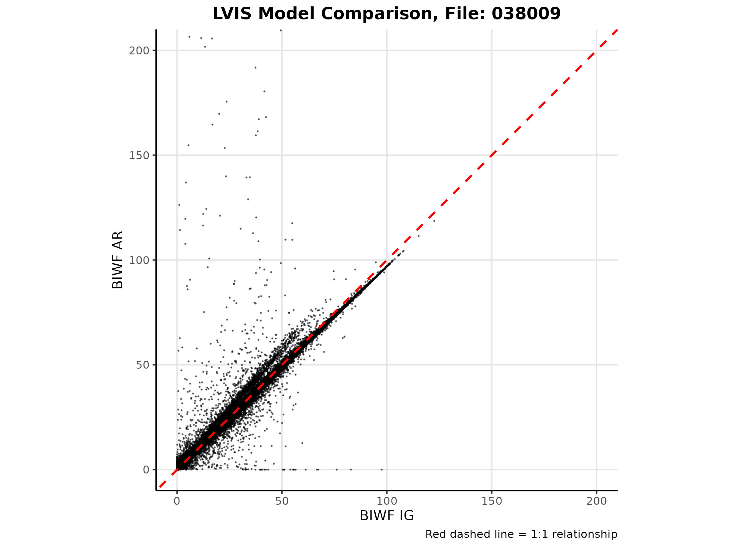

Figure 1: Scatterplot comparison of IG and AR implementations showing a subset of shots following a different slope from the primary 1-to-1 relationship.

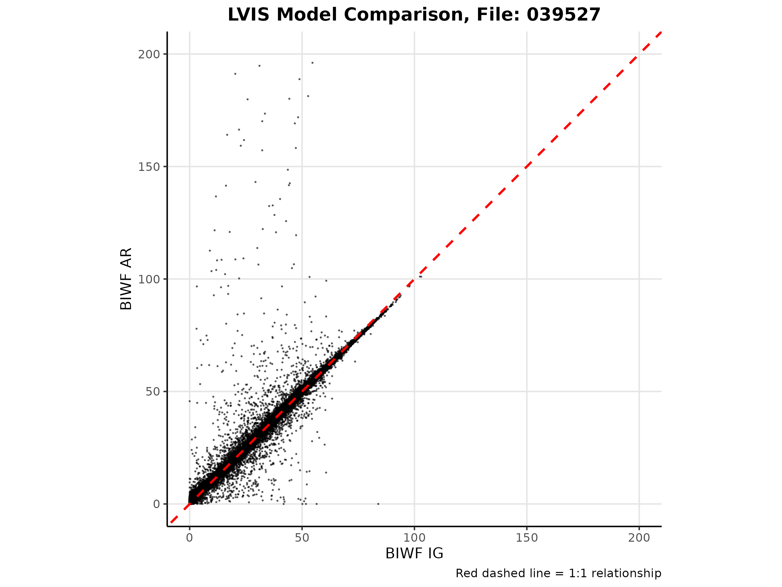Figure 2: "Normal" scatterplot comparison of IG and AR implementations with good alignment for most shots and a small number of outliers.

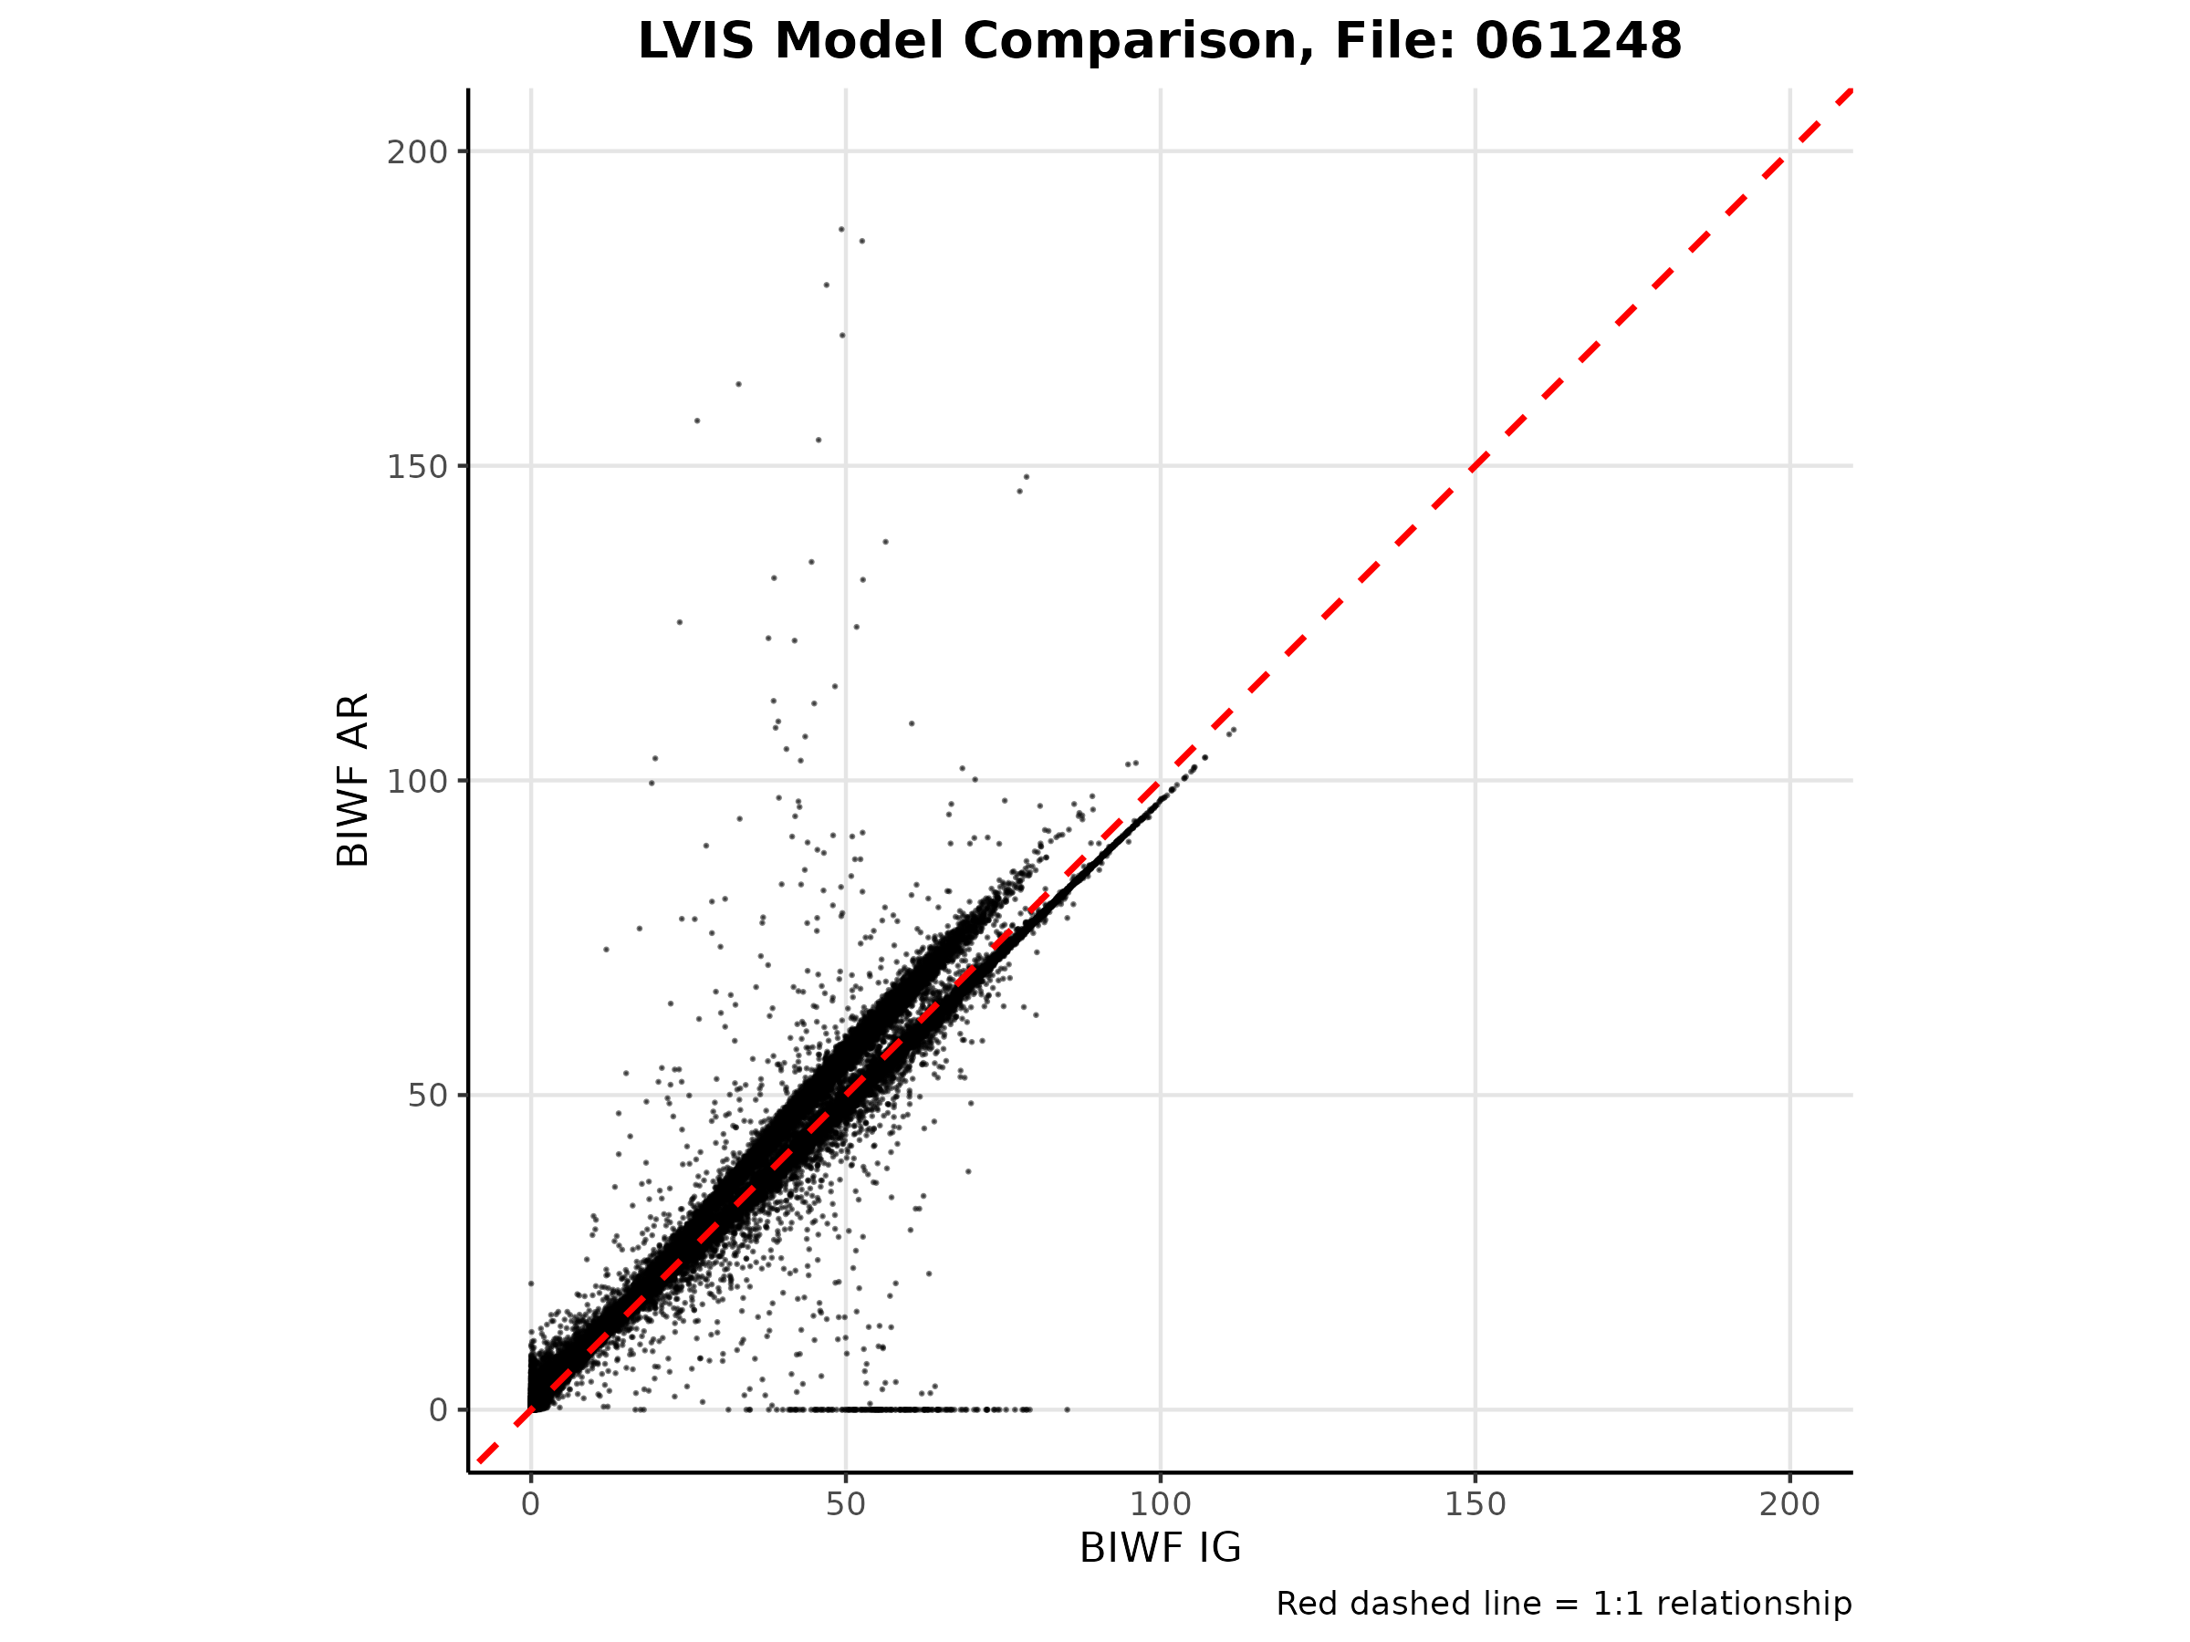

Figure 3: Scatterplot demonstrating the subset discrepancy pattern with distinct slopes for different groups of shots.

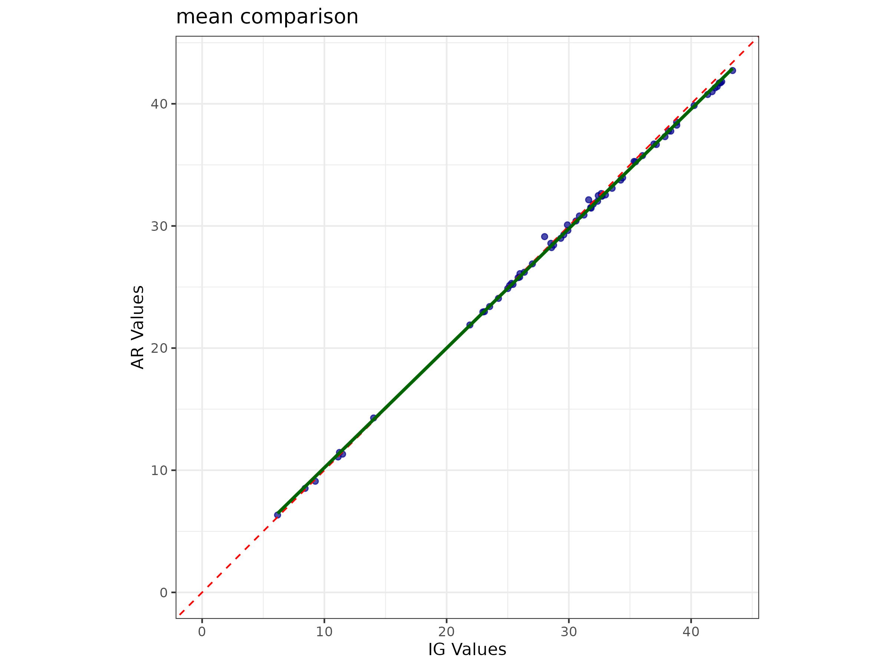

Figure 4: Comparison of mean BIWF values per file between IG and AR implementations, showing close alignment with slightly lower AR values for highest biomass files.

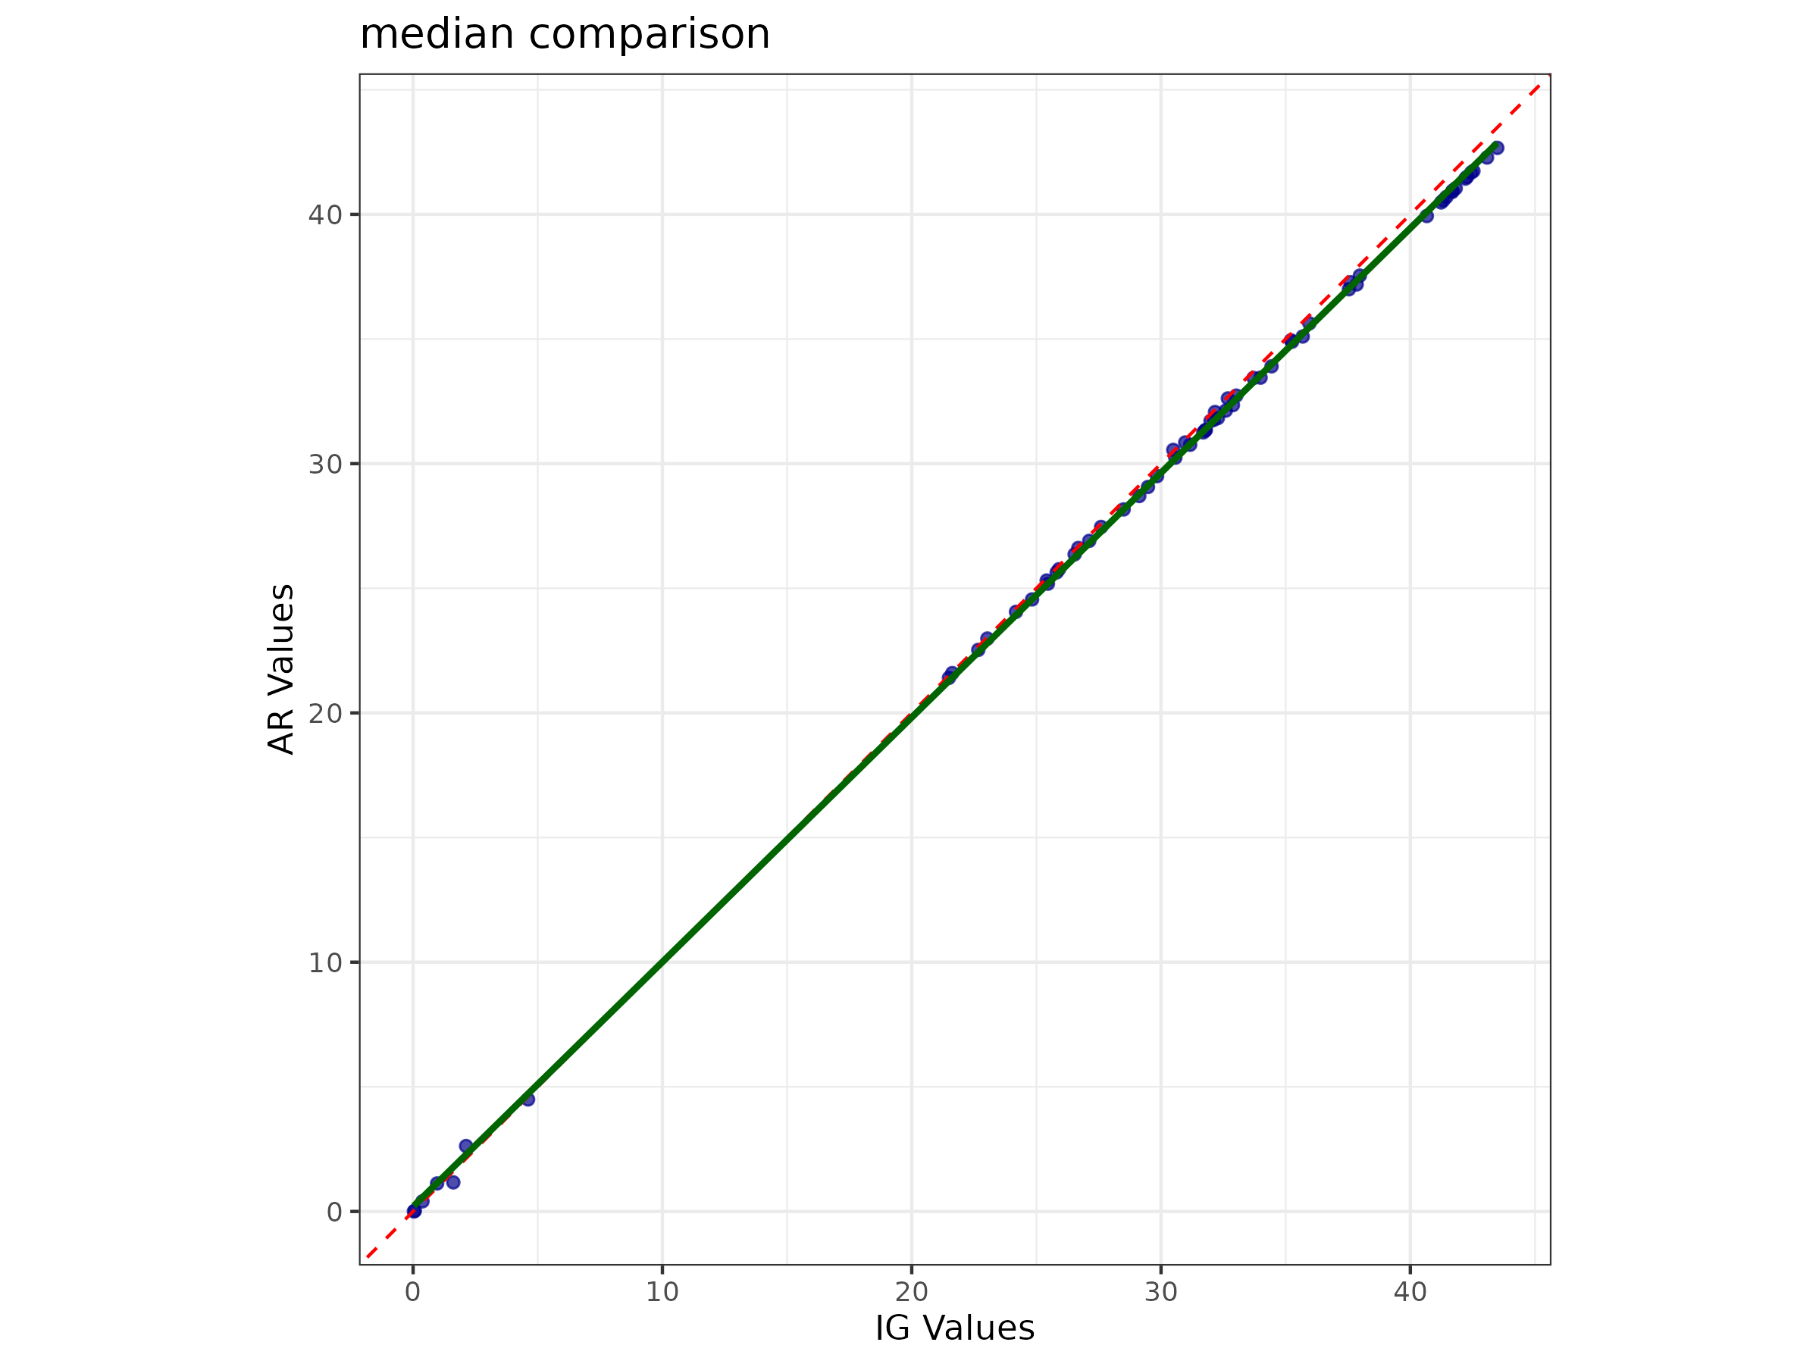

Figure 5: Comparison of median BIWF values per file between IG and AR implementations, demonstrating similar alignment patterns to the mean values.

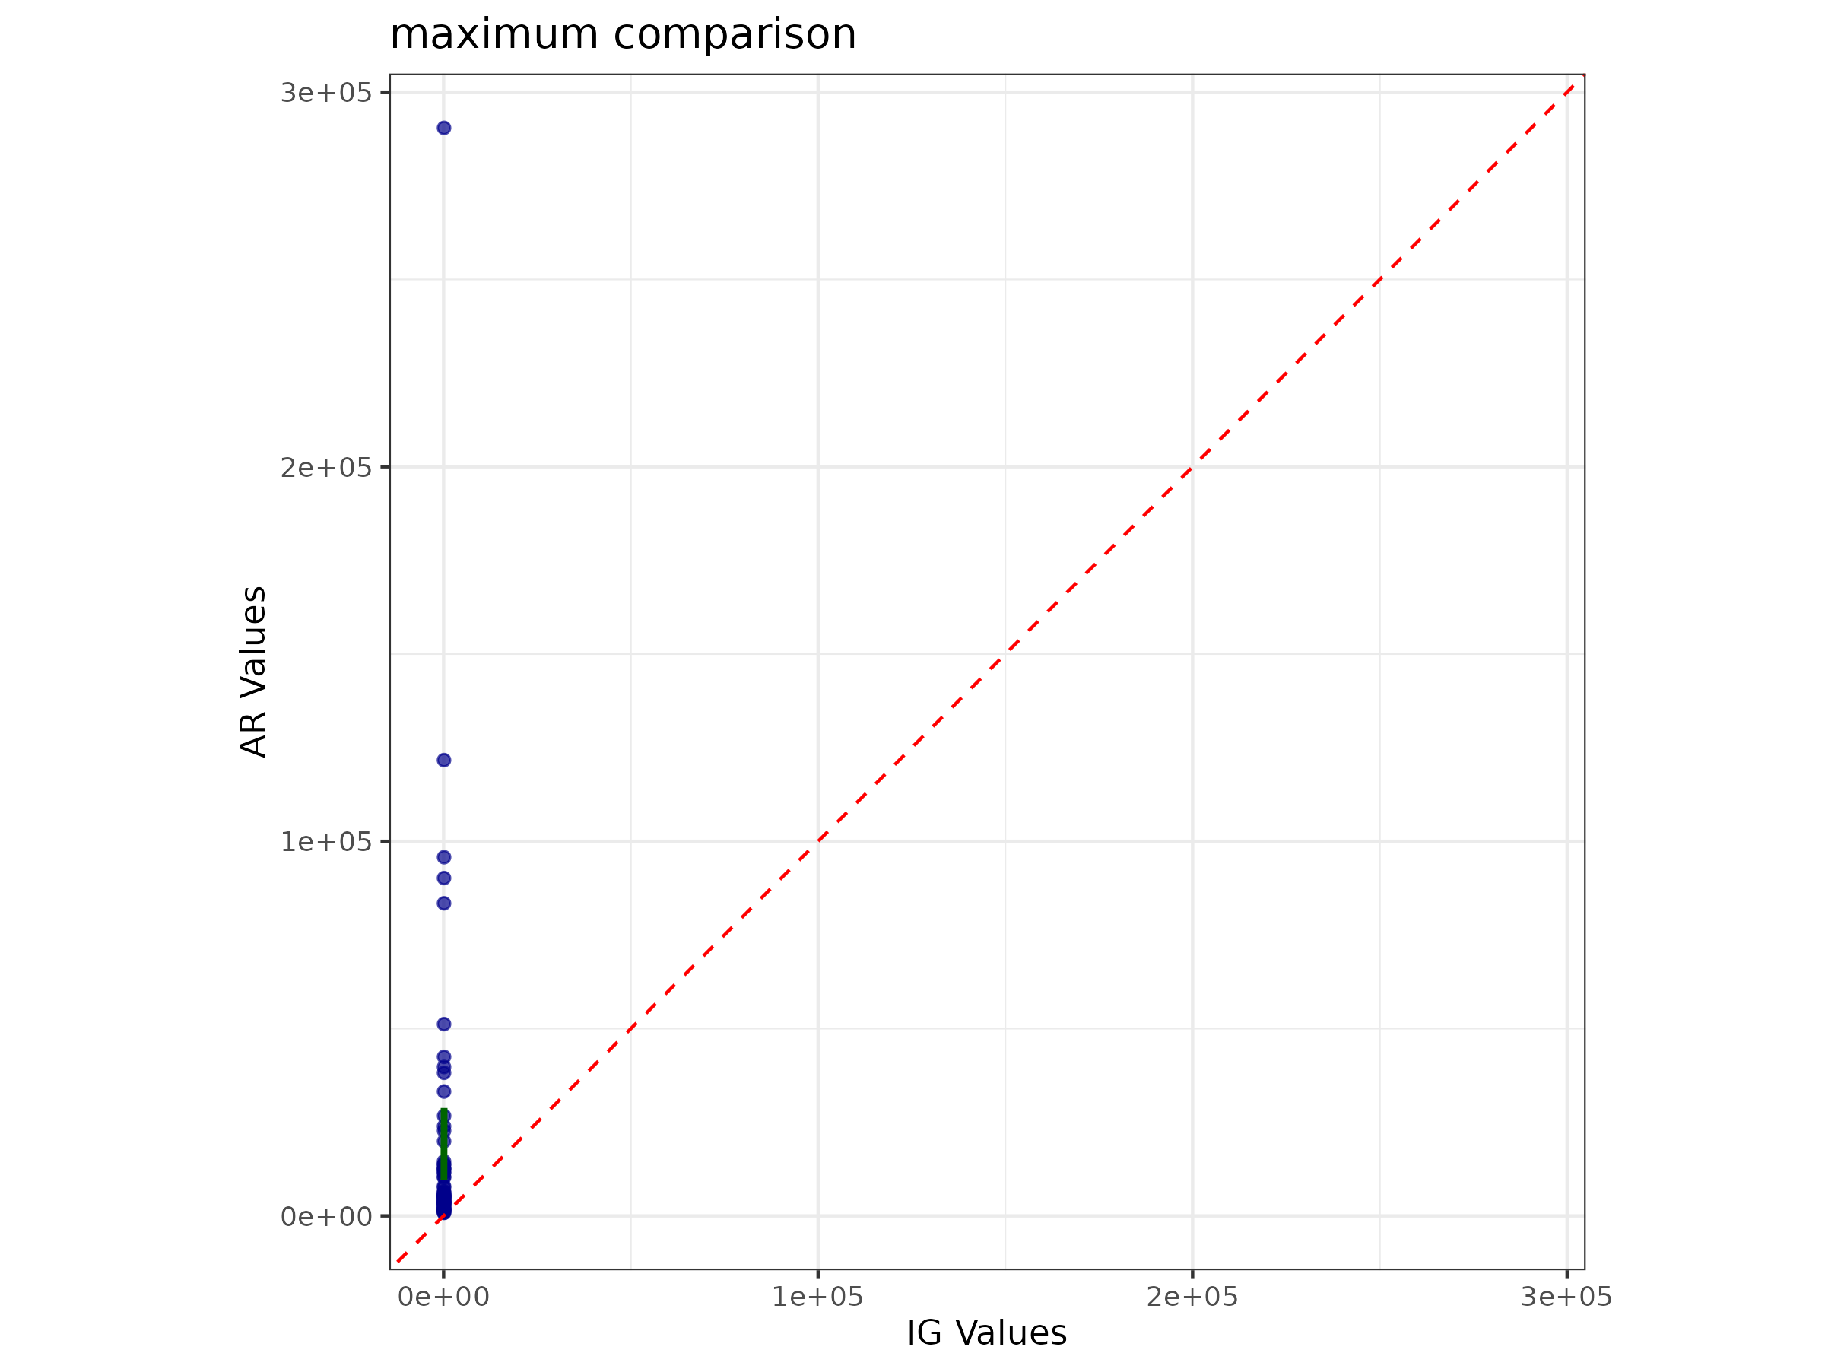Figure 6: Maximum BIWF value comparison revealing major discrepancy between implementations, with AR values exceeding 10,000 while IG values remain within expected ranges.

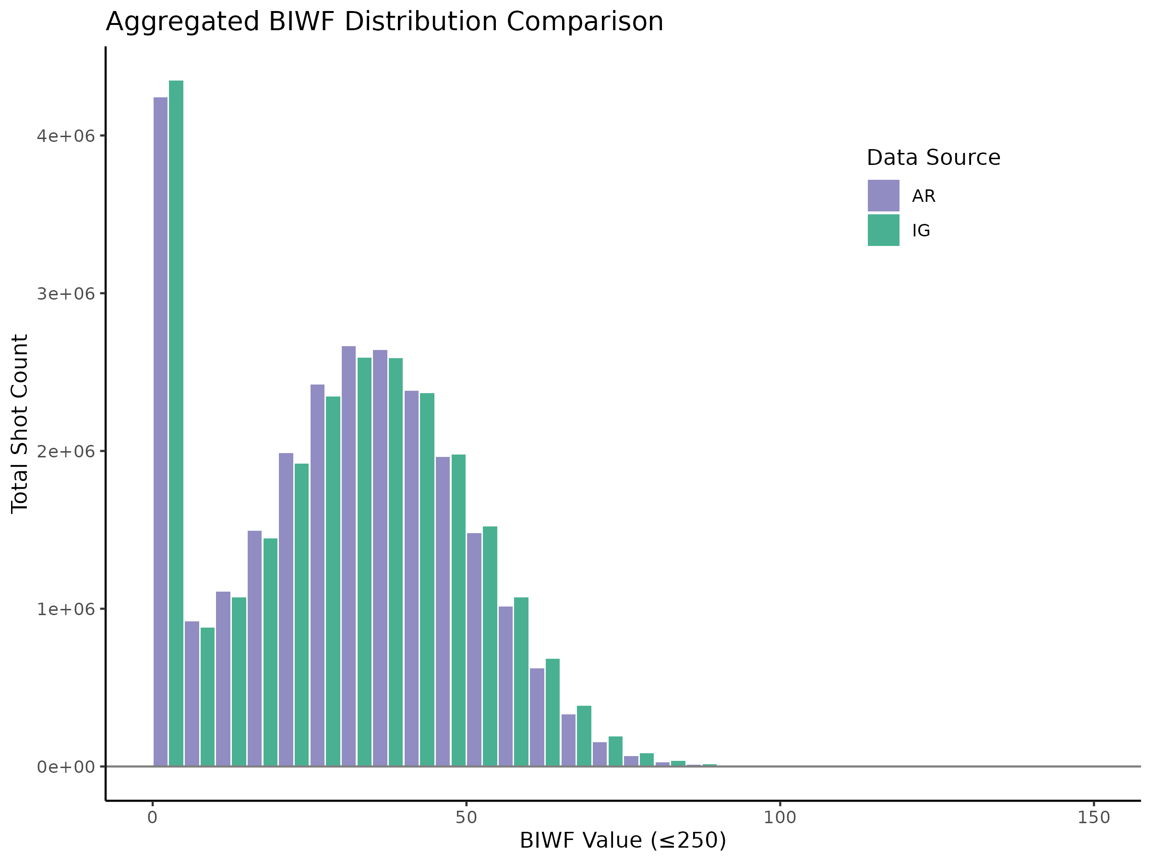Figure 7. Histogram comparison of BIWF values for all LVIS shots in Gabon 2016.