CoinFlow: forecasting teenagers' weekly spending — comparing five algorithms and building them into a free financial-literacy app
Author: ____________________, Grade 12
School: ____________________
Supervisor: ____________________
Field: Software / Economics · MoldSEF & Infomatrix 2026

Problem and relevance
Teenagers in the Republic of Moldova receive pocket money or first salaries, but school rarely teaches how to manage them. In 2025, online scams cost people in Moldova more than 272 million lei (General Police Inspectorate). Commercial budgeting apps cost 359–1 955 lei a year, are made for adults and know nothing about the leu, the official National Bank (BNM) rates or Moldovan taxes.
Aim and objectives
Aim: build a free web app in Romanian, Russian and English that helps teenagers plan their money, and choose, based on evidence, the algorithm that predicts next week's spending. Objectives: (1) a working, secure, tested app; (2) a reproducible experiment comparing forecasting methods; (3) an economic benefit analysis.
Hypothesis (registered before the experiment)
H1: Holt's method (exponential smoothing with trend) has a lower mean absolute error (MAE) than the 4-week simple moving average (SMA), with p < 0.05, and is at least 10 % more accurate on ledgers with a trend. H2: every smoothing method beats the naive “same as last week” forecast.
Materials and methods
App: Next.js, TypeScript, Supabase (PostgreSQL with Row Level Security), amounts stored as integers in bani; 42 unit tests and continuous integration. Experiment: 150 synthetic spending ledgers (26 weeks each, 5 profiles: stable, rising, falling, monthly allowance, impulse purchases), generated with fixed seeds (reproducible). Methods: NAIVE, SMA, SES (simple exponential smoothing), HOLT and, as an exploratory method, damped-trend Holt. Parameters α, β, φ are tuned automatically using only past data (grid search). Rolling-origin evaluation: 18 forecasts per ledger, 2 700 per method. Metrics: MAE, RMSE, sMAPE, computation time. Statistics: paired Wilcoxon signed-rank test, α = 0.05.
Results
SMA had the lowest error: 174.0 lei/week (SES 178.8; HOLT 216.6; NAIVE 226.1). H1 is not supported: Holt was 24.5 % less accurate than SMA (z = 10.2; p < 0.001; r = 0.83), even on trend ledgers (−19.5 %). H2 is supported: every smoothing method beat the naive forecast (p < 0.01). Damping the trend reduced Holt's error by 9.7 % but did not reach SMA. The sensitivity analysis shows the Holt–SMA gap shrinking from 21 % to 5 % as day-to-day noise falls, without reversing. SMA computes a forecast in under 0.001 ms.
Conclusions
On short, noisy data, simple methods are more accurate: trend models mistake random spikes for trends. This agrees with the international M3 forecasting competition (Makridakis & Hibon, 2000). Based on this result, CoinFlow uses the 4-week SMA for its in-app forecast. Limitation: the data is synthetic; the next step is validation on real, anonymised ledgers from volunteers.
Economic benefit
The app costs users 0 lei. Hosting is free up to about 1 000 students and costs about 0.97 lei per student per year at 10 000 students. For a class of 30, the saving compared with YNAB is about 58 660 lei a year. All calculations run in the browser, so the algorithms add no server cost.
Selected bibliography
1) Hyndman & Athanasopoulos (2021), Forecasting: Principles and Practice, 3rd ed., OTexts. 2) Holt (2004), Int. J. Forecasting 20(1). 3) Gardner & McKenzie (1985), Management Science 31(10). 4) Makridakis & Hibon (2000), Int. J. Forecasting 16(4). 5) Wilcoxon (1945), Biometrics Bulletin 1(6). 6) OECD (2024), PISA 2022 Results, Vol. IV.

Graphical annex
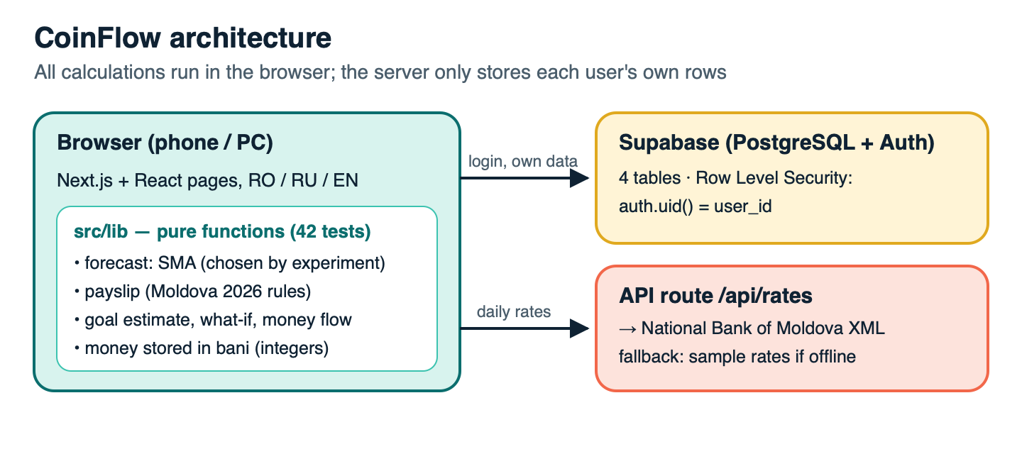
Fig. 1. CoinFlow architecture.
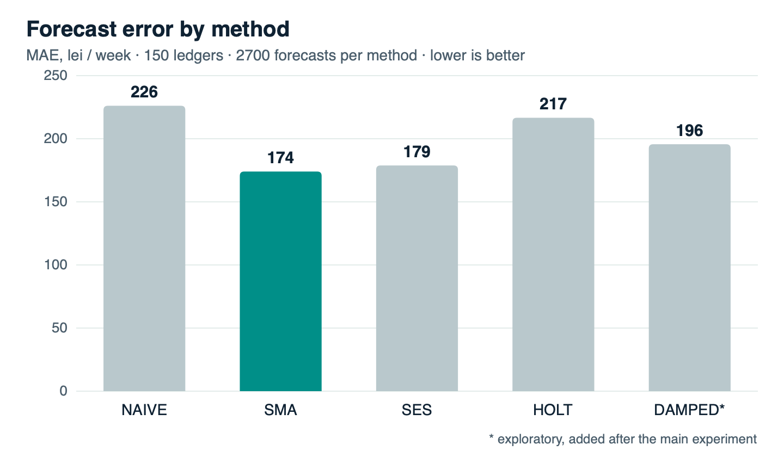
Fig. 2. Mean absolute error per method (lei/week; lower is better).
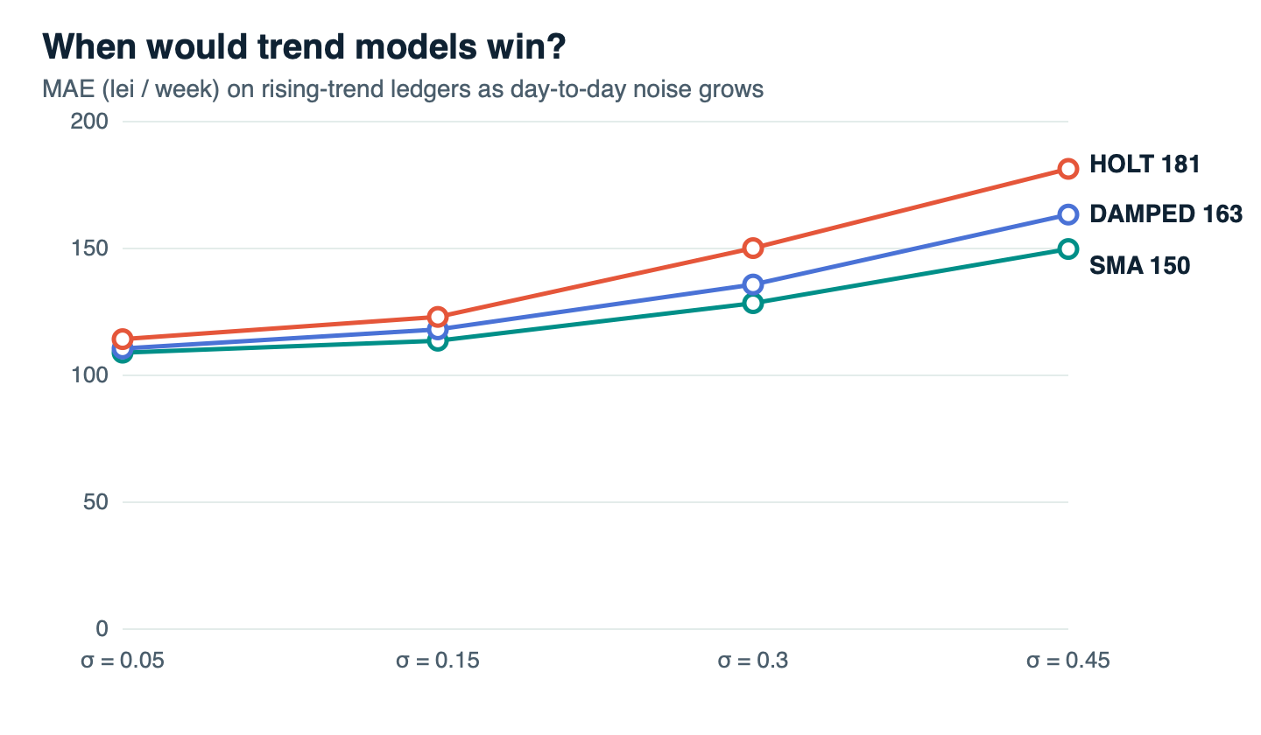
Fig. 3. Sensitivity analysis: trend ledgers at different daily noise levels.
Table 1. Wilcoxon tests (paired, 150 ledgers)
Comparison | MAE A | MAE B | Difference | p | r
HOLT vs SMA | 216.6 | 174.0 | −24.5 % | < 0.001 | 0.83
SMA vs NAIVE | 174.0 | 226.1 | +23.0 % | < 0.001 | 0.83
SES vs NAIVE | 178.8 | 226.1 | +20.9 % | < 0.001 | 0.84
DAMPED vs HOLT * | 195.6 | 216.6 | +9.7 % | < 0.001 | 0.82
* exploratory. Code, data and results: github.com/i-c-js/coin-flow · App: coin-flow-theta.vercel.app

