Supplementary Materials: Autistic Adults More Often Report Absent Sensory Imagery

Table S1. Participants and raw scores
Measure | Comparison | Autism | ADHD-only
Retained participants | 749 | 150 | 84
Age (years) | 25.08 (3.57) | 25.01 (3.37) | 25.19 (3.37)
Overall imagery (comparison SD) | 0.00 (1.00) | -0.43 (1.40) | -0.07 (1.16)
Sight score (5-35) | 24.57 (6.23) | 22.22 (8.18) | 24.05 (6.75)
Sound score (5-35) | 26.85 (5.71) | 24.48 (8.30) | 26.52 (6.20)
Smell score (5-35) | 23.05 (7.15) | 20.89 (8.87) | 22.62 (7.78)
Taste score (5-35) | 25.49 (6.96) | 22.75 (9.23) | 25.10 (7.57)
Touch score (5-35) | 24.91 (6.49) | 22.83 (7.98) | 24.33 (7.32)
Movement score (5-35) | 26.08 (6.29) | 24.29 (8.30) | 26.13 (6.84)

Means (standard deviations), except participant counts. Ages: Comparison 18-32 years (n = 748); Autism 18-30 years (n = 150); ADHD-only 19-30 years (n = 84). Each sense score is the sum of five 1-7 ratings (range 5-35). Movement is New et al.'s sixth sense. Sex is shown in Table 1. The archive codes sex as 0, 1 and O; we read 0 as female and 1 as male because the coded totals across New et al.'s two studies (992, 952 and 8) match their published counts of female, male and other respondents in that order.

Table S2. Registered primary tests, full precision
Test | Estimate | 95% CI | One-sided p | Supported
H1. Overall imagery, autism vs comparison | -0.422 | -0.658 to -0.186 | 0.000232 | Yes
H2a. Absent smell imagery | 2.691 | 1.420 to 5.099 | 0.0012 | Yes
H2b. Absent taste imagery | 3.812 | 2.001 to 7.262 | 2.35e-05 | Yes

The first estimate is a difference in comparison-group standard deviations; the others are odds ratios. The file supplement_registered_estimates.csv stores two-sided p values for every model; the one-sided p values above are the registered tests.

Table S3. Registered secondary tests
Test | Definition | Two-sided p | Holm-adjusted p
S1(a) | Autism: smell/taste difference minus sight difference | 0.76 | 1
S1(b) | Autism: difference varies across the six senses | 0.501 | 1
S2 | Autism minus ADHD-only, overall score | 0.0373 | 0.149
S3 | Absent visual imagery, autism vs comparison | 0.0108 | 0.0541
S4 | ADHD-only: smell/taste difference minus sight difference | 0.797 | 1

The ADHD-only versus comparison difference in the three-group model was -0.065 SD (95% CI -0.325 to +0.195). S1 and S4 use one row per person per sense (5,388 rows for 898 people in S1; 4,992 rows for 832 people in S4).

Table S4. Registered sensitivity analyses and Arnold et al. reanalysis
Analysis | Estimate | 95% CI | Units | n
New: autism group without co-reported ADHD | -0.389 | -0.651 to -0.128 | SD; people | 852
New: raw six-sense mean | -2.216 | -3.456 to -0.976 | Points on 5-35 scale; people | 898
New: ages 18-30 only | -0.421 | -0.657 to -0.185 | SD; people | 895
New: no age/sex adjustment | -0.428 | -0.664 to -0.191 | SD; people | 899
New: absent smell, without co-reported ADHD | 2.871 | 1.406 to 5.865 | Odds ratio; people | 852
New: absent taste, without co-reported ADHD | 3.910 | 1.904 to 8.031 | Odds ratio; people | 852
New: sight difference, age/sex effects allowed to vary by sense | -0.380 | -0.602 to -0.158 | Sight SD; person-sense rows | 5388
Arnold: overall imagery, six senses | -0.180 | -0.359 to -0.002 | SD; people | 654
Arnold: sight difference in the per-sense model | -0.134 | -0.307 to 0.039 | Sight SD; person-sense rows | 3924

In the per-sense models, sight is the reference sense, so the group coefficient is the difference for sight only. New et al.'s 5,388 rows are 898 people; Arnold et al.'s 3,924 rows are 654 people. All rows, including interaction terms, are in supplement_registered_estimates.csv.

Table S5. Five-sense check (exploratory)
Dataset | Difference (SD) | 95% CI | Two-sided p | n
New et al. | -0.435 | -0.669 to -0.201 | 0.000275 | 898
Arnold et al. | -0.199 | -0.377 to -0.021 | 0.0286 | 654

Uses sight, sound, smell, taste and touch only, standardised against each dataset's comparison group, with the same age/sex-adjusted model as H1. Specified in the deviations log on 17 October 2026, after the registered results were known.

Table S6. Lowest and highest scores by sense (exploratory)
Sense | New: absent, autism / comparison | New: top score, autism / comparison | Arnold: absent, autism / comparison | Arnold: top score, autism / comparison
Sight | 6.0% / 2.3% | 3.3% / 4.3% | 4.0% / 2.1% | 8.3% / 7.3%
Sound | 6.7% / 1.1% | 8.7% / 9.7% | 2.8% / 0.9% | 11.6% / 10.7%
Smell | 10.0% / 3.9% | 3.3% / 3.5% | 7.3% / 2.4% | 3.4% / 4.6%
Taste | 11.3% / 3.1% | 6.7% / 8.7% | 6.1% / 2.4% | 5.2% / 6.1%
Touch | 6.7% / 2.0% | 6.0% / 5.9% | 3.1% / 1.8% | 10.4% / 9.8%
Movement (New) / bodily sensation (Arnold) | 8.0% / 2.1% | 9.3% / 8.7% | 2.4% / 1.5% | 5.5% / 4.9%

Absent: the lowest possible score in that sense (5 of 35 in New et al.; 0 of 50 in Arnold et al.). Top score: the highest possible score (35; 50). New et al.: 150 autism, 749 comparison. Arnold et al.: 327 each.

Table S7. All other exploratory analyses
Every exploratory analysis run on these data after the registered results were known, including those not discussed in the main text. Differences are autism minus comparison, adjusted for age and sex, with 95% confidence intervals, unless stated otherwise.
Analysis | Result | n
New: overall difference among people who repeated all five activities in the attention check | -0.42 (-0.68 to -0.15) SD | 702
New: emotion imagery (not in the overall score) | -0.43 (-0.65 to -0.21) SD, Holm p < .001 | 898
New: voice imagery | -0.27 (-0.50 to -0.03) SD, Holm p .026 | 898
New: inner-body imagery | -0.37 (-0.59 to -0.16) SD, Holm p .001 | 898
New: overall difference, also adjusted for current treatment | -0.42 (-0.66 to -0.18) SD | 898
New: overall difference, also adjusted for education | -0.41 (-0.65 to -0.17) SD | 889
New: empathy self-rating (1-7), autism minus comparison | -0.39 (-0.67 to -0.12) points | 898
New: overall difference, also adjusted for the empathy rating | -0.34 (-0.57 to -0.10) SD | 898
New: absent imagery in at least one sense, ADHD-only vs comparison | 8.3% vs 6.5%, Fisher p .493 | 833
New: absent imagery in at least one sense, autism vs ADHD-only | OR 2.75, Fisher p .024 | 234
Arnold, AQ 26 or more only: absent imagery in at least one sense | 11.6% vs 4.6% | 569
Arnold, AQ 26 or more only: median difference | -0.20 (-0.42 to +0.01) SD | 569
Arnold, AQ 26 or more only: difference among people with imagery in every sense | -0.19 (-0.37 to -0.02) SD | 526
Arnold, autistic adults: AQ without imagination items, absent imagery in any sense vs none | 30.0 vs 27.4, d = 0.35, Mann-Whitney p .046 | 327
Both datasets pooled: difference among people with imagery in every sense | -0.05 SD (-0.17 to +0.06); two one-sided tests against +/-0.2 SD, p .006 | 1426
Dance et al. (2021), people without aphantasia: AQ vs six-sense imagery | Spearman rho = -0.27, p .001 | 138
Dance et al. (2021), people with aphantasia: AQ vs six-sense imagery | Spearman rho = -0.01, p .885 | 164
Dance et al. (2021), general population: AQ vs visual imagery (VVIQ) | Spearman rho = 0.04, p .749 | 83

Why these analyses were run. Attention check: to see whether careless responding explains the difference. Emotion, voice and inner-body imagery: the three kinds of imagery New et al. measured that are not in the overall score. Treatment and education: possible confounders recorded in the survey. Empathy self-rating: the survey's only non-imagery 1-7 rating, used to check whether autistic respondents simply rate themselves lower on any 1-7 item; adjusting for it reduced the difference from -0.42 to -0.34. AQ 26 or more: Arnold et al.'s own selection. AQ without imagination items: whether absent imagery goes with autistic traits beyond the items that ask about imagination (Bouyer et al., 2025). Dance, Ward and Simner (2021): a public dataset with AQ and six-sense imagery in people with and without aphantasia (OSF h24vm; their AQ total omits item 3). The pooled estimate uses fixed-effect inverse-variance weights across two questionnaires whose sixth senses differ, and it selects people by their scores; the +/-0.2 SD bound is a conventional 'small' effect, chosen after the results were known.
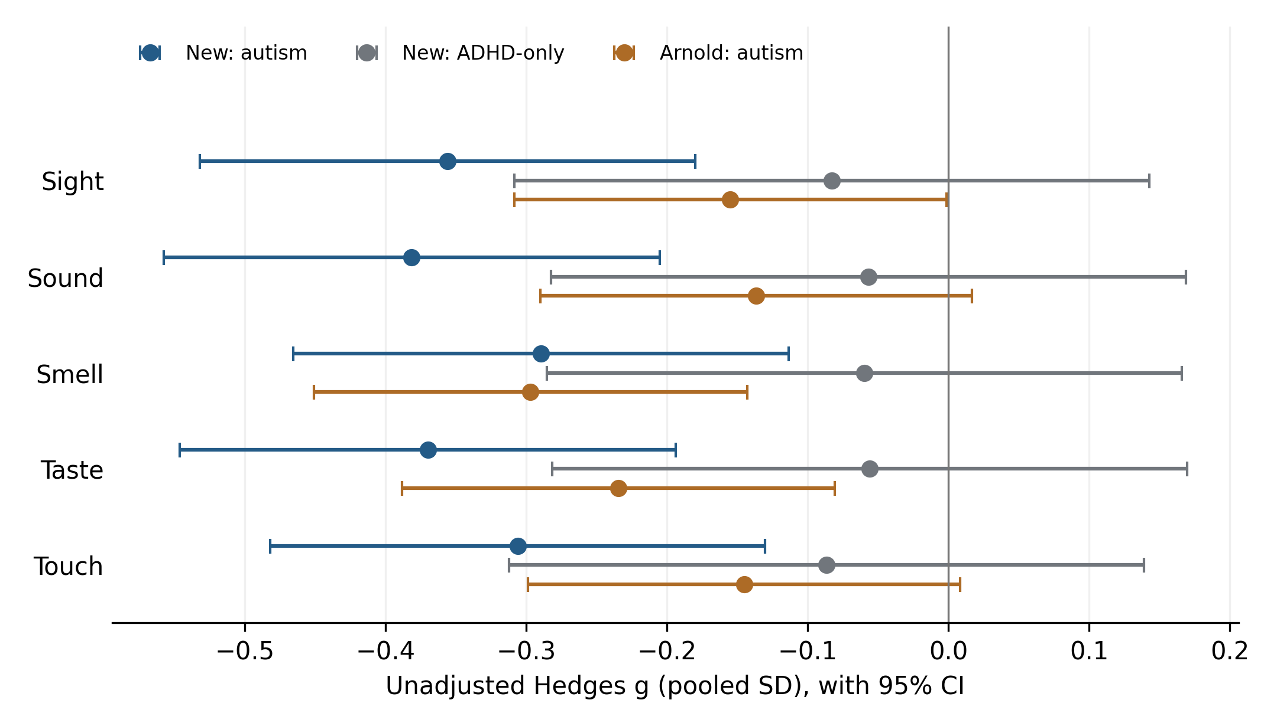
Figure S1. Unadjusted differences in each of the five senses measured in both questionnaires (Hedges g with pooled standard deviations and 95% confidence intervals). This scale differs from the adjusted overall score in the main text. These are descriptive, not additional tests.

Reproduction and checks
All 156 registered estimate rows were reproduced exactly in a separate run (largest absolute difference 0.0). The frozen plan's SHA-256 is ce102d64229b6a4efb2a7c646048f17c5ab338829f73bed4121bcc1deb147c14, and the original output files were unchanged.
The overall-score regression was rebuilt independently with statsmodels (OLS, HC3, t inference) and agreed. Holm adjustment was rechecked with statsmodels. The five Firth fits were refitted in R 4.6.1 with brglm2 1.1.1 (mean bias reduction). Coefficients, covariance matrices, Wald intervals and p values agreed: the largest coefficient difference was 3.7e-07 and the largest covariance difference 8.5e-07. To converge with the small 'other' sex category, the R fit needed an intercept-only start and step size 0.25.
The code, run order and checks are documented in the repository; no participant-level rows are written.

Source measures
New et al.: OSF project 2bdn6. The data file for Study 2 is named Exp3.1020.txt in the archive. The questionnaire (Study2.Questionnaires.pdf in the archive) is the 45-item QMI + VocEmo, New et al.'s extension of the Questionnaire upon Mental Imagery with vocal and emotional items. The six senses used here are its sight, sound, smell, taste, touch and movement scales. Its emotion, voice and inner-body scales are not in the overall score. New et al.'s attention rule keeps people who repeated at least three of their five favourite activities.
Arnold et al.: the public workbook labels its six PSI-Q columns visual, auditory, smell, taste, touch and bodily sensation. All 327 autistic records in Arnold et al.'s analysis code match the workbook on imagery scores, AQ and age, and all have the maximum attention score (13). How the comparison group was recruited is not documented in these files.

Table S8. Deviations from the registered plan
Date | Change | Effect
10 Oct 2026 | The plan gave the effect Arnold et al.'s study had a 33% chance of detecting (used to judge a null H1) as about 0.12 SD; the registered code computed 0.139 SD. | None: only used if H1 had failed.
10 Oct 2026 | Firth regression used for H2a, H2b, S3 and their sensitivity analyses, as the plan allowed, because the 'other' sex category perfectly predicted the outcome. | None; reported as planned.
11 Oct 2026 | The plan's SHA-256 for the New et al. data file was the archive's fingerprint, not the file's. Label corrected. | None; same data.
17 Oct 2026 | The plan treated Arnold et al.'s sixth sense (bodily sensation) as movement. Registered results kept as run; five-sense check added. | Registered six-sense results are not matched across questionnaires.
17 Oct 2026 | Registered analysis reproduced in a separate directory; Firth fits checked against R. | Numerical check only; no discrepancies.
18 Oct 2026 | Shift benchmark (Table 4) added after an internal review. | Exploratory.

The full deviations log is in the repository alongside the registered plan.

Comparing the two datasets
The registered six-sense differences were -0.42 SD (New) and -0.18 SD (Arnold). Their difference, -0.24 SD, had a two-sided p of .11 under a normal approximation. This comparison treats the samples as independent and the two composites as comparable; neither is established, so we do not interpret it.

