NAME – Harsh Singh
Roll No. - 244ca018

SQL COMMAND-------

(base) cds@L2-19:~$ ssh mcalab10.100.36.95
ssh: Could not resolve hostname mcalab10.100.36.95: Name or service not known
(base) cds@L2-19:~$ ssh mcalab@10.100.36.95
The authenticity of host '10.100.36.95 (10.100.36.95)' can't be established.
ED25519 key fingerprint is SHA256:uW9CnHDhXrOrMLdIZ2Tx9Y9jAUKiVOV5/pTv6HAGtoc.
This key is not known by any other names
Are you sure you want to continue connecting (yes/no/[fingerprint])? ^C
(base) cds@L2-19:~$ ssh mcalab@10.100.36.95
The authenticity of host '10.100.36.95 (10.100.36.95)' can't be established.
ED25519 key fingerprint is SHA256:uW9CnHDhXrOrMLdIZ2Tx9Y9jAUKiVOV5/pTv6HAGtoc.
This key is not known by any other names
Are you sure you want to continue connecting (yes/no/[fingerprint])? yes
Warning: Permanently added '10.100.36.95' (ED25519) to the list of known hosts.
mcalab@10.100.36.95's password:
Welcome to Ubuntu 16.04.5 LTS (GNU/Linux 4.15.0-42-generic x86_64)

* Documentation: https://help.ubuntu.com
* Management: https://landscape.canonical.com
* Support: https://ubuntu.com/advantage

471 packages can be updated.
409 updates are security updates.

New release '18.04.6 LTS' available.
Run 'do-release-upgrade' to upgrade to it.

Last login: Fri Feb 12 03:00:25 2016 from 10.100.39.122
mcalab@ProLiant-DL580-G5-2:~$ rlwrap sqlplus

SQL*Plus: Release 11.2.0.2.0 Production on Fri Feb 12 03:01:12 2016

Copyright (c) 1982, 2011, Oracle. All rights reserved.

Enter user-name: ca0018
Enter password:
ERROR:
ORA-01017: invalid username/password; logon denied

Enter user-name: ca0018
Enter password:
ERROR:
ORA-01017: invalid username/password; logon denied

Enter user-name: ca018
Enter password:

Connected to:
Oracle Database 11g Express Edition Release 11.2.0.2.0 - 64bit Production

SQL> CREATE TABLE classroom
2 (building varchar(15),
3 room_number varchar(15),
4 capacity numeric(4,0),
5 primary key(building, room_number)
6 )
7 ;

Table created.

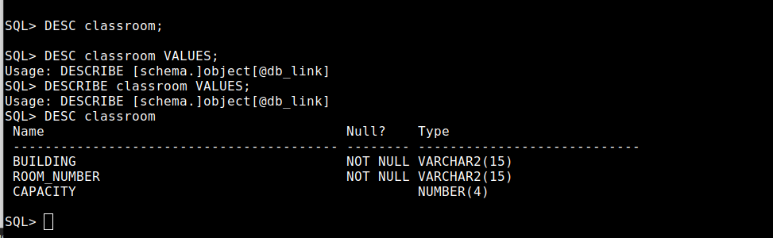

SQL> CREATE TABLE department
2 (dept_name varchar(8),
3 building varchar(15),
4 budget numeric(12,2) check(budget > 0),
5 primary key(dept_name)
6 );

Table created.

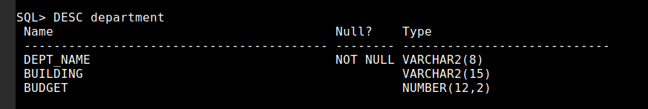

SQL> CREATE TABLE course
2 (course_id varchar(8),
3 title varchar(50),
4 dept_name varchar(20),
5 credits numeric(2,0) check(credits > 0),
6 primary key(course_id),
7 foreign key(dept_name) references department on delete set null
8 );

Table created.

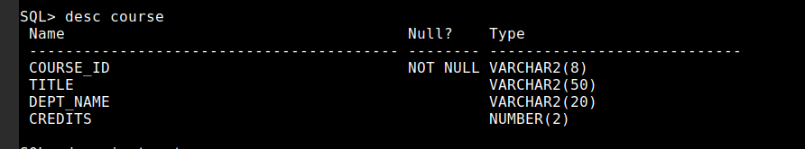

SQL> CREATE TABLE instructor
2 (ID varchar(5),
3 name varchar(20) not null,
4 dept_name varchar(20),
5 salary numeric(8,2) check(salary > 29000),
6 primary key(ID),
7 foreign key(dept_name) references department on delete set null
8 );

Table created.
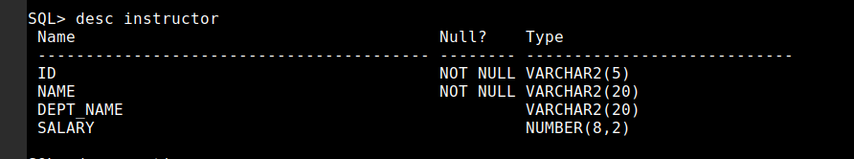

SQL> CREATE TABLE section
2 (course_id varchar(8),
3 sec_id varchar(8),
4 semester varchar(6) check(semester in('Fail', 'Winter', 'Spring', 'Summer')),
5 year numeric(4,0) check (year > 1701 and year<2100),
6 building varchar(15),
7 room_number varchar(7),
8 time_slot_id varchar(4),
9 primary key (course_id, sec_id, semester, year),
10 foreign key(building, room_number) references classroom on delete set null
11 );

Table created.

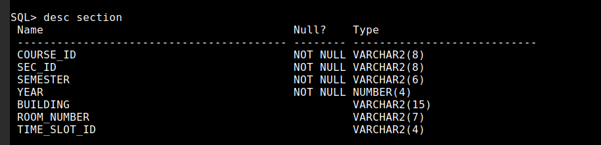

SQL> CREATE TABLE teaches
2 (ID varchar(5),
3 course_ID varchar(8),
4 sec_id varchar(8),
5 semester varchar(6),
6 year numeric(4,0),
7 primary key (ID, course_id, sec_id, semester, year),
8 foreign key(course_id, sec_id, semester, year) references section on delete cascade,
9 foreign key (ID) references instructor on delete cascade
10 );

Table created.

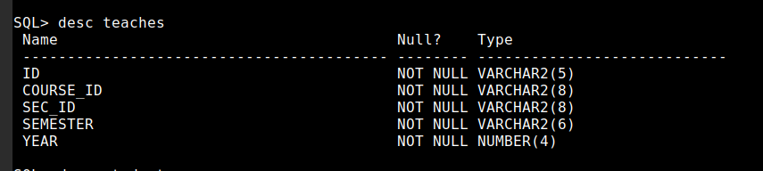

SQL> CREATE TABLE student
2 (ID varchar(5),
3 name varchar(20) not null,
4 dept_name varchar(20),
5 tot_cred numeric(3,0) check (tot_cred >=0),
6 primary key(ID),
7 foreign key(dept_name) references department on delete set null
8 );

Table created.

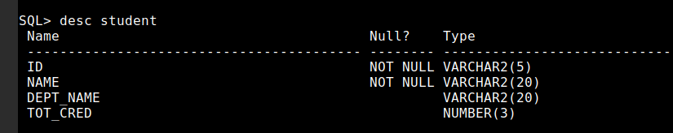

SQL> CREATE TABLE takes
2 (ID varchar (5),
3 course_id varchar(8),
4 sec_id varchar(8),
5 semester varchar(6),
6 year numeric(4,0),
7 grade varchar(2),
8 primary key(ID, course_id, sec_id, semester, year),
9 foreign key(course_id, sec_id, semester, year) references section on delete cascade,
10 foreign key(ID) references student on delete cascade
11 );

Table created.
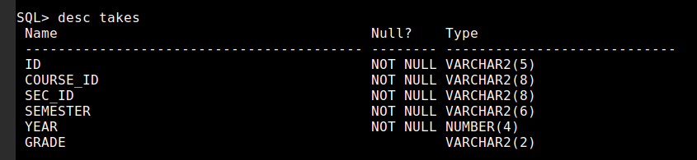

SQL> CREATE TABLE advisor
2 (s_ID varchar(5),
3 i_ID varchar(5),
4 primary key(s_ID),
5 foreign key(i_ID) references instructor(ID) on delete set null,
6 foreign key(s_ID) references student(ID) on delete cascade
7 );

Table created.

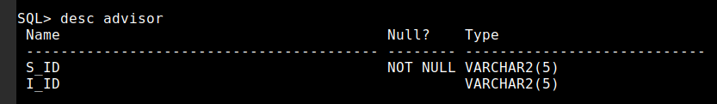

SQL> CREATE TABLE time_slot
2 (time_slot_id varchar(4),
3 day varchar(1),
4 start_hr numeric(2) check (start_hr >= 0 and start_hr <24),
5 start_min numeric(2) check(start_min >= 0 and start_min < 60),
6 end_hr numeric(2) check(end_hr >= 0 and end_hr < 24),
7 end_min numeric(2) check(end_min >=0 and end_min < 60),
8 primary key (time_slot_id, day, start_hr, start_min)
9 );

Table created.

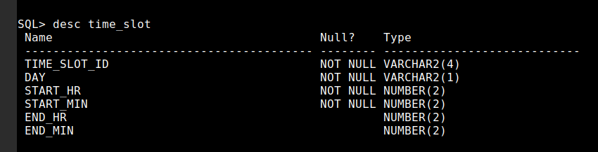

SQL> CREATE TABLE prereq
2 ( course_id varchar(8),
3 prereq_id varchar(8),
4 primary key (course_id, prereq_id),
5 foreign key (course_id) references course on delete cascade,
6 foreign key (prereq_id) references course
7 );

Table created.

