NAME – Harsh Singh
Roll No. - 244ca018

INSERTION COMMAND------

SQL> INSERT INTO classroom VALUES ('LHC A', 2.0, 75);

1 row created.

SQL> INSERT INTO classroom VALUES ('LHC A', 2.1, 80);

1 row created.

SQL> INSERT INTO classroom VALUES ('LHC A', 2.2, 100);

1 row created.

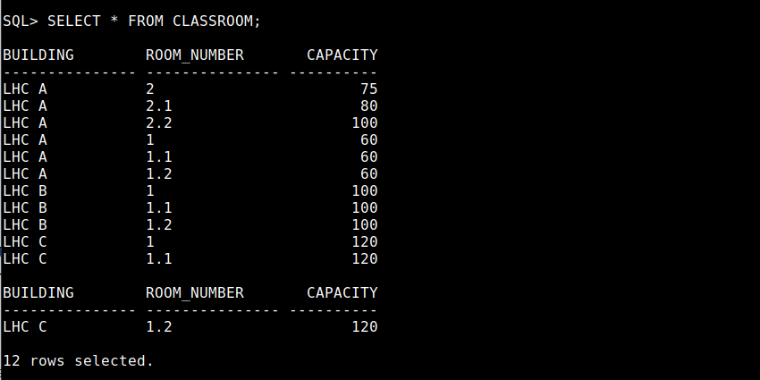

SQL> INSERT INTO department VALUES ('MACS', 'LHC A', 50);

1 row created.

SQL> INSERT INTO department VALUES ('CS', 'LH’ C', 100000000);

1 row created.

SQL> INSERT INTO department VALUES ('IT', 'LHC C', 80000000);

1 row created.
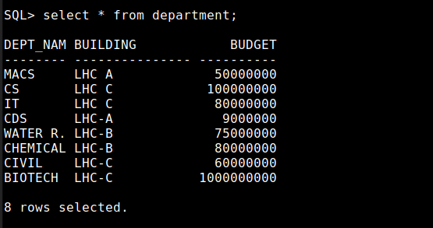

SQL> INSERT INTO course VALUES ('MA602', 'Master in Computer Application', 'MACS', 3 );

1 row created.

SQL> INSERT INTO course VALUES ('MA611', 'Master in Computer Application', 'MACS', 2 );

1 row created.

SQL> INSERT INTO course VALUES ('PR530', 'Master in Computer Application', 'MACS', 2 );

1 row created.
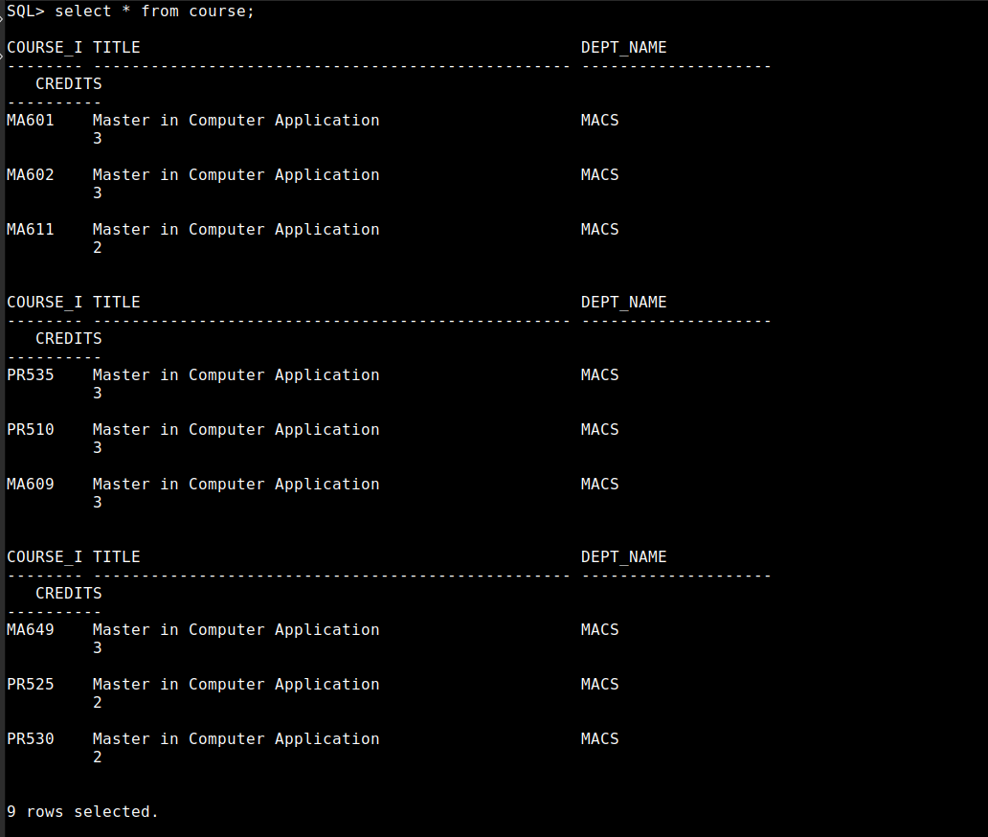

SQL> INSERT INTO instructor VALUES('P-101', 'S. KAMATH', 'MACS', 80000);

1 row created.

SQL> INSERT INTO instructor VALUES('P-501', 'Amit Kumar', 'MACS', 45000);

1 row created.

SQL> INSERT INTO instructor VALUES('P-421', 'Pushpajit Khaire', 'MACS', 55000);

1 row created.

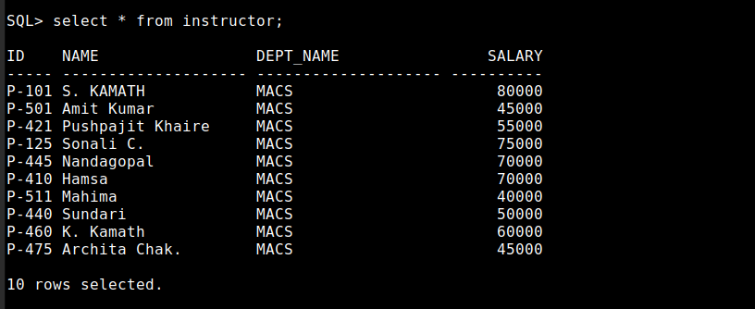

SQL> INSERT INTO section VALUES('MA602','S-151', 'Summer', 2024, 'LHC A', '2.2', '10');

1 row created.

SQL> INSERT INTO section VALUES('MA601','S-110', 'Summer', 2024, 'LHC A', '2.2', '9');

1 row created.

SQL> INSERT INTO section VALUES('MA611','S-221', 'Winter', 2025, 'LHC A', '2.2', '10');

1 row created.

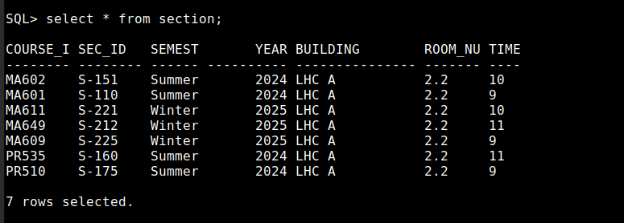

SQL> INSERT INTO teaches VALUES('P-101','MA602','S-151', 'Summer', 2024 );

1 row created.

SQL> INSERT INTO teaches VALUES('P-421','MA611','S-221', 'Winter', 2025 );

1 row created.

SQL> INSERT INTO teaches VALUES('P-125','MA601','S-110', 'Summer', 2024 );

1 row created.

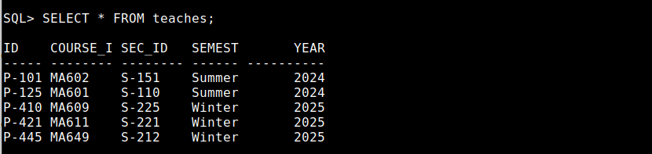

QL> IINNSERT INTO student VALUES('ca008', 'Apurv Kumar', 'MACS', 130);

1 row created.

SQL> INSERT INTO student VALUES('ca018', 'Harsh Singh', 'MACS', 135);

1 row created.

SQL> INSERT INTO student VALUES('ca022', 'Kanhaiya', 'MACS', 135);

1 row created.

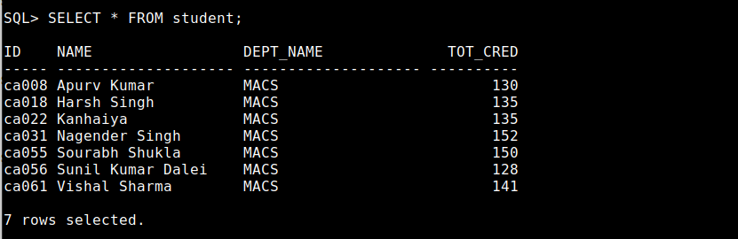

SQL> INSERT INTO takes VALUES('ca008', 'MA601','S-110','Summer', 2024, 'AB');

1 row created.

SQL> INSERT INTO takes VALUES('ca018', 'MA601','S-110','Summer', 2024, 'AB');

1 row created.

SQL> INSERT INTO takes VALUES('ca022', 'MA601','S-110','Summer', 2024, 'AB');

1 row created.
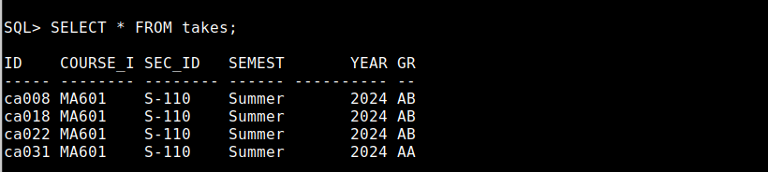

SQL> INSERT INTO advisor VALUES('ca008', 'P-101');

1 row created.

SQL> INSERT INTO advisor VALUES('ca018', 'P-421');

1 row created.

SQL> INSERT INTO advisor VALUES('ca022', 'P-445');

1 row created.

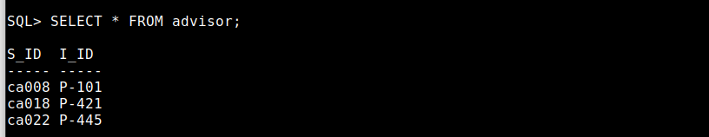

SQL> INSERT INTO time_slot VALUES('T-11', 'M', 9, 00,10,00);

1 row created.

SQL> INSERT INTO time_slot VALUES('T-12', 'M', 10, 00,11,00);

1 row created.

SQL> INSERT INTO time_slot VALUES('T-13', 'M', 11, 00,12,00);

1 row created.

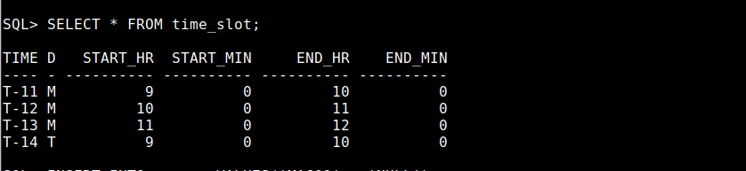

1 row created.

SQL> INSERT INTO prereq VALUES('MA602' , 'PR510');

1 row created.

