Name – Harsh Singh
Roll No. - 244CA018

1. List all students with a total credit count of 100.

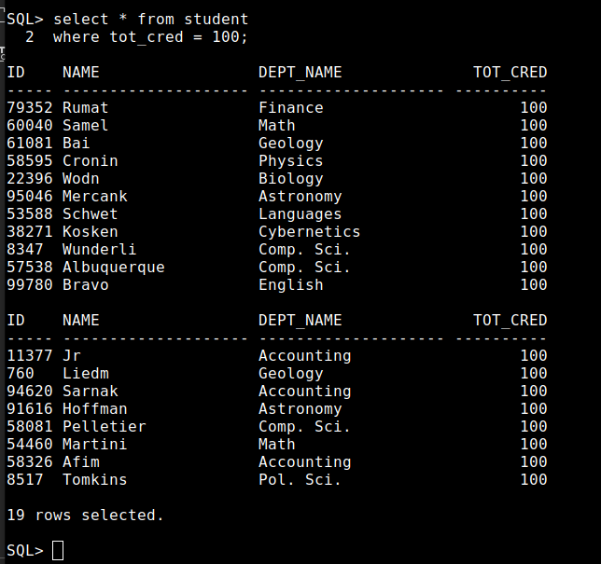

2. Find the names of all courses offered by the "Physics" department.

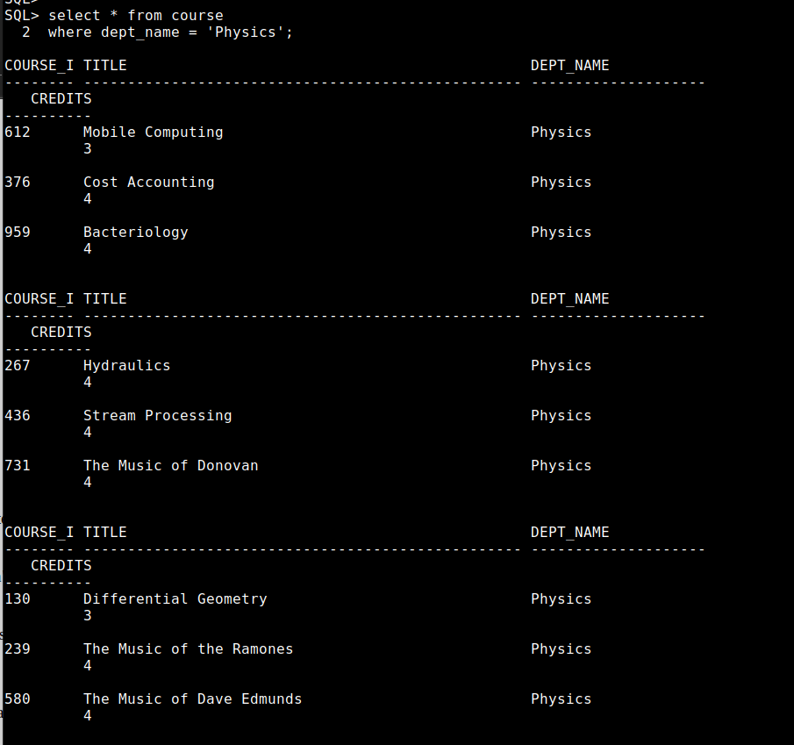

3. Retrieve the names of all instructors who earn exactly ₹50,000.

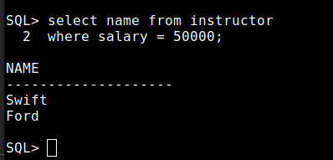

4. List all classrooms with a capacity of exactly 100.
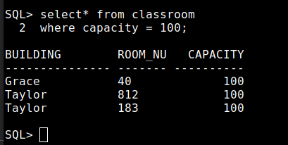

5. Find the total number of courses offered in the "Fall" semester.

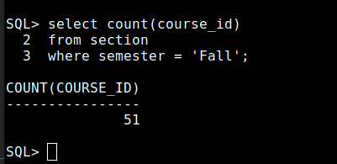

6. List all students who have taken exactly 30 total credits.

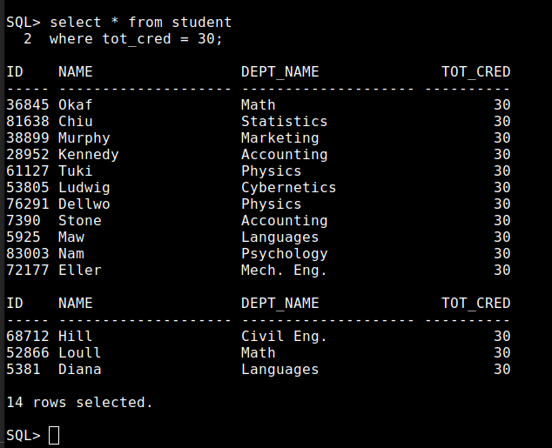

7. Find the names of all courses offered by the "Chemistry" department.
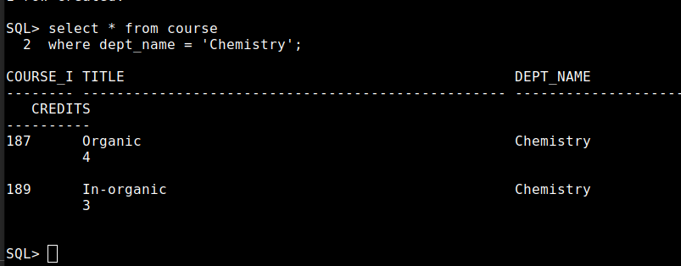

8. Retrieve the names of all instructors who earn more than ₹100,000.

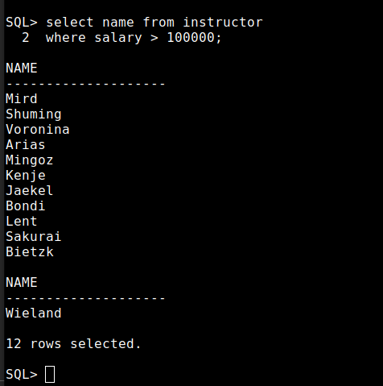

9. List all classrooms located in the "Taylor" building.

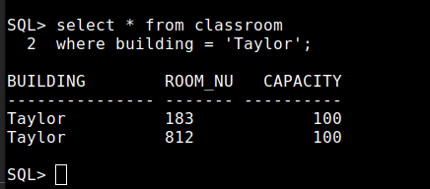

10. Find the total number of courses offered in the "Winter" (“Spring”) semester.

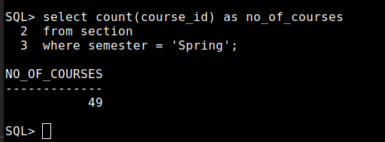

11. List all students who have taken courses with a grade of "C" or lower.

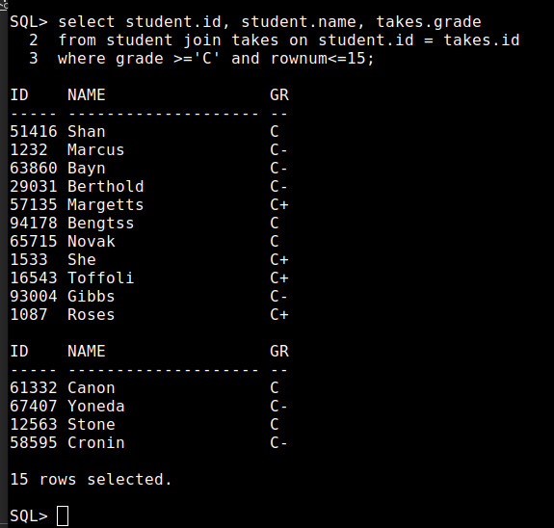

12. Retrieve the names of instructors who have taught in the "Fall" semester of 2002.

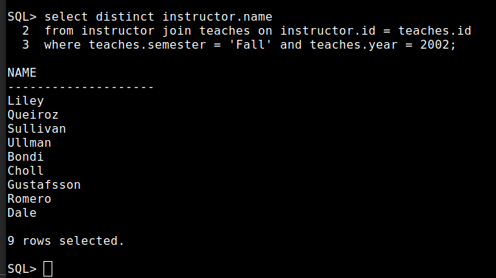

13. Find the average capacity of classrooms in each building.

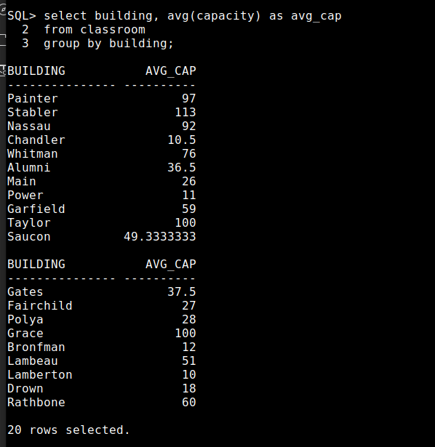
14. List all courses that have more than 3 credits.

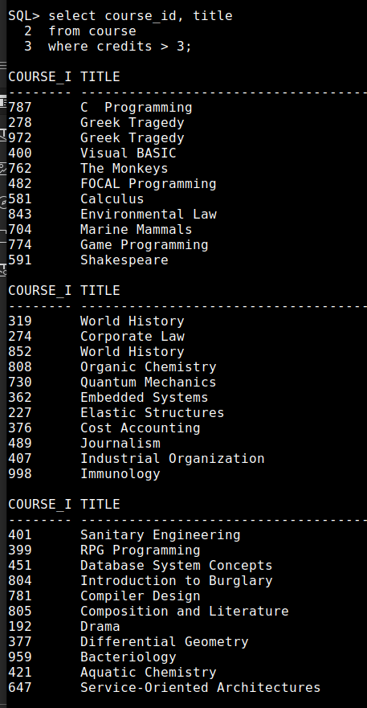

15. Retrieve the names of students who have taken courses in the "Watson" building.

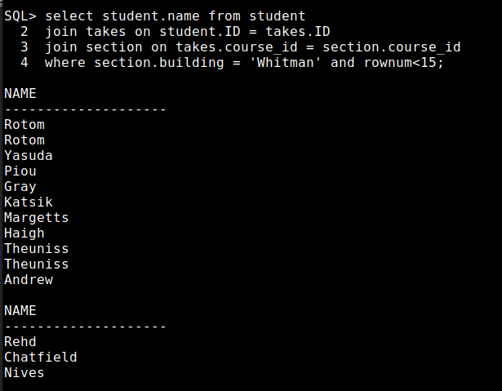

16. Find the total number of students advised by each instructor.

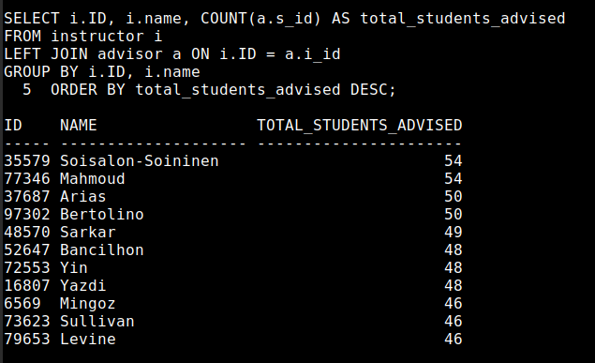

17. List all sections that do not have a classroom assigned.
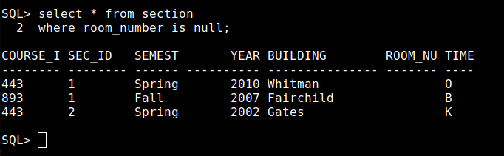

18. Retrieve the names of students who have taken courses with the highest number of
credits.

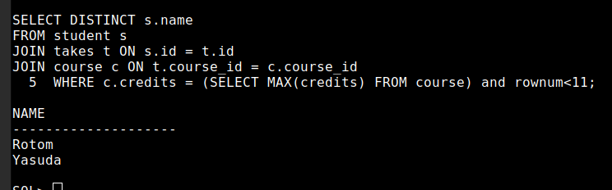

19. Find the departments with the highest average instructor salary.
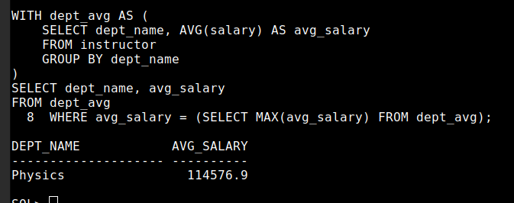

20. List all courses that have been taught by more than one instructor.

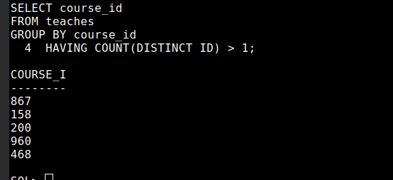

21. List all students who have taken courses with a grade of "A" in the "Fall" semester of
2022 (taken 2006).

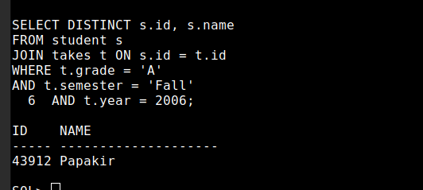

22. Retrieve the names of instructors who have taught in the "Spring" semester of 2023.

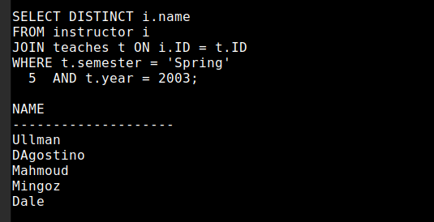

23. Find the average number of students enrolled in each course.

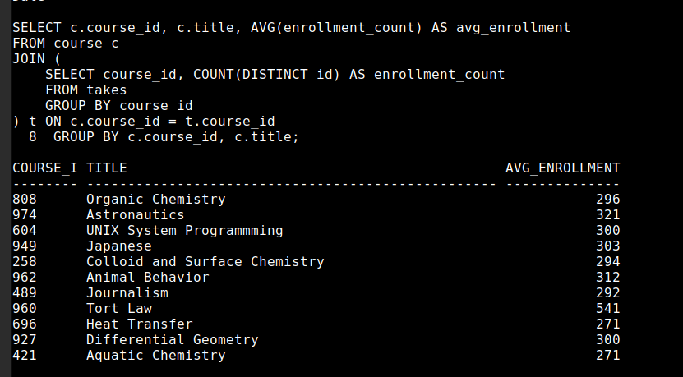

24. List all courses that have exactly 4 credits.

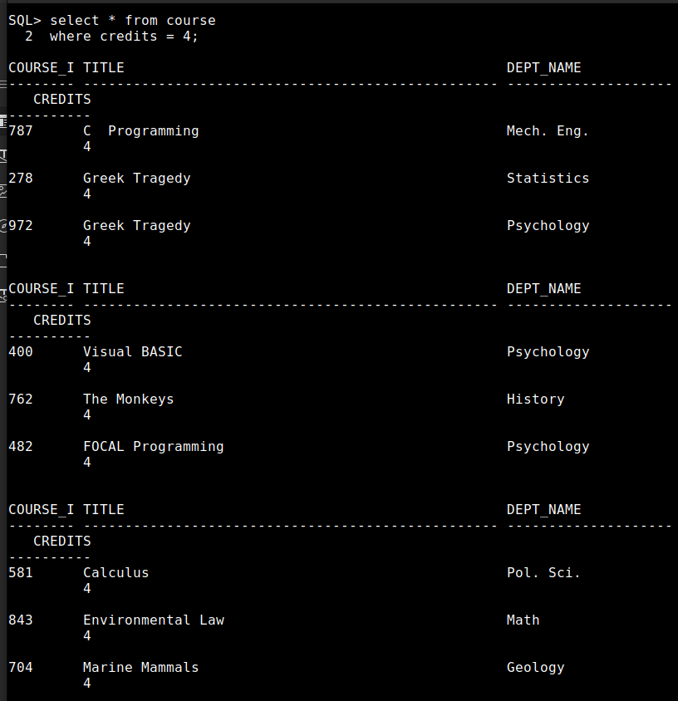
25. Retrieve the names of students who have taken courses in the "Packard" building (taken one more building as Grace).

