Name :- Harsh Singh
Roll no. :- 244ca018

1. List all students who have taken exactly 60 total credits.

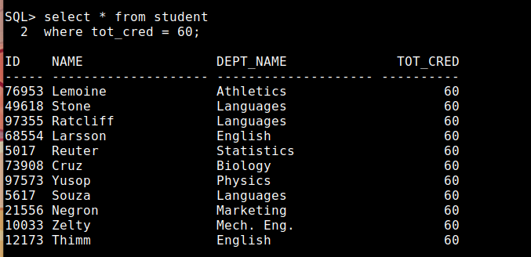

2. Find the names of all courses offered by the "Electrical Engineering" department.

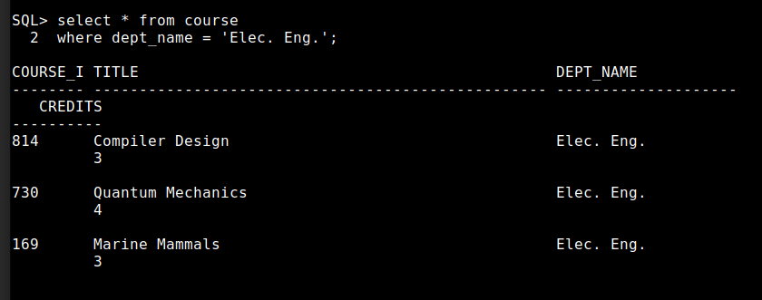

3. Retrieve the names of all instructors who earn less than ₹40,000.

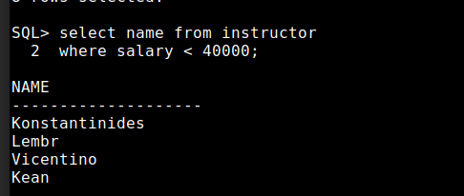

4. List all classrooms located in the "Main" building.

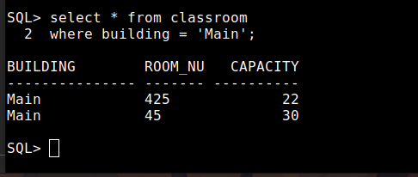

5. Find the total number of courses offered in the "Fall" semester.

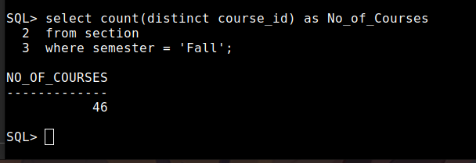

6. List all students who have taken exactly 90 total credits.

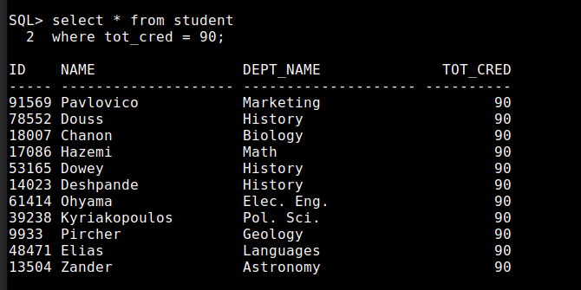
7. Find the names of all courses offered by the "Mechanical Engineering" departmen

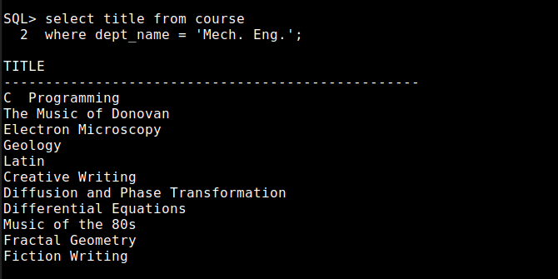

8. Retrieve the names of all instructors who earn exactly ₹75,000.

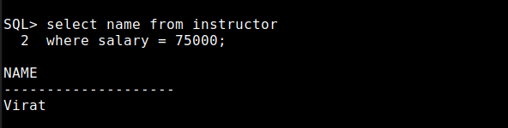

9. List all classrooms located in the "Lambert"(“Lamberton”) building.

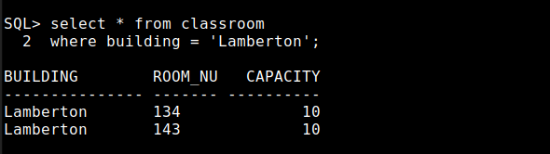

10. Find the total number of courses offered in the "Spring" semeste

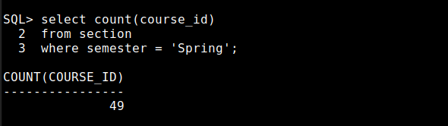

11. List all students who have taken courses with a grade of "B" (B+)in the "Spring" semester of
2023.(2003)

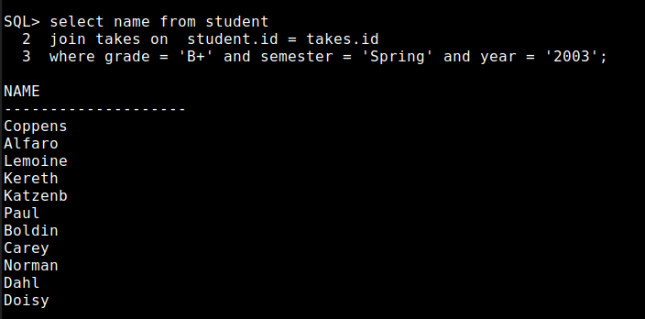

12. Retrieve the names of instructors who have taught in the "Summer" semester of 2022.

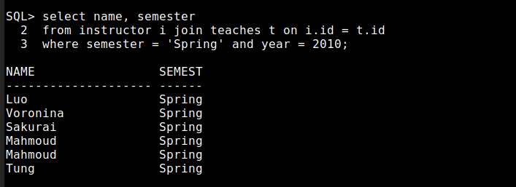

13. Find the average number of credits offered by each department.

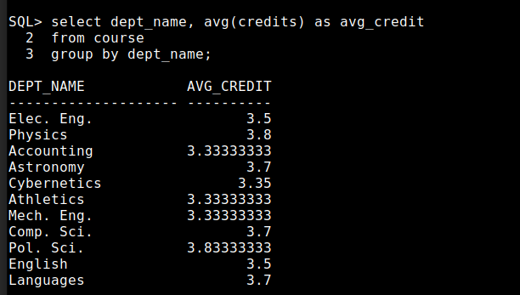

14. List all courses that have exactly 1 credit.

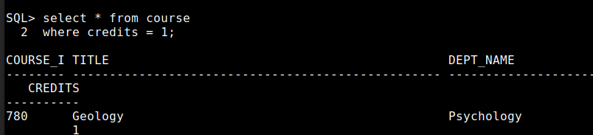

15. Retrieve the names of students who have taken courses in the "Painter" building.

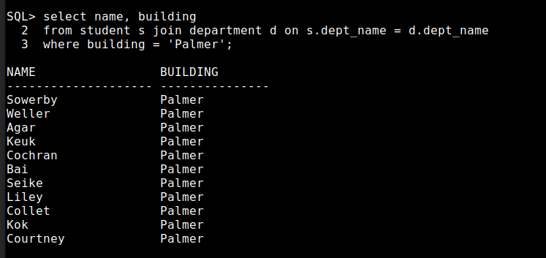

16. Find the total number of students enrolled in each course.

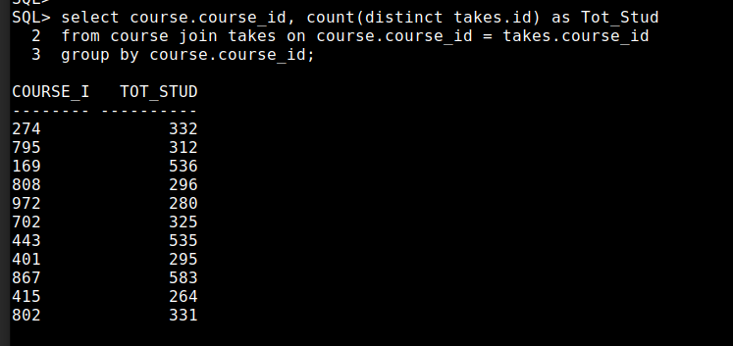

17. List all sections that are held in rooms with a capacity of more than 100.

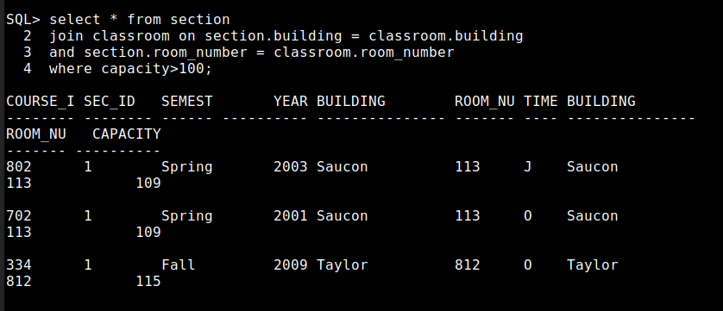

18. Retrieve the names of students who have taken courses with the highest number of
credits in their department.
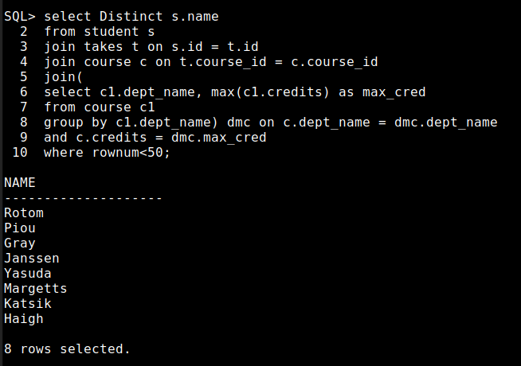

19. Find the departments with the highest total budget.

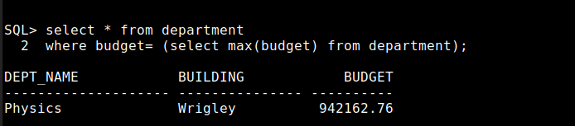

20. List all courses that have been taught by more than 2(more than 1) instructors

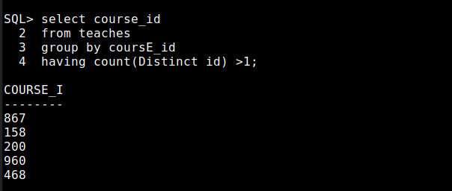

21. List all students who have taken courses with a grade of "C" in the "Winter" semester of
2023.
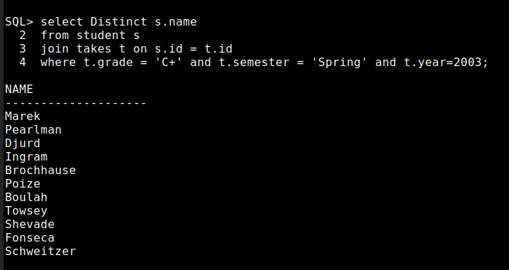

22. Retrieve the names of instructors who have taught in the "Fall" semester of 2021.

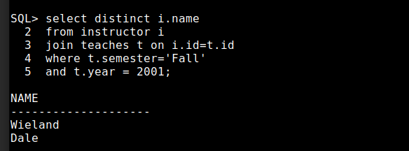

23. Find the average number of sections taught per course.

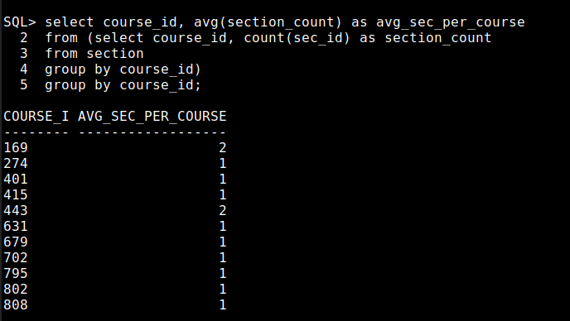
24. List all courses that have exactly 2 credits.

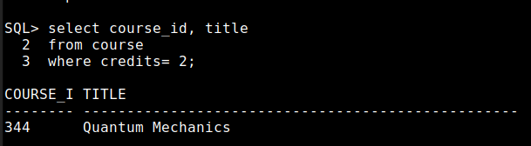

25. Retrieve the names of students who have taken courses in the "Taylor" building.

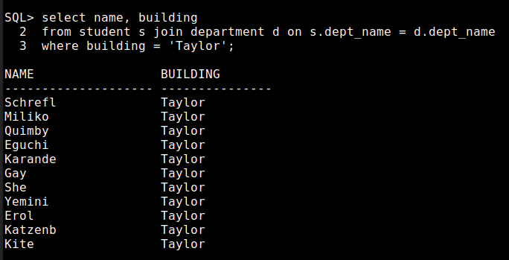

26. Find the total number of courses taught by each instructor.

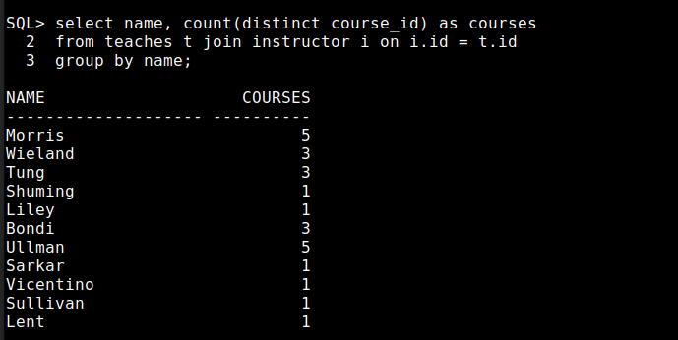
27. List all sections that are held in rooms with a capacity of exactly 75.

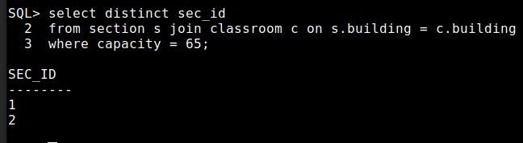

28. Retrieve the names of students who have taken courses with the lowest number of
credits in their department.
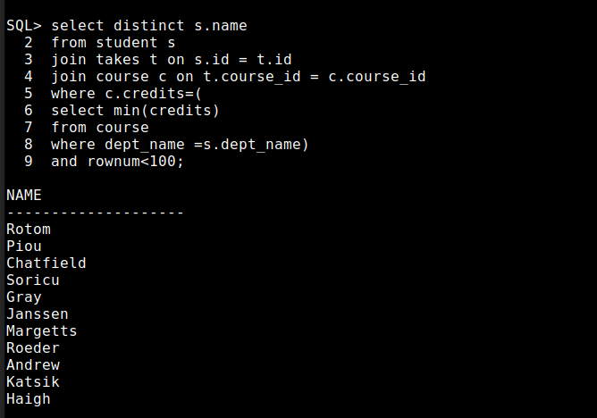

29. Find the departments with the lowest total budget.

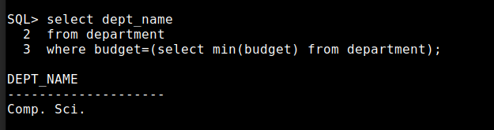

30. List all courses that have been taught by exactly 3 instructors.

