Assignment 5-------
Name – Harsh Singh
Roll No. - 244CA018

1. Create the following tables with the following attributes and constraints on them.

Create all the tables by defining primary key, foreign key and other appropriate constraints.

a. Bank (bk_code, bk_name, bk_address)

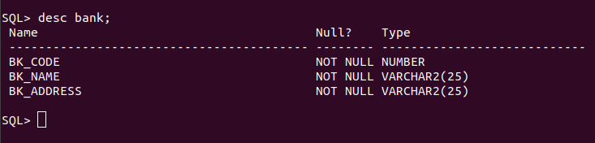
b. Branch (br_id, br_name, br_address, bk_code)

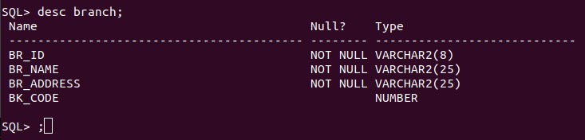
c. Customer (cust_ID, cust_name, phone_no, address)

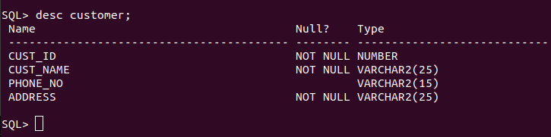
d. Account (acc_no, acc_type, balance, br_id)

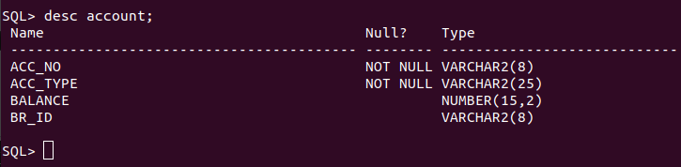

e. Customer_Account (cust_ID, acc_no)

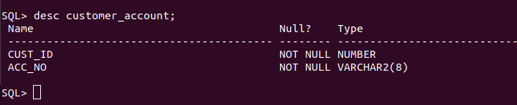

f. Loan (loan_ID, loan_type, amount, br_id)

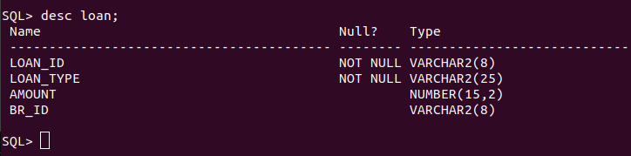

g. Customer_Loan (cust_ID, loan_ID)

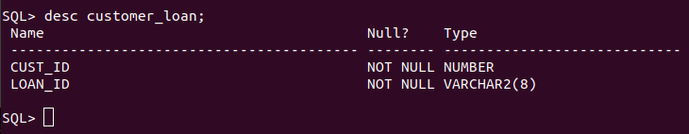

2. Insert atleast five records in each table.

a. Bank

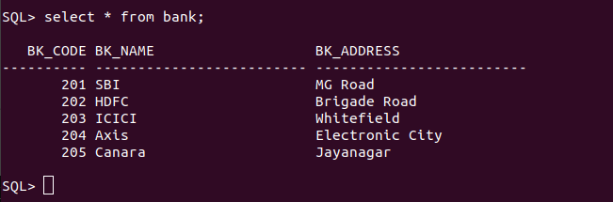

b. Branch

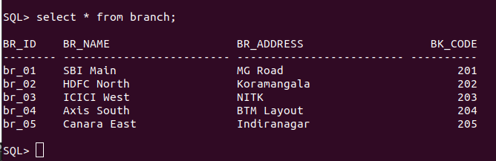
c. Customer

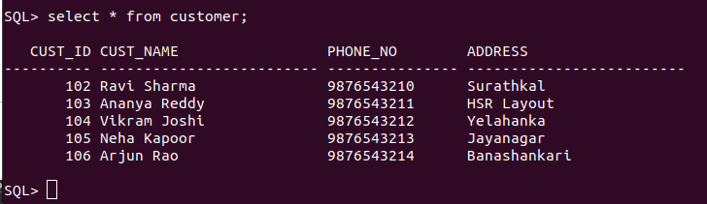
d. Account

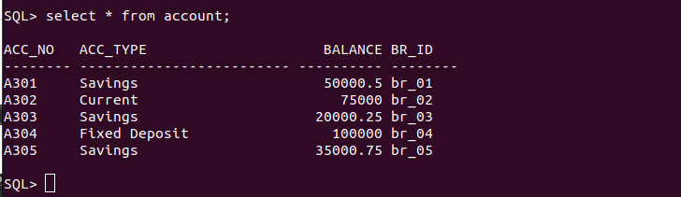
e. Customer_Account

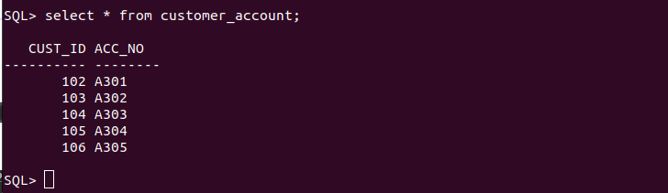
f. Loan

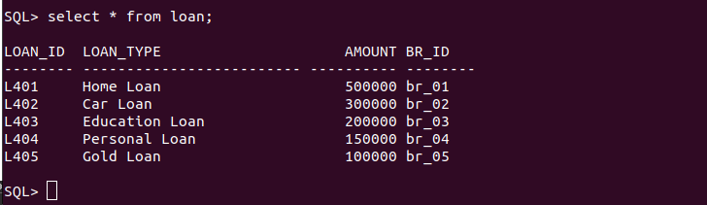

g. Customer_Loan

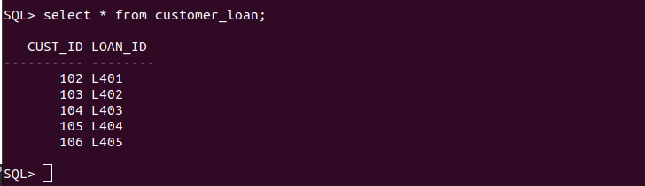

3. List the details of all customers.

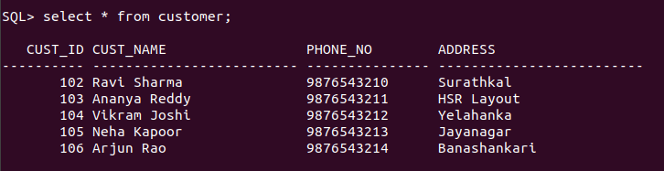
4. Find the cust_ID and phone number of customer ‘Ravi’.



5. Find the Address of all branches of br_01.

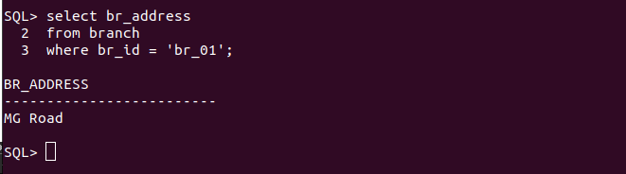

6. Find the details of Customer having ID 103.

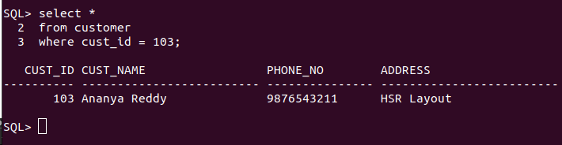

7. List the account details having balance more than 10000.

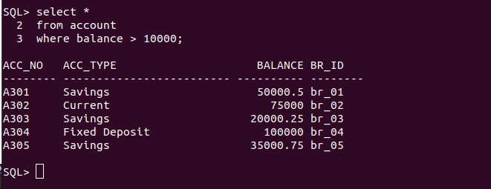

8. List the account details of branch br_02.

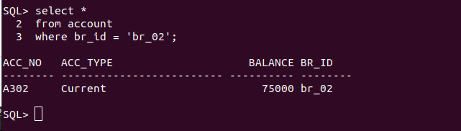

9. List the loan details of branch br_01.

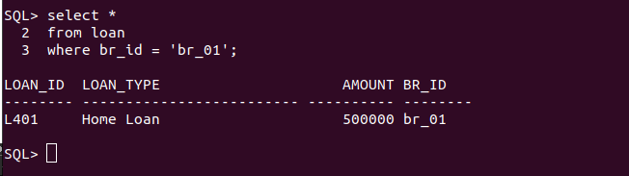

10. List the account details with their branch address.

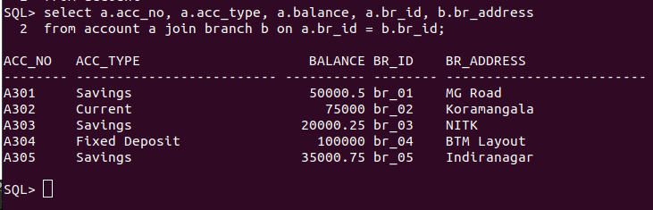

11. List the customer details with their account details.

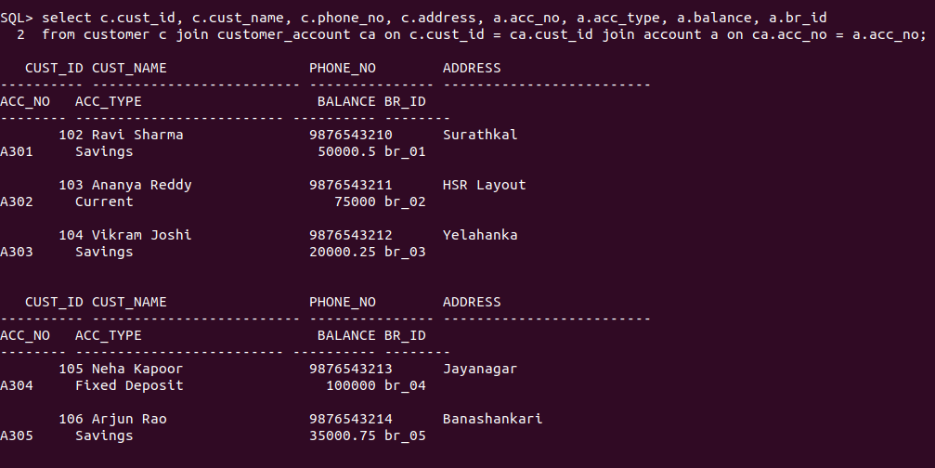

12. List the customer details having account type ‘savings’.

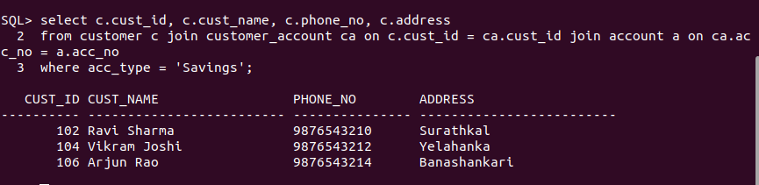

13. List the customer details having vehicle loan.

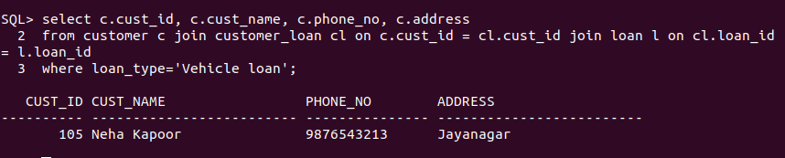

14. List the branch names of all accounts.

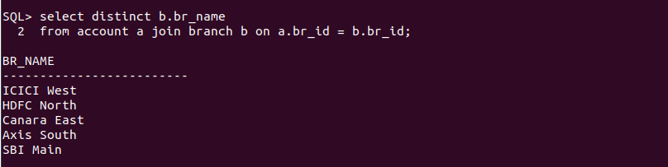

15. List the customer details going to ‘Surathkal’ branch.

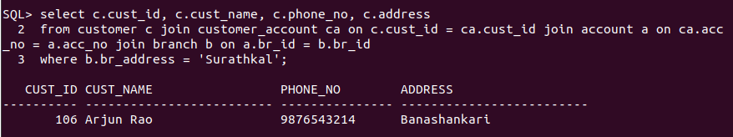

16. List the customers having loan account in ‘MG Road’ branch.

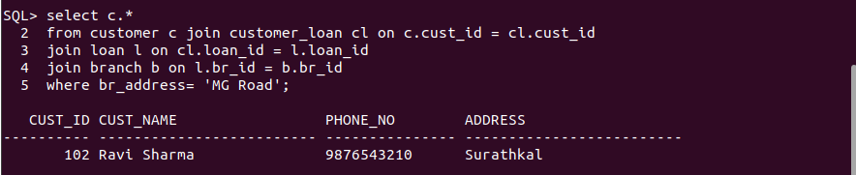

17. Find the customers having balance between 1000 to 10000 .

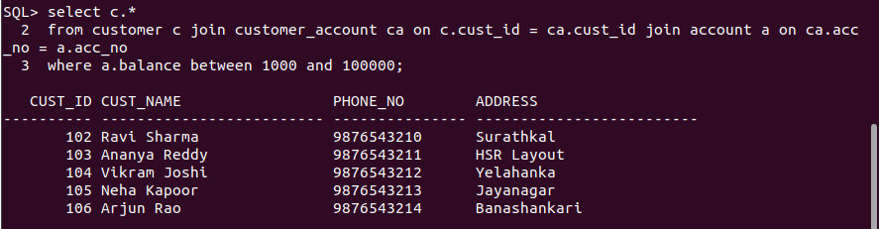

18. Give a bonus of rupees 100 to customers having more than 10000 balance.



19. Deduct 50 rupees from customers having less than 500 rupees in balance.



20. Give the customer details having home loan.

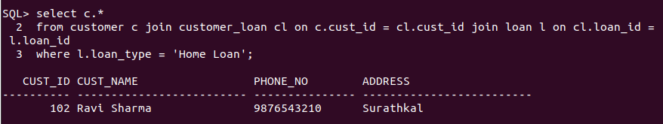

21. Give the customer details having home loan in ‘NITK’ branch.

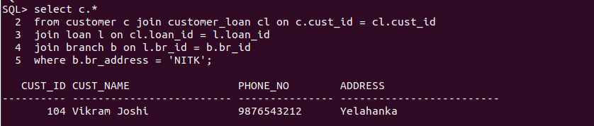

22. Add a column NOMINEE to the customer table with data type varchar (50).



23. List all the account numbers in ascending order of their balance.

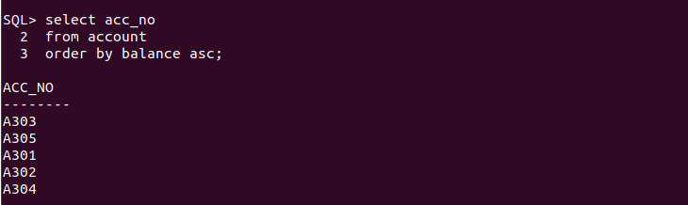

24. Count the number of customers having account type savings.

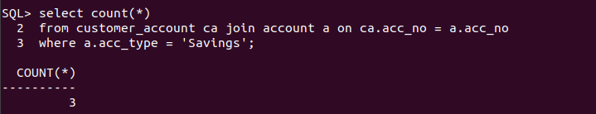

25. Count the number of customers for each account type.

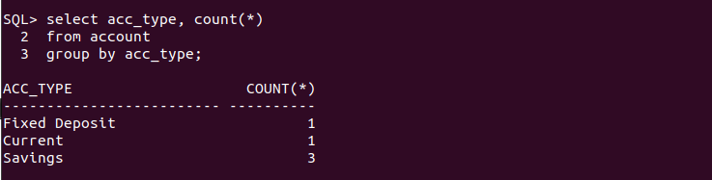

26. Find the total balance in Savings account.

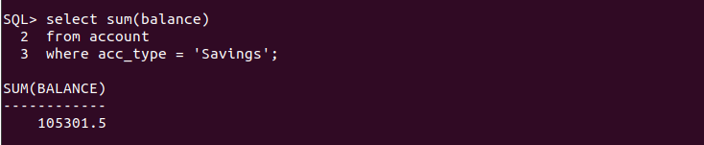

27. Find the average balance of Current account.

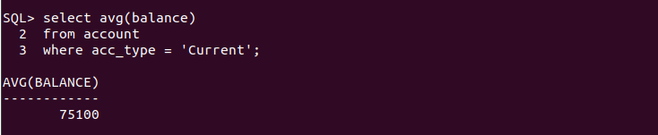

28. Find the average balance for each account type.

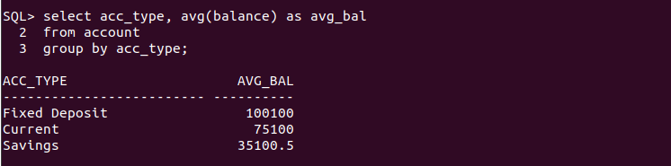

29. Find the customer details having maximum balance.

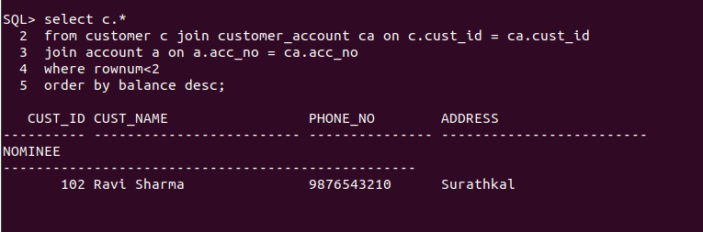

30. Find the average amount for vehicle loan.

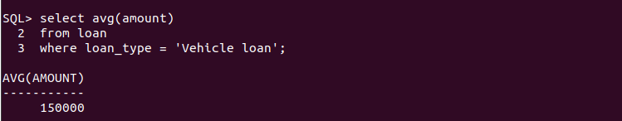

31. Find the average balance in each branch.

