OPERATING SYSTEM
Lab – 3 Bash Scripting

Name = Harsh Singh
Roll No. = 244CA018

Q1 Write a C/ Python program to implement a FCFS CPU scheduling algorithm. The program should produce the ouptut sequence of the processes and waiting time for each of
the process.

Also implement the average waiting time for the process sequences and display the output.

For Example: Take the input sequence for the following processes:
i) Process Burst Time
P1 24
P2 3
P3 3

ii) Process Burst Time
P1 6
P2 8
P3 7
P4 3

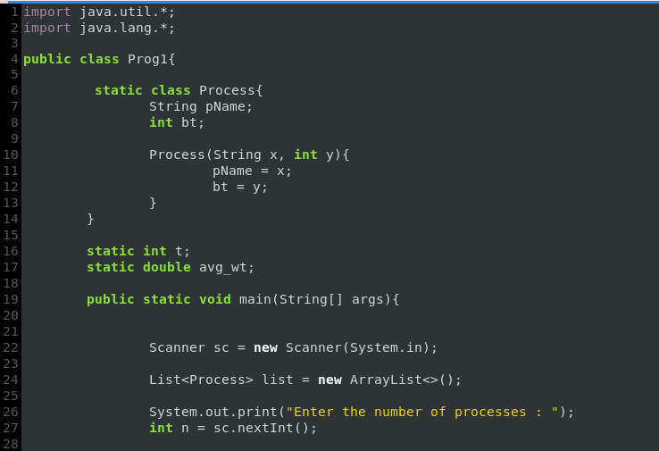

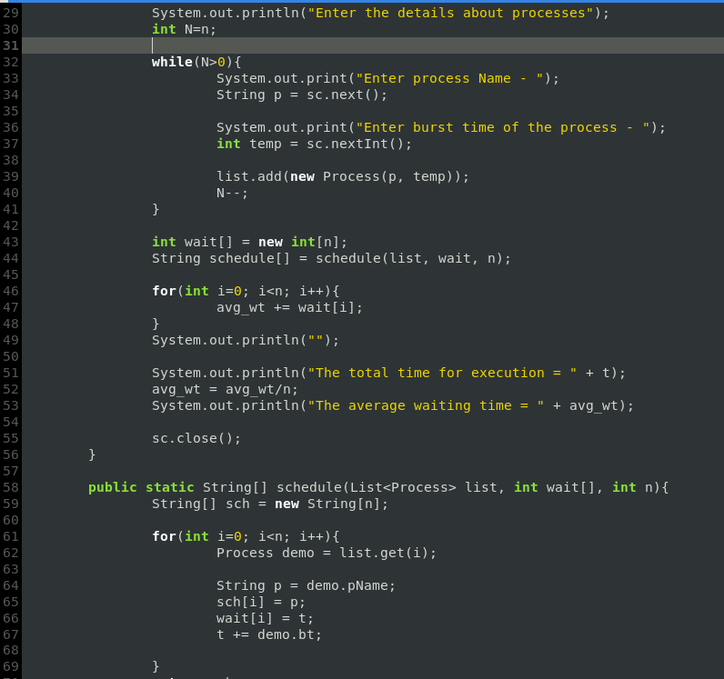
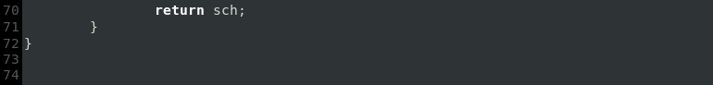

Output :

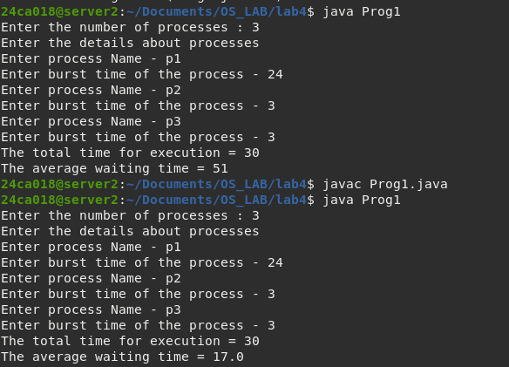

Q2. Using the exponential averaging method which is given below for estimation of the next CPU bursts time of the process.

1. tn = actual length of nth CPU burst
2. τ(n+1)= predicted value for the next CPU burst.
3. α, 0<= α <=1
4. Define :

τ(n+1) = α*tn + (1 – α)*τn

Write a C/python program to estimate the next CPU bursts time for the process. Assume the value of α is 1/2 and the initial value of τ0= 10.
The actual value of t1, t2, t3, t4, t5, t6 is 6 4 6 4 13 13.

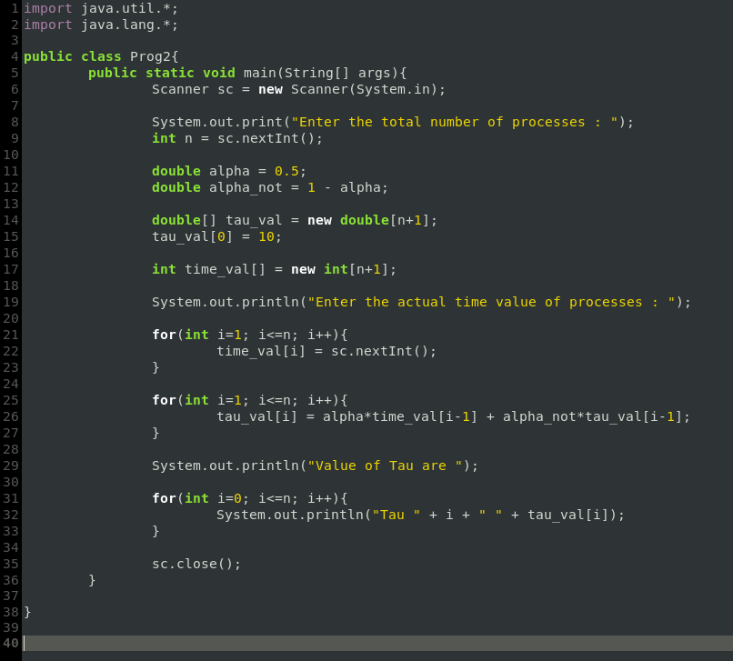

Output :

