OPERATING SYSTEM
Lab – 3 Bash Scripting

Name = Harsh Singh
Roll No. = 244CA018

Experiment 1: Hello World Script
Aim: To create and execute a basic Bash script that displays 'Hello, World!'.

Input -

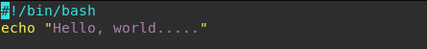

Output -

Experiment 2: Basic Calculator
Aim: To perform addition, subtraction, multiplication, and division of two numbers using a Bash
script.

Input -
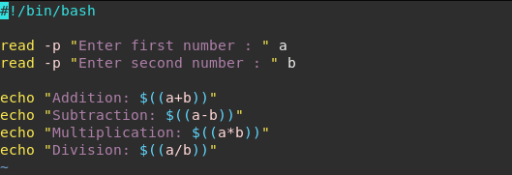

Output -

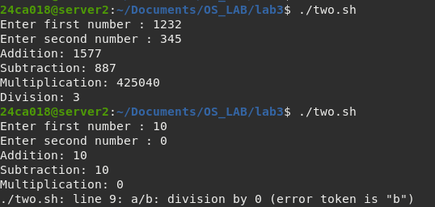

Experiment 3: Odd or Even Checker
Aim: To check whether a given number is odd or even.

Input -
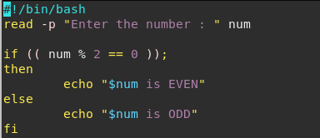

Output -

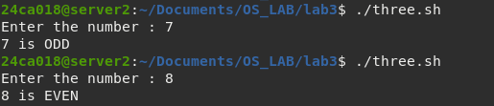

Experiment 4: File Existence Checker
Aim: To check if a file exists in the current directory.

Input -

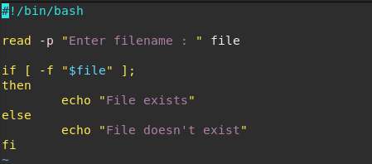

Output -
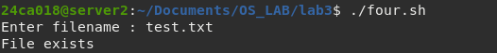

Experiment 5: Current Date and Time
Aim: To display the current system date and time.

Input -
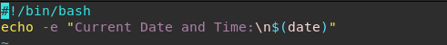

Output -

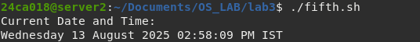

Experiment 6: Directory Size Monitor
Aim: To display the size of a given directory using du command.

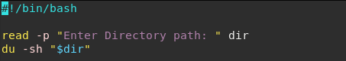
Input -

Output -
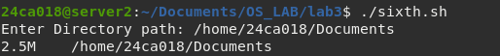

Experiment 7: Backup Script
Aim: To copy all .txt files from one folder to another with a timestamp.

Input -
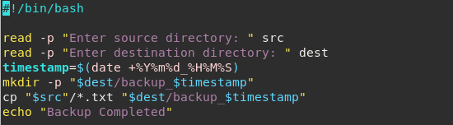
Output -

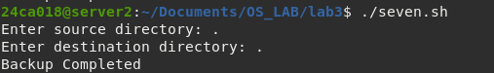

Experiment 8: Simple Login Simulation
Aim: To simulate login by verifying username and password.

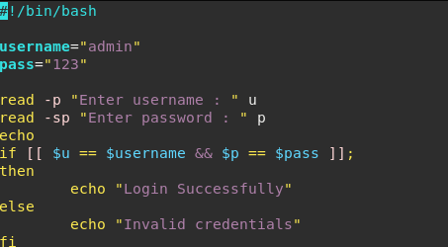
Input -

Output -
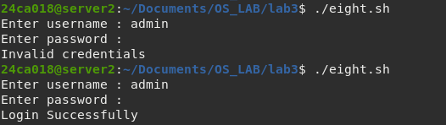

Experiment 9: Countdown Timer
Aim: To accept seconds from user and perform a countdown.

Input -
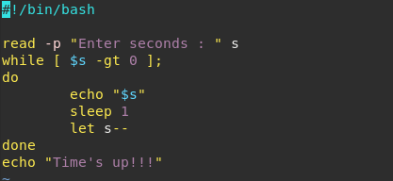

Output -
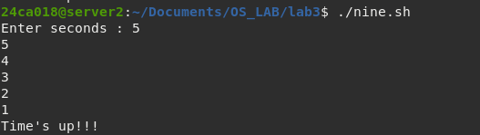

Experiment 10: Batch File Renamer
Aim: To rename all .jpg files in a folder by adding a prefix.

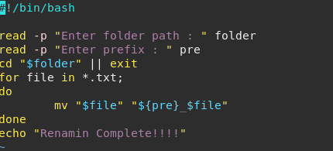
Input -

Output -

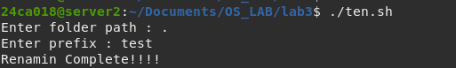

Experiment 11: Word Count Tool
Aim: To count the number of words, lines, and characters in a given file.

Input -
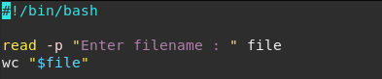

Output -

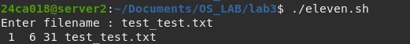

Experiment 12: Search and Replace in Files
Aim: To find and replace text in all .txt files using sed.

Input -
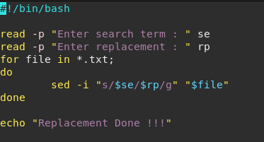

Output -

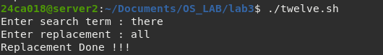

Experiment 13: Log File Filter
Aim: To extract lines containing a keyword from a log file.

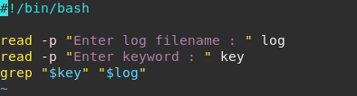
Input -

Output -

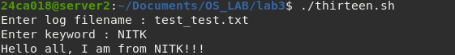

Experiment 14: Remove Duplicate Lines
Aim: To sort a file and remove duplicate lines.

Input -
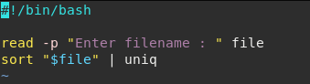

Output -

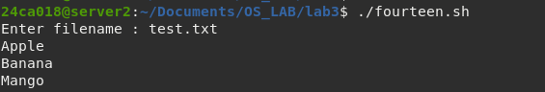

Experiment 15: Merge Multiple Files
Aim: To combine multiple text files into one.

Input -
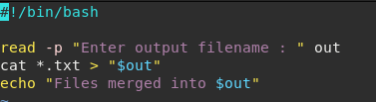

Output -

