Opearting System

Lab 2 (Shell Scripting)

Name = Harsh Singh
Roll No. = 244CA018

1. Write a bash script that takes a user's name as input and uses the echo command to greet the user with "Hello, [name]!".
Script -
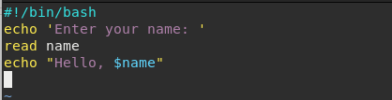

Output -
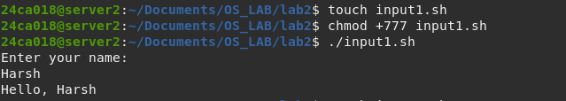
2. Write a Bash script that uses the ls command to list all files and directories in the current directory.
Script -
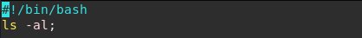

Output -
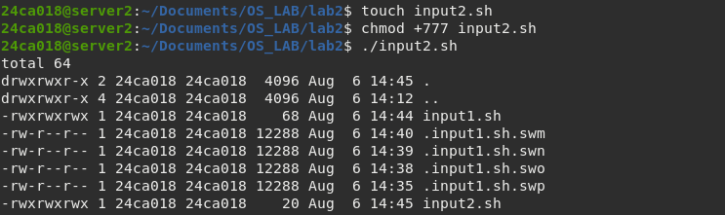
3. Write a Bash script that prompts the user to input a password, and then checks if the password matches a predefined value. If it does, print "Access granted", otherwise print "Access denied".
Script -
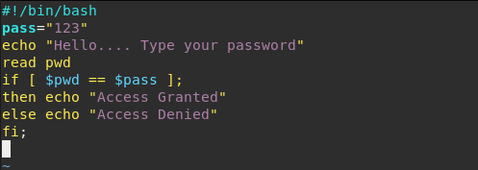

Output -
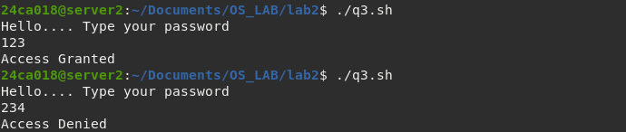

4. Write a Bash script that uses the cat command to concatenate the contents of two text files ("file1.txt" and "file2.txt") and display the result.
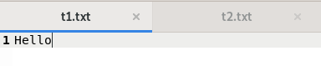
t1.txt -

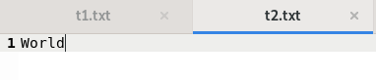
t2.txt -

Script -
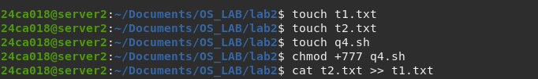

Output -
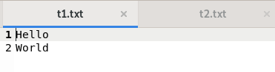

5. Write a Bash script that checks if a given number is even or odd and prints a message accordingly.
`Script -
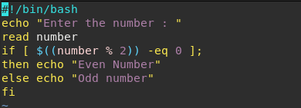

Output -
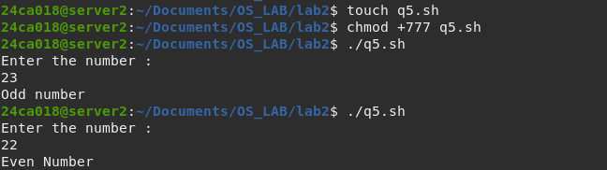

6. Write a Bash script that prompts the user to enter a number and checks if it is positive, negative, or zero, and prints a message accordingly.
Script -
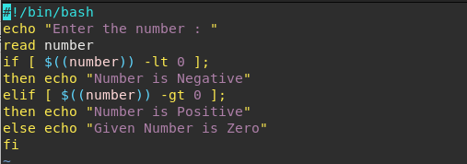

Output -
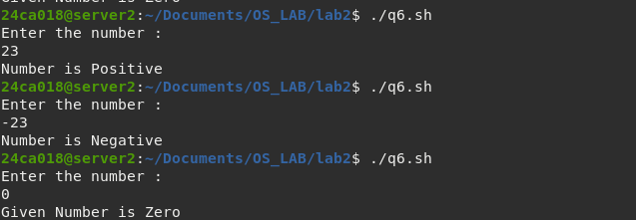
7. Write the bash script to find the factorial of a given number by the user.
Script -
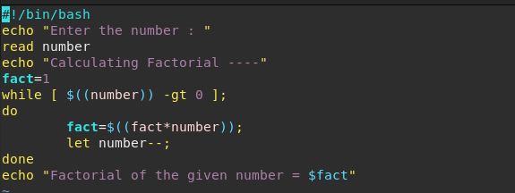
Output -
