Operating System Lab -1

Name = Harsh Singh
Roll No. = 244CA018

1. pwd
24ca018@server2:~$ pwd
/home/24ca018
2. cd
24ca018@server2:~/Desktop$ cd
24ca018@server2:~$
3. cd directory
24ca018@server2:~$ cd Desktop
24ca018@server2:~/Desktop$
4. cd ~
24ca018@server2:~$ cd Documents/Folder1
24ca018@server2:~/Documents/Folder1$ cd ~
24ca018@server2:~$
5. cd ..
24ca018@server2:~/Documents/Folder1$ cd ..
24ca018@server2:~/Documents$
6. cd -
24ca018@server2:~/Documents/Folder1$ cd -
/home/24ca018
24ca018@server2:~$
7. ls
24ca018@server2:~$ ls
a.out clab8 Factorial.c Lab2Prog3.c Prog1 Prog4
circll.cpp cpp Fibonacci Lab2Prog4.c Prog1.c Prog4.c
clab dbl.cpp Fibonacci.c lab3 Prog2 Public
clab5 Desktop 'Fibonacci.C\' mishra Prog2.c Templates
clab6 Documents Lab2Prog1.c Music Prog3 thinclient_drives
clab7 Downloads Lab2Prog2.c Pictures Prog3.c Videos
24ca018@server2:~$
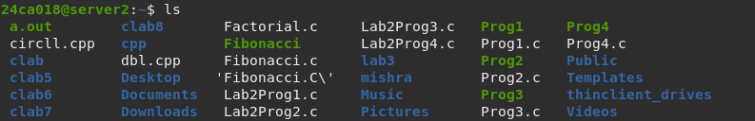
8. ls directory
24ca018@server2:~$ ls Documents
CandDoubly.odt filedata.txt Folder1
24ca018@server2:~$

9. ls -l
24ca018@server2:~$ ls -l
total 216
-rwxrwxr-x 1 24ca018 24ca018 17560 Sep 12 2024 a.out
-rw-rw-r-- 1 24ca018 24ca018 1482 Sep 12 2024 circll.cpp
drwxrwxr-x 3 24ca018 24ca018 4096 Sep 10 2024 clab
drwxrwxr-x 2 24ca018 24ca018 4096 Oct 1 2024 clab5
drwxrwxr-x 2 24ca018 24ca018 4096 Oct 15 2024 clab6
drwxrwxr-x 2 24ca018 24ca018 4096 Oct 29 2024 clab7
drwxrwxr-x 2 24ca018 24ca018 4096 Nov 5 2024 clab8
drwxrwxr-x 12 24ca018 24ca018 4096 Apr 4 14:28 cpp
-rw-rw-r-- 1 24ca018 24ca018 1783 Sep 12 2024 dbl.cpp
drwxr-xr-x 3 24ca018 24ca018 4096 Jul 30 14:31 Desktop
drwxr-xr-x 3 24ca018 24ca018 4096 Jul 30 14:52 Documents
drwxr-xr-x 2 24ca018 24ca018 4096 Jul 30 14:20 Downloads
-rw-rw-r-- 1 24ca018 24ca018 169 Sep 3 2024 Factorial.c
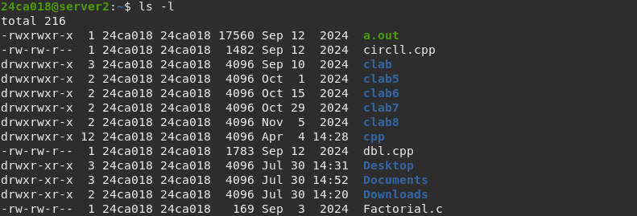

10. ls -a
24ca018@server2:~$ ls -a
. Fibonacci .pcsc17 .Xauthority
.. Fibonacci.c .pcsc20 .xorgxrdp.10.log
a.out 'Fibonacci.C\' .pcsc21 .xorgxrdp.10.log.old
.bash_history .gnupg Pictures .xorgxrdp.11.log
.bash_logout Lab2Prog1.c .profile .xorgxrdp.11.log.old
.bashrc Lab2Prog2.c Prog1 .xorgxrdp.12.log
.cache Lab2Prog3.c Prog1.c .xorgxrdp.12.log.old
circll.cpp Lab2Prog4.c Prog2 .xorgxrdp.13.log
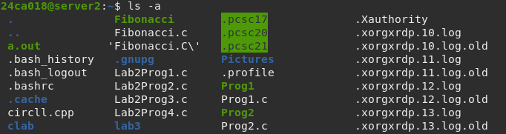

11. ls -ld directory
24ca018@server2:~$ ls -ld Documents
drwxr-xr-x 3 24ca018 24ca018 4096 Jul 30 14:52 Documents
12. ls usr/bin/
24ca018@server2:~$ ls F*
Factorial.c Fibonacci Fibonacci.c 'Fibonacci.C\'
24ca018@server2:~$
