**­**

|  |  |
| --- | --- |
| **Total Marks:** | **04** |
| **Obtained Marks:** |  |

**DATABASE SYSTEMS**

**Project Report**

**Last date of Submission: 10 Oct, 2019**

**Submitted To: Aunsia Khan**

**___________________________________________________________________________________________________________________________________________________________________________________________________________________________________________________**

**Student Name: Israr minhas, Israr ul Haq**

**___________________________________________________________________________________________________________________________________________________________________________________________________________________________________________________**

**Reg Number: 1712236, 1712202**

**___________________________________________________________________________________________________________________________________________________________________________________________________________________________________________________**

**Flight booking system**

**Contents**

1. **Introduction**
2. **Distribution of work**
3. **Description**
4. **ER diagram**
5. **Screen shorts**

**Introduction:**

As every organization wants online digital system in this advanced world. In which they can easily access, manage and update the data. And also every person wants comfort and easiness in doing each and every work. For example, while a person wants to book a ticket for flight from an organization (Booking office), first he must have a time to go in a ticket booking office for booking ticket and there may be lot of people waiting in a queue for ticket so it take lot of time to confirm a ticket.

**Distribution of work:**

Israr ul haq:

Front End using

* Html
* CSS
* PHP

Israr minhas:

Back end (Data Base) about us and contact us page using

* MY SQL
* HTML
* CSS

**DESCRIPTION:**

So we will create a software which can be used for ticket reservation management.

 allow tour and activity operators to accept bookings online and better manage their phone and in person bookings. In which, each passenger has its own CNIC, name, email, passport Id, gender and phone number. Passenger has flight details and books ticket from booking office. Ticket is confirmed from booking office. Where ticket gives description of ticket Id, ticket amount, seat no and passenger type. Booking office has office id name, address, email and phone no. Booking office has flight reservation. Each flight has flight code, arrival time, departure time, airplane, class and airline. Flight flies from airport. Airport has details of no of planes, address, name, airport code.

### **Benefits**

**Increase your bookings**

One of the biggest advantages of the online ticket booking platforms is that this is always open for business. You can accept bookings 24/7 so your customers don’t have to wait until the next day to make a reservation or turn to one of your competitors. They have the convenience to book when it’s right for them, and you collect bookings while you sleep.

**Save time**

Booking systems help you do more, with less. Once you have your business set up on the platform, you won’t have to call your guests for reminders, send follow up emails, or manually update your inventory. This all runs in the background so you, and your staff, can focus on serving your guests.

**Smarter insights into your business**

A booking system keeps track of each reservation and the details tied to it. This means that you can use reports to find what tours are making you the most money, get a better understanding of who your typical customer is, and have real-time insights into your cash flow. You have all the tools and information you need to grow your business.

**Relationship between entities:**

**Passenger-Ticket**

* Passenger may book many tickets or at least one ticket.
* Ticket is booked by at least one passenger or no passenger.

**Ticket-Booking_Office**

* Ticket is confirmed from at least or at most one booking office.
* Booking office may confirm many tickets or no tickets.

**Passenger-Flight**

* Passenger has details of many or at least one flight.
* Flight details maybe seen by at least one or no passenger.

**Booking_office-Flight**

* Booking office may have many or no flight reservation.
* Flight is at least or at most reserved from one booking office.

**Flight-Airport**

* Flight atl east or at most flies from one airport.
* Airport may have many or no flights.

|  |  |
| --- | --- |
| Entity | Attributes |
| PASSENGER | Passport, CNIC, Name, Email, Phone No, Gender |
| TICKET | Passenger type , Ticket id, Ticket amount , Seat no |
| BOOKING_OFFICE | Office id, Office name ,Office address, Office Phone noS |
| FLIGHT | Flight code, Arrival time, Departure time, Airplane , Class, Airline |
| AIRPORT | No of planes, name, airport code, address |

**ER Diagram:**

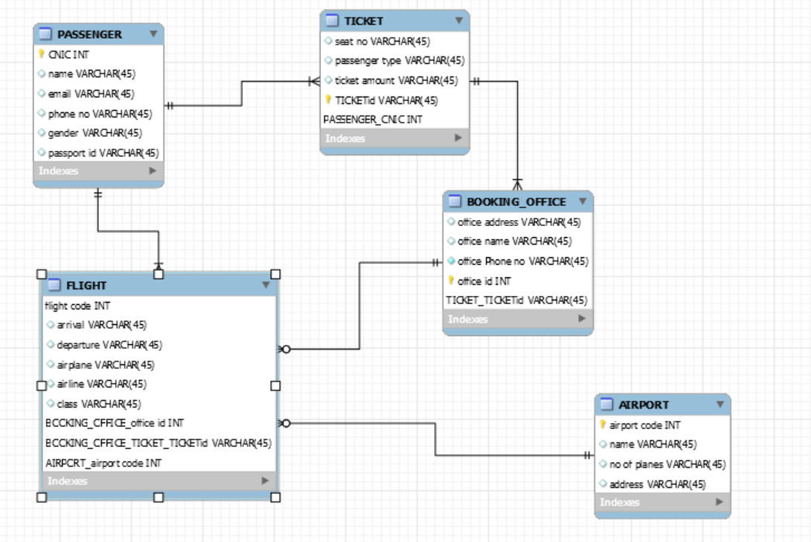

**Screen Shorts:**

SUBLIME:

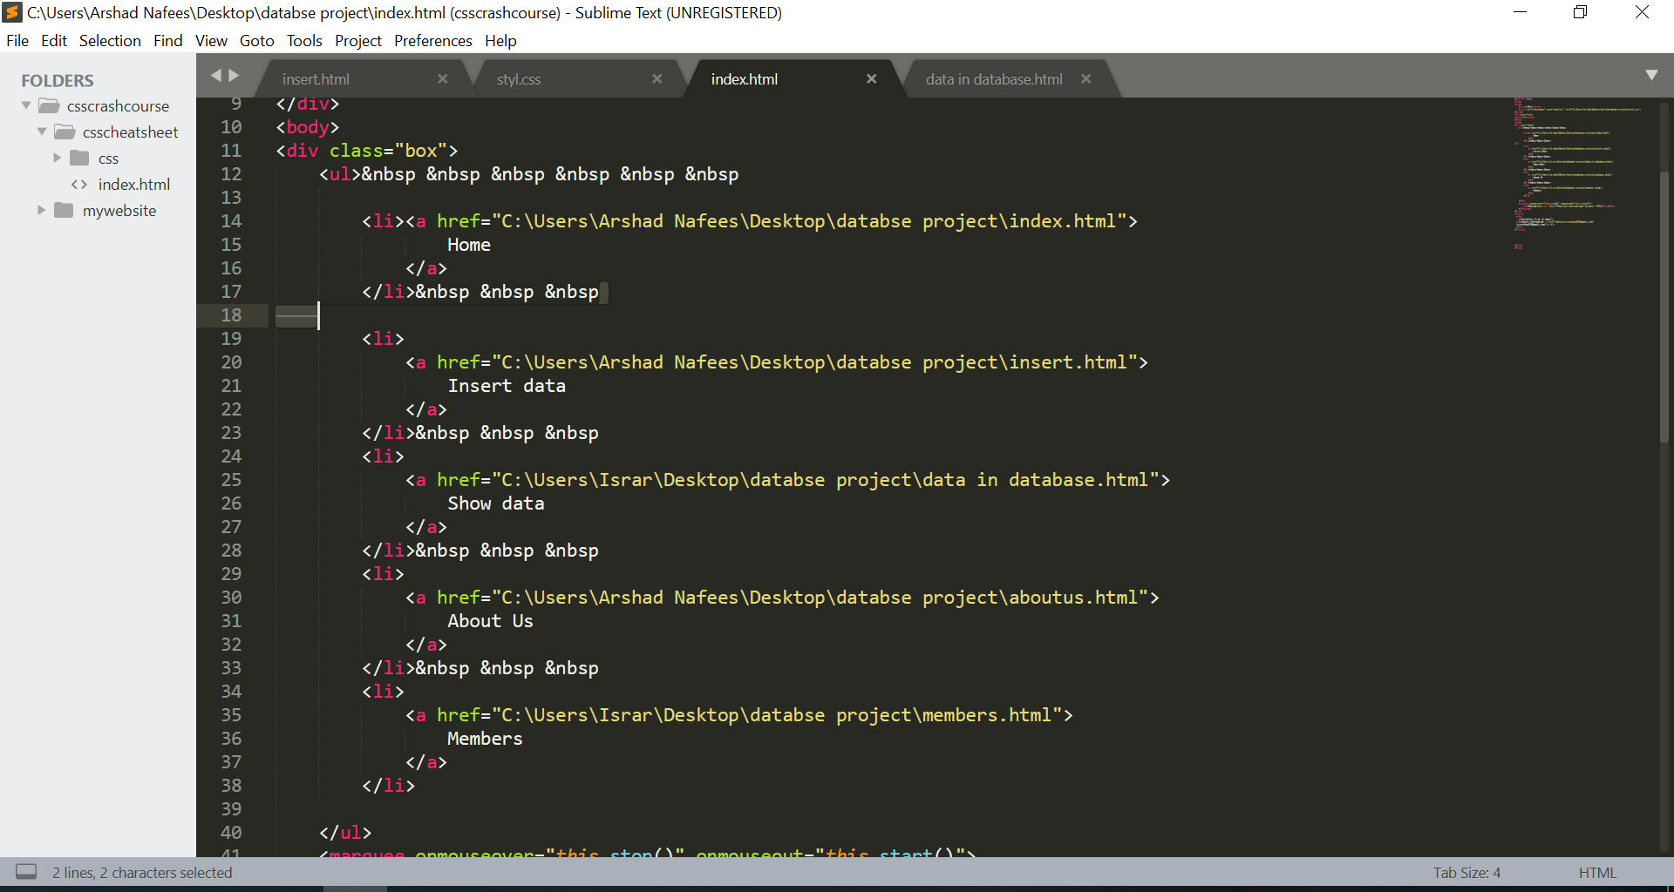

**Tool for backend Database management:**

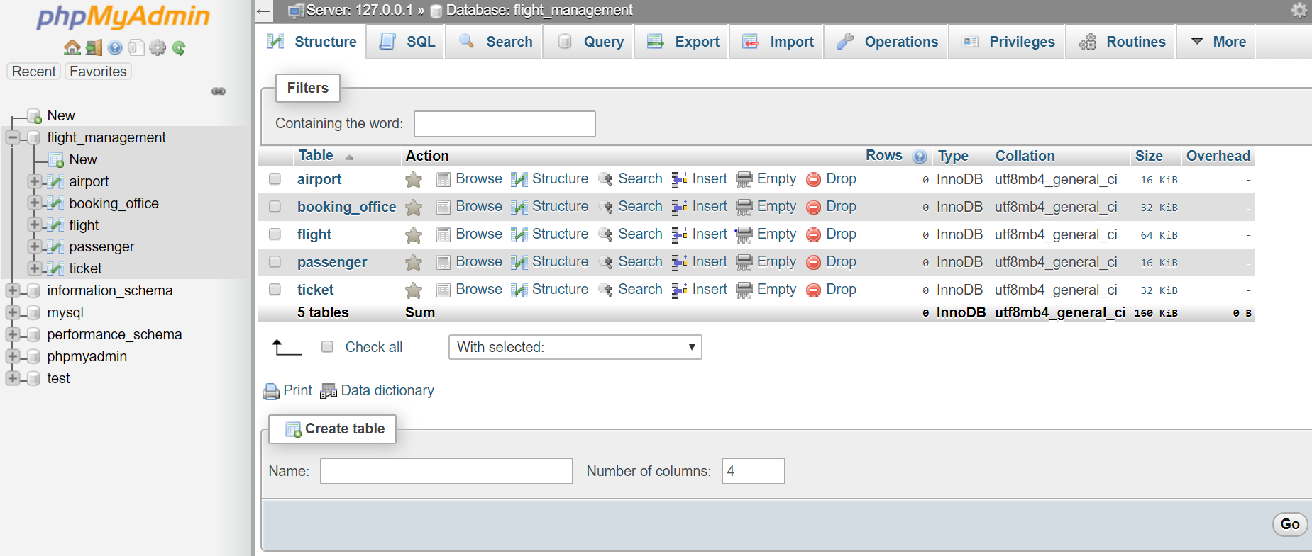

**Our front end main page look:**

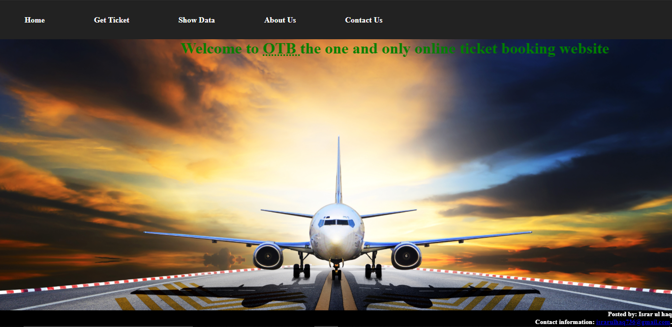

**Form to insert data:**

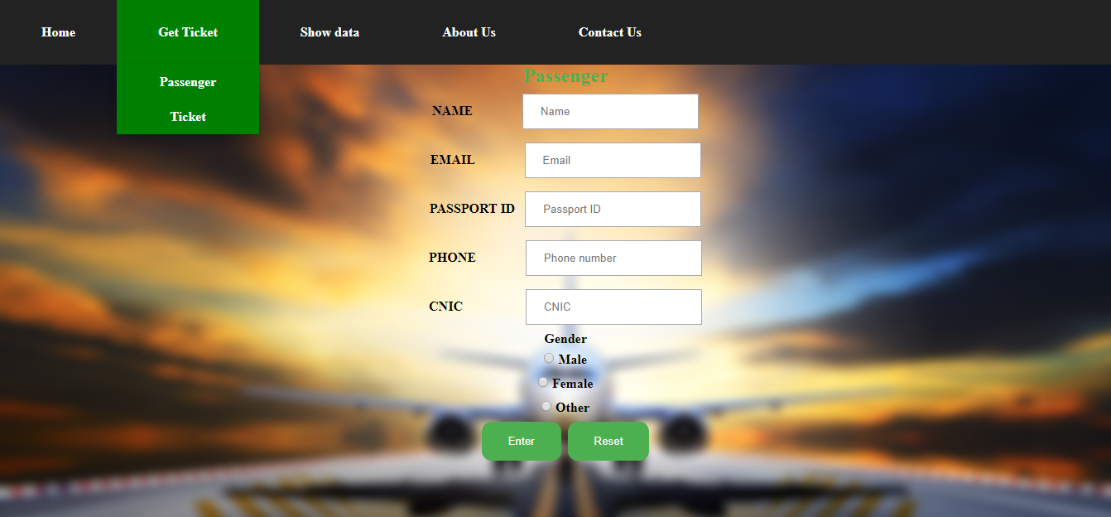

**If the passenger wants to know the flight details:**

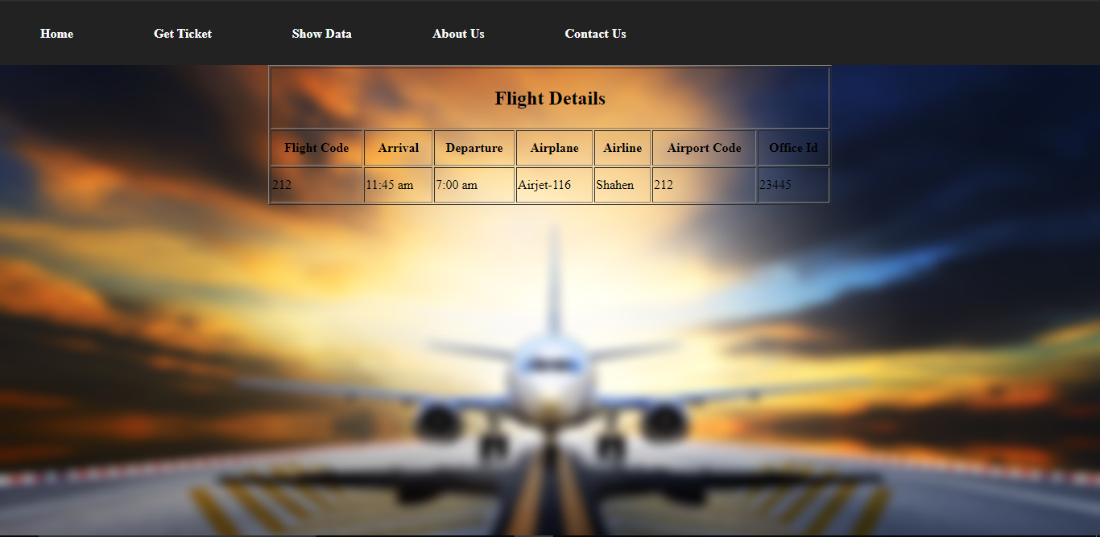

Books

Passenger

TICKET

Booking Office

Confirm from

Has detail of

Has

FLIGHT

AIR PORT

Fly from