Ranjeet Meena

ranjeet_meena

13 ( 10 easy, 3 medium )

Name :-

leetCode Profile :-

Solved Problems :-

-:- PROBLEM SOLUTIONS -:-

9. Palindrome Number: _easy_

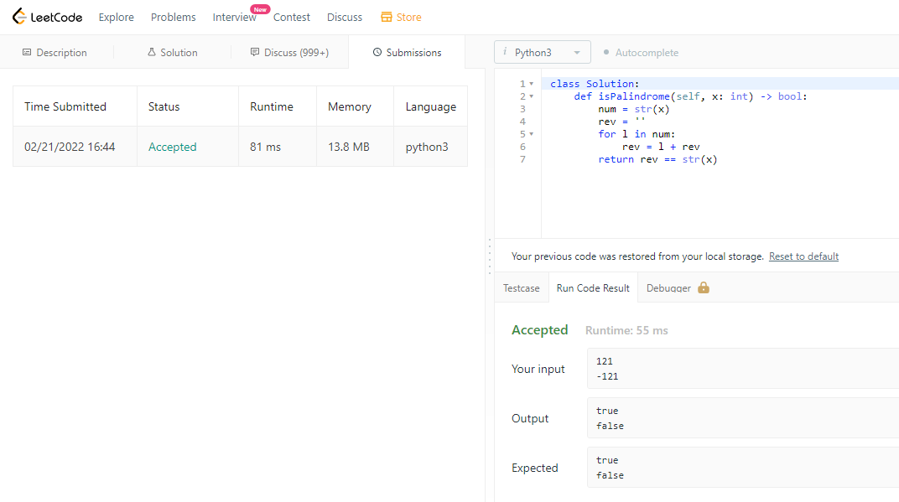

58. length-of-last-word: _easy_

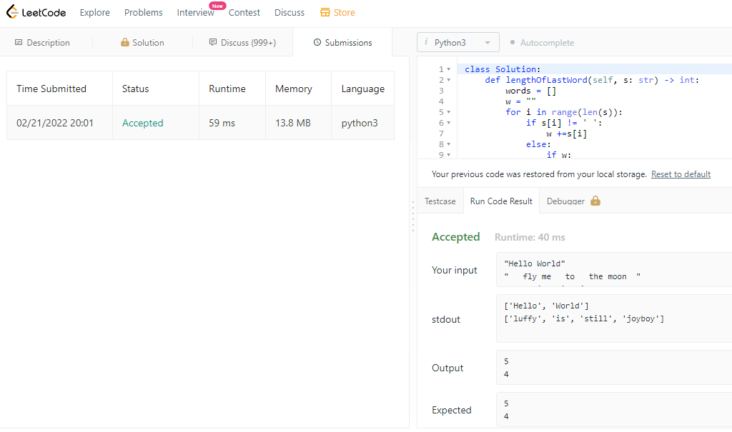

66. Plus One: _easy_

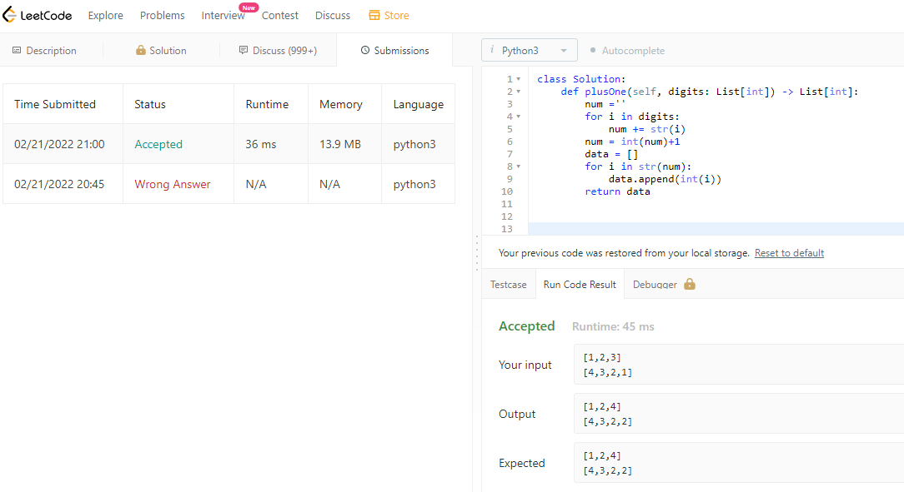

125. Valid Palindrome: _easy_

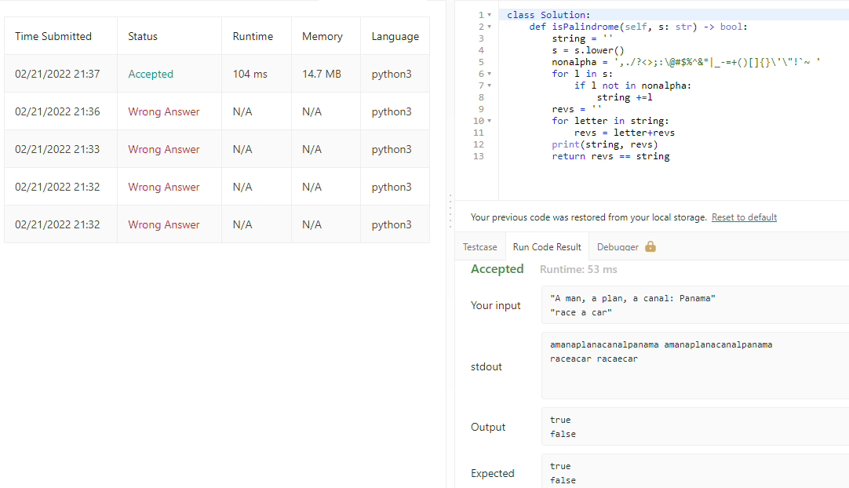

709. To Lower Case: _easy_

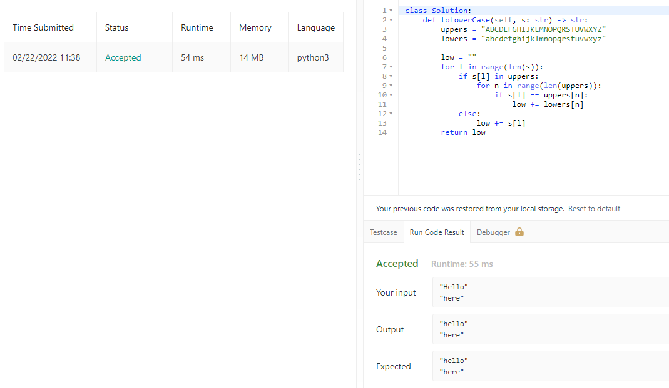

1323. Maximum 69 Number: _easy_

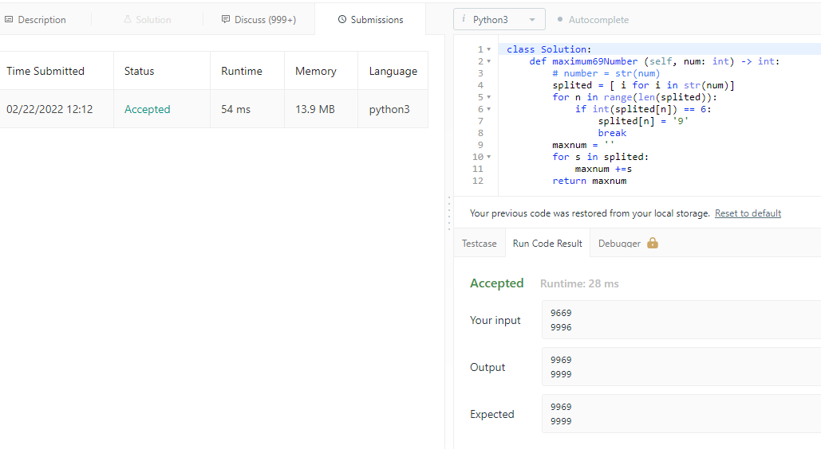

7. Reverse Integer: _median_

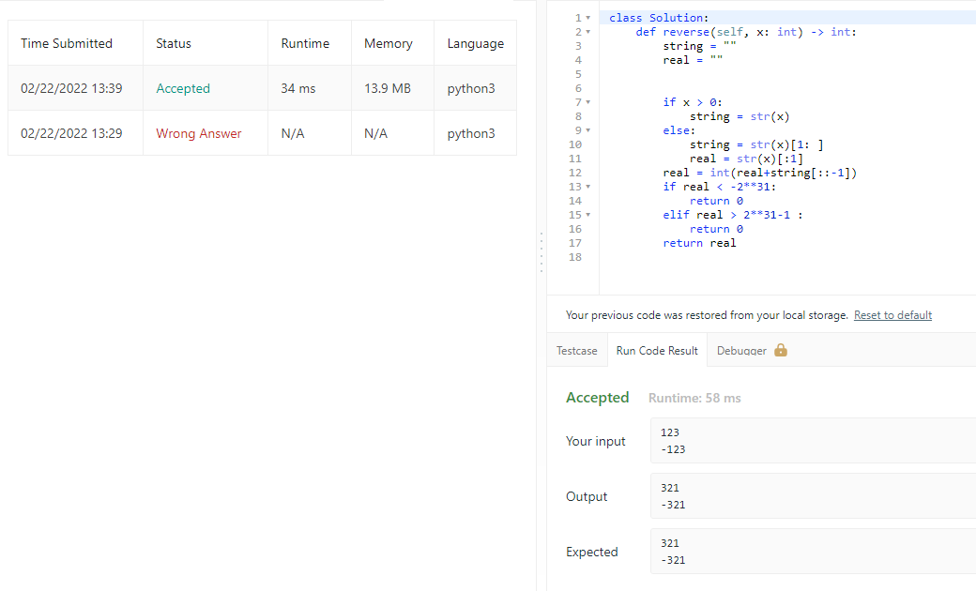

29. Divide Two Integers: __medium__

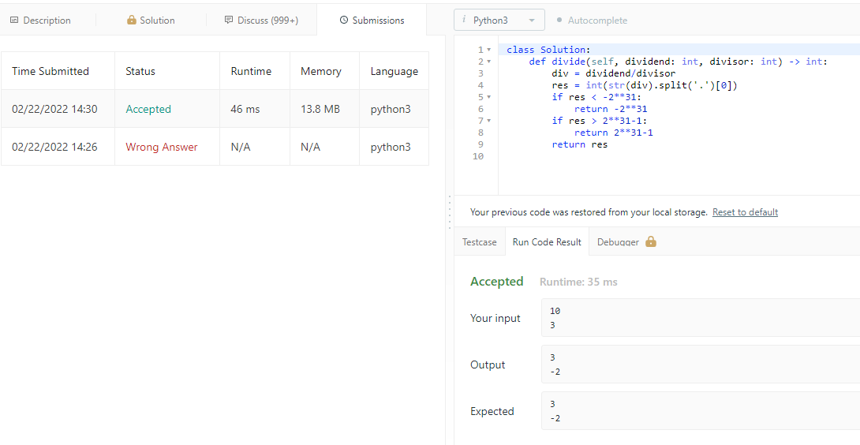

48. Rotate Image: _medium_

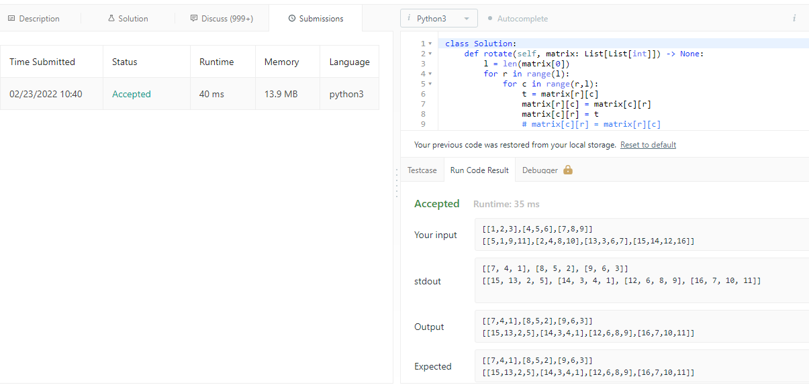

867. Transpose Matrix: _easy_

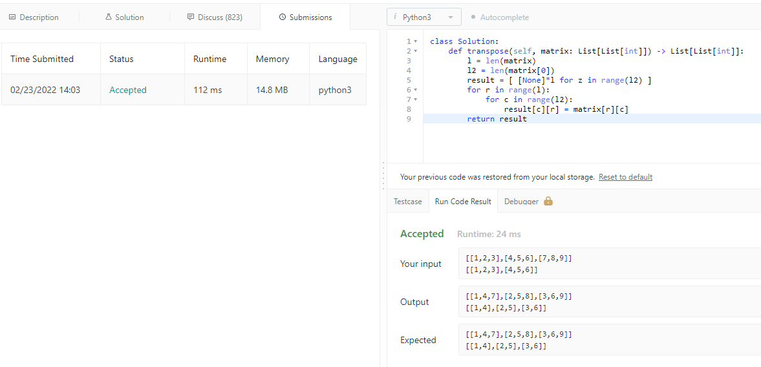

2011. Final Values of Variable After Performing Operation: _easy_

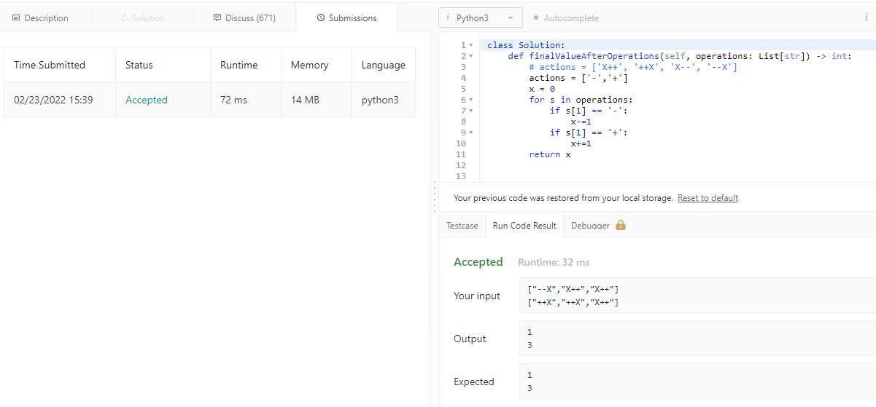

387. First Unique Character in String: _easy_

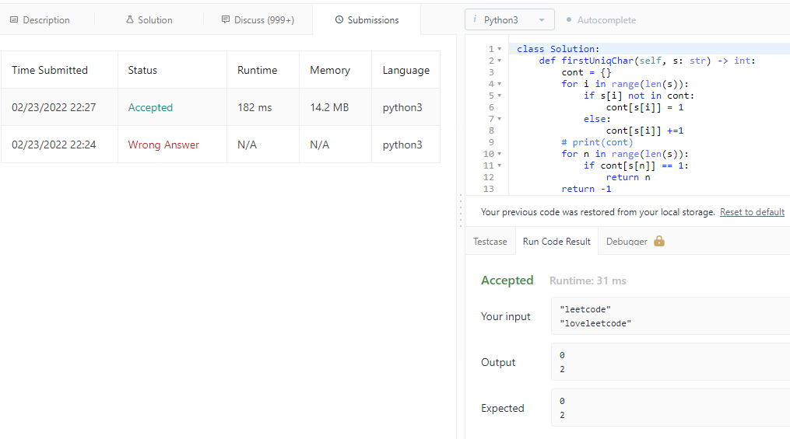

344. Reverse String: _easy_

