**Step-by-Step Guide to Create a Chatbot with IBM Watson Assistant**

**Prerequisites:**

1. **IBM Cloud Account**: Ensure that you have an IBM Cloud account. If you don't have one, you can sign up at [IBM Cloud](https://cloud.ibm.com/registration).

**2.** **IBM Watson Assistant Service**: Create an instance of the Watson Assistant service in your IBM Cloud account.

**Step 1: Accessing IBM Watson Assistant**

1. Log in to your IBM Cloud account at [IBM Cloud](https://cloud.ibm.com).

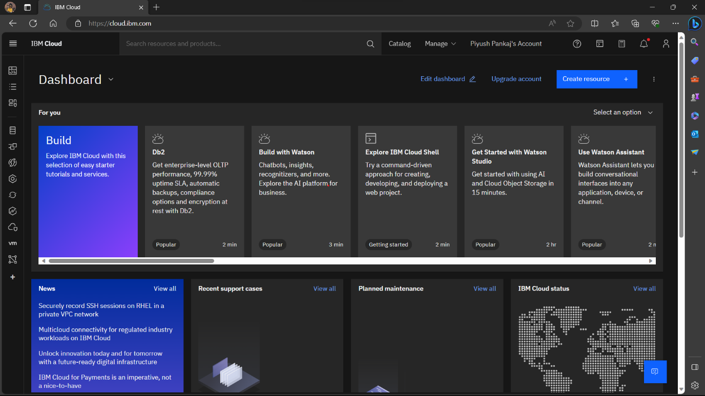

2. Navigate to the IBM Watson Assistant service in the IBM Cloud dashboard.

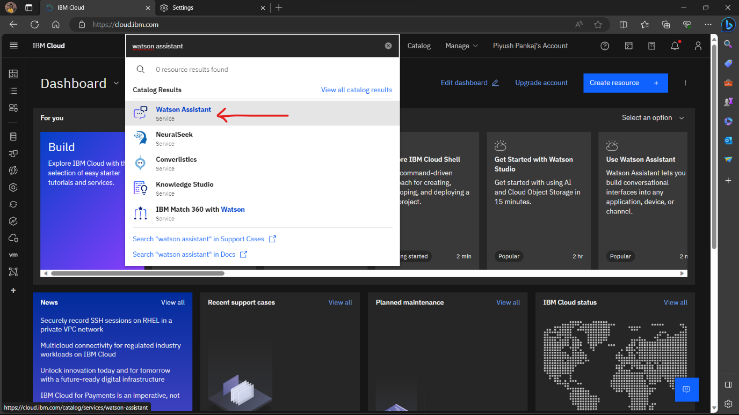

**Step 2: Create an Assistant**

1. Inside the Watson Assistant service, click on "Create assistant" to start creating your chatbot.

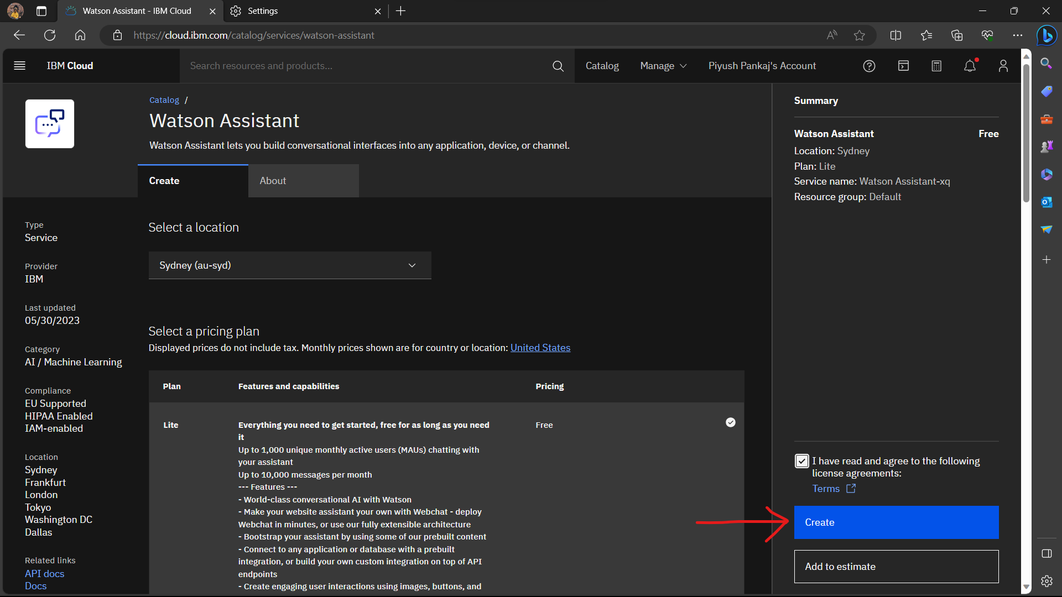

2. Give your assistant a name and a description to help you identify it later.

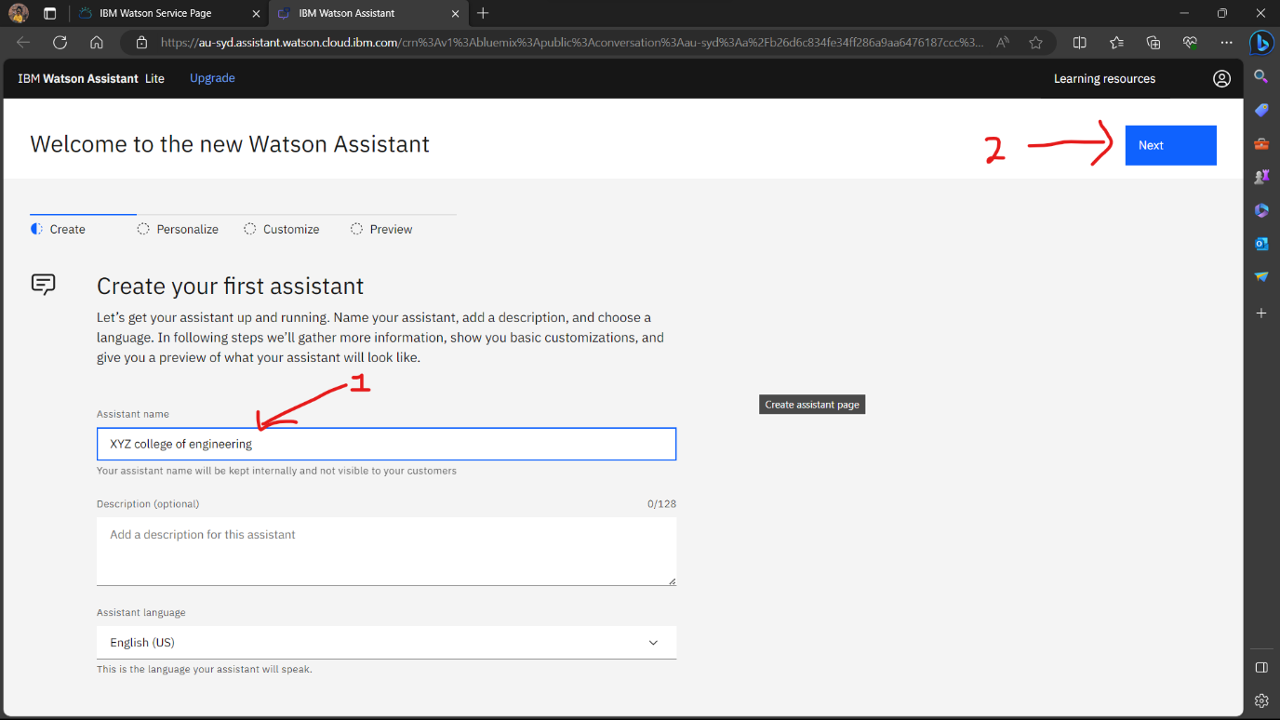

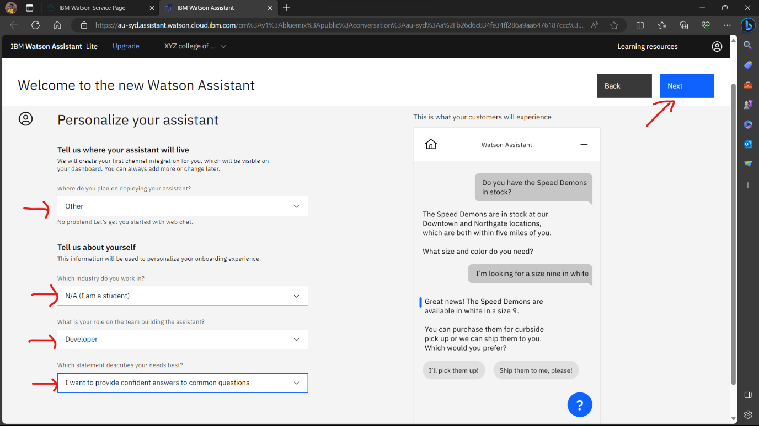

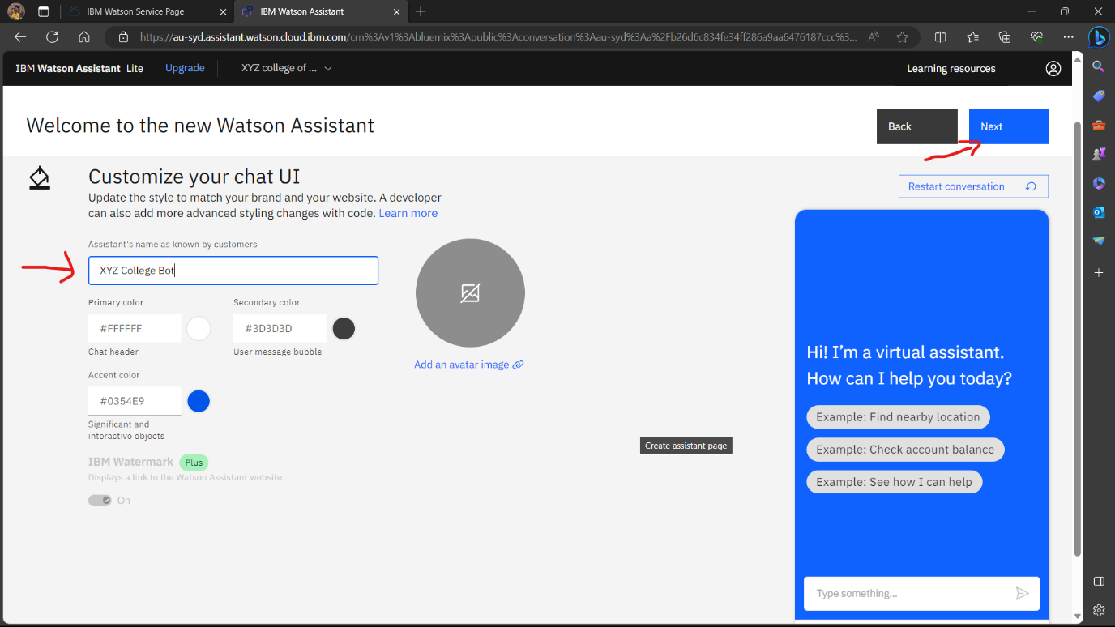

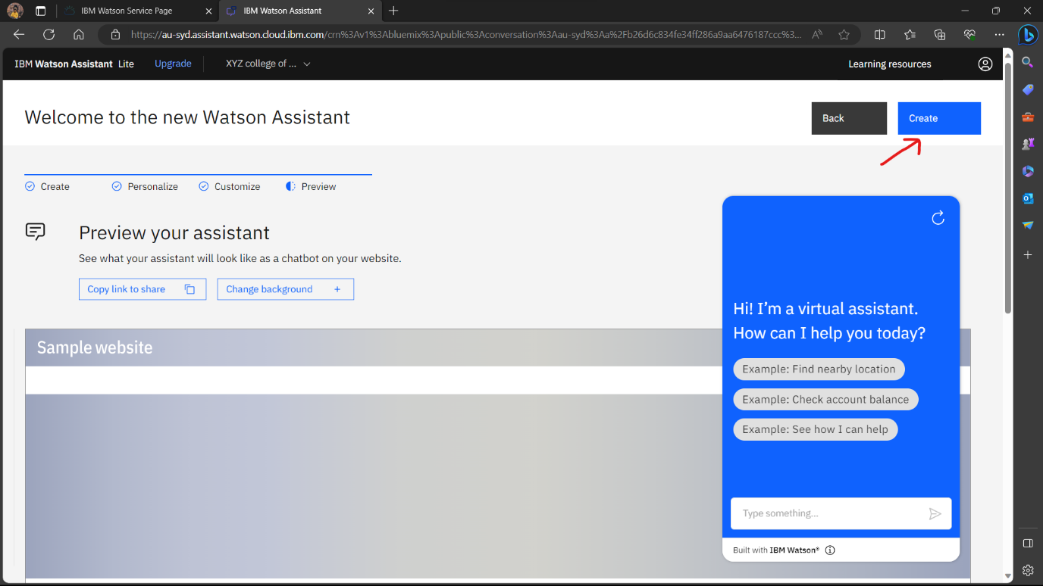

**Step 3: Creating Actions**

1. Click on "Action" to create a new Action for your assistant.

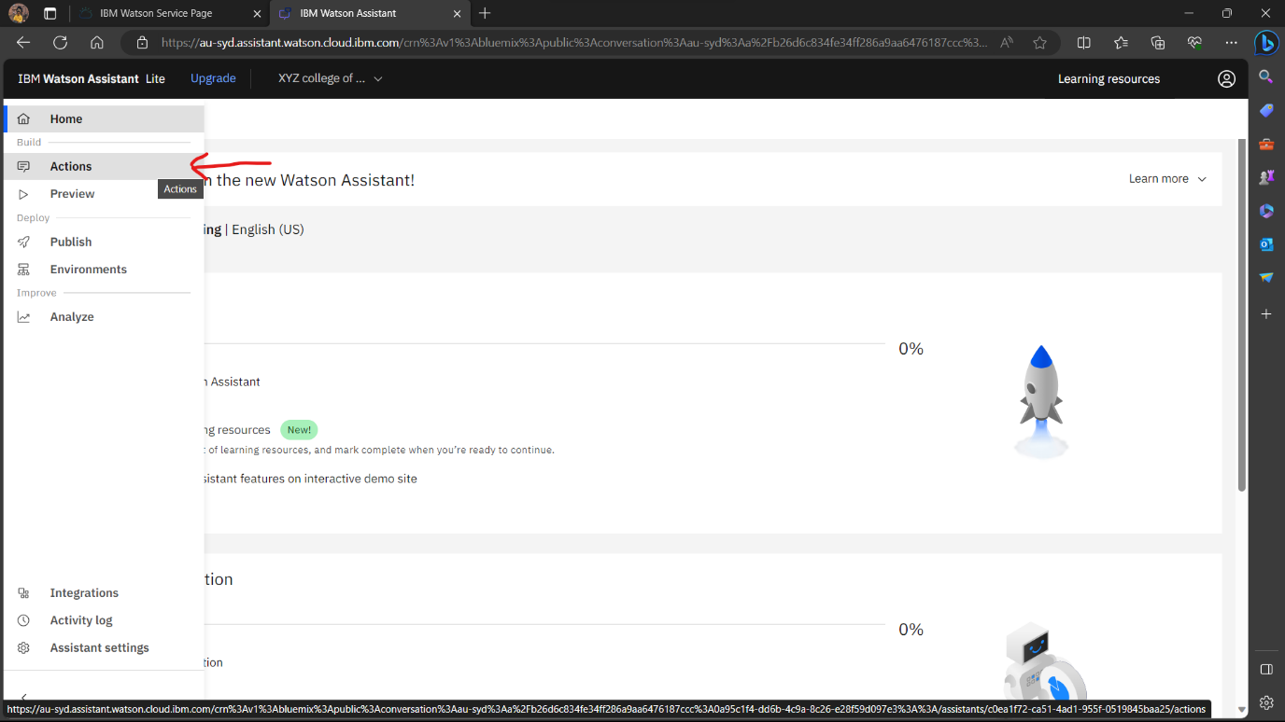

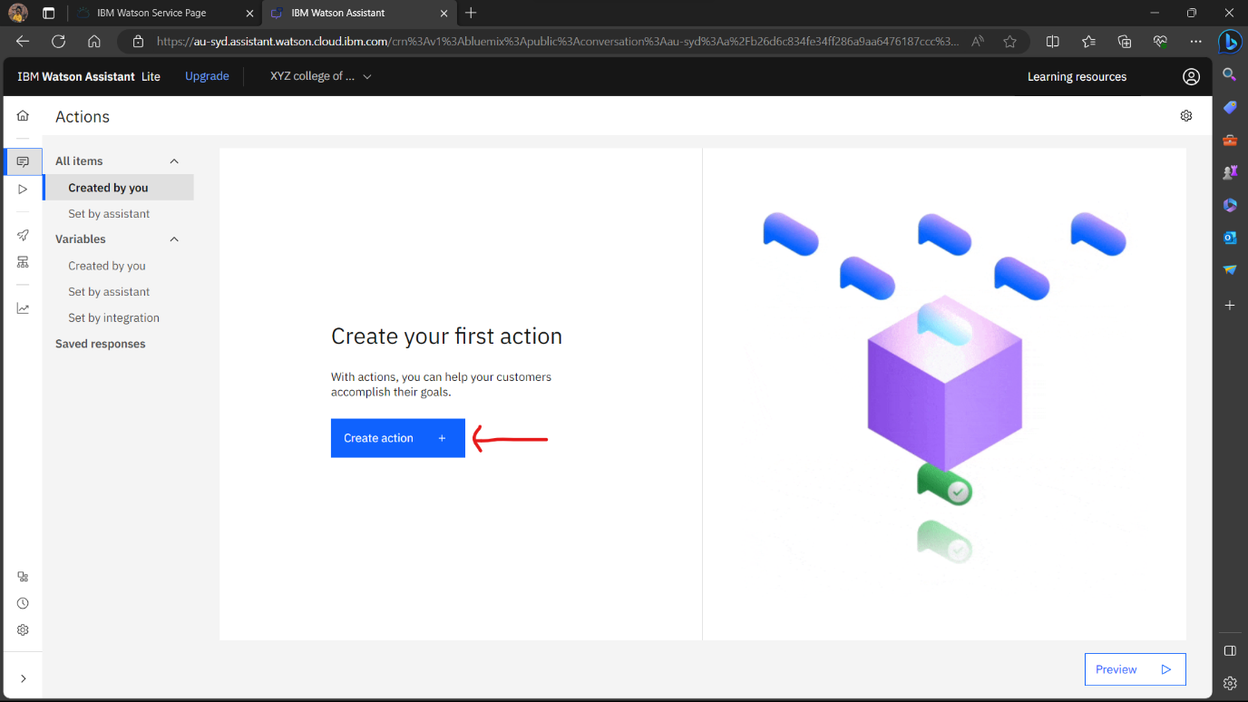

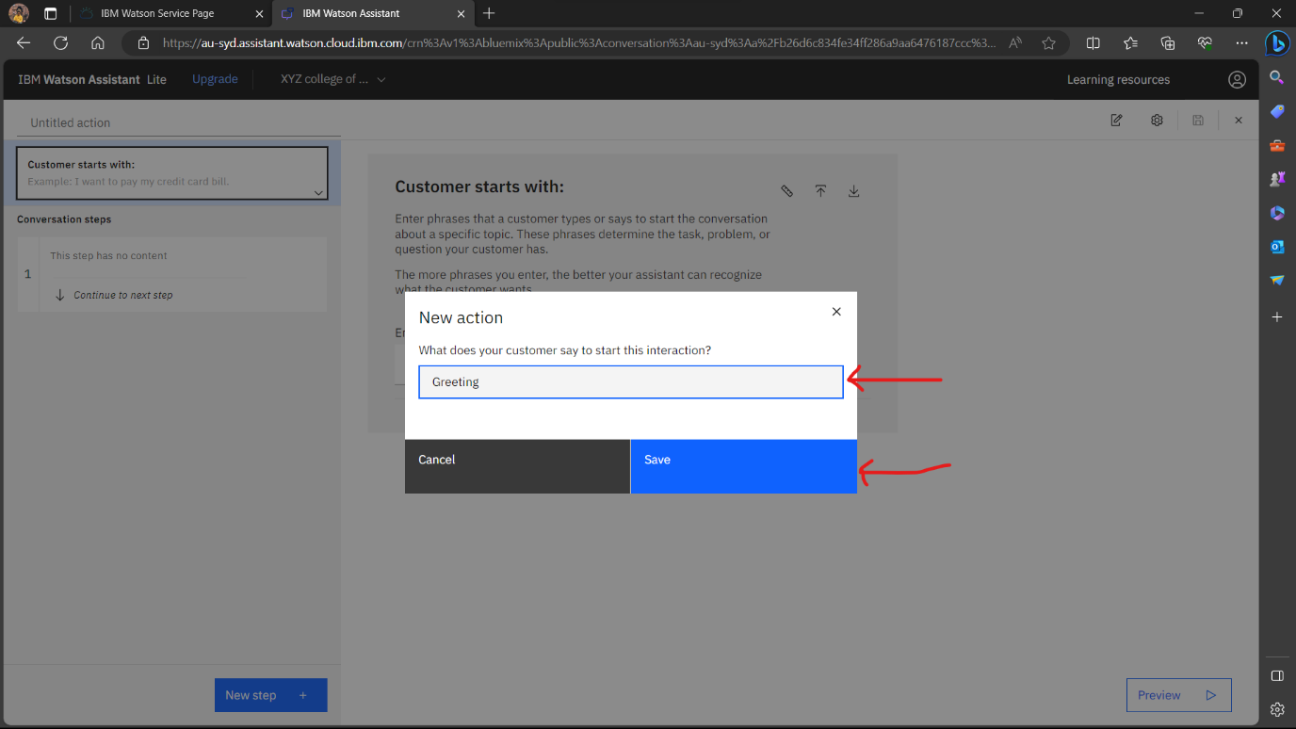

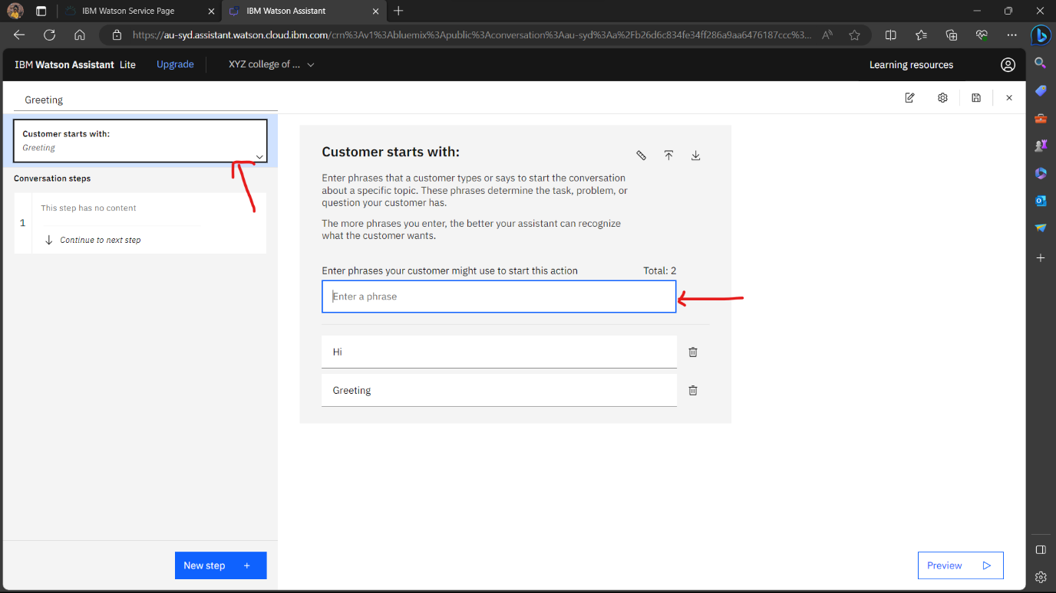

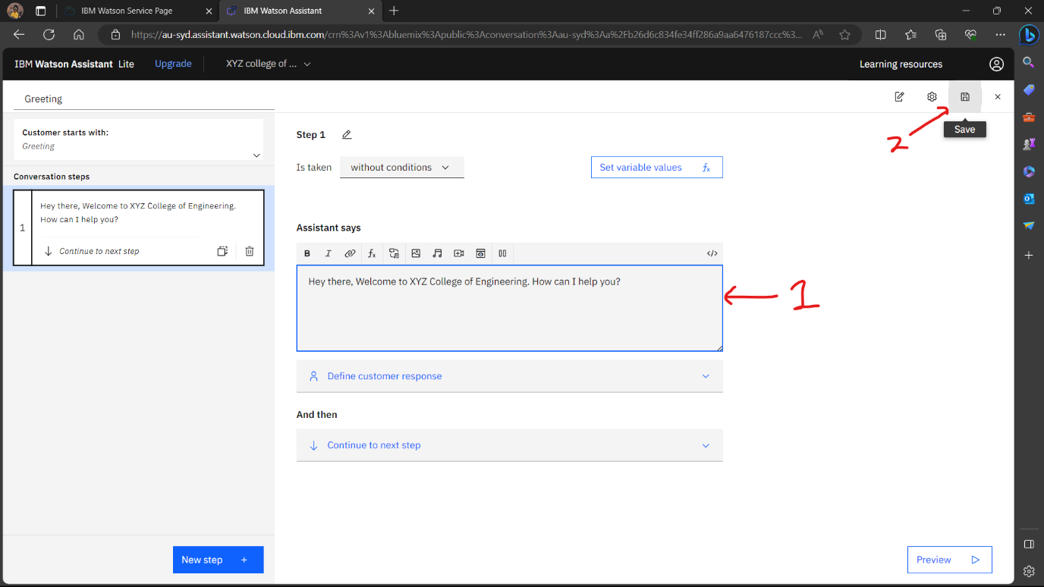

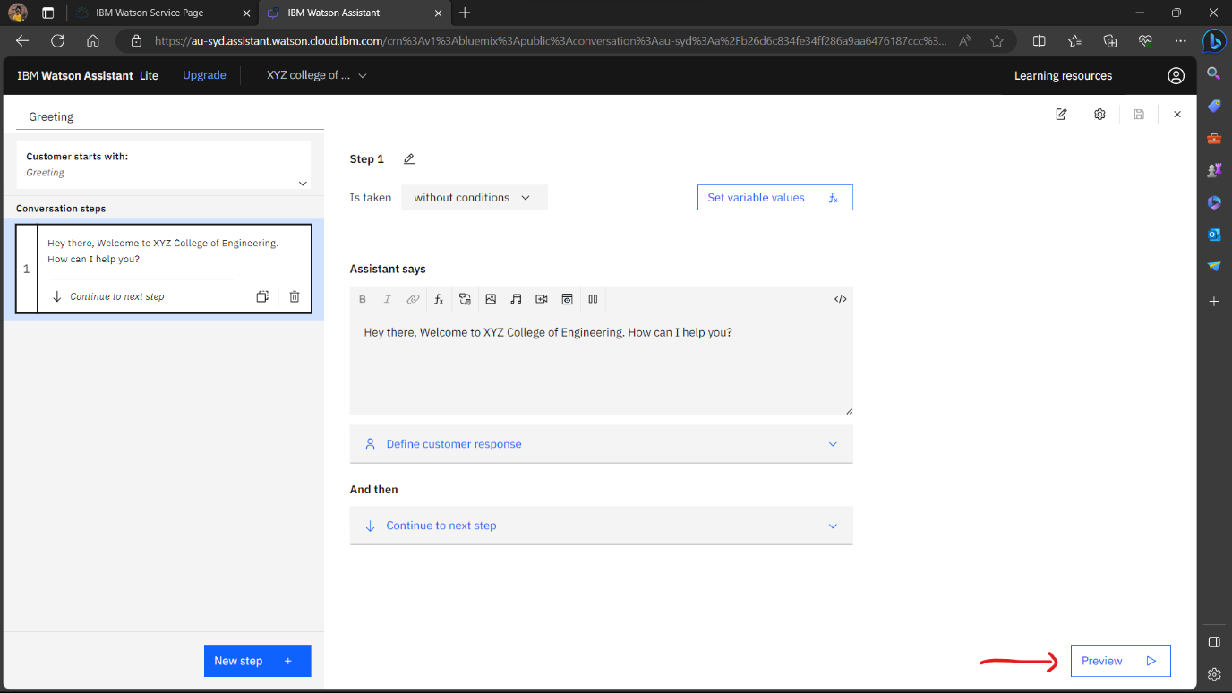

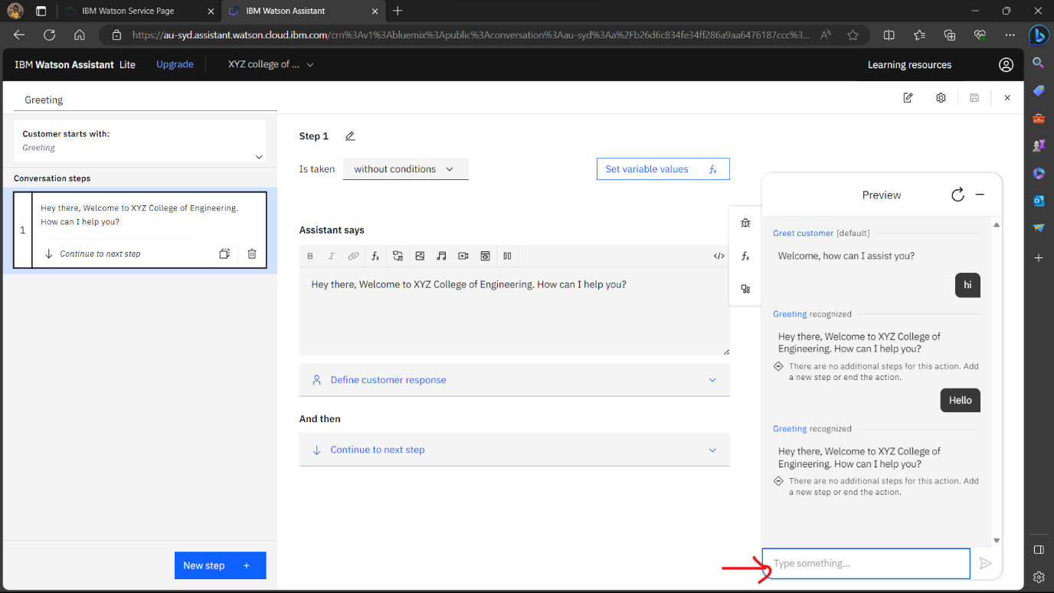

**Step 4: Adding more steps.**

1. By clicking on New Step, we add more steps or text in the reply by our chatbot

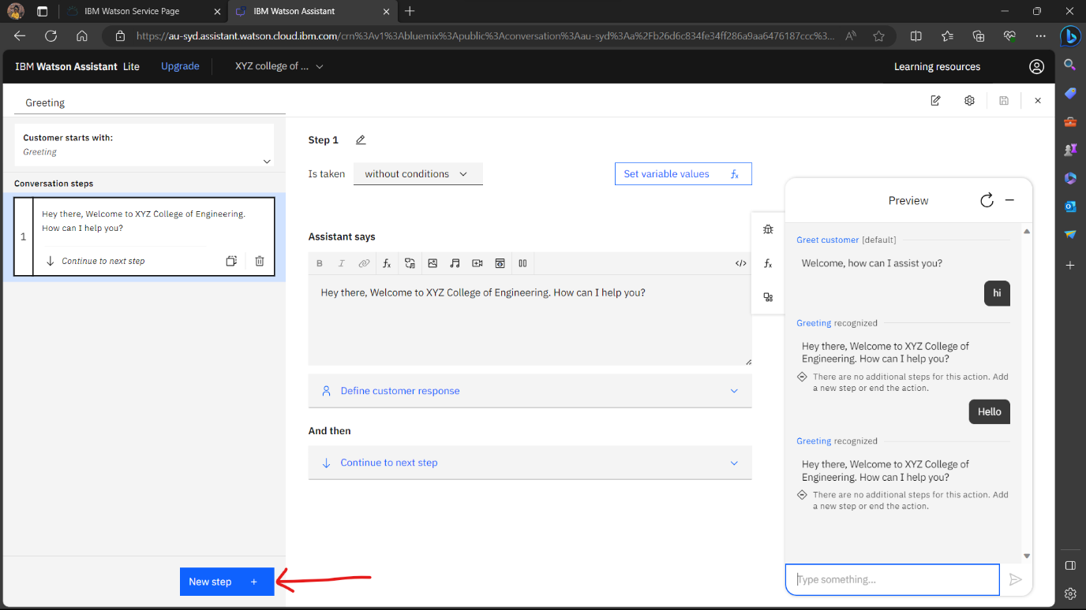

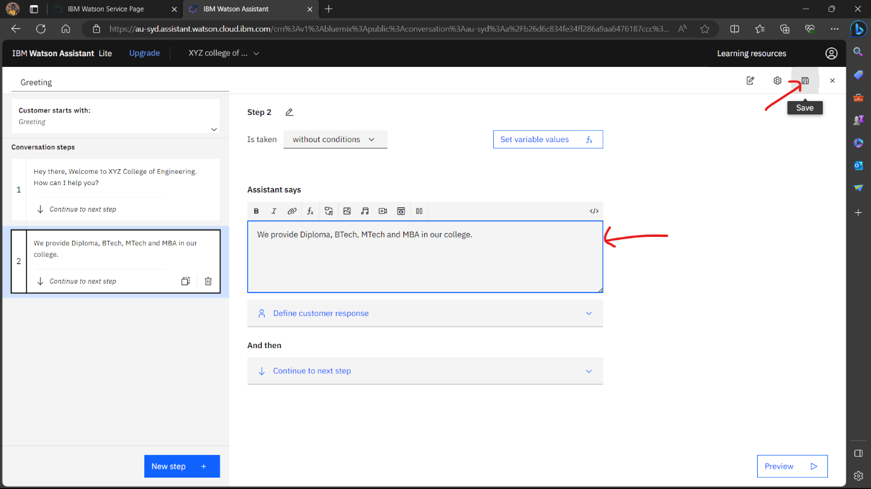

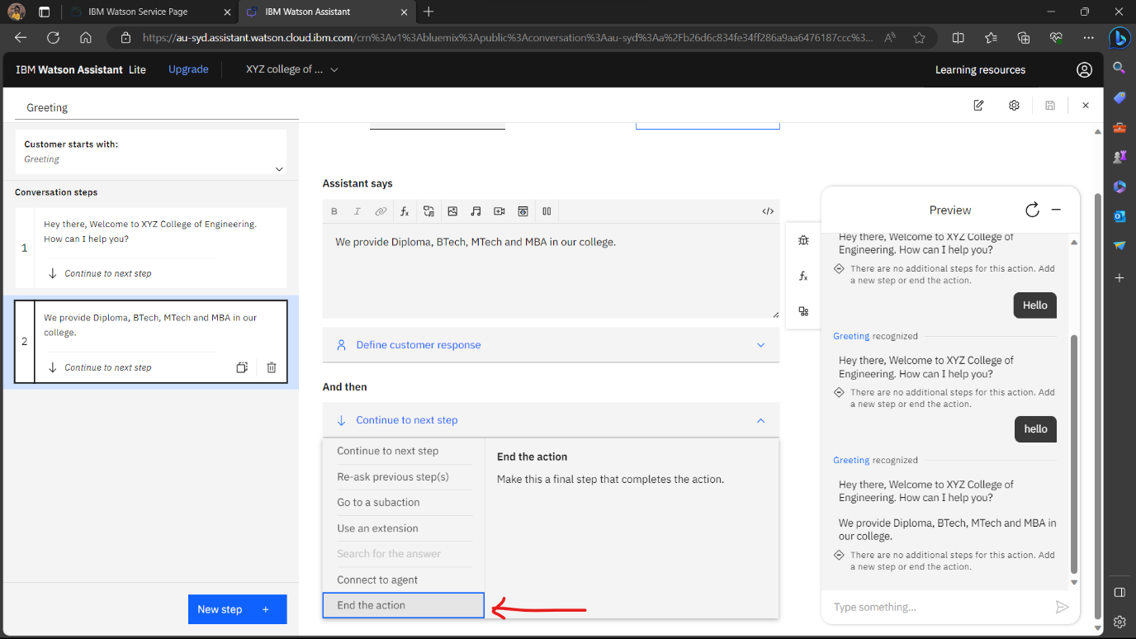

**Step 5: Creating New Actions**

1. There can be N number of actions that we can add to our chatbot based on the Problem Statement/ Domain/ Need.

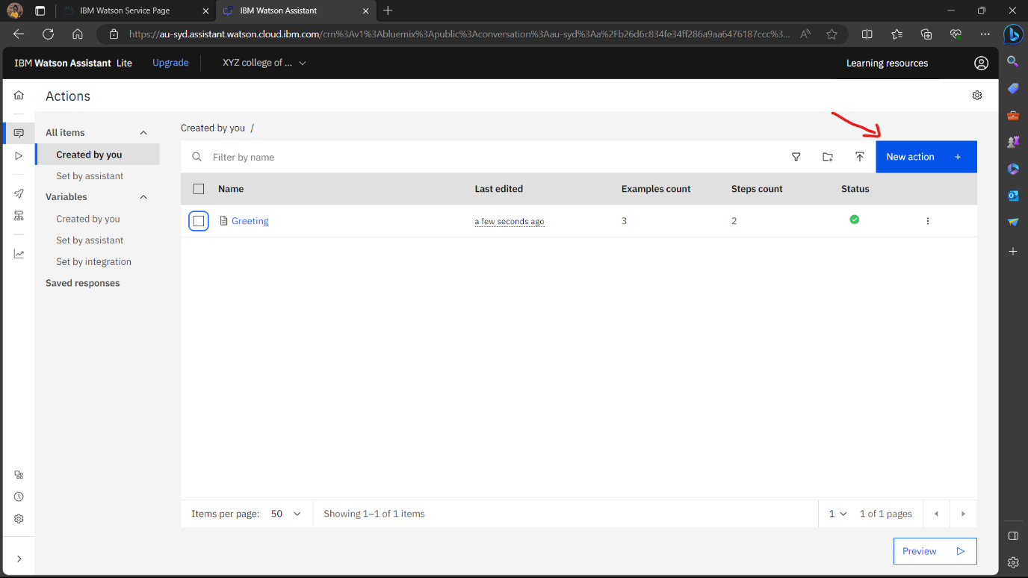

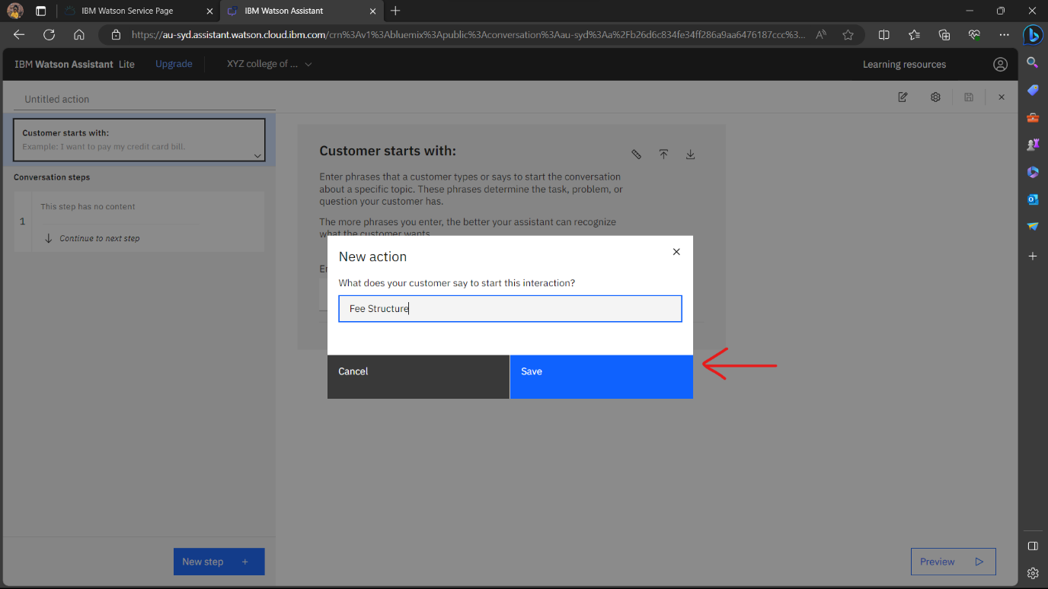

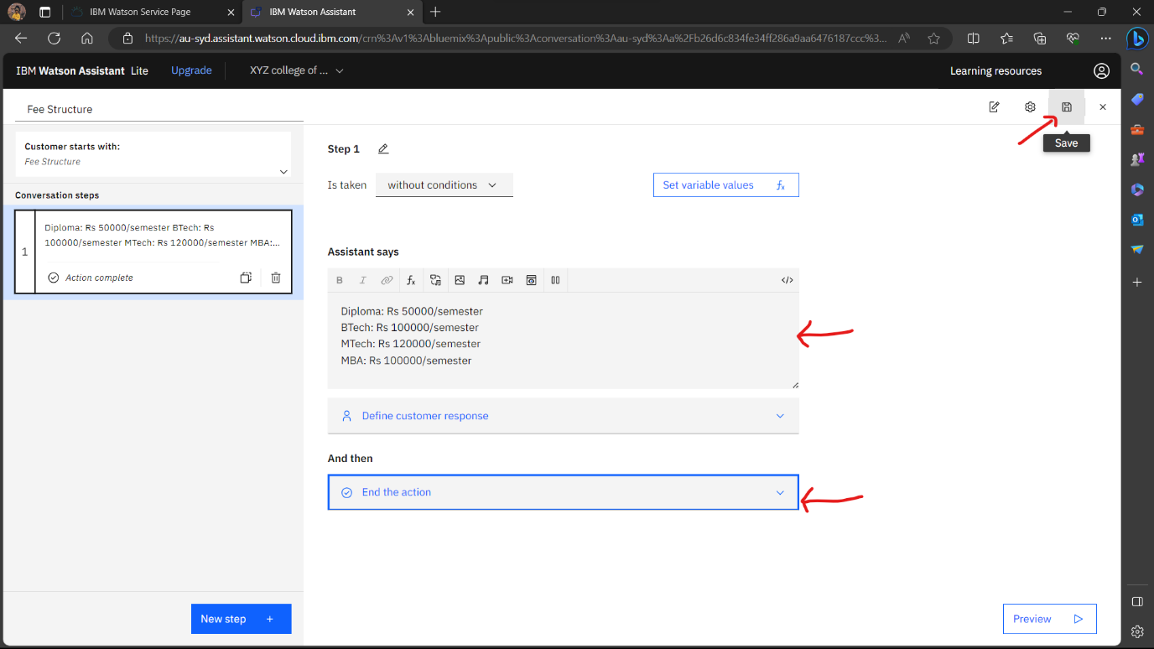

**Step 6: Final preview**

1. When we are done with adding all the actions and various steps then we can see a final preview of our chatbot.
2. In final preview we can check whether our chatbot is working properly/ giving correct responses to the questions or not.

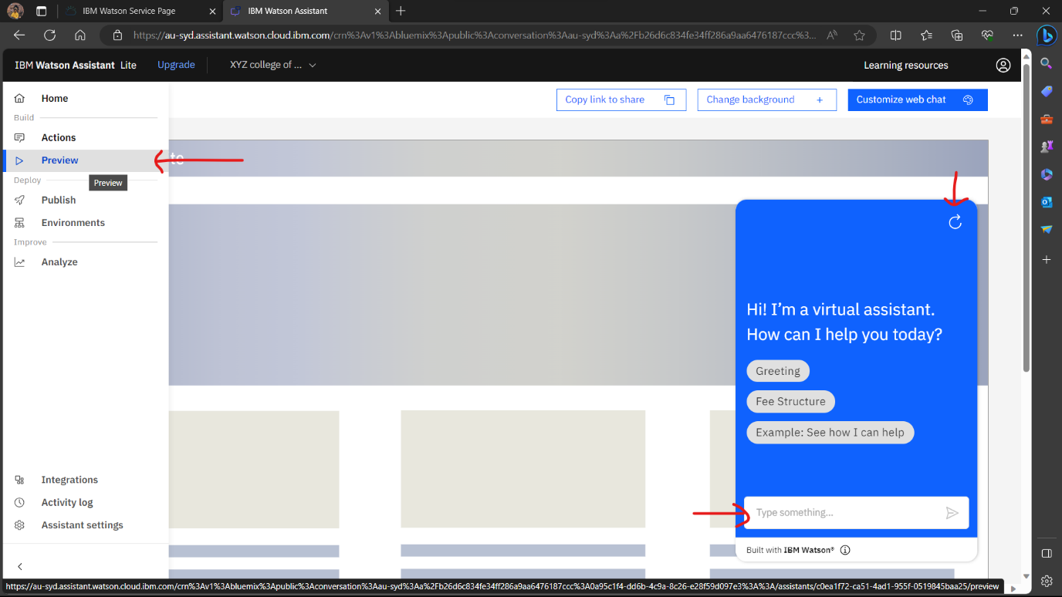

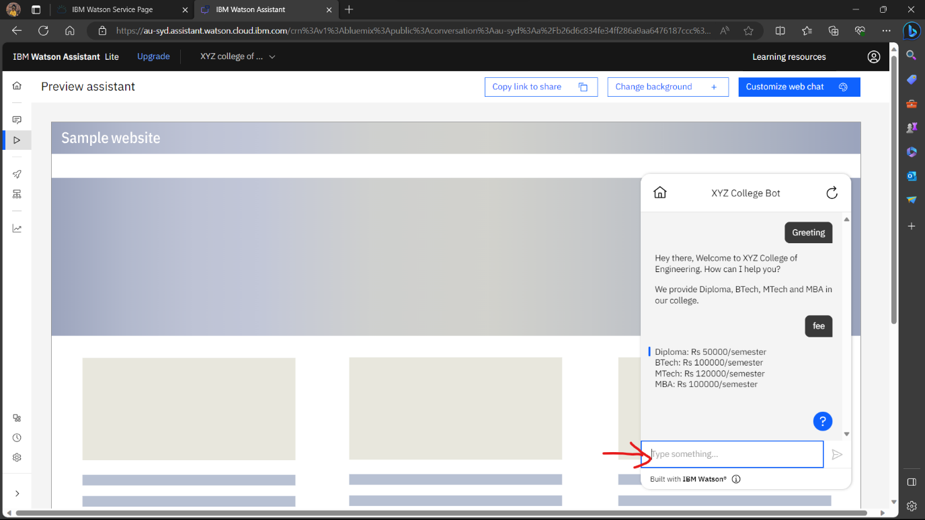

**Step 7: Publish Chatbot**

1. After checking the performance and the ability to give responses to the questions, when we get satisfied then finally, we will publish our chatbot.

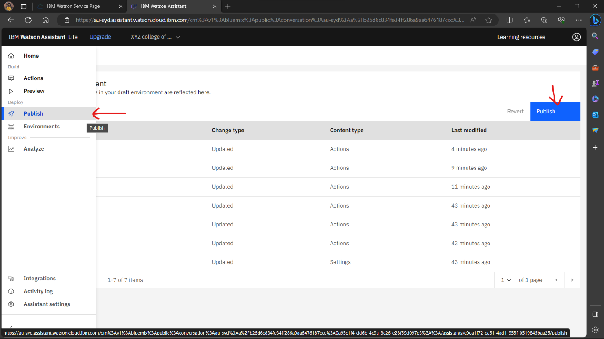

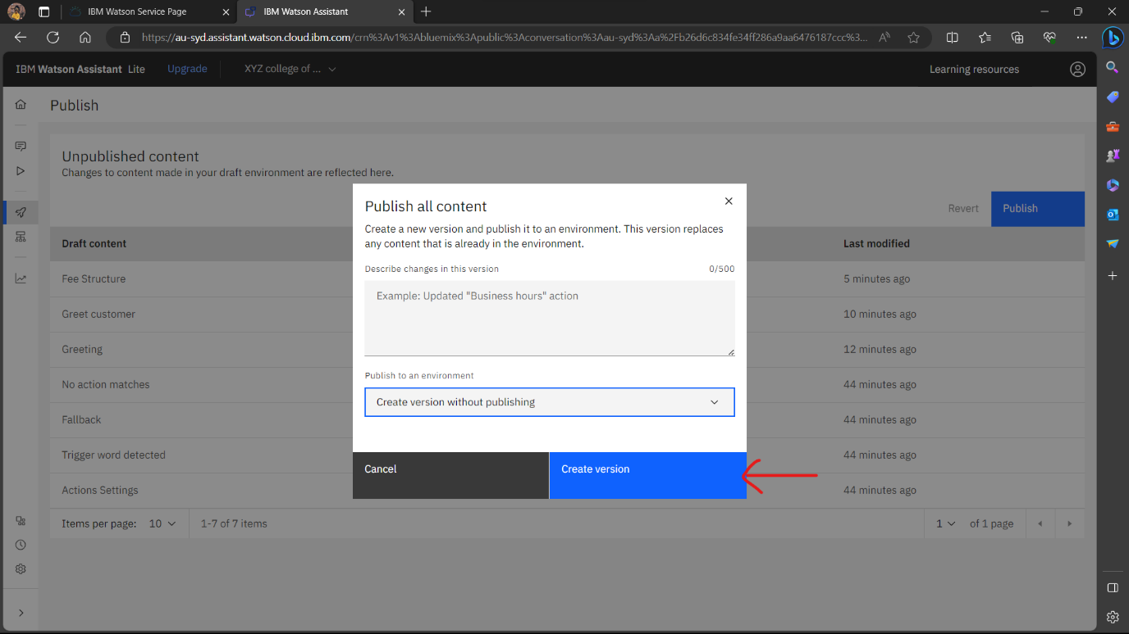

**Step 8: Integrate with Channels**

1. To make your chatbot accessible, integrate it with various channels like websites, mobile apps, or messaging platforms. IBM Watson Assistant supports various integrations.

**Step 9: Train and Deploy**

1. Train your chatbot by providing sample user inputs and expected responses. Watson Assistant uses this training data to improve its understanding.

2. Deploy your chatbot to make it live. Choose the deployment options that suit your project, such as web chat or API integration.

**Step 10: Monitor and Improve**

1. Regularly monitor the chatbot's performance using analytics and user feedback. Make adjustments to improve its accuracy and effectiveness.

2. Continue to refine your chatbot by adding new intents, entities, and dialog nodes as needed.