*A Project Report on*

**Moving Truck In Rain**

*In the partial fulfilment of the Diploma in Computer Engineering for the academic Year 2021-22*

*Submitted to*

**S.M.D.R. GOVERNMENT POLYTECHNIC, DHULE**

*Submitted by*

|  |  |  |
| --- | --- | --- |
| Seat No. | Name of the Student | Class |
| 193815 | Gavale Anand Jagdish | CO 3I |
| 193834 | Chaudhari Durvesh Ajay | CO 3I |
| 193844 | Shandre Samarth Manish | CO 3I |
| 193845 | Chaudhari Mayuresh Sanjay | CO 3I |
| 193857 | Salunke Yash Vijay | CO 3I |

*Under the Guidance of*

**Nayana Borse,**

**Lecturer in Computer Graphics,**

**Department of Computer Enginnering,**

**S.M.D.R. Government Polytechnic, Dhule**



**MAHARASHTRA STATE BOARD OF TECHNICAL EDUCATION**

**CERTIFICATE**

This is to certify that **Group Copy** of **Third** Semester of Diploma in **Computer** **Engineering** of Institute S.M.D.R. **Government Polytechnic, Dhule (0017)** has completed the Micro Project satisfactorily in the Subject Computer Graphics for the Academic Year 2021-22 as prescribed in the curriculum.

Place: Dhule Enrolment No:

Date: Exam Seat No:

Subject Teacher Head of the Department Principal

**WEEKLY WORK REPORT**

|  |  |  |  |  |  |
| --- | --- | --- | --- | --- | --- |
| **SR. NO.** | **WEEK** | | **ACTIVITY PERFORMED** | **SIGN OF GUIDE** | **DATE** |
| 1 | 1st | | Discussion and finalization of Topic |  |  |
| 2 | 2nd | | Preparation and Submission of Abstract |  |  |
| 3 | | 3rd | Literature Review |  |  |
| 4 | | 4th | Collection of Data |  |  |
| 5 | | 5th | Collection of Data |  |  |
| 6 | | 6th | Discussion and Outline of Content |  |  |
| 7 | | 7th | Formulation of Content |  |  |
| 8 | | 8th | Editing and Proof Reading of Content |  |  |
| 9 | | 9th | Compilation of Report and Presentation |  |  |
| 10 | | 10th | Seminar |  |  |
| 11 | | 11th | Viva Voce |  |  |
| 12 | | 12th | Final Submission of Micro Project |  |  |

**EVALUATION SHEET FOR MICRO PROJECT**

**(Academic Year: 2020-21)**

**Name of the Student: (Group Copy)**

**Course:Computer Graphics(22318) Course Code: CO- 3- I**

**Title of the Project:** **Moving Truck In Rain**

**Brief Introduction:** Computer graphics are pictures and films created using computers. Usually, the term refers to computer-generated image data created with the help of specialized graphical hardware and software. It is a vast and recently developed area of computer science. The phrase was coined in 1960, by computer graphics researchers Verne Hudson and William Fetter of Boeing. It is often abbreviated as CG, though sometimes erroneously referred to as computer-generated imagery (CGI). • Computer Graphics refers to the creation, storage and manipulation of pictures and drawings using digital computers. • Used in diverse fields to represent data. • Scientific researches, engineering applications, medicine, business, industry, government, art, entertainment, advertising, education and other fields make use of computer graphics

**The main objectives of this project are:**

a) To implement the features of graphics.

b) interface the applications of graphics to the real world.

c) give some benefits to the disability.

d) make the life easier.

e) become familiarization with Graphics and its logical coding.

|  |  |  |  |  |
| --- | --- | --- | --- | --- |
| Seat No. | **Student Name** | **Marks out of 06 for performance in group activity (D5 Column 08)** | **Marks out of 04 for performance in oral or presentation (D5 Column 09)** | **Total out of 10** |
| 193815 | Gavale Anand Jagdish |  |  |  |
| 193834 | Chaudhari Durvesh Ajay |  |  |  |
| 193844 | Shandre Samarth Manish |  |  |  |
| 193845 | Chaudhari Mayuresh Sanjay |  |  |  |
| 193857 | Salunke Yash Vijay |  |  |  |

**Name & Signature of Faculty:**

ACKNOWLEDGE

The success and final outcome of this project required a lot of guidance and assistance from many people and we are extremely privileged to have got this all along the completion of our project. All that we have done is only due to such supervision and assistance and we would not forget to thank them.

We respect and thank Dr. R. G. Wadekar, Principal, Government Polytechnic, Dhule for providing us an opportunity to do the project work in the institute and giving us all support and guidance which made us complete the project duly. We are extremely thankful to Dr. Wadekar Sir for providing such a nice support and guidance.

 We heartily thank Mr.U.R.Deshmukh Head Department of Computer Department, for his guidance, suggestions and encouragement during this project work.

We owe our deep gratitude to our project guide, Dr. Nayana Borse who took keen interest on our project work and guided us all along, till the completion of our project work by providing all the necessary information for developing a good system.

   We are thankful to and fortunate enough to get constant encouragement, support and guidance from all the Teaching staffs of Department of Computer Enginnering which helped us in successfully completing our project work.

Program Code For Moving Truck In Rain

**#include<stdio.h>**

**#include<graphics.h>**

**#include<stdlib.h>**

**#include<conio.h>**

**#include<dos.h>**

**#define ScreenWidth getmaxx()**

**#define ScreenHeight getmaxy()**

**#define GroundY ScreenHeight*0.88**

**void car(int i){**

**setviewport(0,0,550,440,1);**

**rectangle(50+i,275,150+i,400);**

**rectangle(150+i,350,200+i,400);**

**circle(75+i,410,10);**

**circle(175+i,410,10);**

**delay(100);**

**clearviewport();**

**}**

**void Rain(int x)**

**{**

**int i,rx,ry;**

**for(i=0;i<400;i++)**

**{**

**rx=rand() % ScreenWidth;**

**ry=rand() % ScreenHeight;**

**if(ry<GroundY-4)**

**{**

**if(ry<GroundY-120 || (ry>GroundY-120 && (rx<x-20 || rx>x+60)))**

**line(rx,ry,rx+0.5,ry+4);**

**}**

**}**

**}**

**int main()**

**{**

**int gd=DETECT,gm,x=0,i=-100 ;**

**initgraph(&gd,&gm,"C:\\TC\\BGI");**

**while(!kbhit())**

**{**

**//Draw Ground**

**line(0,GroundY,ScreenWidth,GroundY);**

**Rain(x);**

**car(i);**

**cleardevice();**

**x=(x+2)%ScreenWidth;**

**if(i<=570)**

**i=i+10;**

**else**

**{i=-100; i=i+10;}**

**}**

**getch();**

**}**

**Output**

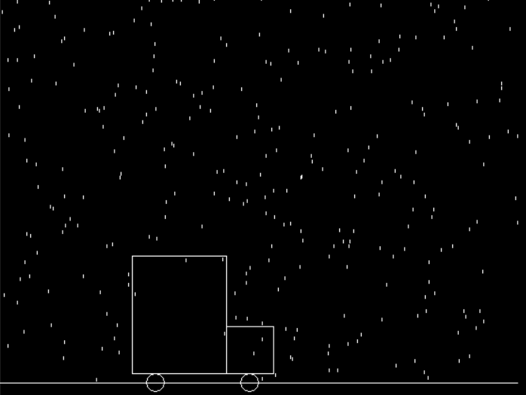

**Thank You**