**FAKE NEWS DETECTION:**

Summary Report:

Using normal pipeline algorithm:

Results for SVM:

Total statements classified: 10240

Accuracy: 64.69090977975252

Confusion matrix:

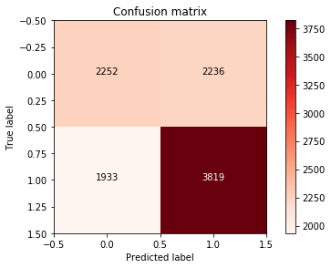

Results for LogR:

Total statements classified: 10240

Accuracy: 61.04687487924283

Confusion matrix:

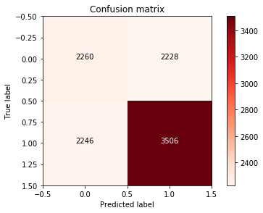

To increase the accuracy of the model we have used n-gram in SVM and LogisticRegression and have come out with the following accuracy.

Using n-gram:

Results for SVM:

Total statements classified: 10240

Accuracy: 70.44355553757985

Confusion matrix:

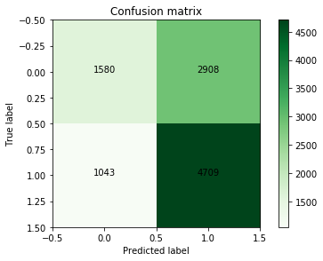

Results for LogR:

Total statements classified: 10240

Accuracy: 67.90920142902142

Confusion matrix:

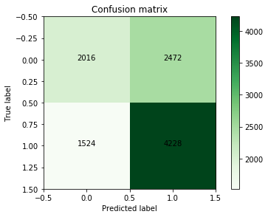

**The desired Precision Recall Curve:**

