Major Project On
“Landslide Detection using Deep Learning Models”



BY:
Vineet Patel (202200530)
Pratham Mir Dutraj (202200521)
In partial fulfillment of requirements for the award of degree in
Bachelor of Technology in Information Technology
(2025)

Under the Project guidance of
Mrs. Sonam Lhamu Bhutia
Assistant Professor

DEPARTMENT OF INFORMATION TECHOLOGY

SIKKIM MANIPAL INSTITUTE OF TECHNOLOGY

(A constituent college of Sikkim Manipal University)
MAJITA R, RANGPO, EAST SIKKIM – 737136

PROJECT COMPLETION CERTIFICATE

This is to certify that the below mentioned student(s) of Sikkim Manipal Institute of Technology have worked under my supervision and guidance from ……….. to …………… and have successfully completed the project entitled “Landslide Detection using Deep Learning Models” in partial fulfillment of the requirements for the award of Bachelor of Technology in Information Technology.

University Registration No | Name of Student(s) | Course
202200530 | Vineet Patel | B.Tech (IT)
202200521 | Pratham Mir Dutraj | B.Tech (IT)

Name of Organization’s Supervisor

Designation

Name of Organization

Address

(Organization Seal)

REPORT REVIEW CERTIFICATE

This is to certify that the work recorded in this project report entitled “Landslide Detection using Deep Learning Models” has been jointly carried out by Mr Vineet Patel (Reg. 202200530 ) and Mr. Pratham Mir Dutraj (Reg. 202200521) of Department of Information Technology, Sikkim Manipal Institute of Technology in partial fulfillment of the requirements for the award of Bachelor of Technology Information Technology. This report has been duly reviewed by the undersigned and recommended for final submission for Major Project Viva Examination.

Name of SMIT’s Supervisor

Designation

Department of Information Technology
Sikkim Manipal Institute of Technology
Majitar, East Sikkim – 737136.

CERTIFICATE ACCEPTANCE

This is to certify that the below mentioned student(s) Department of Information Technology of Sikkim Manipal Institute of Technology (SMIT) have worked under the supervision of Mrs. Sonam Lhamu Bhutia of Sikkim Manipal Institute Of Technology from………………. to…………… on the project entitled “Landslide Detection using Deep Learning Models.”
The project is hereby accepted by the Department of Information Technology, SMIT in partial fulfillment of the requirements for the award of Bachelor of Technology in Information Technology.

University Registration No | Name of Student(s) | Project Venue
202200530 | Vineet Patel | B.Tech (IT)
202200521 | Pratham Mir Dutraj | B.Tech (IT)

Prof.(Dr) Biswaraj Sen
Professor & HOD
Department of Information Technology
Sikkim Manipal Institute of Technology
Majhitar, Sikkim - 737136

DECLARATION
I/We the undersigned, hereby declare that the work recorded in this project report entitled “Landslide Detection using Deep Learning Models” in partial fulfillment for the requirements of award of B.Tech in Information Technology from Sikkim Manipal Institute of Technology (A constituent college of Sikkim Manipal University) is a faithful and bonafide project work carried out at Sikkim Manipal Institute of Technology , Majitar under the supervision and guidance of Mrs. Sonam Lhamu Bhutia , Assistant Professor of Information Technology Dept. of Sikkim Manipal Institute of Technology.
The results of this investigation reported in this project have so far not been reported for any other Degree / Diploma or any other Technical forum.
The assistance and help received during the course of the investigation have been duly acknowledged.

Name: Vineet Patel
(Reg. No. 202200530)
…………………………..
Name: Pratham Mir Dutraj
(Reg. No. 202200521)
…………………………..

ACKNOWLEDGEMENT
We would like to express our sincere gratitude to all those who have supported and guided us throughout the successful completion of our Major Project titled “Landslide Detection using Deep Learning Models.”
First and foremost, we convey our heartfelt thanks to our internal guide, Mrs. Sonam Lhamu Bhutia, for her constant guidance, invaluable suggestions, and encouragement throughout the entire duration of the project. Her mentorship has been a source of inspiration and has greatly contributed to the quality of this work.
We extend our deep sense of respect and gratitude to Dr. Biswaraj Sen, Head of the Department, IT – SMIT, for providing a motivating academic environment and for his continuous support in carrying out this project smoothly.
We are also thankful to the Project Coordinators, IT Department, for their continuous assistance, timely directions, and support during various stages of the project.
Our sincere thanks to all the faculty members and staff of the IT Department, SMIT, for their cooperation, guidance, and encouragement, which have helped shape our learning and understanding throughout the course of our study.
We would also like to acknowledge the valuable feedback and evaluation provided by the internal and external examiners, whose insights have helped refine and strengthen this project.
Finally, we express our gratitude to everyone who directly or indirectly contributed to the successful completion of this project.

DOCUMENT CONTROL SHEET

1 | Report No | SMIT/IT/Major Project/Internal /B.Tech/2025
2 | Title of the Report | Landslide Detection using Deep Learning Models
3 | Type of Report | Technical
4 | Author(s) | Vineet Patel , Pratham Mir Dutraj
5 | Organizing Unit
6 | Language of the Document | English
7 | Abstract | One of the main natural disasters that can seriously harm people, property, and infrastructure is landslides……………………………The final model is useful for applications related to environmental safety and catastrophe response since it can support early warning systems, hazard  mapping, and real-time monitoring
8 | Security Classification | General / Restricted / Classified
9 | Distribution Statement | General / Restricted / Classified

CERTIFICATION FROM EXAMINERS

This document certifies that the students listed below have successfully presented their B.Tech Final Semester Major Project (Sub Code: IT400A5), entitled " Landslide Detection using Deep Learning Models," and have undergone the Final Viva-Voce Examination before the Examination Panel on ___________ date.
Sl | Reg | Name | Course
1. | 202200530 | Vineet Patel | B.Tech (Information Technology)
2. | 202200521 | Pratham Mir Dutraj | B.Tech (Information Technology)

_____________________________________
Ms Sonam Lhamu Bhutia, Assistant Professor
B.Tech (IT) Major Project Coordinator

Examiner-1 ________________
Examiner-2 ________________
Examiner-3 ________________

ABSTRACT
One of the main natural disasters that can seriously harm people, property, and infrastructure is landslides. Early detection of possible landslide areas using drone and satellite imagery can lower risks and assist disaster management teams. Large-scale landscape data analysis is not appropriate for traditional manual inspection procedures, which are slow and heavily rely on specialists.
This study uses an Attention U-Net deep learning model to create an automated landslide segmentation system in order to overcome this difficulty. The Bijie Landslide Dataset, which contains both landslide and non-landslide photos with matching masks, is used to train the model. By incorporating attention gates, the Attention U-Net architecture improves upon the traditional U-Net, enabling the network to more precisely focus on pertinent landslide features while disregarding superfluous background areas.
Binary Cross-Entropy (BCE) and Dice Loss are used to train the model, and measures including Precision, Recall, F1-Score, Dice Coefficient, and Pixel Accuracy are used to evaluate it. Despite dataset imbalance, the top model demonstrated high segmentation capabilities with an F1-score of 0.685. On validation images, visual results demonstrate precise and reliable predictions.
All things considered, this work offers a dependable and effective deep learning method for identifying landslide-prone regions. The final model is useful for applications related to environmental safety and catastrophe response since it can support early warning systems, hazard
mapping, and real-time monitoring

LIST OF CONTENT
Chapter Title Page No.

- Abstract
1 Introduction 1
1.1 General Overview of the Problem 2
1.2 Literature Survey 3 - 7
1.3 Problem Definition 8
1.4 Problem Analysis and SRS 9
1.5 Solution Strategy 10
1.6 Preliminary User’s Manual 11
1.7 Organization of the Project 12
2 Design Strategy for the Solution 13
2.1 SDLC 14
2.2 System Architecture 15
2.2 Detail Diagram 16 - 17
3 Detailed Test Plan 18
4 Implementation Details 19 - 20
4.1 Dataset Description 21 - 22
4.2 Flowchart for Project Implementation 23
4.3 Detail Decription of Implemention Fow Chart 24
5 Results & Discussion 25 - 27
5.1 Performance Graph 28 - 30
6 Summary & Conclusion 31
6.1 Main Difficulties Encountered 32
6.2 Limitations of the Project 33
6.3 Future Scope of Work 34
- Gantt Chart 35
8 References 36

LIST OF FIGURES
Sl.no. Title Page No
- Types of Landslide
1.1 Fig_no 1.1 2
1.2 Fig_no 1.2 2
1.3 Fig_no 1.3 2
1.4 Fig_no 1.4 2
1.5 Fig_no 1.5 2
2. Archicture & Diagram
2.1 Fig_no 1.1 14
2.2 Fig_no 1.2 15
2.3 Fig_no 1.3 16
2.4 Fig_no 1.4
3. Dataset & Implementation
3.1 Fig_no 1.1 22
3.2 Fig_no 1.2 23

4. Result & Graph
4.1 Fig_no 1.1 28
4.2 Fig_no 1.2 28
4.3 Fig_no 1.3 29
4.4 Fig_no 1.4 29
4.5 Fig_no 1.5 30
4.6 Fig_no 1.6 30

LIST OF TABLES
Sl.no. Title Page No

1. Literature Review
1.1 Table_no 1.1 3
1.2 Table_no 1.2 4
1.3 Table_no 1.3 5
1.4 Table_no 1.4 6
1.5 Table_no 1.5 7

2. Result & Metric
2.1 Table_no 1.1 25
2.2 Table_no 1.2 25
2.3 Table_no 1.3 25
2.4 Table_no 1.4 26
2.5 Table_no 1.5 26
2.6 Table_no 1.6 27

3 Gantt Chart
3.1 Table_no 1.1 35

1 INTRODUCTION

Large amounts of soil, rock, and debris lose stability and flow quickly downslope, causing landslides, one of the most abrupt and deadly natural disasters. They are frequently brought on by heavy rains, earthquakes, loose geological formations, deforestation, and other human activities that cause the land to become unstable.

Landslides have a severe and enduring effect on human life. Farmlands can be buried, transit routes obstructed, entire homes destroyed in a matter of seconds, and communities cut off from vital services. In addition to the physical harm, people can suffer from financial loss, mental distress, and dislocation. While better building techniques, local warning systems, and evacuation procedures provide some protection, conventional monitoring techniques are still labor-intensive, slow, and unable to cover vast, hilly areas in real time.

Disaster detection and response have started to change in recent years due to technological breakthroughs, especially artificial intelligence. Compared to manual inspection, deep learning algorithms have demonstrated remarkable capacity to analyze complicated visual patterns and identify hazards more rapidly and accurately. Among these models, U-Net and its variations have proven to be effective tools for segmenting images, particularly in situations where accurate identification of impacted areas is necessary.

By utilizing the Attention U-Net architecture to create a deep learning-based landslide detection system, our project advances this technological change. By adding attention gates, it suppress noise while concentrating on the most important areas of an image. The outcome is a very precise segmentation mask that makes the precise areas damaged by landslides very evident.

The model produces a clear and distinct segmentation mask that precisely delineates the landslide region after processing an input image. Our study uses recognized metrics like Precision, Recall, F1-Score, Dice Score, and Pixel Accuracy to evaluate the model's performance in a rigorous manner. These metrics aid in evaluating the system's accuracy, dependability, and general efficacy under practical circumstances.
1
1.1 GENERAL OVERVIEW OF THE PROBLEM

Landslides are sudden downhill movements of soil and rocks that can damage property, block roads, and endanger lives. Detecting them early is important, but manual inspection of large areas or satellite images is slow and difficult.
This project aims to solve that problem by using AI(Deep Learning) to identify and highlight landslide regions in images. This makes detection faster, more accurate, and more useful for disaster-management teams.
In short:
We are building a model that can quickly detect landslides in images without relying on manual checking.
Falls – Rocks or soil unexpectedly plunge directly downward from a high cliff. Extremely rapid and perilous.
Slides – A large mass of soil moves down a slope over a curved or flat area. Less rapid than waterfalls, yet capable of shifting large volumes of earth.
Topples – A stone or block tilts forward and tumbles over as if it's plunging forward off the incline.
Flows – Mud, earth, and rubble turn into a slurry resembling wet cement and swiftly move down the incline, frequently after significant rainfall.
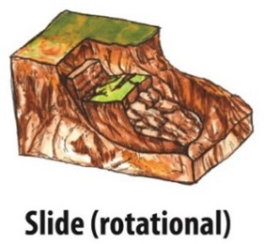
Lateral Spreads – The earth fractures and moves laterally, typically due to the weakness or
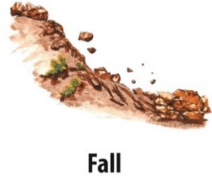
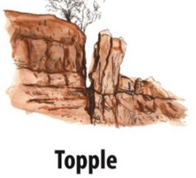
Fig_no: 1.1 Fig_no: 1.2 Fig_no: 1.3
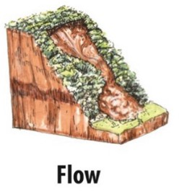
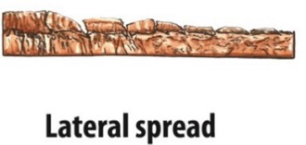
Fig_no:1.5

Fig_no:1.4
2

1.2 LITERATURE SURVEY

Author Name , Journal Name , Vol Page , Year : | Title of the Paper | Inference | Relevance with the present work / Motivation. | Research Gap
[1] S. R. Meena et al., Landslides, Vol. 19, 1209–1229 (2022) | Landslides | Used ML models and U-Net for landslide detection in the Himalayas. U-Net performed best with ~76% MCC. Adding DEM/topographic data helped differentiate terrain features. | Shows how U-Net–based image segmentation can detect natural hazards from satellite images.  Useful because your work also uses CNN/U-Net and image-based classification.  Demonstrates remote-sensing applications similar to environmental/agri-vision tasks. | Small dataset; limited generalization.  DEM fusion didn’t always improve results → need better multimodal fusion.  U-Net still early in landslide domain; needs large, diverse datasets.

Table_no 1.1
3

1.2 LITERATURE SURVEY

Author Name , Journal Name , Vol Page , Year : | Title of the Paper | Inference | Relevance with the present work / Motivation. | Research Gap
[2] C. Fang et al., ,”Remote Sensing, vol. 14, 2022 | “Landslide detection using remote sensing techniques.” | Used LiDAR-derived terrain maps + a lightweight U-Net variant (LAU-Net).  Accurately mapped ~1,900 historical landslides.  Achieved high IoU (~82%) and F1 (~87%). | Shows how topography + deep learning improves detection.  Demonstrates use of segmentation models beyond optical images (important for future remote-sensing projects).  Good reference if integrating DEM/LiDAR in your work. | Requires high-resolution LiDAR → not available everywhere.  Model may not generalize to new terrains without retraining.  Focuses only on historical landslides, not real-time detection.
4
Table_no 1.2

1.2 LITERATURE SURVEY

Table_no 1.3
Author Name , Journal Name , Vol Page , Year : | Title of the Paper | Inference | Relevance with the present work / Motivation. | Research Gap
[3] L. P. Soares, H. C. Dias, and C. H. Grohmann, 2024, | Deep-learning-based landslide mapping,” “Multimedia Tools and Applications”, | Reviews deep-learning techniques (classification, detection, segmentation) used for landslide analysis.  Highlights that DL outperforms traditional methods.  Discusses frameworks, progress, and challenges in geospatial landslide research. | Gives strong background for DL + remote sensing tasks.  Helps position your work within modern DL applications.  Useful for citing overall progress and importance of DL-based segmentation (like your U-Net experience). | Lack of standardized datasets across regions.  Deep models struggle with cross-regional generalization.  Need better multi-sensor data fusion (optical + DEM + SAR).  Real-time monitoring using DL still limited.

5
1.2 LITERATURE SURVEY

Author Name , Journal Name , Vol Page , Year : | Title of the Paper | Inference | Relevance with the present work / Motivation. | Research Gap
[4]Omid Ghorbanzadeh et al. , Remote Sensing , Vol. 11, Article 196 , 2019 | Evaluation of Different Machine Learning Methods and Deep-Learning CNNs for Landslide Detection | CNNs can detect landslides well, but do not always outperform traditional ML.  Best accuracy was CNN with 16×16 window using only spectral data (mIOU = 78.26%).  Topographic layers (slope, aspect) did not improve results. | Supports deep learning for landslide detection (same as your U-Net).  Shows quality training data is crucial.  Confirms spectral data alone works strongly.  Highlights need for better architectures, which motivates your U-Net/Attention U-Net approach. | CNN design not standardized; performance varies a lot.  Not enough labeled landslide datasets for strong training.  Impact of DEM/topographic features unclear.  Patch-based CNN struggles with irregular landslide shapes → motivates using U-Net.
Table_no 1.4
6
1.2 LITERATURE SURVEY

Author Name , Journal Name , Vol Page , Year : | Title of the Paper | Inference | Relevance with the present work / Motivation. | Research Gap
[5]Guangchen Li, Kefeng Li, Guangyuan Zhang, Ke Pan, Yuxuan Ding, Zhenfei Wang, Chen Fu, Zhenfang Zhu  Scientific Reports (Nature)  Vol. 15, Year 2025  Article 11852 | A landslide area segmentation method based on an improved UNet | The improved DEP-UNet (with Dilated Convolution + EMA Attention + Pag module) gives better accuracy than normal U-Net, improving mIoU, Precision, Recall and F1-score by ~2–3%. | Uses U-Net improvements, same as your U-Net / Attention U-Net project.  Shows why attention modules and better skip connections increase segmentation accuracy.  Proves that deep learning is effective for pixel-wise landslide mapping.  Motivates improving your model with better feature extraction + better fusion. | Standard U-Net loses spatial info + has weak skip connections.  Hard to capture multi-scale features of landslides.  Need better feature extraction (context) + better attention.  Existing models struggle with boundaries and fine details.
Table_no 1.5
7

1.3 PROBLEM DEFINITION

Landslide identification currently relies heavily on the manual examination of satellite or ground imagery. This method is time-consuming, subjective, and does not easily accommodate large or hard-to-reach areas. Conventional methods frequently miss detecting landslide zones at the pixel level, face challenges with intricate terrain characteristics, and lack robust quantitative assessment. Consequently, prompt landslide detection and accurate risk evaluation become challenging and inconsistent.

An automatic image-segmentation system utilizing an Attention U-Net architecture is suggested as a solution to this issue. After processing an input image using a deep learning model that has been trained, the system will produce a binary mask that highlights areas affected by landslides. Metrics including Precision, Recall, F1-Score, Dice Score, and Pixel Accuracy will also be used to assess its performance. The goal of this solution is to offer a dependable, precise, and effective instrument that reduces manual labor and facilitates early landslide risk assessment.

8

1.4 ANALYSIS OF THE PROBLEM AND THE SRS

Non-Functional Requirements:
1.⁠ ⁠Performance: Predictions should be generated within a few seconds.
2.⁠ ⁠Accuracy: The system should maintain high F1 and Dice scores.
3.⁠ ⁠Usability: Interface should be simple for non-technical users.
4.⁠ ⁠Scalability: Should support new images and potential dataset expansion.
5.⁠ ⁠Reliability: The system must load the model consistently and not crash for large images.
Hardware Requirements:
•⁠ ⁠GPU/CPU (Colab, Laptop, or Workstation)
•⁠ ⁠4GB+ RAM
•⁠ ⁠Storage for dataset & model weights
Software Requirements:
•⁠ ⁠Python
•⁠ ⁠PyTorch
•⁠ ⁠OpenCV
• NumPy, Matplot, SkittLearn⁠

9
1.5 SOLUTION STRATEGY

Integration of Multispectral Data:
To improve the accuracy of landslide identification, combine several input channels, such as RGB pictures, slope maps, and NDVI (Normalized Difference Vegetation Index), to provide a thorough spatial and environmental context.
Attention U-Net Architecture:
To improve segmentation accuracy on challenging terrain, use an Attention U-Net model to take advantage of its strong encoder-decoder structure with attention gates. This allows the network to concentrate on pertinent features and spatial regions.
Sturdy Data Augmentation and Preprocessing:
Normalize all input data and apply appropriate augmentations (rotation, flipping, scaling) to boost model robustness and help it generalize better across varied landscapes and lighting situations.

Optimizer and Balanced Loss Function:
To effectively address class imbalance (few landslide pixels vs. many non-landslide pixels), train the model using a combination of Binary Cross-Entropy (BCE) and Dice loss, improving both pixel-level accuracy and region overlap.
Validation Monitoring and Model Training:
Implement a learning rate scheduler and early stopping based on validation loss to prevent overfitting and provide consistent convergence, enabling the model to generalize effectively to unseen data.
Performance Evaluation and Metrics:
To guide iterative improvements, evaluate the model's accuracy in identifying landslide sites while reducing false positives and false negatives using precision, recall, and F1-score.
Implementation for Practical Use:
In order to enhance hazard monitoring, risk assessment, and prompt catastrophe response, prepare the trained model to produce dependable, comprehensible binary masks for landslide zones in fresh geospatial ima
10

1.6 PRELIMINARY USER’S MANUAL
1. Overview
This model uses Attention U-Net to segment landslide areas from multispectral images (RGB, NDVI, slope) and outputs a binary mask highlighting landslides.

2. System Requirements
- Hardware: GPU recommended for fast processing; CPU possible but slower.
- Software: Python 3.8+, Tensor Flow/PyTorch, and required libraries.

3. Input Data
- Provide normalized multispectral images (values between 0 and 1).
- Input should have consistent size and channels (RGB, NDVI, slope).

4. Using the Model
- Load the trained model weights.
- Pre-process images (normalize, stack channels).
- Run inference to get landslide probability mask.
- Apply threshold (e.g., 0.5) to get binary segmentation.
- Save or visualize the results.

5. Evaluation
- Use precision, recall, and F1-score to check accuracy.

6. Applications
- Landslide detection and monitoring.
- Hazard mapping

11
1.7 ORGANIZATIONS OF THE REPORT

Chapter 1 – Introduction
Provides background, problem overview, literature survey, formal definitions, SRS, and proposed solution.

Chapter 2 – System Design
Describes architecture diagrams, workflow, model design, dataset structure, preprocessing steps, and segmentation pipeline.

Chapter 3 – Implementation
Covers development tools, model code, training process, loss functions, and major modules implemented.

Chapter 4 – Results & Analysis
Presents training graphs, evaluation metrics, sample predictions, comparison of U-Net vs Attention U-Net, and discussion.

Chapter 5 – Testing
Includes test plan, test cases, test results, and observations.

Chapter 6 – Conclusion & Future Work
Summarizes achievements and outlines possible extensions such as multi-class segmentation, larger datasets, or integration with real-time alert systems.

12
2 DESIGN STRATEGY FOR THE SOLUTION

1. Requirement Analysis:
This phase involves identifying the need for an automated system capable of segmenting landslide regions from satellite imagery. Since manual interpretation is slow and unreliable, the project requires a robust deep-learning approach. Key requirements include selecting the Bijie Landslide Dataset, preparing multispectral inputs (RGB, NDVI, slope, elevation), handling class imbalance, and defining the evaluation metrics such as Precision, Recall, F1-Score, Dice Coefficient, and Pixel Accuracy. These requirements ensure clarity and guide all later steps.

2. System Design
In the system design stage, the architecture of the Attention U-Net model and the data flow pipeline are planned. The design includes preprocessing steps such as normalization, NDVI computation, and mask generation. The model structure incorporates encoder-decoder blocks with attention gates to emphasize landslide features. The loss function (BCE + Dice Loss) and training-validation workflow are defined here to ensure the system performs well on imbalanced data and fulfills the project’s objectives.

3. Implementation
This stage translates the design into working code. It includes loading and preprocessing the dataset, implementing channel normalization, preparing masks, and coding the complete Attention U-Net architecture with attention gates. Custom metrics like Precision, Recall, F1-Score, and Pixel Accuracy are added for performance tracking. The model is trained using BCE-Dice loss, and callbacks are used for optimization. By the end of implementation, the landslide segmentation system becomes fully operational.

4. Testing
Testing evaluates the model’s performance on unseen validation samples. Using metrics like Precision, Recall, F1-Score, Dice Score, and Pixel Accuracy, the system’s accuracy and consistency are measured. Predicted segmentation masks are visually compared with ground truth to verify correctness. This phase checks for issues such as overfitting or weak generalization and ensures the model reliably detects landslide regions across various terrain conditions.

5. Deployment
In deployment, the trained model is prepared for real-world use. A prediction pipeline is created where new satellite images can be loaded and processed to generate binary landslide masks. The system displays both the input image and its predicted mask for interpretation. This deployed model can be integrated into GIS tools or early-warning systems, making it practical for disaster management teams and field monitoring.
13
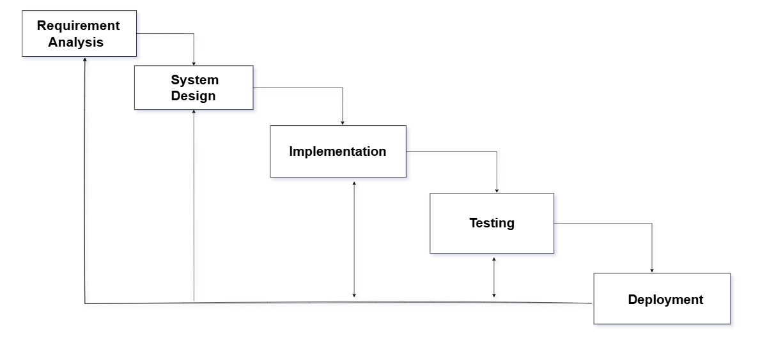
Fig_no:1.1 The above represents the SDLC (Software Development Life Cycle ) diagram that shows the structure and sequential development approach adopted for Landslide

14
2.1 ARCHITECTURE BLOCK DIAGRAM

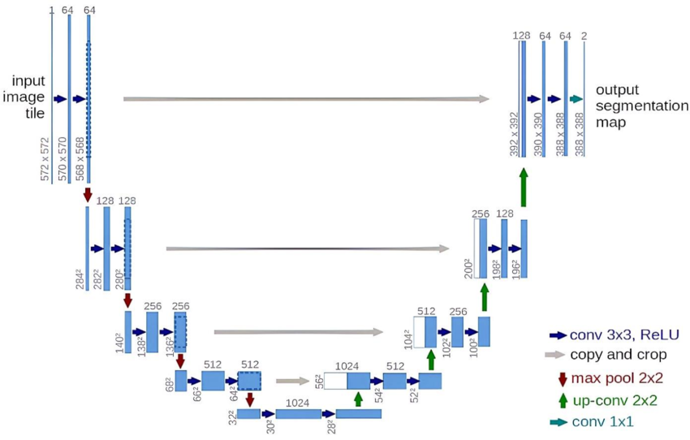

Fig_no:1.2 Standard U-Net Architecture Diagram

Input Image: An input image from satellites, drones, or ground-level sources is the starting point for our U-Net model. The algorithm only analyzes the image to identify distinctive visual patterns at this point; it has no idea where the landslide is.

Encoder (Feature Extraction): The encoder uses ReLU activation and repeated 3x3 convolutions to extract significant features. It picks up on changes in flora, debris patterns, slope variances, and soil textures. Max-pooling helps the model comprehend increasingly complicated landslide characteristics at each level by reducing the image size while boosting feature depth.

Bottleneck: To create a comprehensive knowledge of the image, the model integrates all of the learned elements at the bottleneck. Here, it distinguishes between areas that seem stable and those that mimic surfaces impacted by landslides.

Decoder (Reconstruction & Localization): The decoder highlights landslide areas while reconstructing the image. Skip connections retrieve specific information from the encoder, whereas up-convolutions restore resolution. This aids in the model's ability to precisely pinpoint the landslide and create clear borders.

Output: Each pixel in a segmentation map created by a final 1x1 convolution is labeled as either landslide or non-landslide. This produces a precise, unambiguous mask that delineates the impacted area.

15
2.2 DETAIL DIAGRAM
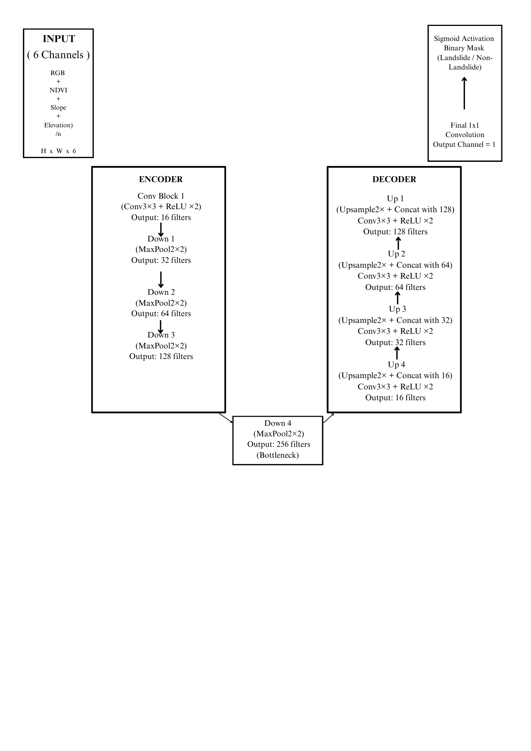
Fig_no:1.3 Attention U-Net architecture, showing how encoder-decoder layers, skip connections, and attention gates work together to produce a segmentation map from an input image.

Input Image:A 6-channel input (RGB + NDVI + Slope + Elevation/DEM) is provided to the model.The spatial dimensions are represented as H × W × 6, where the added channels supply both spectral and terrain information needed to detect landslide patterns.

Encoder (Feature Extraction):
The encoder progressively reduces spatial resolution while increasing the number of feature maps, helping the model learn rich landslide-relevant features.
Each encoder stage performs:
1. Two 3×3 Convolutions + ReLU, which help the model learn soil color changes, vegetation loss, slope shape, and debris textures.
2. MaxPooling (2×2), which reduces size and deepens feature understanding.
The diagram specifically shows:
16
- Conv Block 1 → 16 filters
- Down 1 → 32 filters
- Down 2 → 64 filters
- Down 3 → 128 filters

Bottleneck (Deep Feature Zone):This is the deepest layer (256 filters) where the model gathers highly abstract information.Here, U-Net combines all learned patterns—fracture lines, bare soil patches, slope breaks, and rough textures that are often indicators of landslide activity.

Decoder (Reconstruction):The decoder upsamples the compressed information back to the original image size while focusing on landslide regions.
It uses:
- Upsampling (×2) to increase spatial resolution
- Skip Connections to reintroduce fine details lost during pooling
- Concatenation to merge encoder and decoder features
- 3×3 Convolutions + ReLU for refining boundaries
The diagram includes:
- Up 1 → 128 filters
- Up 2 → 64 filters
- Up 3 → 32 filters
- Up 4 → 16 filters
This helps produce sharp, accurate landslide borders.

Final Output Layer: A 1×1 Convolution reduces the output to 1 channel, followed by Sigmoid Activation that generates the binary segmentation map.
- 1 → Landslide pixel
- 0 → Non-landslide pixel

17

3. DETAIL TEST PLAN

Test Scenario 1 — Model Configuration Check
Objective: Ensure the Attention U-Net architecture is correctly constructed.
Test Scenario 2 — Forward Pass Evaluation
Objective: Confirm that the model accepts and processes input batches.

Test Scenario 3 — Loss Function Validation
Objective: Check correct calculation of BCE-Dice combined loss.
Test Scenario 4 — Training Loop Stability
Objective: Ensure training progresses smoothly.

Test Scenario 5 — Prediction Quality Analysis
Objective: Evaluate the meaningfulness of predicted masks.

Test Scenario 6 — Metric Computation Accuracy
Objective: Validate correctness of precision, recall, and F1-score.

Test Scenario 7 — Dice Coefficient Assessment
Objective: Measure mask overlap quality.

Test Scenario 8 — Pixel Accuracy Evaluation
Objective: Determine overall pixel-level correctness.

18

4 IMPLEMENTATION DETAILS

Pseudo Code / Algorithm :
- Dataset Preparation:
FOR each image in dataset:
load image and its mask
resize both to 256×256
normalize image (0–1)
store (image, mask)
END
split dataset → 85% training, 15% validation
create train_loader and val_loader

2. Model Architecture (Attention U-Net):
Encoder:
Apply DoubleConv blocks and Down-sampling (MaxPool)
Attention Gates:
For each skip connection:
combine encoder feature (x) and decoder feature (g)
compute attention mask
output = x * mask
Decoder:
Upsample + concatenate attended features
Apply DoubleConv
Final Layer:
1×1 convolution → output mask

3. Loss Function
dice_loss = 1 - (2 * intersection / (sum(pred) + sum(mask)))
total_loss = 0.5 * BCEWithLogits + 0.5 * dice_loss

4. Training Loop
best_f1 = 0
FOR epoch = 1 to 45:
set model to train mode
FOR each batch:
pred = model(images)
loss = total_loss(pred, masks)
backpropagate and update weights

set model to eval mode
FOR each validation batch:
pred = model(images)
compute precision, recall, f1
IF current_f1 > best_f1:
19
save model as best_unet.pth
best_f1 = current_f1

END

5. Prediction on New Image:
load best_unet.pth
read input image
resize and normalize
convert to tensor
mask = sigmoid(model(image)) > 0.5
resize mask back to original size
overlay mask on image
display output

6. Evaluation Metrics:
precision = TP / (TP + FP)
recall = TP / (TP + FN)
f1-score = harmonic_mean(precision, recall)
dice = overlap-based metric
pixel_accuracy = correct_pixels / total_pixels

20

4.1 DATASET DESCRIPTION

DATASETLINK: https://www.kaggle.com/datasets/hanstankman/bijie-landslidedataset

MAIN FOLDER NAME: bijie-lanslidedataset

TOTAL IMAGES: 3567

SUB GROUPS OF THE TOTAL IMAGES :
1.⁠ ⁠LANDSLIDE IMAGES : 770
2.⁠ ⁠LANDSLIDE MASKS : 770
3.⁠ ⁠NON-LANDSLIDE IMAGES : 2027

SUB FOLDER DETAILS :
1.landslide/ image/ → landslide images
Land slide_biji_dataset
mask/ → ground-truth segmentation masks
mask pixels = white → landslide
black → non-landslide

2. non-landslide/ image/ → normal terrain images (without masks)
For these images, we create a zero mask (all black)

IMAGE SIZE : 256 x 256

DATASET CHALLENGES:
- Irregular shapes
- Mixed terrain texture
- Shadows, vegetation
- Small landslide areas
- Class imbalance (many non-landslide images)
- Because of these challenges, I used the Attention U-Net architecture.
21
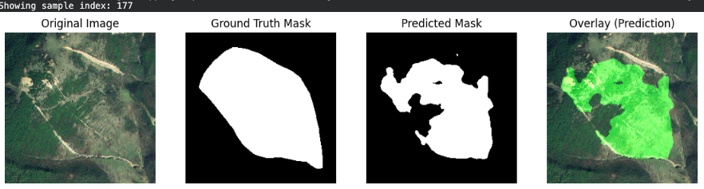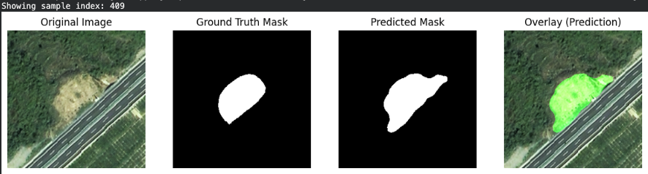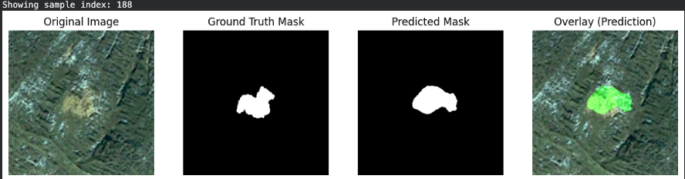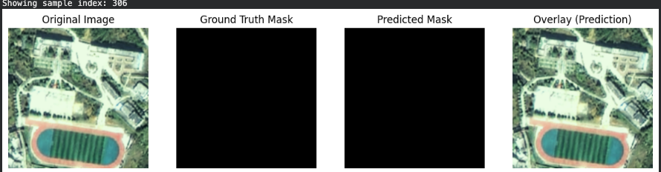
Fig_no:1.1 shows the comparison between the original satellite images, ground truth masks, and the landslide regions predicted by our model. The overlays highlight how accurately the model identifies and segments the landslide areas across different terrains.
Orignal Image: The raw satellite image used as input for landslide segmentation.

Ground Truth Mask: The manually annotated mask indicating the actual landslide region.

Predict Mask: The segmentation mask generated by the trained Attention U-Net model.

Overlay Prediction: The predicted mask overlaid on the original image to visually compare model accuracy.

22
4.2 FLOW CHART OF IMPLEMENTATION

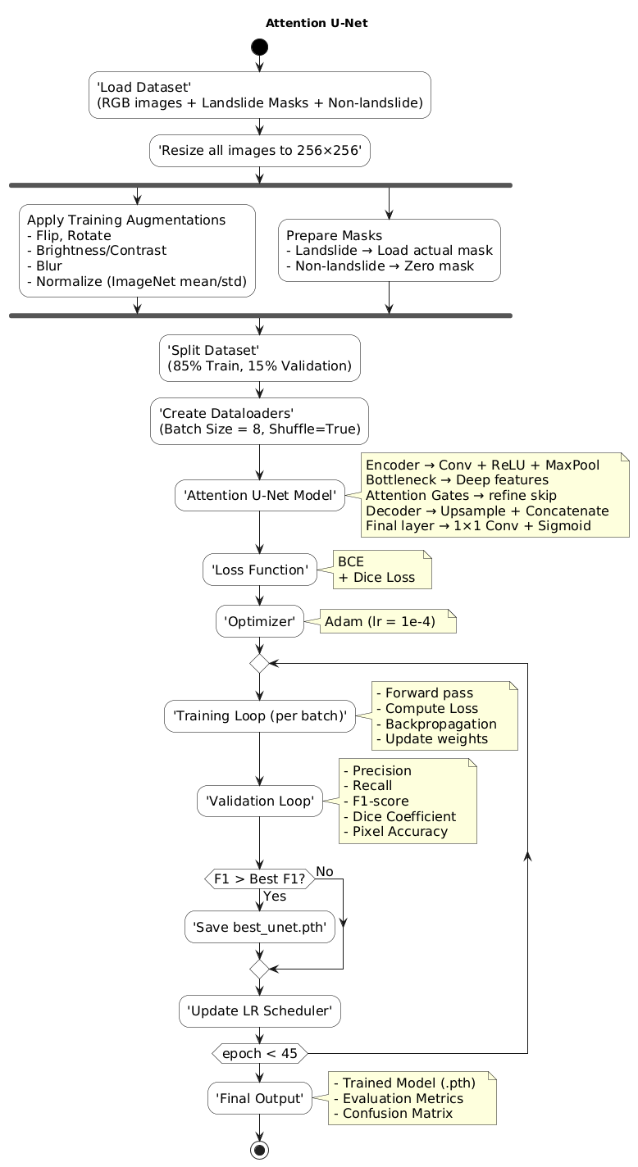

Fig_no:1.2 Workflow of the Attention U-Net Based Landslide Segmentation Model
4.3 DETAILED DESCRIPTION OF FLOW CHART OF IMPLEMENTATION
Figure 1.2 illustrates the complete workflow pipeline followed in our landslide detection project using the Attention U-Net model. The process begins by loading the RGB satellite images along with their corresponding landslide and non-landslide masks. All images are resized to a uniform resolution of 256×256 and undergo data augmentation techniques such as flipping, rotation, and brightness adjustments to improve model generalization. Masks are prepared so that landslide regions retain their labels while non-landslide images receive zero masks.
23
The dataset is then split into 85% training and 15% validation, and dataloaders are created for batch-wise processing. The core model, Attention U-Net, uses an encoder–decoder structure enhanced with attention gates that refine skip-connections, improving focus on landslide-specific features. The training uses a combination of Binary Cross Entropy and Dice Loss, optimized using the Adam optimizer.
During each epoch, the model performs forward passes, loss computation, and backpropagation, followed by validation where metrics such as Precision, Recall, F1-Score, Dice Coefficient, and Pixel Accuracy are evaluated. If the model achieves a better F1-score than previous epochs, it is saved as the best-performing model. This loop continues for multiple epochs with a learning-rate scheduler to improve convergence.
The final output includes the trained model file, overall evaluation metrics, and the confusion matrix, summarizing the model’s performance on landslide segmentation.

24
5 RESULT & DISCUSSIONS

Aspect Evaluated | Observation / Discussion
Training Behavior | Training loss dropped steadily from 0.70 to 0.10, showing the model learned features effectively without instability.
Validation Behavior | Validation loss reduced from ~0.67 to ~0.19 across epochs, indicating that the model generalized well and avoided overfitting.
Precision Trend | Precision improved from ~0.26 in early epochs to peaks of ~0.72, meaning fewer false positives as training progressed.
Recall Trend | Recall reached as high as ~0.80, showing that the model became effective at detecting most landslide pixels.
F1-Score Performance | The best F1-score achieved was ~0.685, demonstrating a strong balance between precision and recall for this dataset.
Model Quality | Attention U-Net produced smoother boundaries and clearer segmentation compared to the vanilla U-Net version, especially in complex terrain.
Visual Evaluation | Overlay results showed that the model accurately highlighted landslide regions, especially where soil exposure or slope patterns were clear.
Table no. 1.1 : This table summarizes the model’s training and validation behavior, precision–recall trends, F1-score performance, and visual quality, showing how the Attention U-Net improved accuracy, reduced losses, and produced clearer landslide segmentation results.

Confusion Matrix:
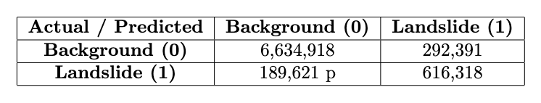
Table_no 1.2 shows the confusion matrix values indicating how accurately the model classified background and landslide pixels, including correct predictions and errors.
Number | Meaning
6,634,918 | Correctly identified background pixels (TN)
292,391 | Background pixels wrongly marked as landslide (FP)
616,318 | Correctly identified landslide pixels (TP)
189,621 | Landslide pixels missed by the model (FN)

Table_no 1.3 summarizes the meaning of each confusion matrix value, explaining the correctly and incorrectly classified background and landslide pixels.
25

Performance Matrix:
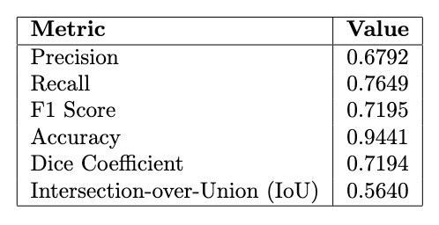
Table_no 1.4 presents the overall performance metrics of the model, summarizing its precision, recall, F1 score, accuracy, Dice coefficient, and IoU.

Performance Metrics and Confusion Matrix

1. Confusion Matrix
 | Predicted: Negative | Predicted: Positive
Actual: Negative | TN = 6,634,918 | FP = 292,391
Actual: Positive | FN = 189,621 | TP = 616,318

Table_no 1.5 provides a detailed confusion matrix showing how many pixels were correctly and incorrectly classified as landslide or non-landslide by the model.

Metric Definitions:

Accuracy:
Accuracy = (TP + TN) / (TP + TN + FP + FN)

Precision:
Precision = TP / (TP + FP)

Recall:
Recall = TP / (TP + FN)

F1-Score:
F1 = 2 × (Precision × Recall) / (Precision + Recall)

Dice Coefficient:
Dice = (2 × TP) / (2 × TP + FP + FN)
26

Performance Summary Table

Metric | Value
Accuracy | 0.94
Precision | 0.67
Recall | 0.76
F1-Score | 0.71
Dice Coefficient | 0.71

Table_no 1.6 provides a concise summary of the model’s overall performance metrics, including accuracy, precision, recall, F1-score, and Dice coefficient.

27
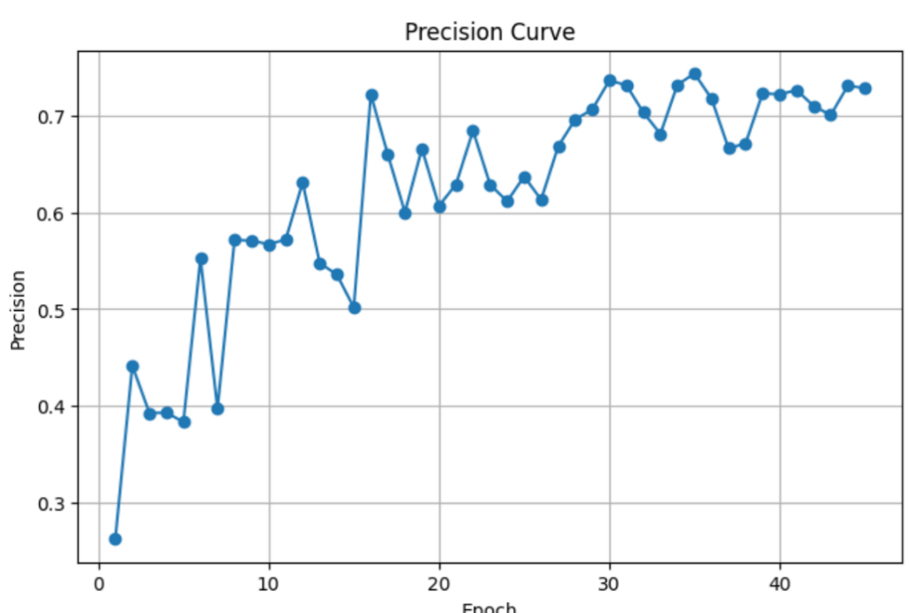
5.1 GRAPH

Fig:1.1 Graphical representation of the Precision Curve: The precision steadily rises from about 0.28–0.35 in early epochs to roughly 0.70–0.73 by the end, with some mid-training oscillations; this shows the model progressively makes fewer false-positive pixel predictions as training proceeds, indicating improved confidence in predicted landslide pixels while still experiencing short-term variability during learning.

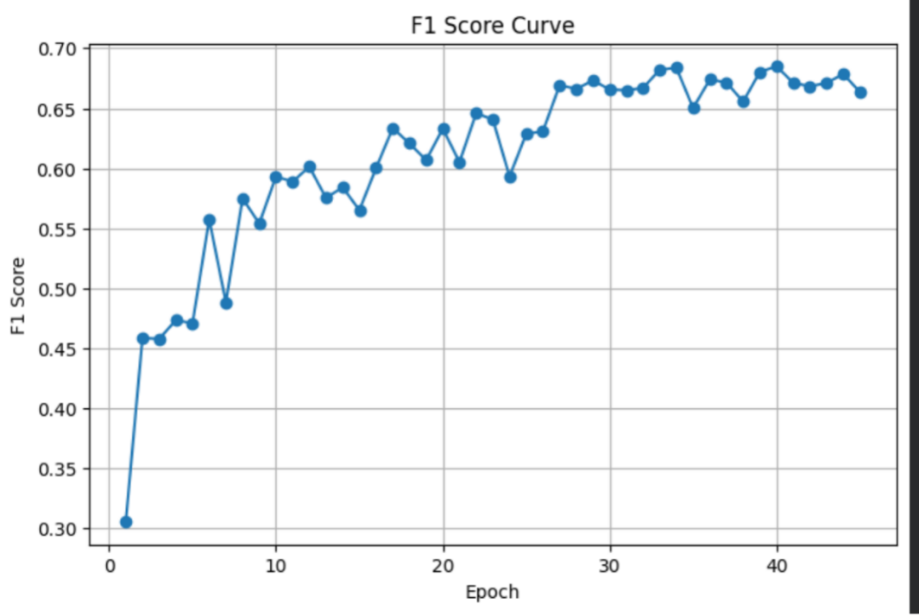
Fig: 1.2 Graphical representation of the F1 Score Curve F1 Score Curve: The F1 score climbs from ≈0.30 to ≈0.66–0.68 across epochs, following a generally smooth upward trend; this improvement reflects a balanced gain in both precision and recall over training, with the curve’s later plateau suggesting the model is approaching its best trade-off between false positives and false negatives.
28
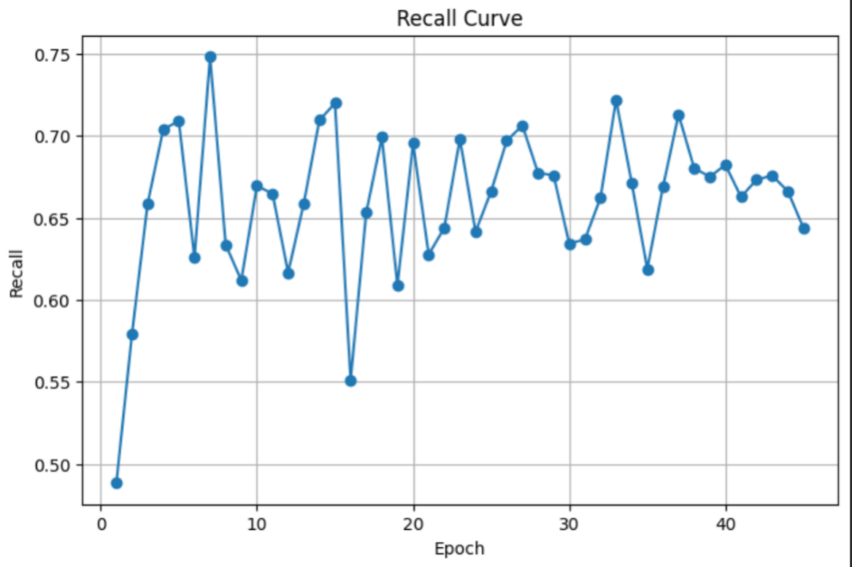
16
Fig: 1.3 Graphical representation of the Recall Curve Recall Curve: Recall rises quickly in early epochs then fluctuates between about 0.55 and 0.72 throughout training, showing the model often succeeds in finding true landslide pixels but remains somewhat unstable in consistently capturing all positive pixels—this variability means the model sometimes trades off detection sensitivity for fewer false positives.

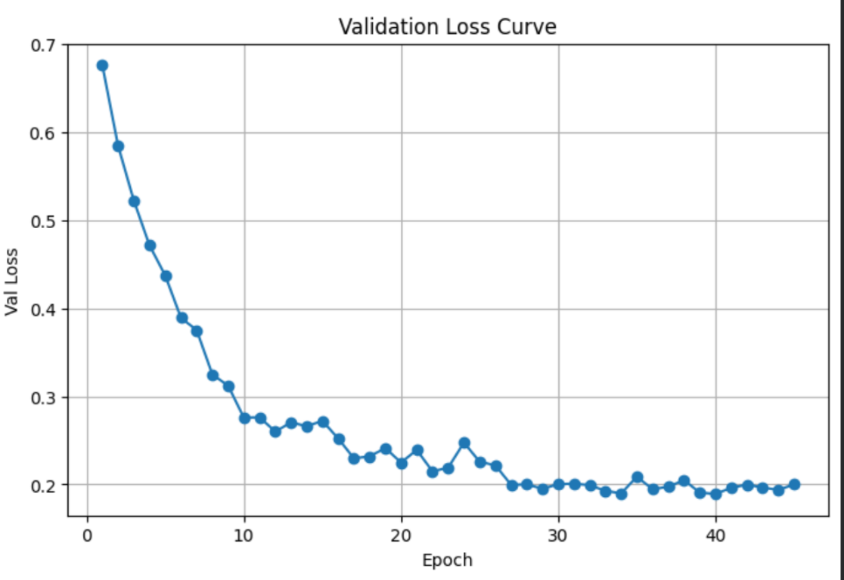

Fig: 1.4 Graphical representation of the Validation Loss Curve: Validation Loss Curve: Validation loss drops sharply from ~0.68 to ~0.25 within the first 10 epochs and then slowly declines and stabilizes around ~0.18–0.22, indicating rapid early learning and then steady convergence with no large late increases — a sign the model is generalizing well to unseen validation data rather than overfitting.

29
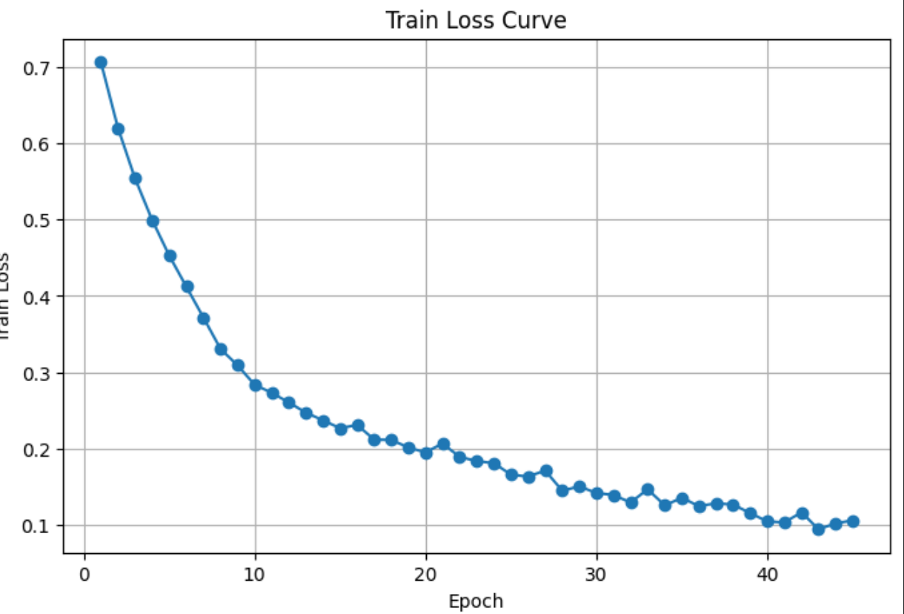

Fig: 1.5 Graphical representation of the Train Loss Curve:
Train Loss Curve: Training loss decreases smoothly and monotonically from about 0.7 down to ~0.10 by the final epochs, showing consistent learning and weight updates; the gap between train and validation loss is small in later epochs, which supports that training is stable and the model is not severely overfitting.

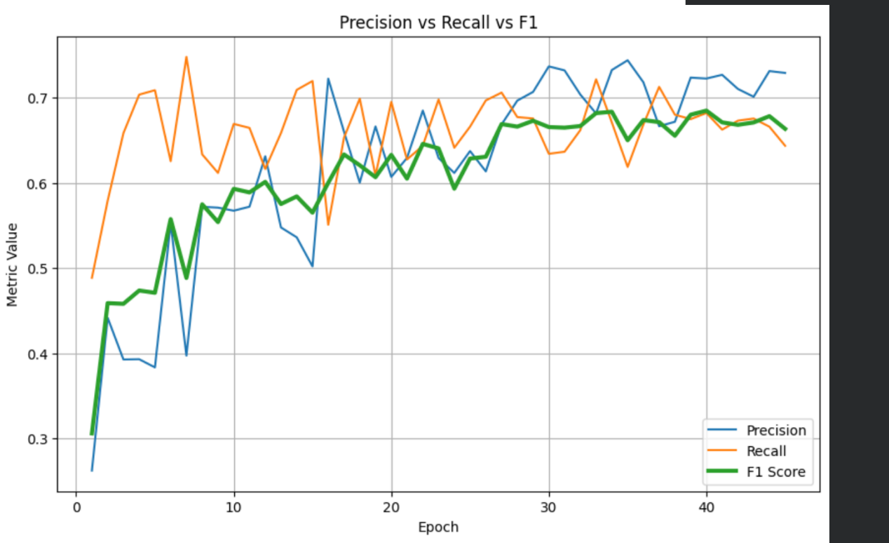

Fig: 1.6 compararive analysis Graphical representation of the Precision curve, F1 Score Curve and Recall : Precision vs Recall vs F1 Comparison Curve: The combined plot shows precision (blue), recall (orange) and F1 (green) beginning apart but converging toward ~0.65–0.72 in later epochs; this convergence indicates the model’s metrics are harmonizing (better balance between identifying true landslides and avoiding false alarms), with F1 tracking between precision and recall as the balanced summary metric.

30

6 SUMMARY OF ACHIEVEMENTS

The Bijie Landslide Dataset and an enhanced Attention U-Net semantic segmentation model were used in this study to successfully construct an automated landslide detection system. The system classifies satellite photos pixel-by-pixel, separating landslide areas from regular terrain.

Important achievements include:
Processing of the Dataset: Every image, both landslide and non-landslide, was cleaned, normalized, and transformed into mask-label pairs. For non-landslide photos, zero-masks were developed.

Augmentation: To enhance generalization, Albumentation alterations such flips, rotations, brightness/contrast adjustments, and normalization were used.

Model Implementation: Attention U-Net outperformed Vanilla U-Net in terms of performance.

Training and Optimization: BCE + Dice Loss, Adam optimizer, learning rate scheduler, and GPU acceleration were used to train for 45 epochs.

6.1 MAIN DIFFICULTIES ENCOUNTERED WITH SOLUTION
31

1.A noisy background and complicated terrain
Rocks, plants, shadows, and uneven textures can all be seen in satellite photos.
Attention gates were used as a solution to assist suppress noise and concentrate on pertinent areas.

2. Tiny and Unpredictable Landslide Forms
Pixels from landslides were frequently tiny and challenging to identify.
Solution: Dice Loss and high-resolution training (256x256) enhanced boundary detection.

3. Unbalanced Classes
There are far more pictures of non-landslides than of landslides.

Resolution:
Sample diversity was enhanced by data augmentation.
The impact of unbalance was lessened by dice loss.

4. Various Image Dimensions
The dimensions of the dataset photos varied.
Solution: Albumentations were used to standardize all inputs to 256x256.

5. Risk of Overfitting:
Potential overfitting resulted from the small dataset size.

6: Resolution:
- Robust enhancements
- Monitoring for validation
- Scheduling learning rates
- Stable and balanced model performance was guaranteed by these tactics.

6.2 LIMITATION OF THE PROJECT
32
20

Requires high-quality photos,When the photos are clear, the model performs well. Images that are low-resolution, blurry, or dark could confound the system and make it less accurate.
Not all terrains allow for perfect landslide detection.The model occasionally makes mistakes because extremely rocky, snowy, or heavily forested terrain may resemble collapses.
Depending on the dataset used for training, the model might not be able to handle novel or unforeseen circumstances if the training photos do not include all sorts of landslides or environments.computationally demanding
A powerful computer or GPU is needed to run the model. Predictions could be slow on low-powered devices.only detects landslides that are visible.Only what is visible on the surface may be detected by the model. Future landslides and subterranean motions cannot be predicted by it.

33
6.3 FUTURE SCOPE OF WORK

1. Model Enhancements
- Integrate more advanced deep-learning architectures such as DeepLabV3+, TransUNet, U-Net++, and Swin-UNet to improve segmentation accuracy.
- Utilize multi-spectral and multi-modal datasets (RGB + Infrared + Digital Elevation Model (DEM) + SAR imagery) to capture deeper terrain characteristics and enhance prediction robustness.
2. Dataset Expansion
- Extend the training database by adding global landslide datasets from multiple countries with diverse terrains and climates.
- Improve the resolution and accuracy of ground-truth masks to achieve finer segmentation boundaries.
3. Real-World Deployment
- Develop a real-time landslide monitoring platform deployable on cloud servers or mobile devices.
- Integrate the system with GIS-based platforms used by disaster-management authorities for regional monitoring and emergency planning.

34
7 GANTT CHART

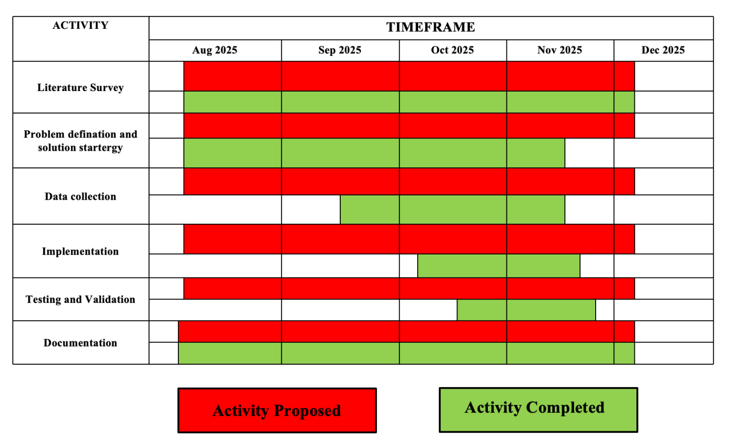

Table_no:1.1 The above shows the Gantt Chart that resembles the timline of the completion of our project based on the Literatue Survey , Problem Definition , Solution Strategy , Data Collection , Implementation , Testiing and Validation , Documentation

35
8 REFERENCE

[1] S. R. Meena, L. P. Soares, C. H. Grohmann, C. van Westen, K. Bhuyan, R. P. Singh, M. Floris, and F. Catani, “Landslides,” Landslides, vol. 19, pp. 1209–1229, 2022, doi: 10.1007/s10346-022-01861-3.
[2] C. Fang et al., “Landslide detection using remote sensing techniques,” Remote Sensing, vol. 14, 2022, doi: 10.3390/su142416311.
[3] L. P. Soares, H. C. Dias, and C. H. Grohmann, “Deep-learning-based landslide mapping,” Multimedia Tools and Applications, 2024, doi: 10.1007/s11042-024-19454-8.
[4] G. Li, K. Li, G. Zhang, K. Pan, Y. Ding, Z. Wang, C. Fu, and Z. Zhu, “A landslide area segmentation method based on an improved UNet,” Scientific Reports, vol. 15, p. 11852, 2025, doi: 10.1038/s41598-025-94039-5.
[5] O. Ghorbanzadeh, T. Blaschke, K. Gholamnia, S. R. Meena, D. Tiede, and J. Aryal, “Evaluation of Different Machine Learning Methods and Deep-Learning Convolutional Neural Networks for Landslide Detection,” Remote Sensing, vol. 11, no. 196, pp. 1–21, 2019, doi: 10.3390/rs11020196.

36

Plagiarism Scan Report


3% Words 925
Exact Match Characters 6608
3% Sentences 100
Plagiarism 97% Paragraphs 135
0%
Partial Match Unique Read Time 5 minute(s)
Speak Time 7 minute(s)

ABSTRACT
One of the main natural disasters that can seriously harm people, property, and infrastructure is landslides. Early detection of possible landslide areas using drone and satellite imagery can lower risks and assist disaster management teams. Large-scale landscape data analysis is not appropriate for traditional manual inspection procedures, which are slow and heavily rely on specialists.
Binary Cross-Entropy (BCE) and Dice Loss are used to train the model, and measures including Precision, Recall, F1-Score, Dice Coefficient, and Pixel Accuracy are used to evaluate it. Despite dataset imbalance, the top model demonstrated high segmentation capabilities with an F1-score of 0.685. On validation images, visual results demonstrate precise and reliable predictions.
All things considered, this work offers a dependable and effective deep learning method for identifying landslide-prone regions. The final model is useful for applications related to environmental safety and catastrophe response since it can support early warning systems, hazard
mapping, and real-time monitoring

- INTRODUCTION
Large amounts of soil, rock, and debris lose stability and flow quickly downslope, causing landslides, one of the most abrupt and deadly natural disasters. They are frequently brought on by heavy rains, earthquakes, loose geological formations, deforestation, and other human activities that cause the land to become unstable.
Landslides have a severe and enduring effect on human life. Farmlands can be buried, transit routes obstructed, entire homes destroyed in a matter of seconds, and communities cut off from vital services. In addition to the physical harm, people can suffer from financial loss, mental distress, and dislocation. While better building techniques, local warning systems, and evacuation procedures provide some protection, conventional monitoring techniques are still labor-intensive, slow, and unable to cover vast, hilly areas in real time.
Disaster detection and response have started to change in recent years due to technological breakthroughs, especially artificial intelligence. Compared to manual inspection, deep learning algorithms have demonstrated remarkable capacity to analyze complicated visual patterns and identify hazards more
rapidly and accurately. Among these models, U-Net and its variations have proven to be effective tools for segmenting images, particularly in situations where accurate identification of impacteo create a deep learning-based landslide detection system, our project advances this technological change. By adding attention gates, it suppress noise while concentrating on the most important areas of an image. The outcome is a very precise segmentation mask that makes the precise areas damaged by landslides very evident.
The model produces a clear and distinct segmentation mask that precisely delineates the landslide region after processing an input image. Our study uses recognized metrics like Precision, Recall, F1-Score, Dice
Score, and Pixel Accuracy to evaluate the model's performance in a rigorous manner. These metrics aid in evaluating the system's accuracy, dependability, and general efficacy under practical circumstances.

  - GENERAL OVERVIEW OF THE PROBLEM
Plagiarism Scan Report


7% Words 925
Exact Match Characters 6608
7% Sentences 100
Plagiarism 93% Paragraphs 135

0%
Partial Match Unique Read Time 5 minute(s)
Speak Time 7 minute(s)

Content Checked For Plagiarism
1.6 PRELIMINARY USER’S MANUAL

- Overview
This model uses Attention U-Net to segment landslide areas from multispectral images (RGB, NDVI, slope) and outputs a binary mask highlighting landslides.
- System Requirements
Hardware: GPU recommended for fast processing; Software: Python 3.8+,
- Input Data
Provide normalized multispectral images (values between 0 and 1). Input should have consistent size and channels (RGB, NDVI, slope) max e
- Using the Model
Load the trained model weights.
Pre-process images (normalize, stack channels). Run inference to get landslide probability mask.
Apply threshold (e.g., 0.5) to get binary segmentation. Save or visualize the results.
- Evaluation
Use precision, recall, and F1-score to check accuracy.

- Tips
Use clear, high-quality images for best results. Verify input format and normalization.
Use GPU for faster prediction.

- Applications
Landslide detection and monitoring. Hazard mapping

3.IMPLEMENTATION DETAILS

Pseudo Code / Algorithm :
1.Dataset Preparation:
FOR each image in dataset:

