**GI: Generating Input**

**Version 1.0**

Fatemeh Jamalidinan

Draft date October 17, 2013

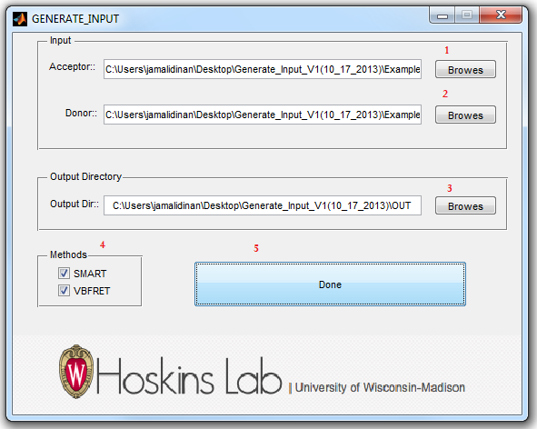

Figure 1.1: GUI_Generating_Input interface (example data)

1. Go to your input directory and select the acceptor (Figure 1.1).
2. Go to your input directory and select the donor (Figure 1.1).
3. Choose the output directory (Figure 1.1).
4. The software allows the user to select VBFRET, SMART, or both (Figure 1.1).
5. Pressing the “Done” button will run the software (Figure 1.1).