

Business Template

subwaY System
Diagram
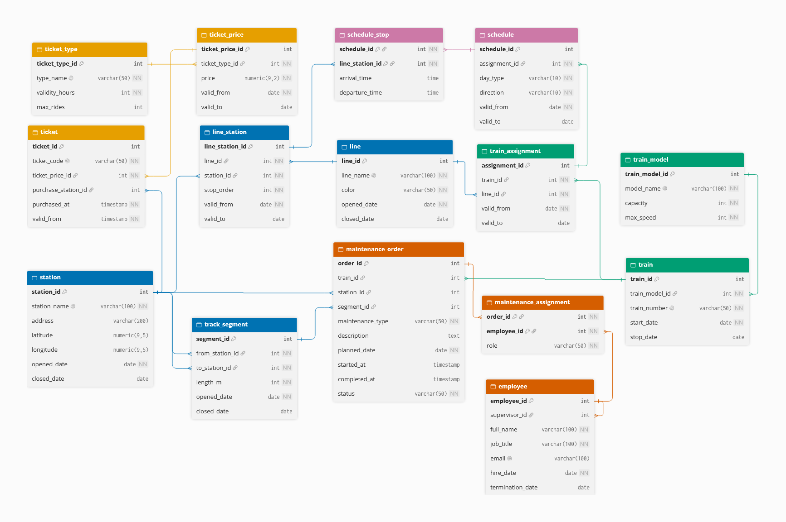

Contents
Business Description 3
1.1 the Benefits of implementing a database. Project Vision 3
2 Model description 3
2.1 Definitions & Acronyms 3
2.2 Logical Scheme 3
2.3 Objects 3

Business Description

the Benefits of implementing a database. Project Vision
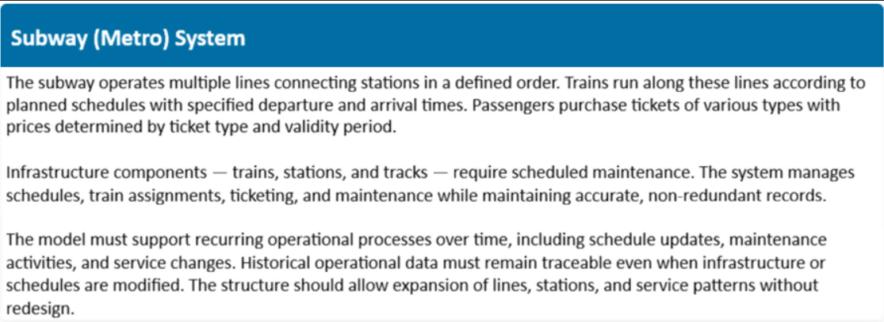

To answer these questions, you can rely on the following questions:
- How will the database solve the problems listed in the description?
The tasks ask to solve problem related to schedules, train assignments, tickets, maintenance and history records, which I solved creating groups of tables (that will listed in objects below):
The network (line, station, line_station, track_segment) that stores the data related to lines etc.
The fleet (train_model, train, train_assignment) stores which train works on which line and when.
The timetable (schedule, schedule_stop) stores the time plan (departure and arrival)
The tickets (ticket_type, ticket_price, ticket) stores ticket types and prices etc.
The maintenance (employee, maintenance_order, maintenance_assignment) stores who did what.
- How will it ensure data integrity, consistency, and traceability?
Integrity ensured by PK and FK, for example, a ticket can’t point to a price that doesn’t exist, UNIQUE stops duplicates, NOT NULL stops missing values and CHECK stops unrelated values.
Consistancy ensured by 3NF rules, like a staion’s name is in one row, changing it will change all.
Traceability ensured by relations that help to trace from one table to another (as ticket > price > type)
- How does your model store the history of changes?
Through date type as in valid_from – valid_to in schedules. Or for instance, a ticket points to the price row that has new value while the old price in row is not changed.
- How does your structure allow the system to scale without major redesign?
By adding new rows in a table (as line, station, schedule).
- Which constraints and checks have you added to keep data correct as volume grows?
NOT NULL, UNIQUE, DEAFAULT, CHECK – which help to ensure the data is correct.

Model description

Definitions & Acronyms
To answer these questions, you can rely on the following questions:
- Which key entities, roles, or processes require formal definitions for correct interpretation of the model?
- Which terms could be misunderstood without clarification?
If person does not know the subway system infrastructure subway. Line – a metro route. Station – a place where passenger enter and leave. Track segment – the stretch of rails between two neighboring stations etc.
- Which abbreviations or role names appear repeatedly in tables or relationships?
I used PK (primary key), FK (foreign key), NN (NOT NULL), UQ (unique), M:N (many-to-many), 3NF (third normal form), id (identifier), m (metres), kmh (kilometres per hour).

Logical Scheme
Answer following questions:
- Which modeling decision was the most difficult and why?
Personally, the unfamiliar field (subway) was new to me, so I had to research how a metro is organized. The challenging decision was related to maintenance_order as the task asked to table for trains, stations and tracks repair table. I could separate them all in different tables or a generic table but decided 3 nullable FK columns with a CHECK constraint so that only one will be filled.
- Provide examples of potential data anomalies that your design prevents. Explain which constraints or structure elements prevent them.
For example, if the price were stored in every ticket row, one price change would change all values, that is why its separated in ticket_price with UNIQUE constraint. Thanks to FKs user cannot sell (by inserting new price) if that price does not exist. Also you cannot delete a station that is till used in line_station or track_segment because of FKs.
- If you were to add new attributes or participants, would the model remain scalable and why?
Yes, because each concept has its own table and connections. User can add new attributes or more table with relations.
- Which part of your model would most likely change if requirements expand?
I think likely maintenance_order and employee because these tables could be done with more complexity and details.

Objects
Table Description:
- What real-world concept or event does this table represent?
- Why must this information be stored separately instead of inside another table?
- What is the normalization level of the table (1NF, 2NF, 3NF)? Explain your reasoning.
- Are there partial or transitive dependencies? How did you eliminate them? Which attributes depend only on the key, and which depend on other fields?
- Why did you choose this primary key (PK) for the table? Could a composite key work instead? Which foreign keys (FK) did you add and why?

Table Name | Field name | Field Description | Data Type
station | Station_id | Unique number, PK | Int
station | Station_name | Official name, NN, UNIQUE | Varchar(100)
station | Address | Unique number, PK | Int
station | Latitude | location | Numeric(9, 5)
station | Longitude | location | Numeric(9, 5)
station | Opened_date | NN | date
 | Closed_date |  | date

Example with data (2-3 rows)

Station_id | Station_name | address | Latitude | Longitude | Opened_date | Closed_date
1 | Bishkek | Chui Ave 120 | 42.8765 | 74.6034 | 2026-05-01 | NULL
2 | Almaty | Aalym | 42.8765 | 74.6034 | 2026-08-01 | NULL

- It represents the metro station where people get on and off the train.
- Because of 3NF rules and one change would lead to change of all rows.
- 3NF, because every values is single, key is one coluns so there are no partial dependencies and no column is determined by another non-key column.
- Everything depends only on station_id (PK). I considered the address enough but added latitude and longitude, because from my experience with GIS datasets it would be nice to include, especially for applications to find locations on map.
- I used station_id because name could change over time. Latitude and longitude as a composite key would also work, but it will long and misleading.

Table Name | Field name | Field Description | Data Type
line | line_id | Unique number, PK | Int
line | line_name | Official name, NN, UNIQUE | Varchar(100)
line | color | NN | Int
line | Opened_date | NN | Date
line | Closed_date | CHECK: closed_date IS NULL OR closed_date >= opened_date. | Date

Example with data (2-3 rows)

line_id | line_name | color | Opened_date | Closed_date
1 | Line1 | red | 2026-05-01 | NULL
2 | Line2 | blue | 2026-08-01 | 2026-08-31

- A metro route.
- Many tables refer to a line, and its name and colour would repeat if stored elsewhere.
- 3NF: a single-column key, and no column determines another.
- None: name, color and dates describe only the line.
- line_id is a surrogate key, since a line can be renamed. It has no FKs.

Table Name | Field name | Field Description | Data Type
line_station | Line_station_id | PK | Int
line_station | Line_id | FK, NN | Int
line_station | Station_id | NN, FK | Int
line_station | Stop_rder | NN | int
line_station | Valid_from | NN | date
line_station | Valid_to | CHECK: valid dates, stop_order > 0. | date

Example with data (2-3 rows)

Line_station_id | Line_id | Station_id | Stop_order | Valid_from | Valid_to
1 | 1 | 1 | 1 | 2020-05-01 | NULL
2 | 1 | 2 | 2 | 2020-05-01 | NULL

- The fact that a station is on a line at a position during a period.
- stop_order belongs to neither the line nor the station alone, so it needs its own table.
- 3NF.
- None: stop_order, valid_from and valid_to depend on the whole fact.
- A surrogate line_station_id. The composite (line_id, station_id, valid_from) could work, but schedule_stop would then need all three columns as its FK. I used FKs: line_id, station_id.

Table Name | Field name | Field Description | Data Type
track_segment | Segment_id | PK | Int
track_segment | From_station_id | FK, NN, CHECK: from_station_id <> to_station_id, | Int
track_segment | To_station_id | FK, NN | Int
track_segment | Length_m | NN, length > 0. | Int
track_segment | Opened_date | NN | Date
track_segment | Closed_date |  | date

Example with data (2-3 rows)

Segment_id | From_station_id | To_staion_id | Length_m | Opened_date | Closed_date
1 | 1 | 2 | 1250 | 2020-05-01 | NULL
2 | 2 | 3 | 1800 | 2022-09-15 | NULL

- The rails between two neighbouring stations, which can be maintained.
- A segment isn’t a property of a station: it connects two, and it has its own length and dates.
- 3NF.
- None
- Surrogate segment_id, with (from_station_id, to_station_id). Two FKs, both to station.

Table Name | Field name | Field Description | Data Type
train_model | Train_model_id | PK | Int
train_model | Model_name | Official name, NN, UNIQUE | Varchar(100)
train_model | Capacity | Unique number, NN, CHECK: capacity > 0. | Int
train_model | Max_speed | NN, speed > 0. | int

Example with data (2-3 rows)

Train_model_id | Model_name | Capacity | Max_speed
1 | MX-100 | 1200 | 80
2 | MX-200 | 1500 | 90

- A type of train with its specifications.
- Capacity and maximum speed depend on the model, not on each train. If they were in train, they would repeat for every train and create a transitive dependency (train > model > capacity).
- 3NF.
- I removed that transitive dependency by creating this table.
- train_model_id and model_name .

Table Name | Field name | Field Description | Data Type
train | Train_id | PK | Int
train | Train_model_id | NN, FK | Int
train | Train_number | NN, unique | Varchar(50)
train | Start_date | NN | Date
train | stop_date | CHECK: stop_date IS NULL OR stop_date >= start_date. | Date

Example with data (2-3 rows)

Train_id | Train_model_id | Train_number | Start_date | Stop_date
1 | 1 | T-001 | 2020-04-20 | NULL
2 | 1 | T-002 | 2020-04-20 | 2025-03-31

- One physical train.
- It has its own life (start and stop dates) and is referenced by assignments and maintenance.
- 3NF.
- None after moving model data out.
- train_id, with train_number as the business id. FK: train_model_id.

Table Name | Field name | Field Description | Data Type
Train_assignment | Assignment_id | PK | Int
Train_assignment | Train_id | NN, FK | Int
Train_assignment | Line_id | NN, FK | int
Train_assignment | Valid_from | NN, default = now() | Date
Train_assignment | Valid_to |  | date

Example with data (2-3 rows)

Assignment_id | Day_type | Direction | Valid_from | Valid_to
1 | 1 | 1 | 2020-05-01 | 2023-12-31
2 | 1 | 2 | 2024-01-01 | NULL

- The period during which a train works on a line
- A train changes lines over time. Storing the line in train would overwrite history
- 3NF.
- None.
- Surrogate assignment_id, because schedule refers to it. FKs: train_id, line_id.

Table Name | Field name | Field Description | Data Type
Schedule | Schedule_id | PK | Int
Schedule | Assignment_id | NN, FK | Int
Schedule | Day_type | NN | Varchar(10)
Schedule | Direction | NN | Varchar(10)
Schedule | Valid_from | NN, default = now() | Date
Schedule | Valid_to |  | date

Example with data (2-3 rows)

Schedule_id | Assignment_id | Day_type | Direction | Valid_from | Valid_to
1 | 2 | weekday | forward | 2024-01-01 | NULL
2 | 2 | weekday | backward | 2024-01-01 | NULL

- A planned timetable pattern: one assignment, one day type, one direction.
- It changes when the timetable changes, so it needs its own validity period.
- 3NF.
- The line and train are not stored here again. They are reached through assignment_id, which avoids a transitive dependency and keeps the data consistent.
- Surrogate schedule_id. UNIQUE (assignment_id, day_type, direction, valid_from). FK: assignment_id.

Table Name | Field name | Field Description | Data Type
train_assignment | Schedule_id | NN | Int
train_assignment | Line_station_id | NN | Int
train_assignment | Arrival_time |  | Time
train_assignment | Departure_time | CHECK: departure_time >= arrival_time. | time

Example with data (2-3 rows)

Schedule_id | Line_station_id | Arrival_time | Departure_time
1 | 3 | NULL | 06:00
1 | 4 | 06:04 | NULL

- The planned arrival and departure at one stop within a schedule.
- A schedule has many stops, and a stop appears in many schedules.
- 3NF
- Times depend on the whole key (this schedule at this stop), so no partial dependency. The stop order isn’t stored again, since it comes from line_station.stop_order.
- Composite PK (schedule_id, line_station_id), since that pair is naturally unique and nothing else refers to this table.

Table Name | Field name | Field Description | Data Type
ticket_type | Ticket_type_id | PK | Int
ticket_type | Type_name | NN, unique | Varchar(50)
ticket_type | Validity_hours | NN, CHECK: validity_hours > 0 | Int
ticket_type | Max_rides | max_rides > 0 | Int

Example with data (2-3 rows)

Ticket_type_id | Type_name | Validity_hoursr | Max_rides
1 | Single ride | 2 | 1
2 | Day pass | 24 | NULL

- A kind of product, such as a day pass.
- Several prices and many tickets refer to it.
- 3NF.
- Validity and ride limit describe the type only
- Composite key with ticket_type_id, type_name

Table Name | Field name | Field Description | Data Type
ticket_price | Ticket_price_id | PK | Int
ticket_price | Ticket_type_id | NN, FK | Int
ticket_price | Price | NN, CHECK: price >= 0, | Numeric(9, 2)
ticket_price | Valid_from | NN, default = now() | Date
ticket_price | Valid_to |  | Date

Example with data (2-3 rows)

Ticket_price_id | Ticket_type_id | Price | Valid_from | Valid_to
1 | 1 | 20.00 | 2025-01-01 | 2026-06-30
2 | 1 | 25.00 | 2026-07-01 | NULL

- The price of a ticket type during a period.
- Prices change. If the price sat in ticket_type, changing it would erase the old one.
- 3NF.
- The price depends on the type and the period together.
- Surrogate ticket_price_id, so ticket can point to one exact price. Composite key with ticket_type_id, valid_from. FK: ticket_type_id.

Table Name | Field name | Field Description | Data Type
Ticket | Ticket_id | PK | Int
Ticket | Ticket_code | NN, unique | Varchar(50)
Ticket | Ticket_price_id | NN, FK | Int
Ticket | Purchase_station_id | FK, NULL = bought online | Int
Ticket | Purchased_at | NN, default | Timestamp
Ticket | Valid_from | NN, CHECK: valid_from >= purchased_at. | timestamp

Example with data (2-3 rows)

ticket_id | Ticket_code | Ticket_price_id | Purchase_station_id | Purchased_at | Valid_from
1 | TK-20260115-0001 | 1 | 1 | 2026-01-15 08:12:00 | 2026-01-15 08:12:00
2 | TK-20260715-0002 | 2 | NULL | 2026-07-15 19:40:00 | 2026-07-16 00:00:00

- One sold ticket.
- There are many sold tickets, and each has its own purchase time and code
- 3NF.
- I don’t store the type or the price here. They’re reached through ticket_price_id (ticket → price → type). Storing them again would create a transitive dependency.
- ticket_id, with ticket_code. FKs: ticket_price_id, and purchase_station_id
Table Name | Field name | Field Description | Data Type
Employee | Employee_id | PK | Int
Employee | Supervisor_id | NULL means the top of the hierarchy, CHECK: supervisor_id <> employee_id, | Int
Employee | Full_name | NN | Varchar(100)
Employee | Job_title | NN | Varchar(100)
Employee | Email | Unique | Varchar(100)
Employee | Hire_date | NN | date
 | Termination_date | termination_date >= hire_date. | date

Example with data (2-3 rows)

employee_id | Supervisor_id | Full_name | Job_title | Email | Hire_date | Termination_date
1 | NULL | Aibek Sadykov | Chief Engineer | a.sadykov@metro.example | 2019-03-01 | NULL
2 | 1 | Nurlan Toktogulov | Maintenance Supervisor | n.toktogulov@metro.example | 2020-02-10 | NULL

- A person working for the metro.
- They work on many orders, and the same person is referenced as a supervisor.
- 3NF.
- None
- employee_id, with email. FK: supervisor_id points to the same table (the self-reference bonus).

Table Name | Field name | Field Description | Data Type
maintenance_order | Order_id | PK | Int
maintenance_order | Train_id |  | Int
maintenance_order | Station_id |  | Int
maintenance_order | Segment_id |  | Int
maintenance_order | Maintenance_type | NN | Varchar(50)
maintenance_order | Description |  | int
 | Planned_date | NN | Date
 | Started_at |  | Timestamp
 | Completed_at |  | Timestamp
 | Status | NN, default | Varchar(50)

Example with data (2-3 rows)

order_id | Train_id | Station_id | Segment_id | Maintenance_type | Description | Planned_date | Starts_at | Completed_at | status
1 | 1 | NULL | NULL | scheduled | Brake system inspection | 2026-09-10 | 2026-09-10 09:00 | 2026-09-10 13:30 | done
2 | NULL | 2 | NULL | repair | Escalator motor replacement | 2026-10-28 | NULL | NULL | planned
3 | NULL | NULL | 2 | inspection | Rail wear check | 2026-10-15 | 2026-10-15 22:00 | NULL | in_progress

- One maintenance job on a train, station or track segment
- It has its own life cycle: planned, started, completed.
- 3NF.
- Everything depends on order_id.
- order_id, with three optional FKs: train_id, station_id, segment_id. CHECK: exactly one is filled, completed_at >= started_at, and status from an allowed list (default 'planned').

Table Name | Field name | Field Description | Data Type
maintenance_assignment | Order_id | NN | Int
maintenance_assignment | Employee_id | NN | Int
maintenance_assignment | Role | NN | Int

Example with data (2-3 rows)

Order_id | Employee_id | role
1 | 2 | lead
1 | 3 | technician

- Which employee took part in which order, and in what role.
- An order has several employees, and an employee works on several orders.
- 3NF.
- role depends on the whole key (this employee on this order), not on either part.
- Composite PK (order_id, employee_id), which stops the same person being added twice and needs no surrogate. FKs: order_id, employee_id.

