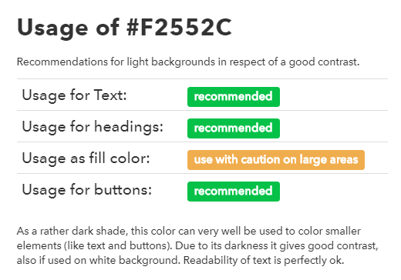<https://www.colorbook.io/hexcolors/view/f2552c#usageinformation>

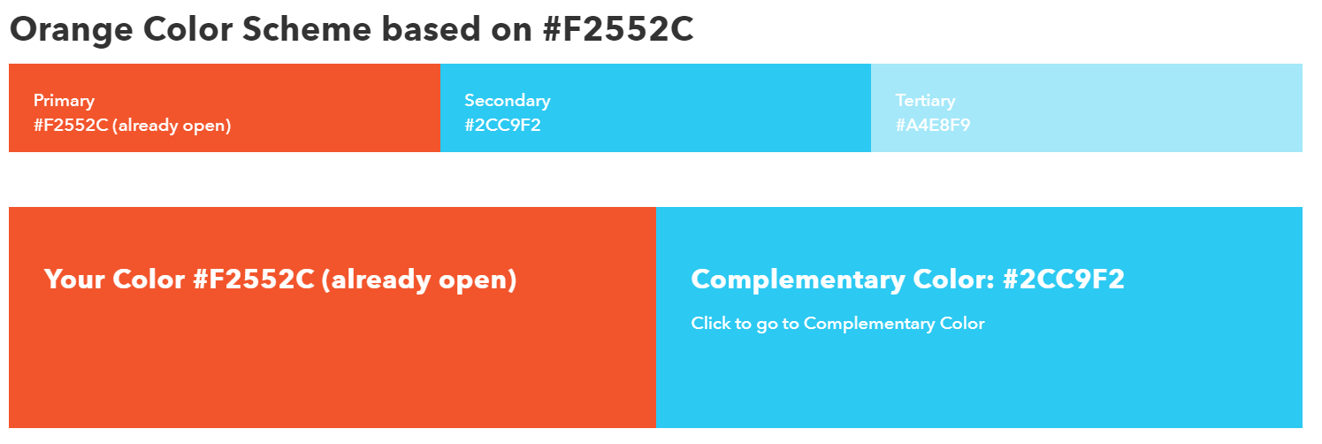

<https://encycolorpedia.com/f2552c>

